Housing Price Drivers in Sydney and Melbourne

Evidence from Macroeconomic Indicators and Econometric Models (2008–2024)
Author: Joyce Xu
Date: December 2024
Project type: Quantitative Research / Econometric Analysis
Tools: Python (pandas, statsmodels), Jupyter Notebook
Data sources: ABS, RBA

Executive summary
Research question: What macroeconomic drivers are most strongly associated with movements in Sydney and Melbourne house prices over time?

Data and analytical approach
I build a panel dataset using official quarterly statistics from sources such as the Australian Bureau of Statistics (ABS) and the Reserve Bank of Australia (RBA).
- Coverage: Sydney and Melbourne, over multiple decades of quarterly data.
- Variables: dwelling price indexes, cash rate, unemployment rate, participation rate, income and wealth indicators, dwelling approvals, and measures of supply tightness.
The analysis combines two complementary approaches:
- Dynamic models (ARDL / distributed lag models)
These models trace how house prices respond over several quarters after a change in a macro variable (e.g. a cash rate hike or a rise in unemployment), capturing short-run and cumulative effects.
- Panel fixed-effects (FE) models
These models look at longer-run relationships in levels, while controlling for unobserved, time-invariant differences between cities and for common national shocks over time (e.g. nationwide policy changes or global cycles).

1.2 Key findings
- Short run: interest rates and labour-market conditions dominate.
Changes in the cash rate and unemployment/participation have the largest and most robust short-run impacts on real house prices. Once these are controlled for, income, wealth and approvals contribute little to explaining short-term movements.
- Cumulative effects: cash rate and participation remain the key macro drivers.
Over horizons of around one to two years, the cash rate exerts the strongest cumulative drag on prices, while higher labour-force participation supports stronger housing outcomes. Other macro variables remain modest in size and are often not statistically distinguishable from zero.
- Fixed effects: interest rates interact with supply tightness.
In the fixed-effects model, lagged cash-rate levels are positively associated with price levels and interact with a local supply-gap measure. This is consistent with interest rates summarising the timing of policy responses to already-strong, supply-constrained housing markets, rather than higher rates directly causing higher prices.

1.3 Policy relevance
- Macro-linked housing and revenue risk.
Because house prices are tightly linked to interest rates and labour-market conditions, forecasts and risk assessments for property-linked tax bases (such as stamp duty and capital-gains-related revenues) should be explicitly conditioned on macro scenarios, rather than simple trend extrapolations.
- Compact, transferable framework for ATO analysis.
The ARDL/DL and fixed-effects framework demonstrated here can be readily adapted to other ATO-relevant questions—for example, how macro shocks affect small-business income, household balance-sheet stress or compliance—using administrative microdata in place of published aggregates.

2. Data and Methodology

2.1 Data
Data sources
All variables are obtained from official ABS and RBA statistics, consistent with the data environment used in government policy analysis:
- House prices: ABS Residential Property Price Indexes (RPPI) for Sydney and Melbourne.
- Labour market: ABS Labour Force statistics (unemployment rate, participation rate, employment).
- Interest rates: RBA Cash Rate Target (quarterly average and end-of-quarter levels).
- Income and wealth: ABS Household Income and Wealth.
- Population and migration: ABS National, State and Territory Population and Overseas Migration.
- Housing supply and construction: ABS Building Approvals and Building Activity (approvals, commencements, completions, supply-pipeline indicators).
Variables
Role | Variable (quarterly) | Notes
Dependent | Log real house price | Log of RPPI, deflated to express changes in real terms.
Explanatory | Cash rate | RBA cash rate (%).
Explanatory | Unemployment rate | ABS unemployment rate (%).
Explanatory | Participation rate | ABS labour force participation (%).
Explanatory | Income | Household income per capita.
Explanatory | Wealth | Proxy for household net worth / dwelling wealth.
Explanatory | Approvals / supply gap | Building approvals and supply-tightness indicators.
Control | Population | Population levels or growth, capturing demand pressure.
In practice, the empirical models use log transformations, growth rates, first differences, and interaction terms (e.g. cash rate × supply gap) constructed from the underlying series.
A full variable list is provided in the data appendix / codebook.

2.2 Methodology

Phase 1 — Dynamic responses (ARDL / distributed-lag models)
These models trace how macro shocks propagate over future quarters. Current house prices depend on:
- Their own lags (capturing persistence), and
- current and lagged macro variables such as the cash rate, unemployment and participation.
From these models, I estimate:
- Short-run effects: immediate responses in the first 1–2 quarters;
- Long-run effects: the eventual impact after all adjustments;
- Cumulative effects: the total price response over a given horizon (e.g., 1–2 years).
This “shock-and-response” framework gives clear answers to “How big?” and “How fast?” macro variables affect house prices.

Phase 2 — Long-run levels (fixed-effects panel model)
A two-city panel (Sydney, Melbourne) is estimated with:
- State fixed effects: controlling for permanent city differences (geography, planning regimes, long-run economic structure).
- Time fixed effects: absorbing national and global shocks affecting both markets.
The model asks: Holding constant structural city traits and common shocks, which macro variables are systematically associated with higher or lower real house prices?
This framework identifies robust relationships (e.g., unemployment → lower prices; interest rates × supply tightness → amplified price movements).

Estimation details
To keep the analysis rigorous but non-technical:
- Time-series properties (trend vs stationarity) were checked to determine appropriate transformations.
- Lag lengths were selected using information criteria and economic judgement.
- Interpretation prioritises economic magnitude and direction, not p-values alone.

3. Empirical results
This section summarises how interest rates, labour-market conditions and income and wealth are related to house prices in Sydney and Melbourne over time. Using time-series models, it first tracks how prices respond to changes in the cash rate and labour-market indicators from quarter to quarter. It then uses a fixed-effects model to examine how levels of these variables are associated with house price levels once we control for broad differences between cities and for nationwide shocks. Together, these models show that monetary policy and labour-market tightness are the main drivers of short-run price movements, while other factors play smaller roles.

3.1 Overview
Across specifications, three groups of variables matter for house prices:
- Monetary policy: the cash rate (or its lag) is always one of the largest coefficients in absolute value.
- Labour-market tightness: the participation rate and unemployment rate show sizeable responses, especially over longer horizons.
- Income and wealth: income and wealth enter with the expected signs but with comparatively modest magnitudes.
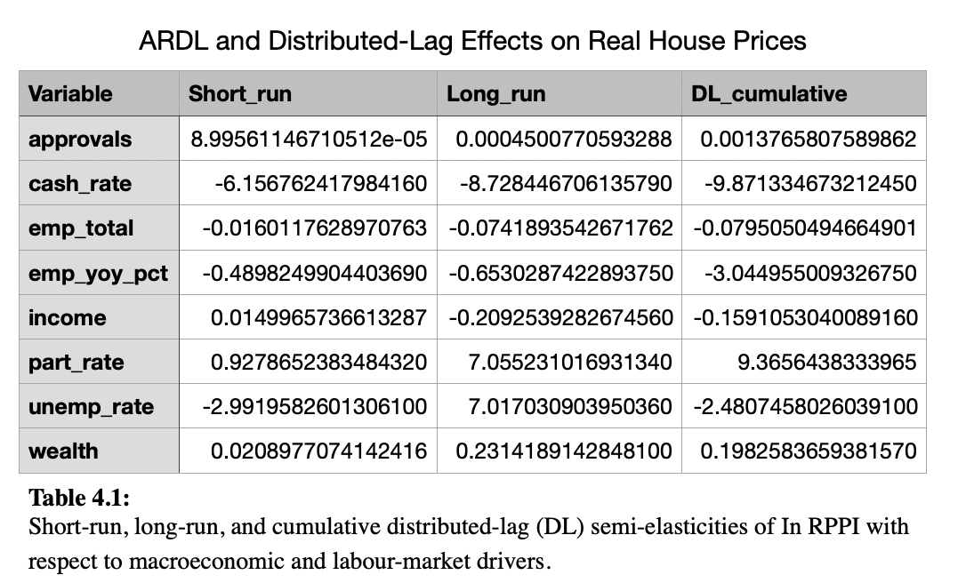
The ARDL/DL models in Table 4.1 and Figures 1–3 capture dynamic responses of prices to movements in these drivers. The FE model in Table 4.2 and Figure 4 then asks how levels of these variables are related to the level of house prices once time-invariant state heterogeneity and common time shocks are removed.

3.2 Short-run dynamic responses
Short-run ARDL coefficients (Figure 1; Table 4.1) show that monetary and labour-market shocks have the largest immediate impact on house prices.
- A one-unit increase in the cash rate produces the largest immediate decline in prices (short-run ≈ −6.16), and this effect is statistically significant at the 1% level.
- The unemployment rate also has a sizeable negative short-run coefficient (≈ −2.99), statistically significant at the 1% level, consistent with weaker labour-market conditions depressing demand.
- A higher participation rate exerts a positive short-run effect (≈ +0.93), statistically significant at the 5% level.
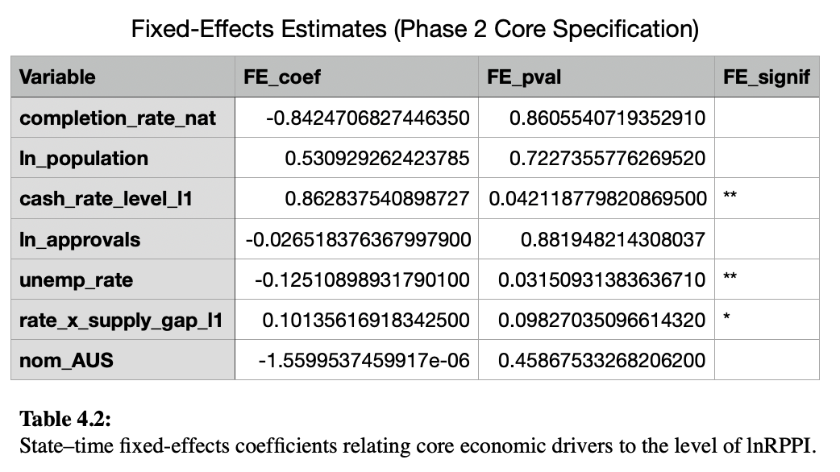
By contrast, income, wealth, approvals and total employment have small coefficients and are not statistically different from zero at conventional levels.
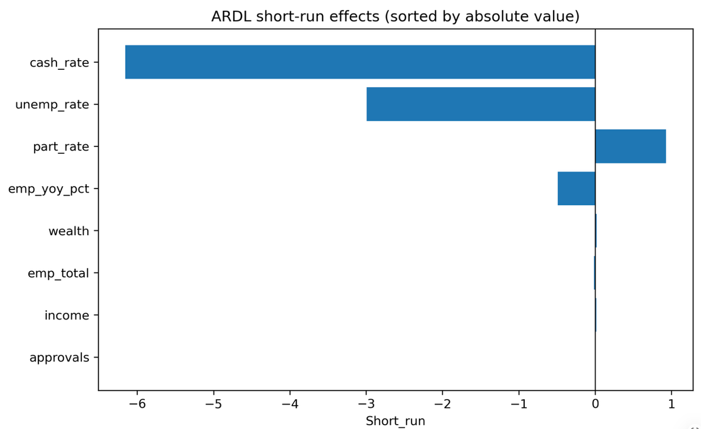
Figure 1:

3.3 Long-run and cumulative impacts

3.3.1 Long-run ARDL elasticities
Long-run ARDL elasticities (Figure 2; Table 4.1) describe the steady-state response after full adjustment.
- The cash rate shows a large and negative long-run effect (≈ −8.73), statistically significant at the 1% level, confirming a persistent contractionary response.
- The participation rate displays an even larger positive long-run elasticity (≈ +7.06), significant at the 1% level.
- The unemployment rate has a positive long-run coefficient (≈ +7.02), statistically significant at the 1% level, though interpretation must be made jointly with the cumulative DL effect.
In contrast, the long-run elasticities of income, total employment, and wealth are modest in magnitude and not statistically different from zero at conventional levels. Approvals also remain economically small and insignificant.
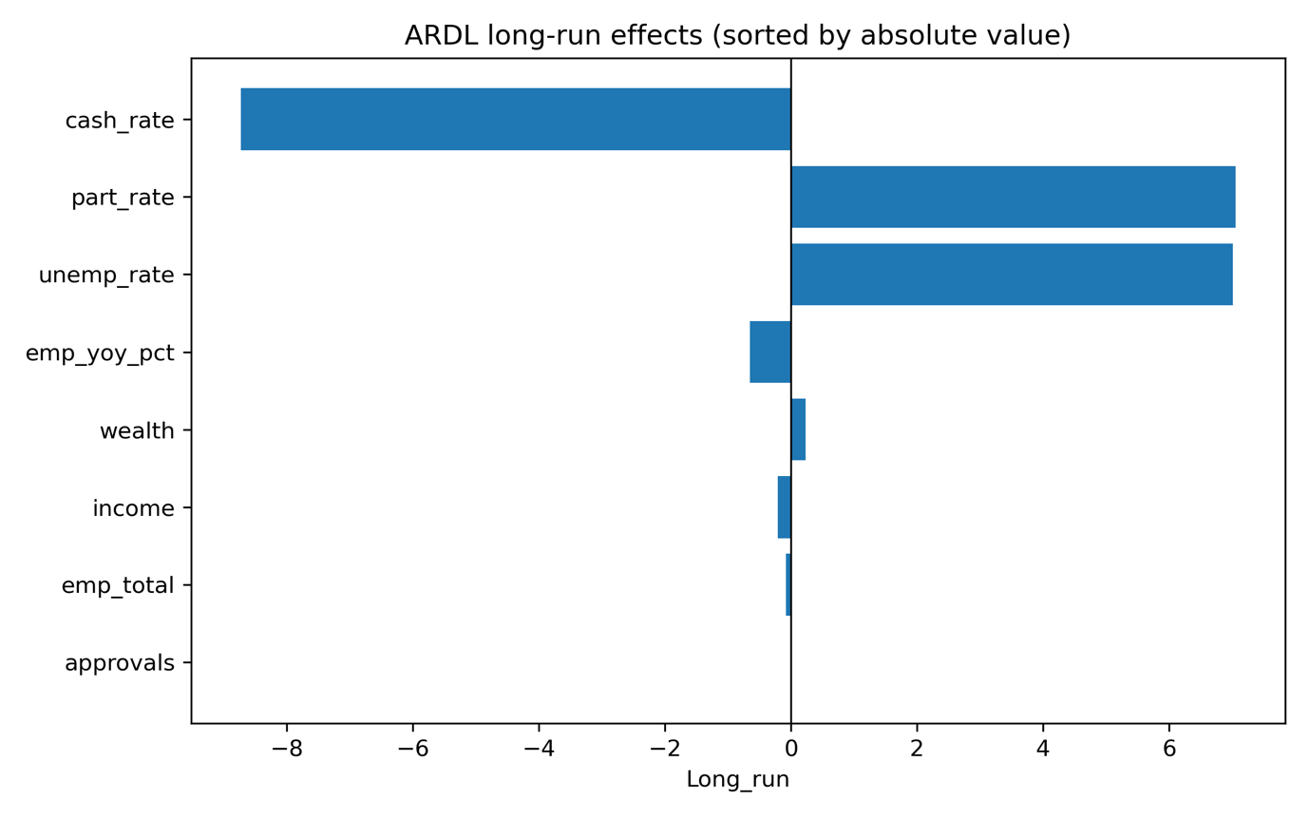
Figure 2:

3.3.2 Cumulative multi-quarter DL responses
DL cumulative effects (Figure 3; Table 4.1) illustrate how impacts accumulate over several quarters.
- The cash rate produces the largest cumulative drag (≈ −9.87), statistically significant at the 1% level.
- The participation rate generates a large cumulative positive effect (≈ +9.37), also significant at the 1% level.
- The unemployment rate has a negative cumulative effect (≈ −2.48), statistically significant at the 10% level, indicating the initial contraction dominates the later rebound.
Cumulative effects for income, total employment, wealth and approvals remain small and not statistically different from zero at conventional levels.
Taken together, the ARDL/DL evidence points to a clear pattern: monetary policy and labour-market tightness (especially participation) dominate both the short-run adjustment and the longer-horizon cumulative response of Sydney and Melbourne house prices.
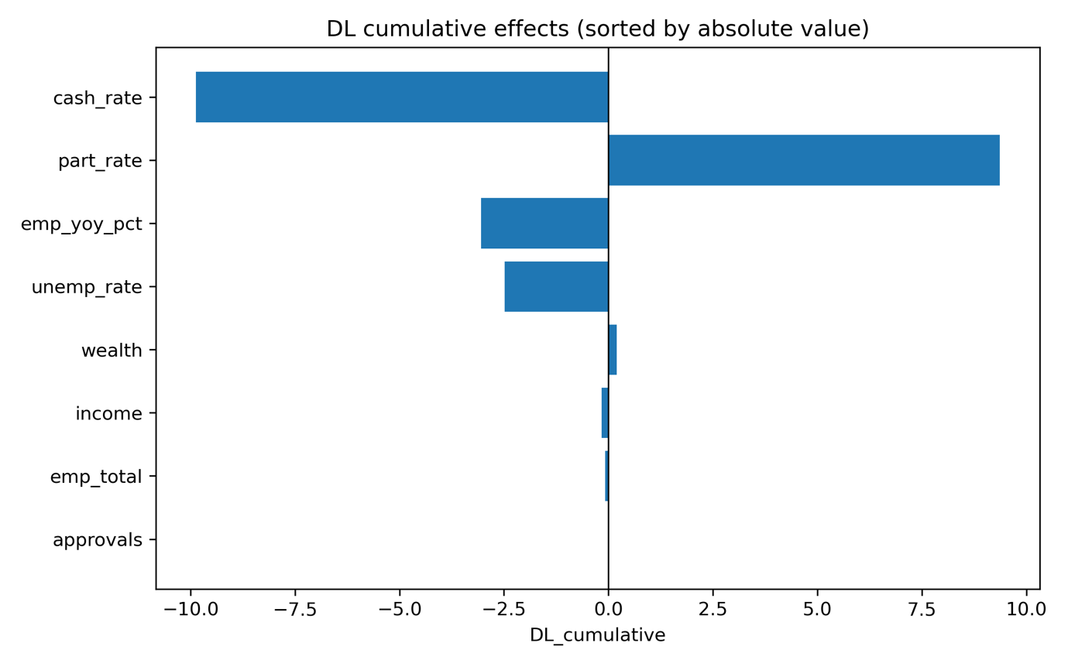
Figure 3 :

3.4 Fixed-effects level estimates (Phase 2)
The Phase-2 fixed-effects specification focuses on a targeted set of core variables and uses state and quarter dummies to purge the level regressions of unobserved heterogeneity. The results, shown in Table 4.2 and Figure 4, identify three coefficients that are statistically significant at conventional levels.
First, the lagged cash-rate level $\left(cash_rate_level_l1\right)$enters positively (around 0.86) and is statistically significant at the 5% level. Conditional on state and time fixed effects, periods with higher lagged policy rates are associated with higher current price levels. This sign reversal relative to the ARDL/DL results suggests that the FE model is picking up monetary-policy regime timing rather than causal effects: the RBA tends to raise rates in economic expansions—when housing markets are strong—and cut rates when conditions weaken.
Second, the unemployment rate has a negative coefficient (around –0.13) that is also statistically significant at the 5% level. This indicates that, after purging unobserved heterogeneity, higher local unemployment is associated with lower house prices, aligning with the dynamic ARDL finding that labour-market weakness depresses housing demand.
Third, the interaction between the lagged policy rate and the local supply gap $\left(rate_x_supply_gap_l1\right)$is positive (around 0.10) and marginally significant at the 10% level. This suggests heterogeneous policy transmission: in markets where supply is tight (larger supply gaps), the price response to higher interest rates is less negative—consistent with constrained supply limiting the extent of price declines.
In contrast, the coefficients on completion intensity, log population, log approvals, and national nominal inflows are imprecisely estimated and not statistically different from zero at conventional levels. These variables should therefore be interpreted primarily as structural controls, not as precisely estimated determinants of price levels in this two-state panel.
Figure 4:
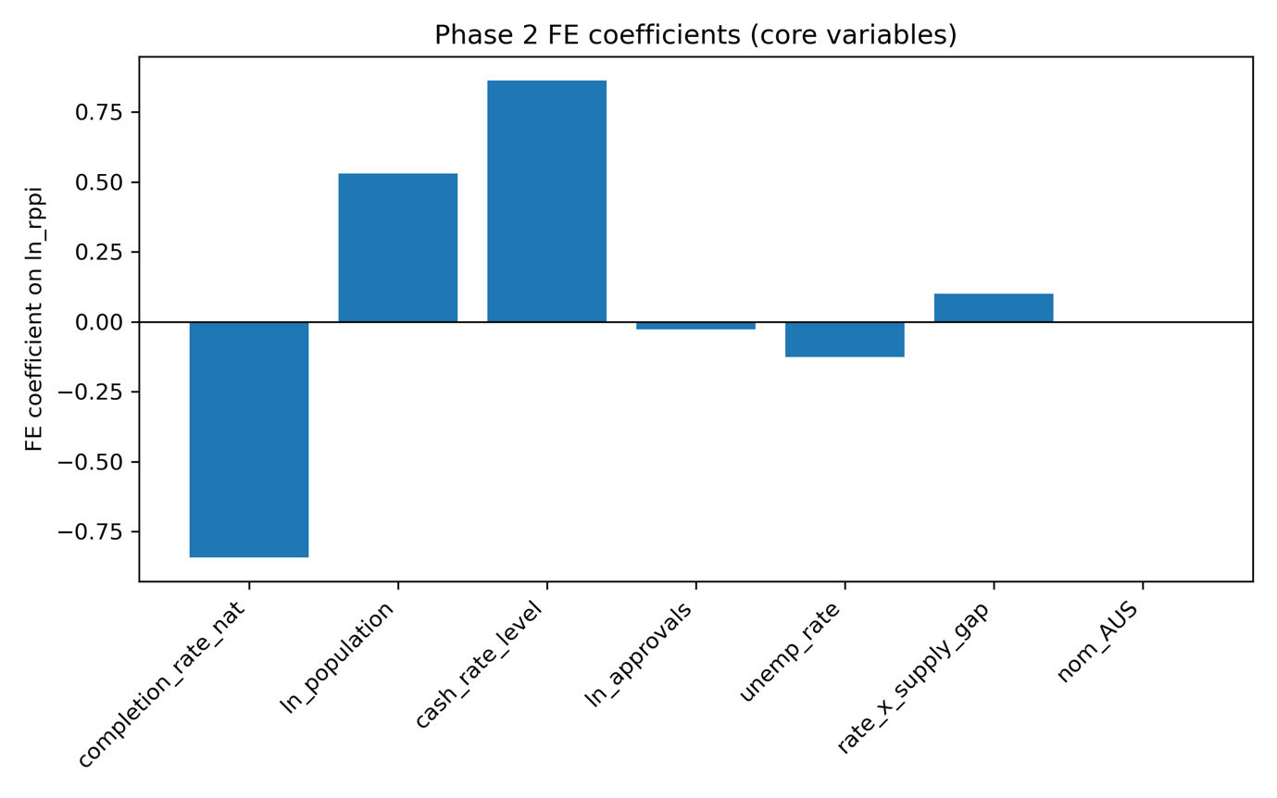
Overall, the FE results complement the ARDL/DL evidence. The dynamic specifications emphasise the contractionary impact of interest-rate hikes and labour-market slack on the path of house prices. The FE model shows that, once we condition on time and state effects, prices are higher in periods when the policy rate and labour-market conditions are stronger, consistent with interest rates reacting endogenously to underlying housing-market strength.

4. Discussion & Policy Implications

4.1 What drives house prices in the short run?
The dynamic models point to two clear short-run drivers of Sydney and Melbourne house prices:
- Interest rates:
Increases in the cash rate are followed by slower real house price growth over the next few quarters. This is consistent with higher borrowing costs tightening credit conditions and dampening demand.
- Labour market conditions:
  - A higher unemployment rate is associated with weaker subsequent price growth.
  - A higher participation rate is associated with stronger price growth, reflecting more people attached to the labour market and able to buy or trade up.
Once these are controlled for, other variables (such as income or approvals) add relatively little in explaining quarter-to-quarter price movements. In the short run, house prices mainly respond to the cost of finance and the strength of the labour market.

4.2 Longer-run patterns and structural drivers
The fixed-effects panel results highlight how longer-run price levels are shaped:
- With only Sydney and Melbourne in the panel, much of the variation in levels is absorbed by:
  - City fixed effects (structural features such as geography, planning regimes, long-run income profiles), and
  - Time fixed effects (national and global shocks that move both markets together).
- Within this structure, labour market conditions and supply tightness still matter:
  - Higher unemployment remains associated with lower house prices.
  - The interaction between interest rates and supply tightness is positive: when supply is constrained, a given change in the cash rate is linked to larger price movements.
Overall, long-run price patterns in these two cities are best thought of as the outcome of structural city traits plus the macro environment, with labour market health and supply constraints shaping how that environment translates into price levels.

4.3 Policy implications
- Monetary policy and housing are tightly connected
Because cash rate changes have clear short-run and cumulative effects, interest rate decisions directly influence housing affordability, household balance sheets and wealth distribution, especially in supply-constrained markets.
- Labour market performance supports housing stability
Policies that keep people employed and participating in the labour force help stabilise housing demand and reduce downside risks in the housing market, reinforcing the link between jobs policy and housing outcomes.
- Macro-sensitive planning and monitoring
Property prices and turnover, and any policies or revenues linked to them, are highly sensitive to the cash rate and labour market shocks. A compact monitoring set—cash rate, unemployment, participation, plus basic supply indicators (approvals, completions, supply gaps)—can serve as an early-warning framework for housing stress and cyclical risk.

5. Limitations and Future Work

5.1 Limitations
- Scope of coverage
The analysis focuses on Sydney and Melbourne only, at a quarterly frequency. This provides a clean, policy-relevant panel but does not capture:
  - differences across other states and territories; or
  - finer spatial variation within cities (e.g. LGAs, dwelling types, price segments).
- Missing dimensions of housing finance and behaviour
The dataset does not directly observe credit conditions, lending standards, LVRs, investor vs owner-occupier shares, or expectations. These factors likely mediate how macro shocks translate into house prices and could explain part of the residual variation attributed to fixed effects.
- Correlations rather than identified causal effects
The ARDL/DL and FE models document associations and dynamic patterns, not fully identified causal effects. The cash rate and labour market variables are themselves outcomes of broader macro conditions. No instrumental variables, policy discontinuities or natural experiments are used here, so reverse causality and omitted variables cannot be ruled out.

5.2 Future work
- Broader and more granular coverage
  - Extend the dataset to all states and territories, and where possible to sub-city or regional levels, to test how far the Sydney/Melbourne patterns generalise and to explore regional heterogeneity in housing responses.
- Richer modelling of credit and policy channels
  - Incorporate measures of credit availability, macro-prudential rules, LVR/DTI limits and investor activity, and explore policy changes or targeted interventions (e.g. lending restrictions, stamp duty reforms) as potential sources of causal identification.
- Linking housing dynamics to fiscal outcomes
  - Embed the housing models in a simple “house prices → transactions → revenue” framework, to translate macro shocks into scenarios for property-related tax bases and to assess how different macro and housing policy settings might affect medium-term fiscal risks.

6. Conclusion
This report examined the macroeconomic forces shaping house prices in Sydney and Melbourne using official ABS and RBA data and a combination of dynamic (ARDL/DL) and fixed-effects models. Across specifications, interest rates and labour market conditions consistently emerged as the strongest and most timely drivers of short-run price movements, while long-run levels were largely shaped by structural city traits and common national shocks, with unemployment and supply tightness still playing meaningful roles.
The core message is that housing in Australia’s major cities behaves as a macro-linked asset class: sensitive to monetary policy, reliant on labour market strength, and amplified by structural supply constraints. These findings highlight the importance of integrating housing, labour, and macro conditions when assessing short-term risks, medium-term planning, or future policy settings. Future extensions—broader geographic coverage, richer credit variables, and causal identification—would deepen this evidence base and strengthen the tools available for housing and macro-fiscal analysis.

7. Appendix A. Data Sources
All variables used in this report are drawn from official public statistics. Key data sources include:
- Total Value of Dwellings – ABS, Total Value of Dwellings
https://www.abs.gov.au/statistics/economy/price-indexes-and-inflation/total-value-dwellings/latest-release
- Household Wealth (Net Worth) – ABS, Household Income and Wealth
https://www.abs.gov.au/statistics/measuring-what-matters/measuring-what-matters-themes-and-indicators/prosperous/household-income-and-wealth
- Cash Rate – Reserve Bank of Australia (RBA)
https://www.rba.gov.au/statistics/cash-rate/
- Dwelling Approvals – ABS, Building Approvals, Australia
https://www.abs.gov.au/statistics/industry/building-and-construction/building-approvals-australia/latest-release
- Population – ABS, National, State and Territory Population
https://www.abs.gov.au/statistics/people/population/national-state-and-territory-population/mar-2025
- Labour Force – ABS, Labour Force, Australia
https://www.abs.gov.au/statistics/labour/employment-and-unemployment/labour-force-australia/latest-release
- Building Activity (Completions, Commencements) – ABS
https://www.abs.gov.au/statistics/industry/building-and-construction/building-activity-australia/latest-release
- Overseas Migration – ABS
https://www.abs.gov.au/statistics/people/population/overseas-migration/latest-release

8. Appendix B. Data and variable definitions
Table A1. Variables used in the empirical analysis
Variable name | Description | Unit / transformation | Source
city | Capital city identifier (Sydney, Melbourne) | Categorical | ABS, author construction
quarter | Calendar quarter of observation | YYYYQ (e.g. 2010Q1) | Author construction
date | Quarter end date | Date | Author construction
ln_rhpi | Log real house price index (capital-city established dwelling price index deflated by CPI) | Natural log of index (base year = 100) | ABS dwelling price index; ABS CPI
cash_rate_level | RBA target cash rate (policy rate) | Percent per annum | RBA statistical tables
cash_rate_level_l1 | Lagged cash rate level (t–1) | Percent per annum | Constructed from cash_rate_level
cash_rate_change | Quarterly change in the cash rate | Percentage points (Δ level) | Constructed from cash_rate_level
unemployment_rate | Unemployment rate, capital-city labour force | Percent of labour force | ABS labour force
unemployment_rate_l1 | Lagged unemployment rate (t–1) | Percent | Constructed from unemployment_rate
participation_rate | Labour-force participation rate | Percent of working-age population | ABS labour force
participation_rate_l1 | Lagged participation rate (t–1) | Percent | Constructed from participation_rate
employment_growth | Growth in total employment | Percent change over quarter | ABS labour force; author calculation
income_real_pc | Real household disposable income per capita | Index or dollars, deflated by CPI | ABS income accounts; ABS CPI
wealth_real_pc | Real household net wealth per capita | Index or dollars, deflated by CPI | ABS household wealth statistics; ABS CPI
approvals_rate | New dwelling approvals relative to existing stock | Approvals per 1,000 dwellings (or %) | ABS building approvals; ABS dwelling stock
approvals_rate_l1 | Lagged approvals rate (t–1) | Same as above | Constructed from approvals_rate
completion_rate_nat | National dwelling completions relative to stock (proxy for construction intensity) | Completions per 1,000 dwellings (or %) | ABS building activity; dwelling stock
completion_rate_nat_l1 | Lagged national completion rate (t–1) | Same as above | Constructed from completion_rate_nat
ln_population | Log of resident population (capital-city) | Natural log of persons | ABS population estimates
supply_gap | Indicator of local housing supply tightness (e.g. cumulative approvals vs population growth or stock) | Index (higher = tighter supply) | Author construction from ABS approvals, stock and population
supply_gap_l1 | Lagged supply-gap measure (t–1) | Index | Constructed from supply_gap
rate_x_supply_gap_l1 | Interaction between lagged cash-rate level and lagged supply-gap measure | Product of cash_rate_level_l1 and supply_gap_l1 | Author construction
state_fe | City fixed effects (absorbed in estimation) | Not stored explicitly (dummies) | Model specification
time_fe | Quarter fixed effects (common shocks) | Not stored explicitly (dummies) | Model specification
Notes:
- All nominal monetary variables (income, wealth, prices) are deflated using the ABS Consumer Price Index to obtain real measures before log transformation.
- Growth rates are computed as quarter-on-quarter percentage changes.
- For ARDL and distributed-lag models, variables enter either in levels, first differences, or lags as indicated in the main text and regression tables.
- For fixed-effects models, city and quarter identifiers are used to construct absorbed fixed effects (state_fe, time_fe) and are not reported as separate coefficients.

