ORM -DRIZZLE
npm install express@5.1.0 @neondatabase/serverless@1.0.0 cors@2.8.5 dotenv@16.5.0
drizzle-orm@0.44.2 cron@4.3.0

npm i nodemon@3.1.10 -D

this is stuff under scripts : {
"dev" : "nodemon server.js",

then you can run npm run dev
but if this is
"Hello" : "nodemon server.js",

this will be npm run hello

make sure your app is running in the correct source folder

"dev" : "nodemon src/server.js",

note changed to : src/server.js

****INSIDE THE package.json***

changing the main : "src/server.js"
is optional

***CONFIG FOLDER***
YOU CAN CREATE env.js

import "dotenv/config";

export const ENV = {
PORT: process.env.PORT,
DATABASE_URL : process.env.DATABASE_URL
}

****DRIZZLE-ORM ***
IT IS USED TO CONNECT / COMMUNICATE TO THE DATA BASE
INSERT OR ANYTHIGNG

***DRIZZLE-KIT
IS IS USED TO SUBMIT ALL CHANGES TO THE DATA BASE

**NOTE :
THE ONLY THING INSIDE THE DB FOLDER
IS THE SCHEMA.JS

WHILE INSIDE THE CONFIG
db.js

*****HOW TO USE THE DRIZZLE ***
Kit and ORM
Kit – Used To Push
ORM : used to build

Inside your shecma file
Must not contain error
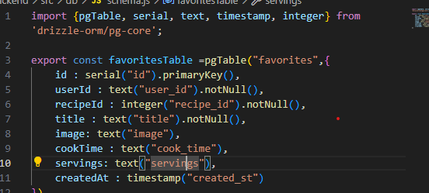
To automatically insert timestamp
createdAt: timestamp("created_st").defaultNow() // ✅ auto set timestamp
Then you create you dribble.config.js

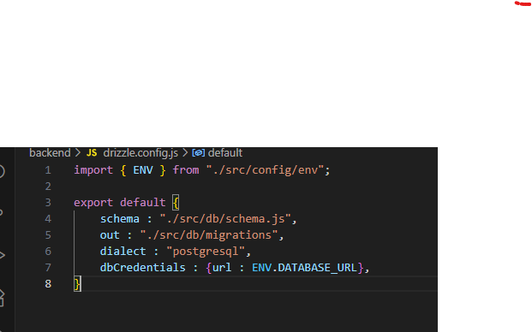

**AFTER SETTING UP THIS SET**
npx drizzle-kit generate
IT WILL CREATE A FOLDER OR FILE ACCORDING TO YOUR DIRECTIONS IN
out : "./src/db/migrations",

THEN RUN

****HOW TO TEST USING POSTMAN***
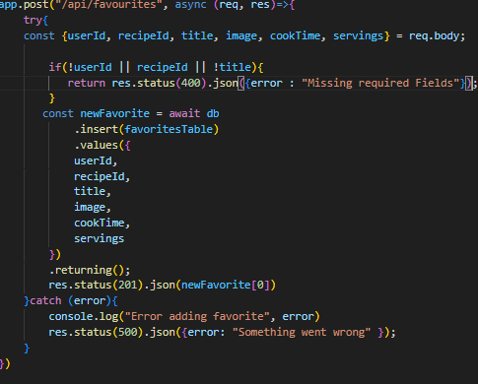

****GO TO POSTMAN****
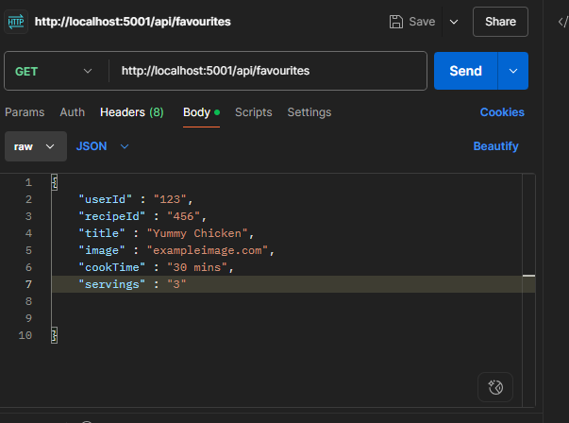

NOTE : GO TO BODY SECTION

“userId” : “123”,
“recipeId” : “456”

All this are inputted manually

