Macro Factors on IT Strategy

Week 7 Independent Learning

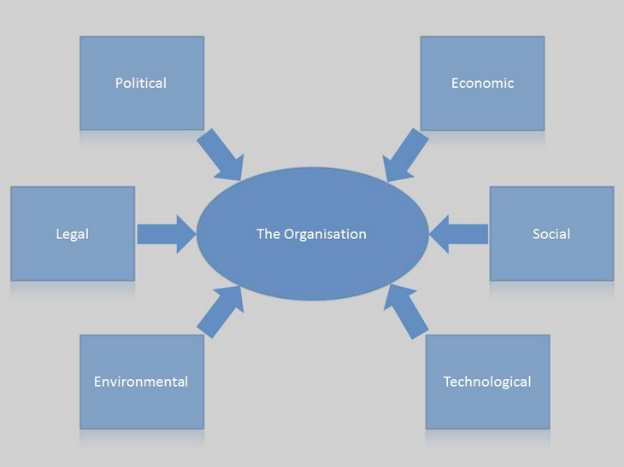

# Activity Background

There are many factors impacting IT Strategy. In the class, we have been focusing mainly on internal factors; however, being aware of the impact of external factors and having a strategy to utilize their benefits will place a critical role in securing competitive advantages for any company.

The purpose of week 7 activity is to identify a macro factor and analyse its impact to a company’s IT strategy.

# Activity Requirements

Each team in the class will be assigned one of the topics from the below list. The students will research and write a 700 word reflection report about it:

1. Identify a government initiative on IT, describe it and explain its impact on IT strategy.
2. Identify an economic factor (such as AEC - Asean Economic Community or TPP), describe it and explain its impact on IT strategy.
3. Identify a technology that will be soon commercialized, describe it and explain its impact on IT strategy.

# Submission Instruction

* Write a word reflection report including: 1) assignment cover page, 2) the reflection note of around 700 words (+/- 10%)
* Submit the reflection report through Tii, under: Assignments -> “Week 7 Independent Learning” -> Week 7 Report Tii Submission
* Due Date**: midnight, MON, week 8**
* Share your findings with other teams in week 8 class

# Team Assignment

|  |  |
| --- | --- |
| **Team** | **Topic** |
| Team 1 | Government Factor |
| Lazy Team | Economic Factor |
| Team 3 | Technology Factor |