

TrivialHub business plan

June 8, 2014

tRIVIALHUB

RMIT UNIVERSITY VIETNAM

**Founders and Executives:**

Nguyen Ngoc Duy Luan

Nguyen Le Thai Giang

Dinh Bach Nga

Vu Binh Minh

Table of Contents

Executive Summary 3

I. BUSINESS CONCEPT 4

1. The Starting Idea 4

2. Trivial Hub’s Vision 4

3. Trivial Hub’s Mission 4

4. Business Partners 4

II. PROFITABILITY WHEEL 5

III. PRODUCT OVERVIEW 6

1. General Description 6

2. Working model 6

3. Time allocation 8

4. Contracted supporting group 8

5. Payment method 8

Online payment 8

Direct payment 9

Non-cash payment 9

Payment schedule 9

Client balance 9

6. Ranking and achievement features 9

7. Pricing 10

8. Customer service 10

IV. PRODUCT DEVELOPMENT 11

STRATEGIC OBJECTIVES 11

V. COMPANY AND OPERATION 12

1. Operation 12

Research and Development Department 12

Finance Department 13

Marketing and Sales Department 13

Human Resource Department 13

2. HR Development Plan 14

3. Advisory Board 15

4. Legal Issue 15

5. Office and Facilities 16

VI. THE INDUSTRY 16

1. Market penetration 16

2. Competitors 16

VI. MARKETING STRATEGIES 17

1. Segmentation 17

2. SWOT 19

3. Objectives 19

4. Differentiation and Positioning 19

5. Product positioning: 20

6. Channels & Tools: 20

7. Action plan 23

VII. SALE 25

1. Strategy 25

2. Sale forecast 26

VIII. FINANCIAL PLAN 26

1. Objectives, Strategy and Funding Plan 26

1.1 Objectives 26

1.2 Funding 26

2. Assumption: 26

2.1 Weighted Average of Product Category 26

2.2 Budget for operation 27

3. Accounting Statement Analysis 27

3.1 Income statement 27

3.2 Cash flow statement 28

3.3 Ratio 28

IX. RISK 29

Appendix 1: Product prototype 31

Appendix 2: Detail Development Plan 0

# Executive Summary

# I. BUSINESS CONCEPT

## 1. The Starting Idea

In Vietnam, Internet is in its booming era. This growth is mostly contributed by teenagers and young adults. Statistics show that more than 6 million of Internet users in Vietnam are in the age of 15 and 24 years old (GroupM 2013). However, as news and articles complaining about the youth’s attitude towards the digital world are flooding all over pages, we – as part of the Generation Y - admit the truth that our time spending on Internet is mostly time wasted. In fact, with an average 128 minutes daily spent on Internet (GroupM 2013) we can all make money from a few minutes spared. That was how we came up with the idea of a virtual crowdsourcing marketplace where any Internet user can work in flexible time and make quick money.

After conducting primary research and spreading 2 surveys for both industry and Internet users, we came to the conclusion that there is a demand for crowdsourcing administrative tasks that need human intelligence such as data entry, objects identification from image, categorizing, survey doing, etc. These tasks are actually done by interns, thus wasting their time for learning and experiencing real working culture. As 2 members in our team are doing their internship at the time of the competition, we identify the opportunity to create a virtual marketplace where companies can crowd-source small, trivial tasks at low cost and get it done in a much shorter period of time. As a result, the time saved from doing trivial tasks can be invested in company’s resources.

That is how TrivialHub was born. We identify the demand from both sides and intertwine them in the simplest manner – a job marketplace. Companies get their job done. Internet users earn quick money. We make profit from charging transactions.

## 2. Trivial Hub’s Vision

TrivialHub’s vision is to provide Vietnamese businesses a time-saving and money-saving solution to accomplish their tasks and offer Internet users a simple, fast and convenient way to earn money. With a trustworthy and professional service, TrivialHub aims to become top-of-mind of both business and workers when talking about a leading crowdsourcing marketplace in Vietnam in the next 5 years.

## 3. Trivial Hub’s Mission

As for business, we aim to be known as a qualified solution that helps reduce wasted time for doing trivial tasks. As for Internet users, we want be recommended as a trustable job marketplace to make quick money with flexible working time.

## 4. Business Partners

|  |  |  |
| --- | --- | --- |
| **Categories** | **Business partner’s name** | **Description** |
| **Payment** | **NganLuong.vn** | NganLuong.vn is the number one online payment vendor in Vietnam with more than 3 million users, linked with many large banks and evaluated by the State Bank of Vietnam. NganLuong only charges companies 3% of the transactions - the lowest price in Vietnam - and free for workers. |
|  | **PayPal** | PayPal is a popular international e-commerce platform that allows online payments and money transfer. Up to now, PayPal is operated in 203 markets and has over 148 million active accounts. |
|  | **Amazon Payments** | Amazon Payments Inc., is a wholly owned subsidiary of Amazon.comthat provides a means to process transactions online. Amazon Payments uses the consumer base of Amazon.com and focuses on giving users the same checkout experience available on Amazon.com. |
|  | **BaoKim** | BaoKim is an online payment provider with the same business model as NganLuong. Verified by Visa and 3D Secure, BaoKim can also be implemented into many websites and applications. |
| **Media** | **Tinhte.vn** | Tinhte.vn is a large online forum with more than 1 million members, 50% active users. The forum focuses on providing technology-related information and has a very strong reputation in IT field in Vietnam. Duy Luan works here as a super moderator. |
|  | **Tuoi tre Newspaper** | Tuoi Tre (Youth) is the one of the largest newspaper publishers in Vietnam with a daily circulation of about 400,000 copies. It has daily newspaper in Vietnamese and online version (Viet and Eng) which target both local and foreign readers. Binh Minh works full time as a reporter. She is in charge of business and lifestyle column. |

# II. PROFITABILITY WHEEL

To generate and maintain sustainable profit, Trivial Hub implements 3 approaches:

**1. Main business:** Charge on each successful transaction. For each completed task, Trivial Hub will charge 10% on client side. The size of profit thus depends on volume.

**2. Online Advertising Package:** There will be space for advertising on Trivial Hub website and mobile application. However the number of advertising partner is limited to reduce annoyance. As an effort to add in value for the package, we will offer more marketing benefits for partners including:

- Free use of Trivial Hub service in 1 year.

- PR articles on Facebook Fanpage of Trivial Hub.

**3.  Mobile prepaid card, game online card payment:** From 2017, there will be option for non-cash payment including  mobile prepaid card and game online card. Payment after each task done will be accumulated until it reaches 20,000VND (~1 AUD). Then worker can choose to get paid by mobile prepaid or game online card. Trivial Hub therefore can get discount from this cooperation because we act as their distributor.

**4. Cooperate promotion with other brand:** From 2016, Trivial Hub will cooperate with other brands to help them promote through code vouchers. This method of payment is also one of marketing tactics. By promoting specific, tangible prizes Trivial Hub will be more appealing to target workers. In exchange, we will earn profit as suppliers have to provide voucher at the least cost (expected to be 50-60% of its real value).

# III. PRODUCT OVERVIEW

## 1. General Description

TrivialHub’s core product is a crowdsourcing Internet marketplace. It is a hub where companies (clients) can post trivial tasks so that end users (workers) can access and choose the suitable ones based on their own skills and preference. This marketplace is operated on 3 different integrated interfaces: a standalone website, a Facebook-integrated website and mobile application. These three points of access will share the same design language, task database, user database and payment methods. This allows convenience for users to perform the tasks anytime, anywhere either at home or on bus.

Both clients and workers will have their own benefits using our service.

Companies can:

* Get the small tasks done in a short time frame
* Save time and cost
* Recruit a source of labor with particular characteristics/skills
* Have a guarantee of quality due to possible request to redo the task.

Workers can:

* Get paid quickly without tax or additional charging
* Have utmost convenience in working time, place and tool
* Efficiently use their time online

*Prototype of TrivialHub website can be found in Appendix 1.*

## 2. Working model

As TrivialHub is a crowdsourcing marketplace, tasks posted are divided into small items so that many workers can contribute at the same time. At any given point of time, one worker can take only one item. Availability status of the item will be displayed in real-time.

The working process of TrivialHub can be seen as follow:

Task

Item 1

Worker 1

Item 2

Worker 2

Item 3

Worker 3

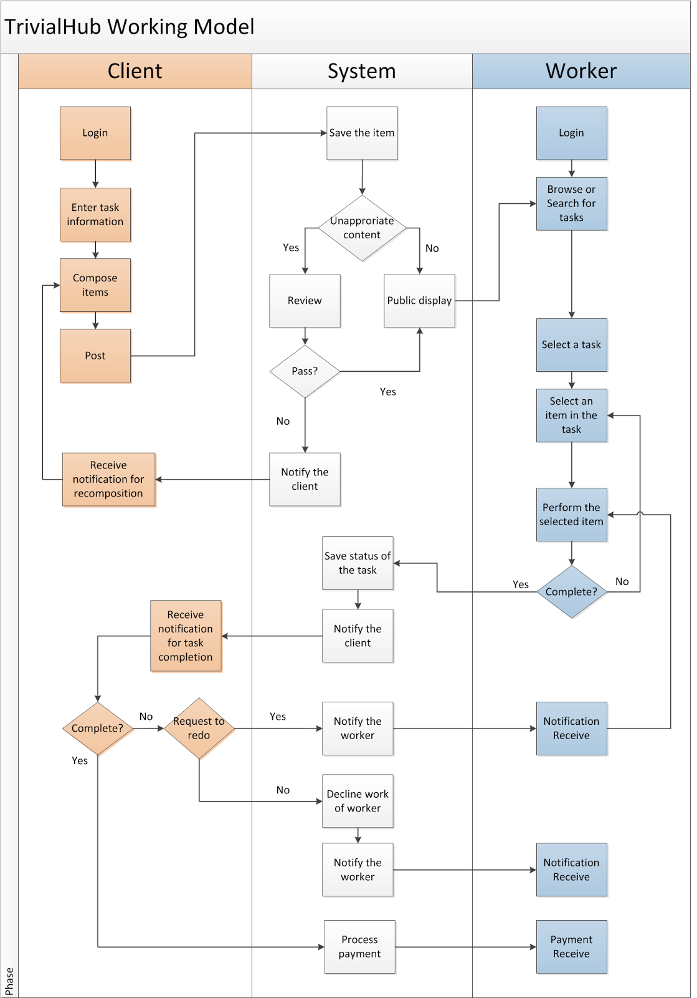

To protect the right of workers, clients cannot disapprove the task more than 3 times. If the performance still does not meet their requirement, current workers will be requested to abandon the task so that other workers can replace them. A feedback form will be provided to collect opinions and ratings from clients about workers.

## 3. Time allocation

A particular duration (eg: 10 minutes) will be allocated by client for each item. That is, when a worker selects an item, he/she cannot acquire the item for more than the predefined period of time. If not, they will be kicked out of the item and their work will be declined by the system. If they want to do it again, they will have to reselect the item.

## 4. Contracted supporting group

TrivialHub will hire a small group of contracted employees to work as back-up workers. Their responsibility is to find near-deadline tasks and complete them to make sure that the number of tasks done is as high as possible. They will be paid a fixed amount of money based on a minimum number of tasks completed per month. In the first phase, the group will consist of 1-5 people. The size of the group will be adjusted accordingly based on the number of tasks given. This workforce allows the consistency in job completion.

## 5. Payment method

A notification will be sent to the client after a predefined number of items are completed. The client will then be asked to check and confirm the quality of task. At this point, the payment process will start. The payment process of TrivialHub is as follows:

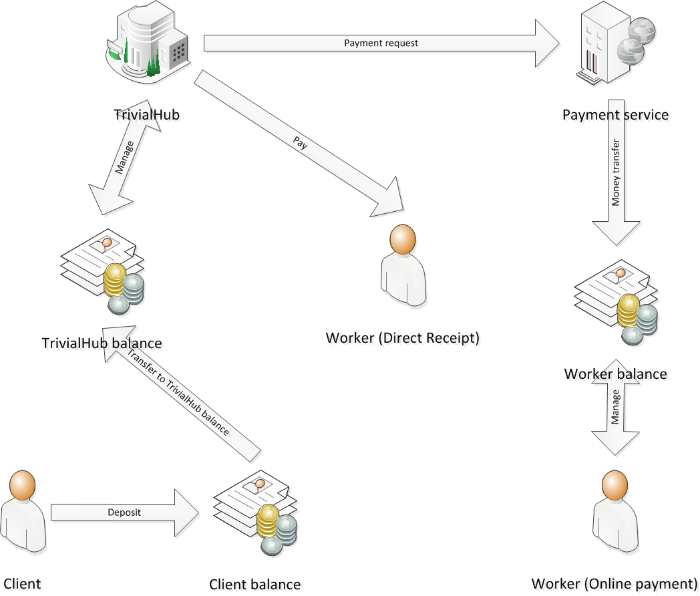

Initially, TrivialHub plans to implement 2 payment methods:

### Online payment

This method is suitable for workers that are familiar with online transactions. The selected payment service provider is **NganLuong.vn**, one of the largest and popular payment portals in Vietnam. Up to now, NganLuong.vn has more than 1 million users with hundred of thousands of payment accounts. The popularity of NganLuong.vn provides TrivialHub’s users with a familiar method to receive reward with a link to worker balance in many big Vietnamese banks. Moreover, NganLuong.vn also has a full set of policies, rules and insurance to protect online transaction, thus TrivialHub does not need to spend resources in these areas.

In the long run, TrivialHub plans to implement other popular payment services such as PayPal and Amazon Payments in order to provide workers with different payment options to their preference. The implementation also allows a gateway for TrivialHub to extend beyond Vietnam.

### Direct payment

In Vietnam, many people still do not have bank account, especially students. Thus, TrivialHub must provide a direct payment to attract these types of workers. They could directly come to TrivialHub’s office to receive cash or TrivialHub will send cash to their desired address.

However, this payment method is not encouraged as it will increase the operating costs for TrivialHub. We will charge worker 10% of their rewarded amount after the 6th month of using direct payment. This 6-month period is enough for them to open a bank account and get familiar with online payment method.

### Non-cash payment

In the long term, TrivialHub plans to provide non-cash payment to workers. These payments are in the form of prepaid mobile phone card, online game card, gift card, and voucher. This plan requires support from external business partners.

*The detail timeframe of development is stated in the Product Development section of this plan.*

### Payment schedule

* With online payment method, transaction to worker will occur as soon as client approves the worker’s performance. By get paid in a short period of time, workers will immediately feel the reward for the time and effort that they have spent to work on TrivialHub. This helps raise the satisfaction of workers and creates a motivation for them to continue their work.
* With direct payment method, payment only occurs once every month.

If a client does not confirm after 3 days of completion, TrivialHub’s staff will revise the quality of the work. If approved, the worker will get paid without further discussion with the client. This will be clearly stated in the contract with client.

### Client balance

Clients are required to deposit a certain amount of money into their balance with TrivialHub before they can post tasks. This deposit is to make sure that payment for workers will be conducted smoothly and timely. Clients are not allowed to post tasks of higher costs than their current balance.

## 6. Ranking and achievement features

TrivialHub will allow client to rank their workers using point. When a worker reach a particular point, they will be awarded. The details can be seen in the table below. In addition, the ranking system will help clients know about the workers: how well they have performed since they joined TrivialHub and how other clients ranked them.

Vice versa, workers can also rank clients for the quality of tasks posted, the number of tasks available in a period of time and the lead-time between the moment of task completion and moment of approval (or moment of payment). This feature helps workers know more about the clients they are working for and how fast they should expect a payment after completing task.

## 7. Pricing

TrivialHub only charges clients when the task is approved. Workers do not need to pay any fee.

At launch, TrivialHub plans to charge clients based on the category of tasks posted online. The detail suggesting prices are as follow:

|  |  |  |
| --- | --- | --- |
| **Category of work** | **Description** | **Price per task (AUD)** |
| Research | Worker have to look for specific information requested by client, e.g. to search for a list of companies’ address and contact, to search for online discussions about a subject. | $0.1 - $0.25 |
| Survey | Worker will need to complete a survey given by client. TrivialHub will provide intuitive tools for client to compose, post and extract data of the survey. | $0.05 - $0.15 |
| Forum seeding | Worker will receive a link on a topic of discussion in a forum. They will have to register a new account, follow basic guides on what to comment. Worker then screenshots the comments to prove the work. | $0.02 - $0.15 |
| **Data entry** | Typing document from paper into a file or a form. TrivialHub will provide tools for client to post document’s image file. Worker needs to look at the image and input data directly into a form provided by TrivialHub. | $0.02 - $0.5 |
| Emailing | Sending emails. Content can be given by client or composed by workers and sent to given addresses. | $0.02 - $0.3 |
| **Rating** | Workers will be asked to rate a collection of information based on a set of criteria defined by the client with form provided by TrivialHub. | $0.05 - $0.5 |
| **Categorization** | Worker will be asked to categorize a group of items into different categories predefined by client. Items can be posted as images or texts.. | $0.05 - $0.5 |
| Transcribe | Worker will be asked to transcribe a sound recording into text. Client will post the sound file or URL link to the file. Workers will be provided a text entry to perform the task. | $0.5 - 1$ |

## 8. Customer service

TrivialHub will have these customer services:

* **Support for workers**: help workers know how to perform tasks, basic usage of TrivialHub service, troubleshoot technical issues, and check status of payment.
* **Support for clients**: help clients know how to compose and post tasks, assist with depositing process, payment process, ranking process
* **Customer relation**: renew contracts of clients, inform clients and workers of new features on TrivialHub, build long-term relationship with clients, update workers database.
* **Payment service**: take care of direct payment method

# IV. PRODUCT DEVELOPMENT

*For the first half of the first year*, TrivialHub’s focus is to fully implement all basic functions that allow client to post tasks and allow worker to perform the tasks. Integration with Facebook and NganLuong.vn payment service will be made as this is vital to the operation of the company. TrivialHub expects that by the end of August 2015, the website are ready to be launched with high degree of stability.

*From September to the end of the first year*, TrivialHub will put all focus and resources to retain current customers and maintain a reasonable amount of tasks while enlarging the workforce. This phase is critical to the branding process of the company. Besides, TrivialHub also implements the prepaid mobile card and game card payment for workers.

*From 2016*, TrivialHub development team will start to implement new functions for the service in order to differentiate ourselves from other job marketplaces. First, PayPal will be integrated to the system. Then, there is the notification feature to alert the client on task completion or problem. English interface is also implemented since TrivialHub wants to reach foreign companies and foreign markets. Foreign businesses to enter Vietnam can use TrivialHub to spread survey to the market or prepare preliminary research for their operation in the future.

*A detail product development plan can be seen in Appendix 2*

## STRATEGIC OBJECTIVES

|  |  |  |  |
| --- | --- | --- | --- |
| **Stage** | **Period** | **Objectives** | **KPIs** |
| **Stage 1**:  - Build the website with basic functions.  - Launch the demo version.  -Approach customers: build and strengthen network with companies; raise awareness of TrivialHub among public. | 1st half of the 1st year | In the first half of the 1st year, we want to focus on building the website and successfully launch the demo version on time to easily approach SMEs and build a strong network with them in the first place.  Besides we will launch social media sites at the end of the period (from May) to approach and maintain the connection with the targeted workers and push for TrivialHub’s Facebook interface. | - Reach 100 SMEs  - By the end of June 2015: 5,000 followers on Facebook page  -Registered clients : 10 companies  -Tasks posted:10 tasks/day |
| **Stage 2**:  - Improve website with advanced functions and online payment methods  - Officially launch TrivialHub  - Increase traffic and transaction on website and rank on search engines.  - Orient customer behavior toward choosing TrivialHub service | 2nd half of the 1st year | In the 2nd half of the year, we want to add more advanced functions to the website to facilitate the transaction and make it more user-friendly.    On September the official website of TrivialHub will be launched after testing. We will push for combined marketing tactics during this period to increase the number of customers. | -Registered clients: 30  -Generate an average 100 tasks/day  -Registered workers: 300  - Time on site : 30%  - Website visits: 4,000/day  - Social media sites : 10,000 followers  - Forums & websites endorsement: 10 posts  - Participation in events for students : 5 events  - Organize at least 2 workshops |
| **Stage 3**:  - Build a steady workforce and maintain a good relationship with clients  - Implement mobile application  - Build a strong customer service  - Earn profit to reach break-even point | 2nd year | In the 2nd year, we focus on building a steady workforce to be ready for the demand of clients. This period also sees the launch of TrivialHub’s mobile application to improve the convenience for working. We also collect feedbacks and make appropriate adjustment. We also push sales to reach the break-even point, which is estimated to be achieved in the last quarter of the year. | - Reach 40% time spending on site  - 100,000 followers on social sites  - Web visits: average 10,000 daily visitors  - Generate an average 250 tasks per day  - Release corporate identity materials and raise awareness of 50% of target public. |
| **Stage 4**:  - Sustainable growth based on a steady workforce and loyal customers  - Reach bigger companies  - Expand the scale to all over Vietnam and abroad | 3rd year | In the 3rd year, we will implement more functions to facilitate the transaction and reduce the complexity to limit to allow individual to perform as client. Expansion of TrivialHub to make most use of the e-commerce power will be profited. The business will reach out to customers all over Vietnam and nearby countries. | - Get on top-of-mind, top-of-search on search engine for crowdsourcing administrative tasks in Vietnam  - Average 15,000 web visitors  - Time-on-site increased to 50%  - Generate an average 800 tasks per day |

# V. COMPANY AND OPERATION

## 1. Operation

TrivialHub is a Limited Liability Company in which the shareholders are also executives. Any decision under Trivial Hub brand name needs to be discussed carefully and agreed by the 4 members who are also in charge of different departments based on their profile and background.

### Research and Development Department

Managed by **Nguyen Ngoc Duy Luan.** Luanhas IT background from his part-time job as a writer for Tinhte.vn and as a RMIT Business Information System undergraduate. He has strong network with industry people and opportunities to approach different Internet user types, which helps build and develop the website compatible with real demand and expectation from workers. He is also familiar with web programming, open source technologies, networking and e-commerce models.

The R&D department will be responsible for building website and application for TrivialHub, research for new functions, maintain the website, services, servers and all infrastructure required for TrivialHub’s operation. Besides, R&D team also supports Marketing department with technical problems from customers as well as takes care of the internal systems.

### Finance Department

Managed by **Dinh Bach Nga**. Nga is a key member of RMIT Vietnam Business Club. As an industry liaison and sponsorship leader, she has gained valuable experiences in raising fund, dealing with external business relationships from different industries. Her background as a student of RMIT Economic - Finance major supports her in cash flow management and other financial issues. She is also a business partner of two biggest groupon websites in Vietnam, which gives her great skills in entrepreneurial process.

The key roles of this department include planning, organizing, auditing, accounting for and controlling the company's finance. Finance department is also in charge of producing finance statements to comply with the government’s regulation.

### Marketing and Sales Department

Managed by **Nguyen Le Thai Giang**. Giang has a communication background from her RMIT Professional Communication major and economic knowledge from a second degree in Foreign Trade University. She is an active member in several school clubs and has experienced both as campaign leader and member. She used to work as intern at a digital marketing and PR agency. She is also familiar with raising fund for social work and charity.

The Marketing and Sales Department (M&S) is responsible of finding prospect clients for TrivialHub, making and closing deals with clients, running marketing campaigns, organizing internal and external events to help promote TrivialHub, communicate with both clients and workers to address their concerns. This department also serves the function of customer relationship management.

### Human Resource Department

Managed by **Vu Binh Minh.** Minh has experience in writing as she is reporter at Tuoi Tre Newspaper. She is RMIT Professional Communication alumnus and had PR experience from 4 years working at media companies as well as internship at RMIT Vietnam’s Communication Department. Experience as President of the biggest club in RMIT is necessary for her management skill.

The Human Resource Department will take care of recruitment and arrangement of employee, salary and wage payment, insurance, bonus and reward management, paperwork for the company and government’s concern about TrivialHub operation. Additionally, the HR department will also provide effective policies, procedures, guidelines and support within companies. This department is to make sure that the company mission, vision and values are met and principles, metrics, factors to success are optimized.

## 2. HR Development Plan

|  |  |  |  |  |  |  |  |
| --- | --- | --- | --- | --- | --- | --- | --- |
| Department | Number of staffs | | | Expected Salaries | | | Job Descriptions |
|  | 2015 | 2016 | 2017 | 2015 | 2016 | 2017 |  |
| Product Development  -  Customer Support | 0  0 | 1  1 | 1  2 | 0  0 | 150  100 | 150  100 | - Managing the entire product line life cycle from strategic planning to tactical activities  - Specifying market requirements for current and future service by conducting market research  - Manage the existing service and lead the development for enhancement to continuously support customers.  - Manage the execution of consumer research to further support rationale for product development and positioning within the marketplace. |
| Accounting and Finance | 0 | 1 | 1 | 0 | 100 | 100 | - Administer and monitor the financial system to ensure that the company  finances are maintained in an accurate and timely manner  - Administer clients and workers files and records in order to ensure accurate payment  - Perform other related duties as required |
| Marketing and Sale | 0 | 0 | 2 | 0 | 0 | 125 | - Develop and implement marketing and sales plans  - Develop and manage sales/marketing operating budgets  - Develop and recommend product positioning, packaging and pricing strategy to produce the highest possible long-term market share.  - Ensure effective control of marketing results which still falls within designated budgets.  - Monitor competitor products, sales and marketing activities.  - Establish and maintain relationships with key strategic clients.  - Meet with key clients, assisting sales representative with maintaining relationships and negotiating and closing deals.  - Coordinate liaison between sales department and other sales related units.  - Perform other related duties as required |

## 3. Advisory Board

Associated people in advisory board include:

***Technology - Legal***:

Mr. Thanh Dinh, administrator of Tinhte.vn - the Vietnamese biggest technology site, will advise to design TrivialHub as most usable possible. As an owner of a software company and director of Vimobi - an online payment system, he will also support the improvement of functions and payment system.

Mr. Mike Tran, founder of Ticketbox.vn - one of the most successful start-up e-commerce businesses in Vietnam is also willing to give his attorney’s advice.

***Marketing - PR:***

Senior Marketing lecturer Melvin Fernando at RMIT Vietnam will help us in marketing and sales.

Mr. Thanh Nguyen - founder and CEO of Emerald, a digital marketing and PR agency that has experience in online marketing and network with big brands.

Mr. Son Nguyen – PR specialist. He will help us develop effective marketing campaigns.

***Finance:***

Mr. Tai Tran – Risk Management lecture, also an investment consultant will support the risk analysis of TrivialHub.

Mr. Nghiep Dinh - Board Member of a Vietnamese Bank is willing to support us on raising fund and controlling reserve for unexpectted situations.

## 4. Legal Issue

Mr Mike Tran and Thanh Dinh will help TrivialHub with legal issues since they have operated their own e-commerce websites for several years. They will also advise TrivialHub on obtaining legal documents and certificates before the company go on operation.

Initially, TrivialHub will need these licenses:

* Business License - Department of Industry and Trade of Ho Chi Minh City
* E-Commerce Credit Rating - Vietnam E-Commerce and Information Technology Agency
* Website License - Vietnam E-Commerce and Information Technology Agency
* Security Certificate - People Committee of the Ward where TrivialHub will operate
* Patents and Trademark - National Office of Intellectual Property of Ho Chi Minh City

## 5. Office and Facilities

**Office rental**: TrivialHub plans to rent a 100-square meter office at My Phuoc Apartment, 280 Bui Huu Nghia, Binh Thanh District, with the cost of 300 AUD per month.

**Server Rental**: TrivialHub needs servers and hosts to run the website, application and services. However, the company plans to rent servers and hosts from CMC Telecom Corp. since the costs of operating, maintaining and backing up will be much cheaper. The costs for rented servers will be about 130 AUD per month.

# VI. THE INDUSTRY

## 1. Market penetration

## 2. Competitors

|  |  |  |
| --- | --- | --- |
| **Competitors** | **Strength** | **Weakness** |
| [Local] Viec Vat Online Freeway (<https://www.facebook.com/viecvatonlinefreeway>) | Uses Facebook, a social network which currently attracts a huge number of users in VN, easy to share new information and draw target customers. | Totally manual: recruiters and workers send their tasks/demands to the page’s inbox. After being approved, the tasks will be published on the Facebook page. Recruiters and workers will comment directly under the post to hire an employee or ask about the tasks. |
| [Local] Viec Cho Ban (<http://viecchoban.vn/>) | Tasks posted directly on homepage, specific categories | Aims at workers (searchers for jobs)  Crowded and unprofessional interface |
| [International] MicroWorkers  <http://microworkers.com/?Id=d5286211> | Prominent features, various functions, visually attractive | Require users to register before allowing them to use/see the service.  Lack of a visual overview of the job/task/service.  Not popular in Vietnam |
| [International] Amazon Mechanical Turk (<https://www.mturk.com/mturk/welcome>) | Post the key information on its home page so the prospective customers can understand its operational procedures and see its task list. | Requesters are restricted to US-based entities only.  Not popular in Vietnam |
| [International] Elance (merged with oDesk) (<https://www.elance.com/?r>) Guru (<http://www.guru.com/>)  Freelancer ([https://www.freelancer.com](https://www.freelancer.com/)) | Post the numbers of the site’ freelance workers in different categories, testimonials of both workers and businesses. | For freelancers  Not popular in Vietnam |

# VI. MARKETING STRATEGIES

## 1. Segmentation

With about 40% of Vietnamese people using Internet versus 480.000 unemployed aged 15-24 in Vietnam in 2013, we have identified an opportunity for our business in this blooming digital era of distance work. Currently 61% of Vietnamese Internet users are used to E-commerce websites. This emphasizes the great opportunity for our business.

As a marketplace, the target customers we look at are divided in two:

- **Workers**

|  |  |  |
| --- | --- | --- |
|  |  | **Workers** |
| **Demographic** | Age | Young Vietnamese aged 18 -25 |
|  | Location | Vietnam – urban areas |
|  | Gender | Male and Female |
|  | Income | >200 USD/month |
|  | Occupation | University and college students |
| **Psychographic** | Social class | Medium class |
|  | Lifestyle | Internet users, spend at least 3hrs/day online, having their own computer/laptop, social media users |
|  | Personality | Honest, hard-working, passionate, innovative, modern, adaptive, impatient, changeable |
| **Behavioral** | Behavior | Need and willing to make money but lack of time and means of transportation  Easily influenced by trends and peer reviews |
|  | Skills | Basic office skills, familiar with online payment methods, multi-tasking, digital literate |

- **Clients**:

*According to Ministry of Industry and Trade Vietnam, the number of small and medium enterprises is more than 500,000 -> great source of potential clients for TrivialHub.

|  |  |  |
| --- | --- | --- |
|  |  | **Clients** |
| **Geographic** | **Location** | Vietnam, urban cities |
| **Purchase behavior** | **Purchase criteria** | Quality, price, service, convenience, sophistication, completion, availability, security, sales control |
| **Firmographics** | **Industry** | Communication / E-commerce / Education / Consumer products / Entertainment / Market research |
|  | **Size** | Small, medium enterprises and Start-ups |
|  | **Customers** | Unemployed, housewives, office workers in their break time |
|  | **Technology** | High level of technology as a marketplace |
| **Product Usage** | **Share** | Share of end-customer target market |
|  | **Frequency** | First time, regular, continuous, seasonal, occasional |
| **Benefit Desired** | **Buyer motives** | Multiple administrative tasks to be done daily  Save time and human resources for better productivity  User database for research purpose |

## 2. SWOT

|  |  |
| --- | --- |
| **Strength**  - First comer in this niche market -> no direct competitor  - Tasks that require no or very less skills from workers -> wide target -> suitable for a majority of unemployed.  - Online - based business -> small budget and investment -> fewer risks  - Fast, convenient, user-friendly interface with integration with other platforms, mobile app => optimize the search for task  - Cheap price for outsourcing task -> provide human resources solution for business | **Weakness**  - Take long time to integrate multiple payment methods to the system -> limited choice of payment  - Potential but yet to exist workforce -> hard to guarantee and deal with business  - Limited categories of tasks due to filter requirement-> not responding to the demand from business. |
| **Opportunities**  - 39.5% of VNese population can get access to Internet => huge market.  - Approximately 2,200,000 students in approximately 500 universities in Vietnam => potential workforce  - 500,000 SMEs in Vietnam => potential job supply | **Threats**  - VNese people aren’t used to online payment methods => need to provide different payment methods  - Existing popular websites that provide jobs for freelancers => potential competitors  - Growing groups and forums where individuals can post tasks and look for workers => direct competitors  - Many businessed haven’t been offered this service before -> hard to build credibility |

## 3. Objectives

**\*Awareness:**

- To raise awareness of 40% of target market after 1 year of launching

- To achieve at least 4,000 web visits daily after 6 months of launching

- To increase 30% of time-on-site after 4 months of launching

- To get on top of search for crowdsourcing administrative tasks in Vietnam

**\*Sales:**

- To increase sales growth by at least 10% each month

## 4. Differentiation and Positioning

Current indirect local competitors including vietnamworks.com, timviecnhanh.com, vieclam.24h.com are popular websites with a steady amount of visitors. They provide jobs that require certain academic levels and certificates from workers, or freelancers. Therefore the process is more complicated with all kinds of contract and commission, thus do not provide instant payment for workers or available workforce for clients.

Our business platform is different. We encourage business to crowdsource unimportant, administrative tasks to save time and human resources; on the other hand, we create jobs for hundreds of thousands of students who spend much time online but yet to make money from it.

We differentiate our business based on the following core values:

Product differentiation:

* **Integrative**: TrivialHub is an Internet marketplace for companies to crowdsource tasks. With a well built website and trustworthy partners, it is a credible, convenient platform to request and receive tasks.
* **Boundless**: Companies are now able to crowdsource users from different areas without spending for transportation. They can quickly find the exact person needed for a certain type of task.

People differentiation

● Steady work force

● Trustworthy, diverse business partners

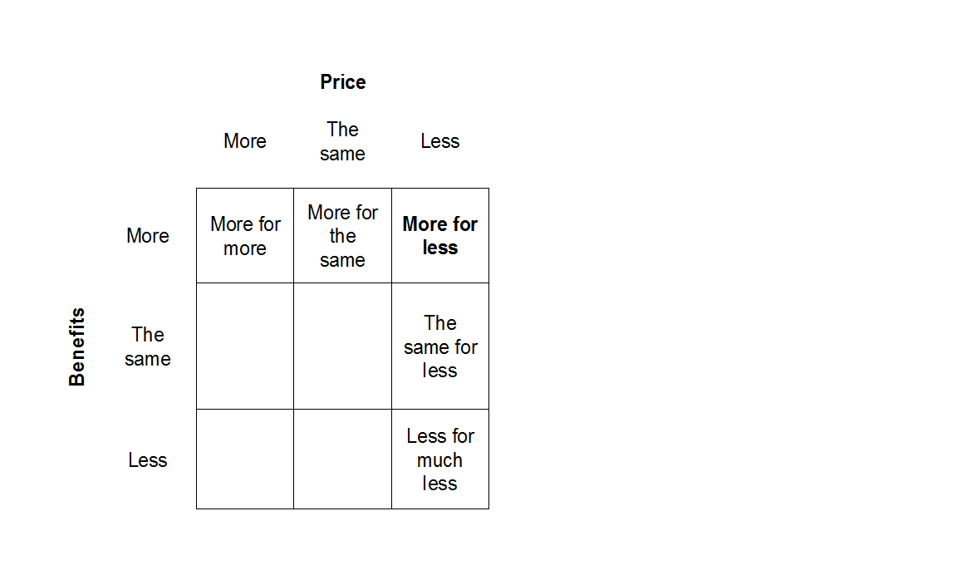

## 5. Product positioning:

We aim to position our service as cheap price with high quality. On average, a task is charged less than 0.5$ with a guarantee in quality and timeliness due to the availability of workforce and possible evaluation for clients. Not until the task is approved does the worker get paid. Urgent tasks will be given priority with suitable extra payment from clients.

For the first year implementation, we want to deliver the image of TrivialHub as an integrative, convenient marketplace for trivial tasks.

## 6. Channels & Tools:

|  |  |
| --- | --- |
| **Social media (Facebook, Zing, YouTube)** | ***Facebook****:* TrivialHub will keep in touch with its target customers via Facebook fanpage and other social media pages such as Zing Me (Vietnamese social network). We also ask for support from popular fanpages, groups for students from universities and outside that are related to job opportunities. Actually, groups that provide similar jobs for students do exist, but scattered and require to register via a third party. Therefore, we believe our integrity will be an advantage.    Besides, as we intend to make a Facebook website for TrivialHub – this enables integration and expansion of the business – we will also create a notification for registration. This will allow post on user’s timeline saying they have successfully registered for TrivialHub, thus help raise the brand awareness within their social network.    ***YouTube:*** Trivial Hub will also own a YouTube channel with tutorial videos on how to get started in doing trivial tasks, problem solving tips, online payment guides, introduction about the business model |
| **Online news/forums/websites** | ***Blog****:* PR articles on blog written by hot bloggers with experience in the field. This will help workers easily figure out the working method and get attracted to the job opportunity. We believe peer recommendations influence is strong for the target workers.    ***Forum:*** Popular forums in Vietnam such as tinhte.vn, enbac.com, Yahoo ask, vozforums.com, etc.. with frequent visits from young people are potential markets for TrivialHub to promote itself.    ***Wikipedia:*** With a great number of people using Wikipedia as one of the most table reading sources, an article about TrivialHub will consolidate the trust in our customers and helps branding the website. |
| **Internet** | ***Searching Engine Optimizer (SEO):***  PR articles on blog, forums, Wikipedia; posts on social media; TrivialHub website will contain related, preferred keywords and appropriate website description, URL, Backlink to optimize the searching results on popular search engines such as Google, Bing, Yahoo. SEO helps economize budget for online marketing.    ***Professional design:*** To maximize the effectiveness of marketing, our website interface will be designed as fresh, user-friendly, well-organized and attractive.  Main colors for web design and other related marketing items are Navy blue and White. We want to describe ourselves as neat, simple but professional and trustable.    ***FB ads, GG adw, Admicro:*** A certain limited amount of budget will be dedicated to online advertising including FB Ads, Admicro, Google Adwords to make sure that the advertising target the desired public and elevates the brand recognition to get on top-of-mind of the public.    ***Email marketing:*** Email marketing may not be the most effective way to approach target clients, but it’s the fastest way to massively promote our service. We will search for database of over 100,000 SMEs in Vietnam, up-to-date with contacts. A short email introducing our service with link to the website will be sent to them with attractive promotion for new register. Expected ROI is 10%.    ***Mobile marketing:*** As smartphone industry is growing fast in Vietnam, TrivialHub will luanch a mobile app for both popular systems: Android and iOS to reinforce the convenience for working. Push notifications is set to alert workers on new tasks due to preference and clients on the progress of task on demand.    ***Customer Relationship Management (CRM):*** Sugar CRM - an online database of customers that will help us ensure the contact with both sides and provide timely care and solution. |
| **Sales promotion** | ***Vouchers:*** We will provide voucher as an optional payment method for workers by collaboration with coffee shops, cinema, shopping malls, music events, fairs, etc. These venues and events are preferred by students and can also help attract more of them. This collaboration makes it easier for us to promote our business by request to appear on their websites/fanpages and other marketing items.    ***Bank***: We will collaborate with a bank to provide service for workers who haven’t owned a bank account yet. Our survey shows that ¼ of students don’t have a bank account (130 samples). We can take advantage of this collaboration to offer attractive discount. |
| **Direct marketing** | ***Insert media:*** To raise awareness of our business, logo and short description of TrivialHub will request to appear on leaflets, catalogs, package of other brands with similar target public such as    ***Out-of-home***: We also ask to put our own flyers at their counter. Here we intend to collaborate with convenient stores (Circle K, Shop n Go); fast food brands (Lotteria, KFC); take-away coffee shops (Urban Station, Effoc) … These brands are popular among students, thus help spread our identity better.    ***Telemarketing:*** The next step of email marketing is telemarketing. After identifying potential SMEs, we will use telemarketing method to promote our service and ask for appointment if possible.    ***Personal selling:*** We believe that the best way to get customers is to do business face to face. We target about 100 SMEs with highest potential to use our service. The sales team will take care of each and every business and make sure that our mission and function are well delivered.    Flyers will be distributed to students in targeted universities and in activities such as clubs, events like flea markets, sport leagues. We will also target conferences and networking fairs that gather students and young workers to promote our business.    ***Workshop and Contest:*** We will conduct some short workshops (1 per month) to help workers get familiar with the working style of TrivialHub, show tips and answer questions. These workshops will be recorded and uploaded as tutorial videos on our Youtube channel. We will contact with clubs in universities to announce about the workshops and ask for support.    During these workshops, there will be games related to the categories of job on our website to enhance interaction between students and our business people. |
| **Public relation** | ***Grand Opening:*** There will be an official grand opening for TrivialHub where industry people, school clubs representatives and reporters will be invited to get information and help spread the reputation of TrivialHub via word-of-mouth and personal networks.  ***Press release***: As one member in our team is currently reporter for one of the best-known newspapers in Vietnam, we can get other print and online newspapers and publications to publish news about our business before the Grand Opening ceremony and other milestones of development.    ***Corporate Identity Material***:  Sticker: TrivialHub logo will be printed in sticker and asks to stick on keyboard in Internet coffee shops and university computer labs.  Cord holder: Cord holders giveaway with logo of TrivialHub in front of university and at events, conferences will help strengthen the branding for our business. |

## 7. Action plan

|  |  |  |  |  |  |  |  |
| --- | --- | --- | --- | --- | --- | --- | --- |
| **MARKETING ACTION PLAN** | | | | | | | |
| **Tools** | **Feb-May 2015** | **June-Aug 2015** | **Sep-Dec 2015** | **Jan-June 2016** | **Jul-Dec 2016** | **Jan - June 2017** | **Jul - Dec 2017** |
| **Social Media** |  |  |  |  |  |  |  |
| **Blog** |  |  |  |  |  |  |  |
| **Forum** |  |  |  |  |  |  |  |
| **Wikipedia** |  |  |  |  |  |  |  |
| **SEO** |  |  |  |  |  |  |  |
| **Online advertising (FB ads, GGAdw...)** |  |  |  |  |  |  |  |
| **Professional design** |  |  |  |  |  |  |  |
| **Email marketing** |  |  |  |  |  |  |  |
| **Mobile marketing** |  |  |  |  |  |  |  |
| **CRM** |  |  |  |  |  |  |  |
| **Vouchers** |  |  |  |  |  |  |  |
| **Collaboration with bank** |  |  |  |  |  |  |  |
| **Insert media** |  |  |  |  |  |  |  |
| **Out-of-home** |  |  |  |  |  |  |  |
| **Telemarketing** |  |  |  |  |  |  |  |
| **Personal selling** |  |  |  |  |  |  |  |
| **Workshop** |  |  |  |  |  |  |  |
| **Grand Opening** |  |  |  |  |  |  |  |
| **Press release** |  |  |  |  |  |  |  |
| **Corporate Identity Material** |  |  |  |  |  |  |  |

# VII. SALE

## 1. Strategy

For client, we will make direct deal with corporate, meaning that personal selling is focused. There will be promotion for new clients and loyal clients such as discount, free trial, etc. Sales plan runs accordingly to Marketing plan.

In the first year, we classify our potential clients as SMEs and Start-up business. The strategy for each is as follows:

- SMEs: Word-of-mouth, face-to-face meeting

- Start-up: going to conference; registering to groups with many fresh entrepreneur people such as Global Shapers, Hatch!, Start-up Weekend, etc.

These channels are suitable for us since it reduces capital requirements and provides networking with different fields. It also fosters long term business relationships.

Once the contract with corporate is done, their profile will be published on our website. TrivialHub’s partner portfolio will be updated frequently. Loyal clients with more than 50 successful transactions will be requested to give a brief feedback for Trivial Hub service. This will strengthen Trivial Hub’s reputation and contribute to our improvement. According to our survey for clients, 90% of those who support the launch of Trivial Hub are top and senior managers. As they are decision-makers (CFO, CIO, COO) in corporate, our goal is to approach them. Each and every customer will be carefully taken care and the deal will be proceeded quickly.

First, we will search for database of SMEs in Vietnam (about 500,000 existing SMEs), localize prospects and email them for introducing purpose. Expected ROI of this sales tactic is 10%. Then we will use telemarketing to persuade and arrange personal meeting to win clients. At the same time we will expand our network by going to conference and events to be able to share the idea of Trivial Hub to prospective clients with prepared proposal tailored to their need, offer them trial and promotion. There will be incentives for each deal won. We strongly believe that this approach is more effective and likely to reach long-term relationship as well as loyal support.

In 2016, when TrivialHub have collected a certain amount of feedback from partners, we will adjust our sales approach to achieve better efficiency. In later years, when Trivial Hub has started to have reputation, sales team will be more invested to run both traditional approach and planned approach. Trivial Hub’s sale approach then combines direct sales force, relationship selling, subcontractors, direct marketing, Internet marketing. We will adjust the sales strategy according to objectives and unexpected situations. If the objectives are not met, we will target selected magazines, publications, forums and blogs to reach desired clients.

Our marketing tools and channels mostly aim at target public for worker. There will be frequent checks on objectives to make sure the sales objectives are met. If not, push for personal review and recommendation about Trivial Hub will help consolidate the reputation of the business. Besides, we will consider sponsoring for club’s events and activities to directly address the prospective workers.

## 2. Sale forecast

The sale is expected to increase every months at about 10% to 20% growth rate. In the seasonal period of December to January next year, the growth rate will be at 1.8 to 2 times while June to July period's growth rate wil be at 1.3 to 1.5 times. According to our client survey, almost of them estimate that the trivial task in those period will dramatically increase by 1.5 to 2 times (June-July) and 2-2.5 times (December-January).

# VIII. FINANCIAL PLAN

## 1. Objectives, Strategy and Funding Plan

### 1.1 Objectives

Trivial Hub aims to hold a healthy financial status for long term with competitive rate of return for owner among start-up businesses.

### 1.2 Funding

Each member will contribute total 3000AUD for Trivial Hub. In the first year, 800AUD total from members will be sent to Trivial Hub’s account every month. Especially in September, the amount will be 1200AUD to prepare for launching. Additionally, to separate out the liability, we agreed to create a bank account of  2000 AUD under the name of 4 as reserved for Trivial Hub. The reason is first 3 years of start-up is highly risky, so that reserve must be separated out from Trivial Hub account. If there is any legal issue which leads Trivial Hub to run out of cash, the reserve is still safe and can be used to continue the business.

However, whenever Trivial Hub run out of cash, we will raise fund from angel investor. In the longer development stage (over 5 years), if Trivial Hub needs more fund, we will consider a bank loan, but not investor since we do not want to loose even a little control to other's hand.

## 2. Assumption:

### 2.1 Weighted Average of Product Category

- According to survey done by 196 corporates, the weighted average ratio of product is as follows

|  |  |  |  |  |  |  |
| --- | --- | --- | --- | --- | --- | --- |
|  | Category of work | Payment to worker Range | Average Payment to worker | Sale Mix | Trivial Hub's Charge | Total Payment |
| Group 1 | Survey  Categorizations | 0.1-0.4 | 0.25 | 0.3 | 0.025 | 0.275 |
| Group 2 | Forum Seeding  Data Entry  Emailing  Judging/Commenting | 0.4-0.6 | 0.5 | 0.6 | 0.05 | 0.55 |
| Group 3 | Research  Transcribe | 0.7-0.8 | 0.75 | 0.1 | 0.075 | 0.825 |

## 2.2 Budget for operation

|  |
| --- |
|  |

- Cash for Marketing will increase sharply in August 2015 (to prepare for the official launch of the website in September), in June and of 2016 and 2017 (when business d report for the first six months of the year), in November - December - January of 2016 and 2017 (greeting season, Tet holiday and year-end report preparation). Beside those periods, marketing cost is expected to be constant or slightly down.

- Website building cost will be paid by 30% when the coder signs the contract, 60% when the website is completed and 10% after 3 months of website launching.

- Trivial Hub will rent an office by September 2015. In the early phase, to save cost, we will operate at Grandview C Building - shared office with family business.

- Insurance for staffs paid by Trivial Hub are 22% of total monthly salaries.

- Contracted employees, who are student fellows of management team will be hired in September 2015 and December 2015 (rush hour in business period - year end and new year preparation). They are paid monthly to complete near deadline tasks. The team will raise the percentage of task done.

## 3. Accounting Statement Analysis

Unlike other start-up business concept which is trying to reach customer as early as possible, Trivial Hub's strategy is to focus on the long-term growth. Our concept is mainly about dealing with corporate through building up credibility. Therefore it is necessary to generate sustainable profit. The following accounting statement clearly reflects that strategy. It shows the slight growth or even negative profit in the first phase (Q4/2015 to Q2/2016) while reaching the peak at the end of 2017.

### 3.1 Income statement

|  |  |  |  |
| --- | --- | --- | --- |
|  | 2015 | 2016 | 2017 |
| Sale | $4,762.30 | $221,845.56 | $1,580,015.93 |
| Online Advertising | $0.00 | $9,600.00 | $9,600.00 |
| Total Revenue | $4,762.30 | $231,445.56 | $1,589,615.93 |
| less COGS | $4,329.36 | $201,677.78 | $1,436,378.12 |
| Gross Profit | **$432.94** | **$29,767.78** | **$153,237.81** |
| Less Expense | $7,686.99 | $18,777.03 | $27,985.13 |
| Net profit before Tax | -$7,254.05 | $10,990.75 | $125,252.68 |
| Tax | - | $2,198.15 | $25,050.54 |
| Net profit after Tax | - | **$8,792.60** | **$100,202.14** |

|  |
| --- |
|  |

Launched in September 2015, Trivial Hub is expected to generate profit in July 2016. It takes approximately 6 months to reach positive profit due to 2 main reasons: As a start-up, we spend a significant amount of expense for marketing and promotion in the first phase. Secondly, our profitability completely depends on the volume, which takes time to rise. However, since it takes 6 months long to reach breakeven, it will take more than 1 year to actually generate profit. In the meantime, Trivial will grow strong enough to dominate the market. With the Cooperation Package, Trivial Hub can strengthen its profit as well as ease the pressure of budget. In 2017, Trivial Hub is expected to rise sharply because of 3 reasons:

* It has gained reputation
* Marketing cost is reduced and other costs are constant.
* Expected increasing number of start-up business and SMEs from 2015 to 2017. Since the generation Y will enter the business market, it will be easier for marketing and sales to reach them in that period.

### 3.2 Cash flow statement

|  |  |  |  |
| --- | --- | --- | --- |
|  | 2015 | 2016 | 2017 |
| Cash Inflow |  |  |  |
| Sale | $4,762.30 | $221,845.56 | 1580015.93 |
| Online Advertising | $0.00 | $9,600.00 | 9600.00 |
| Owner's Capital | 10,000 | 0 | 0 |
| Total Cash Inflow | **$14,762.30** | **$231,445.56** | **$1,589,615.93** |
| Cash Outflow |  |  |  |
| Operating | 8942.37 | 221361.78 | 1463966.119 |
| Investing | $2,452.00 | 108 | 108 |
| Financing | $85.57 | 2069.62 | 51127.23 |
| Profit Distribution | $0.00 | 0 | 24000 |
| Total Cash Outflow | $11,479.94 | 223539.4 | 1542861.45 |
| Net Cash Flow | $3,282.36 | $7,906.16 | $46,754.48 |
| OB | $0.00 | $3,282.36 | $11,188.52 |
| CB | $3,282.36 | $11,188.52 | $57,943.00 |

|  |
| --- |
|  |
|  |

Trivial Hub is subjected to have positive cash flow since its launching in September. However, there are 2 negative cash flow records due to huge payment for launching (August-September/2015) and marketing push in January to March 2016. In the first period, each owner will contribute 2500 AUD (total 10,000 AUD) for business and in 2017, they are allowed to receive 6,000 AUD (total 24,000 AUD) in 2017. Healthy Closing Balance is also Trivial Hub’s another advantage.

### 3.3 Ratio

|  |  |  |  |
| --- | --- | --- | --- |
|  | 2015 | 2016 | 2017 |
| Profit after tax | - | **$6,352.52** | **$93,203.75** |
| Projected expenditure | $7,822.99 | $21,465.03 | $32,785.13 |
| Initial Investment | 11,710 |  |  |
| Profit Distribution | - | - | 24000 |
| ROI | - | 0.54 | 7.96 |
| NPV | 28,237.50 |  |  |
| Breakeven in Revenue | 23,428.87 |  |  |
| Breakeven in Units | 47331 |  |  |
| Payback period | 1.4 |  |  |

|  |
| --- |
|  |

|  |
| --- |
|  |

As mentioned above, Trivial Hub strategy is to focus on long term development. With ROI of 54% in 2016 and 796% in 2017, we can easily meet the objectives. ROI of 796% in 2017 clearly shows the huge return in investment.

Trivial Hub gets over breakeven point of 47331 units (in July 2016) although its profit already starts to be positive one month earlier due to the Online Advertising Package’s contribution. The fact that it takes almost 9 months to get to the breakeven point shows the high barrier to enter the market for potential competitors. However, once breakeven is reached, profit will significantly grow.

Trivial Hub's NPV of 28,237 is far away from 0, emphasizing a great future value for today investment.

According to the cash flow, Trivial Hub will spend 1.4 years to generate enough revenue for first initial investment. Looking deeper in the timeline, we spend 9 months (0.75 of the year) to prepare for launching. Therefore, it just takes more than half year (0.65 years) from launching to completely pay back investment.

# IX. RISK

|  |
| --- |
|  |

|  |  |  |  |
| --- | --- | --- | --- |
| **Risk** | **Probability** | **Level** | **Strategic Solution** |
| 1. Indirect competitors add in new function like concept of Trivial Hub |  | 3/5 | First mover advantage |
| 2. Client disagree to deposit |  | 4/5 | Convince and offer trial |
| 3. Poor sale in client side |  | 5/5 | Push for personal selling and adjust marketing tactics, e.g. target selected magazines such as (Thoi bao Sai Gon, Tech in Asia, etc.) |
| 4. Poor sale in worker side |  | 3/5 | Push for online marketing. Sponsor for club’s events. |
| 5. Capital Shortage |  | 2/5 | Bank Loan  Angel Investor |
| 6. Government policies change |  | 1/5 | Adapt to the changes with more social contribution campaigns  Review the company’s vision and operation to fit with changes |
| 7. Payment partner’s problems |  | 3/5 | If the payment partner NganLuong.vn has issues, Trivial Hub will:  + Delay the payment until the issues are resolved, then pay to the workers  + If the issues lasted too long (more than 10 days as stated in the contract) and they are still not fixed, TrivialHub will bring the case to court and ask for remedy  + If the issues still persist, TrivialHub will consider switching to other providers such as PayPal or BaoKim |
| 8. Fixed cost increase |  | 2/5 | Capital Reserve |
| 9. New competitor enter the market |  | 4/5 | More promotion |
| 10. Technical risk |  | 4.5/5 | + Servers fail: run the backup applications and website. It may takes up to 15 minutes to restore the operation of TrivialHub  + Hacking and DdoS: Contact the host provider to solve the issues. The estimated downtime should be less than 30 minutes  + User data is compromised: co-operate with government agency and all related partner to find the hackers and take down any piece of exposed data. |

# Appendix 1: Product prototype

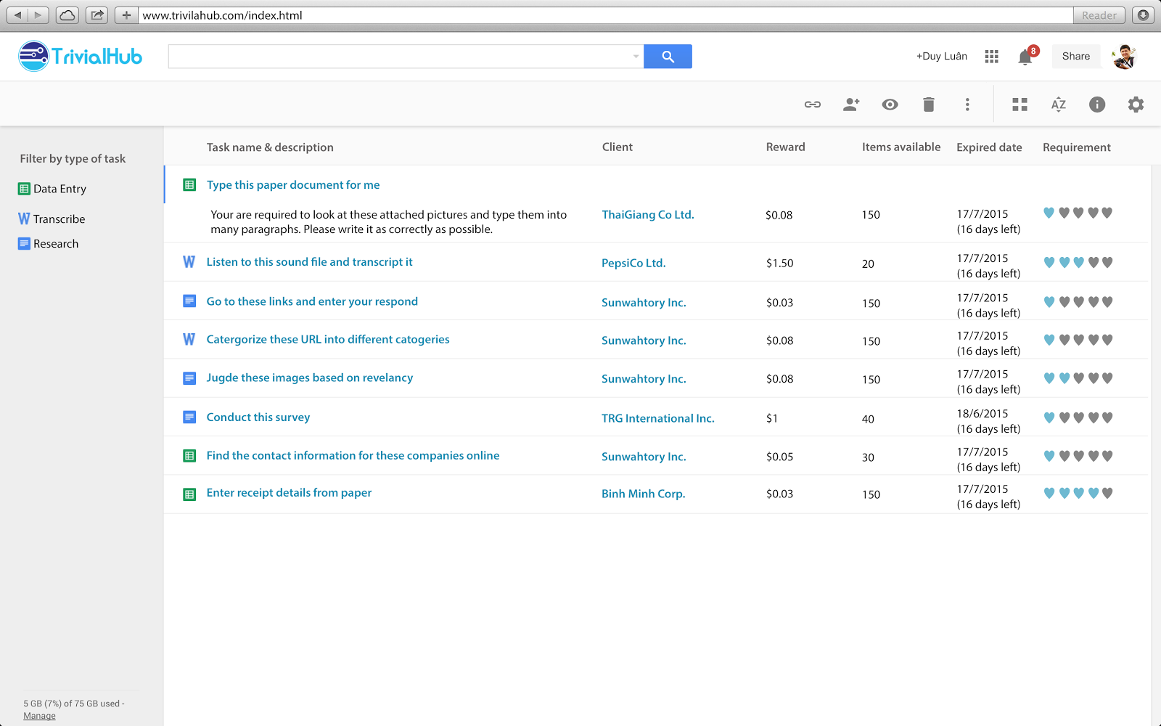

Figure: TrivialHub main page with many tasks displayed for workers - Prototype

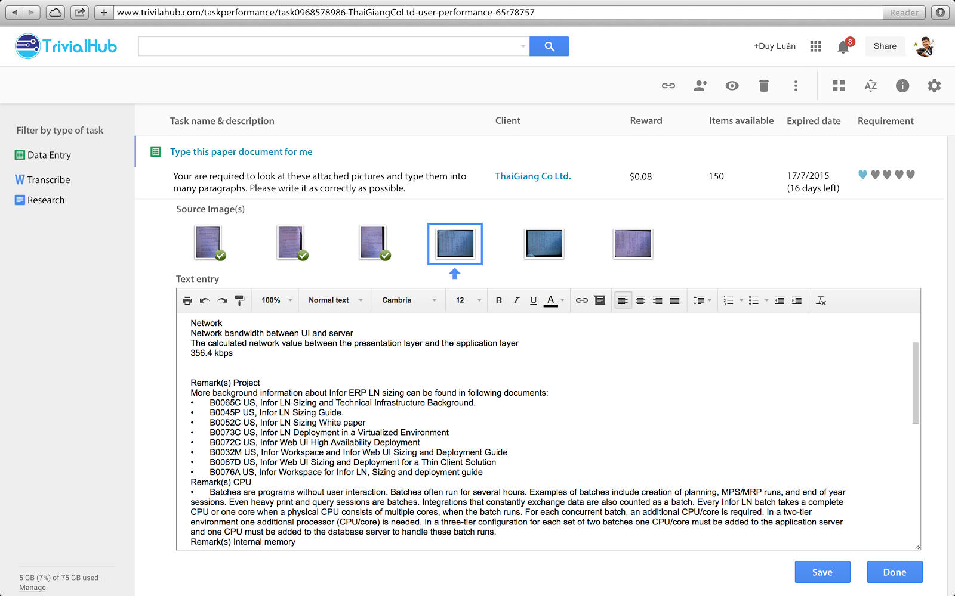

Figure: User Interface for **Worker** to do a Data Entry task. TrivialHub focuses on simplicity and usability for our service - Prototype

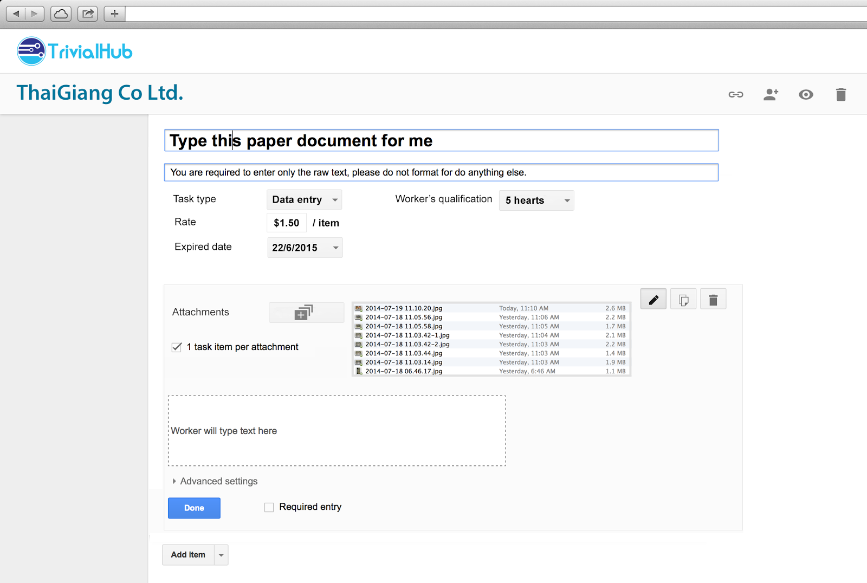

Figure: User Interface for **Client** to compose a Data Entry task. When client finishes creating this task, it will be displayed to worker as demonstrated in the above figure - Prototype

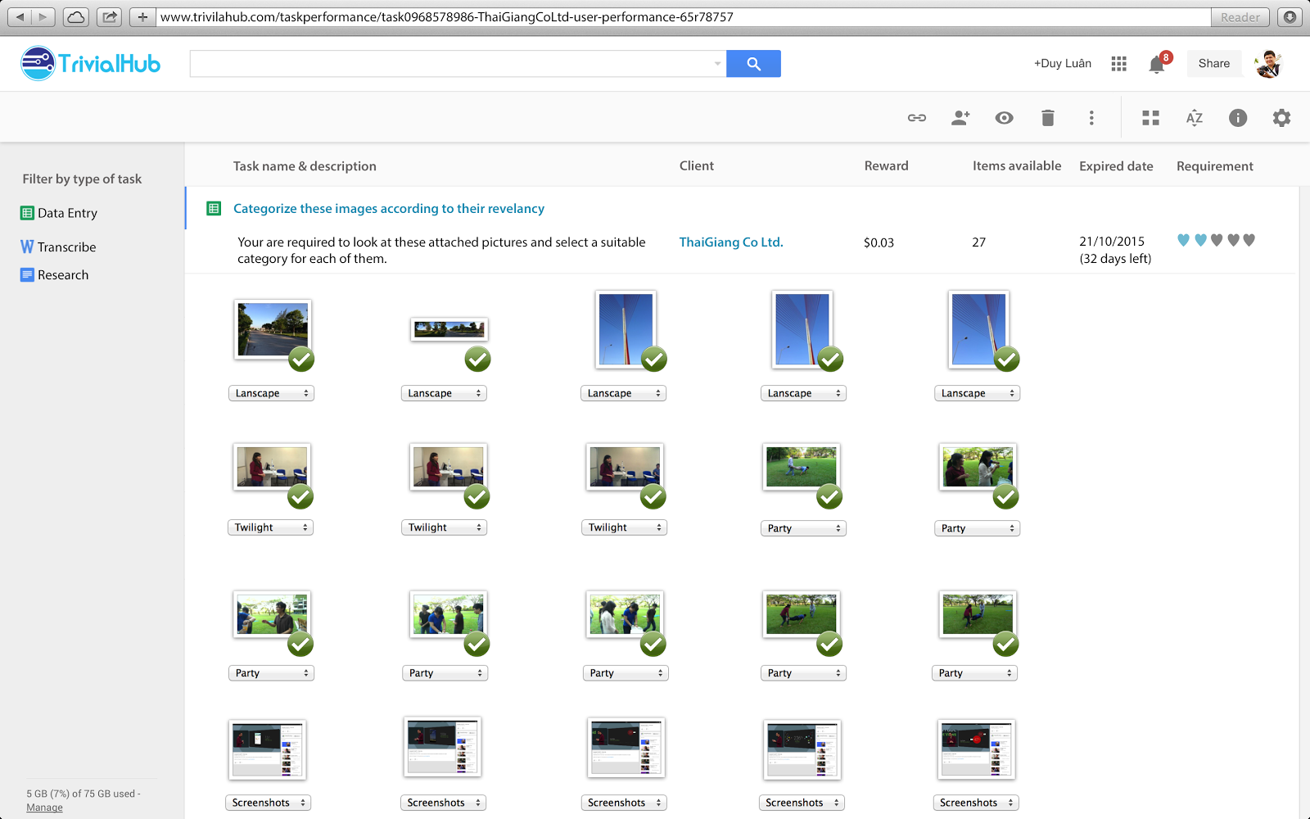Figure: Another User Interface for **Worker** to perform a different type of task. This task requires worker to categorize these attachments (images) into different categories - Prototype

# Appendix 2: Detail Development Plan

