Wiring the BME280

The BME280 is and digital sensor that measures temperature, pressure, and humidity, and altitude.
Wiring
Start by wiring the device over the SPI bus as shown in the diagram below.

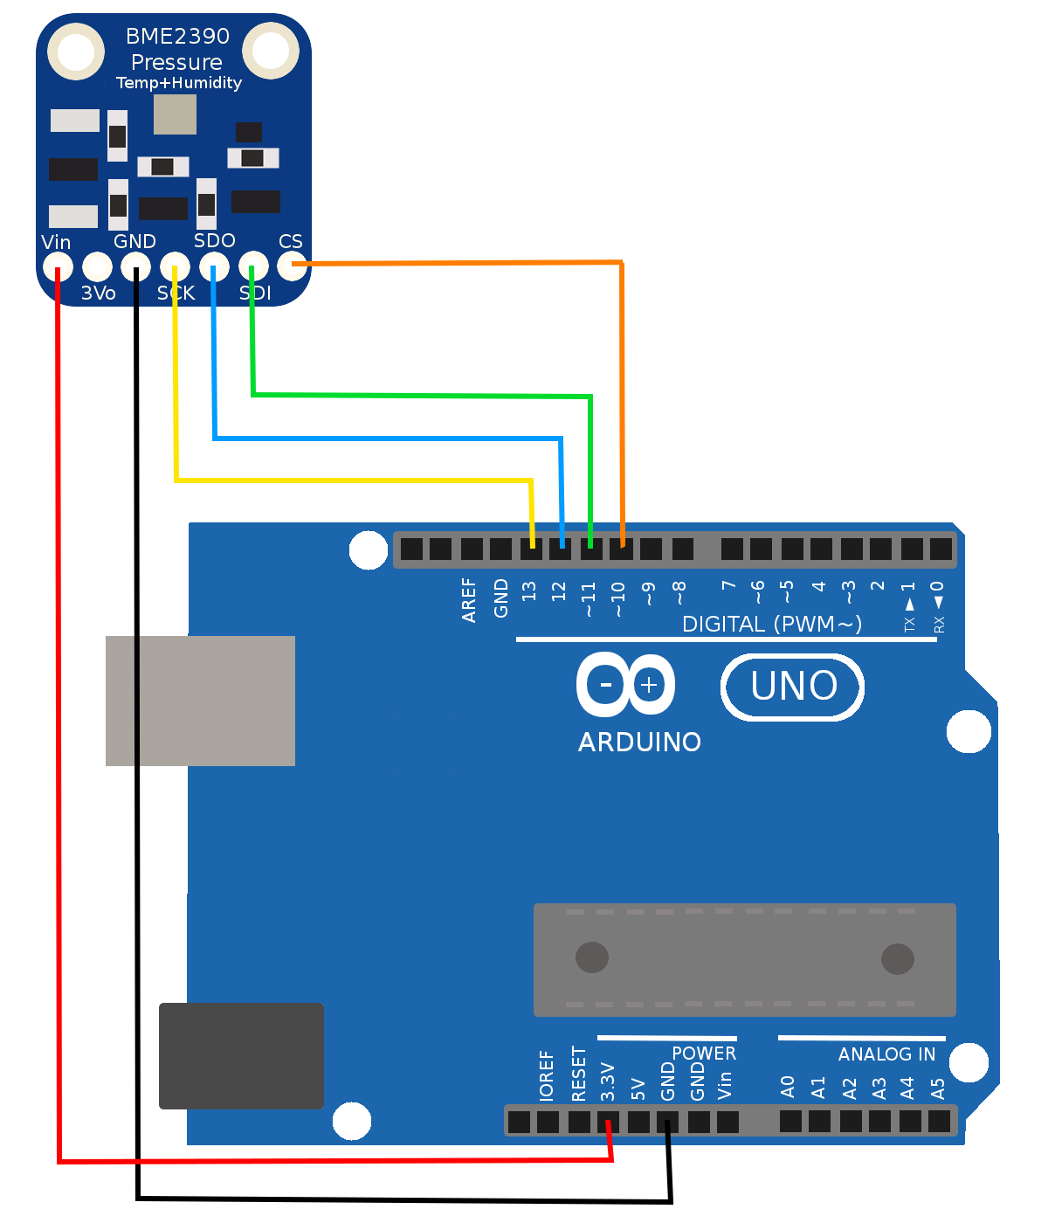
 | Device Pin | Arduino Pin | Name
 | Vin | 3.3V | Power
 | GND | GND | Ground
 | SCK | 13 | Serial Clock Line
 | SDO | 12 | Serial Data Out
 | SDI | 11 | Serial Data In
 | CS | 10 | Chip Select

