Microcontroller Prototyping 180
The advent of open source hardware has lead to a wide array of tools and components that have made it easier than ever to design and build your own custom electronic devices. What was possible only to multi million dollar companies just a few short years ago has quickly become accessible to the average garage inventor. Designing new tools and products from scratch is now cost effective and approachable. From mobile devices, to scientific instruments, wearable electronics, and even circuits designed just for fun, you’ll be amazed at what you can do with the tools at your disposal. This hands-on workshop focuses on rapid prototyping using the Arduino microcontroller.
The most pervasive challenge in microcontroller prototyping is learning how to get devices to inter-operate. An Arduino alone doesn’t offer much capability; the power lies in the myriad sensors, input and output devices, actuators, and other components to which it can be connected. As such, this class focuses on the different interfaces through which the Arduino can communicate with other devices. The workshop will introduce you to Arduino programming fundamentals and connecting digital devices over the I ²C and SPI interfaces. With these prototyping fundamentals in hand; you’ll be well equipped to tackle an almost unlimited set of possible projects.
Hour 1 | Arduino Programming
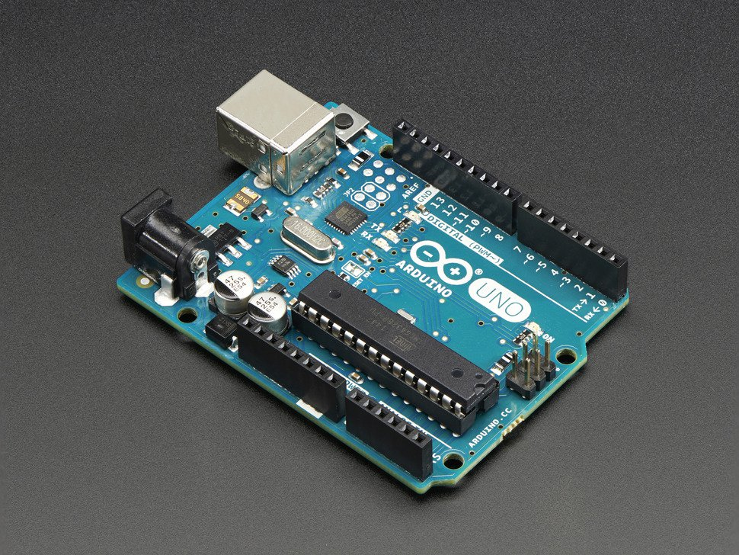 | In this hour, students will learn how to write, upload, and debug code for the Arduino. They will learn how to connect the Arduino to their computers over the serial interface, how to work with the Arduino Integrated Development Environment to write code, the basic structure of an Arduino program, and how to get debug messages back from the Arduino. Along the way, we’ll introduce just enough information about C/Processing programming to get you started without being overwhelming.

Hour 2 | SPI Device (BME280)
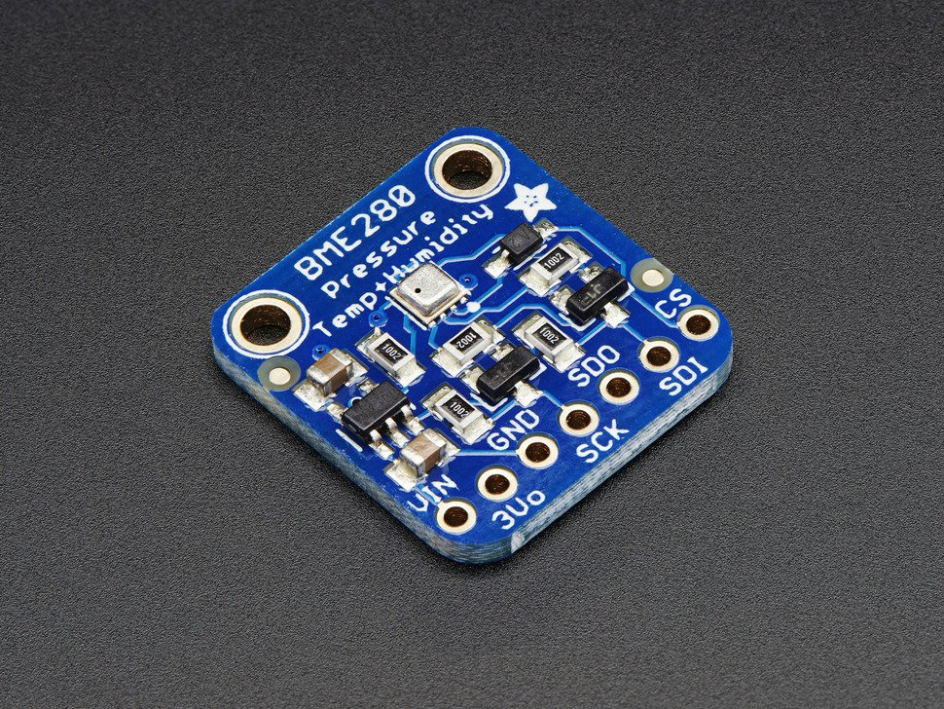 | In this hour, students will wire and program a device using the Serial Peripheral Interface (SPI). This device will be the BME280 Temperature, Pressure, Humidity, and Altitude sensor. This gives us a wide variety of environmental measurements to experiment with. Along the way, we’ll introduce you to working with manufacturer provided libraries and how to keep your wiring manageable and reliable with simple wiring harnesses.

Hour 3 | I²C Device (OLED)
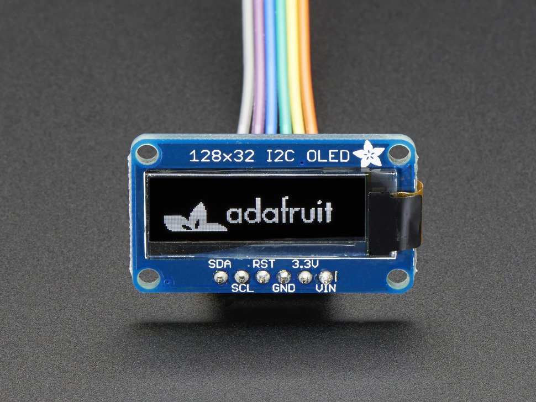 | In this hour, students will wire and program a device using the Inter Integrated Circuit (I²C) interface. The device will be a small organic LED screen. This will give us a versatile output device that we can use to display information even when the Arduino is not connected to the computer. Along the way, we’ll examine how the I²C and SPI interfaces differ, and which interface is best suited to which types of applications.

Hour 4 | Integration (Thermometer)
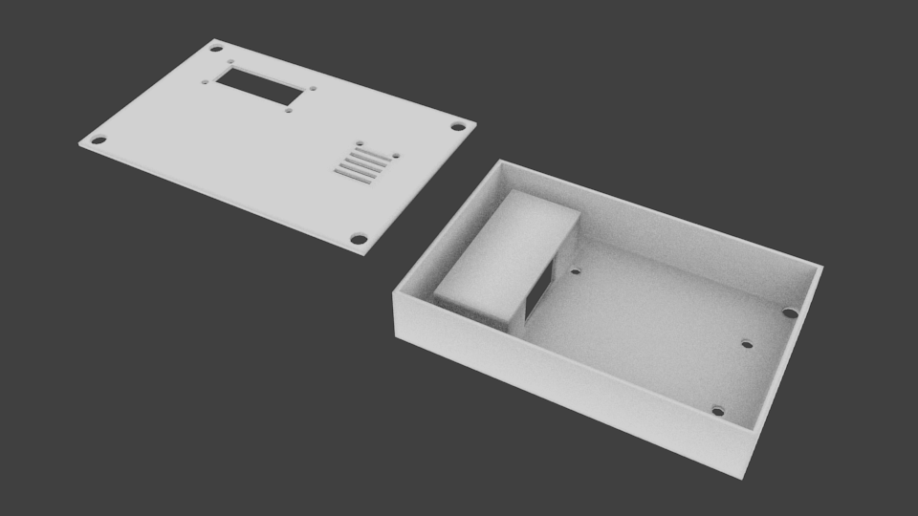 | In the final hour, students will take everything they have learned to try and solve an open-ended real-world application of prototyping. They will combine the input from the BME280 with the output of the OLED to create a digital thermometer; including building up the code that drives it. They will also mount the electronics into a custom designed 3D printed enclosure. Each student will leave with a functional and complete product which is theirs to keep.

If you’re new to programming or electronics engineering, don’t panic. This workshop is designed to be a fast-paced and fun introduction to prototyping. There are prerequisites for this workshop. If you have a computer you’d like to use for developing Arduino projects, feel free to bring it and receive assistance setting up your development environment in the hour before or after the workshop where you instructor will be available. If you’d like to discuss and receive guidance on any Arduino projects you might already have in mind, your instructor will be available during the hour before and after the workshop for that as well.
If you’ve been looking for the right workshop to get you ready to build that invention you’ve had in mind, or even if you’ve just been curious about what all the fuss is about with Arduino; this is the course for you.
Class Fee: $90
Materials Fee: $90
Total: $180
All the course lessons and source materials can be viewed on our GitHub page: https://github.com/chimera/single-day-arduino-course/tree/singleDayStudent

