1. This question is about atomic spectra and energy levels.
Diagram 1 below shows part of the emission line spectrum of atomic hydrogen. The wavelengths of the principal lines in the visible region of the spectrum are shown.
Diagram 2 shows some of the principal energy levels of atomic hydrogen.
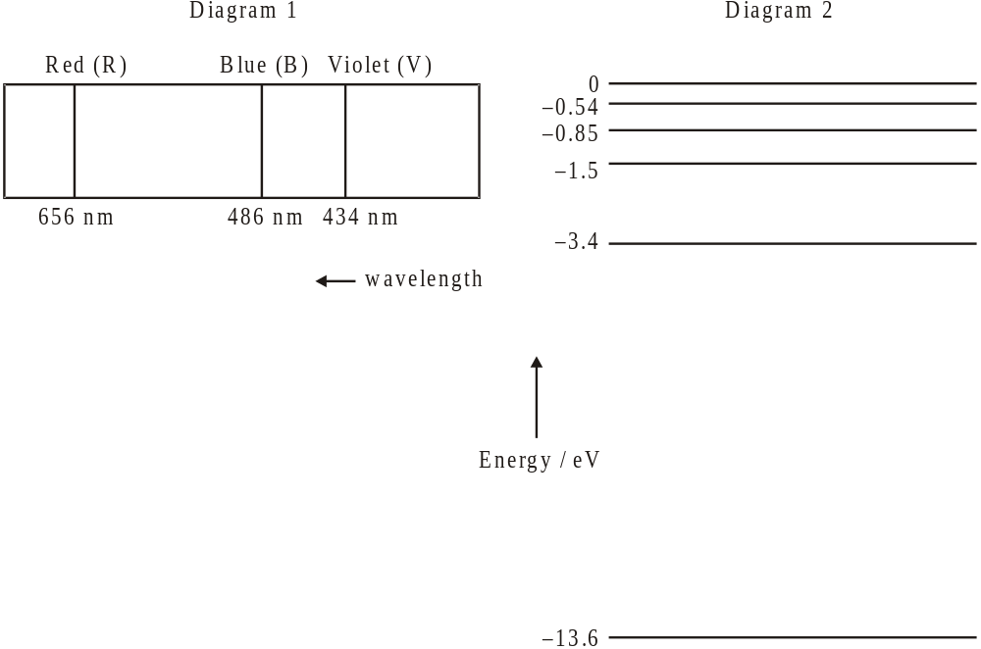

(a) Name the spectral series shown in diagram 1.
Balmer Series (1)
(b) Show, by calculation, that the energy of a photon of red light of wavelength 656 nm is 1.9 eV.
.....................................................................................................................................
.....................................................................................................................................
.....................................................................................................................................
(3)
(b) On diagram 2, draw arrows to represent
(i) the electron transition that gives rise to the red line (label this arrow R).
(1)
(ii) a possible electron transition that gives rise to the blue line (label this arrow B).
(1)
(Total 6 marks)

2. This question is about the radioactive decay of potassium-40.
A nucleus of the nuclide K (potassium-40) decays to a stable nucleus of the nuclide Ar (argon-40).
(a) State the names of the two particles emitted in this decay.
Beta particle and electron................................................................................................
(2)

(b) A sample of the isotope potassium-40 initially contains 1.5 × 1016 atoms. On average, 16 nuclei in this sample of the isotope undergo radioactive decay every minute.
Deduce that the decay constant for potassium-40 is 1.8 × 10−17 s−1.
.....................................................................................................................................
.....................................................................................................................................
.....................................................................................................................................
.....................................................................................................................................
(3)

(c) Determine the half-life of potassium-40.

1.251×10⁹ years................................................................................................
(1)
(Total 6 marks)

3. This question is about particle physics.
A neutron can decay into a proton, an electron and an antineutrino according to the reaction
n → p + e +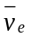.
(a) Deduce the value of the electric charge of the antineutrino.
All three flavors of neutrinos have zero charge.......................................................
(1)
(b) State whether a proton is a baryon or a lepton.
Baryon...........................................................................................................................
(1)

(b) State the name of the fundamental interaction (force) that is responsible for this decay.
(1)
electromagnetic force.................................................................................................

(c) State how an antineutrino differs from a neutrino.
An antiparticle of a neutrino and has the opposite spin and charge.
(1)
(Total 4 marks)

4. Nuclear binding energy and nuclear decay
(a) State what is meant by a nucleon, giving an example of two nucleons.
Nucleons are neutral sub-atomic particles that can be found in the nucleus of an atom.
(2)
(b) Explain what a nucleon is made of and what force holds it together. Include a description of the exchange particle that mediates the interaction between nucleons.
...................................................................................................................................
...................................................................................................................................
...................................................................................................................................
(2)
(c) Define what is meant by the mass defect of a nucleus.
Mass defect is the missing mass of an element when single elements are added up.
Mass defect would be the difference in between the actual element and the added up
value of that same element.
(1)
(c) Define what is meant by the binding energy of a nucleus.

Binding energy this is the energy used in combining particles.
(1)

The graph below shows the variation with nucleon (mass) number of the binding energy per nucleon.
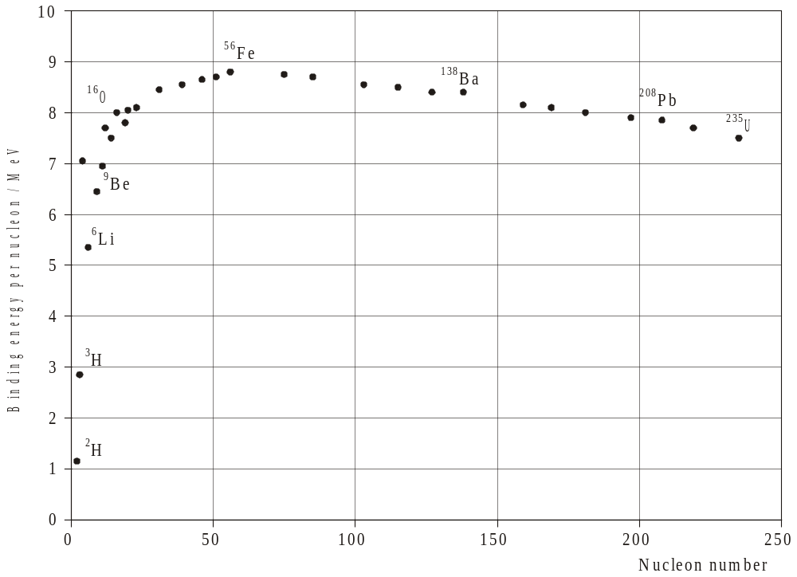
(c) Use the graph to explain why energy can be released in both the fission and the fusion processes.
- Fission involves the separation of particles, which would require a release of energy
during the process.
- Fusion involves a release of energy because two particles are
combining.
(3)
(c) Use the graph to explain why there is an abundance of iron (Fe) in the universe.
Iron (Fe) has a very stable binding energy and it is very hard to have a nucleon at
such a binding energy which is why the higher the nucleon number went the less
binding energy per nucleon.

(2)

(d) A sample of carbon-11 has an initial mass of 4.0 × 10–15 kg. Carbon-11 has a half-life of approximately 20 minutes. Calculate the mass of carbon-11 remaining after one hour has elapsed.
...................................................................................................................................
...................................................................................................................................
...................................................................................................................................
(2)

(e) Uranium-238, 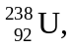 undergoes α-decay to form an isotope of thorium. Write down the nuclear equation for this decay.

.......................................................................
...................................................................................................................................
...................................................................................................................................
(2)
(Total 11 marks)

5. This question is about a proton.
The proton is made out of three quarks.
(a) Explain why the three quarks in the proton do not violate the Pauli exclusion principle.

Protons and some atoms are fermions and are therefore also subject to the Pauli exclusion principle.
(2)

(b) Quarks have spin 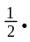Explain how it is possible for the proton to also have spin

Atoms can have different overall spin, which determines whether they are fermions or bosons. A fermion has a spin of and a boson has a spin of 0.

(2)
(Total 4 marks)

6. Which one of the following correctly gives the number of electrons, protons and neutrons in a neutral atom of the nuclide 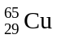?
 | Number of electrons | Number of protons | Number of neutrons
A. | 65 | 29 | 36
B. | 36 | 36 | 29
C. | 29 | 29 | 65
D. | 29 | 29 | 36
(1)

7. The unified mass unit is defined as
A. the mass of one neutral atom of C.
B. 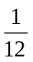 of the mass of one neutral atom of C.
C. of the mass of one neutral atom of C.
D. the mass of the nucleus of C.
(1)

8. Which of the following provides evidence for the existence of atomic energy levels?
A. The absorption line spectra of gases
B. The existence of isotopes of elements
C. Energy release during fission reactions
D. The scattering of α -particles by a thin metal film
(1)

