## Installation

1. Install the XAMPP first
2. Locate the XAMPP folder -> open htdocs -> inside htdocs place the emotion-detection folder
3. Open the emotion-detection folder and open the Generate.php file with any text editor.
4. Find this line: *$file = 'C:\\Users\\username\\Desktop\\emotion.txt';* then replace [username] with your username. Save the changes. If this does not work, then change the whole path to point directly to your desktop with emotion.txt at the end.
5. If you are using the exe program, jump to step number 6. Else, if you are using the jar program then open the Thesis-ITS folder afterwards, locate the resources folder. Jump to step number 7.
6. Open the Thesis-ITS folder then go to app folder and then resources folder. Read step number 7.
7. Open the fer folder and open the FacialExpressionRecognitionPath file rename the line: *C:\Users\username\Desktop\emotion.txt* then replace [username] with your username. Save the changes. If this does not work then change the whole path to point directly to your desktop with emotion.txt at the end.
8. Open the XAMPP and start the apache. See the picture below.

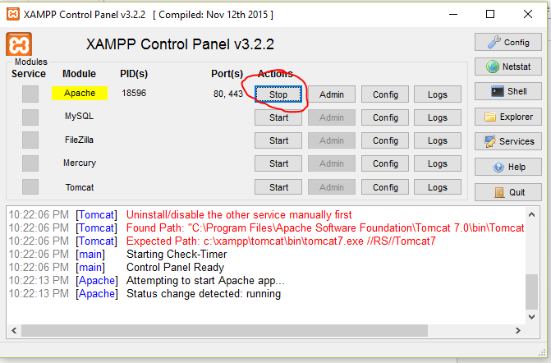

Figure : XAMPP Start Apache

1. The program is now ready to run.