**Anggota:**   
1. Fitra Putri Oganda  
2. Marviola Hardini  
3. Nur Sohit  
4. Ujang Selamat

**Group exercise 2**

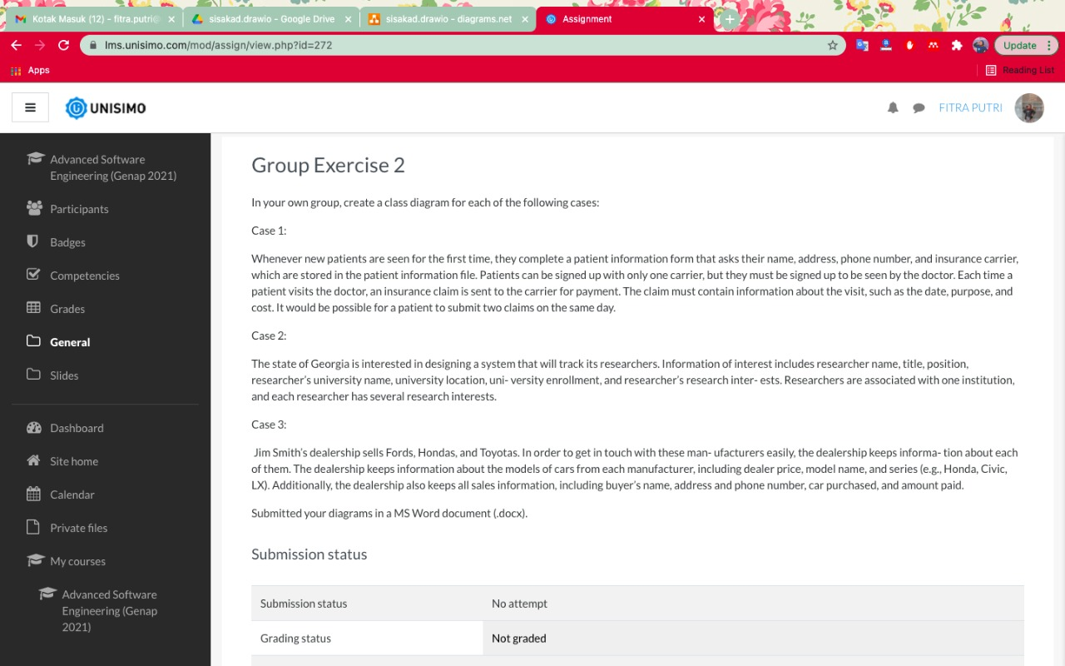

In your own group, create a class diagram for each of the following cases:

Case 1:

Whenever new patients are seen for the first time, they complete a patient information form that asks their name, address, phone number, and insurance carrier, which are stored in the patient information file. Patients can be signed up with only one carrier, but they must be signed up to be seen by the doctor. Each time a patient visits the doctor, an insurance claim is sent to the carrier for payment. The claim must contain information about the visit, such as the date, purpose, and cost. It would be possible for a patient to submit two claims on the same day.

Case 2:

The state of Georgia is interested in designing a system that will track its researchers. Information of interest includes researcher name, title, position, researcher’s university name, university location, uni- versity enrollment, and researcher’s research inter- ests. Researchers are associated with one institution, and each researcher has several research interests.

Case 3:

Jim Smith’s dealership sells Fords, Hondas, and Toyotas. In order to get in touch with these man- ufacturers easily, the dealership keeps informa- tion about each of them. The dealership keeps information about the models of cars from each manufacturer, including dealer price, model name, and series (e.g., Honda, Civic, LX). Additionally, the dealership also keeps all sales information, including buyer’s name, address and phone number, car purchased, and amount paid.

Submitted your diagrams in a MS Word document (.docx).

**Case 1:**

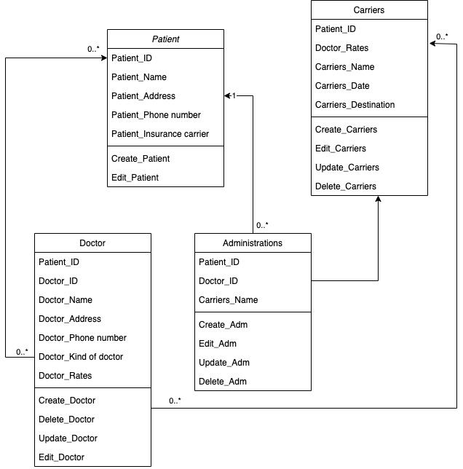

**Case 2:**

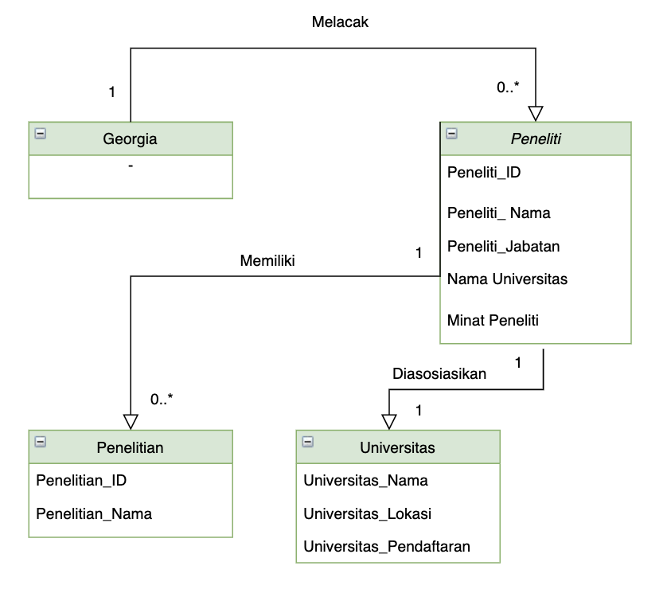

**Case 3:**

