MPLIMENTATION OF A DYNAMIC, HIGHLY AVAILABLE, ACCELERATED AWS BGP SITE-TO-SITE VPN

Senerio…
Your company headquarter has just migrated fully to AWS cloud but wants one of its branch offices that still operates a private remote cloud to be able to access the head-office resources in AWS Virtual Private Cloud, VPC and vice versa. This has to be done through a secured connection and also allow for exchange routing information using Border Gateway Protocol, BGP. One of the ways to achieve this is to establish an AWS Site-To-Site VPN connection.
FUN-TIME WITH ADRIAN CANTRILL…
In this advanced demo, I implemented a dynamic, highly available, accelerated VPN connection that uses BGP to share route information with other Autonomous Systems. I followed the original work by Adrian Cantrill which he made available on his git-hub ripo: https://github.com/acantril/learn-cantrill-io-labs.git Both side of this infrastructure is created within AWS. The on-premise network is simulated via a second AWS VPC.

Cost of this Demo was $1.83
Transit Gateway VPC Attachment for 5Hours =$0.25
Transit Gateway VPN Attachment for 8Hours =$0.40
VPN Connection for 8Hours =$0.40
VPC Endpoint for 8Hours =$0.08
Global Accelerator for 1Hour =$0.50
$0.0208 per On Demand Linux t3.small Instance for 9.45Hours =$0.20
Note: that this project will probably cost you less because I recreated this project several times to master it and besides I had exhausted my free EC2 tier for the month.
Prerequisites
Good understanding of CloudFormation template and CloudFormation Stack creation. AWS VPC, Subnets and EC2 Instances. How to navigate through the AWS Management Console. Fundamental knowledge on Linux and Linux commands
Definition of Terms.
Site-To-Site VPN connection: This is an encrypted connection between your AWS VPC and on-premise DC (say your a branch office).
Transit Gateway TGW: Provides transitive hub-and-spoke peering connections between several VPCs and on-premises including connections through AWS Direct Connect, DX and Site-To-Site VPN. To define what resource can talk to another, we create route table for our TGW.
BGP: Border Gateway Protocol runs through the IPsec tunnels allowing for exchange of routing information between Autonomous Systems, AS. It chooses best route for exchange of information between connected routers.
Customer Gateways, CGW: Resource created on the AWS that provides information about your on-premise resources. They represent the physical customer on-premise routers.
StronSwan: This is an opensource IPsec-based VPN implementation.

FRR
IPSec: Encrypted Tunnels over the public internet created when we create VPN Connections. Two tunnels each connect the Endpoints on the AWS side to a single Customer Gatways representing the on-premise routers. So we have a total of 4 tunnels. The outside IP address of Endpoints connet to the outside IP of the CGW. The AWS Endpoints and CGWs also have inside IP addresses. BGP and DATA being shared roams through these tunnels using the inside IP addresses.

Use CloudFormation, CF to create both sides of the infrastructure by using the one-click deployment created by Adrian Cantrill and made available here: https://github.com/acantril/learn-cantrill-io-labs/tree/master/aws-hybrid-bgpvpn
Or simply click the link below.
https://console.aws.amazon.com/cloudformation/home?region=us-east-1#/stacks/create/review?templateURL=https://learn-cantrill-labs.s3.amazonaws.com/aws-hybrid-bgpvpn/BGPVPNINFRA.yaml&stackName=ADVANCEDVPNDEMO
You have to be logged in to your AWS account in the us-east-1 region that has administrator access. Accept the ‘capabilities and click on ‘create stack’. It took about 6minutes for CloudFormation to provision and create the following infrastructures withing AWS:

On the AWS side, it created
VPC, Two Subnets with CIDR ranges 10.16.32.0/20 and 10.16.96.0/20 in different AZs, AZA and AZB, Two EC2 Instances, AWS-EC2-A and AWS-EC2-B each launched in one of the created subnets, Transit Gateway, TGW attached to the VPC with two Route Tables; default routes pointing to the TGW.
On the simulated on-premise side, the following were created
VPC with CIDR block range 192.168.8.0/21, Public Subnet as seen in the image in which 2 EC2 instances namely: ONPREM-ROUTER1 and ONPREM-ROUTER2 simulating the on-premise Routers were launched. Private Subnets with CIDR block as seen in the image below in which 2 EC2 instances, ONPREM-SERVER1 and ONPREM-SERVER2 simulating on-premise servers.

Go back to the CF console, you will see ‘CREATE_COMPLETE’ on the indicating that our infrastructure is ready. Click on the created CF stack named ‘ADVANCEDVPNDEMO’ . Note the public and private IP addresses of the routers by going to the ‘output’ tab.

Next you will need to create two Customer Gateways, CGW inside AWS that represent the routers running on-premise that will inform AWS how to connect with them.
- go to VPC console by typing and clicking on VPC in the searchbox
- select ‘Customer Gateway’ on the LHS of the console
- click on ‘Create Customer Gateway’ to open the wizard
- populate the ‘Name’ space with ‘ONPREM-ROUTER1’
This type of connection needs BGP ASN.
- If you click on ‘info’ next to ‘BGP ASN’, additional information on Autonomous Systems Number, ASN will show. In this demo we used 65,016 for the on-premise environment.
- populate the ‘IP address’ space with the public IP of ‘Router1Public’ found under the ‘Output’ tab of the created CF stack.
- Scroll down and click to ‘Create Customer Gateway’
- Repeat the same process to create CGW for router2. Name it ‘ONPREM-ROUTER2 and populate the IP address space with the IP of ‘Router2Public’.

Go to the EC2 console, select ‘instances’ to view the 6 instances that were launched by CF. To confirm that at this stage both sides of our infrastructure are not aware and cannot communicate with each other, select the ‘ONPREM-SERVER1’ instance and copy its private IP. Then connect to the ‘AWS-EC2-A’ instance through the Session Manager and ping the ‘ONPREM-SERVER1’ instance by running the ‘ping’ command with the private IP you copied. You will receive no respond because there is no connectivity between the seperate environments.

STAGE 2: Creation of TGW VPN Attachments, Endpoints and VPN Connections
In this stage we will create two TGW VPN attachment with the accelerated VPN option selected. This will ensure two TGW VPN attachments per connection of the Accelerated VPN Endpoints created. The endpoints provide transit back to the TGW over the AWS Global Network. This process will also create VPN Connections to be used to connect the Accelerated VPN Endpoints to the on-premise routers using IPSec Tunnel with additional configuration.
On the LHS of VPC console, scroll down and
- select ‘Transit Gateway Attachments’ under ‘Transit Gateway’.
- Click on ‘Create Transit Gateway Attachment’
- click in the ‘Transit Gateway ID’ to select the TGW that was created with the one-click deployment.
- Select VPN as the ‘Attachment type’
- click the ‘Customer Gateway ID’ to select the first CGW, ONPREM-ROUTER1 from the dropdown.
- Select ‘Dynamic (requires BGP)’ as the ‘Routing option’.
- Check the ‘Enable Acceleration’ box
- scroll down and click to create attachment.

Repeat the above process to create the second attachment for ONPREM-ROUTER2. The above process has equally created 2 Site-To-Site VPN Connections authomatically and you can select ‘Site-To-Site VPN Connections’ on the LHS to confirm this.
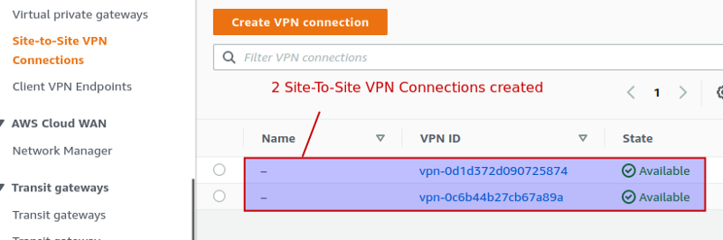
Next download the configuration of each of these VPN Connections. To easily do this,
- Compare the CGW ID to each of the Site-To-Site VPN connection to know which of the connections relates to on-premise routers 1 and 2.
- Select each of the Site-to-Site VPN connections and click to download the corresponding configuration. A dialogue screen will appear.
- Change the ‘Vendor’ to ‘Generic’ and leave the rest and click to download. You can locate the downloaded file and rename each to correspond to the connection it belongs to.
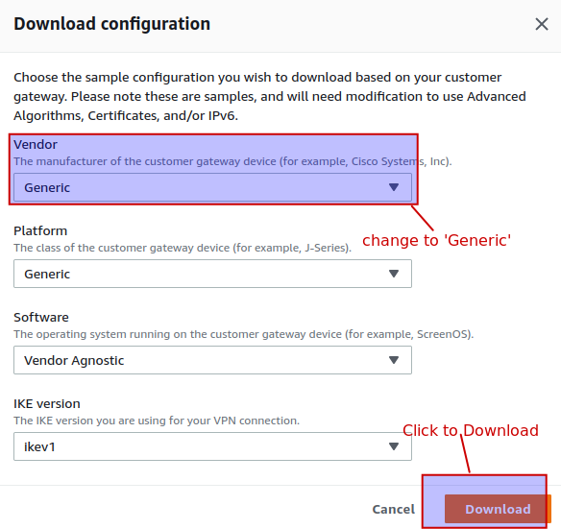
Extraction of Configuration Informations from the downloaded configuration files.
Download and Open the DemoValueTemplate file available here: https://raw.githubusercontent.com/acantril/learn-cantrill-io-labs/master/aws-hybrid-bgpvpn/02_INSTRUCTIONS/DemoValueTemplate.md
Also open the connection configuration file downloaded earlier and populate the DemoValuerTemplate with corresponding value from the connection configuration. Note: that the ROUTER1_PRIVATE_IP and ROUTER2_PRIVATE_IP is found under the output tab of the CloudFormation stack created. Repeat the procedure for Connection2. Be sure to populate the tunnels 1 and 2 placement holders with the corresponding tunnels values in the files.
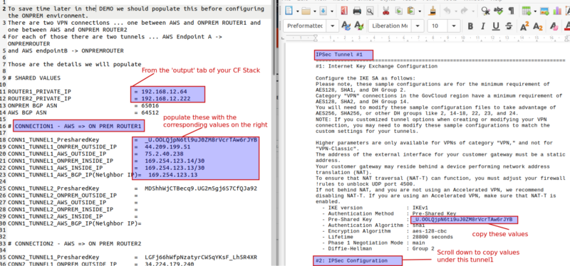

Configuration of the IPSec Tunnels and the BGP protocol of the on-premise side of our Environment.
In order to establish the IPsec tunnels between the on-premise router and AWS, carryout some configurations on both on-premise routers. Before you begin, make sure that VPN Connections established in the ‘Site-To-Site VPN Connections’ are in ‘Available’ State. Starting with router1:
- Open the EC2 console => Instances
- select ONPREM-ROUTER1 and connect to the instance through the Session Manager
- Enter the following codes
sudo bash #gives you root permission on this linux instance.
cd /home/ubuntu/demo_assets #navigate to folder containing some configuration files to be edited
ls -la #lists the files in the current folder.
nano ipsec.conf #opens the file containing the actual configurations for the IPsec tunnel
This file configures the IPSec tunnel of Router1 to Both AWS Endpoints. Replace the placeholders with the corresponding values in the DemoValueTemplate extracted from the connection configuration files.
- Press Ctrl + X, press y and Enter keys to save and close the file
Do
nano ipsec.secrets #open and edit the authentication information to be used by linux server to authenticate with AWS.
Scroll down to the buttom
Populate the 6 placeholders with the corresponding values from the DemoValueTemplate.
- Save and close the file.
Next edit the script file
nano ipsec-vti.sh
Close to the top part of the file, replace the 4 placeholder with the corresponding inside IP of AWS and On-Premise.
- Save and close the file
Next copy all the ipsec files to the ‘/etc’ directory where they will be read by StrongSwan by doing;
cp ipsec* /etc
chmod +x /etc/ipsec-vti.sh #makes the script file executable.
systemctl restart strongswan #restart the StrongSwan software to test our connection. This command brings up both of the tunnels from the CGW to the AWS side. Next run
ifconfig #to see if our configuration is OK. If works perfectly, you will see 2 virtual tunnel interfaces, vti1 and vti2.This means that the on-premise router1 tunnels are active and connected to AWS. Now close this session, connect to ONPREM-ROUTER2 and repeat the above procedure to configure the router2 tunnels.
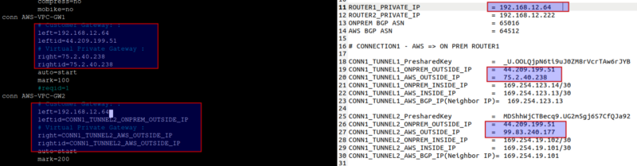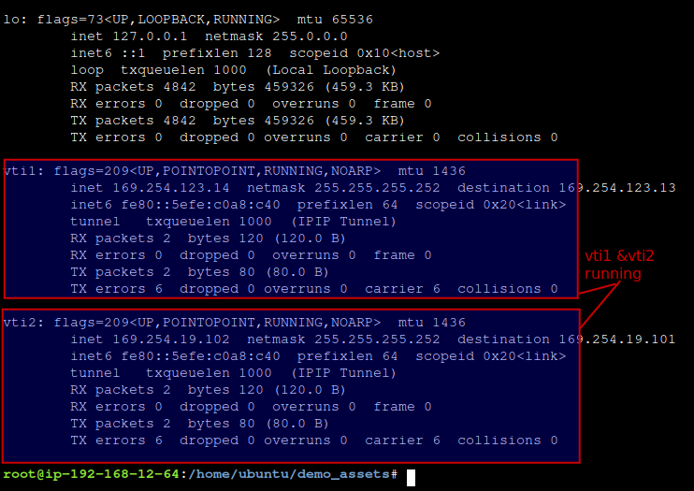
- Go to the VPC console
- select the ‘Site-To-Site VPN Connection’
- select the connection for router1 that we configured first
- on the ‘Tunnel details’ tab, under the ‘details’ column. It should say ‘IPSEC IS UP’. If not give it few minutes and refresh.
- Note that ‘status’ column will indicate down because we have not configured BGP.
We have successfully configured four IPsec tunnels between two customer premises routers and 4 AWS Endpoints.
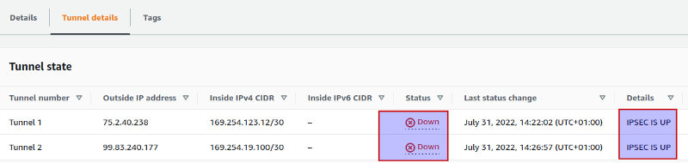

BGP configuration
Here we have to configure BGP to run over these tunnels to make the VPN fully functional. To do this, we install FRR using a script preinstalled on both on-premise routers and secondly configure FRR to use BGP to share routing information with AWS.
- Navigate to the EC2 console and
- Connect to the ONPREM-ROUTER1 through the session manager
Do
sudo bash
cd /home/ubuntu/demo_assets
ls -la
The ffrouting-install.sh is a script to install ffrouting. FRR provides BGP capability. We need to make this script executable and then run it.
chmod +x ffrouting-install.sh
./ffrouting-install.sh
This process took about 10minutes to complete. While the installation is on-going, go and connect to ONPREM-ROUTER2 and repeat the same process.
Note that both of our on-premise routers and AWS still doesn’t have any routing information of each other side network. You can confirm this by typing ‘route’ in the command line. Or go to the TGW route table in the VPC console and notice how it only knows about the AWS side VPC.
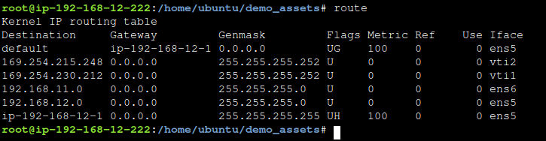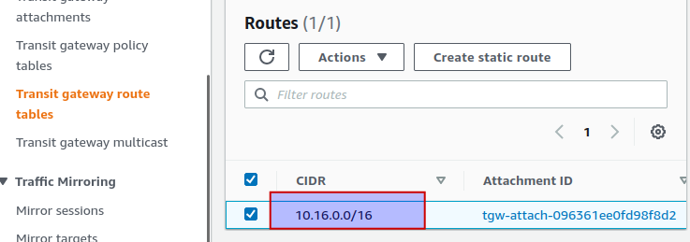
Close down the session connection to both on-premise routers and connect to ONPREM ROUTER1 again to configure BGP. To configure FRRouting’s BGP capabilities, we need to go into the shell used to configure FRRouting by doing:
vtysh #get into the FRRouting console
conf t #gets into configuration mode
frr defaults traditional
Remember that both sides of this architecture requires unique ASN and we choose 65016 for the on-premise side.
router bgp 65016 #configures the ASN 65016 which is the on-premise router BGP ASN
neighbor CONN1_TUNNEL1_AWS_BGP_IP remote-as 64512 #defines the BGP neighbors (other IP addresses that the customer router will exchange routing information with) which are the BGP IP addresses that AWS provided, the tunnels’ inside IP addresses. Replace CONN1_TUNNEL1_AWS_BGP_IP with CONN1_TUNNEL2_AWS_BGP_IP.
neighbor CONN1_TUNNEL2_AWS_BGP_IP remote-as 64512
no bgp ebgp-requires-policy #a configuration option required to make the customer instance of BGP work with AWS
Now configure which networks are advertized by our instance of BGP so we don’t have to manually specify those networks…
address-family ipv4 unicast #changes mode
redistribute connected #configures the router to redistribute any addresses it is aware of.
- Save the configuration, restart the router to initiate the connection with AWS by doing...
exit-address-family
exit
exit
wr
exit
sudo reboot #reboots ONPREM-ROUTER1. Note that you will be disconnected from your session which is ok.
Now Connect to ONPREM-ROUTER2 and repeat the commands above but using the IP, CONN1_TUNNEL2_AWS_BGP_IP(neighboh IP) for the second sets of IPsec tunnel coming from on-premise router 2.
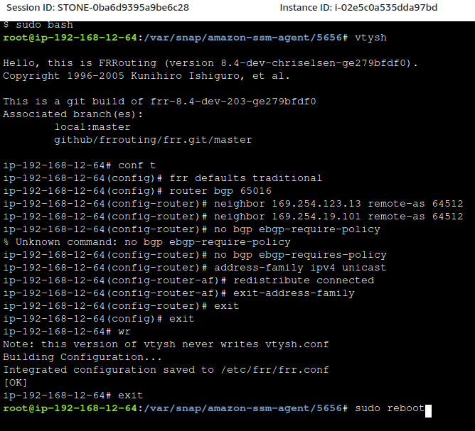
When done, go to ‘Site-to-Site VPN Connections’ in the VPC console. Select any of the connections and go the ‘Tunnel details’ and notice both of the tunnels in the UP state. Under the ‘Details’ tab, you will see the number of BGP routes that are being exchanged.
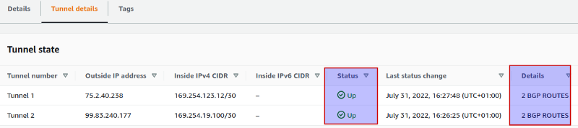
Go to the ‘TGW Route Tables’, select the TGW and go the ‘Routes’ tab to see all the networks being advertized by the on-premise route using BGP.

Go back and connect to any of the on-premise router do sudo bash then route to see the updated routes including the AWS side VPC.
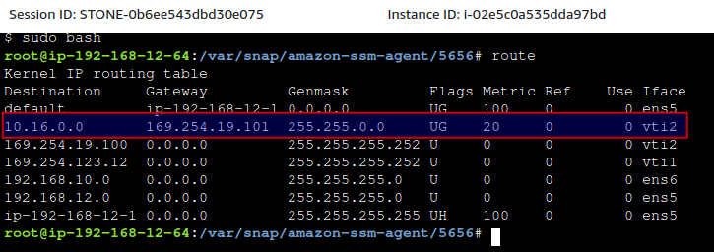
Do
vtysh
show ip route
The on-premise side now has 4 independent paths to get to the AWS side and vice versa.
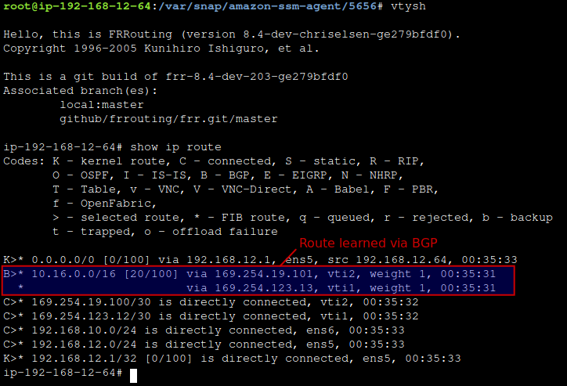
Now we have a highly available VPN architecture that can survive a failure.
Go to EC2 console and connect to either ONPREM-SERVER1 or ONPREM-SERVER2 and ping the AWS side EC2 using its private IP address.
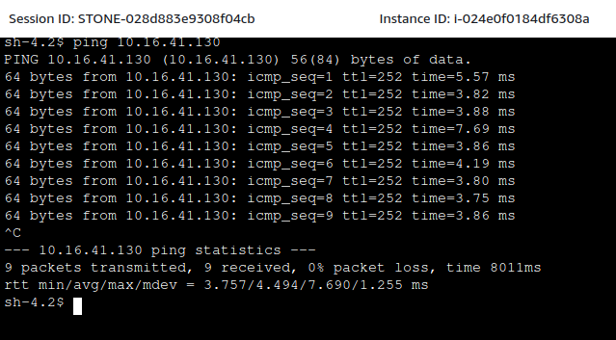
CONGRATULATIONS ON COMPLETING THE PROJECT…
CleanUP.
Go to the VPC console, select S2S VPN Connections and delete the connections we created
Delete the CGW
Go to the CF console and delete the created stack.

