ATLANTIC TECHNOLOGICAL UNIVERSITY DONEGAL

ASSIGNMENT COVER SHEET

To Be Completed By The Student

Lecturer’s Name: Ruth Lennon
Assessment Title: Assignment 2
Submission Date: 25th November 2022

Student’s Name: Chimezirim Ugochukwu Id. Number:___L00170994__
Course / Stage Msc DevOps
Subject/Module: IAC for DevOps Pipeline
Word Limit: Actual Word Count: _________________
I confirm that the work submitted has been produced solely through my own efforts.
Student’s signature: Chimezirim Ugochukwu Date: 24th November 2022

Note: PENALTIES

- The total marks available for an assessment will be reduced by 15% for work submitted up to one week late. The total marks available are reduced by 30% for work up to two weeks late.
- Assessment work received more than two weeks late, without prior approval by the lecturer will receive a mark of zero.
- Marks awarded will be reduced by 10 % if submitted work is greater than 10% above or below the assigned word limit.
- A further hard or electronic copy of your submitted work may be requested, and therefore you must keep a copy on disc.
- Incidents of alleged plagiarism and cheating are dealt with in accordance with the Institute’s Assessment Regulations
Plagiarism: Presenting the ideas, words of someone else without proper acknowledgement. Refer to the Institutes’ procedures and guidelines for the assessment of learners.

CONCLUSION

Github repository: https://github.com/chimezirimugochukwu/IAC-ASSIGNMENT.git

Working on this project, reading various articles, and papers to provide a viable solution to the challenges presented, the urgency for more companies to adopt a DevOps lifestlye became apparent.
Making the transition from conventional software development to DevOps is not something that can be accomplished immediately.
Equipping your team with the right tools is crucial, but the key to successful DevOps implementation is establishing a culture in which everyone is focused on the big picture and collaborates to achieve it.
Embracing this attitude and following best practices in developing a delivery pipeline with CI/CD will optimize DevOps' massive potential.
DevOps enables you to boost revenue, improve customer satisfaction, and minimize software development errors.

It is the correct decision to modernize existing business-critical applications.
The right strategy, on the other hand, can mean the difference between a successful migration and an enormous backlog of challenges as you transition to a cloud-native architecture. It is wise to spend time carefully analysing each stratgy o see how they can help achieve your plan, and always beging with non buisness critical codes, modernizing them bit by bit.
This process can take a long period of time depending on the size of the code base to be modernized.

REFERENCES

Geert-Willem, H. (2020). Containerization of legacy applications. [Online]. IBM. Last Updated: 15 September 2020. Available at: https://developer.ibm.com/articles/containerization-of-legacy-applications/ [Accessed 18 November 2022].

Gikonyo, J. (2021). Linux Containers vs Docker - What is the Difference and Why Docker is Better. [Online]. Section. Last Updated: 22 June 2021. Available at: https://www.section.io/engineering-education/lxc-vs-docker-what-is-the-difference-and-why-docker-is- [Accessed 18 November 2022].

Gonzalez, D. (2021). Why you need DevOps — and how to get it right. [Online]. nearform. Last Updated: 12 January 2021. Available at: https://www.nearform.com/blog/why-you-need-devops-and-how-to-get-it-right/ [Accessed 20 November 2022].
Google. (NA). What is Kubernetes?. [Online]. google cloud. Last Updated: NA. Available at: https://cloud.google.com/learn/what-is-kubernetes#section-3 [Accessed 19 November 2022].

IBM Cloud Education. (2021). Containerization. [Online]. IBM. Last Updated: 23 June 2021. Available at: https://www.ibm.com/cloud/learn/containerization [Accessed 18 November 2022].

Kalinin, K. (2022). Why DevOps Strategy Is a Must for Your Business: Implementation Steps, Plan and Examples. [Online]. topflightapps. Last Updated: 06 April 2022. Available at: https://topflightapps.com/ideas/how-to-implement-devops/#5 [Accessed 18 November 2022].

Kaplarevic, V. (2020). How to Containerize Legacy Applications. [Online]. phoenixnap. Last Updated: 27 February 2020. Available at: https://phoenixnap.com/kb/how-to-containerize-applications [Accessed 18 November 2022].
Linthicum, D. (NA). A bulletproof DevOps strategy to ensure success in the cloud. [Online]. techbeacon. Last Updated: NA. Available at: https://techbeacon.com/app-dev-testing/bulletproof-devops-strategy-ensure-success-cloud [Accessed 17 November 2022].

Lipnitski, A. (2019). DevOps Implementation: Where to Start And How to Make It Result in Success?. [Online]. scnsoft. Last Updated: 27 June 2019. Available at: https://www.scnsoft.com/blog/devops-implementation-guide#summary [Accessed 19 November 2022].

Mehdi, S and Tauckoor, H. (2022). How to containerize legacy code into Red Hat OpenShift on AWS (ROSA). [Online]. aws. Last Updated: 01 August 2022. Available at: https://aws.amazon.com/blogs/containers/how-to-containerize-legacy-code-into-red-hat-openshift-on-aw [Accessed 17 November 2022].

NEX. (NA). The Importance of Kubernetes in DevOps. [Online]. nexsoftsys. Last Updated: NA. Available at: https://www.nexsoftsys.com/articles/importance-of-kubernetes-in-devops.html [Accessed 19 November 2022].

Niklas, H. (2021). Strategies for modernizing your applications. [Online]. IBM. Last Updated: 11 November 2021. Available at: https://developer.ibm.com/articles/strategies-for-modernizing-your-applications/ [Accessed 18 November 2022].

Oliveira, D. (NA). DevOps Implementation Plan: A Comprehensive 6 Step Strategy. [Online]. cprime. Last Updated: NA. Available at: https://www.cprime.com/resources/blog/devops-implementation-plan-a-comprehensive-6-step-strategy/ [Accessed 19 November 2022].

Oracle. (NA). The Top 10 Benefits of Cloud Computing. [Online]. oracle. Last Updated: NA. Available at: https://www.oracle.com/cloud/what-is-cloud-computing/top-10-benefits-cloud-computing/ [Accessed 19 November 2022].

Valdes , A. (2021). DevOps strategy: How DevOps help boost your productivity?. [Online]. clickittech. Last Updated: 29 April 2021. Available at: https://www.clickittech.com/devops/devops-strategy/ [Accessed 19 November 2022].
Vaniukov, S. (2022). How to Implement DevOps in Business: 8-Step Plan and Strategy. [Online]. softermii. Last Updated: 25 May 2022. Available at: https://www.softermii.com/blog/devops-for-business-ultimate-guide [Accessed 18 November 2022].

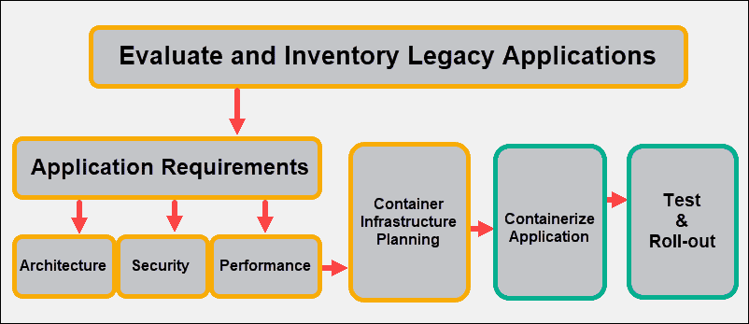
APPENDICE 1

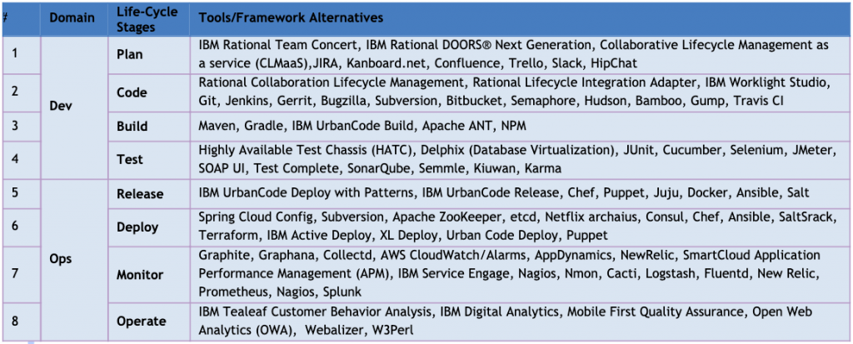
APPENDICE 2

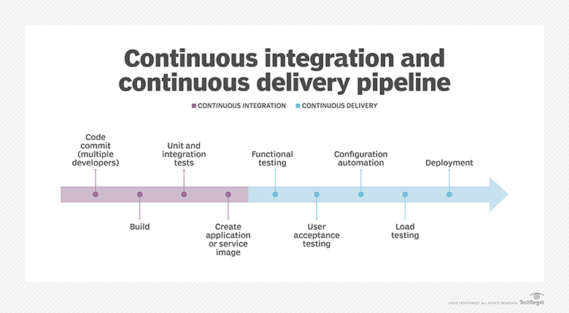
APPENDICE 3

