**Junit Test in Eclipse**

This is a simple implementation of Junit testing in Eclipse.

For this we need:

1. The main app code
2. The AppTest code

**STEPS:**

1. Create a maven project in Eclipse.

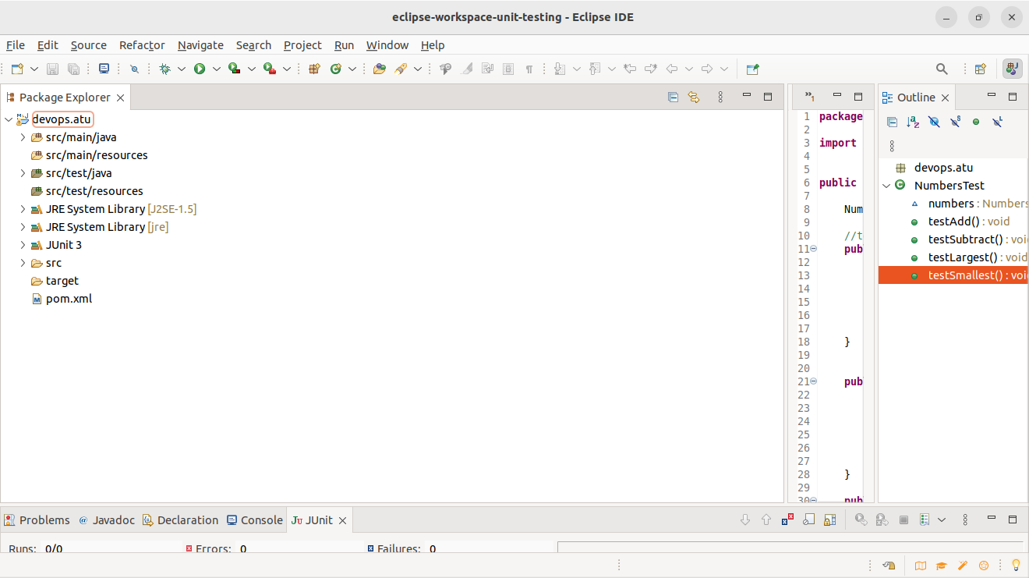

2.Enusre all your configurationa are correct

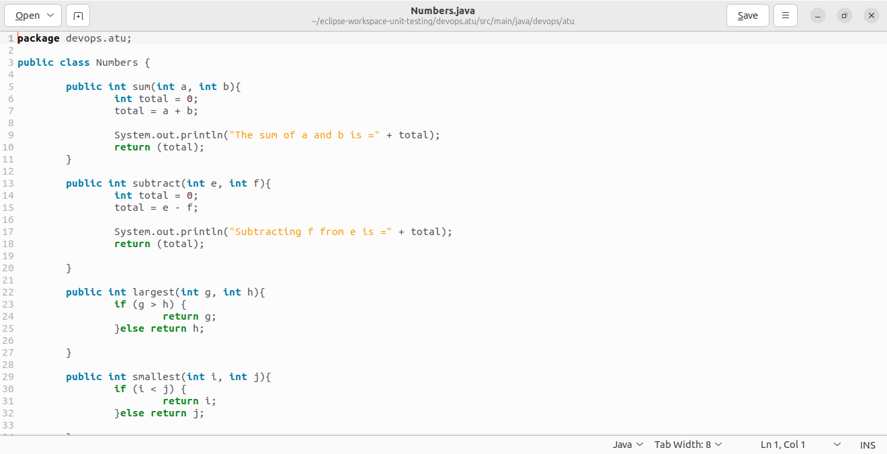3. Write the code for Main app

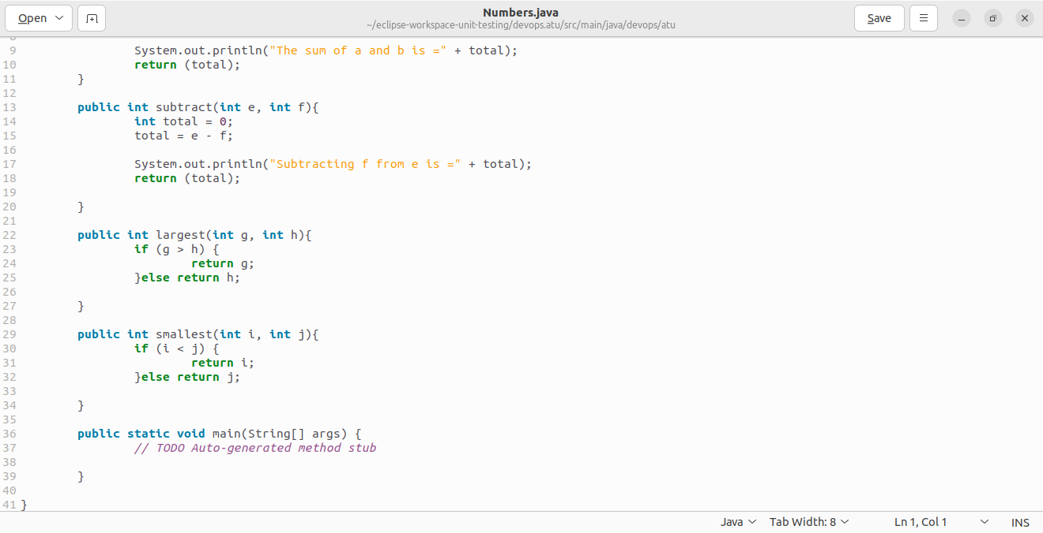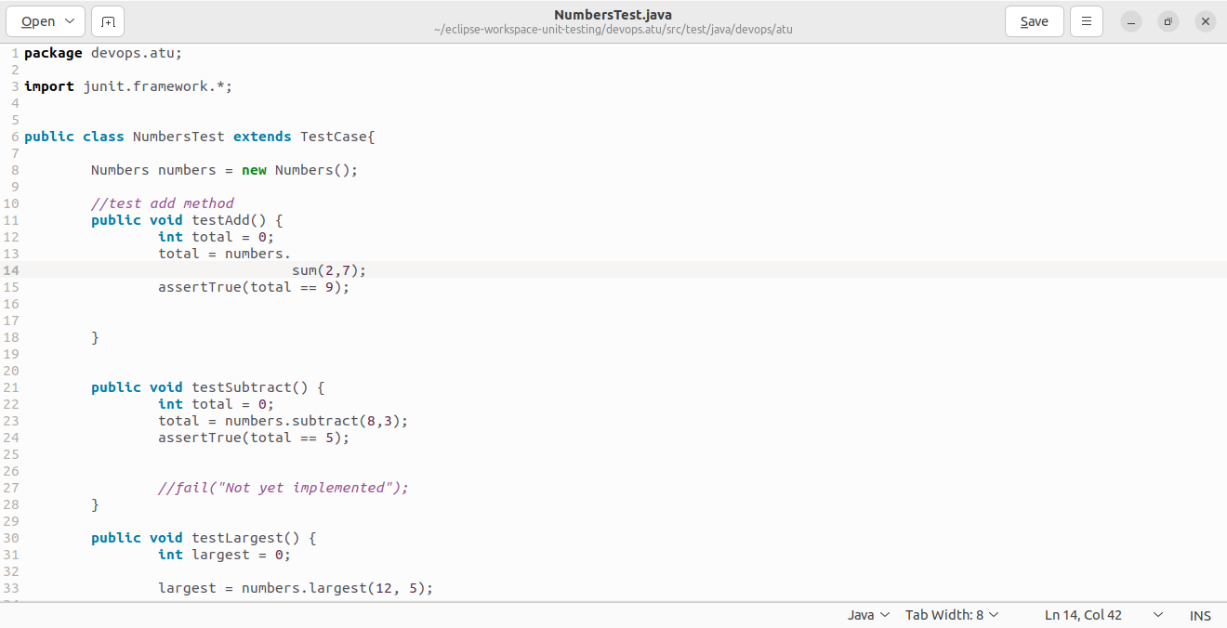4. Write the AppTest code

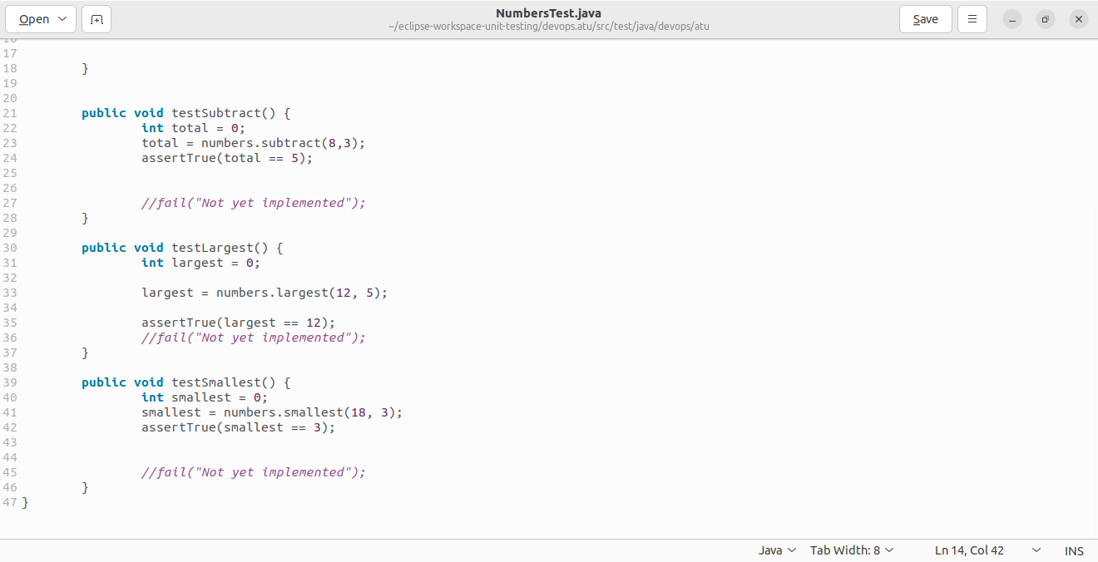

5. Upload the codes and run the Junit test

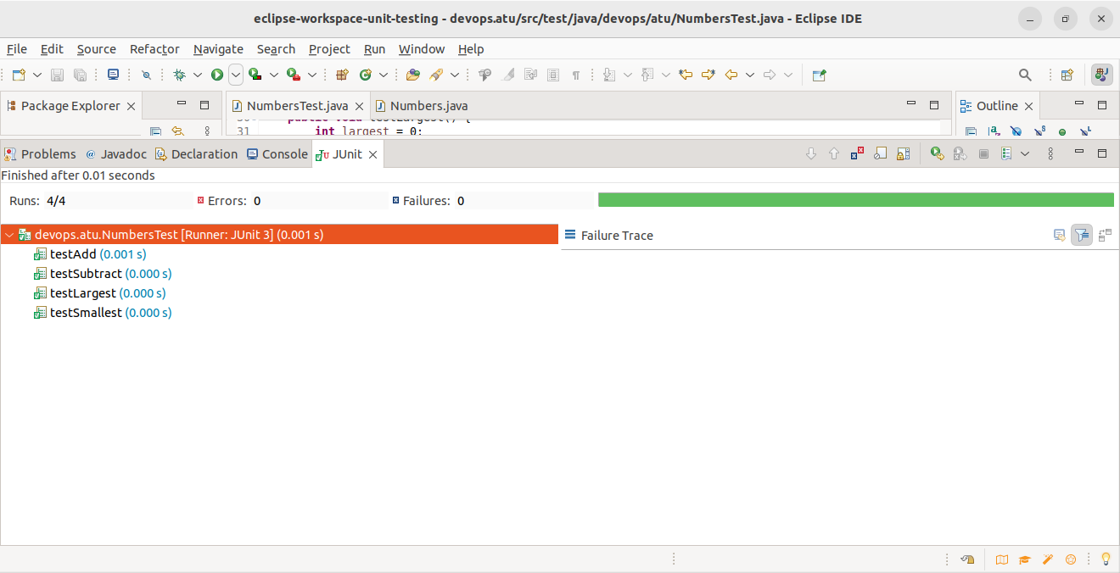

**RESULT:**

The outcome of the Junit test shows that it ran 4 tests and all were successful. This means the main code is bug free and meets all the requirements.