**Appendix A**

User’s Manual

BEFORE USING THE DEVICE

1. 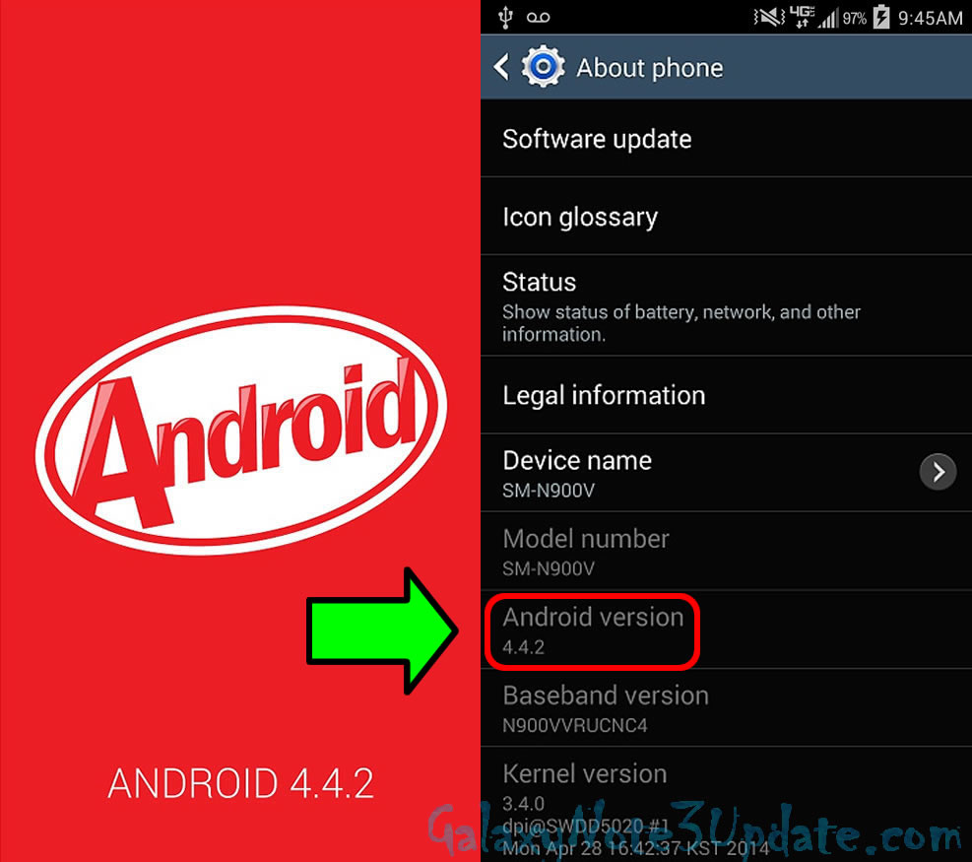Your mobile phone must have an android version 4,4 and above

**Figure 1 ANDROID VERSION**

.

1. Download the Augmented Reality Application on your mobile phone.
2. Ready the manual book and the AR Gear.

**Figure 2 AR CODE**

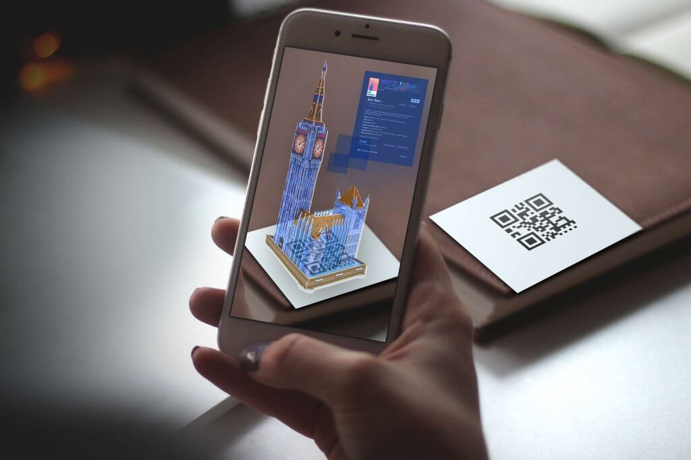

UPON USING THE DEVICE

1. Open the AR application on your mobile phone.
2. 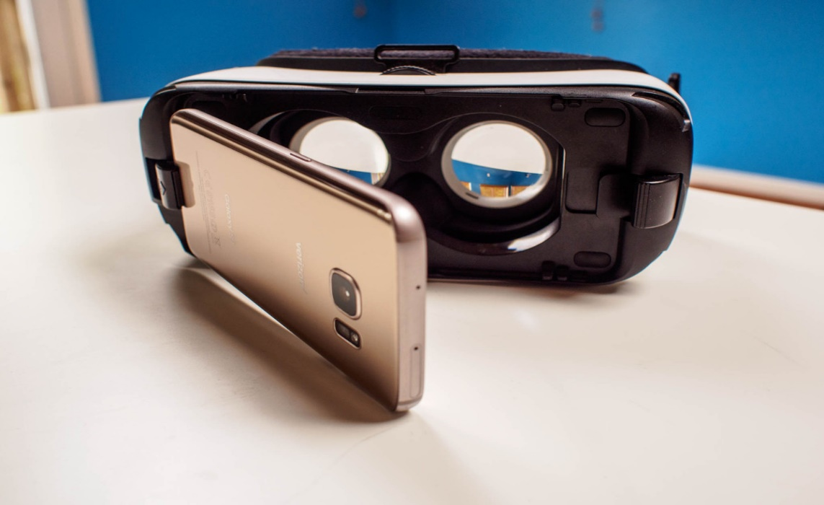 Make sure that the AR Application is still open while inserting the mobile phone in front of the AR Gear.

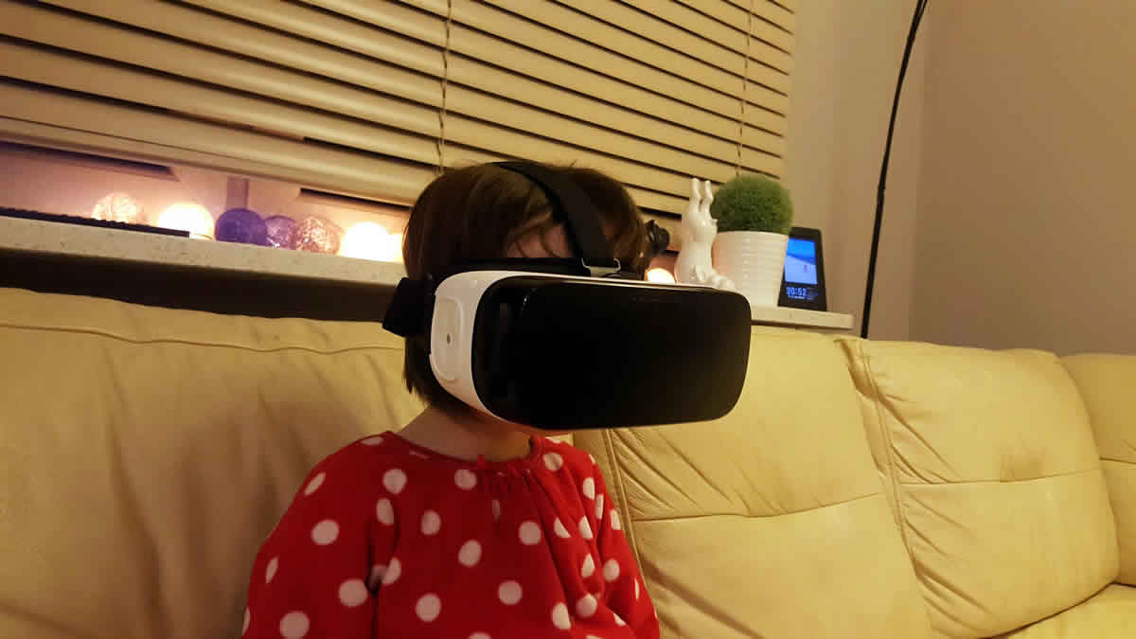

1. Wear the AR Gear after putting the mobile phone.
2. 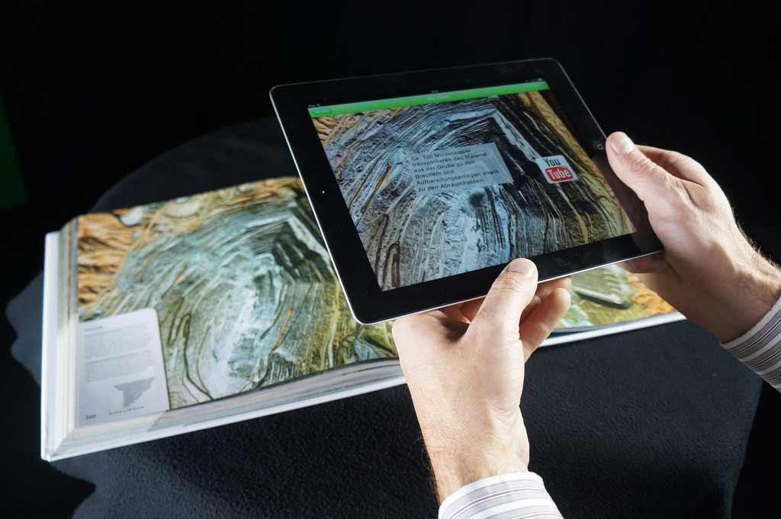Open the Manual Book you want to read and focus the camera in the AR Code of the book. Then wait for the code to be scanned by the AR Application and finally display the image stored in the code.
3. 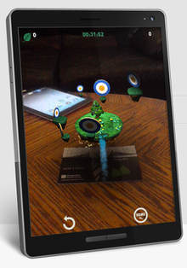The User can utilize the volume of the mobile phone when a video is being shown in the AR Application.
4. 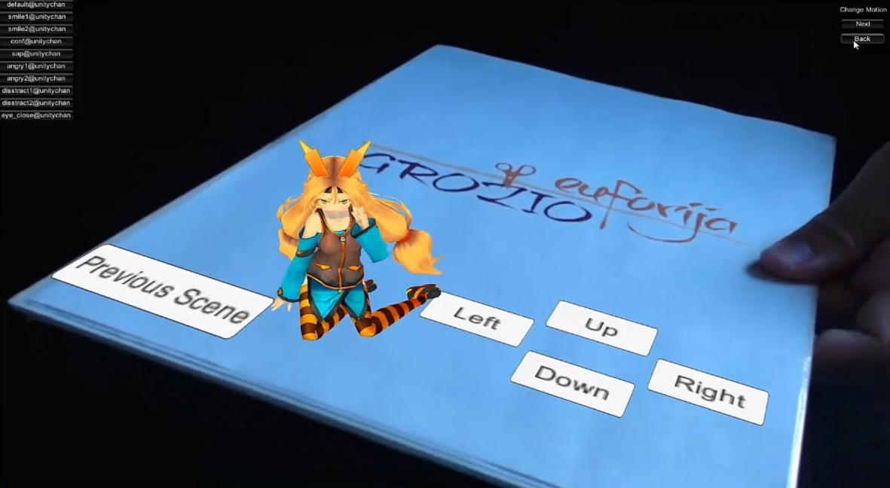The User also can click a button that can be seen on the scanned AR Code.

AFTER USING THE DEVICE

1. Hold carefully the AR gear upon removing it on your head.
2. Close the Manual Book.
3. Remove the Mobile Phone on AR Gear,
4. Close the AR Application.

**Appendix B**

Project Layout

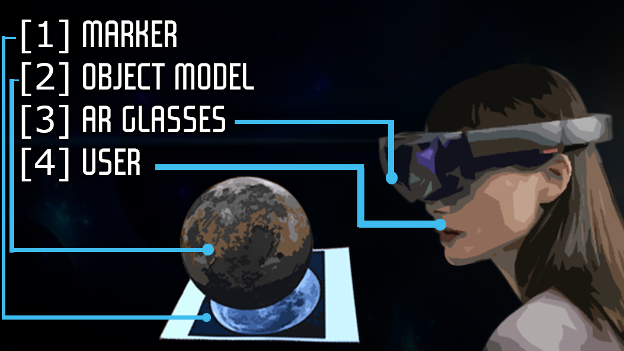

**Figure B.1 Interface of Augmented Reality**



**Figure B.2 Scanning of the AR Code**



**Figure B.3 Actual Image of Scanned Code from the book**

**Appendix C**

Deed of Donation

**Appendix D**

Recommendation

|  |  |
| --- | --- |
| **Recommendations** | **Remarks** |
| 1. “Sabi mo yung battery mo sandali lang, hindi ba pipwedeng magkaroon ng backup? Kasi yung klase natin lalo na sa workshop is 3 hours, sabi mo kasi kanina kaparehas lang ng cellphone edi sandali lang yun lalo na pag ginagamit”. | Complied |
| 1. “So you focus muna on ano, specific subject kasi napakalawak nung title nyo academic learning through augmented reality, ang broad nun” “Sa title nyo para di kayo hanapan, ilagay nyo dun yung specific subject, tas dun na kayo mag focus sa module ng subject”. | Complied |

Table C.1 Design Project 1 Recommendations

Panelists:

.

Engr. Renato C. Salvo

.

Engr. Marife E. Gomez

|  |  |
| --- | --- |
| **Recommendations** | **Remarks** |
| 1.“ You said the battery is just a moment, cannot you have a backup? That's why our class especially in the workshop is 3 hours, because you said that just the same cell phone so it won’t last long if it is used.” | Complied |
| 2. “So you will focus first on what, subject matter, because of your huge title about academic learning through augmented reality. In your title, look for a specific subject, and then focus on that subject module ". | Complied |

Table C.1 Design Project 1 Recommendations

Panelists:

.

Engr. Renato C. Salvo

.

Engr. Marife E. Gomez

**Appendix E**

Curriculum Vitae

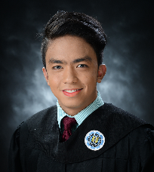

**CHRISTIAN JAY D. CONOCONO**

Pluto St. Centennial II-A Nagpayong Pinagbuhatan,

Pasig City

[cjayconocono@gmail.com](mailto:cjayconocono@gmail.com)

Contact no.: (+63) 9275649386

**QUALIFICATIONS**

• Computer Literate.

• Computer Programming.

• Web Page (Backend/Frontend).

• Basic Networking.

• Photo Editing/Photoshop.

• Video Editing.

• PC Troubleshooting.

**WORKING EXPERIENCE**

**Company :** Office of the Presidential Adviser on the Peace Process (OPAPP)

**Position : Intern**

**EDUCATIONAL BACKGROUND**

TERTIARY SCHOOL

**School**  : Rizal Technological University

**Address** : Mandaluyong, Metro-Manila

**Degree** : Bachelor of Science in Information and Communications Technology

**School Year** : 2013 – present

**PERSONAL INFORMATION**

**Age** : 20 Years Old.

**Birthdate** : September 1, 1996

**Sex** : Male

**Height** : 5’4

**Weight** : 60 Kg

**Nationality** : Filipino

**CHARACTER REFERENCES**

**Engr. Jay Tumanda**

Business Analyst

**Ms. Donna Rose Feliciano**

Security Bank

Teller

*“I hereby certify that the above information’s are true and correct to the best of my knowledge and belief.”*

**Conocono, Christian Jay D.**

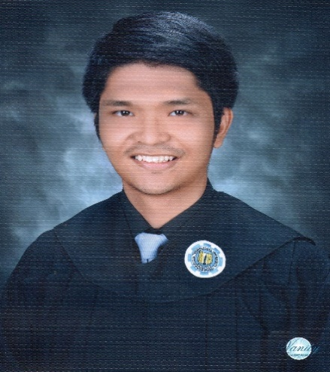

**Juan Miguel P. Cortez**

40 Florante St., Barangay Plainview,

Mandaluyong City

[miguel_ccortez@yahoo.com.ph](mailto:miguel_ccortez@yahoo.com.ph)

Contact no.: (+63) 9972100408

**QUALIFICATIONS**

Knowledge in Computer Hardware and troubleshooting

Programming Languages

* C++
* Java Programming
* PHP
* Using C# in Unity

Database Management

* MYSQL
* Microsoft Access

Photo Editing

* Adobe Photoshop CS6

**WORKING EXPERIENCE**

**Company :** NetPacific Inc.

**Position :** Design and Estimate in the Engineering Department

**Company :** YLF Inc.

**Position :** Web Designer

**Company :** Halcyon Marine Healthcare Systems

**Position :** Web Developer in the MIS Department

**EDUCATIONAL BACKGROUND**

TERTIARY SCHOOL

**School**  : Rizal Technological University

**Address** : Mandaluyong, Metro-Manila

**Degree** : Bachelor of Science in Information and Communications Technology

**School Year** : 2013 – present

SECONDARY SCHOOL

**School**  : Makati High School

**Address** : Gen. Luna, Poblacion, Makati City

**School Year** : 2009 – 2013

PRIMARY SCHOOL

**School**  : Makati Elementary School

**Address** : Gen. Luna, Poblacion, Makati City

**School Year** : 2003 – 2009

**PERSONAL INFORMATION**

**Age** : 21 yrs. old

**Birthdate** : Sept. 28, 1996

**Gender** : Male

**Height**  : 5’9’’

**Weight** : 80 Kg.

**Religion** : Catholic

**Civil Status** : Single

**Nationality** : Filipino

**CHARACTER REFERENCES**

**Mr. Leo Jose L. Luz**

Systems Analyst

**Engr. Jay Tumanda**

Business Analyst

*“I hereby certify that the above information are true and correct to the best of my knowledge and belief.”*

**____________________**

**Juan Miguel P. Cortez**



**DANICA ROCELLE N. FELICIANO**

962 Alley 6 C. Castañeda St. Mandaluyong City

09094852803

danica_feliciano@yahoo.com

**OBJECTIVES**

To enhance my knowledge and skills and to work well to the company I am committed.

**QUALIFICATIONS**

* Computer literate in MS Word, Powerpoint, Excel
* Familiar with the basic computer hardwares
* Knows how to use Adobe Photoshop
* Can design a website using HTML and Dreamweaver

**WORKING EXPERIENCE**

**Company** : Convergys Makati

**Positon** : Student Trainee

Technical Support (IT Department)

**Company** : Romago Inc. Mandaluyong

**Position** : Student Trainee

**Company** : Unisafe Industrial Company Incorporated

**Position** : Student Trainee

**EDUCATIONAL BACKGROUND:**

TERTIARY : **Rizal Technological University**

Mandaluyong City

Bachelor of Science in Information and Communications Technology

2012-present

SECONDARY : **Arellano University Plaridel Campus**

2010-2012

**Isaac Lopez Integrated School**

2008-2010

Mandaluyong City

ELEMENTARY : **Tomas Earnshaw Elementary School**

Punta, Sta. Ana, Manila

2002-2008

**PERSONAL INFORMATION**

**Birthday :** December 02, 1996

**Birthplace :** Mandaluyong City

**Sex :** Female

**Status :** Single

**Religion :** Roman Catholic

**Citizenship :** Filipino

**Language Spoken :** English/ Filipino

**Mother’s Name :** Rossana N. Feliciano

**Father’s Name :** Dominador S. Feliciano Jr.

**CHARACTER REFERENCES:**

**Dra. Marites Marcelino**

Dentist

09228111335

**Marissa Baculio Asilo**

Administrative Officer V

City Health Department, Mandaluyong City Hall

534-0163

**Danny Figueroa**

Call Center Agent

09234730265

*I hereby certify that the above information are true and correct to the best of my knowledge and belief.*

**____________________________**

**DANICA ROCELLE N. FELICIANO**



**ALFRED P. FLORES**

#22 Pampanga St. Nag. Pinagbuhatan Pasig City

[alfred_flores1994@yahoo.com](mailto:alfred_flores1994@yahoo.com)

Contact No.: (+63) 950433814

**OBJECTIVES**

To enhance my skills through this kind of work and apply my knowledge acquired from education. To develop my self - confidence. To be an asset to the company, not a liability.

**QUALIFICATIONS**

* Willing to be learn.
* Computer Literate.
* Computer Programming ( C++ , vb6.0 , PHP )
* Web Page Designing ( HTML , CSS )
* Basic Networking
* PC Troubleshooting

**WORKING EXPERIENCE**

**Company :** Office of the Presidential Adviser on the Peace Process (OPAPP)

**Position** : Intern

**Company**  : Municipal of Pasig (PASIG CITY)

**Position** : Intern

**EDUCATIONAL BACKGROUND**

TERTIARY : **Rizal Technological University**

Diploma in Information and Communications Technology

Boni, Mandaluyong City

S.Y. 2013 - 2016

VOCATIONAL : **Gateways Institute of Science and Technology**

Two-year Diploma Course in Computer Science

San Nicolas Pasig City

S.Y. 2011 - 2013

SECONDARY : **Pinagbuhatan High School**

Pinagbuhatan Pasig City

S.Y 2007 - 2011

PRIMARY : **Liberato Damian Elementary School**

Sta. Cruz Pasig City

S.Y 2001 – 2007

**PERSONAL INFORMATION**

**Nick name** : Fred

**Religion** : Catholic

**Age** : 22 years old

**Height** : 5’2

**Date of birth** : May 10, 1994

**Weight** : 82kg

**Place of birth** : Pasig city

**Citizenship** : Filipino

**Civil status** : Single

**CHARACTER REFERENCES**

**Roel Galvan**

Professor

GIST Pasig

**Sarah Jean Trajano**

Software Programmer

Office of the Presidential Adviser on the Peace Process (OPAPP)

*I hereby certify that the above information are true and correct to the best of my knowledge and belief.*

**__________________ ALFRED P. FLORES**

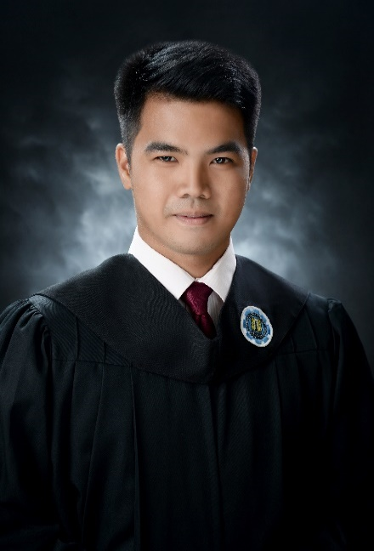

**John Albert R. Mendoza**

605 Nueve de Pebrero St. Pleasant Hills,

Mandaluyong City

[jarmendoza@rtu.edu.ph](mailto:jarmendoza@rtu.edu.ph)

Contact no.: (+63) 9565397679

**OBJECTIVES**

* To develop my knowledge and personality as a career person.
* To learn new skills and spread out my potentials.
* To seek more knowledge and information about technologies

**QUALIFICATIONS**

Knowledge in Hardware Computer such as:

* Formatting Windows Operating System. Using imaging
* Repair of the Desktop

Knowledge in Network Administration

* Student Assistant in Nexus
* Assisting Student to Configure server in Putty

Oriented in Microsoft Office such as:

* Word, Excel, and Powerpoint

Oriented in Programming

* Visual C++, Basic Java, Visual Basic6

Photo Editing

* Using Adobe Photoshop CS6
* Using Paint
* Using Microsoft Office, Microsoft Powerpoint

Encoding Data

Oriented in Webpage Design

* Using Notepad
* Using PHP SQL

**WORKING EXPERIENCE**

**Company :** National Economic and Development Authority

**Position :** ICTS Department

**Company :** Philippine Deposit Insurance Corporation (PDIC) Resource Center

**Position :** IT Department

**Company :** NEXUS Education Training Services

**Position :** Admin Staff

**EDUCATIONAL BACKGROUND**

TERTIARY SCHOOL

**School**  : Rizal Technological University

**Address** : Mandaluyong, Metro-Manila

**Degree** : Bachelor of Science in Information and Communications Technology

**School Year** : 2012 – present

SECONDARY SCHOOL

**School**  : San Miguel National High School

**Address** : San Miguel, Bulacan

**School Year** : 2008 – 2012

PRIMARY SCHOOL

**School**  : San Miguel Elementary School

**Address** : San Miguel, Bulacan

**School Year** : 2002 – 2008

**PERSONAL INFORMATION**

**Age** : 21 yrs old

**Birthdate** : June 29, 1996

**Gender** : Male

**Height**  : 5’9’’

**Weight** : 143 lbs.

**Religion** : Christian

**Civil Status** : Single

**Nationality** : Filipino

**CHARACTER REFERENCES**

**Mr. Cristonick Rivera**

Philippine Deposit Insurance Corporation

Supervisor in IT Department

**Mr. Jose Ryan P. Babon**

National Economic and Development Authority

Supervisor in ICTS Department

**Mr. Chris Buenaventura**

Nexus Education Services

Supervisor in IT Staff

*“I hereby certify that the above information are true and correct to the best of my knowledge and belief.”*

**____________________**

**John Albert R. Mendoza**

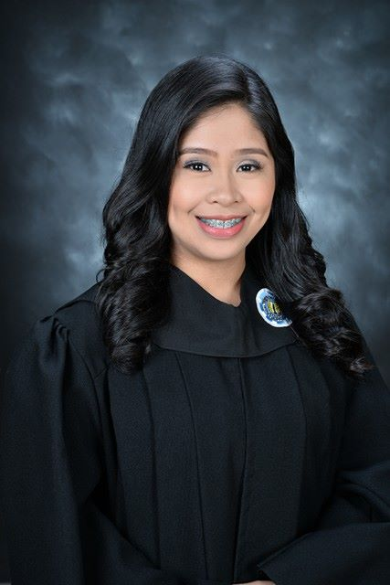

**Tricia Arbotante Natividad**

3115 New Panaderos St. Sta. Ana, Manila

tricianatividad17@gmail.com

Contact no.: (+63) 9262432260

**OBJECTIVES**

To obtain a position that will enable me to use my expertise and knowledge from my previous experiences, educational background, and ability to work well with people.

**QUALIFICATIONS**

* Languages written and spoken: English and Tagalog
* Knowledgeable in Microsoft Office and Internet applications
* Basic knowledge in graphic designing using Adobe Lightroom and Adobe Photoshop
* Experienced in software applications such as: Dreamweaver and Eclipse for Android Application
* Knowledge in Troubleshooting, Network Management, MySQL, Visual Basic 6.0 and VB.net, C++.
* Knowledge in Desktop computer and laptop assembly and disassembly
* Can work under minimum supervision
* NCII – Computer Hardware Servicing (CHS)

**WORKING EXPERIENCE**

**Company :** San Miguel Purefoods

**Position :** Intern

**Period :** July 2014 – October 2014

**Company :** Alumni Relations Office, Rizal Technological University

**Position :** Intern

**Period :** November 2014 – March 2015

**Company :** Unisafe Industrial Co. Inc.

**Position :** Intern

**Period :** May 2017 – August 2017

**EDUCATIONAL BACKGROUND**

TERTIARY SCHOOL

**School**  : Rizal Technological University

**Address** : Mandaluyong, Metro-Manila

**Degree** : Bachelor of Science in Information and Communications Technology

**School Year** : 2012 – present

SECONDARY SCHOOL

**School** : Mandaluyong High School

**Address** : Mandaluyong, Metro-Manila

**School Year** : 2008 – 2012

ELEMENTARY SCHOOL

**School**  : Tomas Earnshaw Elementary School

**Address** : Sta. Ana, Manila

**School Year** : 2002-2008

**PERSONAL INFORMATION**

**Age** : 21 yrs old

**Birthdate** : April 17, 1996

**Gender** : Female

**Height**  : 5’0’’

**Weight** : 110 lbs.

**Religion** : Roman Catholic

**Civil Status** : Single

**Nationality** : Filipino

**CHARACTER REFERENCES**

**Mrs. Hazel Ann Tejoso Tividad**

High School Teacher/Advisor

Mandaluyong High School

**Ms. Eunice Sison**

Web Admin

Rizal Technological University

*“I hereby certify that the above information’s are true and correct to the best of my knowledge and belief.”*

**_________________**

**Tricia A. Natividad.**

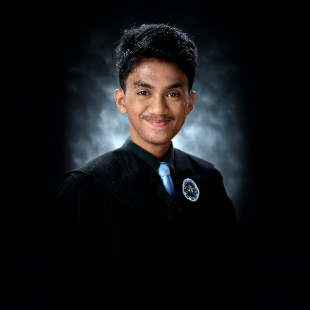

**Arnold T. Ondevilla Jr.**

696 Nueve De Pebrero Block 3 Brgy. Mauway

Bliss Compound, Mandaluyong City

[arnoldondevillajr@gmail.com](mailto:arnoldondevillajr@gmail.com)

Contact No.: (+63) 9500516578

**OBJECTIVES**

Seeking for job in the field of Information and Communications and Technology which focuses on Web Development, Software Programming or Graphic Designing and to improve creative, technical, debugging, problem solving, and logical skills.

**QUALIFICATIONS**

Technical Skills

* Php
* SQL
* .net
* C++
* Java
* CSS
* JS
* PS

**WORKING EXPERIENCE**

**Company :** Netopia Internet Cafe

**Position :** IT intern

**Company :** DellHertz Restaurant Cafe

**Position :** IT Intern

**EDUCATIONAL BACKGROUND**

TERTIARY SCHOOL : Rizal Technological University

Bachelor of Science in Information and Communications Technology

2013-present

SECONDARY SCHOOL : Mataas na Paaralang Neptali A. Gonzales

2009-2013

PRIMARY SCHOOL : Addition Hills Elementary School

2003-2008

**PERSONAL INFORMATION**

Date of Birth : March 25, 1997

Civil Status : Single

Religion : Catholic

Height : 5’7”

Nationality : Filipino

*“I hereby certify that the above information are true and correct to the best of my knowledge and belief.”*

**____________________**

**Arnold T. Ondevilla Jr.**

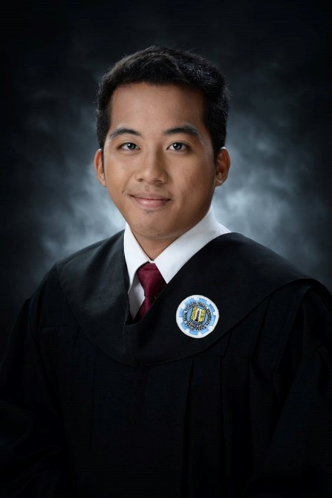

**Wilfred M. Ribleza Jr.**

1686 Mahogany St. Centennial II, Nagpayong, Pinagbuhatan, PasigCity

[wilfredribleza@gmail.com](mailto:wilfredribleza@gmail.com)

Contact no.: (+63) 9073067225

**OBJECTIVES**

To be able to utilize and boost my skills and knowledge and to be part of a company’s growth.

**QUALIFICATIONS**

* Programming Language - Developed programs/systems through the use of Programming Languages such as C#/C++ and Java. Also developed a simple application on Android Platform through the use of Android Development Kit on Java Eclipse. Experienced in developing simple webpages using HTML.
* Multimedia Workshop – Conducted photography including photo editing. Experienced in full-length video editing.
* System Development – Developed an Inventory/Point of Sale program connected via Database using Microsoft Visual Studio 2010.

**WORKING EXPERIENCE**

**Company :** SPES

**Position :** Intern

**Period :** Summer 2012

**Company :** National Economic and Development Authority - NEDA

**Position :** Intern

**Period :** Summer 2015

**Company :** Dellherts Cafe Bar & Restaurant

**Position :** Intern

**Period :** December 2015 – March 2016

**Company :** Spark Global Tech Systems, Inc.

**Position :** Intern

**Period :** May 2017 – January 2018

**EDUCATIONAL BACKGROUND**

**TERTIARY SCHOOL**

**School**  : Rizal Technological University

**Address** : Mandaluyong, Metro-Manila

**Degree** : Bachelor of Science in Information and Communications Technology

**School Year** : 2013 – present

**PERSONAL INFORMATION**

**Age** : 20 yrs old

**Birthdate** : April 9, 1997

**Gender** : Male

**Height**  : 5’3’’

**Weight** : 110 lbs.

**Religion** : Christian

**Civil Status** : Single

**Nationality** : Filipino

**CHARACTER REFERENCE**

**Mr. Jay E. Tumanda**

Business Manager

Spark Global Tech Systems Inc.

*“I hereby certify that the above information’s are true and correct to the best of my knowledge and belief.”*

**__________________**

**Wilfred M. Ribleza Jr.**

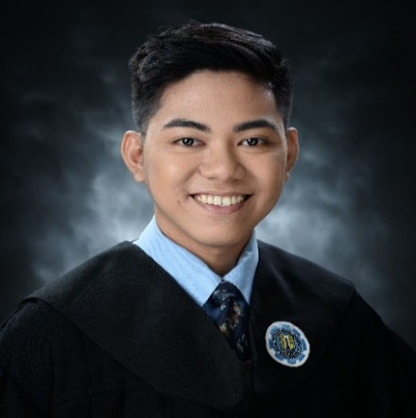

**Franz Arvin B. Villegas**

# 1220 Metropolis East. Brgy. Pag-asa

Binangonan, Rizal

franzbrundial@gmail.com

Contact no.: (+63) 9470386858

**OBJECTIVES**

To obtain a position in company that I will utilize my skills and knowledge.

**QUALIFICATIONS**

* Photography
* Basic knowledge in Adobe Photoshop
* Basic knowledge in Computer Network
* Basic knowledge of Html
* Oriented in Microsoft Office

**WORKING EXPERIENCE**

**Company :** SPi Global

**Position :** Intern

**Period :** June 2015 – August 2015

**Company :** Dellherts Cafe Bar & Restaurant

**Position :** Intern

**Period :** December 2015 – March 2016

**Company :** Nexus Education Service

**Position :** Intern

**Period :** May 2017 – August 2017

**EDUCATIONAL BACKGROUND**

TERTIARY SCHOOL

**School**  : Rizal Technological University

**Address** : Mandaluyong, Metro-Manila

**Degree** : Bachelor of Science in Information and Communications Technology

**School Year** : 2013 – present

**PERSONAL INFORMATION**

**Age** : 20 yrs old

**Birthdate** : October 26, 1996

**Gender** : Male

**Height**  : 5’4’’

**Weight** : 105 lbs.

**Religion** : Catholic

**Civil Status** : Single

**Nationality** : Filipino

**CHARACTER REFERENCE**

**Ms. Eunice Sison**

Web Admin

Rizal Technological University

**Timothy John Madlang-awa**

Technical Support Engineer

Spi Crm Mandaluyong City

*“I hereby certify that the above information’s are true and correct to the best of my knowledge and belief.”*

**___________________**

**Franz Arvin B. Villegas**