
THE UNIVERSITY OF ZAMBIA
SCHOOL OF NATURAL & APPLIED SCIENCES
DEPARTMENT OF COMPUTING AND INFORMATICS

HOUSEMATCH: A Secure Web Platform for Connecting Landlords and House Seekers

BY
CHIMWEMWE NAMUTOWE

CSC 4004 FINAL YEAR COURSE PROJECT

A THESIS SUBMITTED IN PARTIAL FULFILMENT OF THE
REQUIREMENTS FOR THE AWARD OF A BACHELOR’S DEGREE
OF COMPUTER SCIENCE

SUPERVISOR: MR ANDIREA THEU

ABSTRACT

The housing rental process in Zambia is riddled with inefficiencies, misinformation, and a lack of secure digital infrastructure. Existing platforms often serve as passive listing boards, offering minimal verification, poor user experience, and limited protection against fraud. House seekers are frequently exposed to fake listings, unverified landlords and opaque communication channels, while landlords struggle to find reliable tenants without risking data exposure or reputational harm. These systemic issues demand a secure, scalable, and user-centric solution.
HouseMatch is a web-based platform designed to bridge this gap by securely connecting landlords and house seekers through a role-based access system. The frontend is built using React and JavaScript, offering a responsive and intuitive interface tailored to each user role. The backend is powered by Django and Django REST Framework,enabling modular API design, secure data handling, and scalable deployment. Key features include secure authentication, dynamic dashboards, verified landlord onboarding, and real-time property listings — all designed to reduce fraud and improve match accuracy.
Unlike existing platforms, HouseMatch introduces innovations such as role-based routing, form-level validation, and structured onboarding flows that guide users through each step of the rental process. The system enforces secure password handling using hashing algorithms to protect user credentials, and integrates an admin approval layer to verify landlord accounts before listings go live. These mechanisms significantly reduce the risk of impersonation, fake listings, and unauthorized access. The platform also supports static file management, environment isolation, and production-grade deployment readiness. Every component is designed with modularity and maintainability in mind, ensuring that the platform can evolve with user needs and market demands.
This thesis documents the design, implementation, and evaluation of HouseMatch, demonstrating its potential to redefine digital housing platforms in Zambia. By addressing the shortcomings of current systems and introducing a robust, secure alternative, HouseMatch sets a new benchmark for trust-driven property technology in emerging markets. The project not only contributes to academic discourse but also offers a practical blueprint for scalable, secure, and user-friendly housing solutions.

DECLARATION
I, the undersigned, hereby declare that the project titled HouseMatch: A Secure Web Platform for Connecting Landlords and House Seekers is entirely my own work. To the best of my knowledge, it has not been submitted for any degree or examination at any other university or institution. All sources consulted or quoted have been fully acknowledged through complete and accurate references.

Author:
Chimwemwe Namutowe
2021505600

Signature: ___________________________

Supervisor:
Mr. Andirea Theu

Signature: ___________________________

DEDICATION

I dedicate this project to God Almighty, whose grace, wisdom, and strength have guided me through every challenge and triumph along the way.
To my parents, whose unwavering love, sacrifices, and encouragement have been the foundation of my academic and personal growth.
To my sisters, for their constant support, laughter, and belief in me, you’ve been my quiet strength.

ACKNOWLEDGEMENTS

First and foremost, I thank God Almighty for His unfailing presence, strength, and grace throughout this journey.
To my mother, Lilian Phiri Simutowe. Your love, wisdom, and unwavering support have been my anchor. You believed in me even when I doubted myself, and your sacrifices have carried me through.
To my father, Greenwell Simutowe. Thank you for your quiet strength and steadfast support. Your commitment to my education laid the foundation for all that I have achieved.
To my sisters, Suwilanji Namutowe Nyambe, Lukundo Namutowe, and Salifyanji Namutowe. Each of you has supported me in your own unique way. Suwilanji, your encouragement and financial support kept me going. Lukundo, your spiritual guidance and belief in me gave me strength when I needed it most. Salifyanji, your companionship, generosity, and availability made the hardest days easier.
To my study group and friends. You were more than classmates; you became a family away from home. Thank you for the shared knowledge, encouragement, and laughter that made this academic journey both meaningful and enjoyable.
Finally, I extend my heartfelt appreciation to my supervisor, Mr. Andirea Theu, for his patience, guidance, and encouragement. Your mentorship challenged me to grow and played an invaluable role in shaping this project.

Contents

INTRODUCTION 8
1.1 Background 8
1.2 Problem Statement 9
1.3 Research Questions 9
1. How can a web-based platform be designed to securely connect landlords and house seekers in Zambia’s rental housing market? 9
2. What role does user verification and role-based access control play in reducing fraud and improving trust between platform users? 9
3. How can form-level validation and admin approval workflows enhance the accuracy and reliability of rental listings? 9
4. What technologies and architectural patterns are most effective for building a scalable, modular housing platform tailored to Zambia’s context? 9
5. How does the implementation of secure communication channels impact user engagement and confidence in digital rental platforms? 9
1.4 Aims 9
1.5 Objectives 10
LITERATURE REVIEW 11
2.1 Introduction 11
2.2 REVIEW OF SIMILAR SYSTEMS 11
2.2.1 Systems Centered on Property Listings 11
2.2.2 Systems Embracing Rental Matching and Communication 14
2.2.3 Summary of Observations 21
2.3 Research Methodology for HouseMatch 21
2.4 SUMMARY 22
3.REQUIREMENTS ANALYSIS 23
3.1 SOFTWARE DEVELOPMENT METHODOLOGY 23
3.1.1 Development Method 23
3.1.2 Required Resources 24
3.2 Requirements 25
3.2.1 Approach 25
3.2.2 Functional Requirements 25
3.2.2.1 House Seeker 25
3.2.2.2 Landlord 26
3.2.2.3 Admin 26
3.2.3 Non-Functional Requirements 26
4. SYSTEM DESIGN 27
4.1 Proposed System 27
4.2 System and Algorithm Flowcharts 27
4.2.1 User Registration Flow 27
4.2.2 Property Search & Viewing Flow (House Seeker) 29
4.2.3 Property Listing Management Flow (Landlord) 30
4.3 System Structure Charts 31
4.4 User Interface Design 32
4.5 Entity Relation Diagram 32
5. SYSTEM IMPLEMENTATION 33
5.1 Description of the Developed System 33
5.2 Technical details 33
5.2.1 Authentication System 33
5.2.2 Property Management System 34
5.2.3 Messaging System 34
5.3 Screenshots 35
6. TESTING AND VERIFICATION 40
6.1 Testing Methodology 40
6.2 Test Cases 41
6.3 Analysis and Test Results 42
7. CONCLUSION 43
7.1 Results and Achievements 43
7.2 Limitations and Problem Faced 44
7.3 Future works and recommendation 44
8. APPENDICES 45
8.1 Appendix 1 - Domain Terms 45
8.2 Appendix 2 – Installation 45
8.2.1 Setting up the Development Environment 46
8.2.2 Backend Setup (Django) 46
8.2.3 Frontend Setup (React) 46
8.2.4 Database Configuration 46
8.3 Appendix 3 - Selected source code 47
8.3.1 listings/views.py 47
9. REFERENCES 50

LIST OF FIGURES

Figure 1: Screenshot of Homenet Zambia rental listing interface. .......................................... 13
Figure 2: Example of an informal Facebook rental listing using a rice image. ....................... 14
Figure 3: : HouseMatch Admin Dashboard – Listing Review and Image Management
Panel ......................................................................................................................................... 15
Figure 4: HouseMatch landlord landing page. ......................................................................... 16
Figure 5: HouseMatch landlord landing page. ......................................................................... 17
Figure 6: HouseMatch Landlord listing form. ......................................................................... 18
Figure 7: HouseMatch HouseSeeker Landing Page. ............................................................... 19
Figure 8:HouseMatch HouseSeeker landingpage. ................................................................... 20
Figure 9: The Agile iterative development model.................................................................... 23
Figure 10: Landing page .......................................................................................................... 34
Figure 11: Landing page. ......................................................................................................... 35
Figure 12: HouseSeeker Login page ........................................................................................ 35
Figure 13:HouseSeeker Landing page. .................................................................................... 36
Figure 14: HouseSeeker HomePage. ....................................................................................... 36
Figure 15:Landlord LandingPage. ........................................................................................... 37
Figure 16: Landlord LandingPage ........................................................................................... 37
Figure 17:Listing Form. ........................................................................................................... 38
Figure 18:Admin Dashboard. ................................................................................................... 38
Figure 19:Admin Dashboard .................................................................................................... 39
Figure 20:Admin Dashboard .................................................................................................... 39

1. INTRODUCTION

1.1 Background
Over the past several years, the housing sector in Zambia has faced rapid growth and increasing demand, particularly in urban areas such as Lusaka, Ndola, and Kitwe. This rise in demand has been driven by urbanization, population growth, and the pursuit of affordable accommodation by students, young professionals, and families. Despite this demand, the rental housing market continues to face persistent challenges that affect both tenants and landlords.
Traditionally, the process of finding rental accommodation has relied heavily on informal networks, word of mouth, and manual advertising methods such as posters and newspaper listings. These approaches are often inefficient, time-consuming, and unreliable, leaving tenants vulnerable to misinformation, scams, or unverified agents. Landlords, on the other hand, struggle to reach a wider audience, maintain accurate records, and manage tenant relationships effectively. The lack of secure and structured platforms has made the rental experience fragmented and prone to exploitation.
While digital solutions have begun to emerge in Zambia’s housing market, most platforms focus broadly on real estate sales rather than affordable and verified rentals. These systems often fall short in critical areas such as user authentication, secure communication, and rolebased access control. Coupled with practical issues like inaccurate listings and frequent scams, these shortcomings make it difficult for tenants and landlords to navigate the housing ecosystem with confidence, leaving the rental experience fragmented and unreliable.
In light of these challenges, the need for a dedicated platform that prioritizes trust, efficiency, and accessibility has become increasingly evident. HouseMatch was conceived as a modern response to this gap, providing a secure and user-friendly web platform tailored specifically to Zambia’s rental housing market. By addressing issues of verification, communication, and accessibility, HouseMatch seeks to empower both tenants and landlords not only as an alternative to traditional rental processes but also as a more reliable and effective platform compared to existing applications that fall short in these areas, ultimately contributing to a more transparent and efficient housing ecosystem.

1.2 Problem Statement
Despite the growing demand for rental housing in Zambia, both tenants and landlords continue to face significant challenges due to the absence of a secure, centralized platform. Existing methods are fragmented and vulnerable to inefficiency, fraud, and unverified listings. The lack of proper user authentication, role-based access control, and reliable communication channels leaves both parties exposed to risk and frustration.
This project responds to the urgent need for a trusted digital solution that enables safe, structured, and transparent interactions between landlords and tenants. By integrating user verification, secure messaging, and streamlined workflows, HouseMatch seeks to enhance confidence, reduce fraud, and foster trust within Zambia’s rental housing ecosystem

1.3 Research Questions

1. How can a web-based platform be designed to securely connect landlords and house seekers in Zambia’s rental housing market?

2. What role does user verification and role-based access control play in reducing fraud and improving trust between platform users?

3. How can form-level validation and admin approval workflows enhance the accuracy and reliability of rental listings?

4. What technologies and architectural patterns are most effective for building a scalable, modular housing platform tailored to Zambia’s context?

5. How does the implementation of secure communication channels impact user engagement and confidence in digital rental platforms?

1.4 Aims
The aim of this project is to develop a secure, full-stack web platform that connects landlords and house seekers in Zambia, streamlining rental interactions through verified user roles, structured workflows, and a trustworthy digital experience.

1.5 Objectives
Below are the objectives for the project:
- To create a safe and easy-to-use website where landlords and house seekers can connect directly.
- To make sure every user is clearly identified and given the right access based on whether they are a landlord, house seeker, or administrator.
- To allow landlords to post houses for rent only after their listings are checked and approved, so that house seekers see only real and verified options.
- To guide new users through a smooth registration process that helps them get started quickly and safely.
- To provide a way for landlords and house seekers to message each other securely without sharing personal contact details.
- To design the platform in a way that it can grow and improve over time without needing to be rebuilt from scratch.
- To make sure the website works well on different devices and is easy to navigate, even for first-time users.
- To launch the platform in a way that it’s ready for real use — fast, reliable, and available online.
- To build trust through a clean design, clear instructions, and a professional look that makes users feel confident using the platform.

2.LITERATURE REVIEW

2.1 Introduction
The literature review serves as a foundational component of this research, offering a critical exploration of existing digital housing platforms and the broader technological landscape surrounding rental property management. This section aims to contextualize the HouseMatch project by examining current solutions, identifying their strengths and limitations, and highlighting the gaps that this system seeks to address.
In recent years, the digitization of housing services has gained momentum globally, with various platforms emerging to facilitate property listings, tenant-landlord interactions, and rental agreements. However, in Zambia, many of these systems remain either inaccessible, overly generalized, or lacking in features that address the unique challenges of the local rental market. Issues such as impersonation, fake listings, poor verification processes, and fragmented communication continue to undermine user trust and platform reliability.
By reviewing existing systems, both local and international, this literature review will uncover the architectural patterns, user experience strategies, and security mechanisms employed across the housing tech space. These insights will inform the design and implementation of HouseMatch, ensuring that the platform is not only technically sound but also contextually relevant and user-centered.

2.2 REVIEW OF SIMILAR SYSTEMS

2.2.1 Systems Centered on Property Listings
A subset of housing platforms in Zambia is dedicated primarily to property listings. These systems allow landlords, agents, or property managers to upload rental properties with basic details such as location, price, and contact information. Examples include platforms like Homenet Zambia, BE FORWARD Real Estate Zambia, and AgentA Homes. These platforms typically present listings in a catalog format, often accompanied by images and brief descriptions.
While these systems offer convenience in browsing available properties, they rely heavily on external communication channels such as phone calls or WhatsApp, which introduces risks related to impersonation, misinformation, and fraud. There is minimal verification of landlords or listings, and no structured onboarding or role-based access control. As a result, house seekers are frequently exposed to fake listings, duplicate entries, and misleading property descriptions.
The figure 1 below is a screenshot of the mobile iOS version of Homnet Zambia.

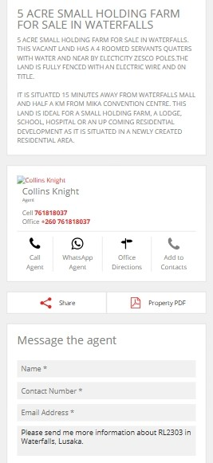
Figure 1: Screenshot of Homenet Zambia rental listing interface.

Additionally, many listings are shared informally through social media platforms such as Facebook Marketplace and community groups. These posts are typically unmoderated and lack any form of verification, making them highly susceptible to scams, impersonation, and misinformation. In some cases, users post listings with irrelevant or misleading images, such as food items or unrelated visuals, which further highlights the lack of oversight and the potential for confusion or fraud. This undermines the credibility of the platform and exposes house seekers to unnecessary risks. The figure 2 below is a screenshot of a facebook listing.
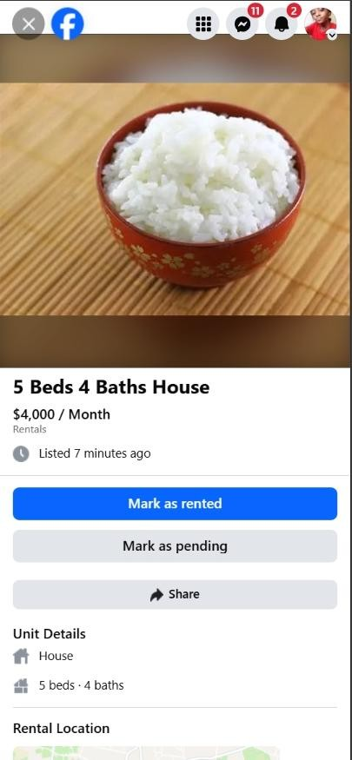
Figure 2: Example of an informal Facebook rental listing using a rice image.

2.2.2 Systems Embracing Rental Matching and Communication
Another segment of housing platforms attempts to facilitate matching between landlords and tenants. These systems may include filters for location, price range, and property type, and in some cases, offer basic messaging features. However, the majority still operate without secure, in-platform communication channels. Users are required to exchange personal contact details, which compromises privacy and opens the door to scams and harassment.
Furthermore, these platforms do not incorporate listing approval workflows or structured validation processes. Listings are published immediately upon submission, regardless of completeness or accuracy. This lack of moderation contributes to a fragmented user experience and limits the platform’s ability to foster trust and reliability. Figure3 below is shows the admin listing review.
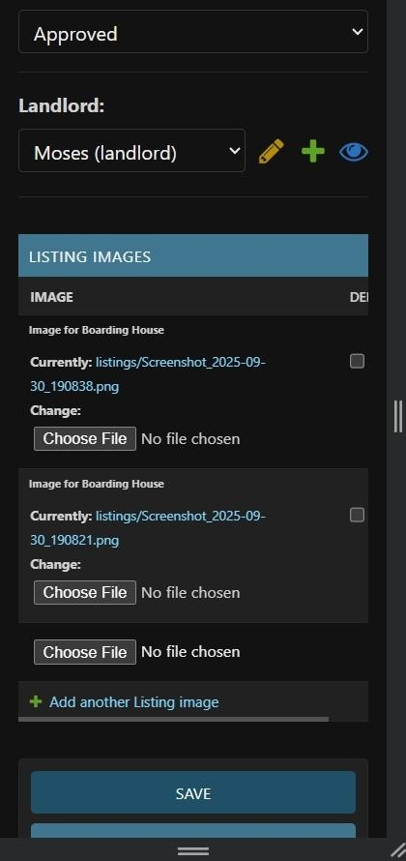
Figure 3: : HouseMatch Admin Dashboard – Listing Review and Image Management Panel

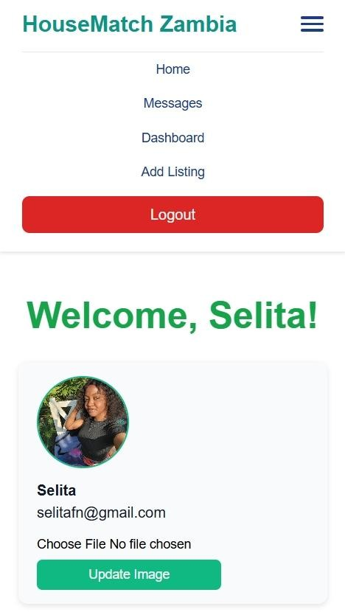
Figure 4: HouseMatch landlord landing page.
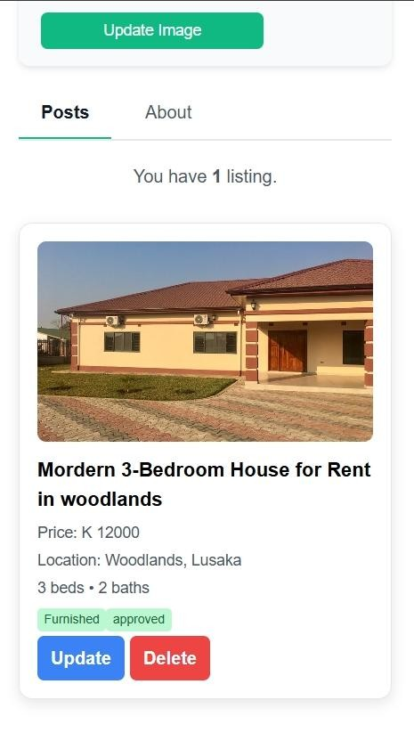
Figure 5: HouseMatch landlord landing page.
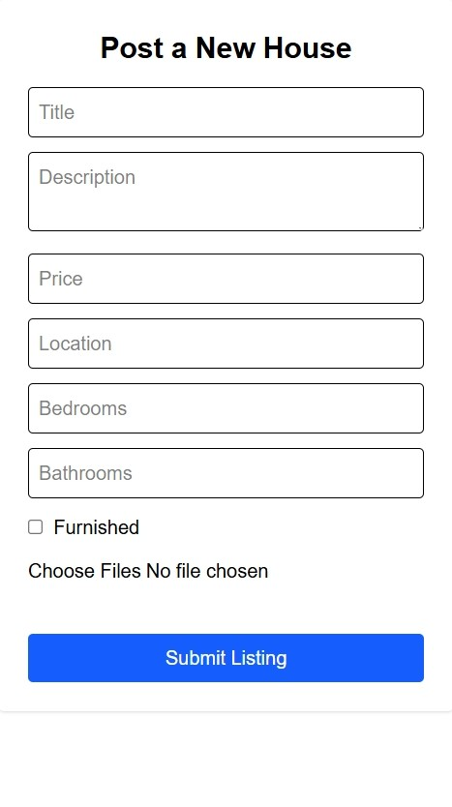
Figure 6: HouseMatch Landlord listing form.

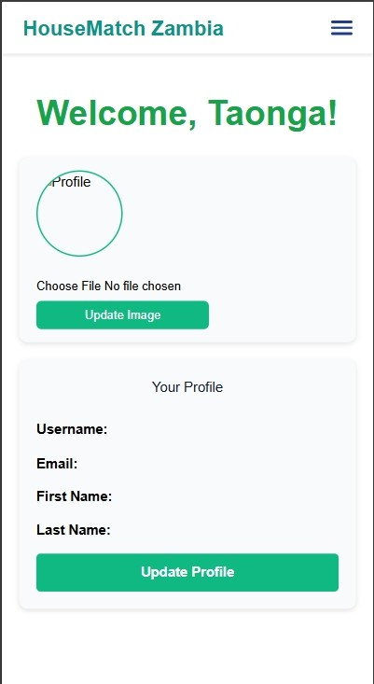
Figure 7: HouseMatch HouseSeeker Landing Page.

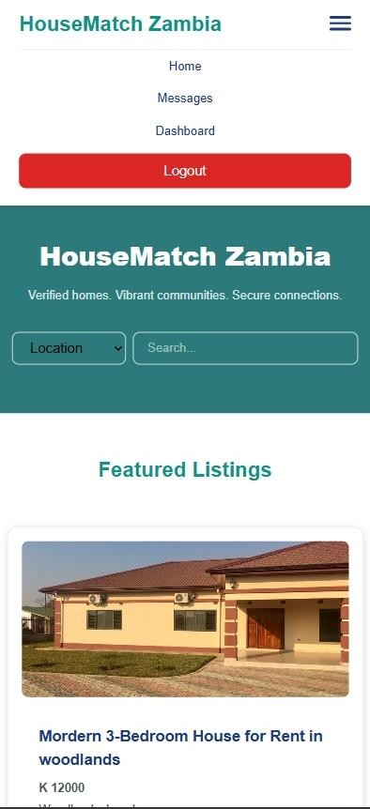
Figure 8:HouseMatch HouseSeeker landingpage.
.

2.2.3 Summary of Observations
The review of existing systems reveals a consistent pattern of limitations that undermine trust and efficiency in Zambia's digital rental market:
- Absence of user verification and role-based access control, leaving platforms vulnerable to impersonation and fraud.
- Lack of secure, in-platform communication channels, forcing users to share personal contact details and use external apps like WhatsApp.
- No listing approval or validation mechanisms, resulting in the publication of inaccurate, duplicate, or fake property listings.
- Overreliance on external apps for negotiation and follow-up, which fragments the user experience and compromises privacy.
- Limited s support for structured onboarding and personalized dashboards, leading to a generic and often confusing user journey.
These identified gaps underscore the critical need for a purpose-built solution tailored to Zambia's rental housing ecosystem. HouseMatch is designed explicitly to address these shortcomings by offering a secure, role-driven platform with verified listings, administrative oversight, and safe communication between users. The system aims to elevate the rental experience by combining robust technical safeguards with intuitive, usercentered design.

2.3 Research Methodology for HouseMatch
The formulation of the system requirements for the HouseMatch platform was a practical process focused on understanding the real-world challenges in Zambia’s rental housing market. The following methodologies were employed:
- System Analysis and Observation:
A hands-on analysis was conducted by actively using and evaluating existing local rental platforms and observing interactions on informal channels like Facebook
Marketplace. This process revealed critical shortcomings, such as the reliance on external communication apps, the prevalence of unverified listings, and the lack of user-specific features.

- Personal Experience:
Direct, firsthand experience with the process of searching for rental accommodation provided deep insight into key pain points. This included encountering issues like unresponsive landlords, inaccurate listings, and the general lack of trust and security in existing methods.
- Informal Interviews and Discussions:
Conversations were held with fellow students, young professionals, and individuals who have rented out properties. These discussions provided external validation of the frustrations within the current system, with common themes including the fear of scams, the inefficiency of property searches, and the desire for a more structured and secure platform.
This practical, experience-driven research methodology ensured that the HouseMatch platform was designed to tackle genuine problems faced by its users, focusing on security, efficiency, and a tailored user experience.

2.4 SUMMARY
In summary, our review of the current landscape for rental housing in Zambia identified a significant gap in the market. Existing platforms and informal channels, such as Facebook Marketplace, primarily function as basic listing boards. They lack critical features like user verification, secure in-platform communication, and listing approval mechanisms, which leads to widespread issues of fraud and mistrust.

The research methodology for HouseMatch was designed to directly address these shortcomings. It combined a practical analysis of existing systems with valuable insights from personal experience and user discussions. This approach ensured a deep understanding of the real-world problems faced by both house seekers and landlords.

The findings from this research have directly shaped the design goals of HouseMatch. The platform is being developed to introduce a secure, role-based system that prioritizes user safety through verification, enables structured communication, and streamlines the rental process for all parties involved. This foundation aims to create a more reliable and efficient housing marketplace for Zambia.

3.REQUIREMENTS ANALYSIS

3.1 SOFTWARE DEVELOPMENT METHODOLOGY
In formulating the methodology for implementing the proposed project, a survey of the problem domain was conducted. The insights derived from this survey played a pivotal role in shaping the methodology envisioned for the project's execution.

3.1.1 Development Method
The HouseMatch project consists of multiple interconnected modules for the frontend, backend, and database, all of which require seamless integration. Given the interlinked nature of these components and the need for iterative feedback, an Agile development approach was adopted. This strategy breaks the project into manageable sprints, facilitating thorough testing and continuous improvement at each stage.

The following diagram illustrates the iterative cycle of the Agile methodology:

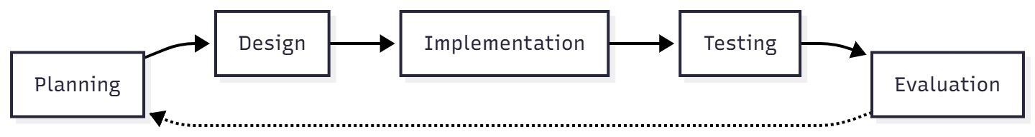
Figure 9: The Agile iterative development model.

3.1.2 Required Resources
The HouseMatch project is a full-stack web application. The hardware devices used to access the envisaged system include computers, smartphones, and tablets.

- Integrated Development Environment (IDE)
Visual Studio Code was used as the primary code editor.
- Version Control
Git and GitHub were used for version control and collaboration.

• Frontend (Client-Side)
The frontend of the HouseMatch system was built as a modern single-page application (SPA) using React. The development was accelerated using Vite as the build tool. The user interface was styled and made responsive using the Tailwind CSS framework. Key functionalities were enhanced with the following libraries:
- Axios for making HTTP requests to the backend API.
- React Router Dom for handling navigation between different pages.
- React Hot Toast for displaying user notifications.
- Swiper for implementing interactive image carousels in property listings.
- Framer Motion for adding smooth animations to improve the user experience.

• Backend (Server-Side)
The backend was developed using Django and Django REST Framework to create a robust and secure API.
- Database
SQLite was used as the relational database management system for the project.
- Other Technologies
JSON Web Tokens (JWT) for securing user authentication sessions.

3.2 Requirements

3.2.1 Approach

The methodology employed involved gathering requirements through a series of meetings with the supervisor and potential users. Additionally, requirements were identified during progress report meetings and through observational insights from using existing platforms. Subsequently, meetings with the supervisor were scheduled to precisely plan the implementation of each requirement.
Given the use of an Agile development methodology, each sprint concentrated on implementing one or two specific system functionalities at a time.

3.2.2 Functional Requirements

3.2.2.1 House Seeker
- User registration and login.
- Can browse and search available property listings.
- Can filter listings by location, title, price, number of bedrooms, and bathrooms.
- Can view detailed property information and images.
- Can contact lanords through secure messaging.

3.2.2.2 Landlord
- Landlord registration and login.
- Can create and manage property listings.
- Can upload property images and details.
- Can view and respond to messages from house seekers.

3.2.2.3 Admin
- Admin login.
- Can view and manage all user accounts.
- Can approve or reject property listings before publication.
- Can view system statistics and reports.
- Can manage platform content and categories.

3.2.3 Non-Functional Requirements
- Usability: The system interface should be user-friendly and easy to navigate.
- Performance: The system must load quickly and handle multiple users efficiently.
- Security: User data and passwords must be protected through encryption.
- Reliability: The system should be available with minimal downtime.
- Scalability: The system should handle increasing numbers of users and listings.
- Maintainability: The code should be well-structured for future modifications.
- Responsiveness: The interface should work well on both desktop and mobile devices.

4. SYSTEM DESIGN

4.1 Proposed System
The HouseMatch system is a responsive web application built with a React frontend and Django REST Framework backend. The platform provides a unified web experience that works seamlessly across desktop computers, tablets, and smartphones, connecting landlords and house seekers through a secure, role-based interface.

4.2 System and Algorithm Flowcharts
Below are flowcharts that depict the core user journeys within the HouseMatch web application.

4.2.1 User Registration Flow

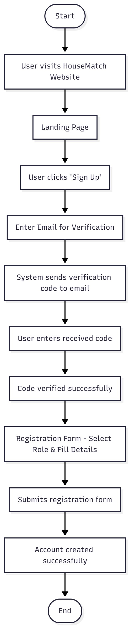

4.2.2 Property Search & Viewing Flow (House Seeker)
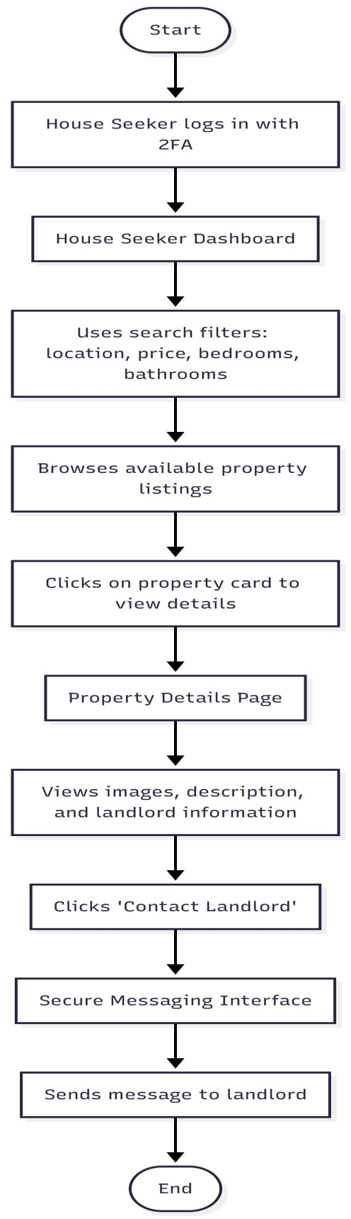

4.2.3 Property Listing Management Flow (Landlord)
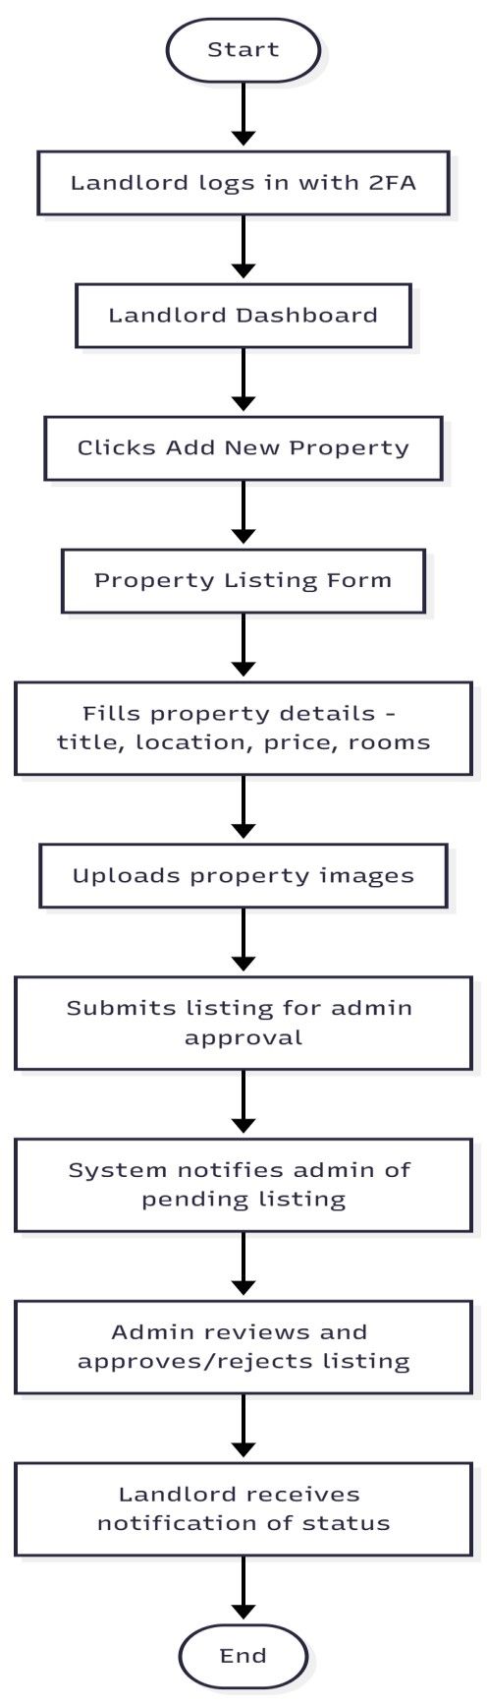

```

4.3 System Structure Charts

The HouseMatch system is organized into three main layers that work together:

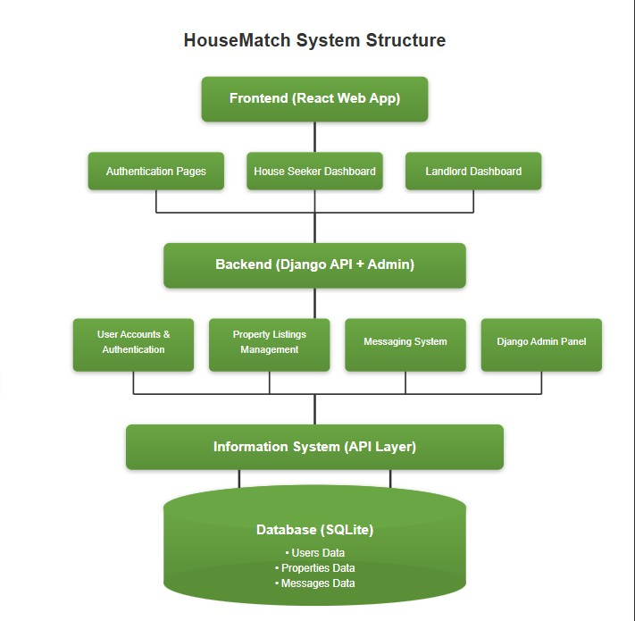

4.4 User Interface Design
The user interface for HouseMatch was designed with a focus on simplicity, clarity, and responsiveness. Built with Tailwind CSS, the interface provides a consistent experience across desktop and mobile devices.

Key design principles included:
- Role-Based Interfaces: Each user type (House Seeker, Landlord, Admin) receives a customized dashboard tailored to their specific needs and workflows.
- Intuitive Navigation: Clear navigation menus and visual hierarchy guide users through the platform's features.
- Responsive Design: All components adapt seamlessly to different screen sizes, ensuring usability on smartphones, tablets, and desktop computers.
- Clean Aesthetics: Aminimal color scheme and ample white space create a professional, trustworthy appearance that enhances user confidence.

The interface prioritizes functionality while maintaining an attractive, modern appearance that encourages user engagement and trust in the platform.

4.5 Entity Relation Diagram
The database consists of the following main tables:

- accounts_user: Contains user profile details including email, password, and user type. • accounts_passwordresetcode: Stores verification codes for password reset and email confirmation.
- listings_listing: Contains property listing details such as title, price, location, number of bedrooms, and approval status.
- listings_listingimage: Stores images associated with property listings
- chats_message: Contains messages exchanged between users including chat participants and message content.
- chats_chat: Manages chat sessions between users.

5. SYSTEM IMPLEMENTATION

This chapter gives a detailed description of the system and how each module is designed to perform its functions.

5.1 Description of the Developed System
HouseMatch introduces a secure and streamlined approach to rental property management in Zambia. A key functionality is the automated user verification system, where both house seekers and landlords must verify their email addresses before gaining full access to the platform. This strategic enhancement serves to reduce fake accounts and build trust between users, providing a more secure and reliable experience for both parties.

5.2 Technical details

5.2.1 Authentication System
- Sign Up and Verification Module
The sign up module involves a two-step process where users first verify their email address with a code before completing their profile. The system automatically assigns a user type
(house seeker or landlord) and sends verification codes via email to confirm account authenticity.

- Login and 2FA Module
For the login module, users enter their credentials and then must input a verification code sent to their email. This two-factor authentication adds an extra layer of security to protect user accounts.

5.2.2 Property Management System
- Listing Creation Module
This module allows landlords to create property listings with details such as title, location, price, number of bedrooms and bathrooms. Landlords can upload multiple images for each property.

- Listing Approval Module
All property listings submitted by landlords are queued for admin approval before being published. This ensures that only legitimate and complete listings are visible to house seekers.

5.2.3 Messaging System
• Secure Communication Module
This module enables house seekers and landlords to communicate directly through the platform without sharing personal contact information. All messages are stored securely and accessible through user-specific inboxes.

5.3 Screenshots
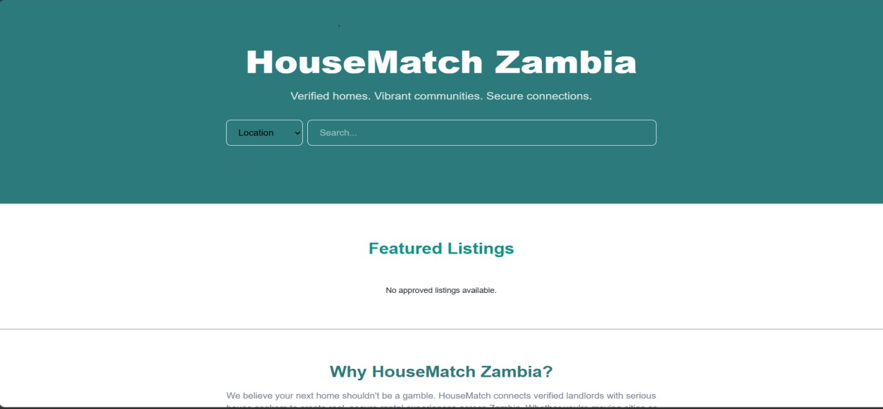
Figure 10: Landing page
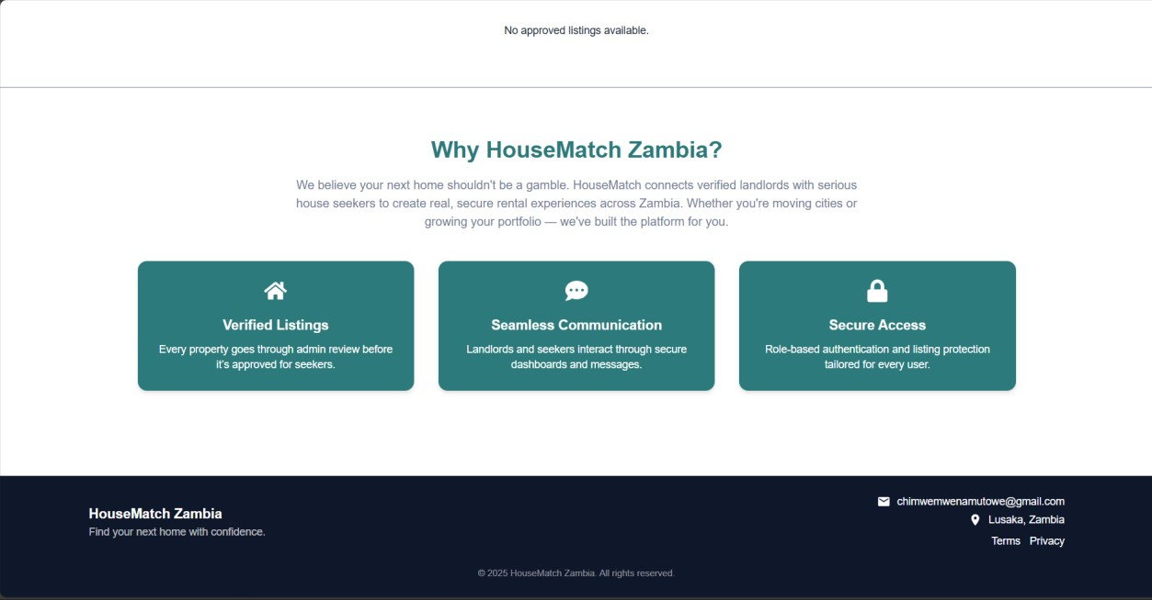
Figure 11: Landing page.
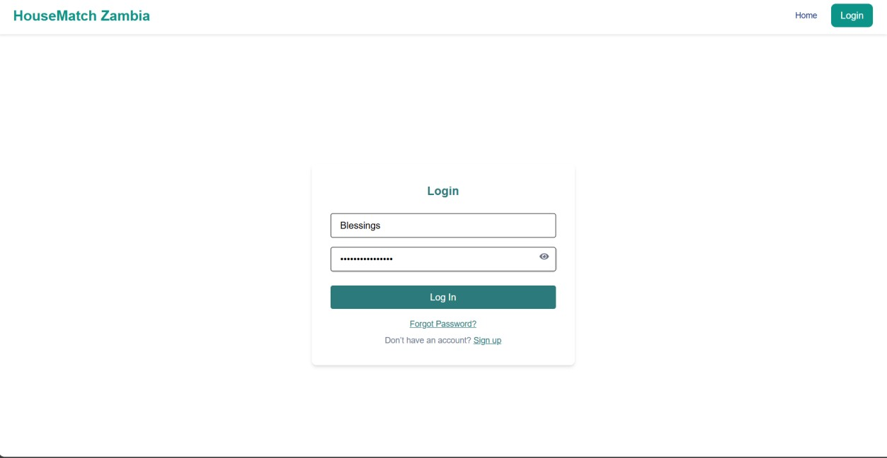
Figure 12: HouseSeeker Login page

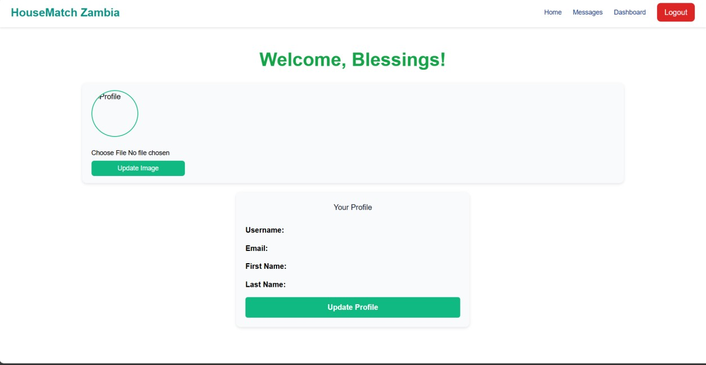
Figure 13:HouseSeeker Landing page.

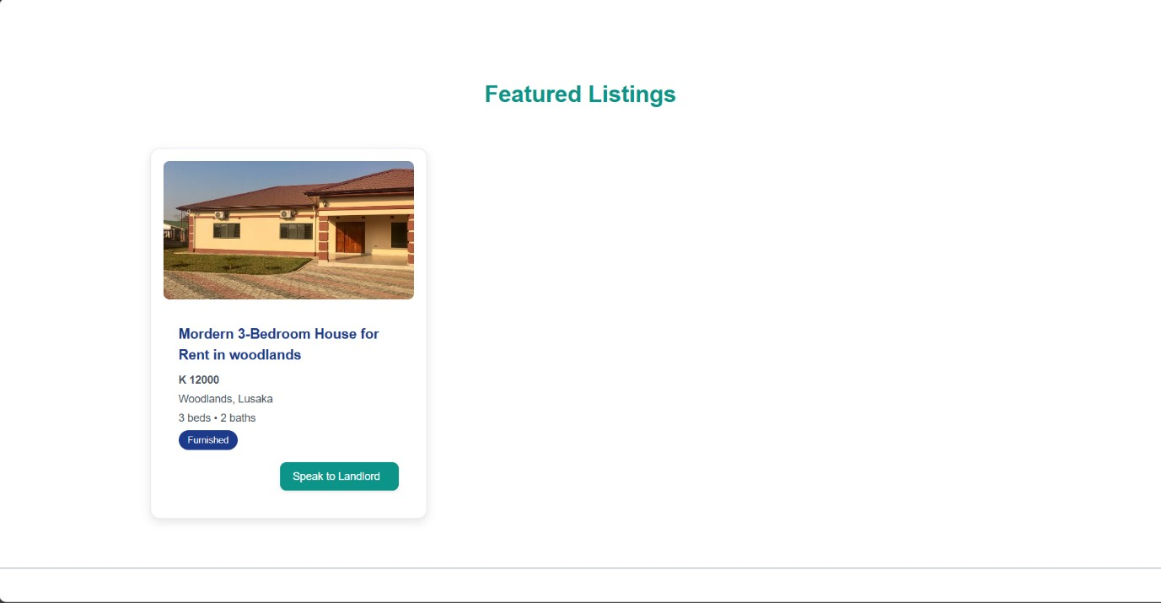
Figure 14: HouseSeeker HomePage.

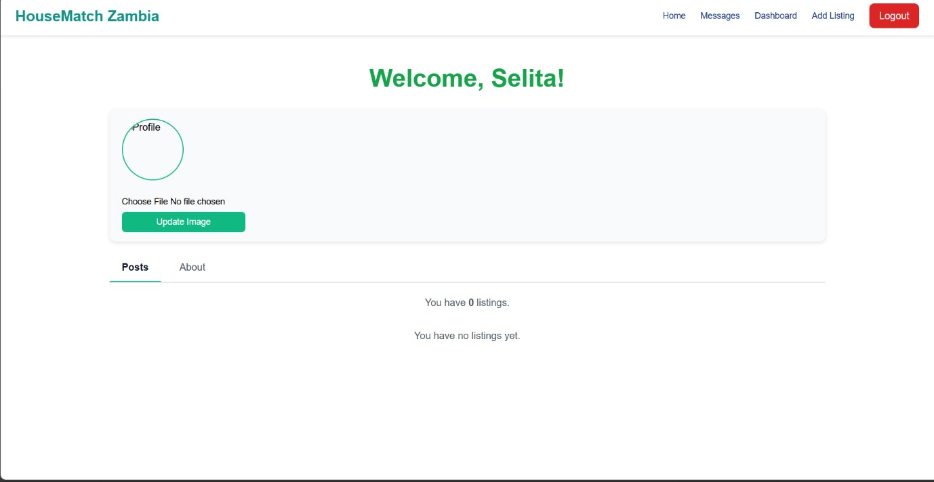
Figure 15:Landlord LandingPage.

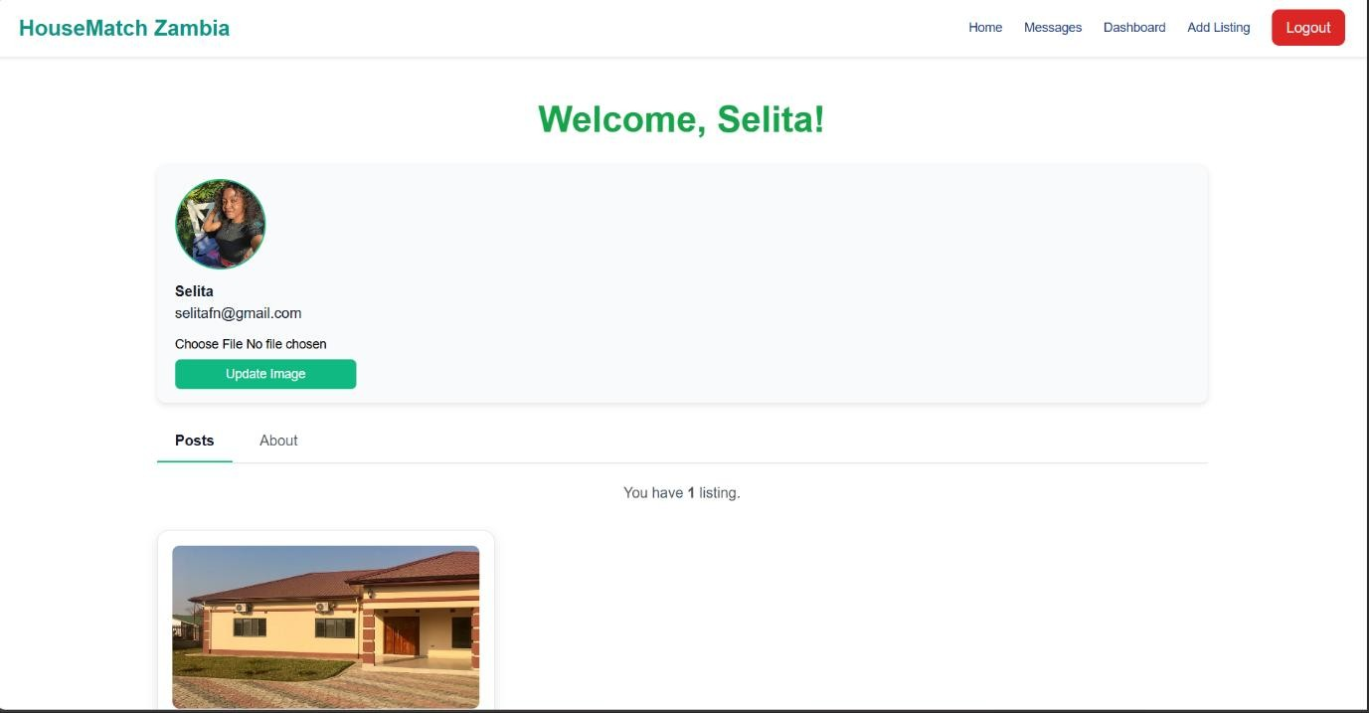
Figure 16: Landlord LandingPage
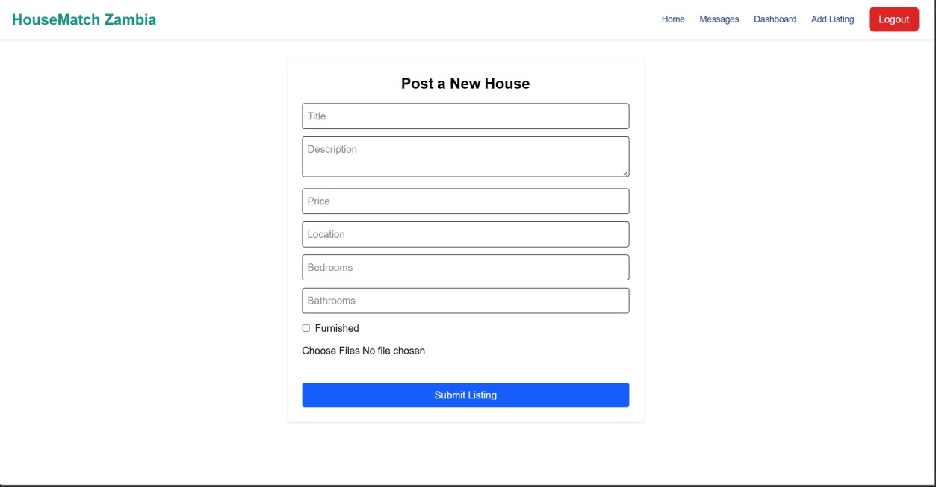
Figure 17:Listing Form.
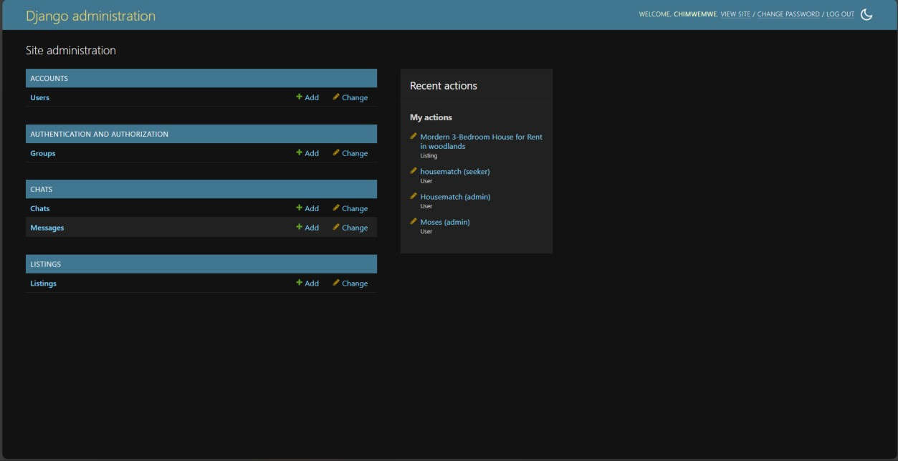
Figure 18:Admin Dashboard.
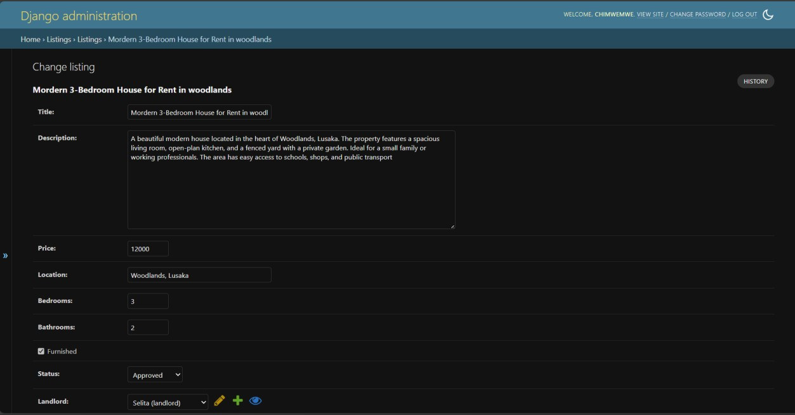
Figure 19:Admin Dashboard

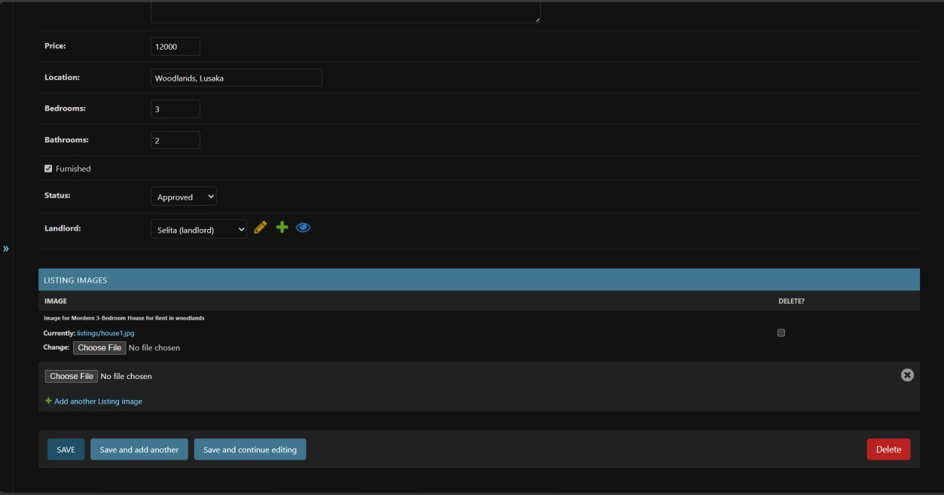
Figure 20:Admin Dashboard

6. TESTING AND VERIFICATION

6.1 Testing Methodology
Formulating an appropriate testing methodology for this project necessitated the consideration of various quality dimensions pertaining to web applications. These dimensions encompass:

- Functionality: Verifying that each function of the software operates in conformance with its requirement specifications.Usability: Testing how easily the user interface can be learned and navigated.
- Performance: Ensuring the system remains stable and responsive under normal usage conditions.
- Security: Identifying and addressing vulnerabilities in the authentication and data protection mechanisms.
- Compatibility: Verifying that the web application displays and functions correctly across different web browsers and devices.

6.2 Test Cases
Within this section, individual test cases corresponding to each requirement are provided. Each test case encompasses a unique identification (ID), the associated requirement, the chosen test approach, and defined pass criteria.

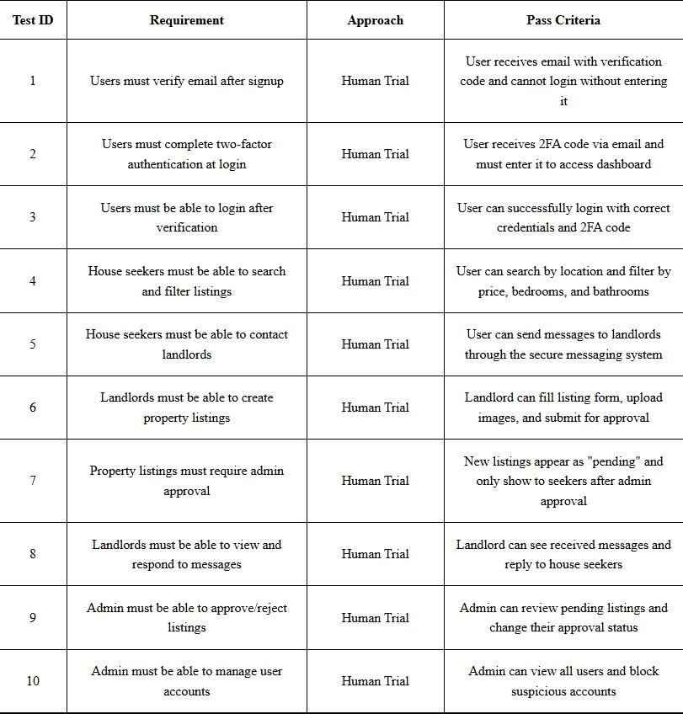

6.3 Analysis and Test Results

This section shows the test results from section 6.2. A detailed analysis is given for each test case.

- Test ID: 1
Result: Pass
This test was passed. Users could not proceed to complete registration without verifying their email address with the received code.

- Test ID: 2 Result: Pass
This test was passed. Users were required to enter the two-factor authentication code sent to their email before accessing their dashboard.

- Test ID: 3 Result: Pass
This test was passed. Verified users could successfully login using their credentials and
2FA code.

- Test ID: 4
Result: Pass
This test was passed. House seekers could successfully search for properties by location and use filters for price range, number of bedrooms, and bathrooms.

- Test ID: 5 Result: Pass
This test was passed. House seekers could initiate conversations with landlords through the secure messaging interface without exposing personal contact information.

- Test ID: 6 Result: Pass
This test was passed. Landlords could successfully create new property listings by completing the listing form, uploading multiple images, and submitting them for admin review.

- Test ID: 7
Result: Pass
This test was passed. New property listings were automatically set to "pending" status and only became visible to house seekers after being approved by an administrator.

- Test ID: 8 Result: Pass
This test was passed. Landlords could view messages received from house seekers and send replies through their dedicated messaging inbox.

- Test ID: 9
Result: Pass
This test was passed. Administrators could review all pending listings in the admin panel and either approve or reject them with appropriate status updates.

- Test ID: 10
Result: Pass
This test was passed. Administrators could view all registered user accounts and had the ability to block or suspend accounts when necessary.

All test cases were executed successfully, confirming that the HouseMatch system meets its functional requirements and provides a secure, reliable platform for connecting landlords and house seekers.

7. CONCLUSION

7.1 Results and Achievements

The HouseMatch system has successfully met all its outlined objectives, delivering a secure and functional web platform that effectively connects landlords and house seekers in Zambia. The system demonstrates robust performance in user authentication, property management, and secure communication, aligning precisely with its intended purpose. The successful implementation of email verification, two-factor authentication, and admin approval workflows stands as a testament to the strategic planning and dedicated development efforts employed throughout the project lifecycle.

The system's achievements extend beyond basic functionality, showcasing reliability in real-world scenarios and the capacity to handle diverse user interactions with consistency. The positive outcomes in system performance underscore the effectiveness of its architecture and user-centered design approach.

7.2 Limitations and Problem Faced

One significant challenge encountered was the financial constraint associated with purchasing a custom domain name and securing professional web hosting services. The costs involved in obtaining a dedicated domain and production-grade hosting presented a barrier to making the platform publicly accessible online.

Additionally, technical challenges were faced in seamlessly connecting the main landing page to the role-specific dashboards after user authentication. Ensuring smooth navigation between the public-facing pages and the private, role-based interfaces required careful routing configuration and state management within the React application architecture.

7.3 Future works and recommendation

Looking ahead, there are exciting possibilities for expanding and enhancing HouseMatch to provide an even more comprehensive user experience. The immediate next step would be to acquire a custom domain name and deploy the platform on a production server, making it publicly accessible to users in Zambia.

Furthermore, the platform could be enhanced with mobile application versions for both Android and iOS platforms, increasing accessibility for users who primarily access digital services through smartphones. The integration of SMS notifications alongside email alerts would also improve communication reliability, particularly for users with limited internet access.

Another promising enhancement would be the implementation of advanced analytics and reporting tools for landlords, providing insights into property performance, market trends, and tenant engagement metrics. These proposed future works would significantly expand the platform's reach and utility within Zambia's growing digital rental market.

8. APPENDICES

8.1 Appendix 1 - Domain Terms
HouseMatch: A web-based platform designed to connect landlords and house seekers in Zambia through a secure, verified system.

Two-Factor Authentication (2FA): A security process where users provide two different authentication factors to verify themselves, in this case, password and email verification code.

Role-Based Access Control: A system security approach that restricts system access to users based on their roles (House Seeker, Landlord, or Administrator).

8.2 Appendix 2 – Installation

8.2.1 Setting up the Development Environment
- Install Python 3.8 or higher
- Install Node.js and npm
- Install Git for version control

8.2.2 Backend Setup (Django)
- Create a virtual environment: `python -m venv venv`
- Activate virtual environment: `venv\Scripts\activate` (Windows) or `source venv/bin/activate` (Mac/Linux)
- Install dependencies: `pip instll -r requirements.txt`
- Run migrations: `python manage.py migrate`
- Start development server: `python manage.py runserver`

8.2.3 Frontend Setup (React)
- Navigate to frontend directory: `cd frontend`
- Install dependencies: `npm install`
- Start development server: `npm run dev`

8.2.4 Database Configuration
- SQLite database is used by default for development
- Database file: `db.sqlite3` in project root directory

8.3 Appendix 3 - Selected source code

8.3.1 listings/views.py
---from django.shortcuts import get_object_or_404 from django.contrib.auth import get_user_model from rest_framework.views import APIView from rest_framework.response import Response from rest_framework import status from .models import Listing, ListingImage from .serializers import ListingSerializer

User = get_user_model() # get the actual User model

class ListingCreateView(APIView): def post(self, request, *args, **kwargs): title = request.data.get("title") description = request.data.get("description") price = request.data.get("price") location = request.data.get("location") bedrooms = request.data.get("bedrooms") bathrooms = request.data.get("bathrooms") furnished = request.data.get("furnished") == "true"

# get landlord ID from request landlord_id = request.data.get("landlord") landlord = get_object_or_404(User, id=landlord_id) # fetch actual user

listing = Listing.objects.create( title=title,
description=description, price=price, location=location, bedrooms=bedrooms, bathrooms=bathrooms, furnished=furnished, status='unapproved', landlord=landlord, # assign landlord
)
# handle multiple images
images = request.FILES.getlist("images") for img in images:
ListingImage.objects.create(listing=listing, image=img)

return Response({"message": "Listing created successfully"}, status=status.HTTP_201_CREATED)

# List approved listings class ApprovedListingsView(APIView): def get(self, request, *args, **kwargs):
listings = Listing.objects.all().order_by('-created_at')
serializer = ListingSerializer(listings, many=True, context={'request': request}) return Response(serializer.data)

User = get_user_model() # get the actual User model

from rest_framework.permissions import IsAuthenticated from rest_framework_simplejwt.authentication import JWTAuthentication

class ListingUpdateView(APIView): authentication_classes = [JWTAuthentication] # <-- must match your frontend token permission_classes = [IsAuthenticated] # user must be logged in

def put(self, request, pk, *args, **kwargs): listing = get_object_or_404(Listing, pk=pk) if listing.landlord.id != request.user.id: return Response({"error": "You are not allowed to update this listing"}, status=403) serializer = ListingSerializer(listing, data=request.data, partial=True) if serializer.is_valid():
serializer.save() return Response(serializer.data)
return Response(serializer.errors, status=400)

class ListingDeleteView(APIView): def delete(self, request, pk, *args, **kwargs): listing = get_object_or_404(Listing, pk=pk)

# Check that the request includes the correct landlordId landlord_id = request.data.get("landlordId")
if not landlord_id or int(landlord_id) != listing.landlord.id: return Response({"error": "You are not authorized to delete this listing."}, status=status.HTTP_403_FORBIDDEN)

listing.delete()
return Response({"message": "Listing deleted successfully."}, status=status.HTTP_204_NO_CONTENT)

9. REFERENCES

[1] Python Software Foundation, Python Documentation, 2023. [Online]. Available: https://docs.python.org/3/. [Accessed: Oct. 10, 2025].
[2] Django Software Foundation, Django Documentation, 2023. [Online]. Available: https://docs.djangoproject.com/. [Accessed: Oct. 10, 2025].
[3] Django REST Framework, Django REST Framework Documentation, 2023. [Online]. Available: https://www.django-rest-framework.org/. [Accessed: Oct. 10, 2025].
[4] React Team, React Documentation, 2023. [Online]. Available: https://react.dev/. [Accessed: Oct. 10, 2025].
[5] Vite, Vite Documentation, 2023. [Online]. Available: https://vitejs.dev/guide/. [Accessed: Oct. 10, 2025].
[6] Tailwind CSS, Tailwind CSS Documentation, 2023. [Online]. Available: https://tailwindcss.com/docs. [Accessed: Oct. 10, 2025].
[7] SQLite, SQLite Documentation, 2023. [Online]. Available: https://www.sqlite.org/docs.html. [Accessed: Oct. 10, 2025].
[8] Mozilla Developer Network, HTTP Authentication, 2023. [Online]. Available: https://developer.mozilla.org/en-US/docs/Web/HTTP/Authentication. [Accessed: Oct. 10, 2025].

