XML作业二

软工11502 曹敏昱 3

1. 构造函数和析构函数的调用顺序
2. 代码

#include <iostream>

using namespace std;

//基类

class Person

{

public:

Person(){cout<<"constructor - Person! "<<endl;} //构造函数

~Person(){cout<<"deconstructor - Person! "<<endl;} //析构函数

};

//派生类(父亲)

class Father : public Person

{

public:

Father(){cout<<"constructor - Father! "<<endl;} //构造函数

~Father(){cout<<"deconstructor - Father! "<<endl;} //析构函数

};

//派生类(儿子)

class Child : public Father//继承CStudent类，三层结构

{

public:

Child(){cout<<"constructor - Child! "<<endl;} //构造函数

~Child(){cout<<"deconstructor - Child! "<<endl;} //析构函数

};

//实验主程序

void main()

{

cout<<"Person派生Father，Fater派生Child"<<endl;

Child child;

}

1. 实验结果

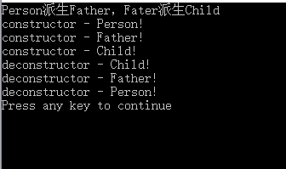

1. XML描述学生信息，用到CDATA
2. 代码

<?xml version="1.0" encoding="GB2312"?>

<class>

<![CDATA[学生信息]]>

<student>

<student1>

<![CDATA[姓名]]>

<name>张三</name>

<![CDATA[序号]]>

<number>1</number>

<![CDATA[性别]]>

<gender>男</gender>

<![CDATA[年龄]]>

<age>20</age>

</student1>

<student2>

<![CDATA[姓名]]>

<name>李四</name>

<![CDATA[序号]]>

<number>2</number>

<![CDATA[性别]]>

<gender>女</gender>

<![CDATA[年龄]]>

<age>20</age>

</student2>

<student3>

<![CDATA[姓名]]>

<name>王五</name>

<![CDATA[序号]]>

<number>3</number>

<![CDATA[性别]]>

<gender>男</gender>

<![CDATA[年龄]]>

<age>20</age>

</student3>

</student>

</class>

1. 实验结果

