Minor Project

Unmanned Mapping Vehicle Using L.O.A.M.[1] in Real-time

Technical Report

6th sem, 2017 Batch

Automation and Robotics Dept.

B. V. Bhoomaraddi College of Engineering and Technology, Hubli.

Team 9

Adarsh Belvatagi 2BV13AR002

Darshan Bafna 2BV13AR018

Manikanta Pujar 2BV13AR031

Prajankya Sonar 2BV13AR043

# **Table of Contents**

1. Requirement list
2. Functional Analysis
3. Performance specification
   1. Rplidar
   2. IMU [GY80]
      1. L3G4200D: Gyroscope
      2. ADXL345- Digital accelerometer
      3. HMC5883L 3 axis Digital compass
   3. Intel NUC DN2820
   4. Power supply
   5. Screw & Bolt
   6. Material for base
4. Morphological chart
5. Detailed design and Production drawings
   1. Mechanical
   2. Electronics
6. Bill of materials & Component Procurement
   1. Electronics
   2. Mechanical
7. Hardware / Software architecture
8. Model In Iterations & Improvement Cycle
9. Component Testing
10. Characterization
11. Software prototyping
12. Components Manufacturing
    1. Mechanical components manufacturing
    2. Electronics components manufacturing

# 

# 

# 

# Abstract:

This project is about an Unmanned Mapping Vehicle Using L.O.A.M. in Real-time that is achieved by using ROS( Robotic Operating System) which will map any indoor environment, RPlidar is an sensor that will help us to map the environment, for navigation of the bot IMU(Inertial measurement unit ) is used. RPlidar and IMU are connected to Arduino and inturn it is connected to NUC mini computer which is on the bot, all the commands are sent to master in NUC from the maincontroller.

# Introduction:

Mapping, localization, and path-planning are three fundamental problems of robot. Robot needs a map to perform actions like path-planning. When positioning system is not available, the map is also used for localization. Therefore here we use an RPLIDAR to help us map the indoor environment with the help of Robotic Operating System in 2D.

# 

# **Requirement list**

* 1. Autonomous 3D mapping device
  2. Bot should be compact
  3. Generate 3D map of the environment and save it
  4. It should avoid obstacle
  5. It should be independent
  6. It should locate itself when left in an unknown terrain`
  7. Bot should be light weight
  8. Should have emergency stop button
  9. Battery backup should be good
  10. The bot could be manually overridden with the help of an Graphical User Interface

# **Functional Analysis**

* 1. 3D mapping
     1. RP LIDAR(sensor)
  2. Autonomous
     1. Locomotion
     2. Power supply
     3. Obstacle detection
  3. Storage
     1. Memory to save the data of the 3D map
  4. Manual control
     1. Use of an remote joystick to manually control the bot using an GUI.

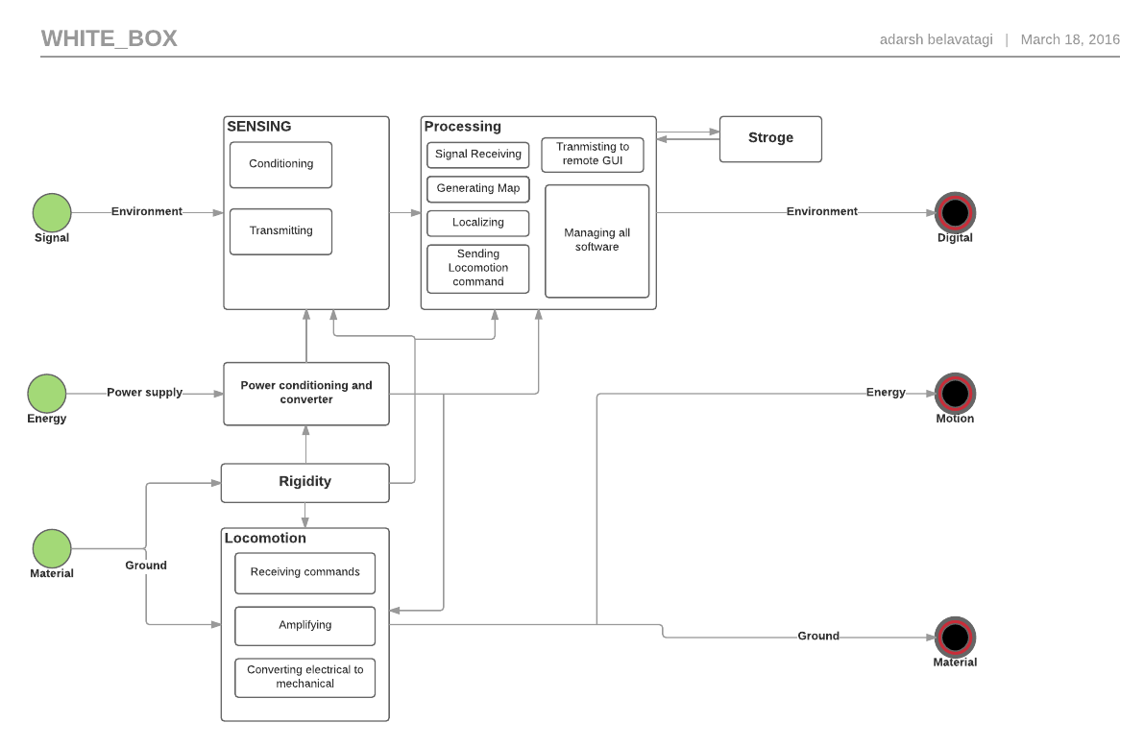

# Performance specification

## Rplidar

* + 1. Range: 0.2 m(min)\
    2. 6.0 m(max)
    3. Angular range : 0-360 Degree
    4. Distance Resolution: 60mm
    5. Angular Resolution: 1 Degree
    6. Sample Frequency :>=2000 Hz
    7. Scan rate : 5.5 Hz
    8. i/p voltage : 6V
    9. o/p voltage : 6V
    10. Weight: 170 gm

## IMU [GY80]

* + 1. L3G4200D: Gyroscope
       1. Measurement range:± 500 dps
       2. Sensitivity :17.5 mdps/digital
       3. Digital zero rate level: ±15dps
       4. Zero rate level charging v/s temp:±0.04dps
       5. Non linearity:0.2 of measurement range
       6. Rate noise density: 0.03 dps/sqrt HZ for 150 HZ
       7. Operating temp: -40 to 80 c\
    2. ADXL345- Digital accelerometer
       1. Measurement range: ± 2 ±4 ±6 ±8 ±16 g
       2. Output resolution: 12 bits for ±8 g range
       3. Noise (x,y axis): 0.75 LSB rms Z direction 1.1 ILS me
       4. Power supply: min 140mA 5V
       5. Operating temp: -40 to 85 ∘C
    3. HMC5883L 3 axis Digital compass
       1. Supply voltage: 2.16 to 3.6V
       2. Field range: -8 to +8 gauss
       3. Magnetic dynamic range: ±1- ±8 gauss
       4. Sensitivity: 220 to 1370 ISB /gauss
       5. Operating temp: -40 to 85 ∘C

## Intel NUC DN2820

* + 1. Processor: Intel Celeron Processor N2820
    2. Memory: 8gb max
    3. Graphics: Intel HD graphics up to 756 MHz
    4. Peripheral Connectivity
       1. 1 * USB 3.0 port on the front panel
       2. 2 * USB 2.0 port on the back panel
       3. Front panel 1R sensor
    5. Storage: Internal for 2.5 inch HDD or SSD
    6. Dimensions: 116.6 mm *112mm*515mm
    7. Power adapter: 12V 36W wall mount AC

## Power supply

* + 1. Lithium polymer - (11.2V 5.5A)
    2. UBEC - Input 24V Output 12V
  1. Screw & Bolt
     1. Size M4
  2. Material for base
     1. Acrylic

# Morphological chart

|  |  |  |  |  |
| --- | --- | --- | --- | --- |
| **Sl.no** | **FUNCTION** | **Alternative1** | **Alternative2** | **Alternative 3** |
| **1** | Sensing |  |  |  |
| **1.1** | **obstacle** | IR | LIDAR | Proximity |
| **1.2** | **Position/Orientation** | Gyro | Magnetic | IMU |
| **1.3** | **Surrounding** | LIDAR | Kinect | Image processing |
| **2** | Processing |  |  |  |
| **2.1** | **Signal Receiving** | ATMEL | Intel NUC | RASBERRY |
| **2.2** | **Generating Maps** | ROS | Hector_mapping |  |
| **2.3** | **Localizing** | AMCL | ROS_hector |  |
| **2.4** | **Localizing commands** | Microcontroller  (arduino ,PLC) | Microprocessor | FPGA |
| **2.5** | **Managing all programs** | ROS | Custom programming | Player_Stage |
| **2.6** | **Storage** | Hard Drives | Google Drive(cloud) | Intel NUC |
| **2.7** | **Transmitting to**  **Remote GUI** | RF | wifi | Optical link |
| **2.8** | **Power conditioning** | Transformer filter circuit | Battery Eliminator circuit | Linear regulator circuit |
| **3** | Locomotion |  |  |  |
| **3.1** | **Receiving commands** | Microcontroller  (arduino,PIC) | Microprocessor | FPGA |
| **3.2** | **Amplifying** | Motor driver | H-bridge | Relay operated |
| **3.3** | **Converting electrical to Mechanical** | solenoid | motor |  |
| **4** | Rigidity |  |  |  |
| **4.1** | **Between motor and base** | L clamp | C CLAMP | Screw and nuts |
| **4.2** | **Between two acrylic sheet** | C clamp | Screws and nuts | Studs and screws |

## 

WHY Rplidar?

|  |  |  |  |  |  |  |  |  |  |
| --- | --- | --- | --- | --- | --- | --- | --- | --- | --- |
|  | **Hokuyo URG-04LX Scanning Laser Rangefinder** | **Parallax 15-122cm Laser Rangefinder** | **Hokuyo UTM-30LX-EW Scanning Laser Rangefinder** | **Loke 0.2 to 30m Industrial Laser Distance Meter (10Hz)** | **Loke 0.2 to 35m Industrial Laser Distance Meter (50Hz)** | [**Hokuyo UXM-30LN-PW Scanning Laser Rangefinder**](http://www.robotshop.com/en/hokuyo-uxm-30ln-pw-scanning-laser-rangefinder.html) | [**Hokuyo UST-10LX Scanning Laser Rangefinder**](http://www.robotshop.com/en/hokuyo-ust-10lx-scanning-laser-rangefinder.html) | [**RPLIDAR 360° Laser Scanner**](http://www.robotshop.com/en/rplidar-360-laser-scanner.html) | [**LeddarTech LeddarOne Optical Rangefinder (RS-485)**](http://www.robotshop.com/en/leddartech-leddarone-optical-rangefinder-rs-485.html) |
|  | **RB-Hok-01** | **RB-Plx-257** | **RB-Hok-16** | **RB-Hok-11** | RB-Hok-09 | RB-Hok-14 | RB-Hok-24 | RB-Rpk-01 |  |
|  |  |  |  |  |  |  |  |  |  |
| Serial (UART) Pins | 1 | 1 | 0 | 0 | 0 | 0 | 0 | 1 | 0 |
| USB | 1 | 0 | 1 | 0 | 0 | 1 | 0 | 1 | 0 |
| Nominal Current [A] | 0.5 |  | 0.7 | 0.0042 | 0.0042 | 0.3 |  | 130 |  |
| Nominal Voltage [V] | 5 | 5 | 12 |  |  | 24 |  | 5 | 5 |
| Voltage (Min) [V] |  |  | 0 | 10 | 10 |  | 0.15 | 3.6 | 5 |
| Weight | 160 g |  | 370 g | 500 | 4000 g | 800 g | 130 g | 200 g |  |
| Accuracy [mm] | 60mm à 1m : ±10mm, 1m à 5m : 1% de la distance | <5%, average 3% | 0.1 to 10m:±30mm, 10 to 30m:±50mm*1 | ±2 mm à ± 5 mm | Environ ±2mm | 0.1 to 10m : ±50mm, 10 to 30m : ± 100mm | +/- 40mm | <0.5mm (1% of the distance) | 50 |
| Angular Resolution [°] | 0.36 |  | 0.25 |  |  | 0.25 | 0.25 | 1 |  |
| Distance Min | 20 mm | 0 mm | 30000 mm | 200 mm | 200 mm | 100 mm | 20 mm | 200 mm | 0 mm |
| Angle [°] | 240 |  | 270 |  |  | 190 | 270 | 360 |  |
| Scan Time | 100 |  | 25 |  |  | 50 | 25 | 0.18 |  |
| Voltage (Max) [V] |  |  |  | 30 | 30 |  |  | 9 | 5 |
| Distance Max | 4000 mm | 2400 mm | 60000 mm | 150000 mm | 150000 mm | 30000 mm | 10000 mm | 6000 mm | 20000 mm |

From the above comparison of sensors ,We can Notice that Rplidar as good characteristics and its cost is also less comparative to other sensors..

# 1.Sensing

### 1.1 & 1.3 Obstacle detection and surrounding sensing

### Rp lidar 360°- is preferred than IR and PROXIMITY sensor because A laser scanner development kit with omnidirectional laser scan,it works on the principle of laser triangular whose speed is very high, it is the ideal sensor for robot localization, mapping & obstacle detection and safety ,it has the range of 6 meters ,1 degree angular resolution,5v power supply.

### 1.2 Position and orientation- IMU

* IMU is used because it consist of 4 sensors i.e ADXL345 digital accelerometer ,HMC5883L digital compass, L3G4200D gyroscope and BMP085 digital barometer which gives the sensor 10DOF , there are built in regulator and logic converter to support 3.3V/5.0V microcontrollers, 12C digital interface,The sensor is very compact too.

# 

# 2.Processing

### 2.1 Signal receiving - Intel NUC

Intel NUC is a compact mini computer with full-size computing power, lots of I/O ports ,IR receiver and with a smaller footprint than a wireless modem, the Intel NUC with the 4th generation Intel Core i5 processor It also includes Intel Rapid Start Technology, ensuring you are quickly up and running, and Intel Smart Connect Technology to keep you up to date at all times.

### 2.2 Generating maps: ROS

Robotic operating system has an 3D visualizer tool called as RVIZ which helps us to generate the map with utmost accuracy and helps us to visualize the map in real time .

### 2.3 Localizing: ROS_HECTOR

Hector_mapping is a SLAM approach that can be used without odometry as well as on platforms that exhibit roll/pitch motion (of the sensor, the platform or both). It leverages the high update rate of modern LIDAR systems like the Hokuyo UTM-30LX and provides 2D pose estimates at scan rate of the sensors (40Hz for the UTM-30LX).

### 2.4 Localizing commands: Micro controller

Commands to the bot are given by the microcontroller

### 2.5 Managing all programs:ROS

ROS is an open-source, meta-operating system for your robot. It provides the services you would expect from an operating system, including hardware abstraction, low-level device control, implementation of commonly-used functionality, message-passing between processes, and package management. It also provides tools and libraries for obtaining, building, writing, and running code across multiple computers. ROS is similar in some respects to 'robot frameworks’

### 2.6 Storage: Intel NUC

Since we are using mini computer we have an storage space of 1.5 to 2 TB of data can be stored which is more than enough to store the maps and navigation data.

### 2.7 Transmitting to Remote GUI: Wifi

Since our mini computer has the facility of wireless communication we take the advantage of this facility and reduce the complication of keeping an receiver and transmitter.

### 2.8 Power conditioning:UBEC

It is an universal battery eliminator circuit is an [electronic circuit](https://en.wikipedia.org/wiki/Electronic_circuit) designed to deliver [electrical power](https://en.wikipedia.org/wiki/Electric_power) to other circuitry without the need for multiple [batteries](https://en.wikipedia.org/wiki/Battery_(electricity)). Historically the expression was sometimes used to describe devices used to power battery-driven equipment from mains electricity. This is still the case in many products offered in retail electronic supply stores.

## 3.Locomotion

### 3.1 Receiving commands:Microcontroller (arduino,PLC):

Commands are sent to the bot via arduino software through ROS and microcontroller receives the commands and induces locomotion.

### 3.2 Amplyifying : Motor driver

Signals from the microcontroller are sent to motor via motor driver where the signals gets amplified

### 3.3 Electrical to mechanical:Motor

Motor converts the electrical signal received from the driver and converts them into mechanical energy for the locomotion.

## 4.Rigidity

### 4.1 Between motor and base of the bot: C clamp

As the motor is placed between two acrylic sheet(base) so C-clamp is used to fix the motor to the bot base for stability

### 4.2 Between 2 acrylic sheet: Studs and screws

To fix the two acrylic sheets we use Studs and and screws of size M4

### 

## 

# Detailed design and Production drawings

## Mechanical

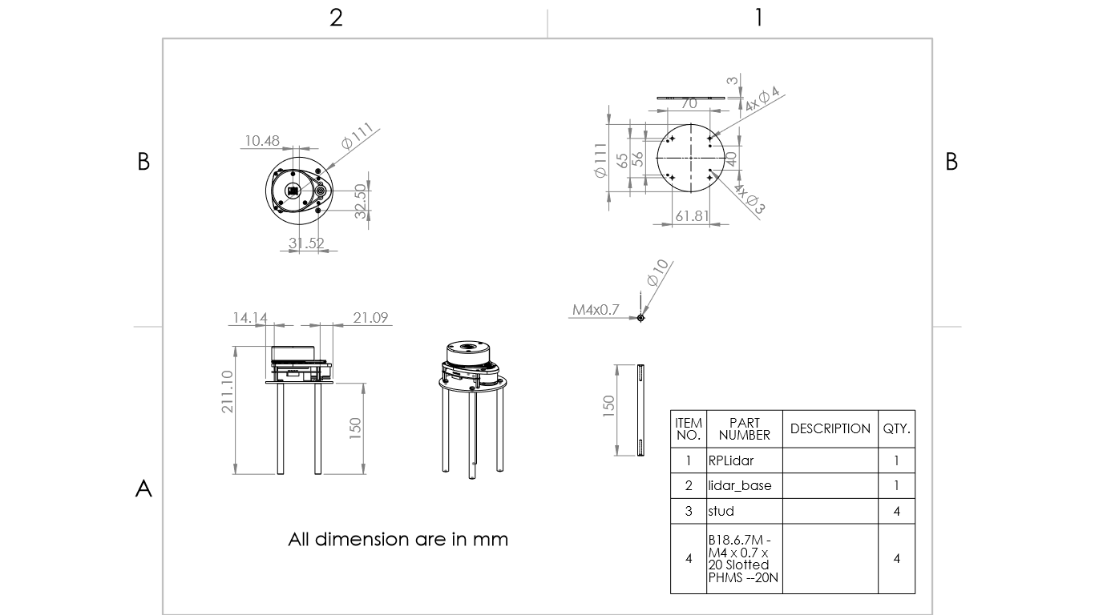

## Electronics

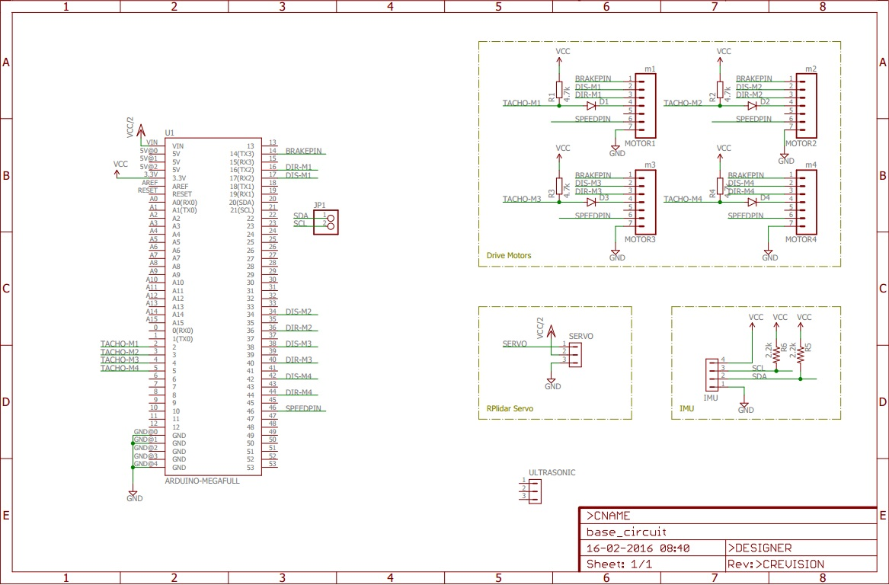

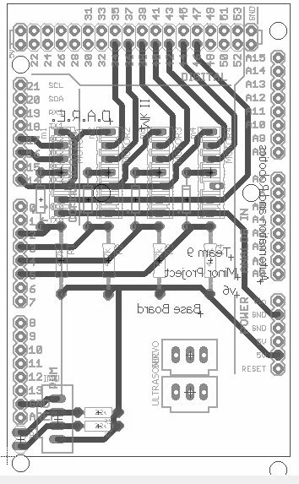

# Bill of materials & Component Procurement

## Electronics

|  |  |  |  |  |
| --- | --- | --- | --- | --- |
| SL.NO | COMPONENT | QUANTITY | VENDOR | Price |
| 1 | RPlidar | 1 | Tennettech.com | 37000₹ |
| 2 | IMU 10dof | 1 | Probots.co.in | 1000₹ |
| 3 | NUC mini Pc | 1 | Dept. of Automation & Robotics | 10000₹ |
| 4 | Resistors 330 ohm | 2 | New Gokhale Electronics | 4₹ |
| 5 | Motor | 4 | Robu.in | 20000₹ |
| 6 | Motor Driver | 4 | Robu.in | 20000₹ |
| 7 | Resistors 2.2k ohm | 4 | New Gokhale Electronics | 4₹ |
| 8 | 8pin connector male | 4 | New Gokhale Electronics | 60₹ |
| 9 | 8pin connector female | 4 | New Gokhale Electronics | 60₹ |
| 10 | PCB | 1 | New Gokhale Electronics | 30₹ |
| 11 | Power supply 22.2V | 2 | robomart.com | 13800₹ |
| 12 | UBEC | 1 | robomart.com | 1000₹ |
| 13 | Screw Terminal | 2 | micro electricals | 20₹ |

## Mechanical

|  |  |  |  |  |
| --- | --- | --- | --- | --- |
| SL.NO | COMPONENT | QUANTITY | Material VENDOR | Price |
| 1 | OMNI wheels | 4 | Robu.in | 36000₹ |
| 2 | C-clamp | 4 | Fabricated | 285₹ |
| 3 | Studs 2 1/2 | 35 | Asian hardware | 169₹ |
| 4 | Base board | 2 | Fabricated | 1480₹ |
| 5 | Nuts(M4) and Bolts(M4) | 78 | Asian hardware | 565₹ |
| 6 | motor shaft | 4 | rupa metals | 245₹ |
| 7 | Side link | 1 | Fabricated | 50₹ |
| 8 | Feedback wheel | 1 | Fabricated | 60₹ |
| 9 | Feedback base | 1 | Fabricated | 60₹ |
| 10 | Hight plate | 1 | Fabricated | 60₹ |

# Hardware / Software architecture

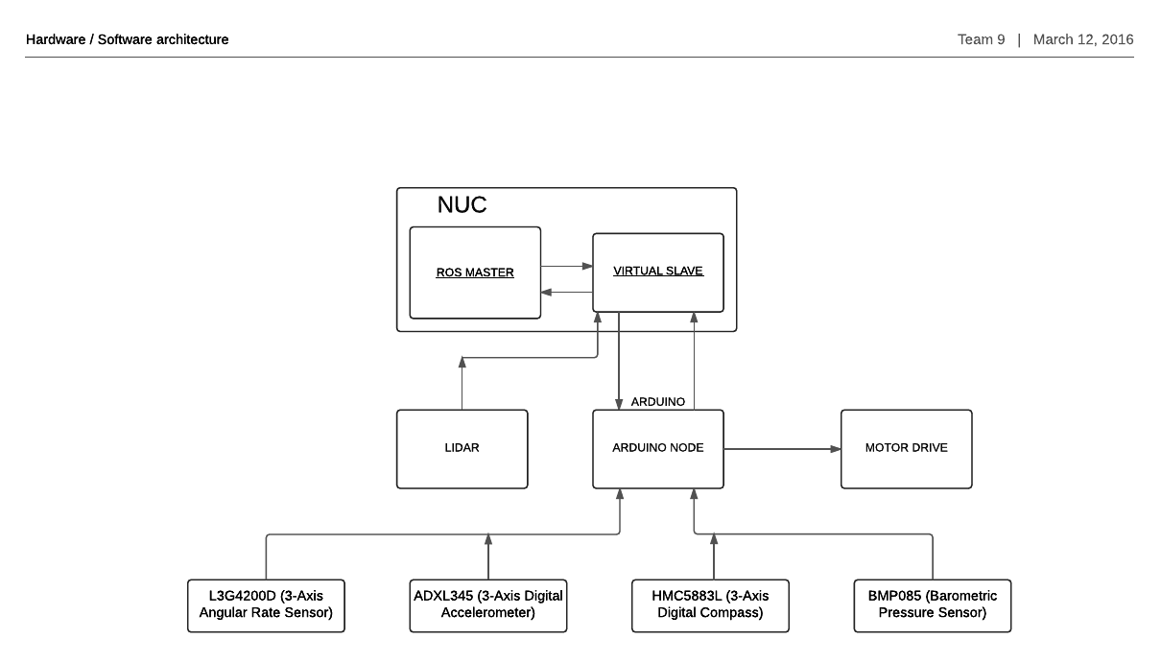

Hardware consists of NUC mini computer which has the ROS master which communicates with a Virtual slave within it, RPlidar sends the real time information to the virtual slave i.e in NUC which intern communicates with the master and makes the map of the surrounding along with this we have have arduino communicating with the slave through a Node that is created by ROS and controls the motor drivers,we have IMU i.e inertial measurement unit which consist 4 sensors Angular rate sensor,Digital accelerometer, Digital compass and Barometer all this sensors communicate in real time with ROS via arduino node in arduino and virtual slave in NUC.

# Model In Iterations & Improvement Cycle

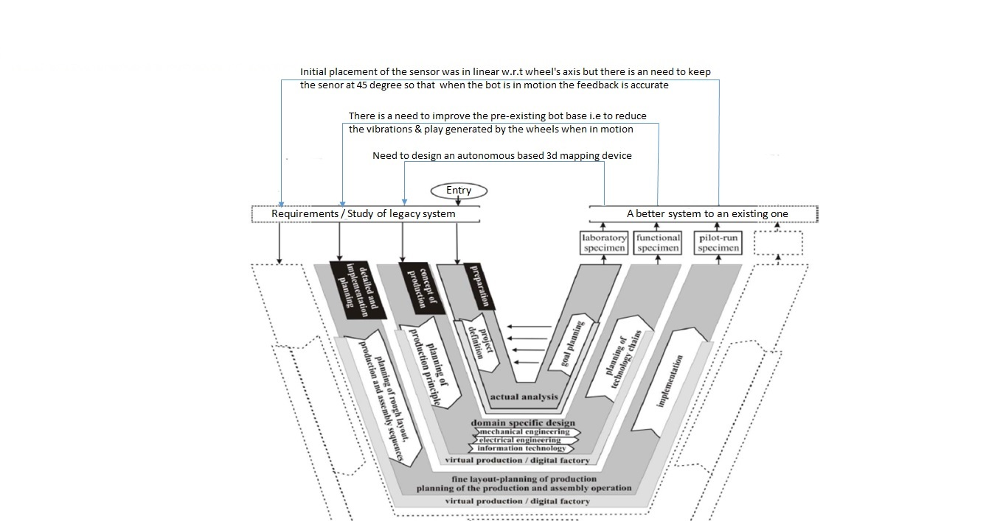

This is an iterative V-model where we have shown how our project was carried out from the start .

* Preparation for the project ,we defined the project definition followed by the project goal planning
* According to the plan we have to design an autonomous 2d mapping device
* In next iteration we started to modify the design of the existing according to our requirements
* We did the analysis our bot in software as well as the physical existing one in terms of mechanical stability ,electrical side and programming part
* After the analysis we verified the results with our requirements, there was a need in the improvement of the bot i.e ,maintain the stability and control the vibrance , make a feedback system for the odometry fix RP lidar on the bot.
* Now we did the detailed

# Component testing

## Electronics

* + 1. IMU “Tested by interfacing with arduino: example programs were used to check the working of each of the 4 sensors, and all the values were found to be same as per the commands given ”
    2. LIDAR “Tested by interfacing with ROS: lidar was interfaced to Robotic Operating system and RViz tool was used to check the map created by the Lidar after the lidar was made to scan the room, it was found that the range if the Lidar is 6m as mentioned in the specs of the sensor and error in the measurement was negligible i.e 0.02cm ”
    3. Motor Driver “ Tested by interfacing with arduino: Signals from arduino were given to the driver and it was found that the motors were working as the commands were given to the driver by the software ”
    4. Arduino “ Tested by Uploading & Running Blink LED program :Working of the arduino board ”
    5. Motors “Tested by connecting with battery: all four motors were connected to LIPO 22.3V battery and were tested ”
    6. PCB board “Probe Test: board was designed in Eagle software and then board was fabricated by the method of etching,then with the help of probes connectivity and continuity check was done ”
    7. Power supply 22.2V “Tested Using Multimeter: Tested continuosly the battery ”
    8. UBEC “ Tested Using Multimeter ”

## Mechanical

* + 1. OMNI wheels “Tested by Creating Solidworks model and mounting to shaft ”
    2. C-clamp “ Tested by Creating Solidworks model and mounting to motor”
    3. Studs “Tested by Creating Solidworks model and mounting between the base boards ”
    4. Baseboard “ Tested by Creating Solidworks model”

### 

# Characterization

## 

|  |  |  |  |
| --- | --- | --- | --- |
| SL.NO | Component | Expected values | Measured values |
| 1 | LIDAR | 6M,0°-360°rotation | 6M,0°-360°rotation |
| 2 | Gyroscope (L3G4200D) | ±2000 dps | reasonable |
| 3 | Digital accelerometer  (ADXL345) | At± 2g  sensitivity=256 LSB/g | ±0.005 g noise at stationary position |
| 4 | Digital compass  (HMC5883L) | Accuracy 2deg | 1~2 deg drift |

# Software prototyping

# The RPlidar is connected to a mobile computer,which give a information about surrounding.In the mini-computer the robot oprating sysytem is installed,This help to set mini computer as Master node and help in creating slave nodes .there is a virtual slave in the mini-computer which is receiving and prosessing the input from the RPlidar .A hardware slave node (i.e.,Arduino) connected to mini-computer which give motor feedback and IMU input to mini computer.The RPlidar and IMU work together to collect the information about surrounding ,the collected information is processed and 2D map of Environment is created in the GUI,Based on the 2D map the bot avoid the obstacles and move.

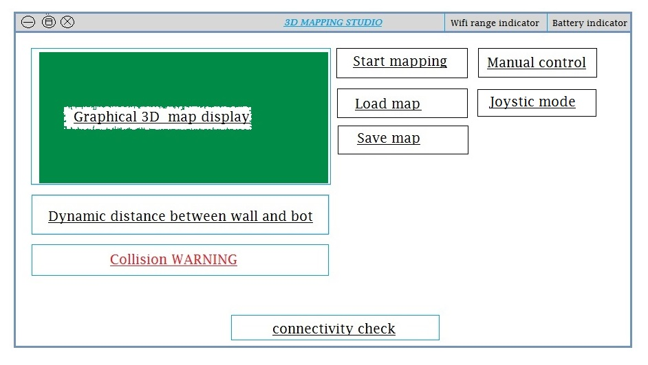

### Graphical user interface prototype (Front end)

### 

# Components Manufacturing

## Mechanical components manufacturing

|  |  |  |  |
| --- | --- | --- | --- |
| SL.NO | components | material | manufacturing process |
| 1 | C-clamp | aluminium | bending & machining |
| 2 | Pulley Shaft | aluminium | machining(lathe machine) |
| 3 | Baseboard | acrylic | machining(cnc router) |
| 4 | Studs 150mm | aluminium | machining(lathe machine) |
| 5 | LIDAR base | acrylic | machining(cnc router) |

## Electronics components manufacturing

|  |  |  |
| --- | --- | --- |
| SL.NO | components | manufacturing process |
| 1 | Baseboard PCB | etching |

# **1.Cost of the components**

|  |  |
| --- | --- |
| List of the component | Cost of the component |
| RPlidar | 37000/- |
| wheels | 36000/- |
| Motors and Drivers | 40000/- |
| Timer pulley | 16000/- |
| Stud | 10000/- |
| NUC | 10000/- |
| IMU | 1000/- |
| UBEC | 1000/- |
| Batteries | 8400/- |
| Wires | 500/- |
| Other electronics | 1000/- |
| GPU | 42000/- |
| **Total :** | **203000/-** |
|  |  |

1. L.O.A.M. - Lidar Odometry and Mapping in Real-time