Starting a training job using Tensorflow Object Detection API :

- Model compatibilty with Tensorflow :
ssd_mobilenet_v1 : Tensorflow 1.15
ssd_mobilenet_v2 : Tensorflow 1.15
ssd_mobilenet_v2_keras : Tensorflow 2.3.1
ssd_mobilenet_v1_keras : Tensorflow 2.3.1
- Before beginning the training job, it is important to organize the workspace and training files. Currently, the directory is organized as follows :

pholus_vision_sumantra
|-models : Folder containing all the models published by Tensorflow
| |-research
| |-community
| |-orbit
| |-official
|-tensorflow_ws : Workspace folder which will contain everything related to training
| |-training_demo_ssd_mobilenet
| | |-pre_trained_models
| | | |-ssd_mobilenet_v2_coco_2018_03_29 : SSD Mobilenet v2 pre-trained model
| | | | |-saved_model
| | | | | |-variables
| | | |-ssd_mobilenet_v1_coco_2018_01_28 : SSD Mobilenet v1 pre-trained model
| | | | |-saved_model
| | | | | |-variables
| | | |-ssd_mobilenet_v2_320x320_coco17_tpu-8 : SSD Mobilenet v2 Keras pre-trained model
| | | | |-saved_model
| | | | |-checkpoint
| | |-models
| | | |-ssd_mobilenet_v1 : Directory where event and checkpoint files will be written for v1
| | | | |-pipeline_ssd_mobilenet_v1.config : Config file to be used for training
| | | |-ssd_mobilnet_v2 : Directory where event and checkpoint files will be written for v2
| | | | |-pipeline_ssd_mobilenet_v2.config : Config file to be used for training
| | | |-ssd_mobilnet_v2_keras : Directory where event and checkpoint files will be written for v2 Keras model (TF2)
| | | | |-pipeline_ssd_mobilenet_v2_keras.config : Config file to be used for training
| | | |-ssd_mobilnet_v1_keras : Directory where event and checkpoint files will be written for v1 Keras model (TF2)
| | | | |-pipeline_ssd_mobilenet_v1_keras.config : Config file to be used for training
| | |-annotations : Folder contatining Tfrecord files for training , validation and testing
| | | |-pascal_label_map.pbtxt : Label map containing class names in the dataset
| | | |-train
| | | | |-train.record : TF record file to be used for training
| | | |-test
| | | | |-test.record : TF record file to be used for testing
| | | |-val
| | | | |-val.record : TF record file to be used for validation
| | |-images
|-scripts : Contains scripts for preprocessing
| |-dataset_tools
| |-doc

2. The training job can be configured using config files (pipeline_ssd_mobilenet_v1/v2.config) This file is used by the model builder to generate the model. Before training can be initiated, the following parameters will have to be set :

- freeze_variables : Add this. Specify which layers to freeze before training. The layer names are mentioned in a seperate file (layer_freezing.ods)

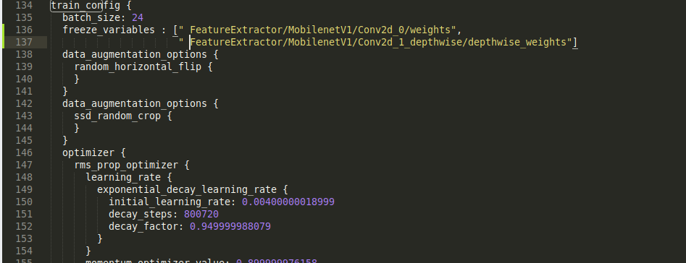

The config file does not contain the freeze_variables parameter yet and this will have to be added on line 136 before starting the trianing job

- fine_tune_checkpoint: Path to the checkpoint file of the pre-trained model (pholus_vision_sumantra/tensorflow_ws/training_demo_ssd_mobilenet/pre_trained_models/<model_name>/model.ckpt)
- label_map_path : Path to the .pbtxt file containing class names
(pholus_vision_sumantra/tensorflow_ws/training_demo_ssd_mobilenet/annotations/pascal_label_map.pbtxt)
- input_path : Path to the tfrecord file to be used for training/validation
(pholus_vision_sumantra/tensorflow_ws/training_demo_ssd_mobilenet/annotations/train/train.record)

3. To start the training job, navigate to pholus_vision_sumantra/models/research/object_detection and run the python script model_main.py for tf1 models and model_main_tf2.py for tf2 models :-

python3 model_main.py \
--model_dir=pholus_vision_sumantra/tensorflow_ws/training_demo_ssd_mobilenet/models/<ssd_mobilenet_v1/ssd_mobilenet_v2> \
--pipeline_config_path=pholus_vision_sumantra/tensorflow_ws/training_demo_ssd_mobilenet/models/<ssd_mobilenet_v1/ssd_mobilenet_v2>/ <pipeline_ssd_mobilenet_v1/v2.config>

python3 model_main_tf2.py \
--model_dir=pholus_vision_sumantra/tensorflow_ws/training_demo_ssd_mobilenet/models/<ssd_mobilenet_v1_keras/ssd_mobilenet_v2_keras> \
--pipeline_config_path=pholus_vision_sumantra/tensorflow_ws/training_demo_ssd_mobilenet/models/<ssd_mobilenet_v1_keras/ssd_mobilenet_v2_keras>/ <pipeline_ssd_mobilenet_v1_keras/v2_keras.config>

