NetWorthy Requirements Document

# 1. Introduction

## 1.1 Overview

Networthy is a personal finance startup focused on helping young alumni achieve financial wellness and freedom. This project involves building a web-based platform that allows customers (alumni) to list their financial goals, view related content (as per goal tags) provided by the coaches, work towards that goal, and progress through the goal stages.

## 1.2 Scope of the Product

Networthy will be a Web Application, which will support multiple APIs, for functionalities like, Login/Signup, adding a goal, selecting a coach for a specific goal, updating the goal stage( Not started / Inprogress / In review / Resolved), for the client, and for the coach to Login/Signup, to resolve the completion request for a goal raised by the client, etc.

# 2. General Description

## 2.1 Product Functions

NetWorthy is a personal finance startup dedicated to helping young alumni achieve financial wellness and ultimately achieving financial freedom.

A user can sign-up on NetWorthy and select a coach from a broad list of NetWorthy verified coaches. Users can sign-up with a coach of their choice who’s experience and skills align with the user’s financial goals. The user can then create desired goals and seek assistance from the coach in completing them and schedule periodic meetings with the coach. Users also get personalized content based on the goals created by the user. Users can track all the goals they have completed over the course of time.

The coach is a NetWorthy verified financial coach with financial experience and skills. With regular meetings and guidance the coach helps users to achieve their desired financial goals and guide them through the journey for their financial wellness.

## 2.2 User Characteristics

There are 3 types of users on the NetWorthy Platform:

**Client**

The client will be the target customer of the platform who can login / signup Networthy portal. Upon sign up he will need to fill in a survey form which includes his personal information. The client can use the platform to set up his financial goals. The client will also select a coach who will provide him with financial guidance. The client can schedule a calendly meeting with the coach. A client will have a one-to-one relationship mapping with a coach.

**Coach**

The coach user will be able to sign up on the net worthy portal. Upon getting his coaching request approved by the admin, he will provide financial guidance to the client. The coach is also responsible for approving the request, whenever a client marks a goal as completed. He has a one-to-many relationship with the clients.

**Admin**

The admin will see the coach profiles who registered on the portal and he can approve or disapprove the request.

## 2.3 General Constraints

Networthy is an early-stage company and the purpose of this project is to build an MVP. Hence, no constraints have been imposed as such. The choice of tech stack has been left to the team and there are no upstream or downstream dependencies. The product has minimal integrations with Twilio and Calendly.

## 2.4 Assumptions and Dependencies

1. This project has the following third-party dependencies:
   1. AWS cloud infrastructure for hosting the web application
   2. Calendly API for scheduling meetings between clients and mentors
2. Some key assumptions made from a user's perspective are listed below:
   1. A user must sign-up on NetWorthy using a valid email address before booking appointments with a coach
   2. Each coach profile must be manually approved by an administrator before it can be on-boarded onto the platform

# 3. Specific Requirements

## 3.1 User Requirements

User requirements / use cases as per user types:

**Client**

* Login
* Verify email
* Fill profile survey form.
* Edit the profile including the initial signup survey form.
* Add a financial goal and assign tags (multiple) for that goal.
* Edit the financial goal.
* Setup meeting with a coach.
* Move the goal stage.
* View Personalized content

Coach

* Login
* Signup
* Move the goal stage for clients
* with the client.
* Provide financial assistance and guidance.

Admin

* Login
* Verify the coach.

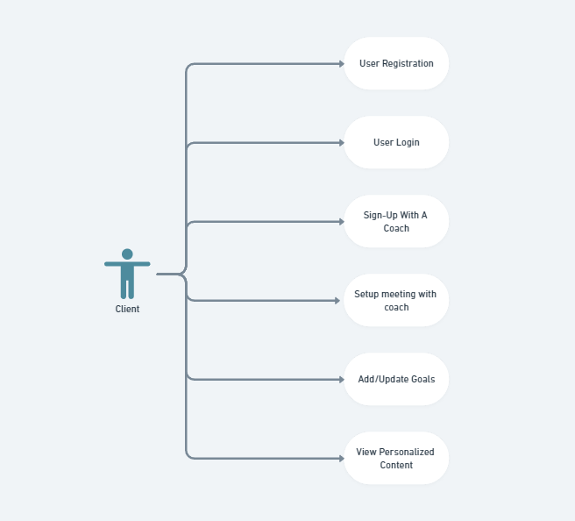

**Client Use-Case**

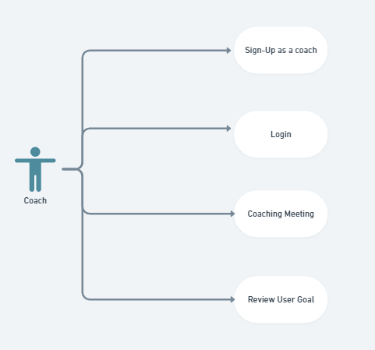

**Coach Use-Case**

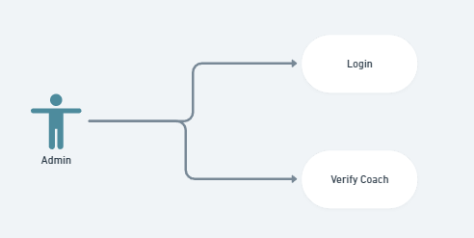

**Admin Use-Case**

## 3.2 System Requirements

* **Frontend**

1. Build process: Bundle React (JS) app through Webpack.
2. Deployments: CI/CD via Git and deployments to AWS EC2 instance via custom deploy scripts.

* **Backend**

1. Deployments: Project code would be deployed using scripts through existing CI/CD tools such as Git/Jenkins.
2. Infrastructure: AWS EC2 instances would be used for both frontend and backend. Initially, small instances would be deployed across IAD and scaled accordingly
3. Logging and metrics: AWS Cloudwatch would be used for logging database metrics and API activities
4. Scalability: EC2 instances allow manual and auto-scaling of hosts

## 3.3 Interface Requirements

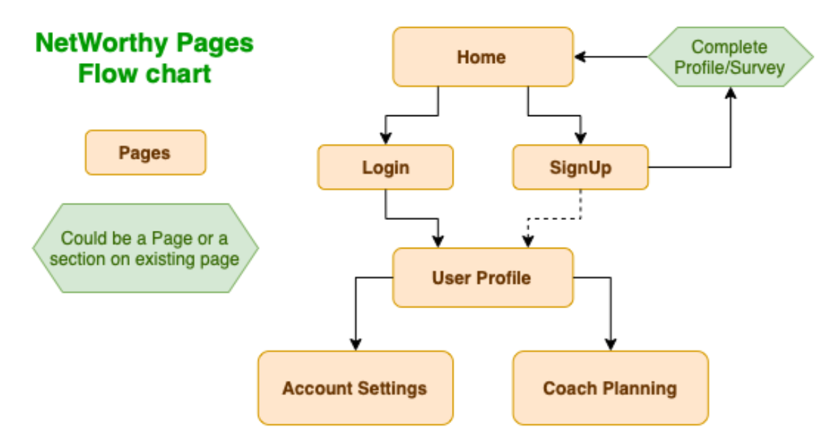

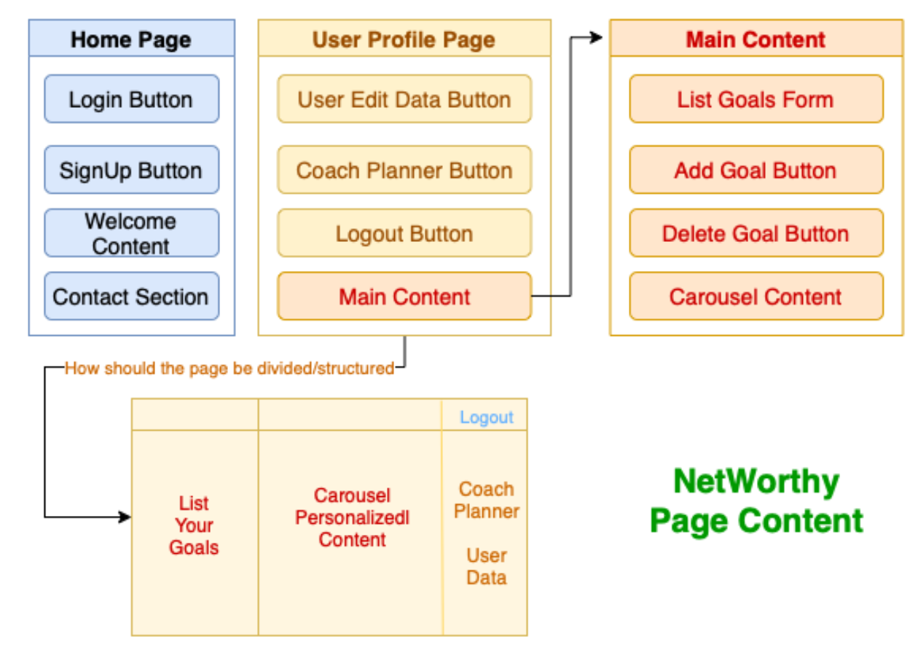

# 4. Appendices

No additional documents.

# 5. Glossary

***Definitions:***

Client: The user who uses NetWorthy, for assistance in their personal finance journey.

Coach: Users who will help the client in their personal finance journey.

Admin: Admin will have the option to verify a coach, add tags and content along with the generic admin functionality of removing any user of NetWorthy.

***Abbreviations:***

CI/CD: Continuous Integration/ Continuous Deployment.

AWS: Amazon Web Services

JS: JavaScript

EC2: Elastic Compute Cloud.

IAD: AWS us-east-1 region in VA

# 6. References

1. Initial project requirement document provided by the client.
2. Use-case Diagram: Whimsical [[https://whimsical.com](https://whimsical.com/)]
3. Webpack [<https://webpack.js.org/concepts/>]
4. AWS EC2: [<https://aws.amazon.com/ec2/>]
5. AWS Cloudwatch: [<https://aws.amazon.com/cloudwatch/>]