Problem 1

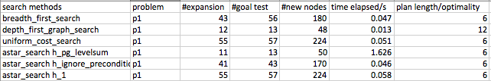

Optimal Path Length: 6

Optimal Plan: astar_search h_ignore_precondition

Load(C1, P1, SFO)

Load(C2, P2, JFK)

Fly(P1, SFO, JFK)

Fly(P2, JFK, SFO)

Unload(C1, P1, JFK)

Unload(C2, P2, SFO), JFK)

Fly(P2, JFK, SFO)

Unload(C1, P1, JFK)

Unload(C2, P2, SFO)

Problem 2

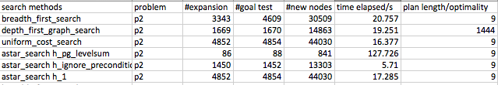

Optimal Path Length: 9

Optimal Plan: astar_search h_ignore_precondition

Load(C2, P2, JFK)

Load(C1, P1, SFO)

Load(C3, P3, ATL)

Fly(P2, JFK, SFO)

Unload(C2, P2, SFO)

Fly(P1, SFO, JFK)

Unload(C1, P1, JFK)

Fly(P3, ATL, SFO)

Unload(C3, P3, SFO)

Problem 3

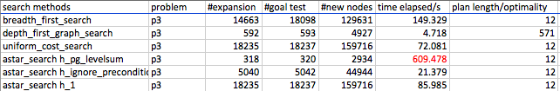

Optimal Path Length: 12

Optimal Plan: astar_search h_ignore_precondition

Load(C1, P1, SFO)

Load(C2, P2, JFK)

Fly(P1, SFO, ATL)

Load(C3, P1, ATL)

Fly(P2, JFK, ORD)

Load(C4, P2, ORD)

Fly(P2, ORD, SFO)

Fly(P1, ATL, JFK)

Unload(C4, P2, SFO)

Unload(C3, P1, JFK)

Unload(C1, P1, JFK)

Unload(C2, P2, SFO)

I will briefly evaluate all search methods here according to their performance.

1. Breadth-first-search will reach optimal solution (in the search section Video 10,11), but it’s time consuming due to exploring too many nodes for shortest path.
2. Depth-first-search in contrast, won’t search for optimal solution (AIMA 3.4.3) and therefore produced higher length path. So this one is always passed.
3. Uniform_cost_search and astar_h1, both expand the same most number of nodes and both used best-first-graph search method. Compared to breadth-first-search, these search methods are not satisfied with reaching a goal, but also looking for best path (Search section, Video 16). Therefore, the search will be more thorough and time-consuming than BFS, but the result is guaranteed to be optimal.
4. A* algorithm is implemented with 3 different heuristic functions. The essence of the algorithm is to expand the path with minimal function value f (AIMA 3.5.2) where:

f = g + h

g = path cost

h = estimated cost to goal

The best heuristics used is the h1 ignore_precondition and it’s also the best algorithm in solving all the 3 problems, in that

1. Among all the search algorithm and heuristics that produce the optimal plan, h1 ignore_precond explored the least number of nodes and reached the result with least amount of time-elapsed.
2. Compared to more advanced heuristic function h_pg_levelsum, h_ignore_precond is easier to compute and thus computationally less expensive, since h_pg_levelsum has to go through multiple levels for goal test and h_ignore_precond only need to deal with the current state level.
3. The advantage of h_ignore_precond over breadth-first search is not that obvious when dealing with problem 1 and search space is still small enough for brutal-force method. However, as the complexity explodes exponentially, using a heuristic function saves a lot of time.