1. IIS Configuration

Enable the Windows Authentication on IIS

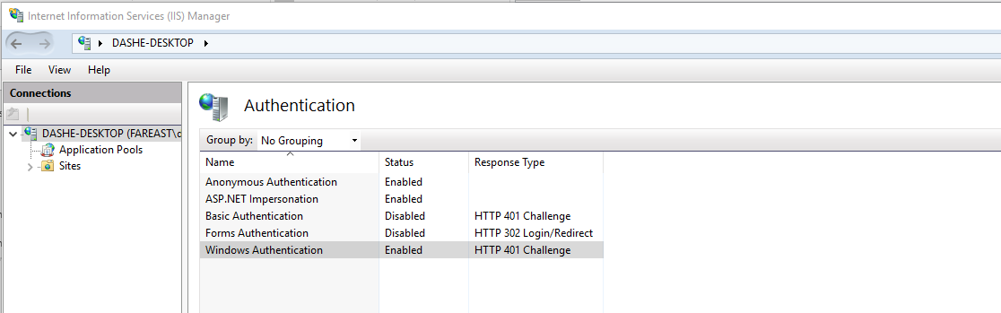

The other option is in web.config file,

<system.web>  
 ...  
 <authentication mode="Windows"/>  
 <identity impersonate="true"/>  
 ...  
 </system.web>

1. Create the dataview

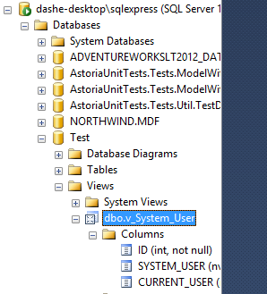

1. For the WebAPIplusEF projects,

a). create a new class UserController which extends ApiController (you use WebAPi, should not extends Controller)

b). Remove existing model, and add new DB connection.

c). Make the request, the windows user is returned,

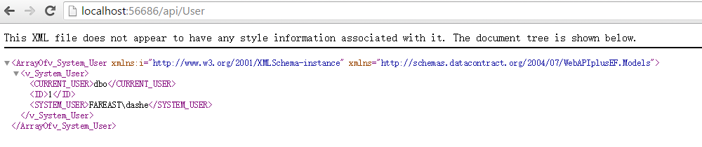

1. For RestierTestWebApplication,

a). remove existing model

b). Add the local model

c). send request, get expected result

