http://www.tuicool.com/articles/Ezuyyi

So far, I’ve covered [***overclocking your Raspberry Pi***](http://www.dingleberrypi.com/2012/09/boost-raspberry-pi-performance-with-turbo-mode/) , preparing to run your[***Raspberry Pi as a web server***](http://www.dingleberrypi.com/2012/09/tutorial-prepare-your-raspberry-pi-to-become-a-web-server/) , installing [***Apache, PHP and MySQL***](http://www.dingleberrypi.com/2012/09/tutorial-install-apache-php-and-mysql-on-raspberry-pi/)  and installing[***PhpMyAdmin***](http://www.dingleberrypi.com/2012/09/tutorial-install-phpmyadmin-on-your-raspberry-pi/) . I’m assuming you’ve at least [***set your hostname***](http://www.dingleberrypi.com/2012/09/tutorial-prepare-your-raspberry-pi-to-become-a-web-server/) and installed Apache, PHP and MySQL on your Raspberry Pi for this tutorial.



Before we go ahead and install WordPress, we need to ensure that outgoing email can be sent from your Raspberry Pi. In this tutorial, I’ll cover installing Postfix, which is a mail transport agent.

**Step 1 – Make sure you’re up-to-date**

To begin, run the following command to make sure you’re running the latest software updates:

su**do** apt-**get** **update**

Any updates available will be downloaded and installed.

**Step 2 – Begin the Postfix Installation**

Once done, go ahead and enter this command to get the ball rolling:

su**do** apt-**get** install postfix

The postfix setup will now start. You will see a blue screen with some information on the various configuration types, arrow down to  **‘ok’** to continue.

Next you will be given the options available. Choose ‘ **internet site** ‘ from the list:

***[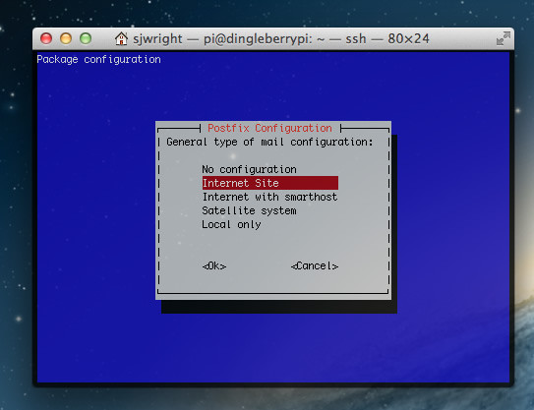](http://www.dingleberrypi.com/wp-content/uploads/2012/09/postfix-configuration.jpg)***

Once you’ve chosen this, go to ‘ **ok** ‘ to continue.

**Step 3 – Configure your Postfix FQDN**

The final step is to configure the FQDN. It is important that you’ve already set the hostname (see [***my tutorial***](http://www.dingleberrypi.com/2012/09/tutorial-prepare-your-raspberry-pi-to-become-a-web-server/) which includes this) as we’re asked to confirm it at this stage.

Set the system mail name to your fully qualified domain name. For example, my Raspberry Pi uses the FQDN ‘dingleberrypi.com’, so I entered  **dingleberrypi.com**here:

***[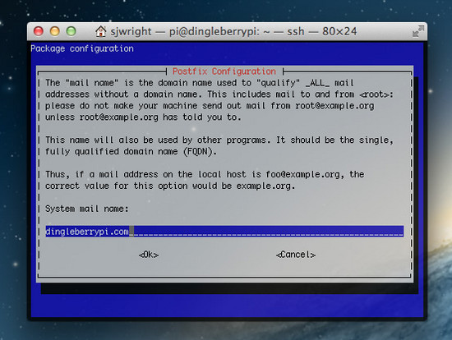](http://www.dingleberrypi.com/wp-content/uploads/2012/09/postfix-fqdn.jpg)***

Once you’ve entered this, double check it and the go to ok. That’s it, you’re ready to rock and roll! You’ll now be able to receive mail from your Raspberry Pi web server!