Criterion A: Planning
Criterion A: Planning
The scenario
The client and the advisor for this Internal Assessment is my chemistry teacher; he wants a program that “tracks[s] the success of our ELL Science students as the progress at [our high school]”. Therefore, a program is needed to analyze the successfulness of the past ELL students, and to use the past data to predict the best courses for future students to take, based on the students’ marks. The choice of client is appropriate because the client is trying to help his students to be as successful as possible by recommending them to appropriate courses.
Rationale for proposed solution
I have discussed with the client about the available courses students will be taking, and he provided me with many different possibilities of courses. The plan is to feed past student data into machine learning algorithms to find out the probability of getting into Science 10 based on a student’s ELLScience and Math mark. The program should also determine the successfulness of past students based on their grades in 20 level and 30 level science courses.
Here is a list of the main areas of programming after consulting with my client:
- The client will provide the students’ data to me in excel file.
- For each student, correctly record their course marks and output them into a text file for machine learning algorithm to use.
- A success criteria to determine how successful the student is:
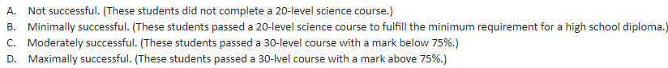
After inspecting the data and consulting further with my client, we decided some more restrictions:
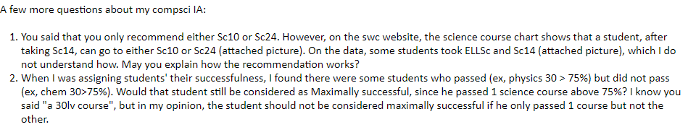
- Based on past students’ marks, calculate the probability of the possible courses that a student can take that best suits their needs.
- For security, the students’ names will be erased so I will not know the students’ names.
The programming language that will be used in this Internal Assessment is Java, because I already have previous Java programming experiences, and therefore I already know how to code many key components of the program. For the machine learning algorithm, a program called Octave will be used in this Internal Assessment. This is because Octave is free, which will be convenient for teachers and myself to install, and it is a programming language that supports machine learning algorithms. The client’s computer can install Java and Octave since they are free to use.
Success criteria
- The students’ data in excel should be read correctly.
- Have error handling for special cases.
- The user can choose to location open and store files.
- Students’ successfulness is correctly considered.
- The program is user friendly.
- The client can search the successfulness of past students by searching their names.
- Successfully use the machine learning algorithms to produce probability results that the client has asked based on a user-entered student’s grades.
- The client should be able to store data for his interests.

Word count: 470

