Criterion B: Design
Criterion B: Solution overview
Libraries used are apache poi excel library and javaOctave library: 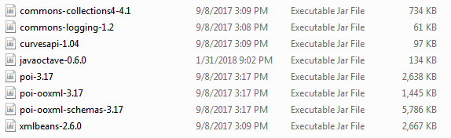
The apache poi excel library can be downloaded at the website: https://poi.apache.org/download.html
The javaOctave library can be downloaded at the website:
https://sourceforge.net/projects/javaoctave/
Some controlled variables:
- To figure out if the excel file format is supported by the apache poi library. This will require manual testing of many possible excel file formats. After some testing, it is evident that .xls and .xlt files can be read with HSSFWorkbook, while other files such as .xlsx, . xlsm, . xltx, . xltm and . xlam files can be read using XSSFWorkbook. Other older files format will not be read by the apache poi library.
- The excel file that the client uses need to be in a specific format so the program can read it correctly. We have decided that the excel format will look like:
- For the octave files to run, they need to be in the same folder, which is similar analogy as all Java classes need to be in the same package. Therefore, the path of octave files needs to be configured at the beginning of the program.
- The Octave program folder name need to be the same as “C:\Octave\Octave-4.2.1” since I did not find a way to change the environmental variables in Java: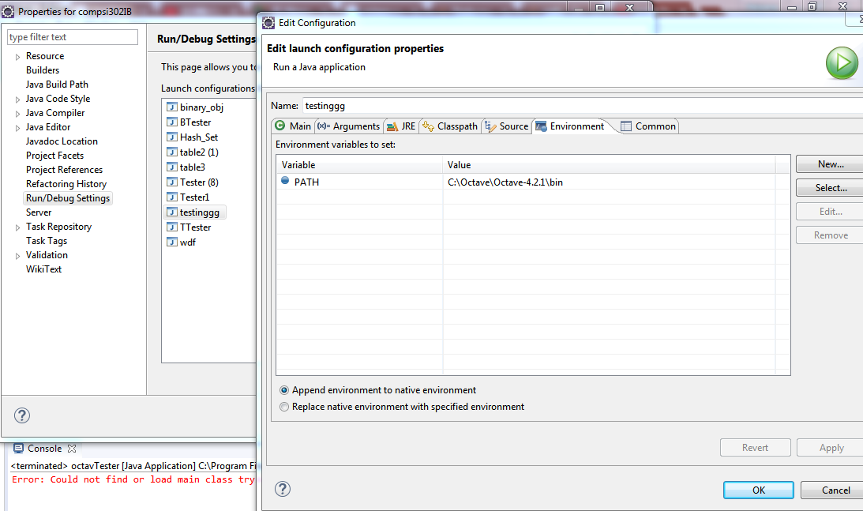
The designs of the solution:
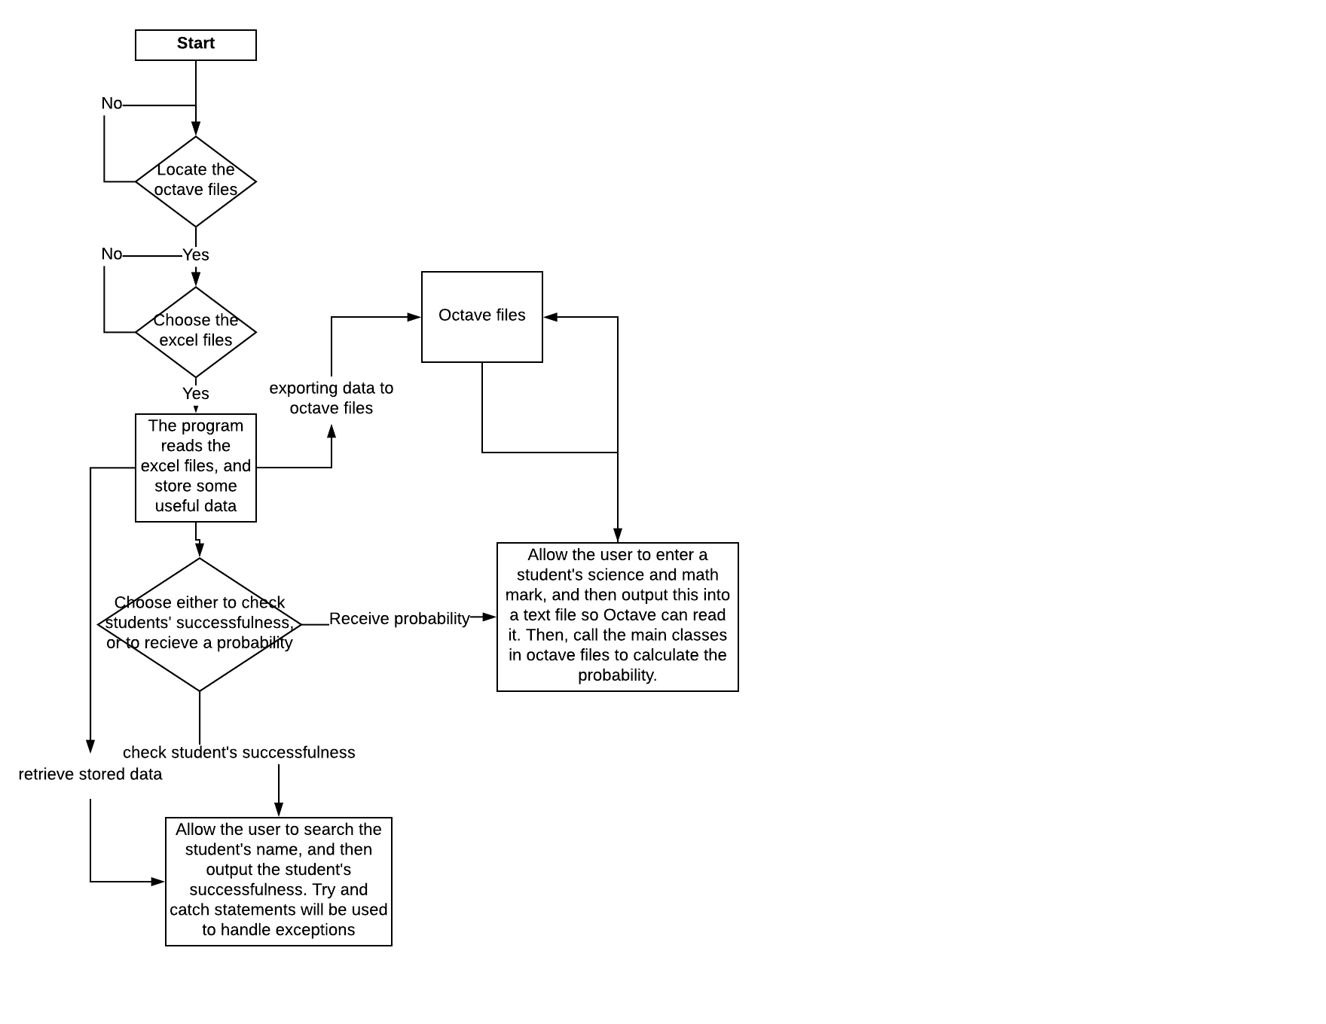
The basic overview of the program:

At the beginning, the program asks the user to choose the location of the octave files:
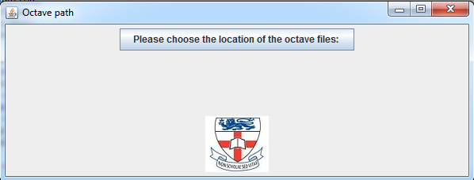
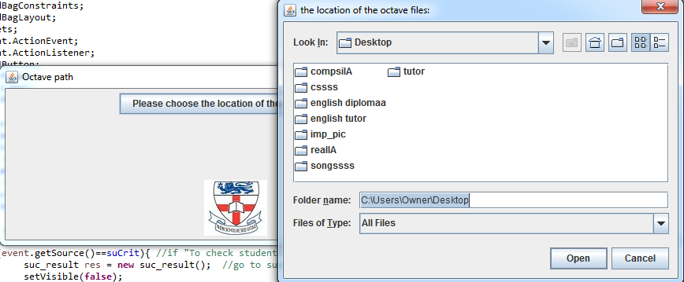
The user can choose multiple excel files:

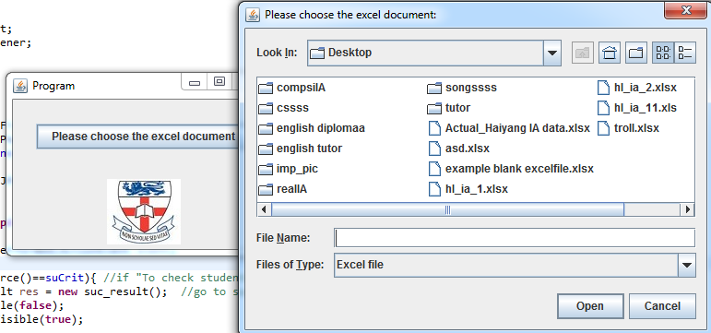
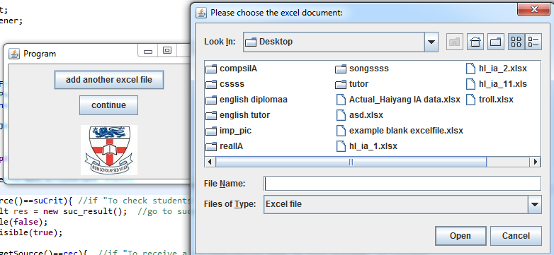
The user then needs to make either of two choices:
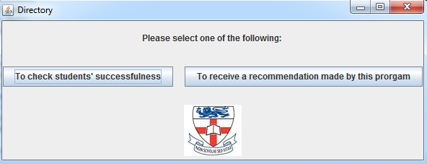

If the user wants to check students’ successfulness:

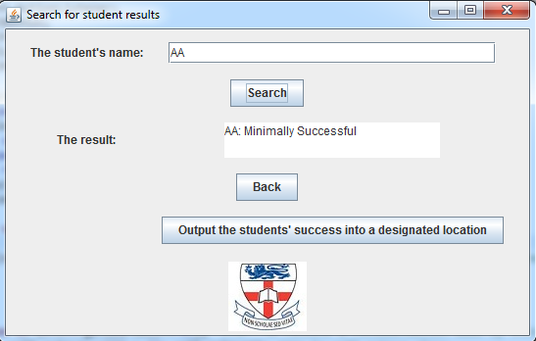

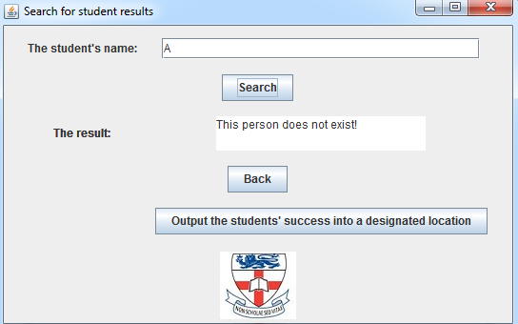

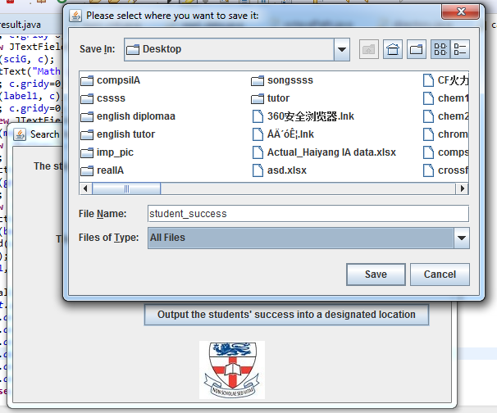

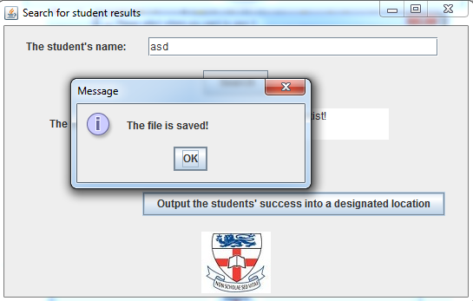

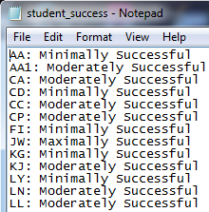

If user wants to receive a recommendation:

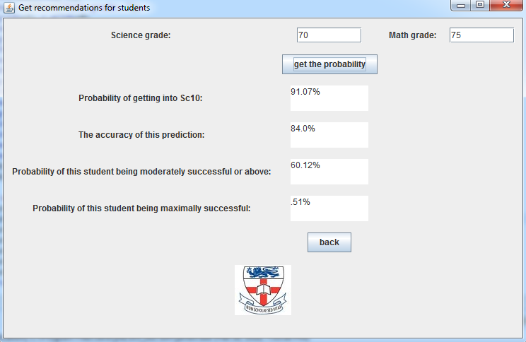

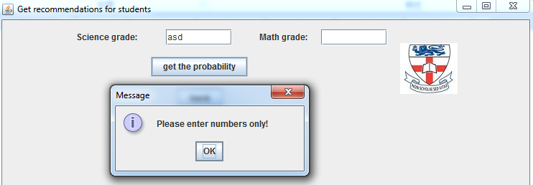
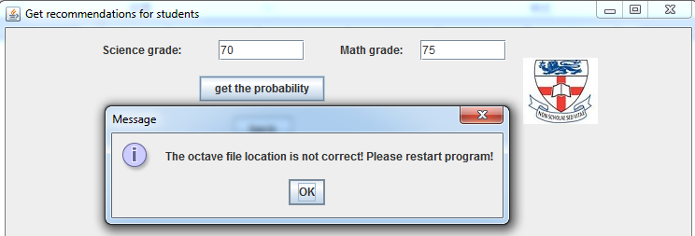

The process of reading and merging data:
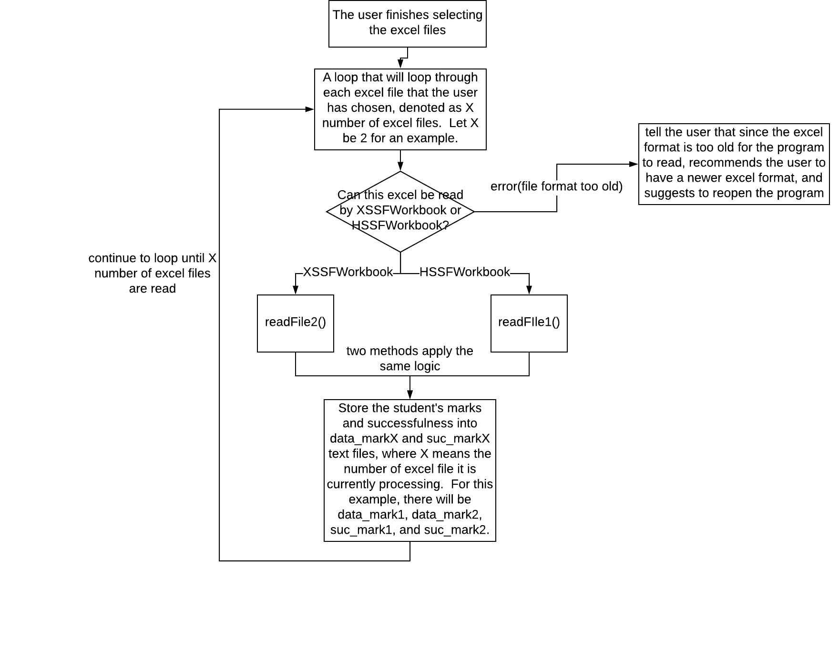

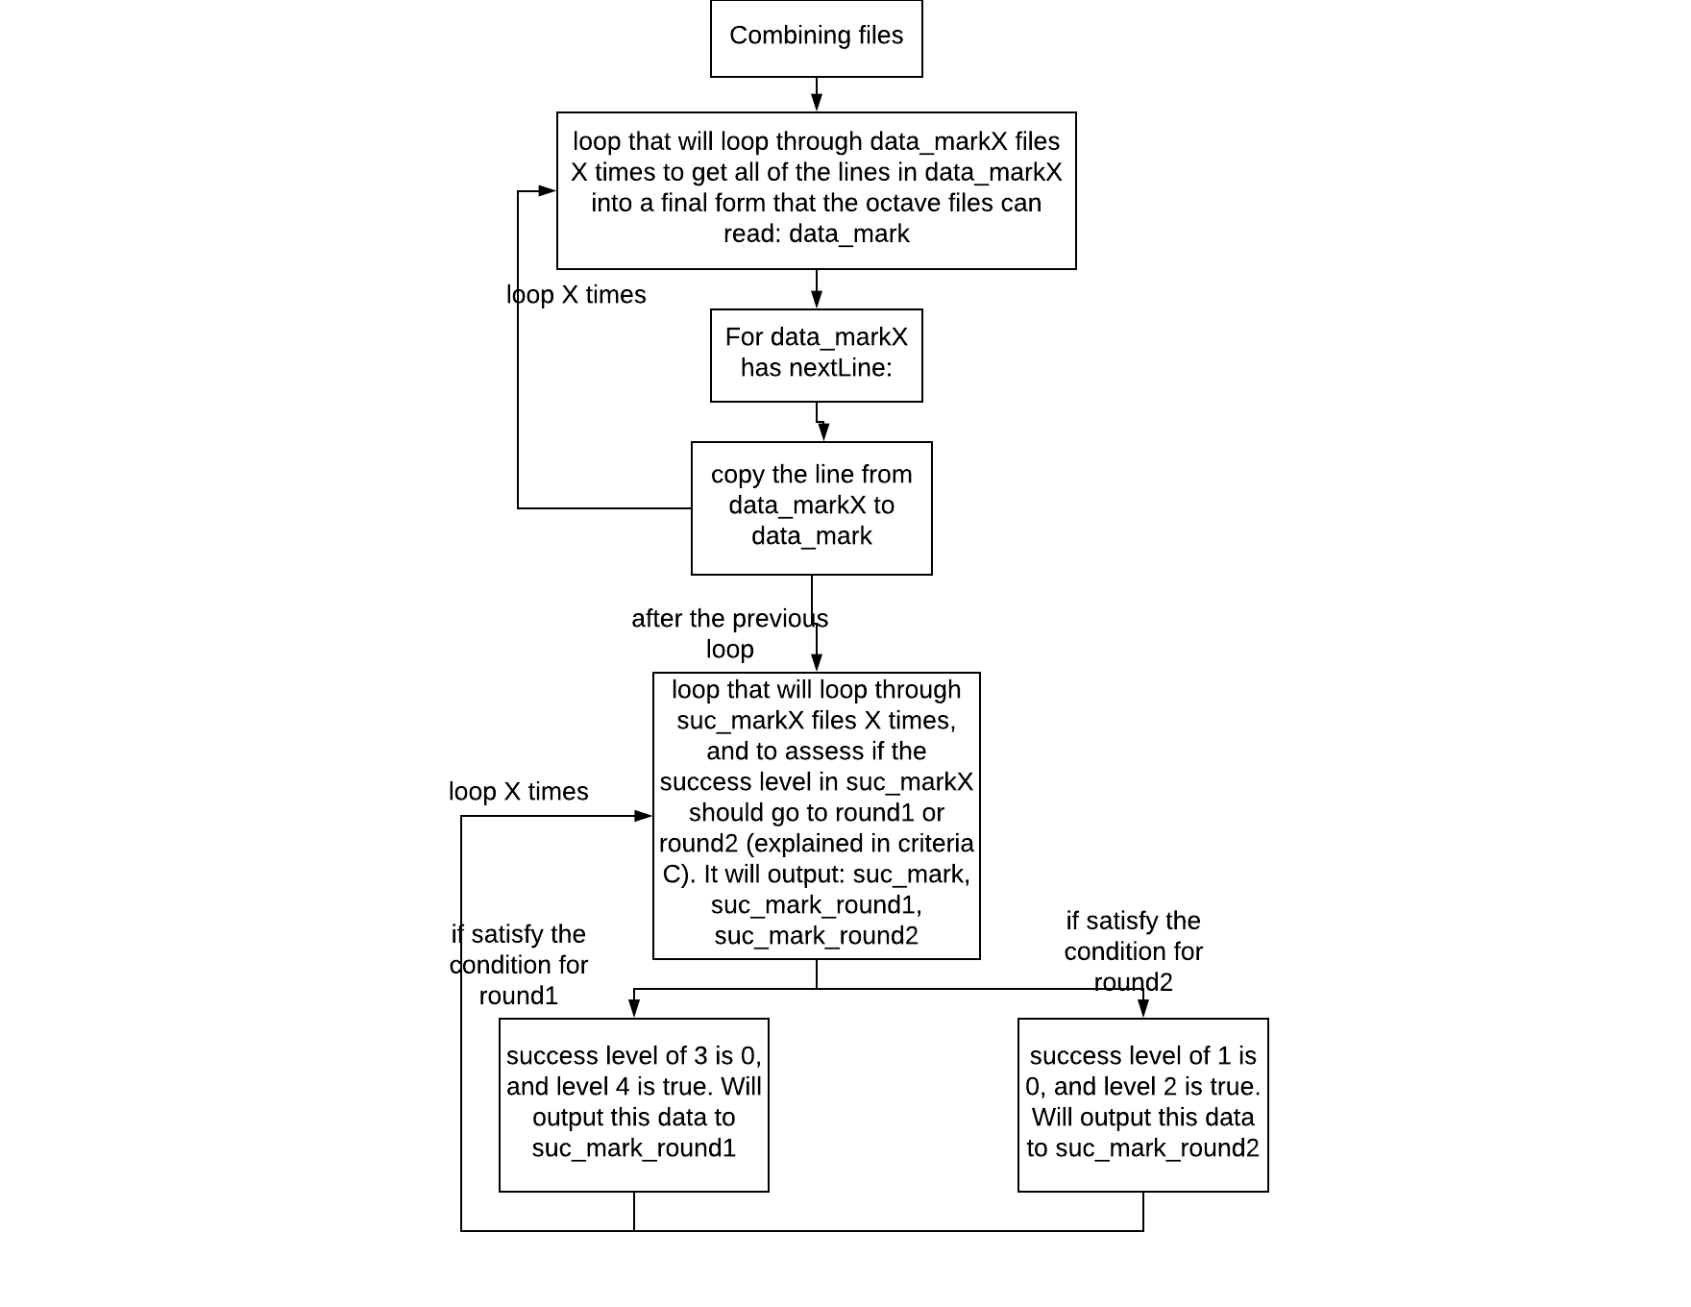
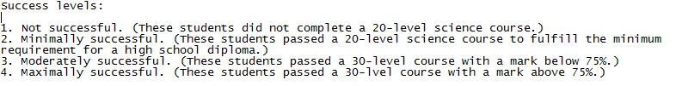
Round1 and round2 will be clearer after showing the basic overview of the functioning of the machine learning algorithm and its connection with Java:
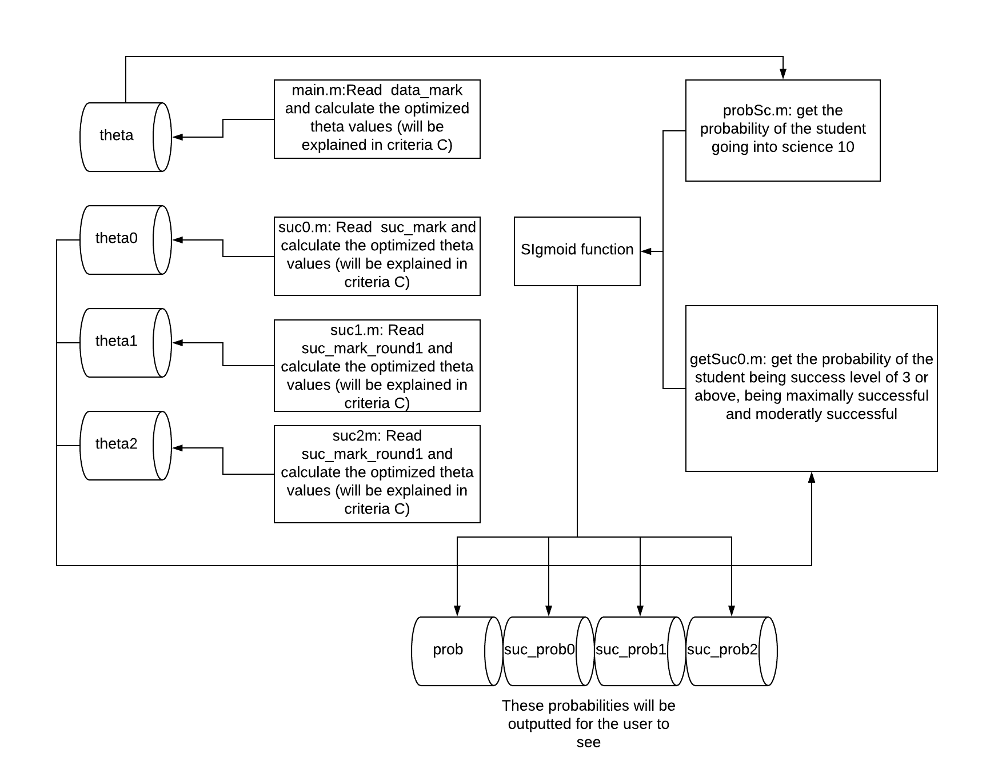

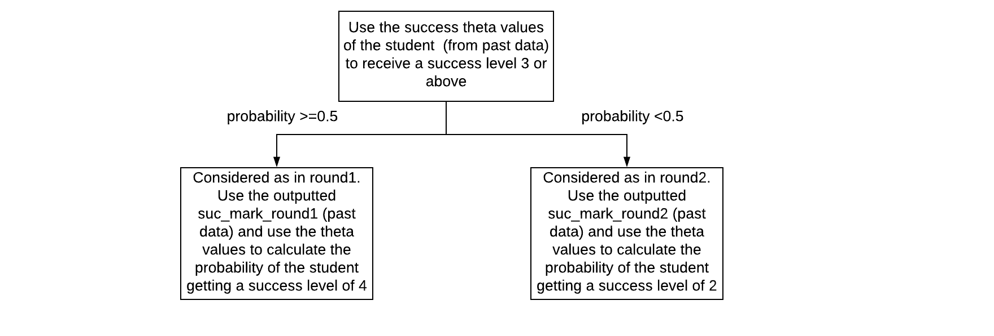
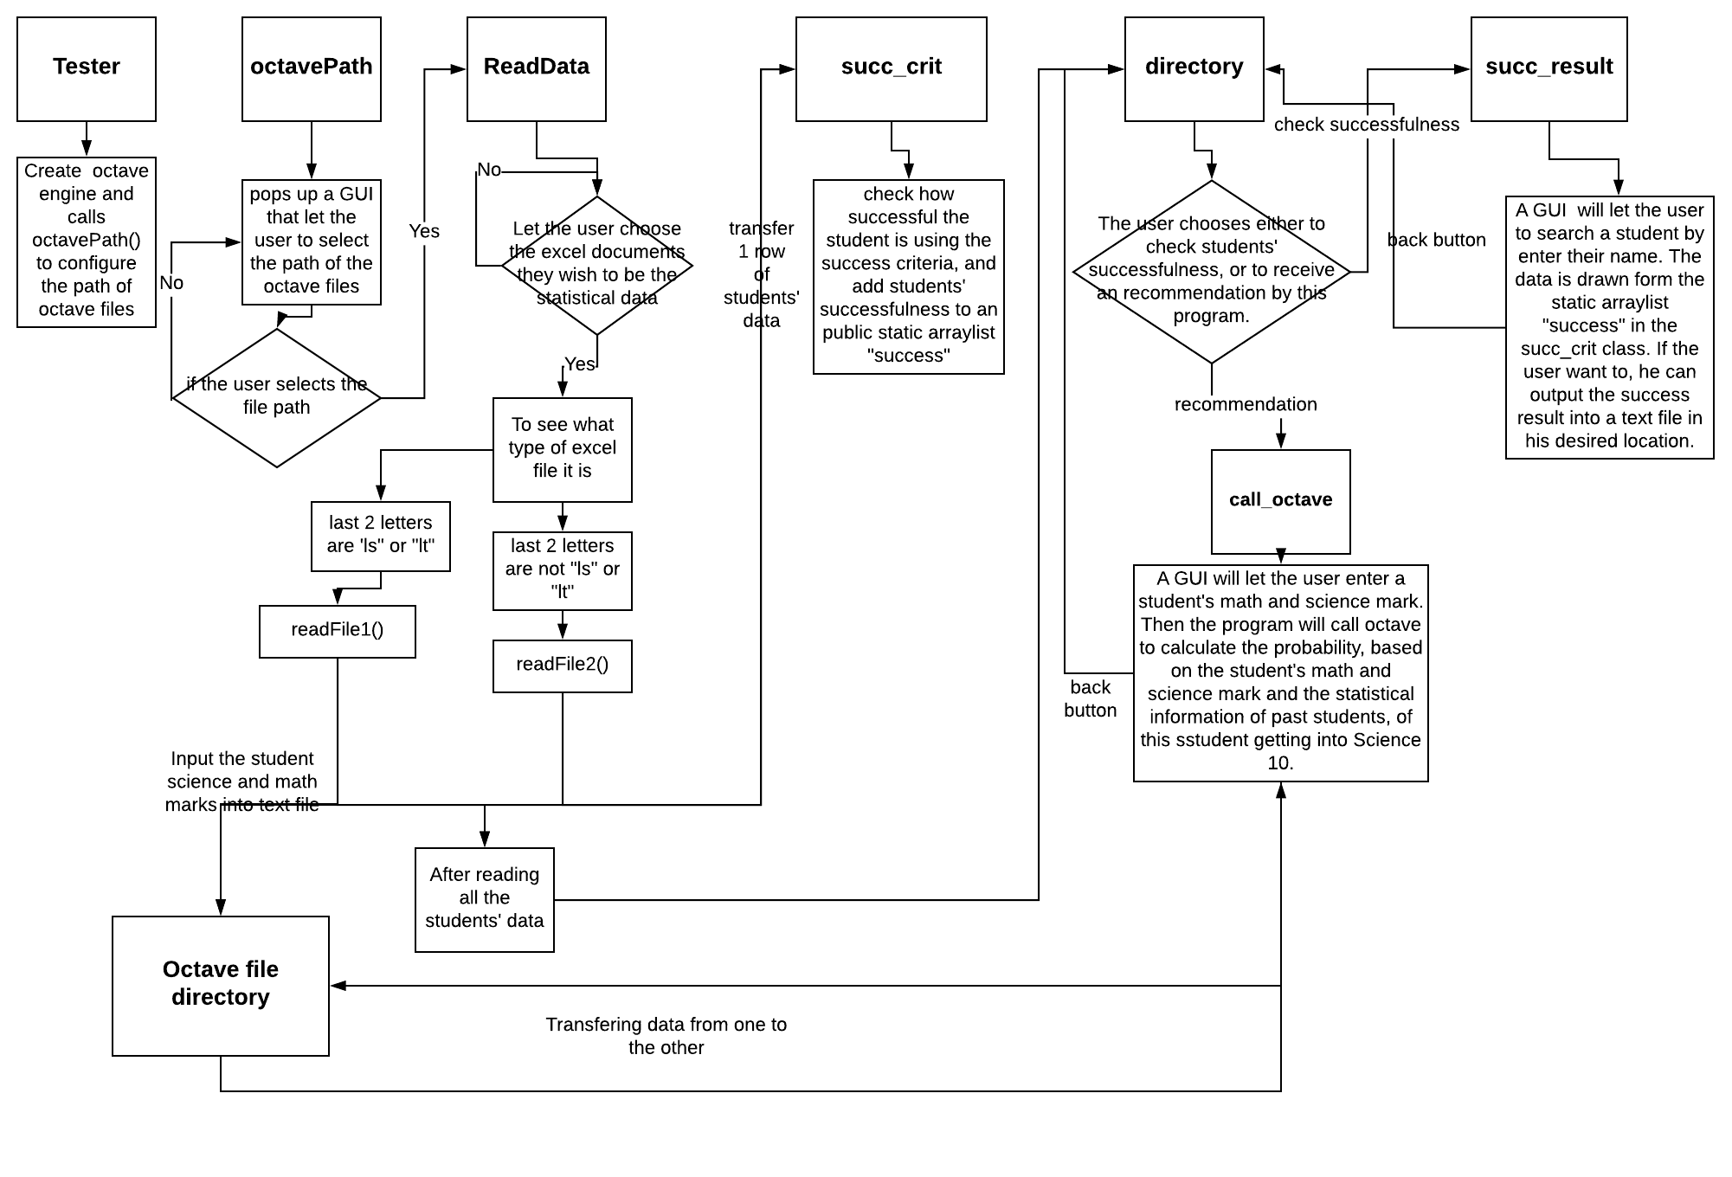
A more in-depth overview of the functionality of all Java classes:

Table 6. Testing type, testing method, and examples.
Testing type | Example
The students’ data in excel should be read correctly. | If one student’s math mark is 50 and science mark is 70, the correct data printed out in the array should be student_name, 50, 70.
Have error handling for special cases. | If the octave file path is wrong, when Java calls octave there will be an error. Thus make a try and catch statement that will catch the OctaveEvalException error
The user can choose to location open and store files. | Outputting the file to a selected location and open it. Debug if it does not output to the correct location.
Students’ successfulness is correctly considered | Make an answer key first manually, then compare the program calculated successfulness with the answer key
The client can search the successfulness of past students by searching their names. | Test if the student’s result is correctly shown after searching.
Successfully use machine learning algorithms to produce a predictive model based on each student’s grades. | 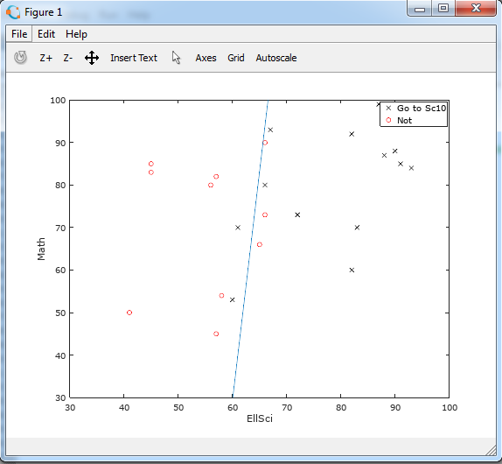  This type of plot will be used to see if the prediction is correct or not. The line in the plot is the predicted cut off line.
The client can receive the probabilities he asked for by input the student’s Science and Math mark. | Refer to the plot to see if it is approximately the same.

Word count: 542

Marks | Awarded | Description
0 |  | The response does not reach a standard described by the descriptors below.
1–2 |  | The record of tasks and the design overview, including an outline test plan, are limited. From this information it is difficult to see how the product was developed.
3–4 |  | The record of tasks and the design overview, including an outline test plan, are partially complete. They provide a basic understanding of how the product was developed.
5–6 |  | The record of tasks and the design overview, including an outline test plan, are detailed and complete. From this information it is clear how the product was developed.

