Criterion C: Development
The main techniques used are:
- Use filechooser to read and write data
- Use of 2d arrays and loops to output data
- Try and catch statements on possible errors
- Some basic GUI handling
- Parsing strings into doubles
- Use additional libraries
- Implementing a hierarchical composite data structure
- Inserting data to an ordered sequential file
- Merging two or more data structures
- Searching
- Implementation of basic logistic regression
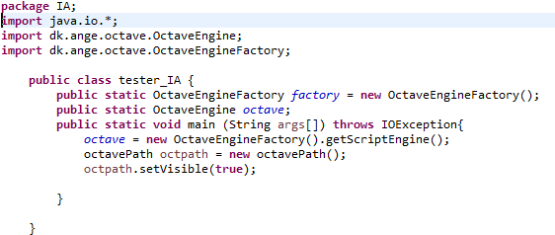
The libraries and variables used in tester_IA class:

The octave engine is called inside tester and is made static because only tester can implement the environmental variables for the launch configuration; the environmental variable can only be applied to tester. Therefore, the only solution is to declare the octave engine inside tester and make it static so call_octave class can use it.
The libraries used in octavePath class:
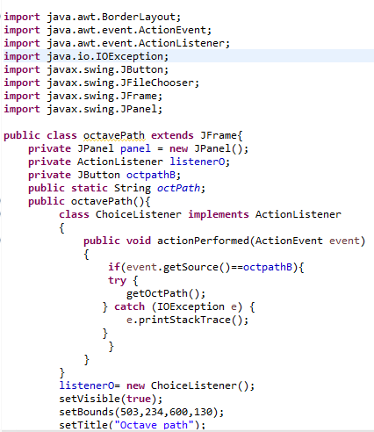
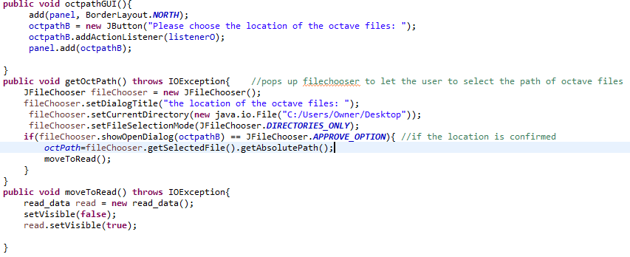
This file chooser can only open folder locations, not file locations. This is intentionally made since only the path of octave files is needed.
The libraries and variables used in read_data class:
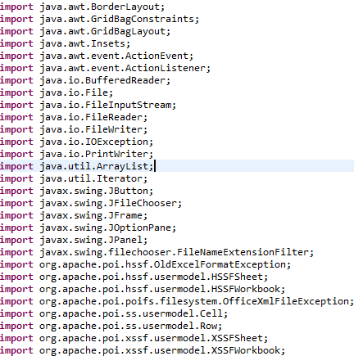
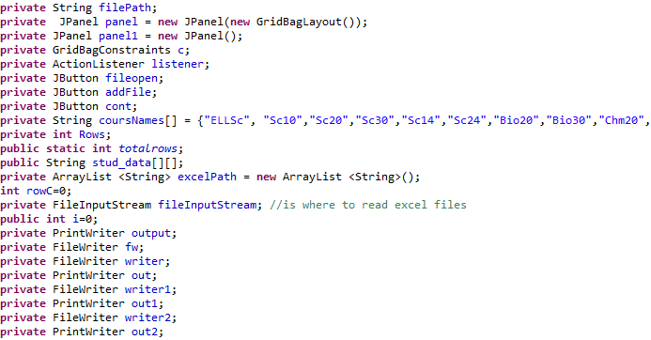

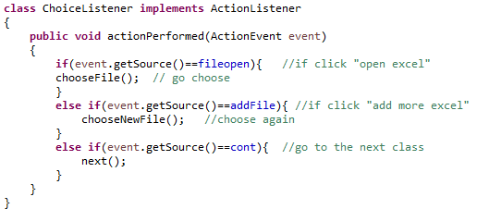

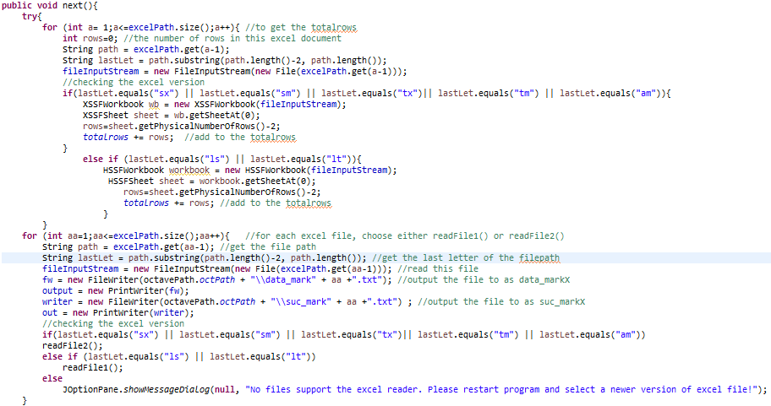

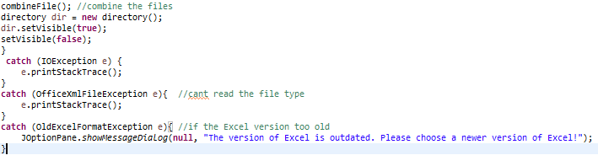
After the user finishes choosing his excel files, the next() method will first get the total row of all the excel files. The number total rows is important because 2d array that stores the student’s successfulness needs to be created as a total rows*2 matrix. Then, PrintWriter output and out will be assigned as data_markX and suc_markX as temporary files. Later on, these temporary files will be merged together, and then deleted. next() will then assign which readFile method to read the excel file (Javainterviewpoint, 2017).
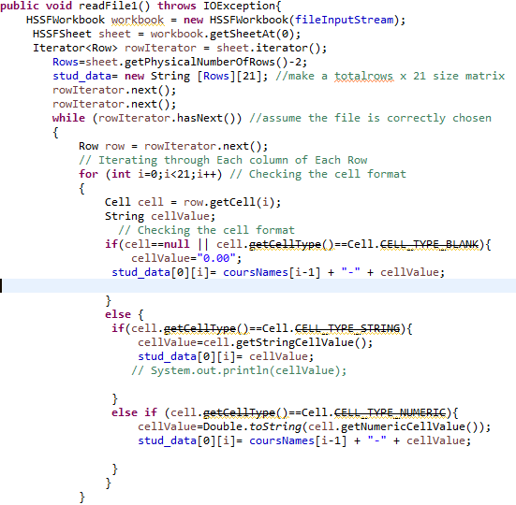
Then, to read the file with less RAM, only one line of the student data is read each time, and outputting them into one line of data_markX and suc_markX.

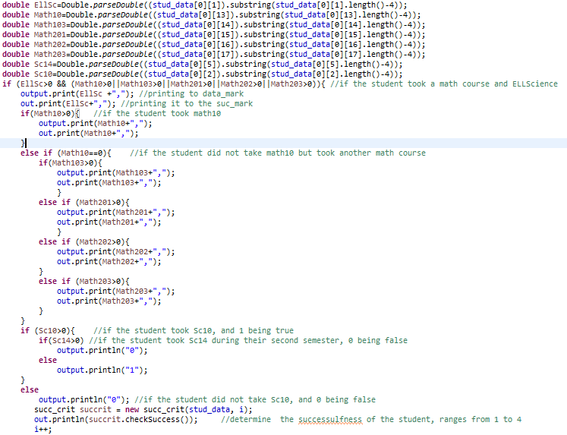
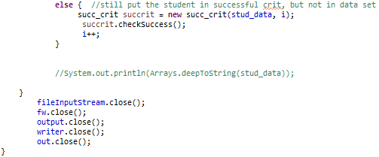
Student’s marks that are outputted into data_markX are also outputted into suc_markX. The int checksuccess() method in the succ_crit class will be called with the student data and integer i, which is a count for the remaining students. Since some students might drop out from school, the possibility of the student not taking ELLScience and Math exists. To exclude dropped out students (outliers) from the data set, a return value is added. It will add the student’s successfulness to success[][], and also return a value (success level) ranged from 1 to 4. This way, the student took ELLScience and Math can get the success level , while the outliars can be added to the success[][] and not into the suc_markX and data_markX.
A hierarchical composite data structure is also used, since stud_data and the text file outputted to the octave file path are stored in a fixed data structure.
The data_mark1.txt that was outputted to the octave files will look like:
The suc_mark1.txt that was outputted to the octave files will look like:

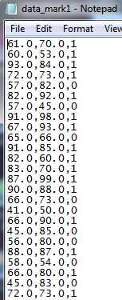
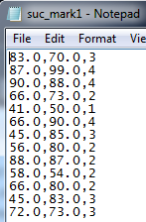

Then, the combineFile() method will combine the data_markX and suc_markX files together, which shows merging two data-structures, and inserting data into a sequential file:
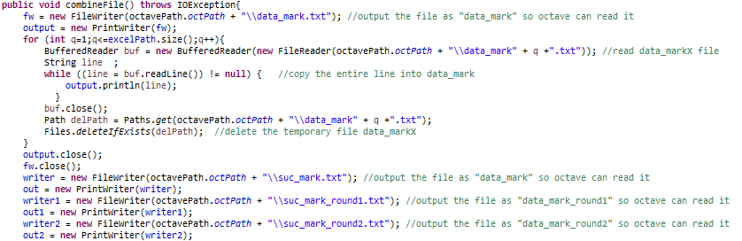
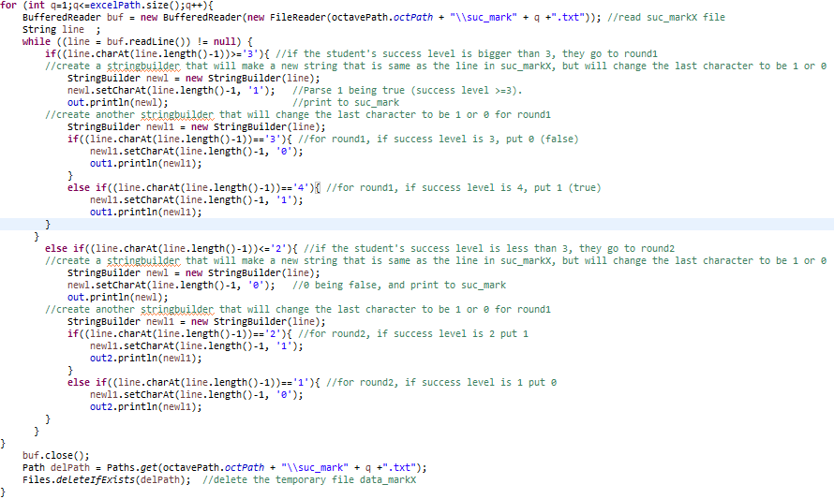
The suc_mark_round1.txt will look like:

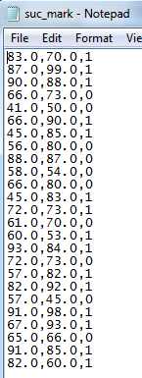
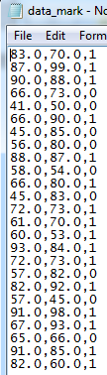
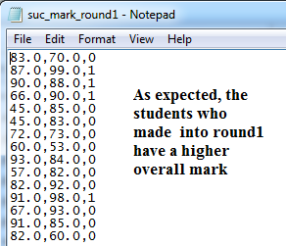
The data_mark.txt (final) will look like:
The suc_mark.txt (final) will look like:
The suc_mark_round1.txt will look like:

The suc_mark_round2.txt will look like:

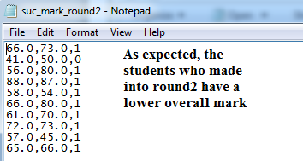

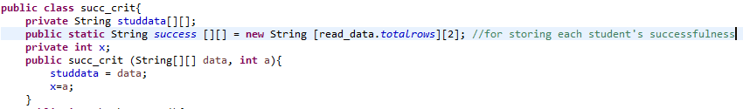
Creating temporary files and then merging them together is appropriate because it saves RAM, and they will be used in machine learning algorithms.
The variables used in succ_crit class:
Int x is assigned from int a, which is int i in read_data class, and will be used as a counter.

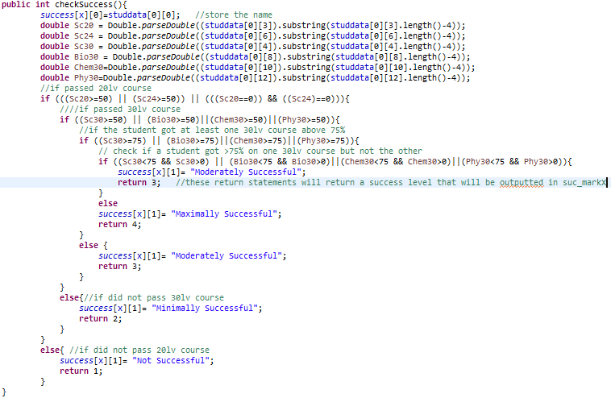
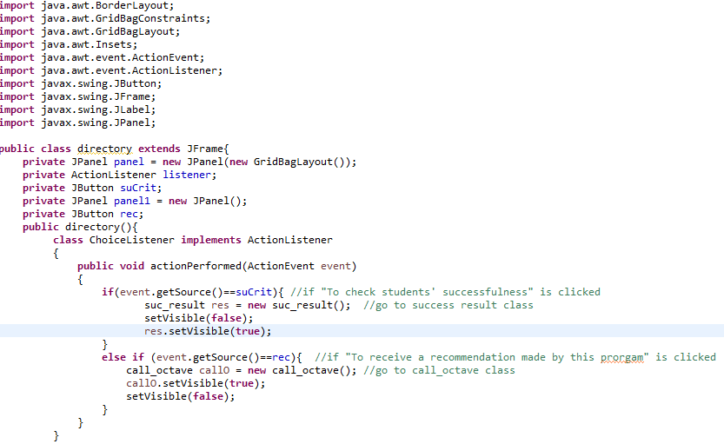
The libraries used in directory class:

GridBagLayout is used for the GUI (MrJavaHelp, 2009).
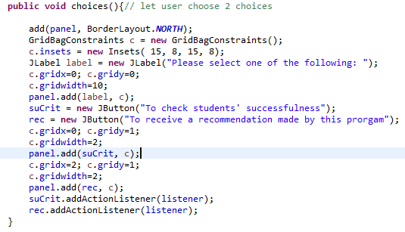

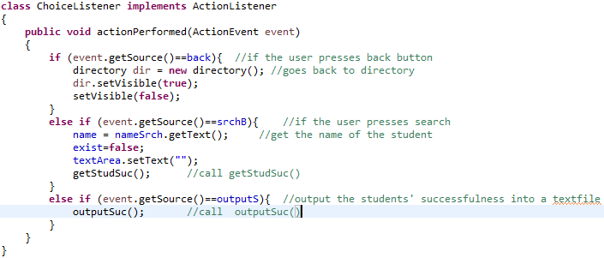

The libraries and variables used in suc_result class:

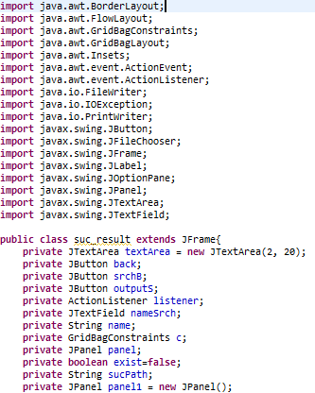

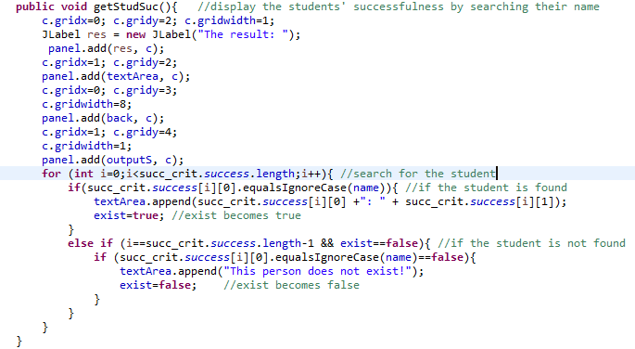
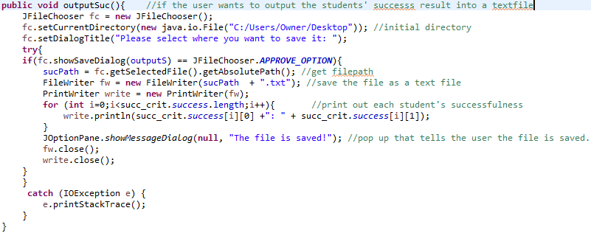
In the getSuc() method, success[][] is called to receive the students’ successfulness.

The libraries and variables used in call_octave class:
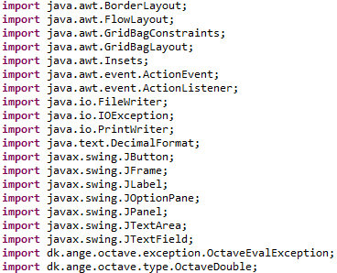

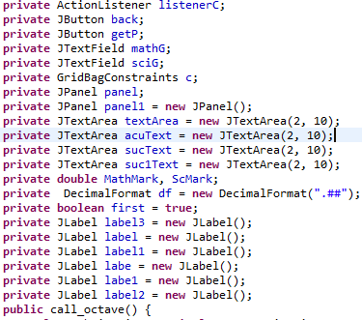

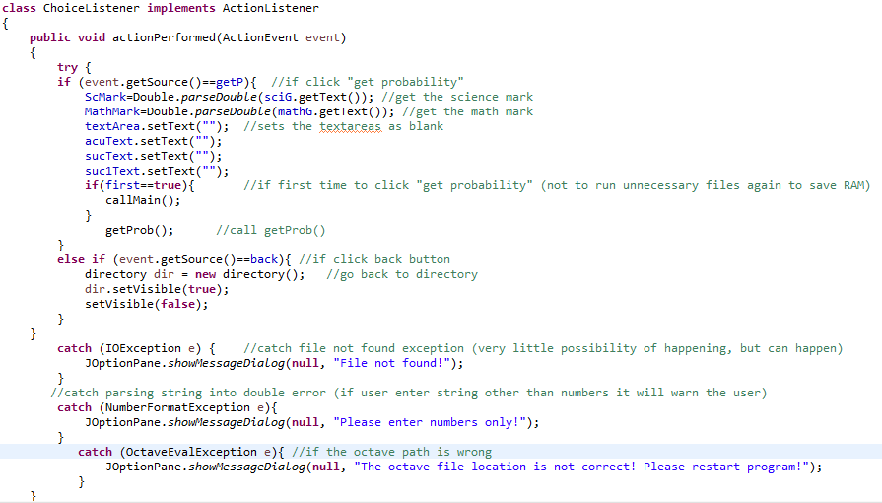
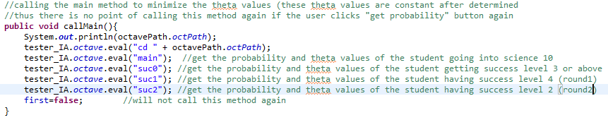
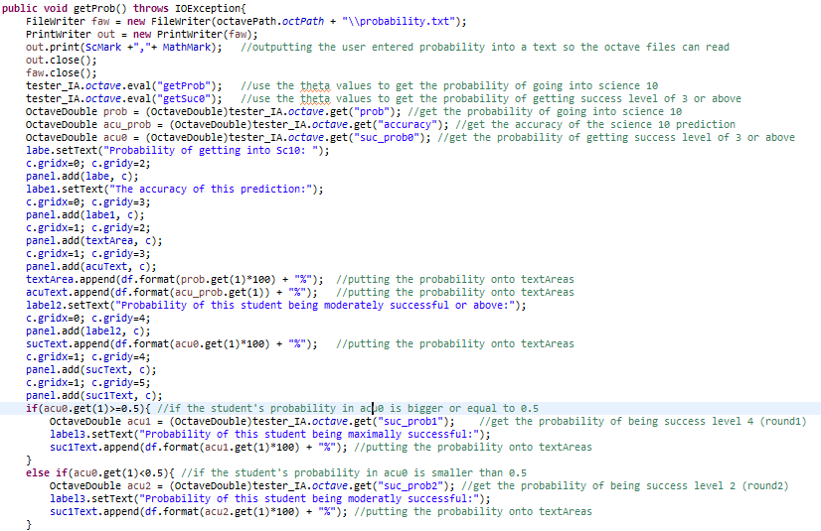
The probability file looks like:
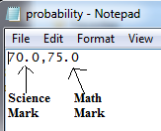
The Machine learning algorithms are implemented from the Machine Learning Class (Ng, 2017)
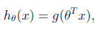
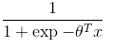
The hypothesis function is defined as:
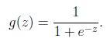
The sigmoid function is defined as:
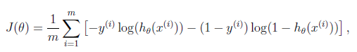
The cost function is defined as:
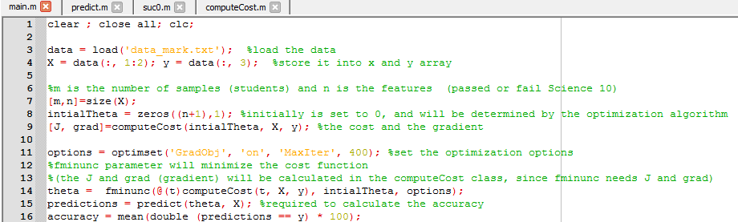
The general idea is: since the cost function uses the hypothesis and sigmoid function, if the cost function is minimized then the theta values will also be minimized. Then, theta will be used to calculate the probabilities with the sigmoid function (Matt, 2017).
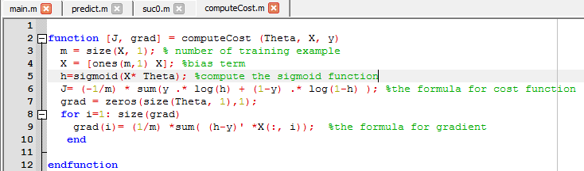
The same logic applies to suc0, suc1, and suc2, where they all calculate the minimized theta value.
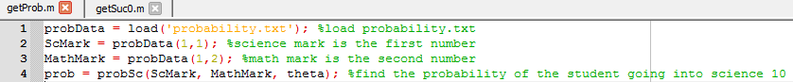
The machine learning code so far is made by the Machine Learning Class. I made getProb, probSc, and getSuc0 methods by myself:
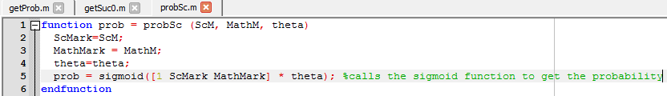
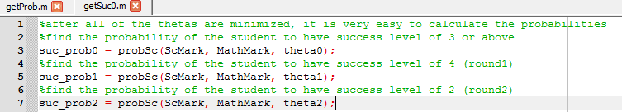
Word count: 671

