

MULTIMEDIA UNIVERSITY ®

TIS1101 Database Fundamentals

Group Assignment

Title: 5. Online Music Store

Prepared by:  
Leader: 1142701684 NG CHIN ANN [chinann6213@gmail.com](mailto:chinann6213@gmail.com)

Member: 1142701883 KHOR KIA KIN [0jetpistol0@gmail.com](mailto:0jetpistol0@gmail.com)

Member: 1142701444 TEY MENG KIAT [manjorney@gmail.com](mailto:manjorney@gmail.com)

Date: 3 FEBRUARY 2016

Table of Contents

Business Rules 1

Entity-Relationship Diagram 2

Data Dictionary 3

Data Definition Command (DDL) 5

Date Insertion 7

Data Manipulation Command (DML) 16

(a) Aggregate Funtions 16

(b) “Group by” with “having” clause. 17

(c) Nested Query/ Sub Query 18

(d) Views 19

(e) Trigger 20

(f) Stored procedure 26

(g) Additional query component 28

# Business Rules

1. A unique username and a valid email address are needed to register a user account.
2. An email address can only be used to make one account.
3. An account is needed to purchase an album.
4. An account can have zero or more than one purchase.
5. User can use many payment methods.
6. An order must be associated with at least one album.
7. An album must consist of its album name, artist name, release date, album format and price.
8. A song must consists of its song name, artist name, duration and genre.
9. Every album must be categorized to new, trending or null.
10. Rating for a song or an album is based on user.

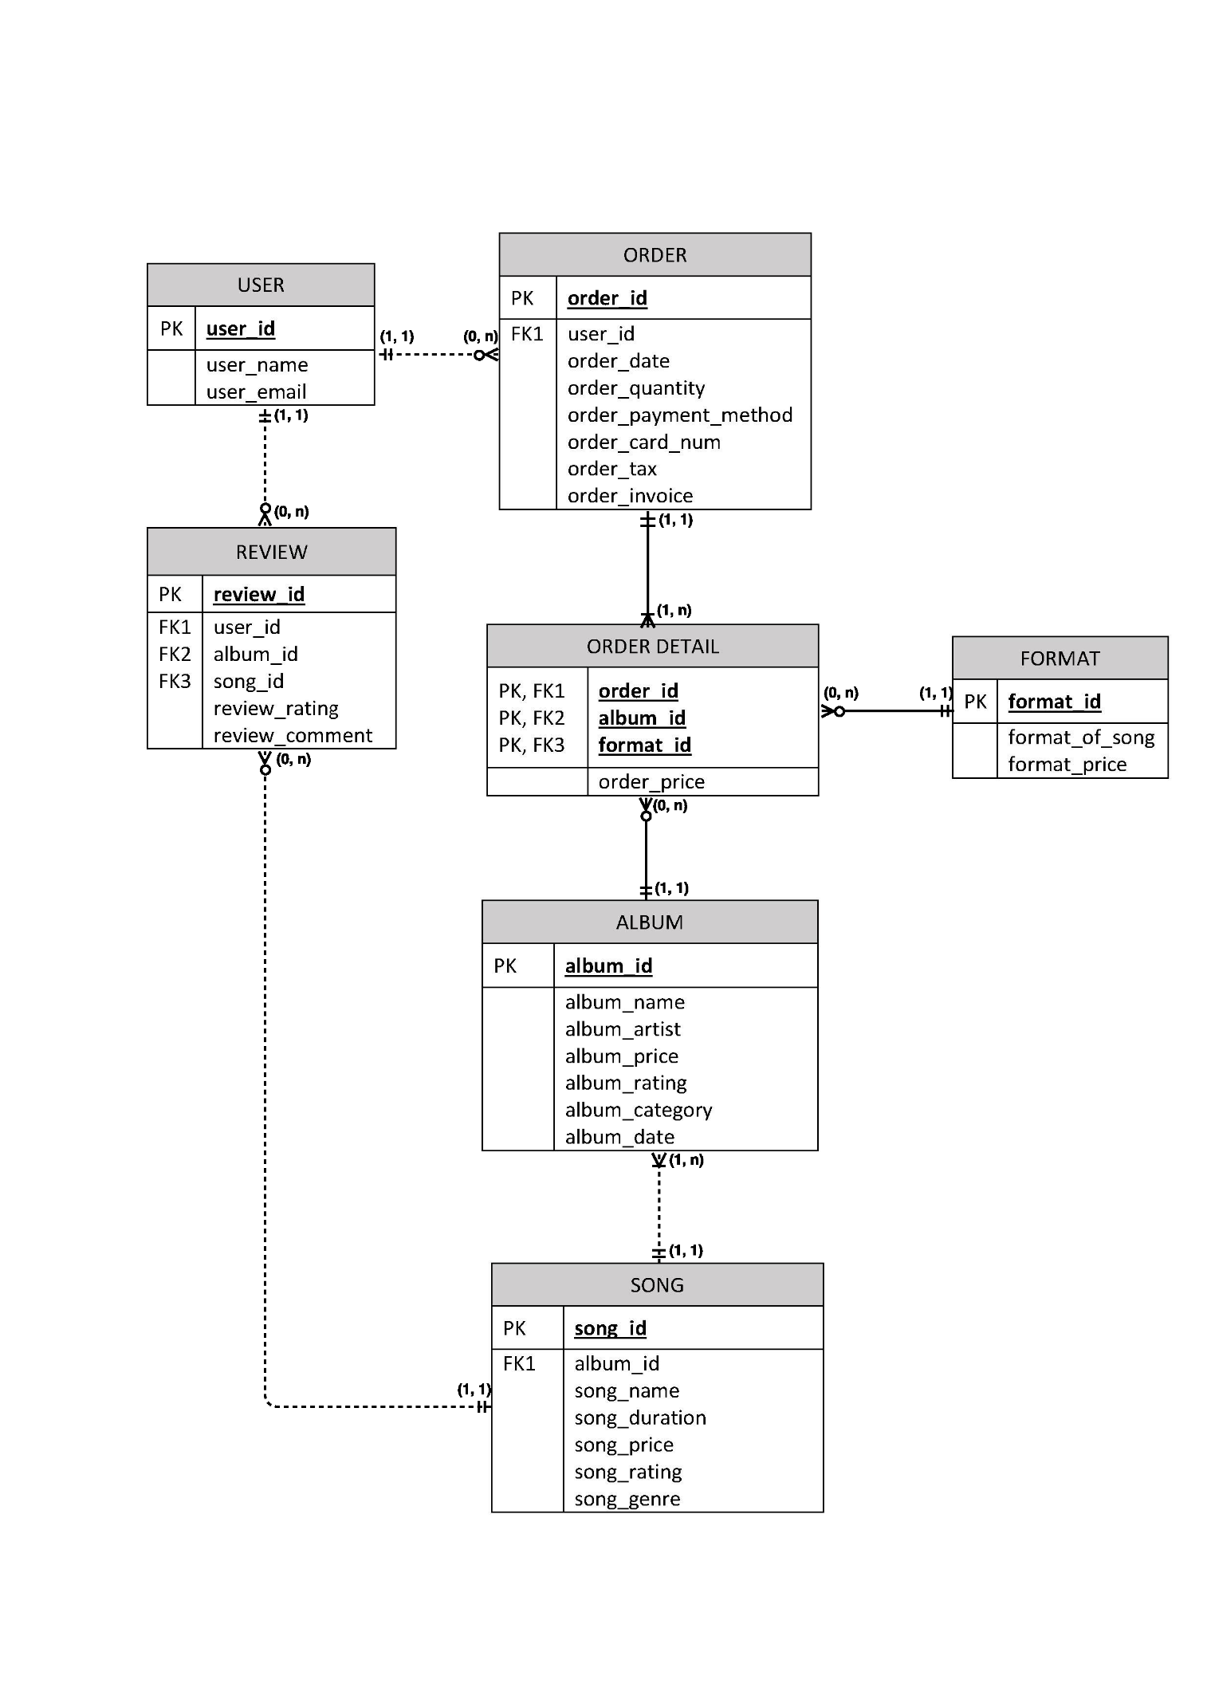

# Entity-Relationship Diagram

# Data Dictionary

|  |  |  |  |  |  |  |  |
| --- | --- | --- | --- | --- | --- | --- | --- |
| Table Name | Attribute Name | Contents/Description | Data Type | Format | Range | PK/ FK | FK Referenced Table |
| USER | user_id  user_name  user_email | User ID  User Name  User Email | INT  VARCHAR(20)  VARCHAR(30) | #  Xxxxx  Xxxxxx | 1 – n | PK |  |
| ALBUM | album_id  album_name  album_artist  album_price  album_rating  album_category  album_date | Album ID  Album Name  Album Artist  Album Price  Album Rating  Album Category  Album Date | INT  VARCHAR(30)  VARCHAR(30)  DECIMAL(5,2)  DECIMAL(2,1)  VARCHAR(20)  DATE | #  Xxxxxx  Xxxxxx  ###.##  #.#  Xxxxx  YYYY-MM-DD | 1 – n | PK |  |
| SONG | song_id  song_name  song_duration  song_price  song_rating  song_genre  album_id | Song ID  Song Name  Song Duration  Song Price  Song Rating  Song Genre  Album ID | INT  VARCHAR(30)  CHAR(5)  DECIMAL(4,2)  DECIMAL(2,1)  VARCHAR(10)  INT | #  Xxxxxxx  xxxxx  ##.##  #.#  Xxxx  # | 1 – n | PK  FK1 | ALBUM |
| FORMAT | format_id  format_of_song  format_price | Format ID  Format of Song  Format Price | INT  CHAR(3)  DECIMAL(5,2) | #  Xxx  ###.## | 1 – 3 | PK |  |
| REVIEW | review_id  user_id  album_id  song_id  review_rating  review_comment | Review ID  User ID  Album ID  Song ID  Review Rating  Review Comment | INT  INT  INT  INT  DECIMAL(2,1)  VARCHAR(50) | #  #  #  #  #.#  Xxxxxxx | 1 – n | PK  FK1  FK2  FK3 | USER  ALBUM  SONG |
| ORDER | order_id  order_date  order_quantity  order_payment_method  order_card_num  order_tax  order_invoice  user_id | Order ID  Order Date  Order Quantity  Order Payment Method  Order Card Number  Order Tax Charged  Order Invoice  User ID | INT  DATE  INT  VARCHAR(20)  CHAR(16)  DECIMAL(3,2)  DECIMAL(7,2)  INT | #  YYYY-MM-DD  ##  Xxxxx  xxxxx  ##.##  #####.##  # | 1 – n | PK  FK1 | USER |
| ORDER_DETAIL | order_id  album_id  format_id  order_price | Order ID  Album ID  Format ID  Order Price(Single album) | INT  INT  INT  DECIMAL(5,2) | #  #  #  ###.## | 1 – n | PK, FK1  PK, FK2  PK, FK3 | ORDER  ALBUM  FORMAT |

# Data Definition Command (DDL)

CREATE DATABASE msicstor;

CONNECT TO msicstor;

CREATE TABLE user

(

user_id INT NOT NULL PRIMARY KEY GENERATED ALWAYS AS IDENTITY (START WITH 1 INCREMENT BY 1),

user_name VARCHAR(20),

user_email VARCHAR(30)

);

CREATE TABLE album

(

album_id INT NOT NULL PRIMARY KEY GENERATED ALWAYS AS IDENTITY (START WITH 1 INCREMENT BY 1),

album_name VARCHAR(30),

album_artist VARCHAR(30),

album_price DECIMAL(5,2) WITH DEFAULT 0,

album_rating DECIMAL(2,1) WITH DEFAULT 0.0,

album_category VARCHAR(20),

album_date DATE,

CHECK (album_rating BETWEEN 0.0 AND 5.0),

CHECK (album_category IN ('New', 'Trending'))

);

CREATE TABLE song

(

song_id INT NOT NULL PRIMARY KEY GENERATED ALWAYS AS IDENTITY (START WITH 1 INCREMENT BY 1),

song_name VARCHAR(30),

song_duration CHAR(5),

song_price DECIMAL(4,2),

song_rating DECIMAL(2,1) WITH DEFAULT 0.0,

song_genre VARCHAR(10),

album_id INT,

FOREIGN KEY (album_id) REFERENCES album,

CHECK (song_rating BETWEEN 0.0 AND 5.0),

CHECK (song_genre IN ('Pop', 'Rock', 'Classical', 'Electric', 'Hip-Hop', 'Jazz', 'Karaoke', 'RnB'))

);

CREATE TABLE format

(

format_id INT NOT NULL PRIMARY KEY GENERATED ALWAYS AS IDENTITY (START WITH 1 INCREMENT BY 1),

format_of_song CHAR(3),

format_price DECIMAL(5,2),

CHECK (format_of_song IN ('mp3', 'wma', 'wav'))

);

CREATE TABLE review

(

review_id INT NOT NULL PRIMARY KEY GENERATED ALWAYS AS IDENTITY (START WITH 1 INCREMENT BY 1),

user_id INT,

album_id INT,

song_id INT,

review_rating DECIMAL(2,1),

review_comment VARCHAR(50),

FOREIGN KEY (user_id) REFERENCES user,

FOREIGN KEY (album_id) REFERENCES album,

FOREIGN KEY (song_id) REFERENCES song,

CHECK (review_rating BETWEEN 1.0 AND 5.0)

);

CREATE TABLE order

(

order_id INT NOT NULL PRIMARY KEY GENERATED ALWAYS AS IDENTITY (START WITH 1 INCREMENT BY 1),

order_date DATE,

order_quantity INT,

order_payment_method VARCHAR(20),

order_card_num CHAR(16),

order_tax DECIMAL(3,2),

order_invoice DECIMAL(7,2),

user_id INT,

FOREIGN KEY (user_id) REFERENCES user,

CHECK (order_payment_method IN ('Visa', 'Master', 'Paypal', 'Maybank2u', 'CIMB Clicks'))

);

CREATE TABLE order_detail

(

order_id INT NOT NULL,

album_id INT NOT NULL,

format_id INT NOT NULL,

order_price DECIMAL(5,2),

FOREIGN KEY (order_id) REFERENCES order,

FOREIGN KEY (album_id) REFERENCES album,

FOREIGN KEY (format_id) REFERENCES format,

PRIMARY KEY (order_id, album_id, format_id)

);

# Date Insertion

INSERT INTO user

(user_name, user_email)

VALUES

('John', 'john@gmail.com'),

('Constantine', 'constantine@hotmail.com'),

('Taylor', 'taylor@yahoomail.com'),

('Lucy', 'lucy@gmail.com'),

('Mary', 'mary@hotmail.com'),

('Brian', 'brian@yahoomail.com'),

('Ming', 'ming@gmail.com'),

('Ali', 'ali@hotmail.com'),

('Saitama', 'saitama@yahoomail.com');

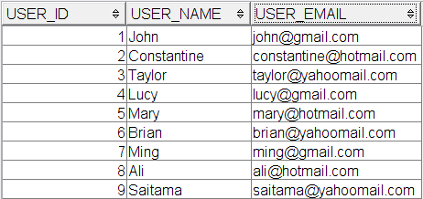SELECT * FROM user;

INSERT INTO album

(album_name, album_artist, album_category, album_date)

VALUES

('25', 'Adele', 'New', '2015-11-20'),

('Purpose', 'Justin Bieber', 'New', '2015-11-13'),

('The Piano Guys', 'The Piano Guys', 'Trending', '2012-10-02'),

('The Marshall Mathers LP 2', 'Eminem', NULL, '2013-11-05'),

('Nothing But the Best', 'Frank Sinatra', 'Trending', '2008-05-13'),

('Thriller', 'Michael Jackson', 'Trending', '1983-07-29'),

('Confident', 'Justin Bieber', NULL, '2013-09-08'),

('Blackstar', 'David Bowie', 'New', '2016-01-08'),

('Girl On Fire', 'Alicia Keys', NULL, '2012-11-23'),

('Under The Mistletoe', 'Justin Bieber', 'Trending', '2011-04-18'),

('Love, Marriage & Divorce', 'Toni Braxton & Babyface', NULL, '2014-01-01'),

('Night Visions', 'Imagine Dragons', 'Trending', '2012-01-01'),

('Does This Look Infected?', 'Sum 41', 'Trending', '2002-01-01'),

('My World 2.0', 'Justin Bieber', NULL, '2010-05-13'),

('Believe', 'Justin Bieber', 'Trending', '2012-02-14');

SELECT * FROM album;

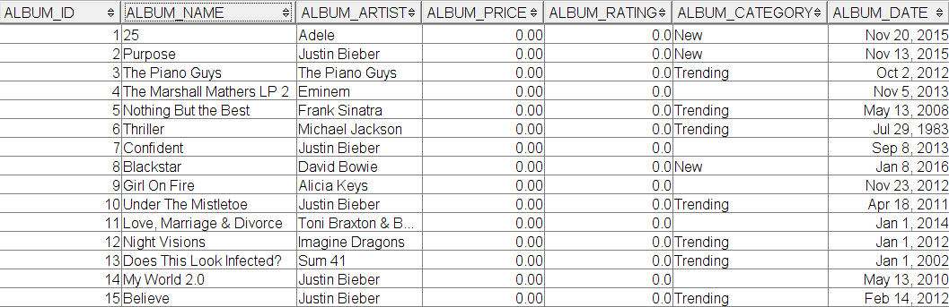

INSERT INTO song

(album_id, song_name, song_duration, song_price, song_genre)

VALUES

-- 25

(1, 'Hello', '04:55', 3.50, 'Pop'),

(1, 'When We Were Young', '04:50', 3.50, 'Pop'),

(1, 'Million Years Ago', '03:47', 3.50, 'Jazz'),

(1, 'All I Ask', '04:32', 3.50, 'Classical'),

-- Purpose

(2, 'I Will Show You', '03:25', 3.00, 'Pop'),

(2, 'What Do You Mean?', '03:25', 3.00, 'Hip-Hop'),

(2, 'Sorry', '03:20', 3.00, 'RnB'),

(2, 'Love Yourself', '03:53', 3.00, 'Pop'),

-- The Piano Guys

(3, 'Over the Rainbow, Simple Gifts', '03:44', 4.00, 'Classical'),

(3, 'Beethoven 5 Secrets', '05:09', 4.00, 'Classical'),

(3, 'A Thousand Years', '04:36', 4.00, 'Classical'),

(3, 'Peponi', '04:10', 4.00, 'Classical'),

-- The Marshall Mathers LP 2

(4, 'The Monster', '04:10', 3.00, 'Hip-Hop'),

(4, 'Rap God', '06:03', 3.00, 'Electric'),

(4, 'Berzerk', '03:58', 3.00, 'Rock'),

-- Nothing But the Best

(5, 'Fly Me To the Moon', '02:27', 3.50, 'Jazz'),

(5, 'My Way', '04:36', 3.50, 'Jazz'),

(5, 'Strangers In the Night', '02:44', 3.50, 'Jazz'),

-- Thriller

(6, 'Thriller', '05:57', 4.00, 'RnB'),

(6, 'Beat It', '04:18', 4.00, 'Hip-Hop'),

(6, 'Billie Jean', '04:54', 4.00, 'Jazz'),

-- Confident

(7, 'Confident', '04:22', 4.00, 'Hip-Hop'),

-- Blackstar

(8, 'Blackstar', '09:57', 3.50, 'Rock'),

(8, 'Lazarus', '06:22', 3.50, 'Electric'),

(8, 'Dollar Days', '04:44', 3.50, 'RnB'),

(8, 'I Cannot Give Everything Away', '05:47', 3.50, 'Hip-Hop'),

-- Girl On Fire

(9, 'Girl On Fire', '04:30', 4.00, 'RnB'),

(9, 'Tears Always Win', '03:59', 4.00, 'RnB'),

(9, 'Brand New Me', '03:53', 4.00, 'RnB'),

-- Under The Mistletoe

(10, 'Fa La La', '03:55', 3.00, 'RnB'),

-- Love, Marriage & Divorce

(11, 'Hurt You', '04:10', 3.00, 'RnB'),

(11, 'Where Did We Go Wrong', '03:37', 3.00, 'Rock'),

(11, 'Reunited', '03:18', 3.00, 'Electric'),

(11, 'I Wish', '03:03', 3.00, 'RnB'),

-- Night Visions

(12, 'Radioactive', '03:06', 3.50, 'Rock'),

(12, 'Demons', '02:57', 3.50, 'Rock'),

(12, 'Its Time', '04:00', 3.50, 'Classical'),

-- Does This Look Infected?

(13, 'The Hell Song', '03:18', 4.00, 'Rock'),

(13, 'Over My Head, Better Off Dead', '02:29', 4.00, 'Rock'),

(13, 'Still Waiting', '02:38', 4.00, 'Rock'),

(13, 'Thanks for Nothing', '03:04', 4.00, 'Rock'),

-- My World 2.0

(14, 'Where Are You Now', '03:45', 3.00, 'RnB'),

-- Believe

(15, 'As Long As You Love Me', '04:11', 4.00, 'Electric'),

(15, 'Beauty And A Beat', '03:32', 4.00, 'Rock');

SELECT * FROM song;

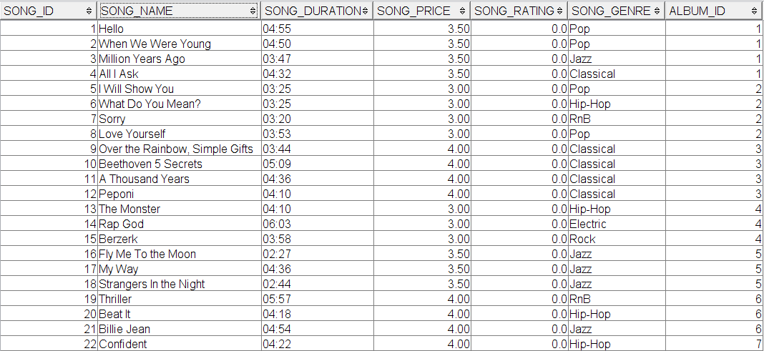

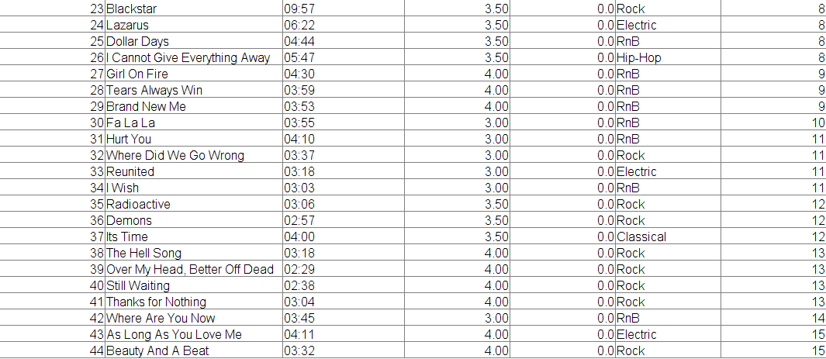

INSERT INTO format

(format_of_song, format_price)

VALUES

('mp3', 1.15),

('wma', 1.10),

('wav', 1.00);

SELECT * FROM format;

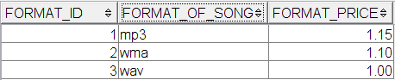

-- album_rating

INSERT INTO review

(user_id, album_id, review_rating, review_comment)

VALUES

(1, 12, 4.0, 'Great album, love it.'),

(7, 9, 5.0, 'One of the best album!'),

(4, 1, 1.0, 'Worst album ever!'),

(6, 11, 4.0, 'Awesome~~'),

(7, 9, 3.0, 'So so..'),

(1, 2, 4.0, 'Like it!'),

(2, 2, 4.5, 'Well done!'),

(5, 3, 2.5, 'A waste of money!'),

(8, 11, 3.0, 'OK...'),

(7, 2, 4.2, 'One of the best albums!'),

(4, 7, 3.8, 'Not bad.'),

(1, 4, 4.1, 'Just like it.'),

(2, 5, 5.0, 'Worth it!'),

(4, 5, 4.8, 'Nice album for collection.'),

(6, 9, 4.1, 'What an album!'),

(2, 6, 3.6, 'Still has space to improve.');

-- song_rating

INSERT INTO review

(user_id, song_id, review_rating, review_comment)

VALUES

(3, 36, 3.0, 'This song is epic.'),

(6, 23, 4.0, 'Addictive song.'),

(6, 9, 5.0, 'This song releases my soul!'),

(2, 5, 2.0, 'Lame song.'),

(7, 18, 5.0, 'It gives me goosebumps!'),

(2, 3, 4.7, 'My favourite song!'),

(9, 19, 5.0, 'A must listen song this year!'),

(5, 18, 4.5, 'Addicted to this song.'),

(4, 11, 3.0, 'So so...'),

(1, 4, 2.0, 'Waste of money...'),

(1, 9, 4.2, 'Like the chorus part!'),

(8, 1, 4.4, 'Amazing!!'),

(4, 2, 4.5, 'Just wow.'),

(9, 6, 3.0, 'OK..');

SELECT * FROM review;

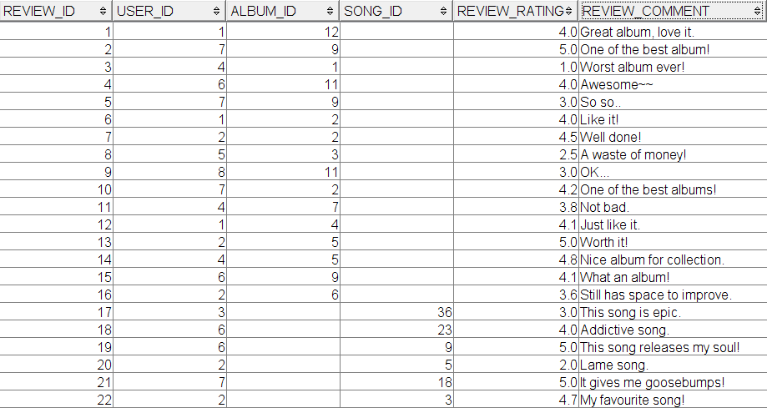

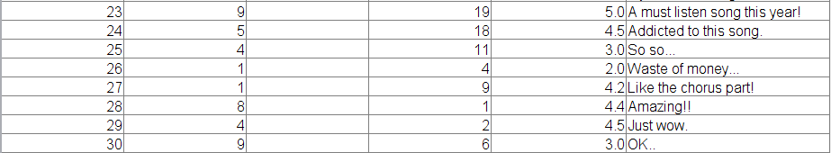

INSERT INTO order

(order_date, order_quantity, order_payment_method, order_card_num, order_tax, user_id)

VALUES

('2012-02-04', 4, 'Master', '5571200428576225', 1.06, 9),

('2015-01-29', 3, 'Master', '1568692387368551', 1.06, 5),

('2014-02-01', 1, 'Master', '4388997619380775', 1.06, 9),

('2015-05-21', 2, 'Visa', '5912626632056525', 1.06, 4),

('2011-09-20', 5, 'CIMB Clicks', '0391325125792567', 1.06, 8),

('2013-06-02', 3, 'CIMB Clicks', '2108903411664564', 1.06, 2),

('2012-06-04', 3, 'Maybank2u', '1665777678804642', 1.06, 6),

('2015-09-20', 2, 'Maybank2u', '1384840526804208', 1.06, 1),

('2016-01-08', 3, 'Visa', '5869674929411283', 1.06, 3),

('2014-07-01', 5, 'Paypal', '7593688480304381', 1.06, 6),

('2015-05-22', 3, 'Master', '5571200428576225', 1.06, 9),

('2015-09-09', 4, 'Visa', '5912626632056525', 1.06, 4),

('2015-12-12', 2, 'CIMB Clicks', '0391325125792567', 1.06, 8),

('2016-01-10', 3, 'Maybank2u', '1665777678804642', 1.06, 6),

('2016-01-15', 1, 'Visa', '5869674929411283', 1.06, 3),

('2016-01-22', 4, 'Maybank2u', '1384840526804208', 1.06, 1),

('2016-01-25', 2, 'Maybank2u', '1384840526804208', 1.06, 1),

('2016-02-03', 1, 'CIMB Clicks', '0391325125792567', 1.06, 8);

SELECT * FROM order;

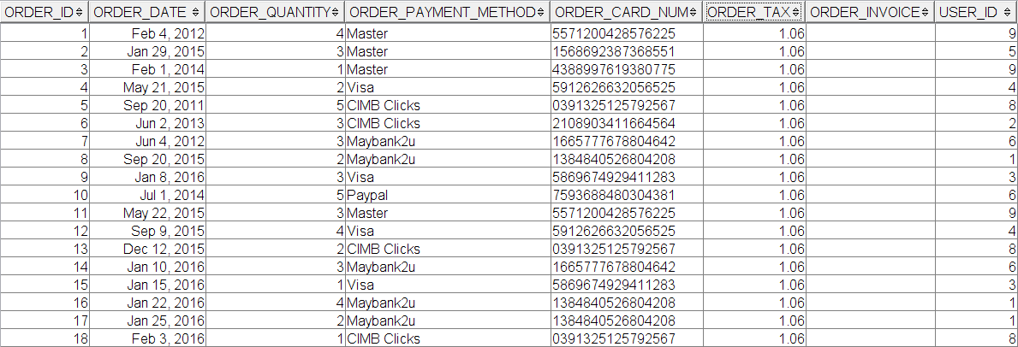

INSERT INTO order_detail

(order_id, album_id, format_id)

VALUES

-- order_id = 1

(1, 3, 1),

(1, 6, 2),

(1, 7, 1),

(1, 9, 1),

-- order_id = 2

(2, 4, 2),

(2, 6, 1),

(2, 5, 2),

-- order_id = 3

(3, 2, 2),

-- order_id = 4

(4, 2, 2),

(4, 10, 3),

-- order_id = 5

(5, 1, 1),

(5, 2, 1),

(5, 4, 3),

(5, 9, 2),

(5, 11, 2),

-- order_id = 6

(6, 5, 3),

(6, 6, 1),

(6, 8, 2),

-- order_id = 7

(7, 3, 1),

(7, 6, 2),

(7, 7, 2),

-- order_id = 8

(8, 6, 2),

(8, 9, 2),

-- order_id = 9

(9, 2, 1),

(9, 3, 1),

(9, 5, 2),

-- order_id = 10

(10, 1, 1),

(10, 5, 1),

(10, 6, 1),

(10, 9, 3),

(10, 10, 2),

-- order_id = 11

(11, 5, 1),

(11, 6, 1),

(11, 2, 2),

-- order_id = 12

(12, 3, 3),

(12, 8, 2),

(12, 7, 2),

(12, 7, 1),

-- order_id = 13

(13, 3, 1),

(13, 8, 3),

-- order_id = 14

(14, 5, 2),

(14, 1, 3),

(14, 3, 2),

-- order_id = 15

(15, 8, 1),

-- order_id = 16

(16, 7, 2),

(16, 4, 3),

(16, 5, 3),

(16, 2, 2),

-- order_id = 17

(17, 8, 3),

(17, 6, 2);

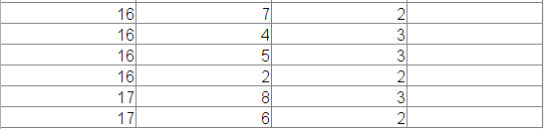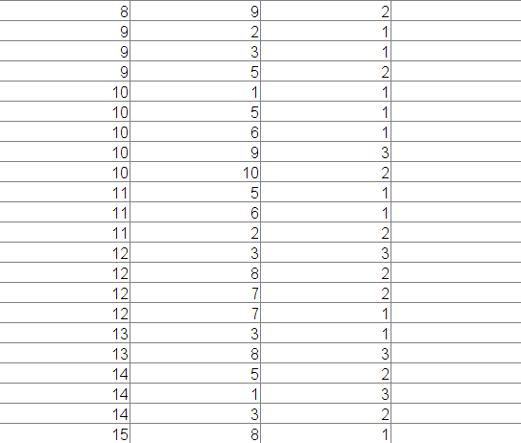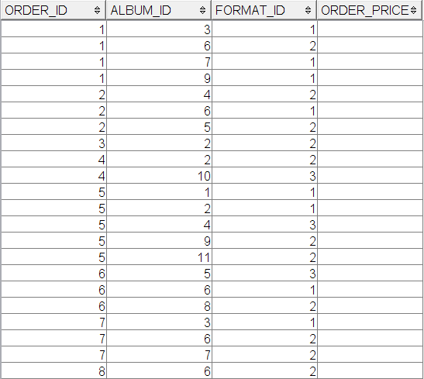SELECT * FROM order_detail;

# Data Manipulation Command (DML)

## (a) Aggregate Funtions

(i) List every song genre and number of songs associated with each.

SELECT song_genre, COUNT(song_id) AS num_of_songs

FROM song

GROUP BY song_genre;

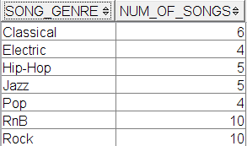

(ii) List albums' popularity by purchase rate.

SELECT album_name, (CAST(((COUNT(order_detail.album_id))/

(SELECT CAST(COUNT(album_id) AS DECIMAL(4,2)) FROM order_detail)) AS DECIMAL(4,2))* 100) AS purchase_percent

FROM order_detail, album

WHERE order_detail.album_id = album.album_id

GROUP BY album_name

ORDER BY purchase_percent DESC;

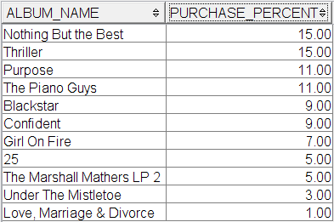

## (b) “Group by” with “having” clause.

(i) List albums with four songs.

SELECT album_name, COUNT(song_id) AS num_of_songs

FROM album, song

WHERE album.album_id = song.album_id

GROUP BY album_name

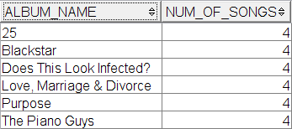 HAVING COUNT(song_id) = 4;

(ii) List albums with its average song rating higher than or equal to four.

SELECT album_name, CAST(ROUND(AVG(song_rating), 2) AS DECIMAL(2,1)) AS AVG_song_rating_of_album

FROM album, song

WHERE album.album_id = song.album_id

GROUP BY album_name

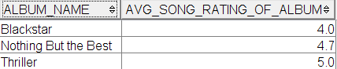 HAVING AVG(song_rating) >= 4;

## (c) Nested Query/ Sub Query

(i) Update username.

UPDATE user

SET user_name = 'Mingo'

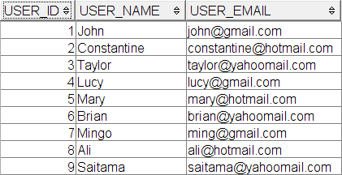WHERE user_id = (SELECT user_id FROM user WHERE user_name = 'Ming');

(ii) Update review rating and comment.

UPDATE review

SET review_rating = 4.0, review_comment = 'Like it after listened n times.'

WHERE user_id = (SELECT user_id FROM user WHERE user_name = 'John')

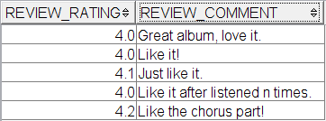AND song_id = (SELECT song_id FROM review WHERE song_id =

## (d) Views

(i) List songs with rating higher than or equal to four.

CREATE VIEW top_rate_songs AS

SELECT song_name, album_name, song_rating

FROM song, album

WHERE song.album_id = album.album_id

AND song_rating >= 4;

SELECT * FROM top_rate_songs;

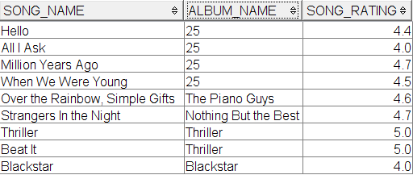

(ii) List users with their total invoice.

CREATE VIEW transaction_history AS

SELECT user_name AS name, COUNT(album_id) AS total_album_purchased, SUM(order_invoice) AS total_price

FROM order, user, order_detail

WHERE user.user_id = order.user_id

AND order_detail.order_id = order.order_id

GROUP BY user_name;

SELECT * FROM transaction_history;

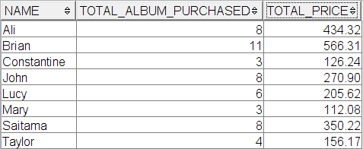

## (e) Trigger

(i) Update album_price

CREATE TRIGGER update_album_price

AFTER INSERT ON song

FOR EACH ROW MODE DB2SQL

UPDATE album

SET album_price =

(SELECT DISTINCT song_price FROM song WHERE album.album_id = song.album_id) *

(SELECT COUNT(song_id) FROM song WHERE album.album_id = song.album_id);

CREATE TRIGGER update_album_price2

AFTER UPDATE OF song_price ON song

FOR EACH ROW MODE DB2SQL

UPDATE album

SET album_price =

(SELECT DISTINCT song_price FROM song WHERE album.album_id = song.album_id) *

(SELECT COUNT(song_id) FROM song WHERE album.album_id = song.album_id);

UPDATE song

SET song_price = 3.80

WHERE song.album_id = 1;

SELECT * FROM album;

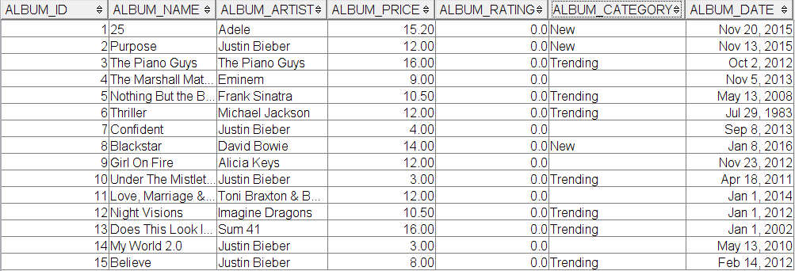

(ii) Update song_rating

CREATE TRIGGER update_song_rating

AFTER INSERT ON review

FOR EACH ROW MODE DB2SQL

UPDATE song

SET song_rating =

(SELECT AVG(review_rating) FROM review WHERE song.song_id = review.song_id);

CREATE TRIGGER update_song_rating2

AFTER UPDATE OF review_rating ON review

FOR EACH ROW MODE DB2SQL

UPDATE song

SET song_rating =

(SELECT AVG(review_rating) FROM review WHERE song.song_id = review.song_id);

INSERT INTO review

(user_id, song_id, review_rating, review_comment)

VALUES

(9, 20, 5.0, 'Legendary song!');

SELECT * FROM song;

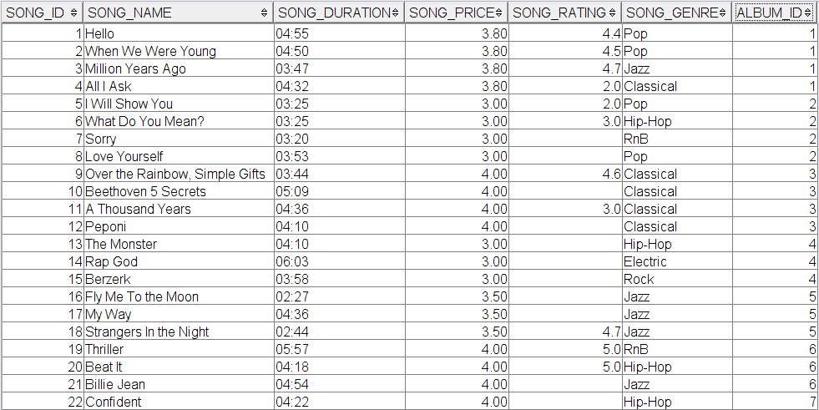

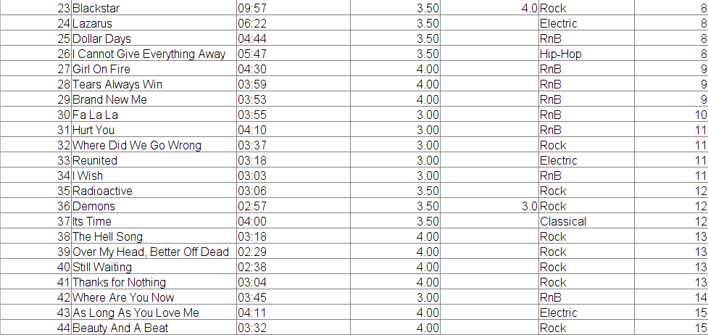

(iii) Update album_rating

CREATE TRIGGER update_album_rating

AFTER INSERT ON review

FOR EACH ROW MODE DB2SQL

UPDATE album

SET album_rating =

(SELECT AVG(review_rating) FROM review WHERE album.album_id = review.album_id);

CREATE TRIGGER update_album_rating2

AFTER UPDATE OF review_rating ON review

FOR EACH ROW MODE DB2SQL

UPDATE album

SET album_rating =

(SELECT AVG(review_rating) FROM review WHERE album.album_id = review.album_id);

INSERT INTO review

(user_id, album_id, review_rating, review_comment)

VALUES

(9, 6, 5.0, 'My favourite album!');

SELECT * FROM album;

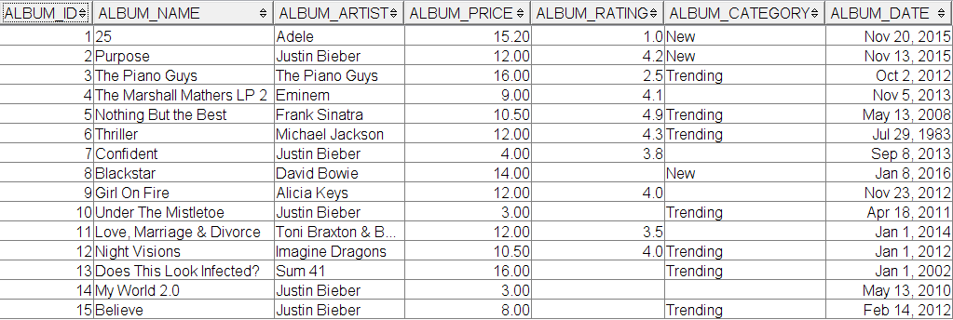

(iv) Update order_price

CREATE TRIGGER update_order_price

AFTER INSERT ON order_detail

FOR EACH ROW MODE DB2SQL

UPDATE order_detail

SET order_price =

(SELECT album_price FROM album WHERE album.album_id = order_detail.album_id) *

(SELECT format_price FROM format WHERE format.format_id = order_detail.format_id);

(v) Update order_invoice

CREATE TRIGGER update_order_invoice

AFTER INSERT ON order_detail

FOR EACH ROW MODE DB2SQL

UPDATE order

SET order_invoice =

order_tax *

(SELECT SUM(order_price) FROM order_detail WHERE order.order_id = order_detail.order_id);

-- Note: Used in conjuction with procedure #1 discount

CREATE TRIGGER update_order_invoice2

AFTER UPDATE OF order_tax ON order

FOR EACH ROW MODE DB2SQL

UPDATE order

SET order_invoice =

order_tax *

(SELECT SUM(order_price) FROM order_detail WHERE order.order_id = order_detail.order_id);

INSERT INTO order_detail

(order_id, album_id, format_id)

VALUES

-- order_id = 18

(18, 5, 2);

SELECT * FROM order_detail; -- after trigger #4

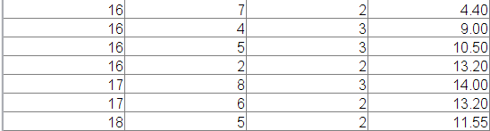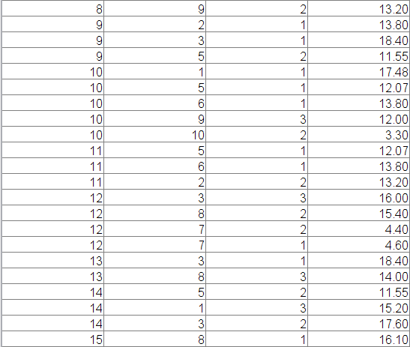

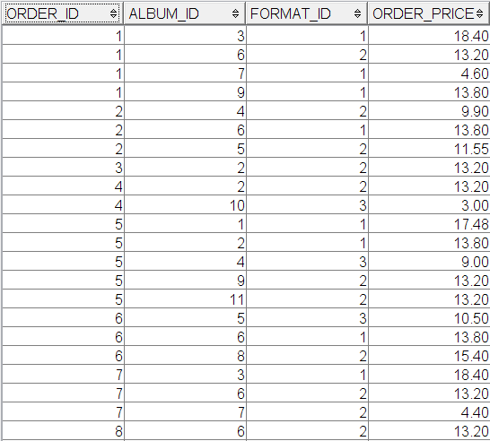

SELECT * FROM order;

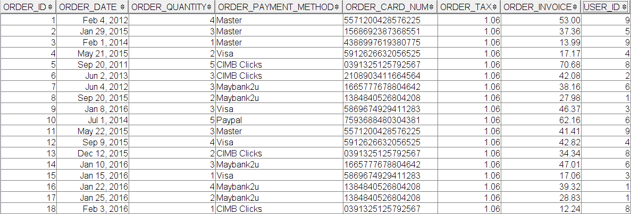

## (f) Stored procedure

(i) Update tax as a discount for customers that purchased more than or equal to three albums. Note: Used in conjunction with trigger #6 update_order_invoice2

CREATE PROCEDURE discount(IN discount_index DECIMAL(3,2))

LANGUAGE SQL

BEGIN

UPDATE order

SET order_tax = order_tax - discount_index

WHERE order_quantity >= 3;

END@

CALL discount(0.06);

SELECT order_id, order_quantity, order_tax, order_invoice

FROM order;

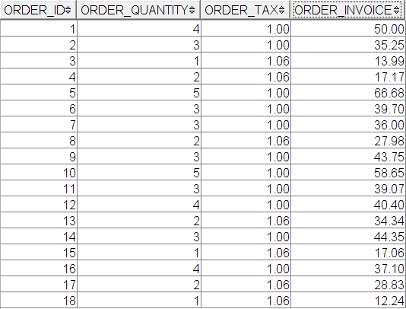

(ii) Update an album's category.

CREATE PROCEDURE update_category(IN category VARCHAR(10), albumID INT)

BEGIN

IF(category = 'New') THEN

UPDATE album

SET album_category = 'New'

WHERE album_id = albumID;

ELSE

UPDATE album

SET album_category = 'Trending'

WHERE album_id = albumID;

END IF;

END@

CALL update_category('Trending', 4);

SELECT * FROM album;

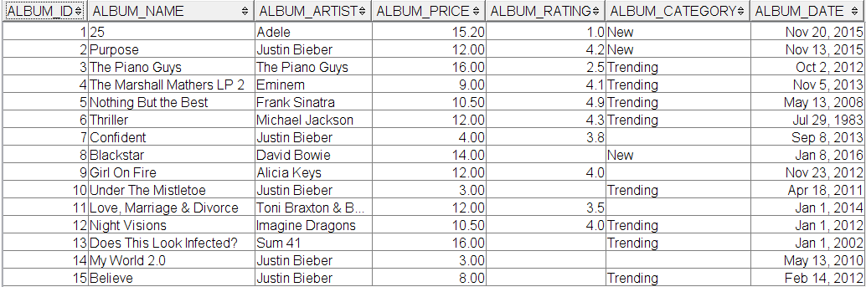

## (g) Additional query component

(i) List the most recent five orders from John.

SELECT order_date, album_name AS album_purchased, CAST(ROUND((order_price * order_tax),2) AS DECIMAL(5,2)) AS final_price

FROM order, album, order_detail

WHERE order_detail.album_id = album.album_id

AND order_detail.order_id = order.order_id

AND user_id = (SELECT user_id from user WHERE user_name = 'John' AND user.user_id = order.user_id)

ORDER BY order_date DESC

FETCH FIRST 5 ROWS ONLY;

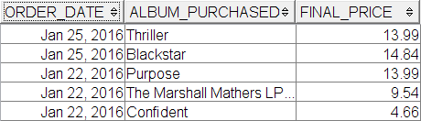

(ii) List songs rated and ratings given by Brian.

SELECT song_name AS rated_song, review_rating AS rating_given, user_name AS rated_by

FROM song, review, user U

WHERE U.user_id = review.user_id

AND review.song_id = song.song_id

AND U.user_id = (SELECT user_id FROM user WHERE user_name = 'Brian');

