Total marks for each student across all subjects.

Maximum marks scored in each subject.

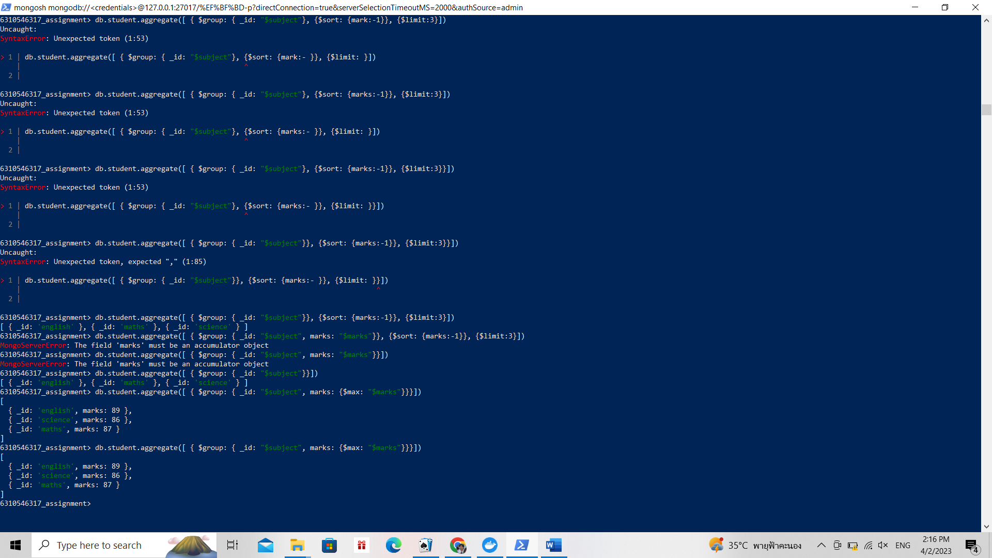

Minimum marks scored by each student.

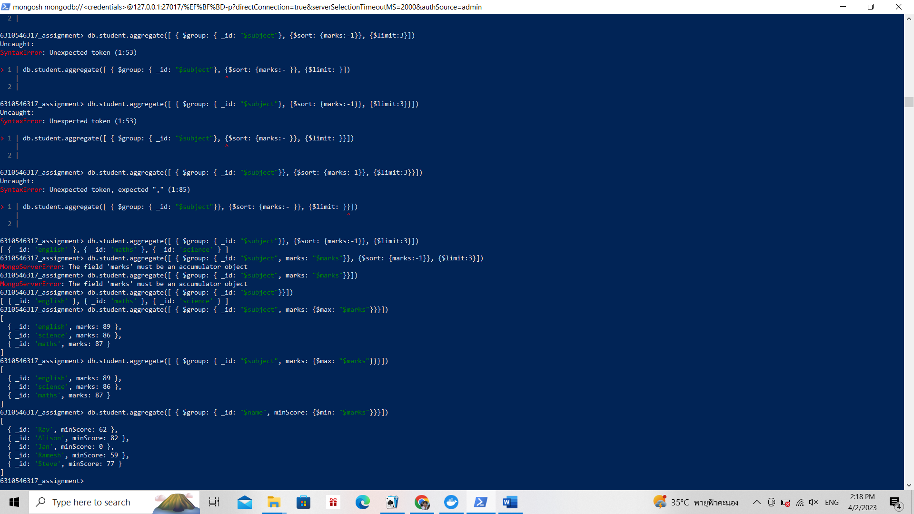

Top two subjects based on average marks.

