# Code review for Power Function

The review was conducted on August 6th, 2021, using a bottom-up approach, starting from the file, and moving towards the code.

## The File

To begin, the function’s file name directly follows the PEP8 convention, which was the agreed-on standard for this project. The agreed upon standard was lowercase characters with underscore separation: standard_deviation.py. The name also perfectly describes what the module is expected to carry and is straight to the point making the file access easy.



Figure : File name

## The Code

One concern is the public declaration of the attribute “base” and “exponent. Object oriented design guidelines suggest encapsulation of class attributes to avoid privacy leak and allow for manipulation of the attribute through safer means like accessors and mutators.

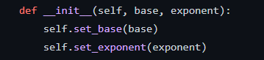

Figure 2: Public attribute

Another concern is the absence of module, class, and function headers however, comments inside the code provide concise description for the attributes and functions.

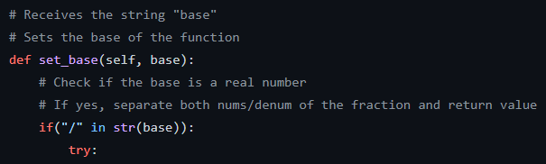

Figure 3: Comments

As for the implementation of the function and all its ‘helper’ functions, they are concise and serve a useful purpose. The code is well structured, it is very easy to read through and understand and follows the PEP8 naming conventions. In short, the code is well written.