Definition of function and glossary

In [mathematics](https://en.wikipedia.org/wiki/Mathematics), hyperbolic functions are analogues of the ordinary [***trigonometric functions***](https://en.wikipedia.org/wiki/Trigonometric_function), but defined using the [***hyperbola***](https://en.wikipedia.org/wiki/Hyperbola) rather than the [circle](https://en.wikipedia.org/wiki/Circle). Just as the points (cos *t*, sin *t*) form a [circle with a unit radius](https://en.wikipedia.org/wiki/Unit_circle), the points (cosh *t*, sinh *t*) form the right half of the [unit hyperbola](https://en.wikipedia.org/wiki/Unit_hyperbola).

Hyperbolic functions occur in the calculations of angles and distances in hyperbolic geometry. They also occur in the solutions of many linear ***differential equations*** (such as the equation defining a ***catenary***), cubic equations, and ***Laplace's equation*** in ***Cartesian coordinates***.[1]

The formula for calculating Sinh(x) is as below:

$$\sin{h\left(x\right)}=\frac{ⅇ^{x}-ⅇ^{-x}}{2}$$

Domain and the Rang of the function is R and there is no limitation for its input. In the figure below, we can see the graph related to this function.

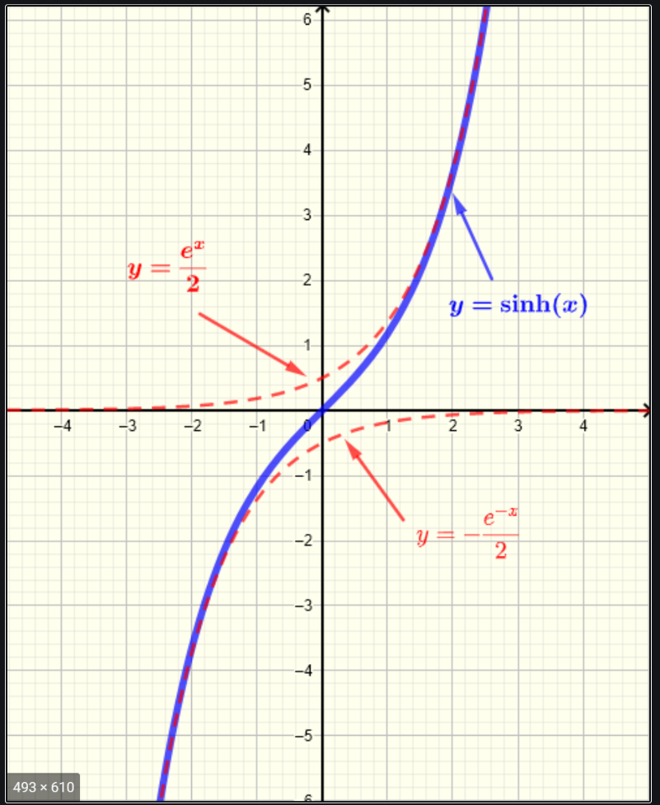

Figure1 [8]

Glossary

* [**trigonometric functions**](https://en.wikipedia.org/wiki/Trigonometric_function)**:**

In [mathematics](https://en.wikipedia.org/wiki/Mathematics), the trigonometric functions (also called circular functions, angle functions or goniometric functions) are [real functions](https://en.wikipedia.org/wiki/Real_function) which relate an angle of a [right-angled triangle](https://en.wikipedia.org/wiki/Right-angled_triangle) to ratios of two side lengths. They are widely used in all sciences that are related to [geometry](https://en.wikipedia.org/wiki/Geometry), such as [navigation](https://en.wikipedia.org/wiki/Navigation), [solid mechanics](https://en.wikipedia.org/wiki/Solid_mechanics), [celestial mechanics](https://en.wikipedia.org/wiki/Celestial_mechanics), [geodesy](https://en.wikipedia.org/wiki/Geodesy), and many others.[2]

* [**hyperbola**](https://en.wikipedia.org/wiki/Hyperbola)

A hyperbola is an open curve with two branches, the intersection of a plane with both halves of a double cone. The plane does not have to be parallel to the axis of the cone; the hyperbola will be symmetrical in any case.[3]

* **differential equations**

differential equation is an equation that relates one or more functions and their derivatives. In applications, the functions generally represent physical quantities, the derivatives represent their rates of change, and the differential equation defines a relationship between the two. Such relations are common; therefore, differential equations play a prominent role in many disciplines including engineering, physics, economics, and biology.[4]

* **Catenary**

The **catenary** curve has a U-like shape, superficially similar in appearance to a parabolic arch, but it is not a parabola. In physics and geometry, a **catenary** is the curve that an idealized hanging chain or cable assumes under its own weight when supported only at its ends.[5]

* **Laplace's equation**

**Laplace’s equation** is a kind of differential equations which is widely used in electrical and magnetic. It has a special kind of solution.[6]

* **Cartesian coordinates system**

A Cartesian coordinate system in a plane is a coordinate system that specifies each point uniquely by a pair of numerical coordinates, which are the signed distances to the point from two fixed perpendicular oriented lines, measured in the same unit of length.[7]

References

|  |  |
| --- | --- |
| [1] | Wikipedia contributors, “Hyperbolic functions,” *Wikipedia, The Free Encyclopedia*. [Online]. Available: https://en.wikipedia.org/wiki/Hyperbolic_functions. [Accessed: 09-Jun-2021]. |
| [2] | Wikipedia contributors, “Trigonometric functions,” *Wikipedia, The Free Encyclopedia*. [Online]. Available: https://en.wikipedia.org/wiki/Trigonometric_functions. [Accessed: 09-Jun-2021]. |
| [3] | Wikipedia contributors, “Hyperbola,” *Wikipedia, The Free Encyclopedia*. [Online]. Available: https://en.wikipedia.org/wiki/Hyperbola. [Accessed: 09-Jun-2021]. |
| [4] | Wikipedia contributors, “Differential equation,” *Wikipedia, The Free Encyclopedia*. [Online]. Available: https://en.wikipedia.org/wiki/Differential_equation. [Accessed: 09-Jun-2021]. |
| [5] | Wikipedia contributors, “Catenary,” *Wikipedia, The Free Encyclopedia*. [Online]. Available: https://en.wikipedia.org/wiki/Catenary [Accessed: 09-Jun-2021]. |
| [6] | Wikipedia contributors, “Laplace’s equation,” *Wikipedia, The Free Encyclopedia*. [Online]. Available: https://www.britannica.com/science/Laplaces-equation [Accessed: 09-Jun-2021]. |
| [7] | “Cartesian coordinate system,” *britannica.com*. [Online]. Available: https://en.wikipedia.org/wiki/Cartesian_coordinate_system [Accessed: 09-Jun-2021]. |
| [8] | “Sinh-graph” *analyzemath.com*. [Online]. Available: https://www.analyzemath.com/GraphsHyperbolicFunctions/GraphsHyperbolicFunctions.html [Accessed: 09-Jun-2021]. |