**Decision making and description (Sinh(x))**

**Decision Making**

There are possible ways to implement the HyperbolicSine class. During the possible ways, I choose to implement it step by step as different functions.

So the formula for the Sinh(x) is $\frac{ⅇ^{x}-ⅇ^{-x}}{2}$. For the implementation as the first function is calculated. Then as the second function, is implemented and in the final part, the total answer is calculated. This way is chosen because it is easier to be followed by a reader. Then setter and getter for the class attributes are implemented.

**Pseudocode**

The pseudocode for the implementation is as follows:

Input: e as Euler number and a real or complex number as x

Output: the result of Sinh(x)

expPositive = e ** x

expNegative = e ** -x

numerator = expPositive – expNegative

return (numerator/2)

The time and space complexity of the algorithm O(1).

**Test**

As it can be seen in the following photo, the test has been done on two variables x. The first one is a real variable, and the second one is a complex variable.

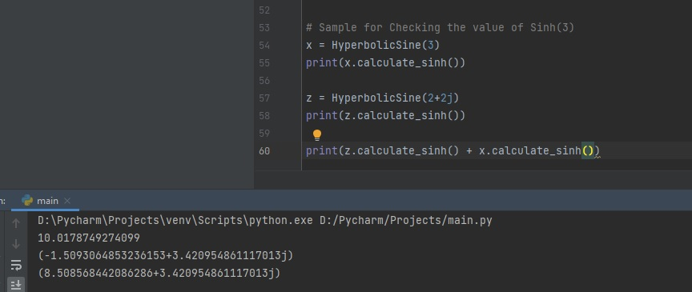

**Task**

Compute the multiplication of Sinh(2.5) with Sinh(3), and add the result to Sinh(2+2j) using the Sinh(x) Function. (Sinh(2.5)*Sinh(3)) + Sinh(2+2j))

**Micro** **Structure**

The micro-structure for the Sinh(x) function is conforming to Object-Oriented design. For doing the process, at the first step, one instance of HyperbolicSine class should be created. The parameters of the constructor of this Class are the value that we want to do the calculation on. The Class has two more attributes. The first one is the Euler number, which is a constant, and we use the math library to use it. The second parameter is the Sinh, which is initialized in the constructor to be zero.

The first function of the class which is *_calculate_exponential* will calculate $e^{x}$. As the Sinh function is $\frac{ⅇ^{x}-e^{-x}}{2}$, the second function(*_calculate­_numerator*) is calculating the numerator of the fraction. The third function (calculate_*sinh*), which is the main function of the class, is calculating the answer of the function. It uses two last functions to calculate the final response.

Other functions of the Class are setters and getters, which will set the values of the Class.