1. Check if PCI-e Current-Link-Speed is correct by the command “$lspci” & the tool “RU_Linux”.
2. Device Side: PCIE Capability Header + Offset 0CH (Support Speed)

PCIE Capability Header + Offset 12H (Current Link-Speed)

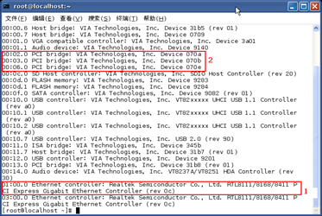

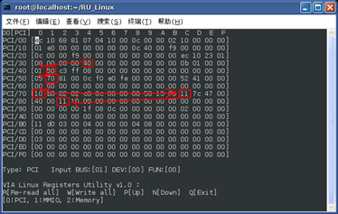

1. Root Port Side:  Check if RX “19” is the device “Bus” address. If so, check from RX“34”to find the value “10”.

RP_Rx4C[7:4](Link width x8/x4/x2/x1), Rx4C[3:0](Supported Link Speed)

RP_Rx52[7:4](Link width x8/x4/x2/x1), Rx52[3:0](Current Link Speed)

