Using Grafana In A Web Application

**Introduction**

Grafana is a way of visualizing time series data, i.e. a set of paired data (x, y) where x measured in time and y is measured in some other unit, such as meters, users or doodads. With Grafana, you create dashboards through the UI which can then be accessed through calls to a server and embedded in web applications.

When running, Grafana sets up a server and exposes an API that allows you to make post and get requests to obtain the dashboards you create within the Grafana UI. You can also manually create dashboards through API calls. The API documentation can be found at:

[https://grafana.com/docs/reference/http_api/#users](https://grafana.com/docs/reference/http_api/%23users)

There is also a library of pre-made dashboard provided by the Grafana community available at:

<https://grafana.com/grafana/dashboards>

These dashboards can be configured to most data sources and embedded in your web application as you please. In general, Grafana has excellent documentation available at:

<https://grafana.com/docs/>

that will walk you through the whole setup and configuration process. However, if you want the bare minimum to get Grafana up and running and put to work in your application, this document will hopefully provide that. By the end, you should have a local Grafana server serving up a custom dashboard that will display in a simple html component you can embed in a larger web application.

**Grafana Setup**

1. First things first. Download the Grafana binaries. Here are the links.

WINDOWS:

Download zip file containing binaries from:

<https://grafana.com/grafana/download?platform=windows>

LINUX:

*haven't installed on linux yet, see here:

<https://grafana.com/grafana/download?platform=linux>

2. Before extracting file, right click zip file and click Properties. Make sure the 'unblock' checkbox is marked. Then, extract the folder to where ever you want Grafana to run from.

3. Go to the /conf/ folder in the extracted folder. Copy and past the 'sample.ini' file and rename it 'custom.ini'. This file will configure you server.

All of the properties are commented out by default. You will need to uncomment the following,

3A. In the Security heading,

admin_user = root

admin_password = root

**Note: set your username and password to whatever.

3B. In the Server heading,

http_port = 8088

**Note: set your server port to whatever. This is where

grafana serves.

**Setup Local Database**

4. Download Postgres from the following link,

<https://www.postgresql.org/download/>

Create a database on your local computer. You can do so manually, but pgAdmin is much easier. pgAdmin is one of the options you can install along with the basic Postgres installation. If you already have Postgres, but you don't have a pgAdmin, download and install it from here,

<https://www.pgadmin.org/download/>

Once you have pgAdmin, right click your localhost server (create a server on your localhost if one isn't set up by default) and click Create > Database. Title the database whatever you want; I called mine 'dfas'.

This database will act as the data source for Grafana, which we will configure in the next section. Postgres should set up on port 5432 by default. We will need to tell Grafana whatever port Postgres is running on, so take note.

5. Create a table with two columns. Name one of the columns 'value' (otherwise you will need to specify the column to graph in Grafana; by default, Grafana looks for the 'value' column plus a column that contains time-format information, or a ‘timestamp’). Name the other column 'date' or 'time' or something like that. Make sure the columns have the data types seen in the following picture (otherwise you will need to configure a macro to format the incoming time into something Grafana understands).

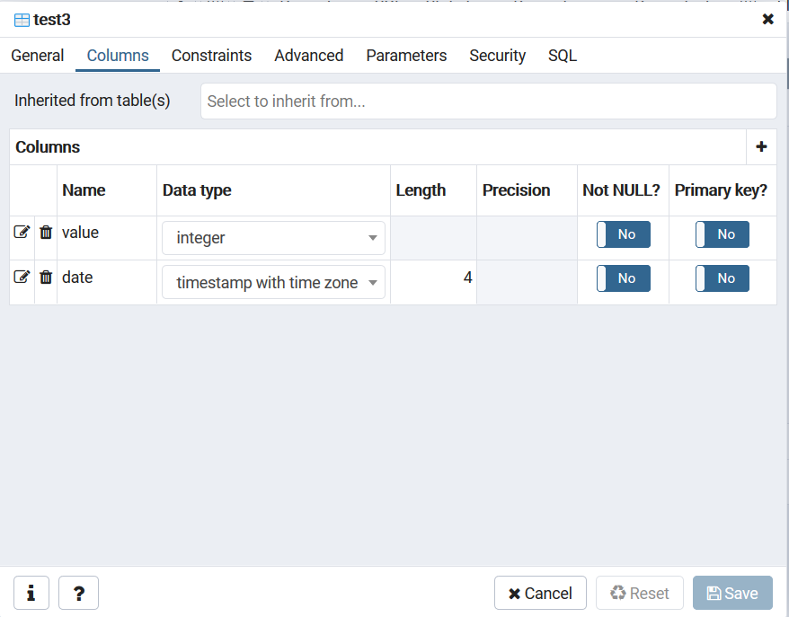

6. Insert some test data by right clicking the table and creating an INSERT script, shown below,

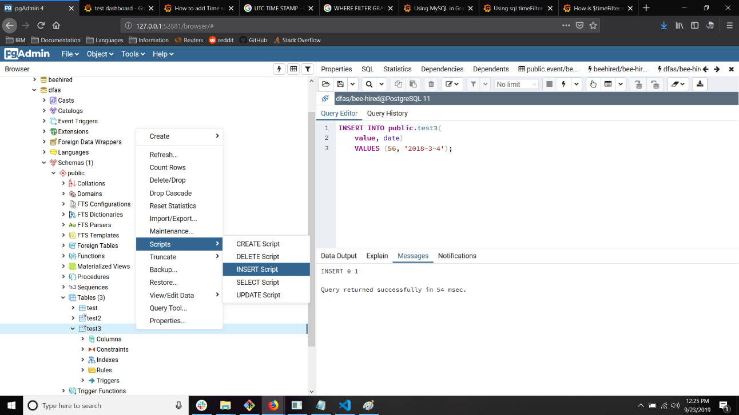

We will create a visualization for this data in Grafana after we connect the database in the following steps.

**Start Grafana Server and Create Dashboard**

7. Go to the Grafana /bin/ folder in the extracted zip file and double-click the 'grafana-server.exe' or navigate to the folder in a shell and call the executable. This will start the Grafana server, assuming there are no other processes running on the port you specified in Step 3.

8. Once the Grafana server is up and running, go to http://localhost:8088 in your browser. You will see the Grafana login page. Enter the admin_user and admin_password from Step 3. You will be taken to the Grafana dashboard,

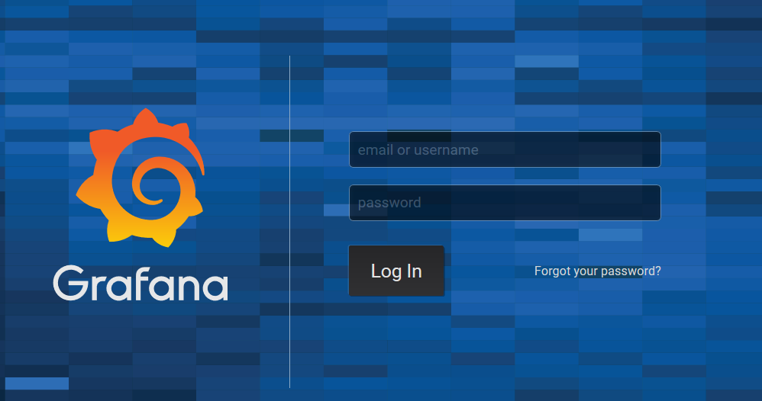

8. From the Dashboard, click the Hamburger Icon and select ‘*Data Sources*’ from the Configuration submenu. Click ‘*Add Data Source*’. You will see a list of common data sources. There should be an entry for PostgresSQL,

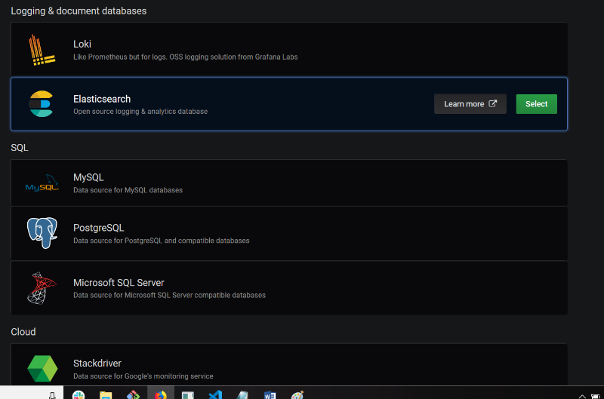

If you don’t see a Postgres data source, try searching for it. If you still can’t find one, you may have to install a plugin from grafana.com.

9. In the PostgresSQL Connection Menu, enter the information about the host, database name, username and password. Disable SSL. Here is what you should see,

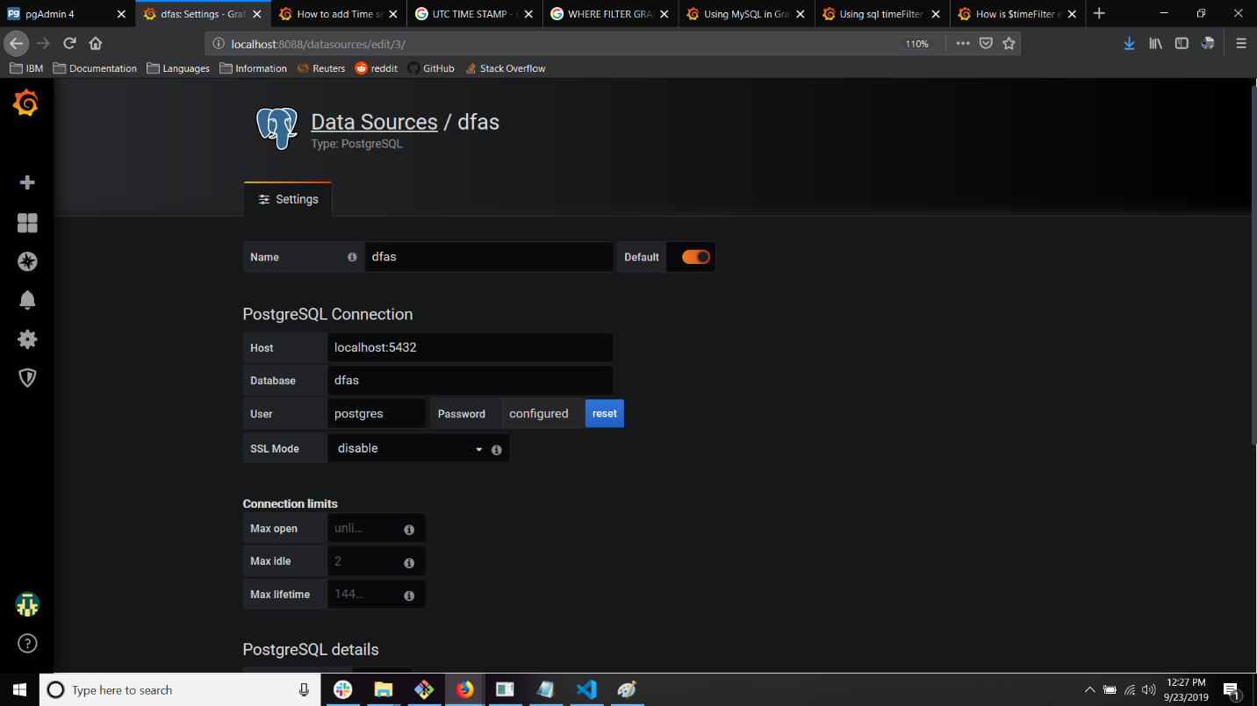

If you have everything configured properly, scroll to the bottom and click 'Save & Test'. If everything goes well, you will see a green success message and the data source will now be available from the ‘*Data Sources’* menu.

NOTE: The Host has the grayed out text localhost:5432 by default, but that isn't actually typed into the box. It can be a source of frustration wondering why it isn't connecting.

10. After the data source is added, you are ready to create a dashboard. Click the Add Dashboard button and Add A New Panel, shown below,

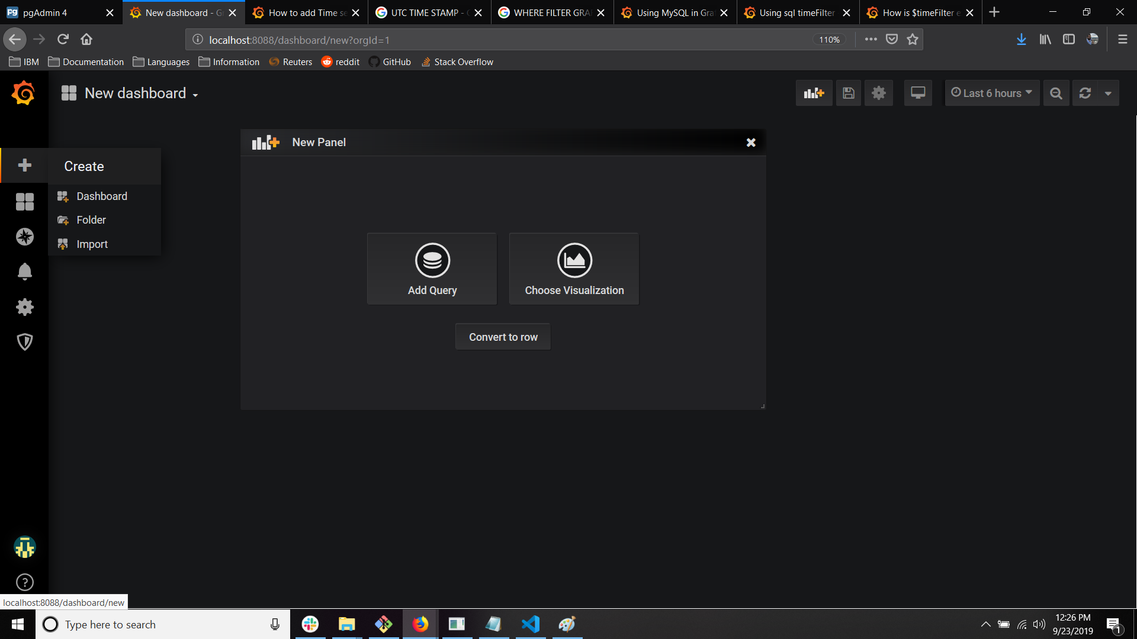

11. Click the Panel title and select Edit. This will bring up the query builder. Enter in the following query and the graph should automatically populate.

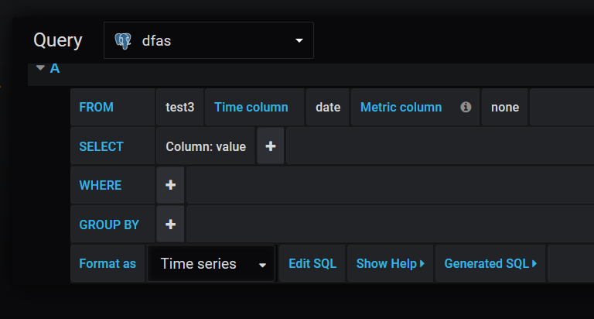

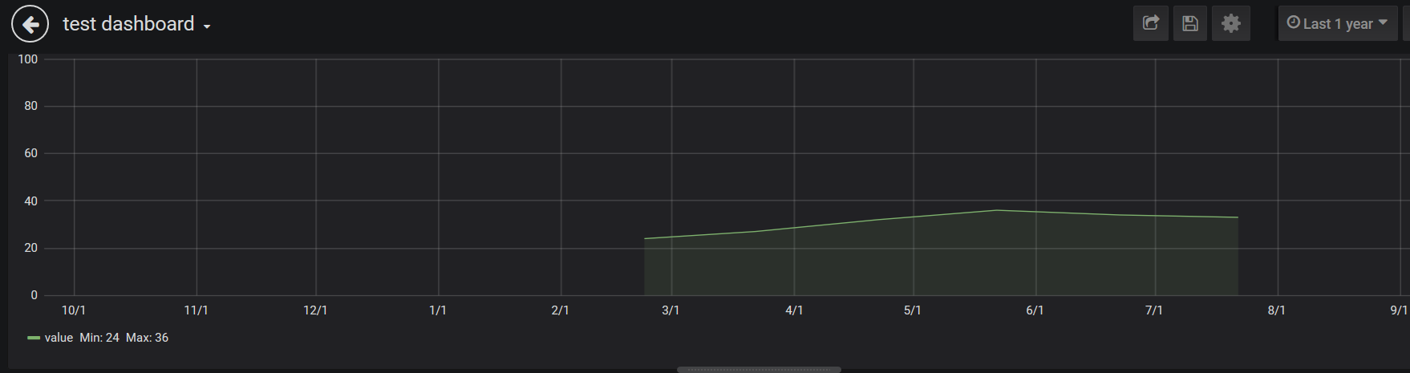

Glorious, isn’t it?

12. Once the Dashboard is created, save it. To access the Dashboard with a HTTP get request, you need to create an API key to append to all those requests so Grafana can authenticate you. The API Key can be created like so,

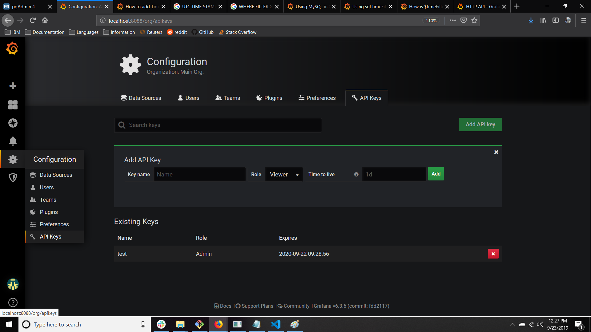

Enter the key name, the role (roles can be edited in the dashboard settings to allow whatever permissions you want), and the lifetime of the key. Now the dashboard can be accessed by the API exposed by the Grafana server. See

<https://grafana.com/docs/reference/http_api/>

for more details about the API. We will use the ‘GET’ documentation in the next section to create an html component that displays the dashboard we just created.

13. With the Grafana server running in the background, verify you can GET the dashboard using either **curl** in bash,

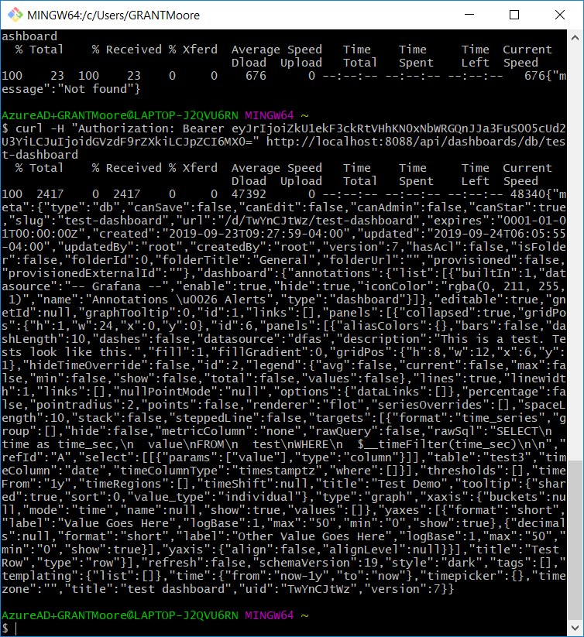

Or by using Postman to form a request with the API key in the Authorization header,

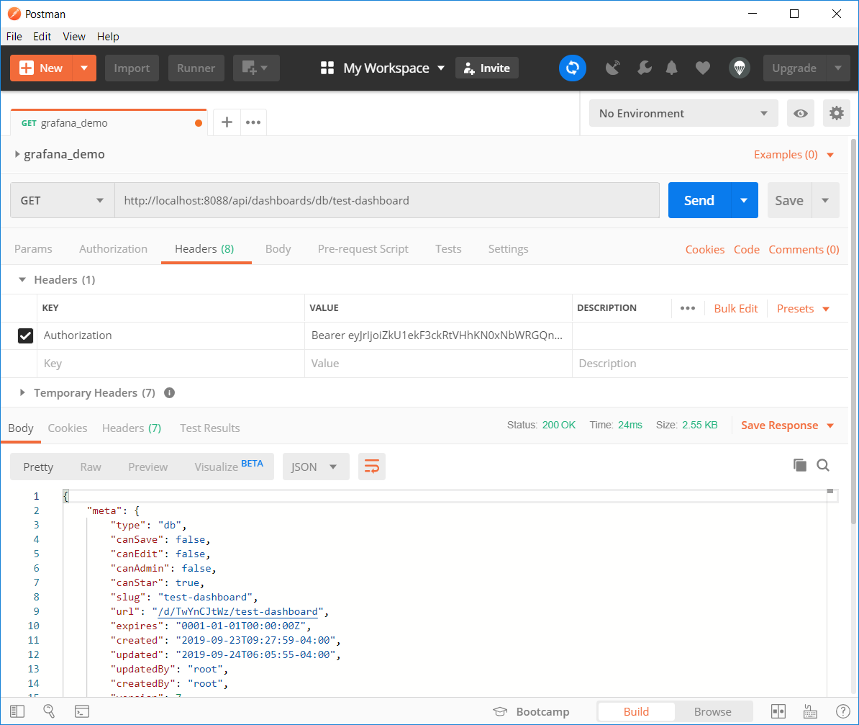

Now we have a Grafana server capable of serving up the dashboard we created. Next let’s create a html component to display this dashboard.

**Embed Dashboard in Html With Iframe Element**

14. The idea is to provide an iframe html element with the GET request for the Grafana dashboard as the iframe source. However, the current Grafana configuration needs all requests to be authenticated with the API key generated in Step 12. The quickest (and least secure way) to get a Grafana panel embedded into your web application is to allow anonymous access to your Grafana server. This can be done in the ‘custom.ini’ file found in the /conf/ folder in the Grafana installation.

Find the following headings and set the properties as shown

14 A. In Auth Heading,

enabled = true  
 org_name = IBM_DFAS  
 org_role =Viewer

15. Almost there. In the previous step, you assigned an organization to anonymous users. You now have to add that organization to Grafana’s list of allowed organization, through its UI. With the Grafana server running in the background on port 8088, navigate to <http://localhost:8088/> and login with the credentials you set up in the first few steps. Find the ‘*Org*s’ tab and add the organization, as shown below,

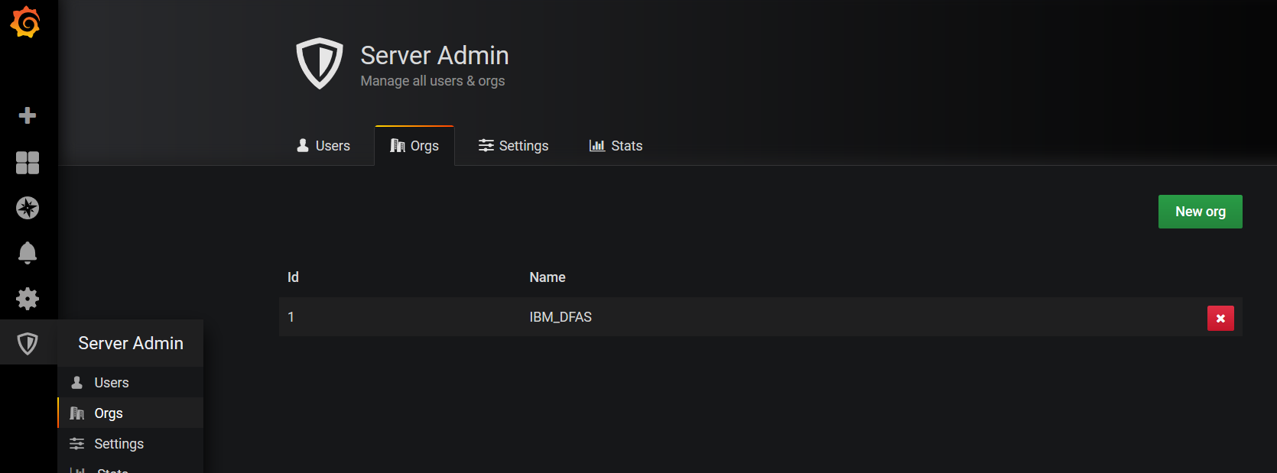

16. Now, all you have to do is create an HTML document, insert an *img* element and set the *src* attribute to the Grafana endpoint that renders your panel,

<http://localhost:8088/render/d-solo/DASHBOARD_KEY/DASHBOARD_NAME>

Or in other words, copy the following element into the HTML document,

<img src = ‘http://localhost:8088/render/d-solo/DASHBOARD_KEY/DASHBOARD_NAME>

17. Open up the document in a browser and you should see the glorious results,

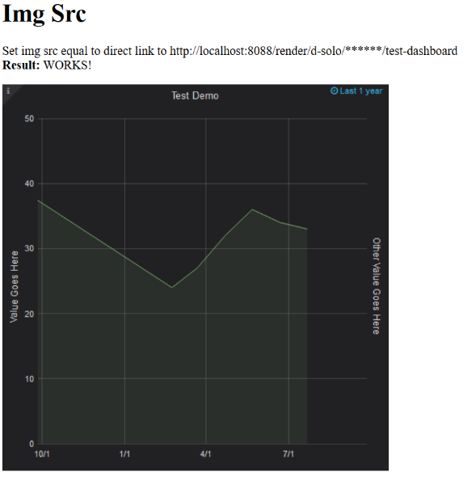

**Setup Proxy To Forward Requests to Grafana Server**

18. The above setup works in local setups and production environments where the Grafana server port is exposed to the public. However, if anonymous access is enabled in Grafana, you probably don’t want to expose the port to the outside world. Instead, you will want to set up a proxy that forwards requests to the Grafana server and returns the response back to the original sender. The final section of this tutorial will cover how to setup a Node server conforming to this configuration.