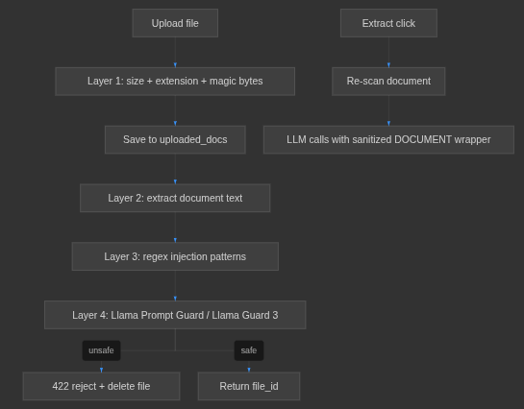
1. Specification Intelligence

/home/tcs/genai_setups/5G_RCA_Electron_New_UI/Backend/resources/extract/datasets/LTE/5G NSA attach and detach of single UE/total_content.txt (searched under Backend/resources/extract)

Upload → extract text → split into chunks
↓
Layer 1 (Deterministic approach) on ALL chunks ← fast, deterministic
↓
Suspicious? ──No──→ skip (clean chunk, continue)
│
Yes
↓
Layer 2 (Llama Guard- model based approach) on that chunk only ← ML
↓
Any chunk unsafe? → REJECT document
All clear? → ACCEPT

LLM Output
↓
Schema Validator
↓
Hierarchy Validator Output Guardrails
↓
Source Traceability Validator
↓
Save Dataset

