**Sprint Review Meeting**

**Sprint 2:**

**When to held:**

* End of each sprint.

**Participant Involved:**

* Scrum Master (Hiew Chin Ching)
* Team member (Christopher Foh Wei Chung, Chu Yung Onn, Ho Kin Hoe, Chua Jien Xian, Kelvin)
* Product owner & Stakeholder

**Purpose:**

* This meeting is held to allow Scrum Master and his team to demonstrate part of the system developed or the part accomplished to the stakeholder to allow full transparency on the system.
* This meeting also allow Scrum Master and his team to gather feedback from the stakeholder regarding the system developed or part of the system developed.
* Another purpose is to gather approval from the customer whether the developed system or the increment product acceptable or not.
* This meeting is also used to allow the Scrum Master to report the status of the sprint and the status of the user stories complete / incomplete so the Product owner can have the full context regarding the whole situation.

**Module Involved:**

* Bus Schedule Module
* Payment Module
* Report Module
* Member Module

**Review User Stories Session**

**Bus Ticketing Module**

|  |  |  |
| --- | --- | --- |
| **User Stories** | **Status** | **Satisfied/Dissatisfied** |
| Customer select date and time for bus | Started | Satisfied |
| Customer able to select schedule and seats | Started | Dissatisfied |
| Customer view bus schedule and available seat | Started | Satisfied |

**Payment Module**

|  |  |  |
| --- | --- | --- |
| **User Stories** | **Status** | **Satisfied/Dissatisfied** |
| Customer select the type of payment method | Started | Satisfied |
| Customer enter their payment detail | Started | Dissatisfied |
| System to verify customer’s payment detail | Started | Satisfied |
| System to calculate cost and refund | Started | Satisfied |
| Online receipt and ticket to be generated | Started | Satisfied |

**Report Module**

|  |  |  |
| --- | --- | --- |
| **User Stories** | **Status** | **Satisfied/Dissatisfied** |
| View yearly, monthly or weekly report | Started | Satisfied |
| Select type of report | Started | Satisfied |
| Print out the report | Started | Satisfied |

**Member Module**

|  |  |  |
| --- | --- | --- |
| **User Stories** | **Status** | **Satisfied/Dissatisfied** |
| Staff delete a member | Started | Satisfied |
| Staff view and search for existing member | Started | Satisfied |
| System to verify customer’s detail | Started | Satisfied |
| Customer edit member detail | Started | Satisfied |
| Customer register as new member | Started | Satisfied |

**Customer Feedback 1**

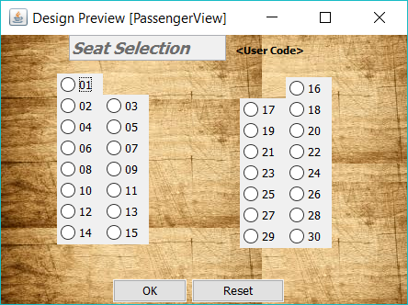

The title should be aligned to the middle. The background picture should be in one piece instead of combining of many pictures together as one background. The radio button should be look more attractive instead of grey and the button if can should be enlarge for ease for selection of seats.

**Customer Feedback 2**

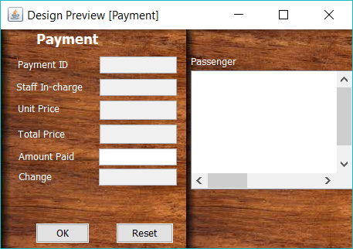

Align the box on the right to make it look better. The button should be right in the middle of the page instead of left align which looks so untidy.