**Contact For Price**

**Product specification**

Contact For Price is a Magento 2 extension developed by PIT solutions which supports e-commerce shop owners to manage the product price and Add To Cart button visibility. It pushes customers to contact the store as well as hide product price effectively.

**Features**

* Hide price and Add To Cart button for individual products.
* Hide price and Add To Cart button for products in a category.
* Replace product price with ‘Request For Price’ or ‘Call For Price’ button.
* Easy to manage price visibility.
* Can customize ‘Request For Price’ button label.
* Pop-up price request form for customers.
* Enable/ Disable the extension.
* Directly communicate with store via email or telephone.
* Access control for admin users.

**Screenshots / Video**

**Configuration:**From the admin backend, go to Stores > PITS Configuration > Contact For Price

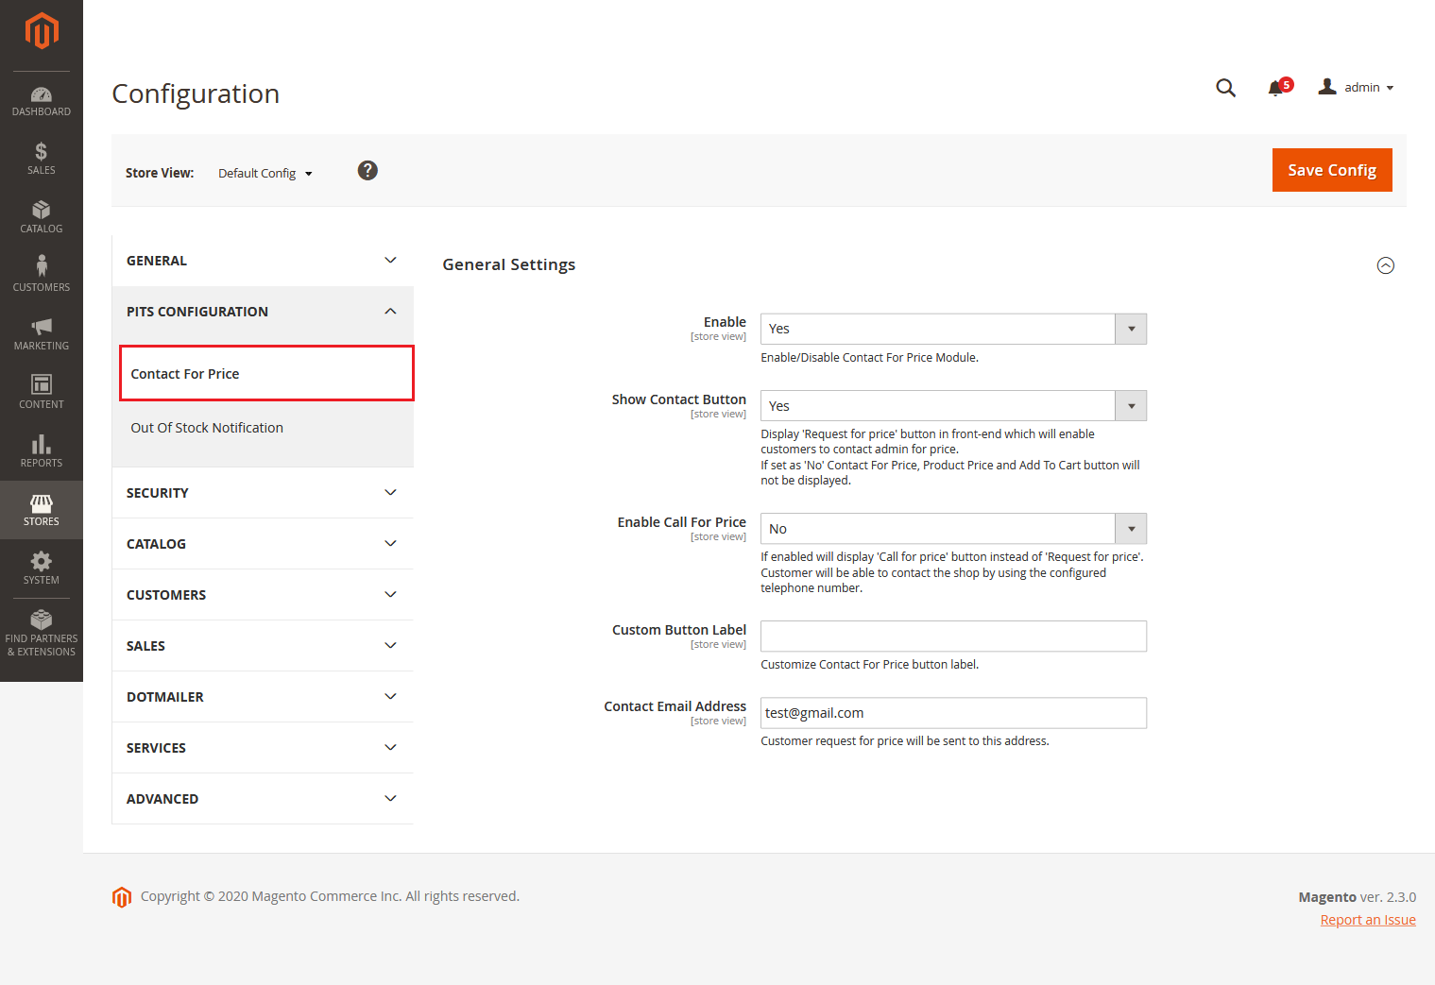

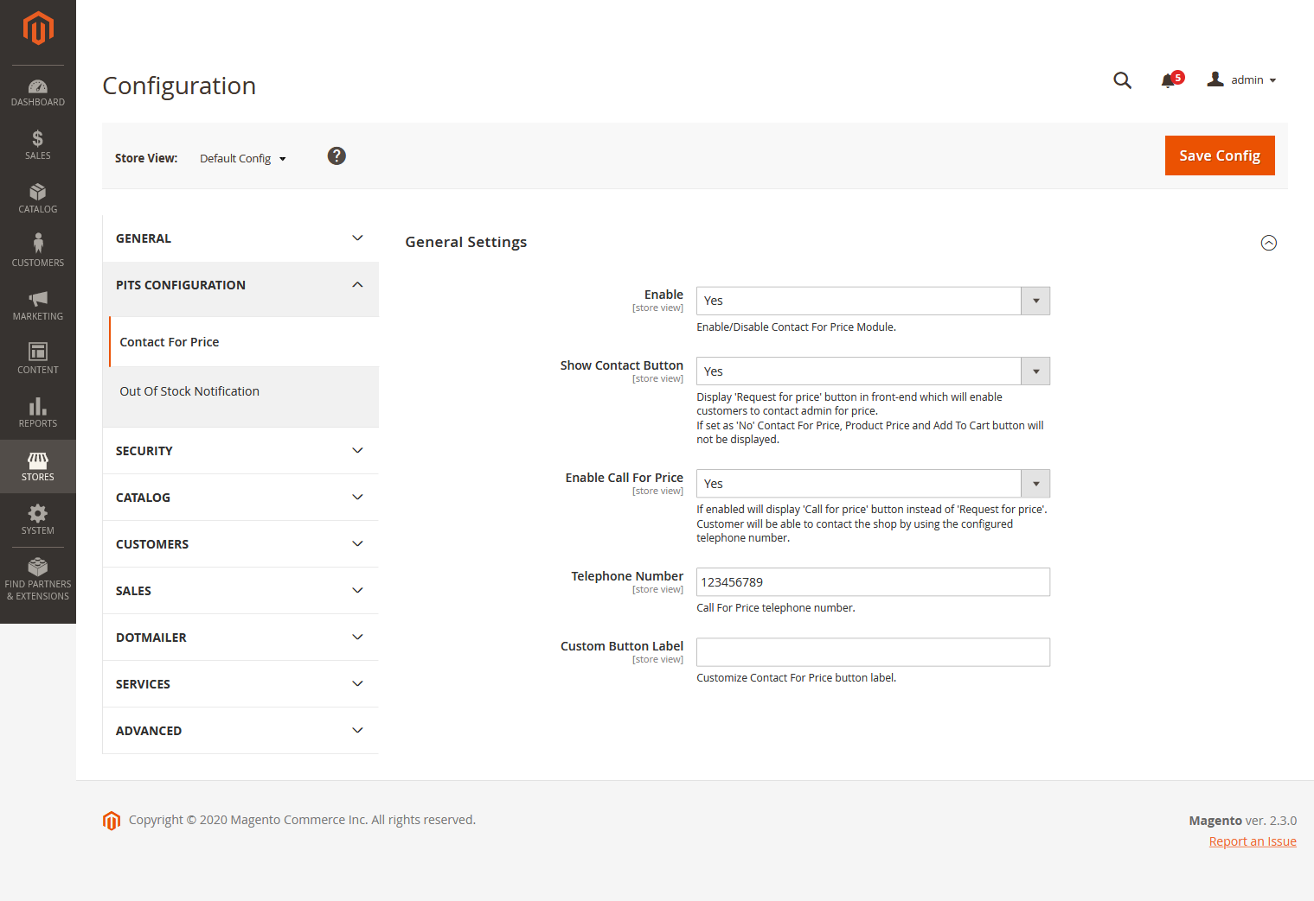

1. Enable the module. Select **Yes** in the Enable dropdown option.

2. Keep **Show Contact Button** option as **No** if you don’t want to show **Request for price** button for the product.

3. Select **Show Contact Button** option as **Yes** if you want to hide price and Add to Cart button of product and display **Request for price** button in place of product price in the frontend. Clicking this button will open a pop-up where customer can submit request for a specific products price.

4. Select **Enable Call for Price** option as **Yes** if you want to enable customers with option to call shop directly via telephone. If the option is enabled ‘**Call for price’** button will be displayed instead of ‘**Request for price**’ button. On clicking the button telephone application will be opened in the customer’s device with Admin’s telephone number in it. You can specify the telephone number in the **Telephone Number** field.

6. You can change the **Request for price/Call for price** button label by entering new label in the **Custom Button Label** field.

7. Please enter the email address in the field **Contact Email Address** to where you want to get the request from customers for price.

8. Click **Save Config** and clear the cache. That’s it.

To hide price and Add to Cart for a specific product set **Hide Product Price** to **Yes** by editing the product.

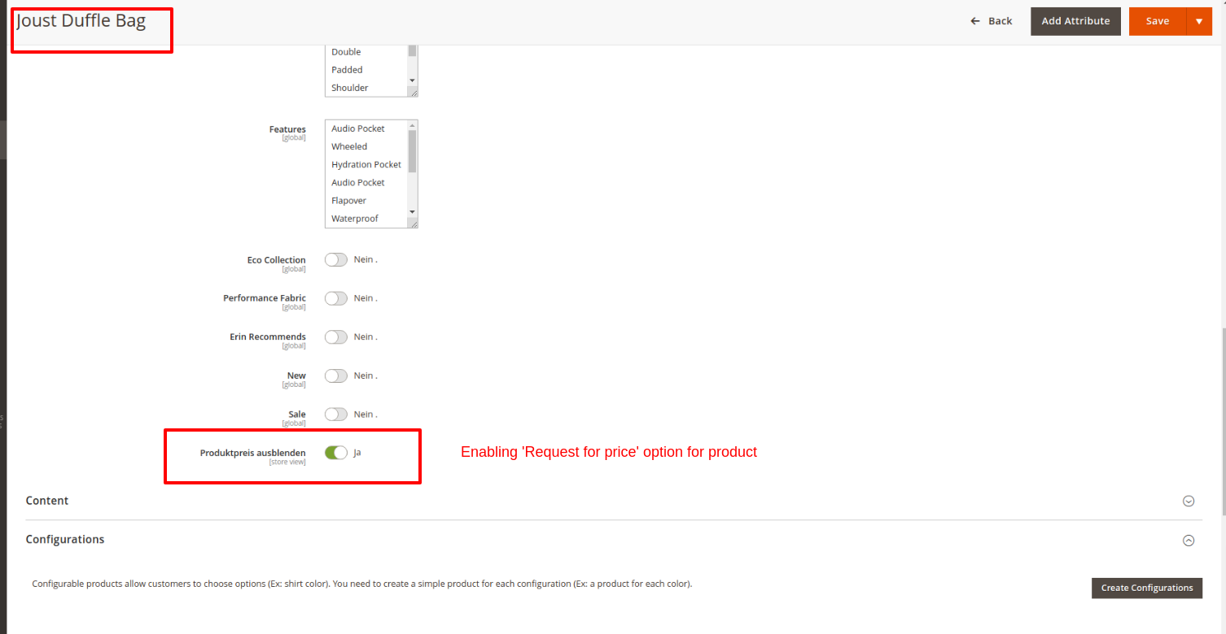

The product will be displayed like below in frontend.

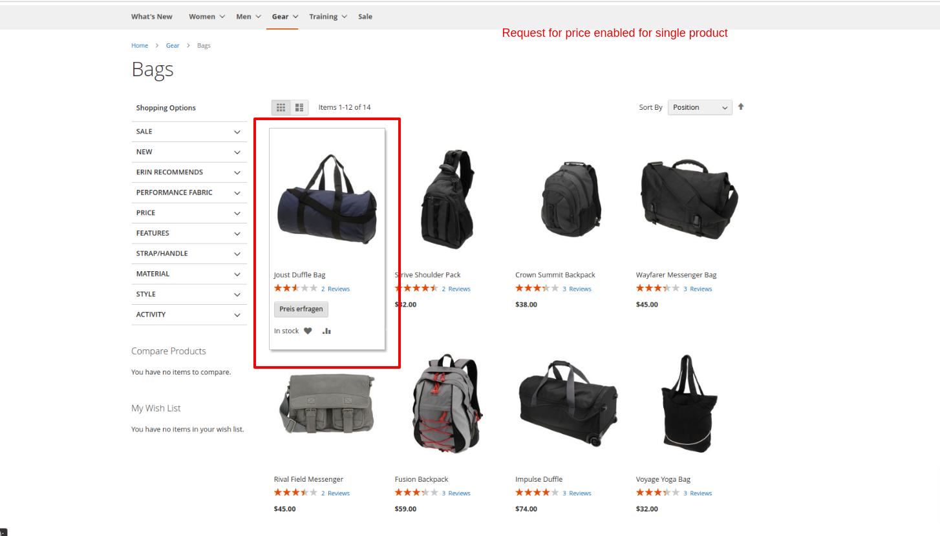

Product detail page view:

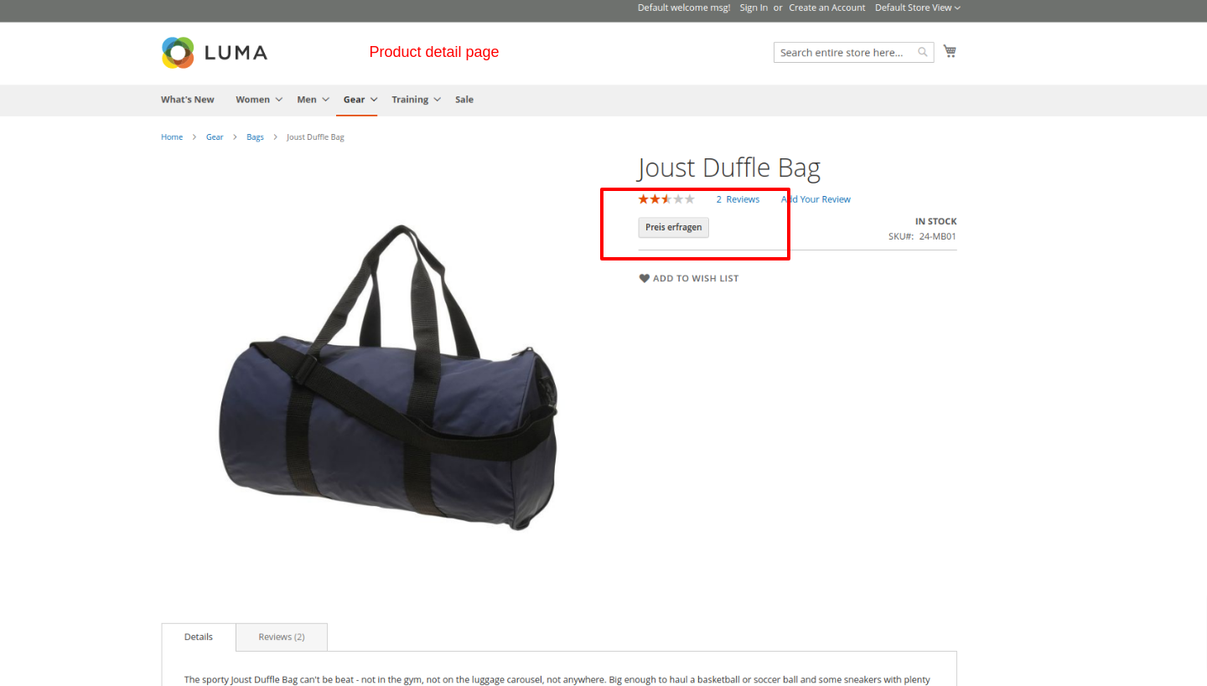

To hide price and Add to Cart for products in a specific category set **Hide Product Price** to **Yes** by editing the category.

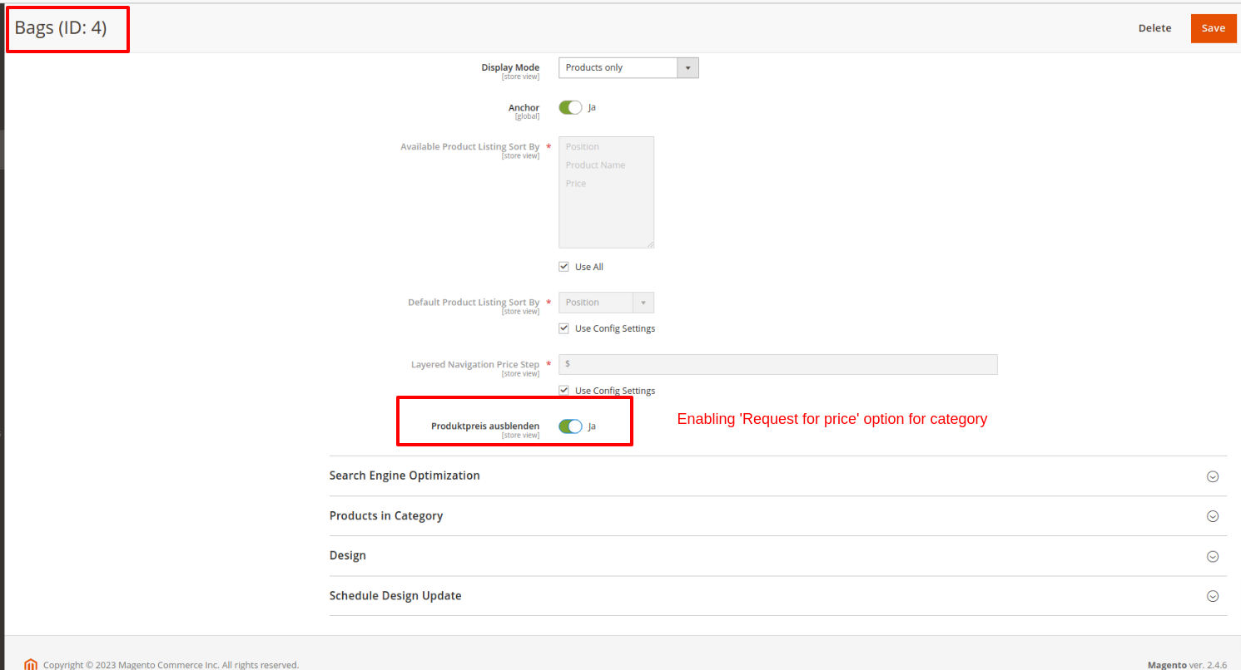

Category page in frontend:

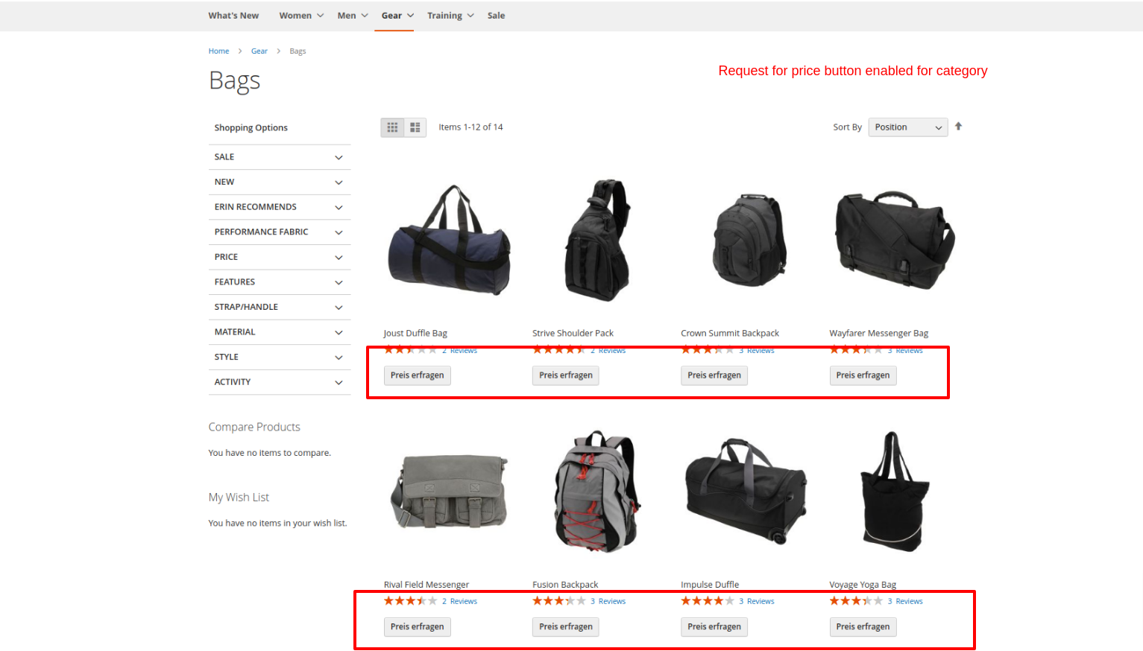

User can contact the store by submitting the pop-up form appearing on clicking the Request for price button. The request will be send as email to the email address set in the **Contact Email Address** field in the admin configuration.

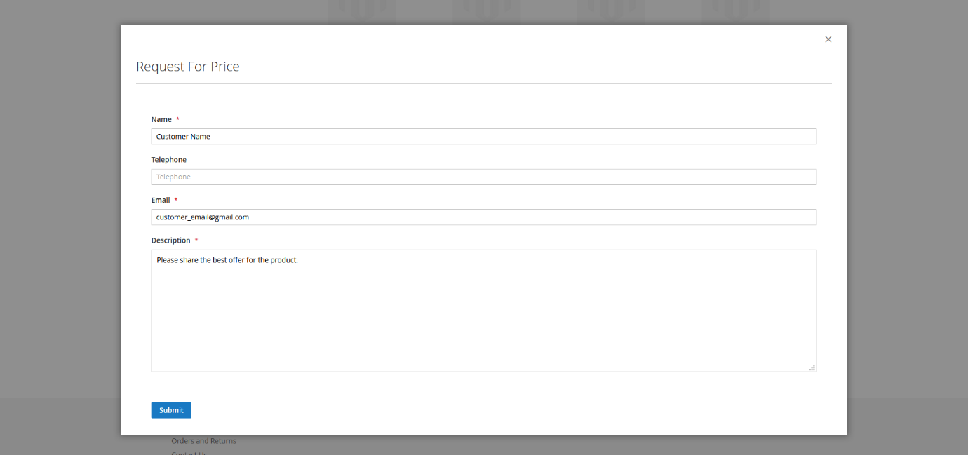

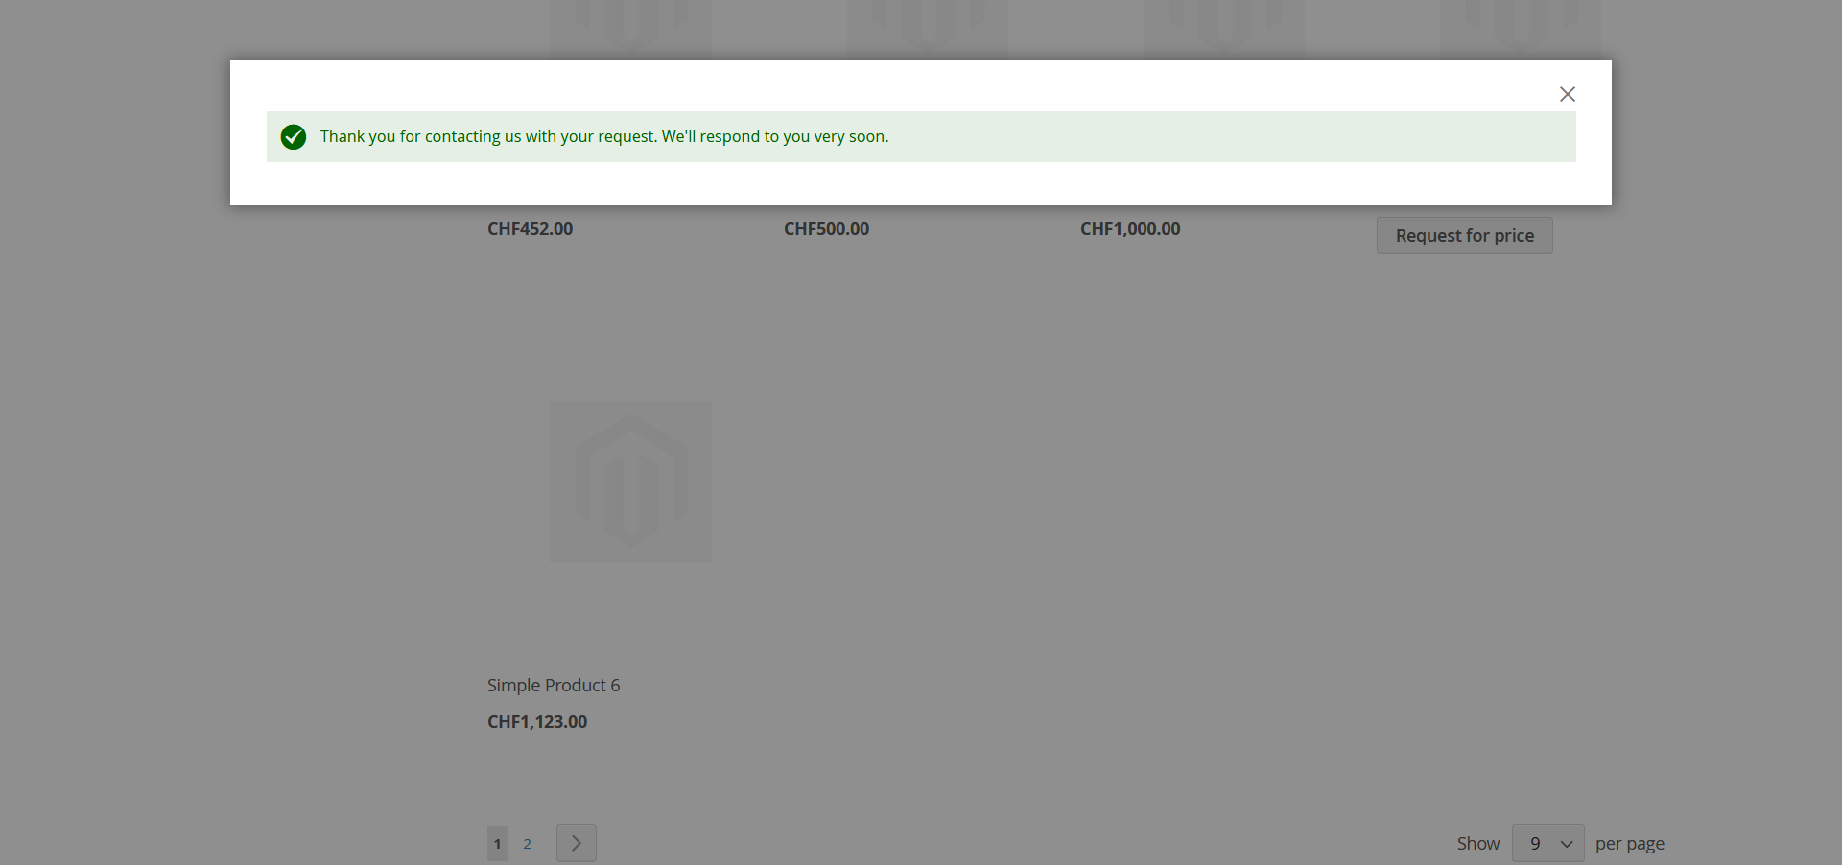

Email will be as below:

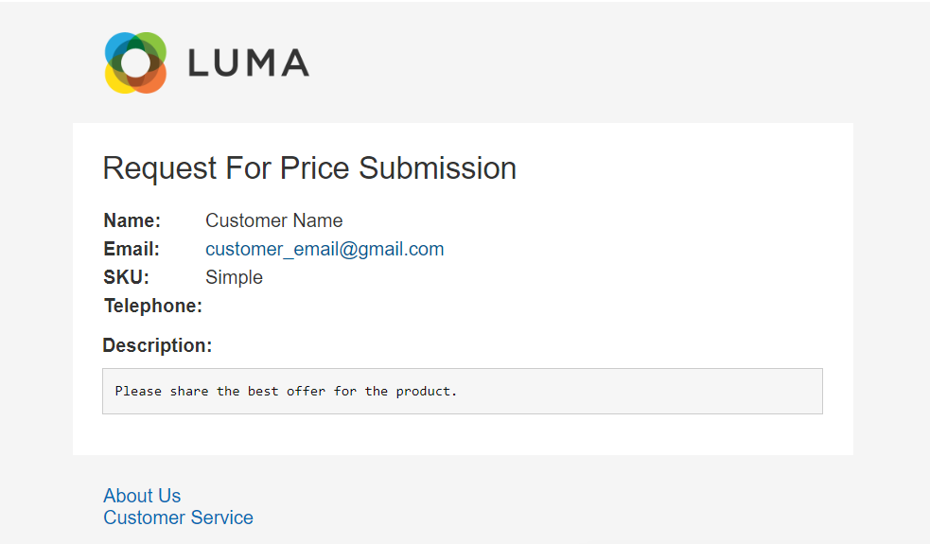

**Note:**

In case of Bundle products, "Hide Product Price" option should be enabled for parent products.

The email template depends on the theme being used in the shop and can be changed from backend by the admin user.

Please make sure to clear cache from backend **System->Cache Management** after

making changes in backend configurations

Need to set the default magento cron for the shop which uses the module. Otherwise mails will not receive.

**Manage User Role**

**Step 1 :** Go to **Admin** > **System** > **User Roles**

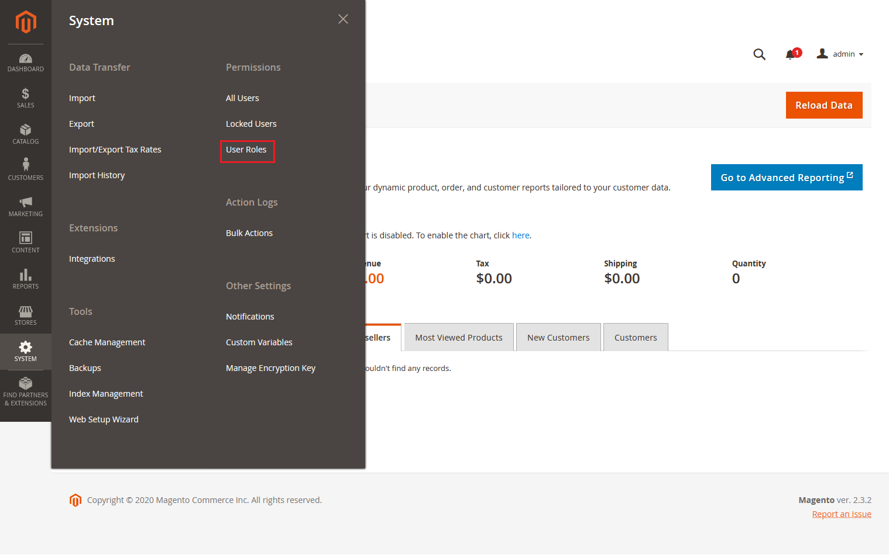

**Step 2 :** Add a new role resource

Fill in the role information section.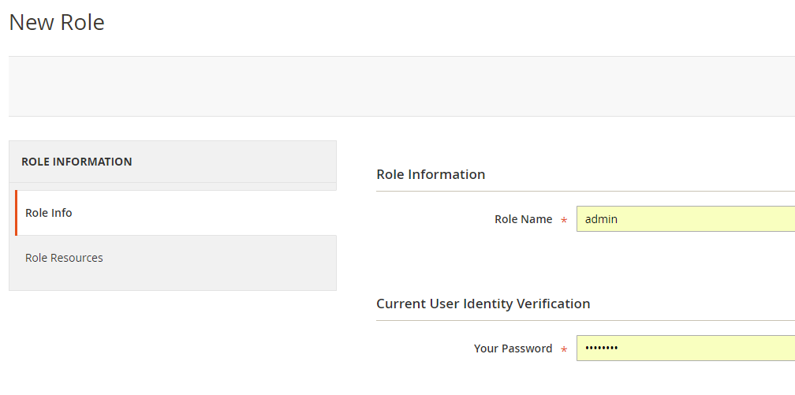

Select **Contact For Price role** at Role Resources section.

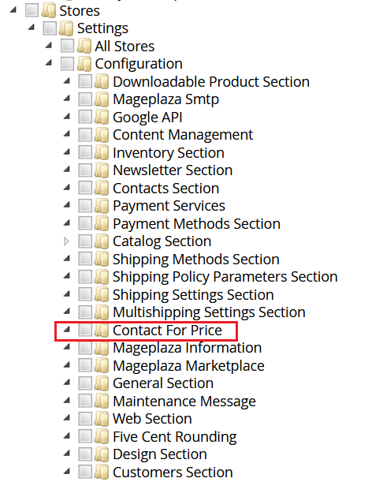

**Step 3:** Set role users for admin accounts, thin click on **Save Role** to finish.

**Technical Requirements / Compatible with:**

Magento Community 2.3.x, 2.4.x

**Supported Languages**

English, German and other Magento supported language packs.

**Change Log / Release Notes**

Version: 1.0.5: May 8, 2023

* Compatible with Open Source (CE): 2.4.6

Version: 1.0.4: October 5, 2022

* Compatible with Open Source (CE): 2.4.5

Version: 1.0.3: June 16, 2022

* Compatible with Open Source (CE): 2.4.4

Version: 1.0.2: October 28, 2021

* Compatible with Open Source (CE): 2.4.3

Version: 1.0.1: January 19, 2021

* Compatible with Open Source (CE): 2.4.x.
* Bug Fix - Incorrect stock display of products in Wishlist and comparison list.

Version: 1.0.0: June 04, 2020

* Added admin configuration option to enable or disable the module.
* Added option to hide price and Add To Cart button for individual products as well as for products in a category.
* Added pop-up price request form for customers.
* Added access control for admin users.

**Support**

If you have questions use our contact form in [webshopextension.com](https://www.webshopextension.com/).