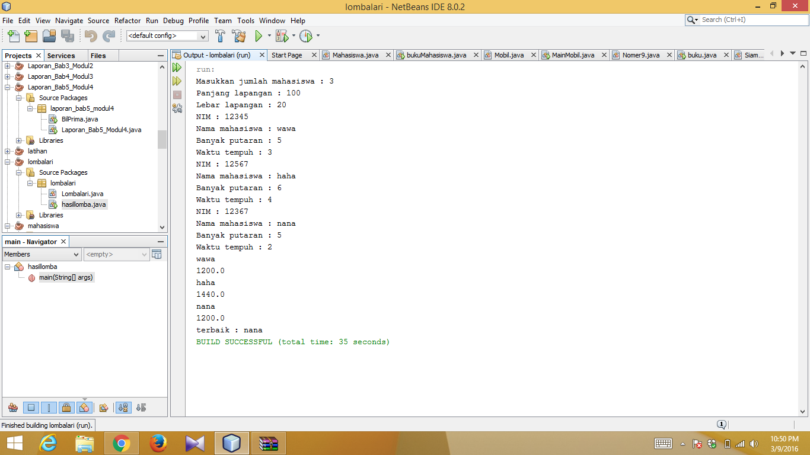

Chindy putri beauty

155150207111057

Tif-h