Projects- Software/Website Documentation



PROJECT – SOFTWARE/WEBSITE DOCUMENTATION
Portfolio Website Documentation
Prepared By
Chibuzor Chinecherem Juliet

Table of Contents
- Project Overview
- Purpose of Documentation
- Technology Used
- Application Type
- Website Structure
- System Documentation
  - 6.1 Landing Page
  - 6.2 Header (Menu)
  - 6.3 Home (Hero Section)
  - 6.4 About Section
  - 6.5 Skills Section
  - 6.6 Projects Section
  - 6.7 Additional Projects
  - 6.8 Featured Projects
  - 6.9 Contact Section
  - 6.10 Footer
- System Workflow
- Functional Requirements
- Conclusion

1. PROJECT OVERVIEW
Project Title
Personal Portfolio Website
Project Description
The Personal Portfolio Website is a responsive web application developed to present the professional profile, technical skills, completed projects, and contact information of the portfolio owner. The website serves as a digital résumé and professional portfolio where employers, recruiters, clients, and collaborators can learn more about the developer and evaluate completed works.
The website was designed using modern frontend technologies to provide a clean, responsive, and user-friendly interface across different screen sizes.

2. PURPOSE OF DOCUMENTATION
This documentation was prepared to:
- Document every section of the website.
- Explain the functionality of each component.
- Provide a technical reference for developers.
- Support software maintenance.
- Assist future upgrades.
- Serve as academic project documentation.
- Support copyright and intellectual property registration.
- Provide technical evidence of software implementation.

3. PAGINATION
Description | Number
Landing Pages | 1
Total Website Sections | 10
Project Cards | 9
Contact Forms | 1
Footer | 1

4. TECHNOLOGY USED
Frontend Technologies
- HTML5
- Tailwind CSS
- JavaScript
Design Tools
- Deepseek
Development Environment
- Visual Studio Code
Version Control
- Git
- GitHub

5. APPLICATION TYPE
Responsive Personal Portfolio Website
Category:
- Portfolio Website
- Professional Profile
- Project Showcase
- Personal Branding

6. WEBSITE STRUCTURE
The Portfolio Website consists of the following sections.
No | Section
6.1 | Landing Page
6.2 | Header
6.3 | Home
6.4 | About
6.5 | Skills
6.6 | Projects
6.7 | Additional Projects
6.8 | Featured Projects
6.9 | Contact
6.10 | Footer

6.1 LANDING PAGE
Figure 6.1: Landing Page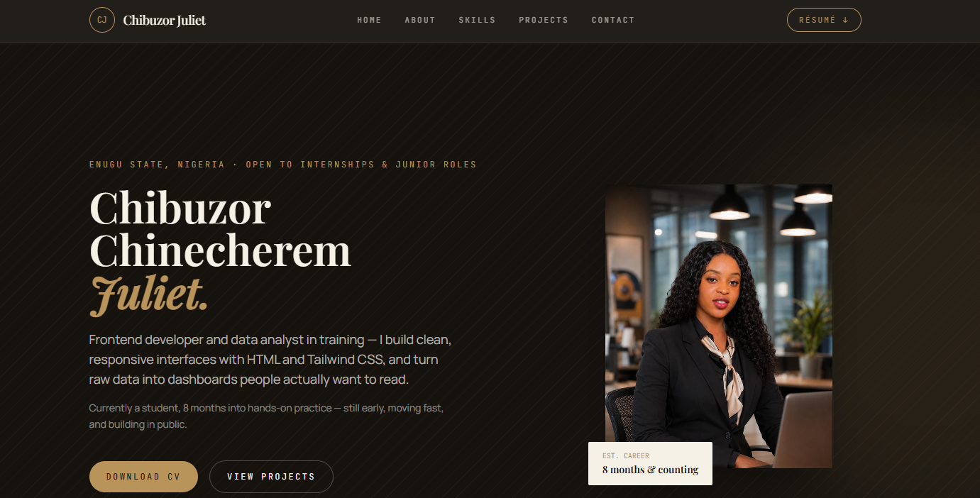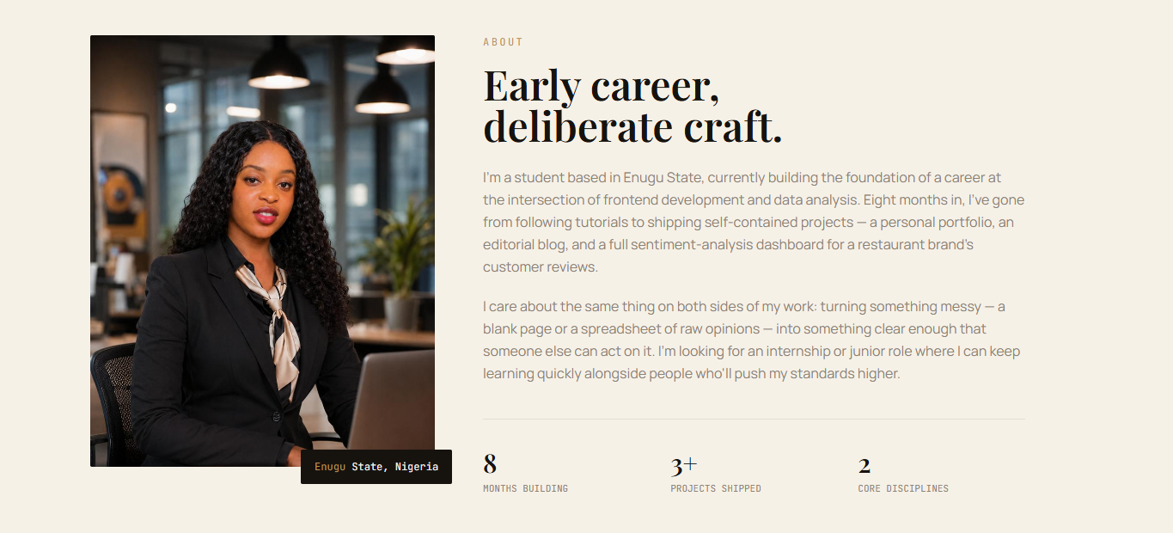 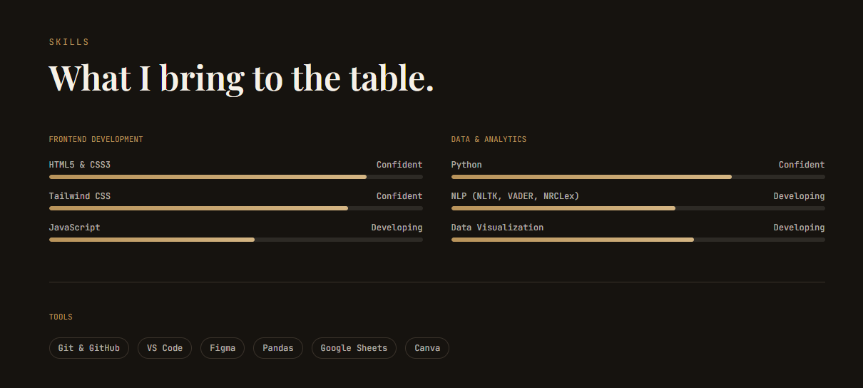
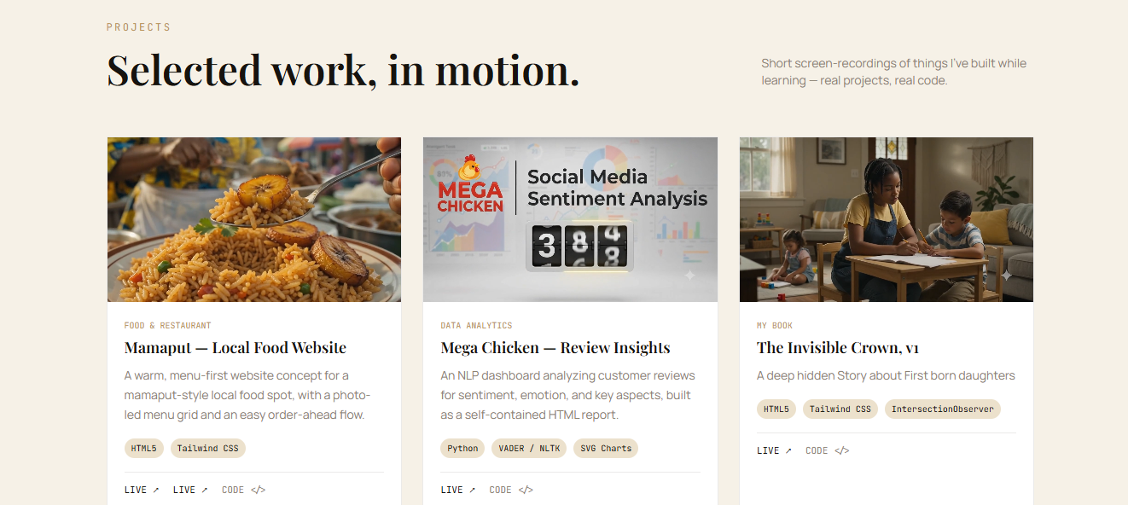
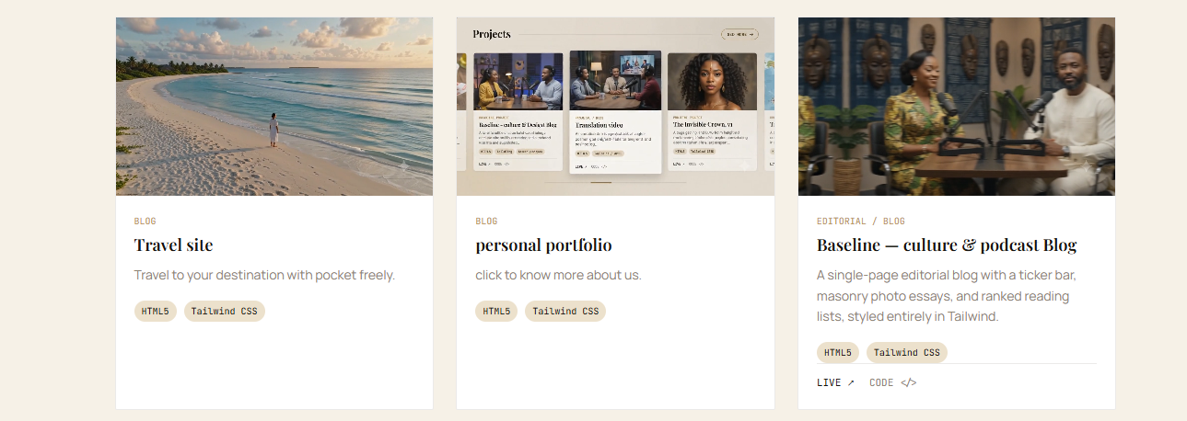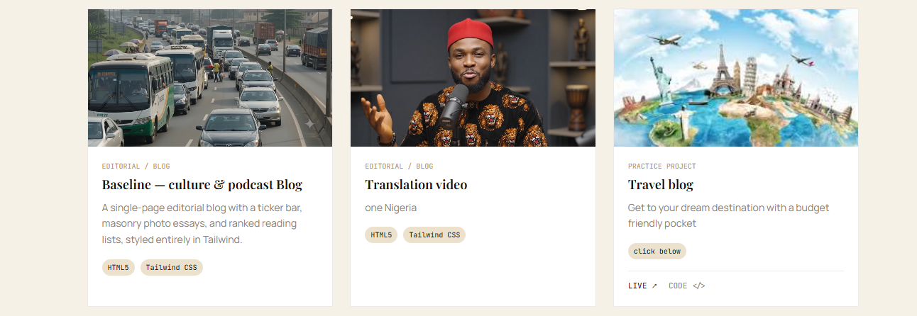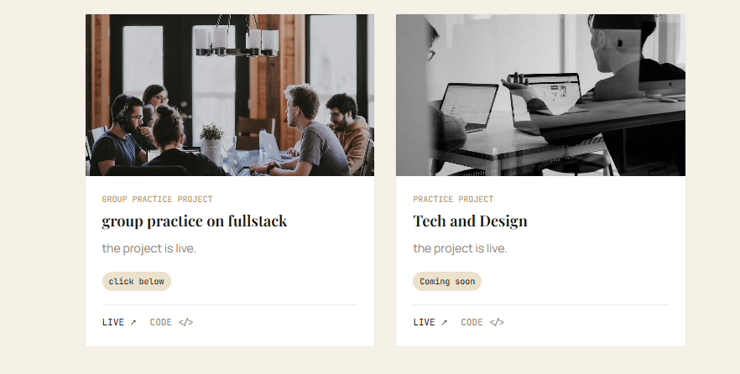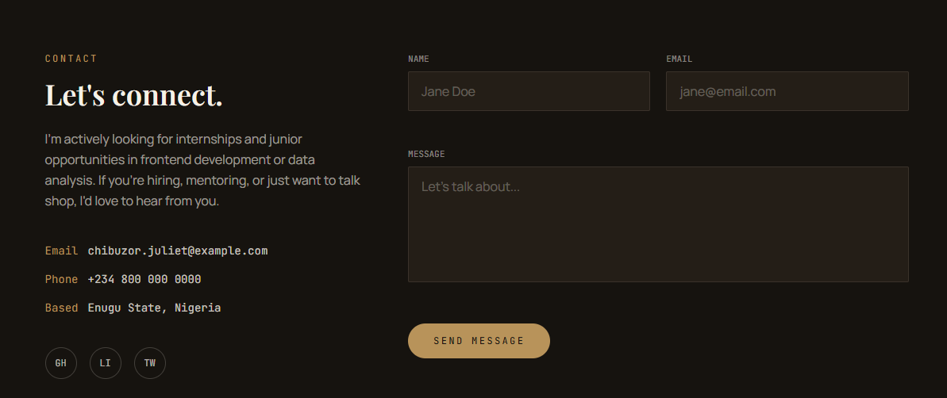

Description
The Landing Page serves as the homepage of the portfolio website. It is the first interface displayed when a visitor accesses the website and provides an overview of the portfolio owner, including navigation, professional introduction, technical skills, completed projects, contact information, and footer.
Objectives
- Introduce the portfolio owner.
- Provide professional branding.
- Showcase completed projects.
- Present technical competencies.
- Improve user interaction.
Functional Components
- Header
- Hero Section
- About Section
- Skills Section
- Projects Section
- Contact Section
- Footer
Expected Output
The visitor gains a complete overview of the portfolio and can navigate seamlessly to any section.

From here, the document continues with:
- 6.2 Header (Menu)
- 6.3 Home (Hero Section)
- 6.4 About
- 6.5 Skills
- 6.6 Projects
- 6.7 Additional Projects
- 6.8 Featured Projects
- 6.9 Contact
- 6.10 Footer

PROJECTS – SOFTWARE/WEBSITE DOCUMENTATION
Project Title
Personal Portfolio Website
URL
https://your-portfolio-link.com

Number of Web Pages – 1 (Landing Page)
Landing Page Subsections
1.1 Menu Section
1.2 Home (Hero Section)
1.3 About Section
1.4 Skills Section
1.5 Projects Section
1.6 Additional Projects Section
1.7 Featured Projects Section
1.8 Contact Section
1.9 Footer

1.0 LANDING PAGE
The Landing Page is the homepage of the portfolio website. It contains all the major sections of the website arranged on a single responsive page. Visitors can navigate to any section using the navigation menu.

1.1 MENU SECTION
Comment 1
This section sits at the top of the landing page.
Comment 2
It occupies 100% of the browser width and remains visible while users navigate through the website.
Comment 3
The portfolio logo and website name are positioned on the left-hand side of the menu bar, while the navigation links are centered and the Resume button is positioned on the right-hand side.
Comment 4
Each navigation item is clickable and automatically scrolls the user to the corresponding section of the landing page.
Components
1.1.1 Portfolio Logo (CJ)
1.1.2 Portfolio Name (Chibuzor Juliet)
1.1.3 Home
1.1.4 About
1.1.5 Skills
1.1.6 Projects
1.1.7 Contact
1.1.8 Resume Button


1.2 HOME (HERO SECTION)
Comment 1
This section appears immediately below the Menu Section.
Comment 2
It introduces the portfolio owner through a professional profile, career summary, and profile photograph.
Comment 3
The left-hand side contains the user's name, professional description, and Call-to-Action buttons, while the right-hand side displays the professional portrait and career information.
Comment 4
The buttons allow visitors to download the résumé or navigate directly to the Projects Section.
Components
1.2.1 Professional Status
1.2.2 Full Name
1.2.3 Professional Summary
1.2.4 Profile Image
1.2.5 Download CV Button
1.2.6 View Projects Button


1.3 ABOUT SECTION
Comment 1
This section provides detailed information about the portfolio owner.
Comment 2
It is divided into two columns consisting of a professional photograph and biography.
Comment 3
The section explains the educational background, technical journey, and career objectives of the portfolio owner.
Comment 4
Career statistics are displayed at the bottom of the section to summarize achievements and experience.
Components
1.3.1 About Heading
1.3.2 Profile Photograph
1.3.3 Biography
1.3.4 Career Statistics
1.3.5 Location Badge


1.4 SKILLS SECTION
Comment 1
This section displays the technical competencies of the portfolio owner.
Comment 2
The skills are grouped into Frontend Development and Data Analytics.
Comment 3
Each skill is represented using a progress indicator to illustrate proficiency.
Comment 4
Development tools used during project implementation are displayed below the technical skills.
Components
1.4.1 Frontend Development
1.4.2 Data Analytics
1.4.3 Progress Bars
1.4.4 Development Tools


1.5 PROJECTS SECTION
Comment 1
This section showcases completed software development projects.
Comment 2
Projects are presented using responsive project cards.
Comment 3
Each project card contains an image, project title, description, technology stack, and navigation links.
Comment 4
Visitors can access the Live Demo or Source Code of each project.
Components
1.5.1 Mamaput Website
1.5.2 Mega Chicken Dashboard
1.5.3 Invisible Crown (book)


1.6 ADDITIONAL PROJECTS SECTION
Comment 1
This section presents additional portfolio projects completed by the developer.
Comment 2
Projects focus on podcast production, personal, editorial blogs, and multimedia content.
Comment 3
Each project card follows the same design pattern as the main Projects Section.
Components
1.6.1 Travel Site
1.6.2 Personal Portfolio
1.6.3 Baseline-culture & podcast Blog


1.7 FEATURED PROJECTS SECTION
Comment 1
This section highlights personal, academic, podcast production, editorial blogs and collaborative software development projects.
Comment 2
The projects demonstrate practical knowledge acquired through continuous learning and teamwork.
Components
1.7.1 Baseline Culture & Podcast Blog
1.7.2 Translation video
1.7.3 Travel Blog
1.7.4 Full-Stack Practice Project
1.7.5 Tech and Design


1.8 CONTACT SECTION
Comment 1
This section allows visitors to communicate directly with the portfolio owner.
Comment 2
The left-hand side displays contact information while the right-hand side contains the contact form.
Comment 3
Visitors can submit inquiries regarding employment, internships, collaborations, or general questions.
Components
1.8.1 Contact Information
1.8.2 Email Address
1.8.3 Phone Number
1.8.4 Location
1.8.5 Social Media Links
1.8.6 Contact Form
1.8.7 Send Message Button

1.9 FOOTER
Comment 1
This section appears at the bottom of the landing page.
Comment 2
It displays copyright information for the portfolio website.
Comment 3
A "Back to Top" link is provided on the right-hand side to improve website navigation.
Components
1.9.1 Copyright Notice
1.9.2 Back to Top Link

