React Native Environment Setup Documentation
1. System Requirements
Minimum System Requirements:
- CPU: Intel Core i5 or equivalent
- RAM: Minimum 8GB
- Operating System: Windows 10 (64-bit) or later, macOS High Sierra or later, or Linux
System Configuration Used (My Laptop):
- CPU: Intel Core i5
- RAM: 16GB
- Operating System: Windows 11 Professional
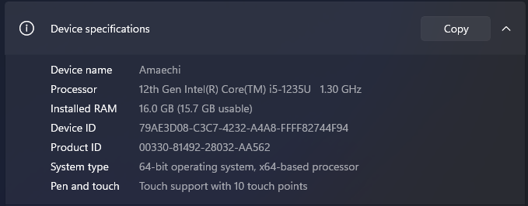
Fig.1: Personal PC System Configuration
Source: Primary
2. Installation Instructions
Following these steps to install the necessary tools and dependencies:
- Node.js
  - Download the latest Long-Term Support (LTS) version of Node.js from the official website
  - Follow the installation instructions provided for your operating system.
  - Verify the installation by running the following commands in your terminal:
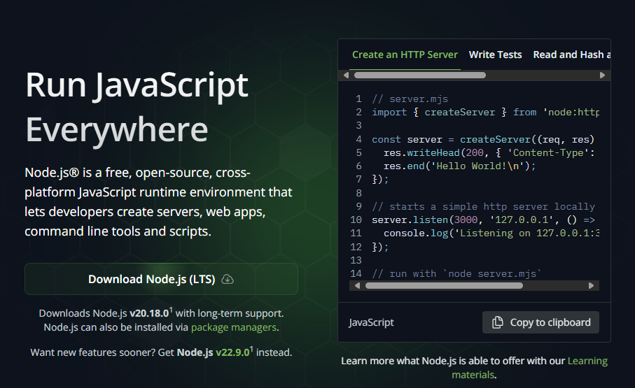
Fig.2: Personal PC System Configuration
Source: [2]
I’ve already installed Node.js earlier, so there’s no need for reinstallation. The figure below shows the version of both my Node.js and NPM(Node Package Manager) installations.
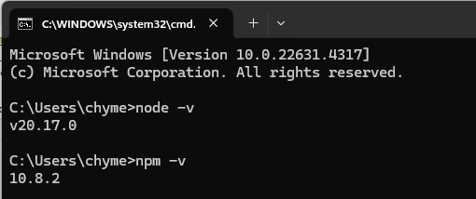
Fig.3: Personal PC System Configuration
Source: [Primary]
- React Native CLI:
  - To Install the React Native CLI globally using npm the following command will be inputted at the command line interface as described in the figure below.
Fig.4: Installing the React-Native Global CLI
Source: [1]
Moreover, I installed this during class time and do not require a reinstallation. The figure below confirms my installation and installed version.
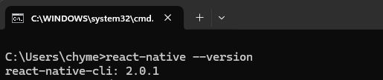
Fig.5: React-Native CLI version
Source: [Primary]
- Java Development Kit (JDK):
  - Download and install the Java SE Development Kit (JDK) from Oracle website [3]. I have installed the Java Development Kit in my Java class (Object-Oriented Programming 3), which is a requirement for Java programming. The figure below indicates the JDK version I have installed.
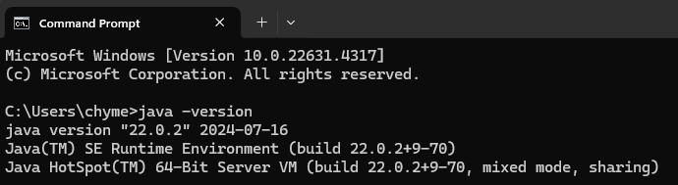
Fig.6: JDK Installed version
Source: [Primary]
- Android Studio:
  - Downloading and installing the Android Studio can be done from the Android Developers website [3]. Once the Installation of the Android Studio is completed, click on “More Actions” to proceed with the SDK Manager settings.
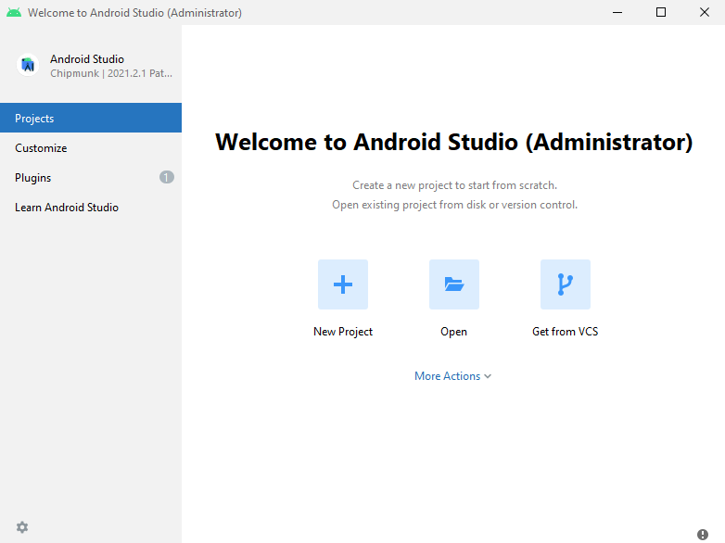
Fig.7: Opening Android Studio after Initial Installation
Source: [1]

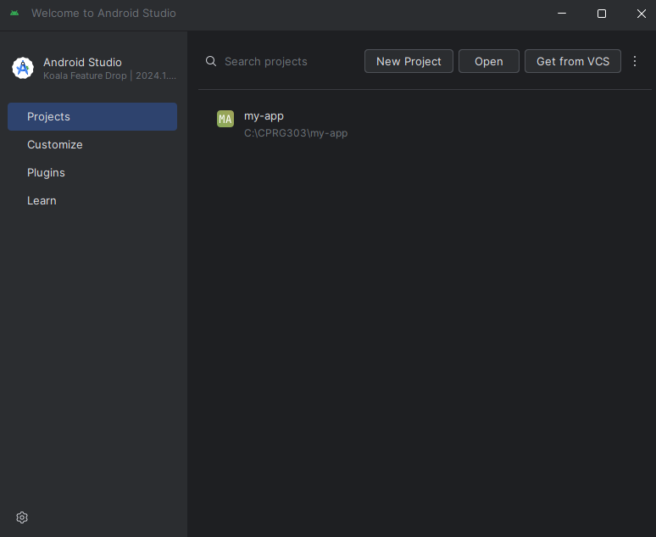
Fig.8: My Android Studio Welcome Screen
Source: [Primary]
3. Configuration Steps
Configure the necessary settings to ensure your environment is ready for React Native development:
- Configure Android Studio:
  - To configure, the Android Studio, open Android Studio and navigate to the gear icon in the toolbar and select the SDK Manager.
  - Alternatively, navigate to File > Settings > Appearance & Behavior > Languages & Framework > Android SDK.
  - Under SDK Tools, in-class installation, make sure to check Android SDK Build-tools , Android Emulator, and Android SDK Platform-Tools.
  - Ensure that the required SDK platforms and tools are installed.
During the in-class installation, I ensured as instructed by the instructor that all the Android SDK, SDK Platform, and Android Virtual Device (AVD) were selected and installed. Specifically, the Android 14 (UpsideDownCake) SDK was selected as the preferred option. This can be see and confirmed as shown in Fig. 9 below. Also, for the SDK Platform-tools, the following options were selected:
    - Android SDK Platform 34 (API Level 34 i.e the Android OS version)
    - Intel x86 Atom_64 System Image
Finally, clicking on “Apply” initiates the download and installation of the Android SDK and related build tools. I have this installed and can seen the figure below. I accessed this from the SDK manager settings in Android Studio.
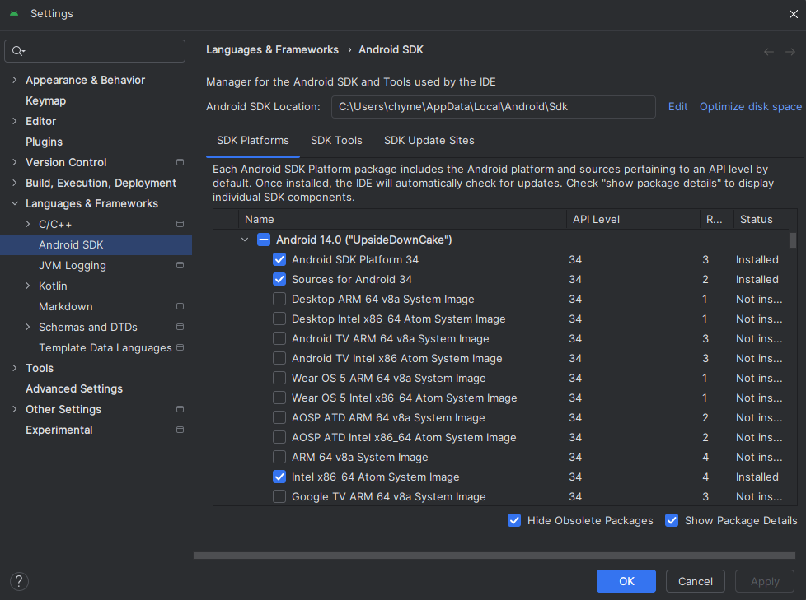
Fig.9: SDK Manager Settings
Source: [Primary]
- Setting Up Environment Variables:
  - Add the Android SDK to your system's environment variables: This has also been implemented during the in-person class with support from the instructor. Below is the figure showing the configured environment variables and PATH variable already implemented. This was accessed from the Control Panel > System & Security > Systems > Advance System Settings > Environment Variables.
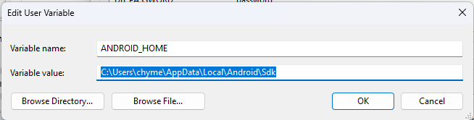
Fig.10: Environment Variable for Android Home
Source: [Primary]
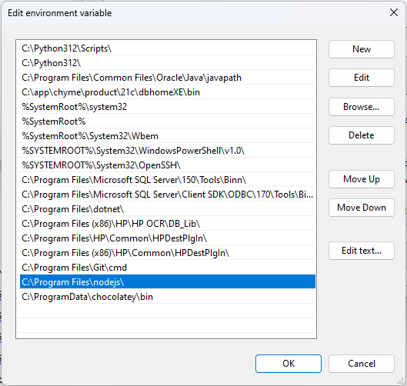
Fig.11: System Variables for PATH
Source: [Primary]
4. Checking the Android Emulator
Once Android Studio and SDK were set up, I launched an Android emulator.
- In Android Studio, I went to Tools > AVD Manager and either created a new virtual device or selected an existing one. But I have earlier created a Medium Phone AVD as shown in the figure below (Fig. 12).
- After configuring the device, I clicked the Play button to start the emulator.
Below, I capture a screenshot of the Android Virtual Device (AVD) Manager with the selected emulator starting (Fig. 13).
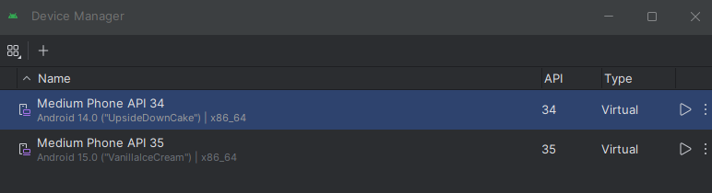
Fig.12: Medium Phone API 34 Android Virtual Device
Source: [Primary]
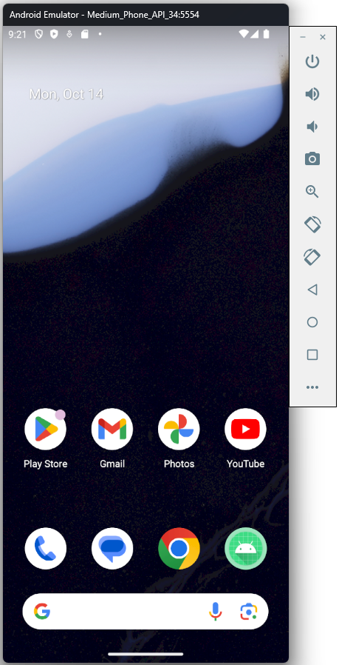
Fig.13: Starting the Android Virtual Device
Source: [Primary]
5. Project Creation
For my React Native project, I decided to use the npx create-expo-app@latest approach as explained during the in-class session to streamline the setup process. Here are the detailed steps I took, alongside the necessary screenshots to illustrate each activity.
- Create a new expo App called “IncredibleTodoListApp”:
I started by opening my command line terminal, then navigating to the parent folder (C:/CPRG303) where I chose to create the new app and then ran the following command as seen the the Fig. 14 below to create a new expo app.
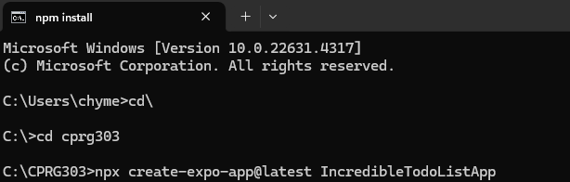
Fig.14: Creating a New Expo App (IncredibleTodoList)
Source: [Primary]
This command set up the project structure and installed the necessary dependencies. The screenshot of my terminal after running the command is seen below (Fig. 15).
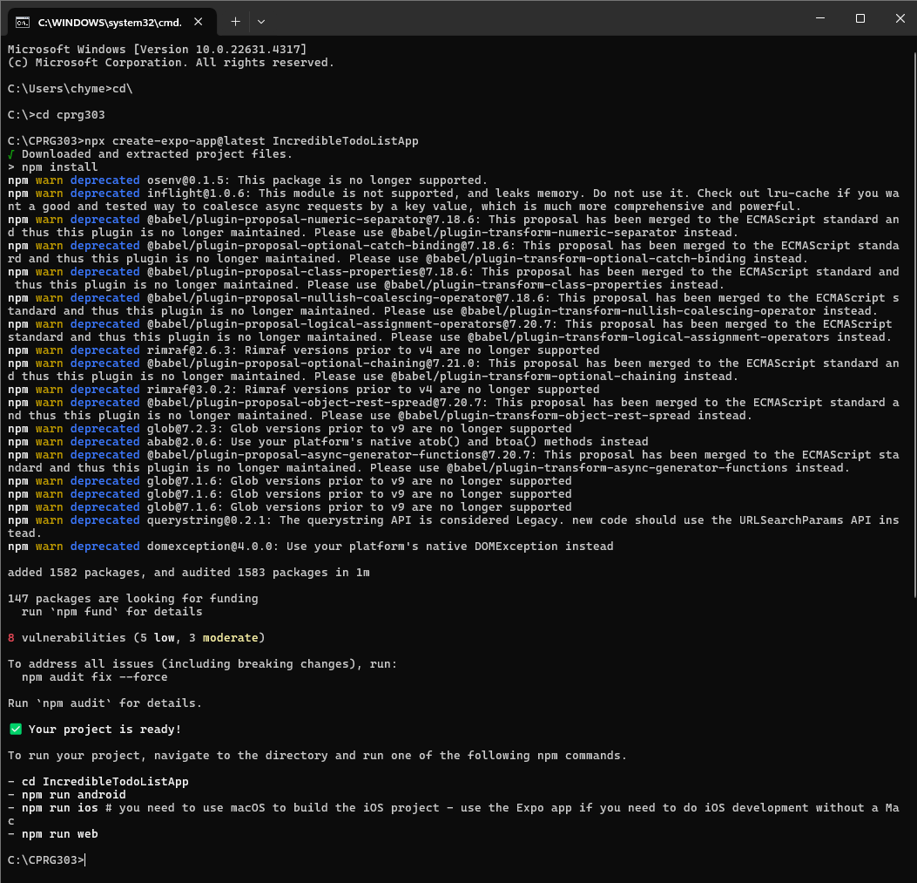
Fig.15: Project App Creation Completed
Source: [Primary]
- Navigate to the Project Directory:
Once the project was created, I displayed the content of the parent folder just to confirm the project folder's existence. Next, I navigated into the project directory as seen in the figure below (Fig. 16). This is where all the project files and configurations are located.
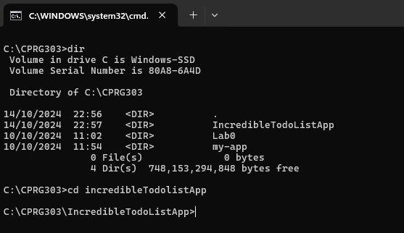
Fig.16: Navigating to Project Directory
Source: [Primary]

6. Running the Project
The next step was to run the project on an Android Device Simulator. Here is my step by step approach itemized below:
- Start Android Studio using AVD:
  - I opened Android Studio and navigated to the AVD Manager to create a new Android Virtual Device (AVD). I selected the device specifications and configuration which has been created earlier (Medium Phone API 34 Android Virtual Device).
  - After creating the AVD, I started it from the AVD Manager. The emulator booted up and displayed the Android home screen.
  - Screenshot of the Android Emulator running:
- Run the Expo App:
  - Back in the terminal, I made sure I was in the project directory and ran the following command to start the project as seen Fig. 17 below. This command
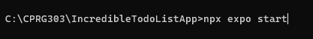
Fig.17: Navigating to Project Directory
Source: [Primary]
This command opened a new browser window with the Expo Developer Tools. With access to a web interface to opens in a browser, allowing you to manage your app, view logs, and access development options (http://localhost:8081 ).
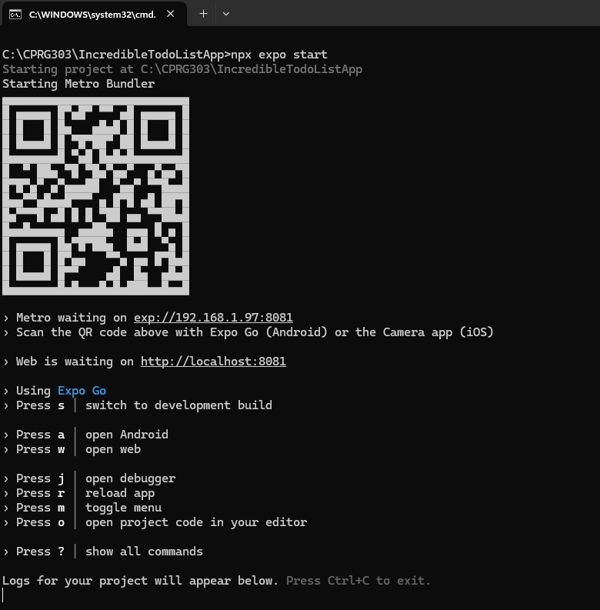
Fig.18: Running the Expo Start Command
Source: [Primary]
- Run on Android Emulator:
  - In the Expo Developer Tools, I selected “w” an option to open the app in a web browser as seen in figure below (Fig. 19).
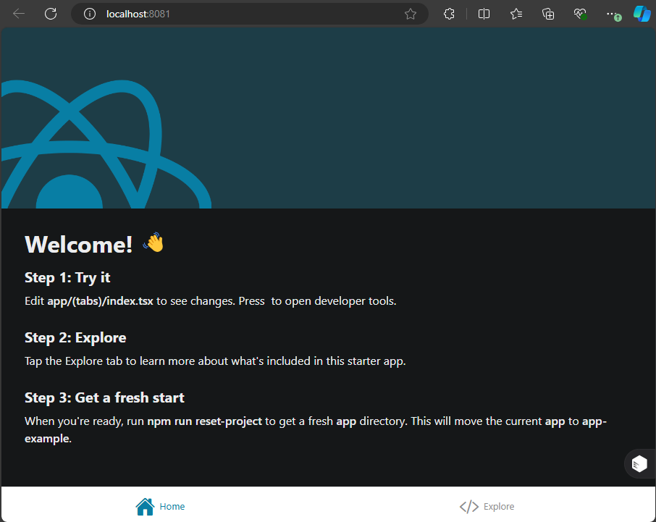
Fig.19: Opens the Expo App on a web browser
Source: [Primary]
  - Also in the Expo Developer Tools, I selected “a” an option to open the app in an Android Studio Emulator (Medium Phone API 34) as seen in figure below (Fig. 20).

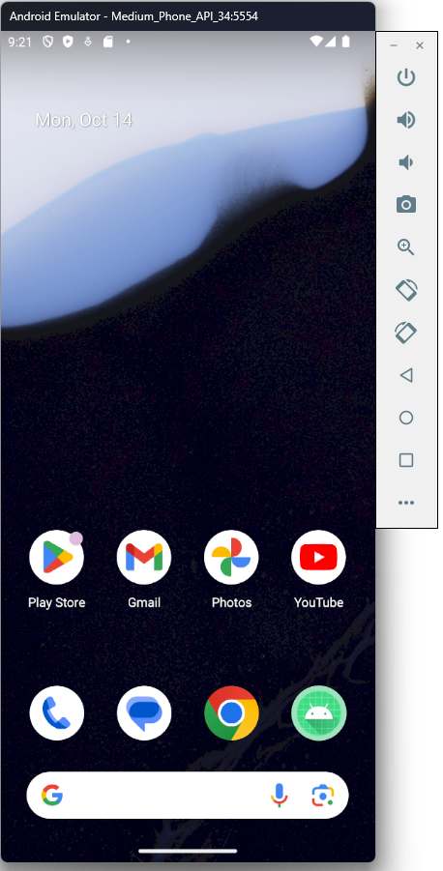
Fig.20: App FAILED to Run on Android Emulator
Source: [Primary]

7. Troubleshooting
Address common issues and troubleshooting steps:
- Android Emulator Issues:
I encountered the following issue while trying to run my project on the Android Emulator as seen in the screenshot below (Fig. 21).
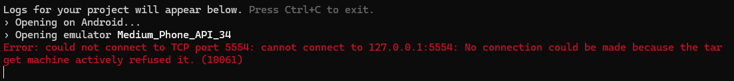
Fig.21: Error message during app run attempt on Android Emulator
Source: [Primary]
- Steps Taken to Resolve:
  - Check AVD Configuration: I ensured that the Android Virtual Device (AVD) was configured correctly [4].
  - Restart the AVD: I restarted the AVD from the AVD Manager to see if it resolved the issue.
  - Restart the ADB Server: I ran the following commands to restart the ADB server [5].

- Stop the ADB server:
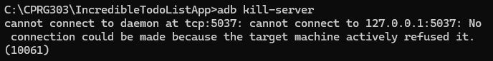
Fig.22: Stop the ADB Server
Source: [Primary]
- Start the ADB server:
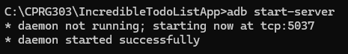
Fig.23: Staring the ADB Server
Source: [Primary]
- Check the connected device to the ADB server:
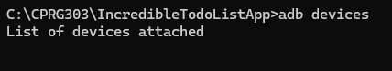
Fig.24: Checking for Connected Devices to ADB Server
Source: [Primary]
I noticed no virtual device was connected to the ADB Server, preventing me from launching my app on the Android Emulator during troubleshooting. I had to create a new Virtual Device in Android Studio to resolve this issue.
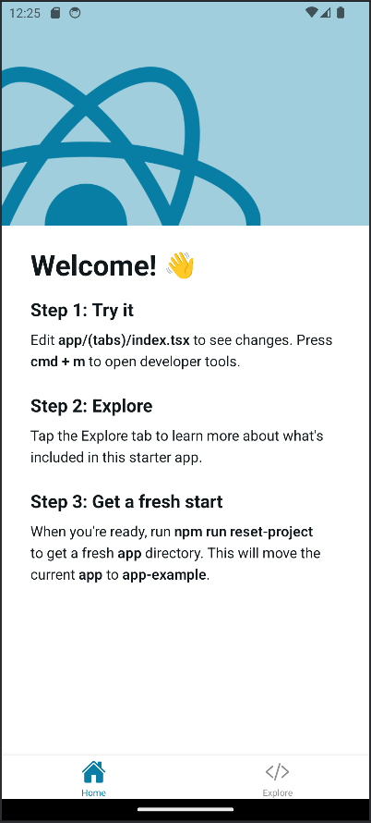
Fig.25: App NOW Runs on Android Emulator
Source: [Primary]

References
[1] “Get Started with React Native · React Native,” Reactnative.dev, Aug. 15, 2024. [Online]. Available: https://reactnative.dev/docs/environment-setup?guide=native/ . Accessed: Oct. 14, 2024.
[2] Node.js Foundation, “Node.js,” Node.js, 2019. [Online]. Available: https://nodejs.org/en/ . Accessed: Oct. 14, 2024.
[3] Android Studio, “Android Studio and SDK tools,” Android Developers, 2019. [Online]. Available: https://developer.android.com/studio/ Accessed: Oct. 14, 2024.
[4] “Set up Android Emulator networking,” Android Developers. [Online]. Available: https://developer.android.com/studio/run/emulator-networking . Access: Oct. 14, 2024.
[5] ReactiveCircus, “could not connect to TCP port 5554: Connection refused · Issue #161· ReactiveCircus/android-emulator-runner,” GitHub, Jun. 23, 2021. [Online]. Available: https://github.com/ReactiveCircus/android-emulator-runner/issues/161/ . Accessed Oct. 15, 2024.

