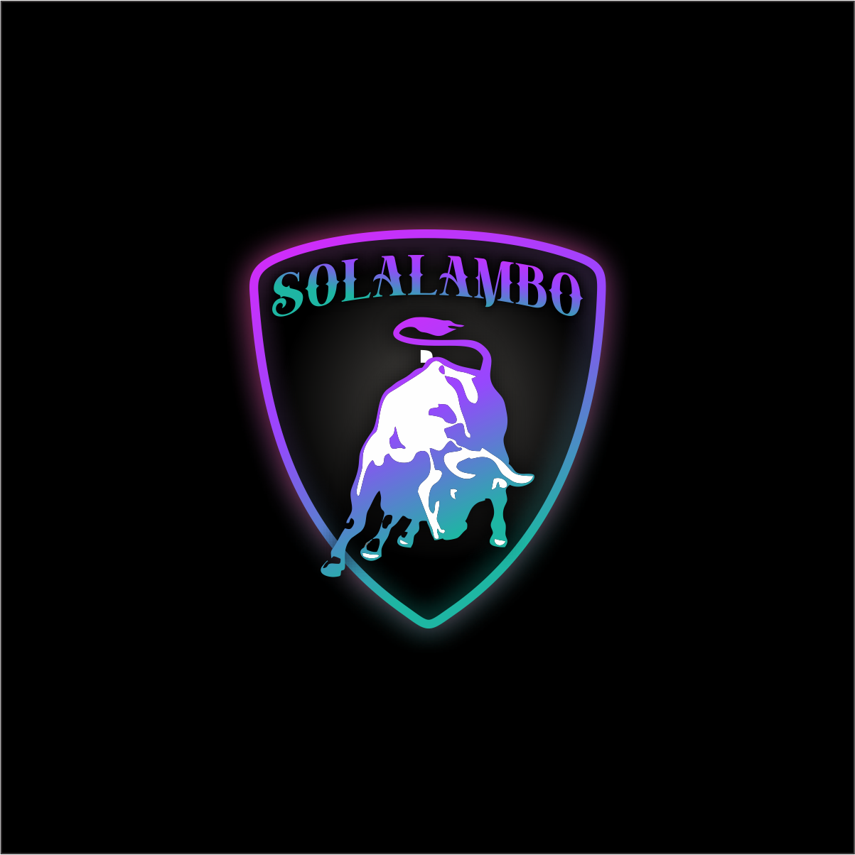

SOLALAMBO

WEBSITE: <https://sob.finance>

TWITTER: <https://twitter.com/SolaLambo>

DISCORD: <https://discord.gg/sy2xymyc7J>

INTRODUCTION

**What is CRYPTOCURRENCY?**

A **cryptocurrency**, **crypto-currency**, or **crypto** is a collection of binary data which is designed to work as a medium of exchange wherein individual coin ownership records are stored in a ledger which is a computerized database using strong cryptography to secure transaction records, to control the creation of additional coins, and to verify the transfer of coin ownership.

**BRIEF HISTORY**

In 1983, the American cryptographer David Chaum conceived an anonymous cryptographic electronic money called ecash. Later, in 1995, he implemented it through Digicash, an early form of cryptographic electronic payments which required user software in order to withdraw notes from a bank and designate specific encrypted keys before it can be sent to a recipient. This allowed the digital currency to be untraceable by the issuing bank, the government, or any third party.

In 1996, the National Security Agency published a paper entitled *How to Make a Mint: The Cryptography of Anonymous Electronic Cash*, describing a Cryptocurrency system, first publishing it in an MIT mailing list and later in 1997, in *The American Law Review* (Vol. 46, Issue 4).

In 1998, Wei Dai published a description of "b-money", characterized as an anonymous, distributed electronic cash system. Shortly thereafter, Nick Szabo described bit gold. Like bitcoin and other cryptocurrencies that would follow it, bit gold (not to be confused with the later gold-based exchange, BitGold) was described as an electronic currency system which required users to complete a proof of work function with solutions being cryptographically put together and published.

In 2009, the first decentralized cryptocurrency, bitcoin, was created by presumably pseudonymous developer Satoshi Nakamoto. It used SHA-256, a cryptographic hash function, in its proof-of-work scheme. In April 2011, Namecoin was created as an attempt at forming a decentralized DNS, which would make internet censorship very difficult. Soon after, in October 2011, Litecoin was released. It used scrypt as its hash function instead of SHA-256. Another notable cryptocurrency, Peercoin, used a proof-of-work/proof-of-stake hybrid.

On 6 August 2014, the UK announced its Treasury had commissioned a study of cryptocurrencies, and what role, if any, they could play in the UK economy. The study was also to report on whether regulation should be considered. Its final report was published in 2018, and it issued a consultation on crypto assets and stable coins in January 2021.

In June 2021, El Salvador became the first country to accept Bitcoin as legal tender, after the Legislative Assembly had voted 62–22 to pass a bill submitted by President Nayib Buckelew classifying the cryptocurrency as such.

In August 2021, Cuba followed with Resolution 215 to accept Bitcoin as legal tender, which will circumvent U.S. sanctions.

In September 2021, the government of China, the single largest market for cryptocurrency, declared all cryptocurrency transactions illegal, completing a crackdown on cryptocurrency that had previously banned the operation of intermediaries and miners within China.

**ABOUT THE PROJECT NAMED “SOLALAMBO”**

Decentralized finance service showed a catalyst growth and increment in its usage with a large number of projects coming in. New projects are constantly entering the market, making the crypto space getting wider. Customers desire fast and cheap execution during transaction. The SOLALAMBO ecosystem is comprised of two projects, $SOB and SOB-NFT which is built on Proof of History (PoH) implemented by the Solana network.

THE TOKENS

SOB is a decentralized community driven token whose focus is to support Solana Ecosystem and connect all Solana SPL token. SOB is hard capped at **1 Million Total Supply**. The community token distribution was completed on October 03, 2021 as an airdrop to thousands of people from all over the world.

This left the remaining token for marketing/promotions, farming, pools and liquidity/staking. Staking will be available through the Raydium Protocol and Orca Platform liquidity pools. Single-sided staking will also be made available through our light, stable and easy to use DEX which will be facilitated on our website (sob.finance).

Liquidity pool will be made available on Raydium, Orca and our DEX. The automated market maker (AMM) liquidity pool is among the most exciting innovations in Defi ecosystem. Users throw their assets to the liquidity pool to make a big digital pie, which is a collection of liquidity locked in a smart contract. Liquidity providers (LP) in SolaLambo Project can earn trading fees (incentives) of all trades proportional to their share or the total liquidity, that occurs in this pool. Also, some of the fees generated by SolaLambo platform are accumulated in the pool in order to stably provide incentives to platform participants. In the long run, the liquidity pool can be operated with only platform fees.

SOB-NFT will be rewarded to all SOB token holders. There will be rarity of the NFT, the rarity will depend on how each user help the SolaLambo projects. Total number of minted NFT will be communicated later. Artists will be gathered together from all part of the world to create a unique SOB-NFT for the community. The artist whose work is rated high will be sponsored and rewarded greatly. SOB-NFT will be listed on Raydium, Solanart, DigitalEyes and surely the SolaLambo DEX. We will open our DEX for artist to showcase their artworks and make it accessible for all to interact (i.e. buy/sell). Further information will be communicated later.

**ROADMAP**

**PHASE ONE**

* **$SOB Token – Mint $SOB on Solana Blockchain**
* **Twitter and discord created**
* **Distribution of Verified and Lamborghini roles to all discord members**
* **Airdrop to Lamborghini roles**
* Airdrop to Cope Holders
* $SOB Market opens: Serum, Raydium, Samo DEX, Dexlab, SolaLambo DEX
* Listing on coingecko
* $SOB price bots
* Contest: Meme, Gaming, promotion in which few SOB will be airdropped
* Official launching of SolaLambo DEX
* Reward to $SOB holders and community

**PHASE TWO**

* $SOB Merchandise is made available for the community
* Staking with tight security
* Orca platform liquidity pool launch
* Listing on coin market cap
* Working on SOB-NFTs and Tipbots
* Orientating North America, Southern Asia, Latin America and Africa about Solana Blockchain
* Continue our mission to be a community driven token and keep emerging first in supporting the Solana Ecosystem.

**PHASE THREE**

* Mission Lamborghini
* Listing on two centralized exchanges: Bitrue and AAX
* AMA with CEO Lamborghini, Stephan Winkelmann regarding the future of Lamborghini super cars.
* Listing on Hotbit and Orca
* Submitting a proposal in making SolaLambo an official token of Lamborghini automobiles

**PHASE FOUR**

* Coming soon…

**REFERENCE**

1. Andy Greenberg (20 April 2011). "Crypto Currency". Forbes. Archived from the original on 31 August 2014*. Retrieved 8 August 2014*.
2. Matteo D'Agnolo. "All you need to know about Bitcoin". Times of India-economic times. Archived from the original on 26 October 2015.
3. "China declares all crypto-currency transactions illegal". BBC News. 24 September 2021*. Retrieved 24 September 2021*.
4. Yakovenko, A. Solana: A new architecture for a high performance blockchain.
5. Serum Foundation. Serum - White Paper.