MACHINE LEARNING-BASED PREDICTION OF COMPLETE CHILDHOOD IMMUNIZATION AMONG NIGERIAN CHILDREN USING THE NIGERIA DEMOGRAPHIC AND HEALTH SURVEY (NDHS) 2023-24 DATASET

ABSTRACT
Complete childhood immunization remains a critical public health priority in Nigeria, where a substantial proportion of children under five years still fail to receive the full schedule of basic vaccines recommended by the World Health Organization (WHO) and the National Programme on Immunization. This study applied machine learning techniques to predict complete childhood immunization status among Nigerian children aged 12-23 months, using data drawn from the 2023-24 Nigeria Demographic and Health Survey (NDHS) Children's Recode (KR) file. Following data cleaning, sample restriction to the standard 12-23 month WHO/DHS age window, and construction of the outcome variable from nine basic vaccine doses (BCG, OPV0-3, Pentavalent 1-3, and Measles 1), a final analytic sample of 4,527 children was obtained, of whom 32.91% were fully immunized and 67.09% were not. Seventeen predictor variables spanning child characteristics, maternal characteristics, household socioeconomic status, media exposure, and maternal healthcare utilization were selected on the basis of Cramér's V association analysis. Five algorithms - Logistic Regression, Decision Tree, Random Forest, XGBoost, and Support Vector Machine - were trained in baseline and hyperparameter-tuned (GridSearchCV, five-fold cross-validation) configurations, giving eleven models in total, each evaluated using Accuracy, Precision, Recall, F1-score, and ROC-AUC on a stratified 80:20 train-test split. The Tuned Random Forest, adopted as the final model on the recommendation of the project supervisor, achieved an Accuracy of 59.16%, Precision of 43.38%, Recall of 79.19%, an F1-score of 0.5606, and a ROC-AUC of 0.6985, the highest ROC-AUC of any model evaluated. Feature importance and SHAP analysis identified the number of antenatal care (ANC) visits and the timing of the first ANC visit as the dominant predictors, followed by maternal education, household wealth index, and place of delivery. These findings indicate that maternal healthcare-seeking behaviour during pregnancy is more strongly associated with complete childhood immunization than demographic or geographic characteristics, and suggest that machine learning-based screening tools built around antenatal care contact could help identify children at risk of incomplete immunization for targeted intervention. The study concludes with recommendations for strengthening antenatal care attendance as an entry point for improving immunization coverage, alongside methodological suggestions for future research.
Keywords: childhood immunization, machine learning, Random Forest, Nigeria Demographic and Health Survey, antenatal care, feature importance

CHAPTER ONE: INTRODUCTION

1.1 Background to the Study
Childhood immunization is widely regarded as one of the most cost-effective public health interventions available, preventing millions of deaths annually from vaccine-preventable diseases such as measles, diphtheria, pertussis, tetanus, and poliomyelitis (World Health Organization [WHO], 2020). Despite decades of investment through the Expanded Programme on Immunization (EPI) and, more recently, the Immunization Agenda 2030 (IA2030), global progress toward universal immunization coverage has plateaued. According to the most recent WHO and UNICEF Estimates of National Immunization Coverage (WUENIC), 90% of infants globally received at least one dose of a diphtheria-tetanus-pertussis (DTP)-containing vaccine in 2025, while 85% completed the full three-dose series; an estimated 13.5 million children nonetheless remained "zero-dose", having received no vaccine at all in their first year of life (WHO, 2026).
Nigeria remains one of the countries with the largest unimmunized child populations in the world. Trend analyses of successive rounds of the Nigeria Demographic and Health Survey (NDHS) show that full immunization coverage among children aged 12-23 months has fluctuated markedly, from 63.6% in 2007 to 82% in 2011, before declining again to 63.7% in 2016/17 and 76.4% in 2021 on some estimation approaches (Adeyinka et al., 2024), while the 2023-24 NDHS Key Indicators Report places full basic-vaccination coverage among children aged 12-23 months at approximately 39%, alongside wide regional disparities that leave more than 80% of states in northern Nigeria below 40% coverage (Alabi et al., 2024; Federal Ministry of Health [FMOH] et al., 2024). This regional and socioeconomic variation, together with the country's large annual birth cohort, means that Nigeria contributes disproportionately to the global pool of under-immunized and zero-dose children (FMOH, 2025).
Traditional epidemiological approaches to understanding the determinants of childhood immunization have relied heavily on logistic regression and related generalised linear models applied to DHS data, which assume linear and largely additive relationships between predictors and the log-odds of the outcome. While informative, such models can struggle to capture complex, non-linear interactions among the many demographic, socioeconomic, and healthcare-utilization variables that jointly influence immunization behaviour. Machine learning (ML) techniques offer an alternative analytical framework capable of modelling such interactions flexibly, and have been applied with encouraging results to childhood vaccination prediction in other sub-Saharan African contexts, including Ethiopia (Tesfaye et al., 2023) and a multi-country East African analysis (Tadese et al., 2024). However, comparable machine learning-based prediction studies using the most recent NDHS round remain limited, particularly studies that combine rigorous data cleaning of the DHS Children's Recode (KR) file with systematic comparison of multiple algorithms, hyperparameter optimisation, and model interpretability techniques such as SHAP (SHapley Additive exPlanations).
This study addresses that gap by developing and comparing eleven machine learning models - baseline and tuned variants of Logistic Regression, Decision Tree, Random Forest, XGBoost, and Support Vector Machine - to predict complete childhood immunization among Nigerian children aged 12-23 months, using the 2023-24 NDHS Children's Recode dataset. The Random Forest algorithm, selected as the final model in consultation with the project supervisor, is examined in detail, including its feature importance and SHAP-based interpretation, to identify the predictors most strongly associated with complete immunization and to draw out their implications for public health practice in Nigeria.

1.2 Statement of the Problem
Despite sustained investment in routine immunization services, a substantial proportion of Nigerian children still do not complete the basic immunization schedule by their first birthday. In the dataset analysed for this study, only 32.91% of children aged 12-23 months had received all nine core vaccine doses (BCG, three doses of Oral Polio Vaccine beyond the birth dose, three doses of Pentavalent vaccine, and Measles 1), while 67.09% had not, even after excluding children with unknown or missing vaccination records. Under-immunization of this magnitude leaves a large proportion of Nigerian children vulnerable to vaccine-preventable diseases and undermines herd immunity at the population level.
Existing efforts to identify children at risk of incomplete immunization have relied predominantly on descriptive and regression-based analyses of survey data, which, while useful for identifying broad associations, are not generally designed to produce individual-level risk predictions that could support targeted outreach. There is, therefore, a need for predictive models capable of flagging children who are less likely to be fully immunized, using information that is realistically available to health workers and programme planners, such as maternal healthcare-seeking behaviour, socioeconomic status, and household characteristics. This study responds to that need by developing and evaluating machine learning models for predicting complete childhood immunization status, with attention to both predictive performance and interpretability.

1.3 Aim
The aim of this study is to develop and evaluate machine learning models for predicting complete childhood immunization status among Nigerian children aged 12-23 months, using data from the 2023-24 Nigeria Demographic and Health Survey, and to identify the predictors most strongly associated with complete immunization.

1.4 Objectives
The specific objectives of the study are to:
- Clean and prepare the 2023-24 NDHS Children's Recode (KR) dataset for machine learning analysis, including construction of a binary outcome variable representing complete childhood immunization status.
- Conduct exploratory data analysis to describe the demographic, socioeconomic, and healthcare-utilization characteristics of the study population and their bivariate relationship with immunization status.
- Develop and compare baseline and hyperparameter-tuned Logistic Regression, Decision Tree, Random Forest, XGBoost, and Support Vector Machine models for predicting complete childhood immunization.
- Evaluate the performance of the trained models using Accuracy, Precision, Recall, F1-score, and ROC-AUC, and select the best-performing model in consultation with the project supervisor.
- Identify and interpret the predictor variables that contribute most strongly to the final model's predictions using feature importance and SHAP analysis, and discuss their implications for public health policy and practice in Nigeria.

Research Questions

- What are the demographic, socioeconomic, and healthcare-utilization characteristics of Nigerian children aged 12-23 months in the 2023-24 NDHS sample, and how do these characteristics relate to complete immunization status?
- How do baseline and hyperparameter-tuned machine learning models compare in their ability to predict complete childhood immunization status?
- Which machine learning algorithm provides the best balance of predictive performance for this classification task, as measured by Accuracy, Precision, Recall, F1-score, and ROC-AUC?
- Which predictor variables contribute most strongly to the final model's predictions, and what public health implications do these predictors carry?

Research Hypotheses
For the purpose of statistical framing, the following hypotheses are proposed:
- H01: There is no statistically significant association between maternal healthcare-utilization variables (antenatal care attendance and timing of first antenatal care visit) and complete childhood immunization status.
- H02: There is no statistically significant association between household socioeconomic status (maternal education and wealth index) and complete childhood immunization status.
- H03: Hyperparameter tuning and class-balancing do not produce a statistically meaningful improvement in model Recall and F1-score relative to baseline (untuned) models.

1.7 Significance of the Study
This study contributes to the growing body of literature applying machine learning to maternal and child health prediction problems in sub-Saharan Africa, and offers several practical contributions. First, by using the most recent (2023-24) round of the NDHS, the study provides an up-to-date, data-driven picture of the correlates of complete immunization in Nigeria. Second, by comparing eleven models spanning five algorithm families under a consistent preprocessing pipeline and evaluation protocol, it offers methodological guidance for future researchers seeking to apply machine learning to DHS-type survey data, particularly regarding the handling of class imbalance. Third, the feature importance and SHAP-based interpretation of the final Random Forest model translate model outputs into actionable public health insights - in particular, the central role of antenatal care attendance - that can inform programme design by the National Primary Health Care Development Agency (NPHCDA) and its partners. Finally, the study may serve as a foundation for future work exploring the deployment of similar predictive tools within routine health information systems for the early identification of children at risk of incomplete immunization.

1.8 Scope of the Study
The study is limited to children aged 12-23 months at the time of the 2023-24 NDHS interview, in line with the internationally standard WHO/DHS age window within which the basic immunization schedule should be complete. The analysis is restricted to the nine basic vaccine doses that constitute the WHO-defined "basic immunization schedule" (BCG, OPV0-3, Pentavalent 1-3, and Measles 1); vaccines introduced more recently into the Nigerian schedule, such as the second dose of measles-containing vaccine, Rotavirus, Pneumococcal Conjugate Vaccine, and Human Papillomavirus vaccine, were not part of the outcome definition, following the definition adopted in the notebooks underlying this analysis. The predictive modelling is confined to the variables available in the NDHS Children's Recode file and the additional engineered variables described in Chapter Three; variables not collected by the NDHS, such as vaccine stock-outs at the facility level or caregiver attitudes toward vaccination, are outside the scope of this study.

Operational Definitions
- Complete (Full) Childhood Immunization: A child aged 12-23 months who, according to maternal recall and/or health card records captured in the NDHS, received all nine basic vaccine doses - one dose of BCG, three doses of Oral Polio Vaccine (excluding the birth dose), three doses of Pentavalent vaccine, and one dose of Measles-containing vaccine.
- Antenatal Care (ANC): Healthcare services received by a woman from a trained health provider during pregnancy, encompassing the number of visits and the gestational timing of the first visit.
- Wealth Index: A composite measure of a household's cumulative living standard, calculated by the DHS Program from household asset ownership and housing characteristics, and expressed in the NDHS as wealth quintiles (poorest to richest).
- Machine Learning: A branch of artificial intelligence in which algorithms learn patterns from data to make predictions or decisions without being explicitly programmed with fixed rules.
- Feature Importance: A measure, derived from a trained model (in this study, the Random Forest's Gini-based importance), of the relative contribution of each predictor variable to the model's predictions.
- SHAP (SHapley Additive exPlanations): A model-agnostic interpretability technique, based on cooperative game theory, that quantifies the contribution of each feature to an individual prediction.

CHAPTER TWO: LITERATURE REVIEW

2.1 Conceptual Review

2.1.1 Childhood Immunization and the Expanded Programme on Immunization
Childhood immunization refers to the process by which a child's immune system is exposed to weakened or inactivated forms of infectious agents, or their antigenic components, in order to confer protection against future infection. In Nigeria, routine immunization is delivered through the National Programme on Immunization, operating within the broader Expanded Programme on Immunization (EPI) framework established by the WHO. The basic immunization schedule targeted at children under one year in Nigeria comprises Bacillus Calmette-Guérin (BCG) at birth, a birth dose of Oral Polio Vaccine (OPV0) followed by three further OPV doses, three doses of Pentavalent vaccine (protecting against diphtheria, pertussis, tetanus, hepatitis B, and Haemophilus influenzae type b), and one dose of measles-containing vaccine at nine months (FMOH, 2013). A child is conventionally classified as "fully immunized" if all doses in this schedule have been received, and as "zero-dose" if none has been received (WHO, 2020).
Global immunization coverage has plateaued over the past decade. The most recent WHO-UNICEF Estimates of National Immunization Coverage indicate that, in 2025, 90% of infants worldwide received at least one dose of a diphtheria-tetanus-pertussis-containing vaccine and 85% completed the three-dose series, yet an estimated 13.5 million children remained entirely unvaccinated (WHO, 2026). Sub-Saharan Africa continues to account for a disproportionate share of these zero-dose and under-immunized children, with Nigeria consistently identified among the countries with the largest absolute numbers (FMOH, 2025).

2.1.2 Machine Learning for Health Prediction
Machine learning encompasses a family of computational techniques that learn patterns from data in order to make predictions or classifications, without being explicitly programmed with fixed decision rules. In binary classification problems such as the prediction of complete versus incomplete immunization, commonly applied algorithms include Logistic Regression, which models the log-odds of the outcome as a linear combination of predictors; tree-based methods such as Decision Trees and Random Forests, which partition the feature space through a series of hierarchical splits; gradient boosting methods such as XGBoost, which build an ensemble of weak learners sequentially to minimise a loss function; and Support Vector Machines, which seek an optimal separating hyperplane, potentially in a transformed feature space via a kernel function (Hastie et al., 2009, as commonly cited in applied health ML literature). Each of these algorithms carries different assumptions about the structure of the relationship between predictors and outcome, and their relative performance on any given dataset is, in practice, an empirical question rather than one resolved by theory alone - a central motivation for the comparative approach adopted in this study.

2.2 Theoretical Review
The Andersen Behavioral Model of Health Services Use provides a useful theoretical lens for interpreting the predictors examined in this study. The model conceptualises health service utilization, including preventive services such as childhood immunization, as a function of three categories of factors: predisposing factors (demographic and social-structural characteristics such as maternal education, religion, and ethnicity), enabling factors (resources that facilitate or constrain access, such as household wealth, residence, and distance to a health facility), and need factors (perceived or evaluated need for care). Within this framework, antenatal care attendance can be understood as both an enabling factor - reflecting a household's capacity to access maternal healthcare services - and a proximate determinant of subsequent immunization-seeking behaviour, since contact with the health system during pregnancy creates repeated opportunities for health workers to inform mothers about, and refer them toward, childhood immunization services. This theoretical framing is consistent with the empirical finding, reported in Chapter Four, that antenatal care variables are the strongest predictors of complete immunization in the present dataset, and offers a coherent explanation for why healthcare-utilization variables outperform purely demographic characteristics in predictive importance.

2.3 Empirical Review

2.3.1 Determinants of Immunization Coverage in Nigeria
Several NDHS-based analyses have documented persistent regional and socioeconomic disparities in immunization coverage in Nigeria. Adeyinka et al. (2024) analysed trends across four NDHS rounds (2007, 2011, 2016/17, and 2021) and found full immunization coverage fluctuating between 63.6% and 82%, with maternal education, wealth index, and geopolitical zone consistently identified as significant predictors; older children (24-35 months and 36-47 months) were also significantly more likely to be fully immunized than children aged 12-23 months, reflecting catch-up vaccination after the standard reporting age. Alabi et al. (2024), focusing specifically on young mothers (aged 15-24 years) in northern Nigeria, found alarmingly low full immunization coverage - 11% in the 2013 NDHS and 18% in the 2018 NDHS - with more than 80% of northern states recording coverage below 40% as of 2018, underscoring the scale of the regional disparity that the present study's inclusion of geopolitical zone as a predictor is intended to capture. A systematic review and equity-impact analysis applying a social determinants of health framework to the 2018 NDHS similarly identified socioeconomic status, maternal education, and healthcare access as key drivers of inequitable vaccination coverage across Nigeria (systematic review of social determinants of childhood immunization in low- and middle-income countries, 2024).
The 2023-24 NDHS Key Indicators Report itself documents continuing improvement from a low base, with the proportion of children aged 12-23 months who received all basic vaccinations rising from 29% in 1990 to only 39% by 2023-24 (FMOH, 2025), a pace of improvement that the Nigeria Child Survival Action Plan 2025-2029 explicitly characterises as insufficient to meet national and Sustainable Development Goal targets for child survival (FMOH, 2025). This context of persistently low and unevenly distributed coverage motivates the search, pursued in this study, for data-driven tools that can help identify children most at risk of incomplete immunization.

2.3.2 Machine Learning Applications to Childhood Vaccination Prediction
A small but growing body of literature has applied machine learning techniques to DHS-type childhood vaccination data, predominantly in East Africa. Tesfaye et al. (2023), analysing the 2016 Ethiopian DHS (1,617 children aged 12-23 months), compared eight algorithms and found PART and J48 decision-rule classifiers outperforming Random Forest and a multilayer perceptron; adequate ANC visits, institutional delivery, health facility visits, higher maternal education, and household wealth emerged as the top predictors, a pattern broadly consistent with the feature importance results obtained for Nigeria in the present study. Tadese et al. (2024) extended this approach to a pooled sample of 27,806 children aged 12-35 months drawn from recent East African DHS rounds, comparing eight algorithms, including Random Forest, XGBoost, Support Vector Machine, and Logistic Regression, for predicting incomplete immunization, and reported that ensemble tree-based methods offered strong discriminative performance alongside interpretable SHAP-based feature attribution. A related ensemble-focused study modelling Ethiopian and pooled East African DHS data reported very high reported accuracy from bagging, boosting, and stacking ensembles built around Random Forest and gradient boosting base learners, illustrating the range of performance achievable with different DHS-based samples, feature sets, and class-balancing strategies. Comparable methodological choices - including the treatment of class imbalance, cross-validated hyperparameter tuning, and SHAP-based interpretation - inform the modelling pipeline adopted in the present study.
Beyond immunization prediction specifically, machine learning has also demonstrated value in related public-health surveillance tasks in Africa; for example, comparative work on measles case prediction in Ghana found Random Forest achieving the highest sensitivity, specificity, and overall accuracy among five algorithms tested, reinforcing the general suitability of ensemble tree-based methods for African public-health prediction problems characterised by moderate sample sizes and a mixture of categorical and continuous predictors.

2.4 Research Gap
While the reviewed literature establishes a well-documented set of demographic, socioeconomic, and healthcare-utilization correlates of childhood immunization in Nigeria and neighbouring countries, three gaps remain. First, machine learning-based prediction studies specific to Nigeria remain scarce; most Nigerian NDHS analyses to date have relied on logistic regression, leaving open the question of whether more flexible algorithms can improve predictive performance. Second, few available studies incorporate the most recent (2023-24) round of the NDHS, meaning that the predictor-outcome relationships they document may not reflect the most current immunization landscape. Third, methodological practice around class imbalance, hyperparameter tuning, and model interpretability (via SHAP) is inconsistently applied across the existing literature, complicating comparison across studies. This study addresses these gaps by applying a systematic, five-algorithm, eleven-model comparison with consistent preprocessing, cross-validated hyperparameter tuning, and SHAP-based interpretation, to the most recent NDHS round available for Nigeria.

2.5 Conceptual Framework
The conceptual framework guiding this study organises the predictor variables retained after data cleaning and association testing (Chapter Three) into four broad domains, consistent with the Andersen Behavioral Model discussed in Section 2.2: (i) child characteristics (sex, age in months, birth order); (ii) predisposing/demographic characteristics (mother's age, religion, ethnicity, geopolitical zone, residence); (iii) enabling/socioeconomic characteristics (mother's education, household wealth index, mother's employment status, household size, media exposure, distance to a health facility); and (iv) maternal healthcare-utilization characteristics (timing of the first antenatal care visit, number of antenatal care visits, place of delivery). These four domains of predictors jointly feed into the machine learning pipeline described in Chapter Three, which produces a predicted probability of complete childhood immunization for each child. The relative contribution of each domain to this prediction, established empirically through feature importance and SHAP analysis in Chapter Four, is then interpreted against the theoretical expectation - supported by the empirical literature reviewed above - that healthcare-utilization variables, as proximate determinants shaped by enabling resources, would exert the strongest influence on the outcome.

CHAPTER THREE: METHODOLOGY

3.1 Research Design
This study adopted a quantitative, predictive-modelling research design based on secondary analysis of cross-sectional survey data. The design followed a standard machine learning workflow comprising data cleaning, exploratory data analysis, feature engineering, model development, hyperparameter optimisation, and model evaluation, structured across three linked Jupyter notebooks: a data-cleaning notebook (DHS_Project.ipynb), an exploratory data analysis notebook (NDHS_EDA.ipynb), and a machine learning modelling notebook (Immunization_Project.ipynb).

3.2 Study Area
The study is based on nationally representative household survey data covering all thirty-six states of Nigeria and the Federal Capital Territory, grouped into the six geopolitical zones (North Central, North East, North West, South East, South South, and South West) used throughout Nigerian demographic and health reporting. As a secondary analysis of an existing national dataset, the study did not involve independent primary data collection in any specific locality.

3.3 Data Source
The data source for this study was the Children's Recode (KR) file of the 2023-24 Nigeria Demographic and Health Survey, obtained in SPSS (.SAV) format and read into Python using the pyreadstat library. The KR file, as loaded, contained 27,783 child-level records and 1,331 variables, covering all children born to interviewed women within the five years preceding the survey, including birth history, vaccination records, and maternal and household characteristics.

3.4 Dataset Description

3.4.1 Defining the Outcome Variable
The outcome variable, fully_immunized, was constructed from nine DHS vaccination variables corresponding to the basic immunization schedule: BCG (h2), the birth dose and first three doses of Oral Polio Vaccine (h0, h4, h6, h8), the three doses of Pentavalent vaccine (h51, h52, h53), and Measles 1 (h9). Each variable was recoded into a binary indicator (1 = dose received, either by health card or maternal recall; 0 = dose not received), with the DHS "don't know" code (8) treated as missing rather than as a negative response. A child was classified as fully immunized (1) only if all nine binary indicators equalled 1; a child was classified as not fully immunized (0) if any indicator equalled 0; and a child's status was classified as unknown (and subsequently excluded) if any indicator was missing rather than explicitly negative. This conservative treatment of missing dose information - excluding rather than imputing - was adopted to avoid introducing systematic bias into the outcome variable.

3.4.2 Building the Analytic Sample
Two candidate child-age variables (hw1 and b19) were compared for reliability in restricting the sample to the standard WHO/DHS age window; b19 (child's age in months, derived from date of birth) was found to be complete for all 27,783 children, whereas hw1 (age at the anthropometric sub-sample interview) was missing for approximately 65% of records, and b19 was accordingly adopted as the age variable. Restricting the full KR sample to children aged 12-23 months yielded 5,275 eligible children. Applying the outcome-variable classification described above, 3,242 children (61.46%) were classified as not fully immunized, 1,658 (31.43%) as fully immunized, and 375 (7.11%) as having unknown immunization status; the latter group was excluded, leaving a working sample of 4,900 children with known immunization status.

3.4.3 Variables
From this working sample, nineteen predictor variables were initially selected on the basis of the DHS variable dictionary and the wider immunization literature, spanning child characteristics (sex, birth order, age in months), maternal characteristics (age, education, religion, ethnicity, employment status), household characteristics (wealth index, residence, geopolitical zone, household size), media exposure (newspaper, radio, and television exposure), maternal healthcare utilization (timing of first antenatal care visit, number of antenatal care visits, place of delivery), and health-access variables (distance to a health facility being a big problem).

3.5 Data Cleaning

3.5.1 Handling Missing Antenatal Care Data
Two variables - timing of first ANC visit (m13) and number of ANC visits (m14) - contained substantial missingness (1,446 and 222 missing observations, respectively, out of 4,900). Rather than applying blanket imputation, the missingness was investigated directly: a cross-tabulation showed that of the 1,228 children with missing m13, 1,224 (99.7%) had m14 = 0 (i.e., no ANC visits at all), indicating that the missing timing values were structurally missing because no ANC visit ever took place, rather than missing at random. These 1,224 cases were therefore logically recoded to m13 = 0 ("no ANC"). After this recoding, 373 rows retained genuinely unresolved missing values in m13 and/or m14 with no logical basis for imputation, and were dropped from the sample, yielding a final analytic sample of 4,527 children.

3.5.2 Duplicate Records
One exact duplicate record was identified in the eighteen-variable modelling dataset (and twelve duplicate profiles were identified in the twenty-variable labelled dataset used for exploratory analysis, prior to variable reduction). Because the dataset does not retain unique child or household identifiers, and because DHS surveys can legitimately contain children who share identical values across a modest number of categorical and low-cardinality numeric variables, these duplicate profiles were interpreted as distinct children with coincidentally identical characteristics rather than data-entry errors, and were retained in the analytic sample.

3.5.3 Special Missing-Value Codes
The DHS "don't know" code 98 present in the raw m13 and m14 variables was recoded to a genuine missing value (NaN) prior to the logical recoding described in Section 3.5.1, ensuring that "don't know" responses were not misinterpreted as a valid numeric timing or visit count.

3.6 Feature Engineering

3.6.1 Cardinality Reduction
Two categorical predictors exhibited very high cardinality that would have produced an unwieldy and highly sparse feature space under one-hot encoding. The raw ethnicity variable contained 194 distinct DHS codes; grouping the ten most frequently occurring ethnicities (Hausa, Igbo, Fulani, Yoruba, Kanuri/Beriberi, Tiv, Nupe, Ijaw/Izon, Igala, and one further group) and combining all remaining ethnicities into an "Others" category reduced this to eleven categories (ethnicity_group). Similarly, the raw place-of-delivery variable contained twenty-one facility-type codes, several represented by fewer than ten children; these were consolidated into five clinically meaningful categories - Home, Public facility, Private facility, Faith-based facility, and Other - using a mapping applied consistently across both the labelled (EDA) and numeric (modelling) datasets.

3.6.2 Media Exposure Score
The three separate media-exposure variables (newspaper reading, radio listening, and television watching, each coded on a four-point frequency scale from "Not at all" to "Almost every day") were summed into a single media_exposure_score, then re-categorised into four ordinal groups (No, Low, Moderate, and High exposure) to reduce dimensionality while preserving the ordinal information relevant to media-based health communication exposure.

3.6.3 Testing Additional Candidate Predictors
Beyond the variables carried over from the literature, four further candidate predictors were tested for association with the outcome variable using Cramér's V, computed from a chi-square test of independence, before a final decision was made on their inclusion:
Table 3.1: Association of Candidate Additional Predictors with Complete Immunization (Cramér's V)
Candidate Predictor | Cramér's V | Decision
Distance to a health facility being a big problem (v467d) | 0.113 | Included
Household size, binned (v136) | 0.085 | Included
Health insurance coverage (v481) | 0.071 (coverage only 2.6% of sample) | Excluded - weak association and near-universal absence of coverage
Preceding birth interval, binned (b11) | 0.024 | Excluded - negligible association; structurally missing for first-born children

On this basis, distance_problem and household_size were retained as additional predictors, bringing the final predictor count to seventeen (excluding the media-exposure sub-items that were consolidated into the single media_exposure variable), while health insurance coverage and preceding birth interval were excluded from the final predictor set.

3.6.4 Final Variable Set
After cleaning and feature engineering, the final modelling dataset (immunization_modelling_dataset.csv) comprised 4,527 observations and eighteen columns: the binary outcome (fully_immunized) and seventeen predictors, summarised in Table 3.2.
Table 3.2: Final Predictor Variables Used in Machine Learning Modelling
Variable | Type | Description
child_sex | Binary | 0 = Male, 1 = Female
birth_order | Numeric | Child's birth order among all live births to the mother
child_age_months | Numeric | Child's age in completed months (12-23)
mother_age | Numeric | Mother's age in completed years
mother_education | Ordinal | 0 = No education, 1 = Primary, 2 = Secondary, 3 = Higher
religion | Nominal | Catholic, Other Christian, Islam, Traditionalist, Other
ethnicity_group | Nominal | Top 10 ethnicities plus "Others" (11 categories)
wealth_index | Ordinal | Poorest to Richest (5 quintiles)
residence | Binary | 0 = Urban, 1 = Rural
geopolitical_zone | Nominal | 6 Nigerian geopolitical zones
mother_working | Binary | 0 = Not working, 1 = Working
first_anc_month | Numeric | Month of pregnancy at first ANC visit (0 = no ANC)
anc_visits | Numeric | Total number of ANC visits during pregnancy
place_of_delivery_group | Nominal | Home, Public facility, Private facility, Faith-based facility, Other
distance_problem | Binary | 0 = Not a big problem, 1 = Big problem accessing a health facility
household_size | Numeric | Number of usual household members
media_exposure | Ordinal | 0 = No exposure to 3 = High exposure (newspaper/radio/TV combined)

3.7 Encoding
A ColumnTransformer-based preprocessing pipeline was constructed to handle the mixed variable types appropriately: the six numeric variables (birth_order, child_age_months, mother_age, first_anc_month, anc_visits, household_size) were standardised using StandardScaler; the four nominal variables (religion, ethnicity_group, geopolitical_zone, place_of_delivery_group) were one-hot encoded using OneHotEncoder with handle_unknown="ignore"; the four binary variables (child_sex, residence, mother_working, distance_problem) were passed through unchanged; and the three ordinal variables (mother_education, wealth_index, media_exposure) were likewise passed through unchanged as they were already encoded as ordered integers. This pipeline expanded the seventeen raw predictors into thirty-nine processed features after one-hot encoding of the nominal variables - a substantial reduction from the 213 columns that would have resulted from one-hot encoding the raw, ungrouped ethnicity and place-of-delivery variables, underscoring the value of the cardinality-reduction step described in Section 3.6.1.

3.8 Scaling
Feature scaling was applied only to the six continuous numeric predictors via StandardScaler, which transforms each variable to zero mean and unit variance; scaling is particularly important for the Support Vector Machine and, to a lesser extent, Logistic Regression, both of which are sensitive to the relative magnitude of input features, whereas tree-based methods (Decision Tree, Random Forest, XGBoost) are invariant to monotonic feature scaling but were nonetheless trained on the same scaled feature matrix for pipeline consistency.

3.9 Train-Test Split
The processed dataset was divided into training (80%, n = 3,621) and testing (20%, n = 906) subsets using scikit-learn's train_test_split function with stratification on the outcome variable and a fixed random seed (random_state = 42) to ensure reproducibility. Stratification preserved the class distribution in both subsets: 67.08% not fully immunized and 32.92% fully immunized in the training set, and 67.11% not fully immunized and 32.89% fully immunized in the testing set, closely matching the full-sample distribution of 67.09% and 32.91% respectively.

3.10 Machine Learning Algorithms
Five classification algorithms were selected to provide a broad comparison across linear, tree-based, ensemble, and kernel-based approaches:
- Logistic Regression - a linear model estimating the log-odds of complete immunization as a weighted sum of predictors; included as an interpretable baseline.
- Decision Tree - a single hierarchical tree of binary splits chosen to maximise class purity at each node; included as a simple non-linear baseline and a component of the Random Forest ensemble.
- Random Forest - an ensemble of decision trees, each trained on a bootstrap sample of the training data with a random subset of features considered at each split, with predictions aggregated by majority vote; selected as the final model for this study.
- XGBoost (Extreme Gradient Boosting) - an ensemble of decision trees built sequentially, with each new tree trained to correct the residual errors of the preceding ensemble, regularised to reduce overfitting.
- Support Vector Machine (SVM) - a maximum-margin classifier that separates classes using a hyperplane, here implemented with both linear and radial basis function (RBF) kernel options.
For each algorithm, a baseline model was first trained using default or lightly adjusted hyperparameters (for Logistic Regression, a class-balanced variant was also trained prior to tuning, given the moderate class imbalance in the outcome variable), followed by a hyperparameter-tuned model selected via grid search, giving eleven models in total: Baseline Logistic Regression, Balanced Logistic Regression, Tuned Logistic Regression, Baseline Decision Tree, Tuned Decision Tree, Baseline Random Forest, Tuned Random Forest, Baseline XGBoost, Tuned XGBoost, Baseline SVM, and Tuned SVM.

3.11 Hyperparameter Tuning
All tuned models were optimised using scikit-learn's GridSearchCV with five-fold cross-validation on the training set, using the F1-score as the scoring criterion - chosen because F1 balances Precision and Recall and is more appropriate than Accuracy for the moderately imbalanced outcome variable in this study. The class_weight="balanced" option (or, for XGBoost, the scale_pos_weight parameter, set to approximately 2.04, reflecting the training-set class ratio) was applied during tuning to counteract the class imbalance. The hyperparameter grids searched for each algorithm are summarised in Table 3.3.
Table 3.3: Hyperparameter Grids and Best Parameters by Algorithm
Model | Hyperparameter Grid Searched | Best Parameters (5-fold CV, scoring = F1)
Logistic Regression | C: [0.001, 0.01, 0.1, 1, 10]; penalty: [l1, l2]; solver: [liblinear] | C = 0.01, penalty = l1, solver = liblinear
Decision Tree | criterion: [gini, entropy]; max_depth: [3, 5, 10, 15, None]; min_samples_split: [2, 5, 10]; min_samples_leaf: [1, 2, 4] | criterion = gini, max_depth = 3, min_samples_leaf = 2, min_samples_split = 2
Random Forest | n_estimators: [100, 200, 300]; max_depth: [5, 10, 20, None]; min_samples_split: [2, 5]; min_samples_leaf: [1, 2]; max_features: [sqrt, log2] | n_estimators = 300, max_depth = 5, min_samples_leaf = 2, min_samples_split = 2, max_features = sqrt
XGBoost | n_estimators: [100, 200]; max_depth: [3, 5, 7]; learning_rate: [0.01, 0.1]; subsample: [0.8, 1.0]; colsample_bytree: [0.8, 1.0] | n_estimators = 100, max_depth = 3, learning_rate = 0.01, subsample = 1.0, colsample_bytree = 0.8
Support Vector Machine | C: [0.01, 0.1, 1, 10]; kernel: [linear, rbf]; gamma: [scale, auto] | C = 1, kernel = rbf, gamma = auto

3.12 Evaluation Metrics
Model performance was assessed on the held-out 20% test set using five complementary metrics, each explained below alongside its interpretation for this classification task:
- Accuracy - the proportion of all predictions (both classes) that were correct. Because the outcome variable is imbalanced (67% not fully immunized versus 33% fully immunized), Accuracy alone can be misleading, as a model that always predicts "not fully immunized" would achieve roughly 67% Accuracy while failing to identify any fully immunized child.
- Precision - of all children predicted to be fully immunized, the proportion who were, in fact, fully immunized. High Precision indicates a low false-positive rate.
- Recall (Sensitivity) - of all children who were actually fully immunized, the proportion correctly identified by the model. In a public-health screening context, Recall is often prioritised, since failing to identify a child at risk of incomplete immunization (a false negative, in the framing where "incomplete" is the class of primary programmatic interest) carries a greater cost than a false positive.
- F1-score - the harmonic mean of Precision and Recall, providing a single balanced measure that penalises models which sacrifice one metric heavily to improve the other; F1 was used as the scoring criterion for hyperparameter tuning in this study.
- ROC-AUC (Area Under the Receiver Operating Characteristic Curve) - a threshold-independent measure of a model's ability to discriminate between the two classes across all possible probability cut-offs, ranging from 0.5 (no better than random guessing) to 1.0 (perfect discrimination).

3.13 Software Used
All analysis was conducted in Python 3.11. Data loading and cleaning used pandas, numpy, and pyreadstat (for reading the SPSS-format KR file); visualisation used matplotlib and seaborn; machine learning model development, preprocessing, and evaluation used scikit-learn (including ColumnTransformer, Pipeline, GridSearchCV, and the sklearn.metrics module); gradient boosting used the xgboost package; and model interpretability used the shap package for SHAP value computation and visualisation. Trained models and preprocessing objects were serialised using joblib for reproducibility and potential deployment.

3.14 Ethical Considerations
This study relied exclusively on secondary analysis of the publicly available, de-identified 2023-24 NDHS Children's Recode dataset, accessed in accordance with the DHS Program's data-use terms following registration and authorisation for the specific research purpose described in this project. The dataset, as released by the DHS Program, contains no personally identifiable information (names, addresses, or contact details), and all original data collection for the NDHS was conducted under ethical approval obtained by the implementing institutions (the National Population Commission and ICF International) with informed consent from all respondents. No additional ethical approval was required for this secondary analysis, consistent with standard practice for DHS-based research; nonetheless, the analysis was conducted with due care to avoid any re-identification risk and to report findings only in aggregate, non-identifiable form.

CHAPTER FOUR: RESULTS

4.1 Descriptive Statistics
The final analytic sample comprised 4,527 children aged 12-23 months. Table 4.1 presents descriptive statistics for the numeric variables in the dataset, and Table 4.2 summarises the outcome variable.
Table 4.1: Descriptive Statistics for Numeric Variables (N = 4,527)
Variable | Mean | Std. Dev. | Min | 25th %ile | Median | 75th %ile | Max
Birth order | 3.70 | 2.42 | 1 | 2 | 3 | 5 | 17
Child age (months) | 16.98 | 3.49 | 12 | 14 | 17 | 20 | 23
Mother's age (years) | 29.29 | 6.76 | 15 | 24 | 29 | 34 | 49
Month of first ANC visit | 3.34 | 2.47 | 0 | 0 | 4 | 5 | 9
Number of ANC visits | 4.56 | 4.42 | 0 | 0 | 4 | 6 | 20

Table 4.2: Distribution of the Outcome Variable (Complete Childhood Immunization)
Immunization Status | Frequency | Percentage
Not fully immunized (0) | 3,037 | 67.09%
Fully immunized (1) | 1,490 | 32.91%

The mean age of children in the sample was approximately 17 months, positioned near the midpoint of the 12-23 month analytic window, indicating a reasonably even spread of ages within the eligible range. Mothers were, on average, 29 years old, with a wide range from 15 to 49 years. Antenatal care attendance varied considerably: while the median number of ANC visits was four, the maximum recorded was twenty, and a substantial share of the sample (as shown in Section 4.2) reported no antenatal care visits at all, reflecting the wide disparity in maternal healthcare-seeking behaviour that later emerges as the dominant predictor of immunization status.

4.2 Exploratory Data Analysis (EDA)
Exploratory data analysis was conducted in two stages: univariate analysis, examining the distribution of each variable independently, and bivariate analysis, examining each predictor's relationship with childhood immunization status. All figures below were produced directly from the cleaned NDHS dataset and are reproduced with their original figure numbering from the exploratory analysis notebook.

4.2.1 Univariate Analysis
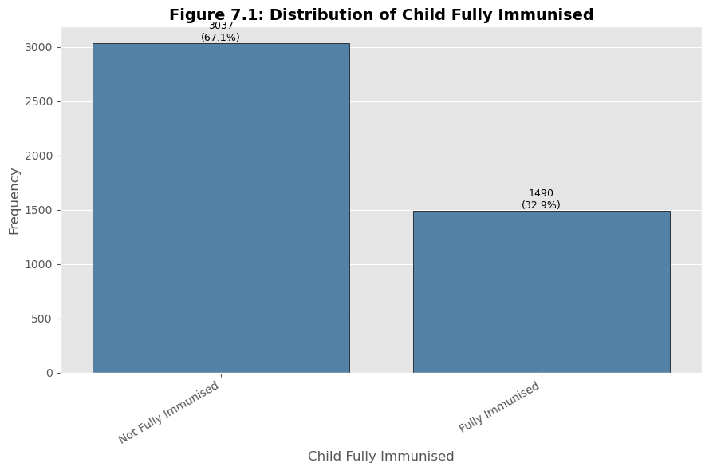
Figure 4.1: Distribution of Childhood Immunization Status
Figure 4.1 confirms the class imbalance already summarised in Table 4.2: 67.1% of children in the sample were not fully immunized, compared with 32.9% who were. This imbalance is moderate rather than severe, but is sufficient to justify the class-balancing and F1-oriented tuning strategy adopted in Chapter Three, since a model optimised purely for Accuracy could achieve a superficially strong score by defaulting toward the majority class.
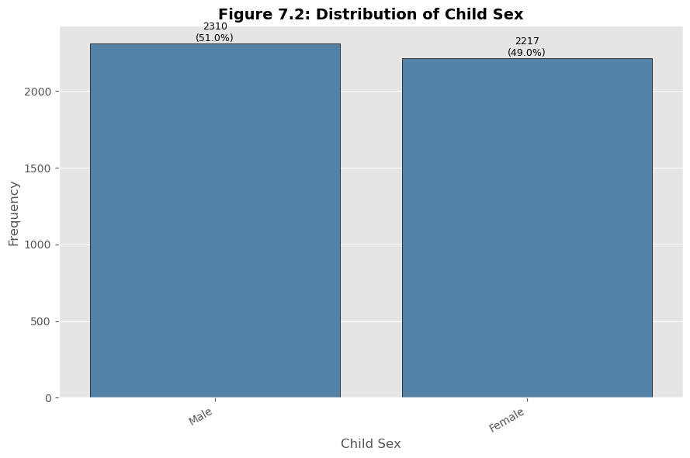
Figure 4.2: Distribution of Child Sex
The sample was almost evenly split between male and female children, consistent with the expected sex ratio at birth and indicating that child sex is unlikely to act as a confounding demographic imbalance in subsequent analysis.
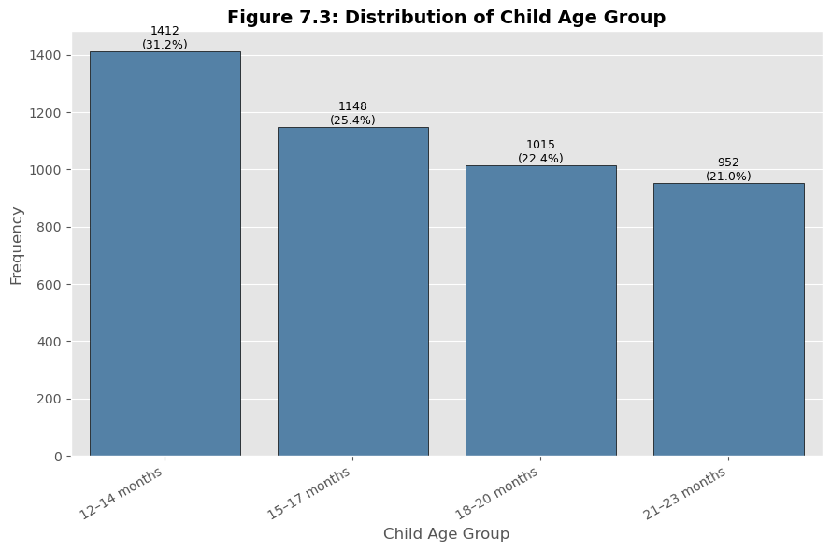
Figure 4.3: Distribution of Child Age Group
Children were fairly evenly distributed across the four three-month age bands spanning 12-23 months, with a slightly higher concentration in the earlier bands. This even spread supports the validity of comparing immunization status across age groups without one group dominating the sample.
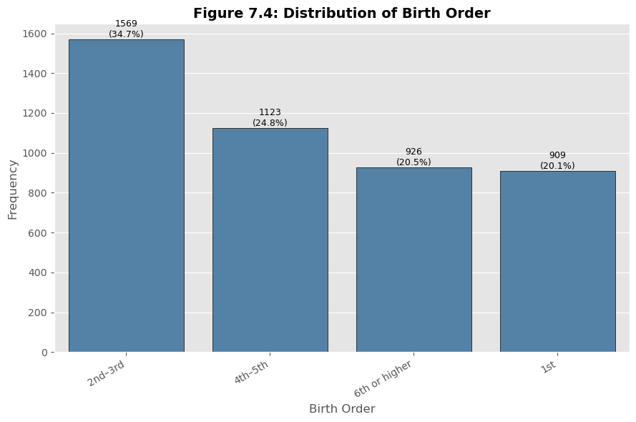
Figure 4.4: Distribution of Birth Order Group
The majority of children fell into the lower birth-order categories (1st and 2nd-3rd), with a declining share in higher birth-order categories, reflecting the general shape of Nigeria's fertility distribution and providing an adequately sized higher-birth-order group for later bivariate comparison.
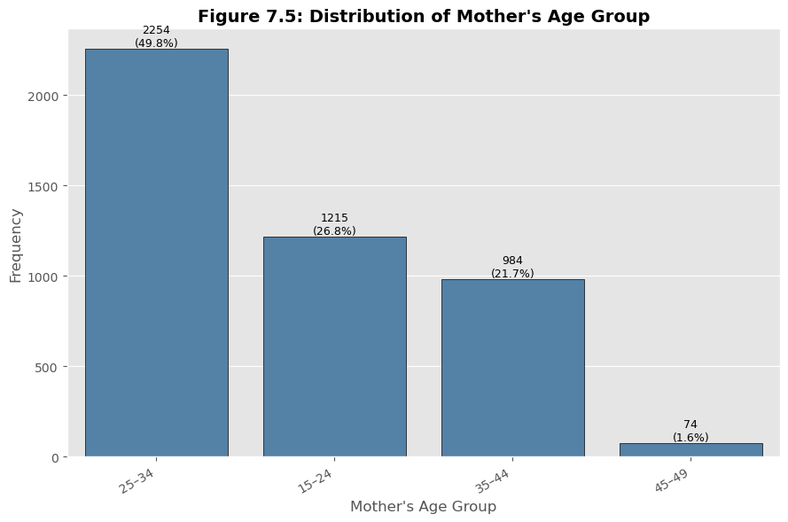
Figure 4.5: Distribution of Mother's Age Group
Most mothers in the sample fell within the 25-34 age band, followed by 15-24 and 35-44, with the smallest share in the 45-49 band, consistent with Nigeria's age-specific fertility pattern in which childbearing is concentrated in the mid-reproductive years.
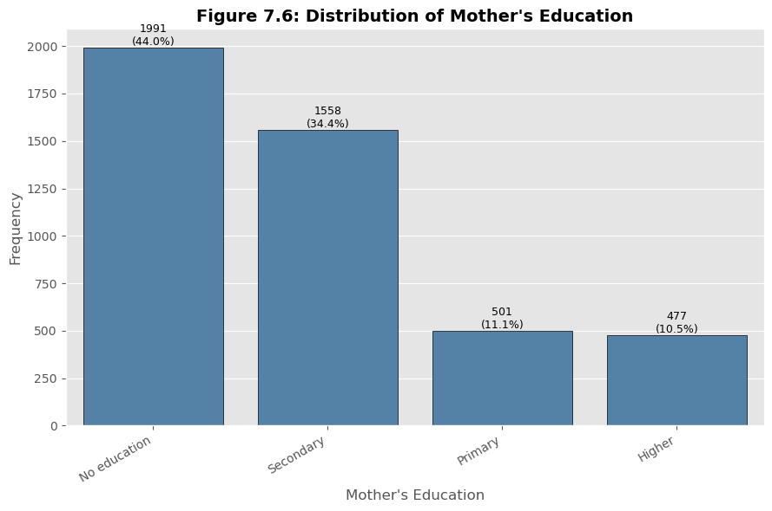
Figure 4.6: Distribution of Mother's Education Level
A substantial proportion of mothers in the sample had no formal education, with progressively smaller shares reporting primary, secondary, and higher education. This distribution reflects well-documented disparities in female educational attainment in Nigeria, particularly in northern regions, and foreshadows the strong bivariate association between maternal education and immunization status reported in Section 4.2.2.
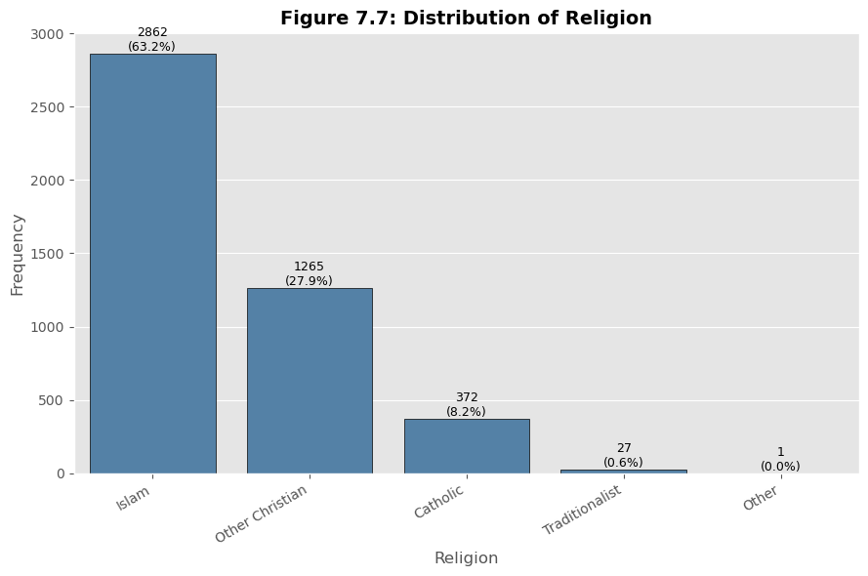
Figure 4.7: Distribution of Religion
Islam was the most frequently reported religion in the sample, followed by Other Christian and Catholic, with small proportions reporting Traditionalist or Other affiliations, broadly reflecting the religious composition of Nigeria's northern-skewed NDHS sampling frame for this age group.
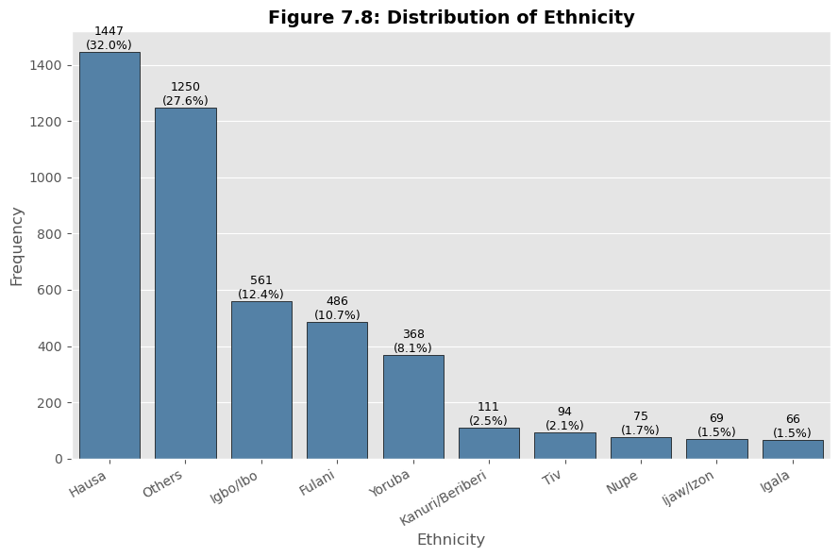
Figure 4.8: Distribution of Ethnicity (Top 10 Groups plus Others)
Hausa was the most frequently represented ethnic group, followed by a large "Others" category (reflecting Nigeria's substantial ethnic diversity beyond the ten largest groups), Igbo, Fulani, and Yoruba, with smaller shares for Kanuri/Beriberi, Tiv, Nupe, Ijaw/Izon, and Igala. This distribution is consistent with the ethnic composition typically captured in nationally representative Nigerian household surveys.
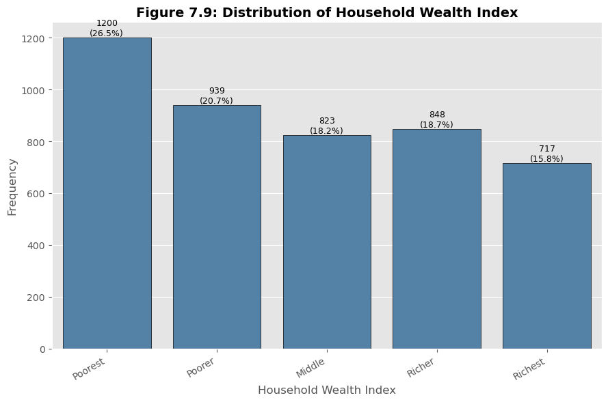
Figure 4.9: Distribution of Household Wealth Index
Household wealth quintiles were distributed relatively evenly across the five categories, with a slightly larger share of children in the poorer quintiles, consistent with the fertility-wealth gradient commonly observed in Nigerian demographic data, whereby poorer households tend to have proportionally more children in the eligible age range.
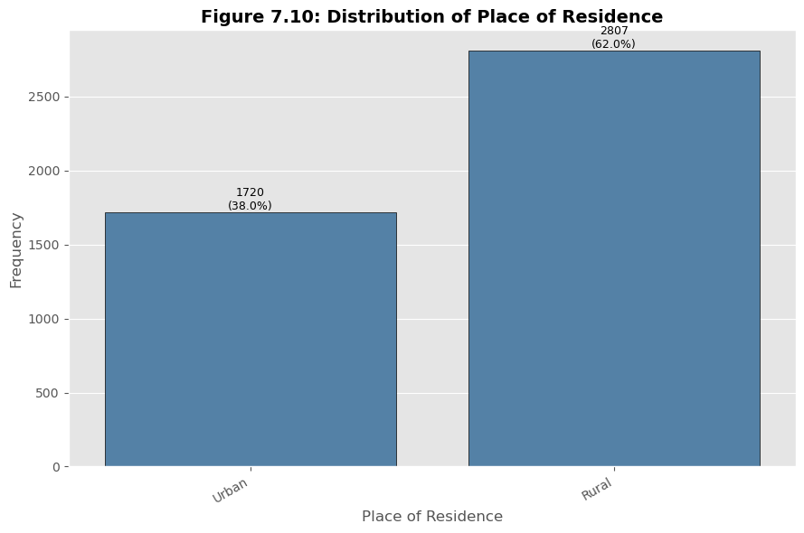
Figure 4.10: Distribution of Place of Residence
A majority of children resided in rural areas, consistent with Nigeria's rural-skewed population distribution and the NDHS sampling design, which weights toward representativeness of the national population rather than the urban population specifically.
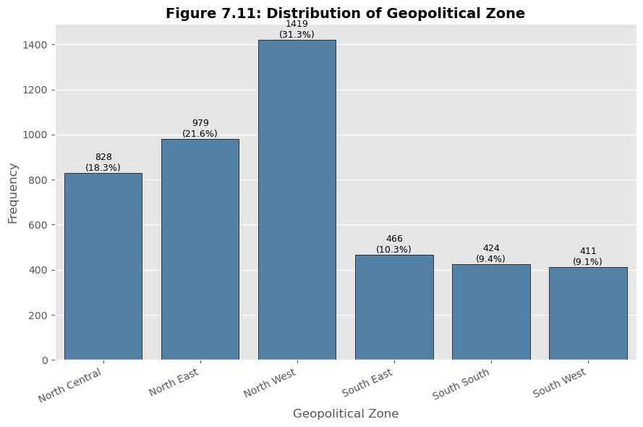
Figure 4.11: Distribution of Geopolitical Zone
The North West zone contributed the largest share of children to the sample, consistent with its position as Nigeria's most populous geopolitical zone and its comparatively higher fertility rate, with the remaining five zones contributing progressively smaller shares.
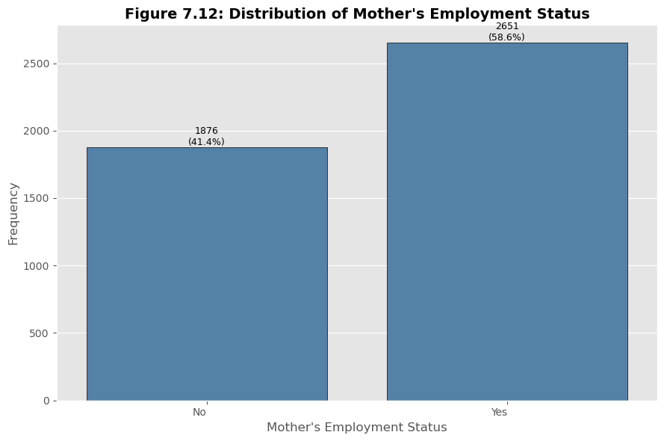
Figure 4.12: Distribution of Mother's Employment Status
A majority of mothers reported being engaged in some form of work, with a substantial minority not working, reflecting Nigeria's high rate of female labour-force participation in informal economic activity, particularly in rural areas.
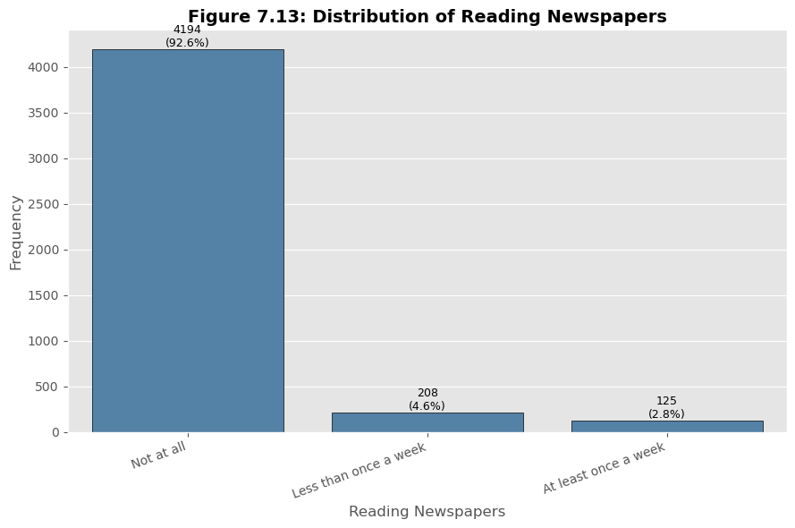
Figure 4.13: Distribution of Newspaper Readership
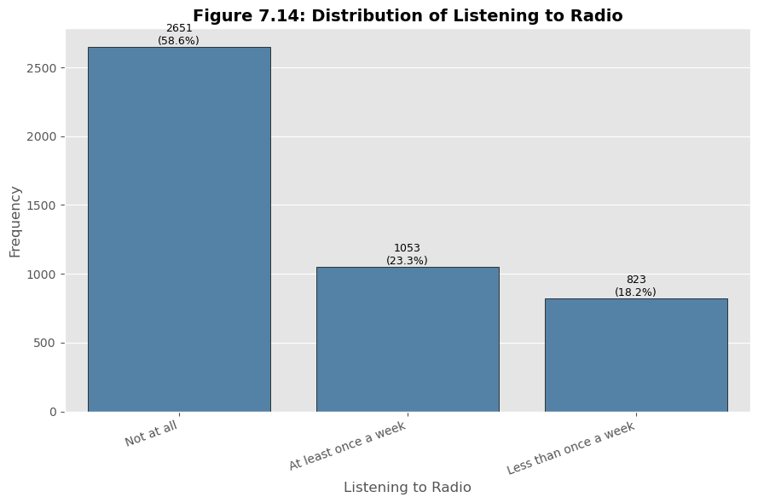
Figure 4.14: Distribution of Radio Listening
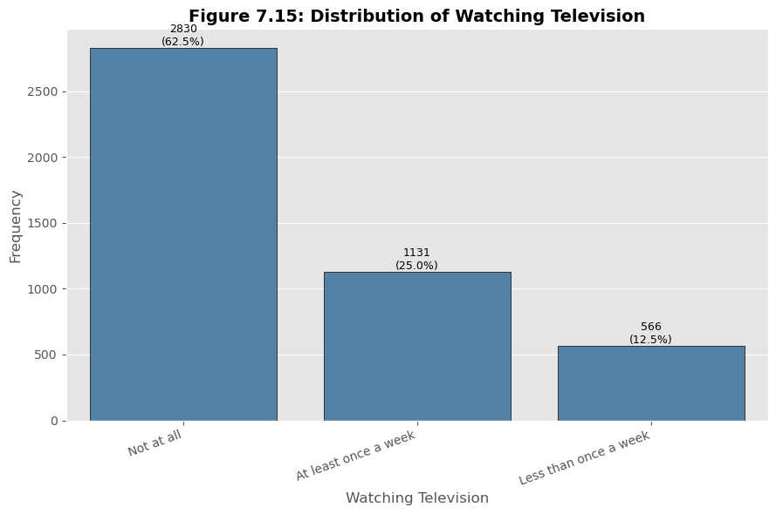
Figure 4.15: Distribution of Television Watching
Across all three media-exposure indicators, the majority of mothers reported no exposure ("Not at all"), with television watching showing a comparatively larger share of regular exposure than either radio listening or newspaper readership. This pattern reflects the relatively limited reach of print media in the study population and the comparative accessibility of television in areas with electricity access, and underlies the construction of the composite media_exposure variable described in Section 3.6.2.
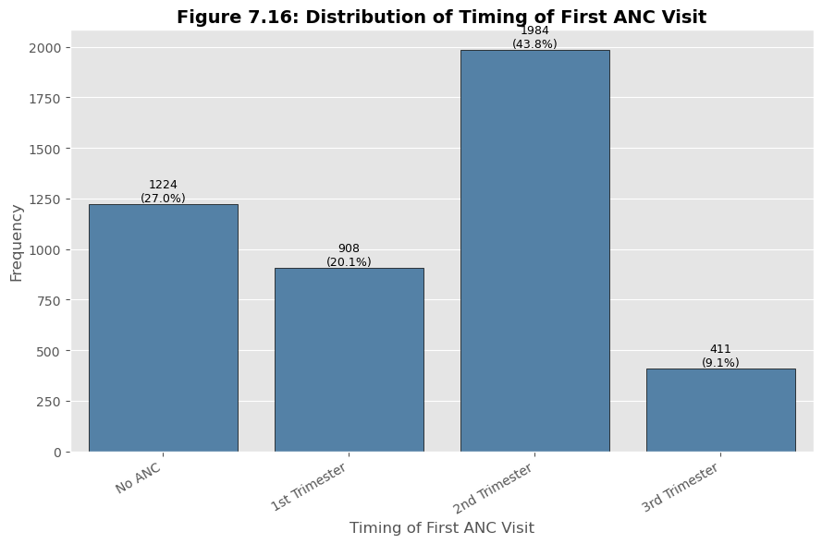
Figure 4.16: Distribution of Timing of First Antenatal Care Visit
A substantial proportion of mothers received no antenatal care at all ("No ANC"), while among those who did attend, initiation was fairly evenly split across the first, second, and third trimesters, with a tilt toward later initiation. This pattern of both non-attendance and delayed initiation is a central concern for maternal and child health programming in Nigeria and reappears as the strongest predictor of immunization status in the machine learning results reported in Section 4.4.
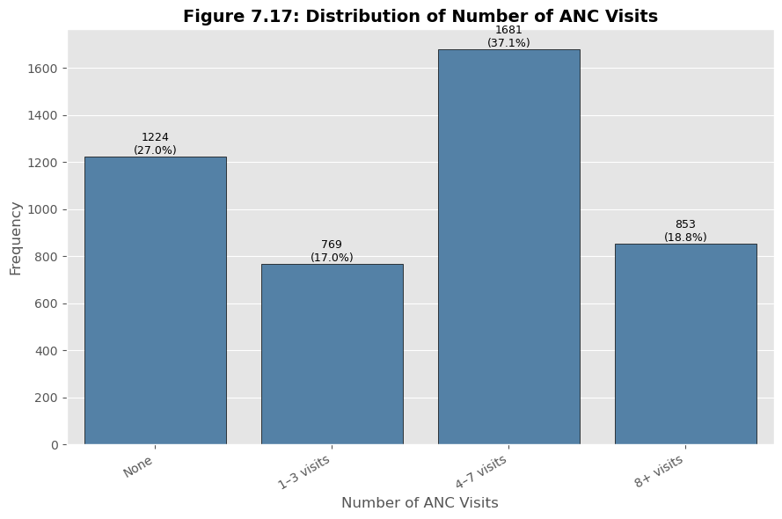
Figure 4.17: Distribution of Number of Antenatal Care Visits
A large share of mothers reported no ANC visits, with the remaining mothers distributed across the "1-3 visits", "4-7 visits", and "8+ visits" categories. The substantial "None" category reinforces the finding, discussed further in Section 4.2.2, that non-attendance at ANC is strongly linked to incomplete childhood immunization.
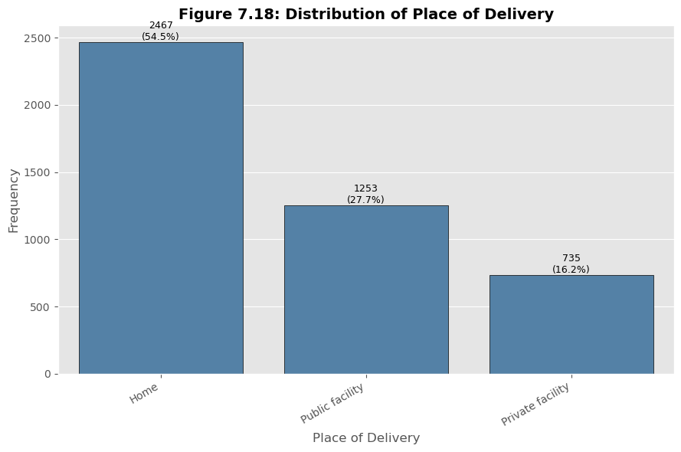
Figure 4.18: Distribution of Place of Delivery
Home delivery was the single most common category, followed by public health facilities and, to a lesser extent, private facilities, with faith-based facilities accounting for a small share. This distribution highlights that a large proportion of Nigerian births in this sample occurred outside formal health-facility settings, representing a missed opportunity for facility-based promotion of childhood immunization at the point of delivery.

4.2.2 Bivariate Analysis
Bivariate analysis examined each predictor's relationship with childhood immunization status, using stacked and grouped percentage-based bar charts that allow comparison across categories irrespective of underlying group size.
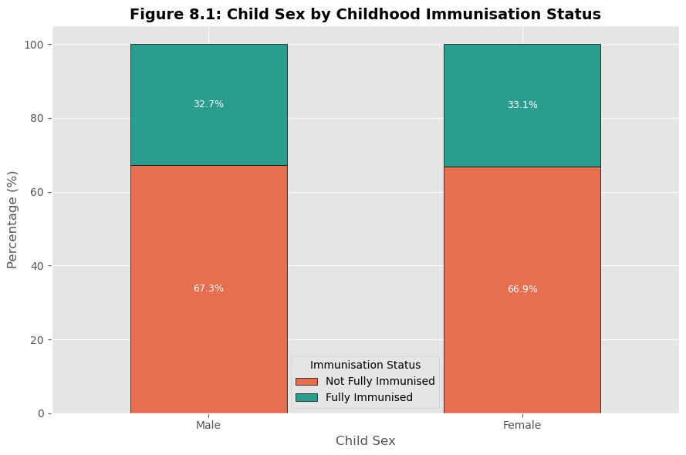
Figure 4.19: Child Sex by Childhood Immunization Status
The proportion of fully immunized children was very similar between male and female children, consistent with the very low Cramér's V (0.004) reported in Section 4.2.3 and indicating that child sex carries essentially no association with immunization status in this sample.
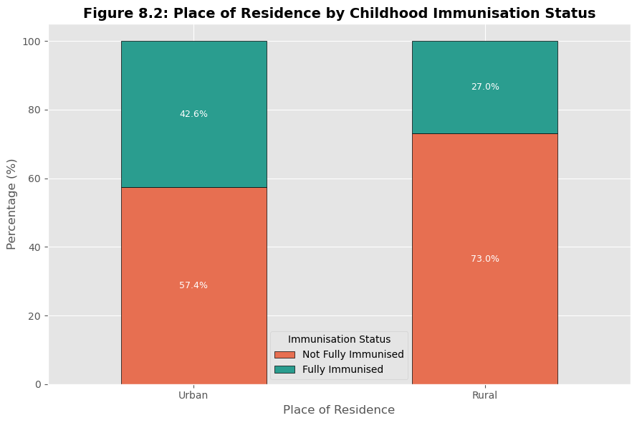
Figure 4.20: Place of Residence by Childhood Immunization Status
Urban children showed a visibly higher proportion of complete immunization than rural children, consistent with generally better healthcare access and health-facility density in Nigerian urban areas.
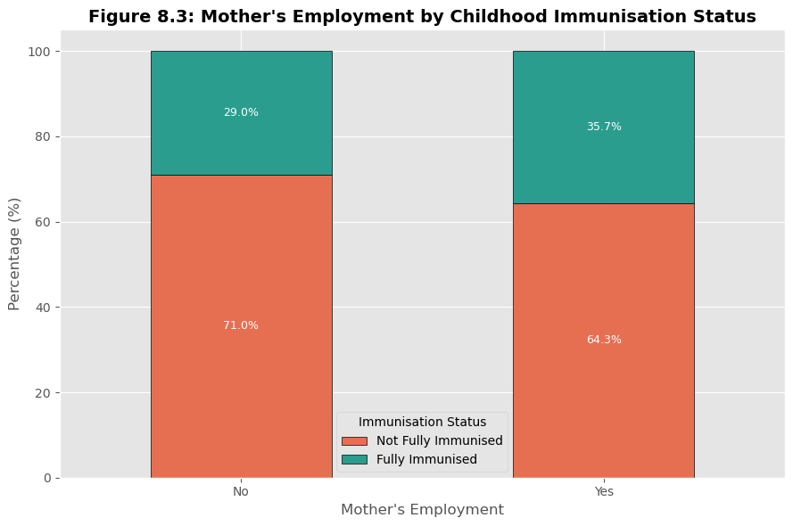
Figure 4.21: Mother's Employment Status by Childhood Immunization Status
Children of working mothers showed a modestly different immunization profile from children of non-working mothers, though the association (Cramér's V = 0.070) was among the weaker of the demographic predictors examined.
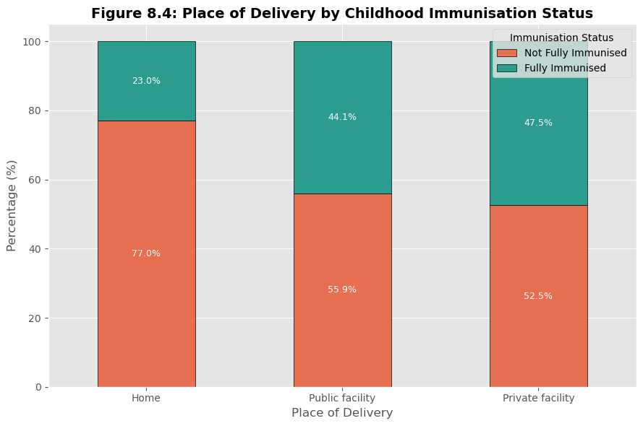
Figure 4.22: Place of Delivery by Childhood Immunization Status
Children delivered in public or private health facilities showed a markedly higher proportion of complete immunization than children delivered at home, consistent with the interpretation that facility-based delivery creates an early point of contact between the health system and the family that facilitates subsequent immunization.
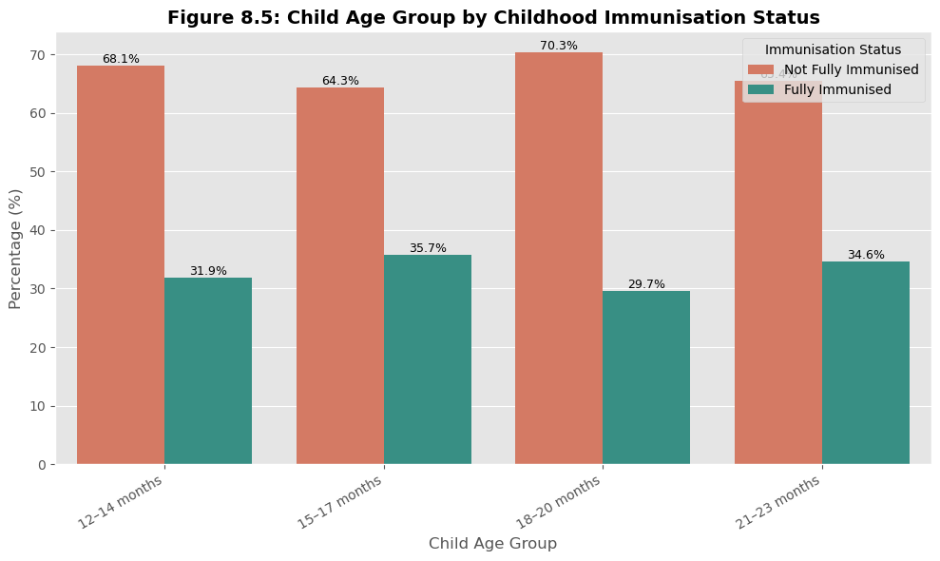
Figure 4.23: Child Age Group by Childhood Immunization Status
Older children within the 12-23 month window showed a modestly higher proportion of complete immunization than younger children, plausibly reflecting the additional time available for catch-up doses as children approach 23 months, though the association (Cramér's V = 0.049) was among the weakest observed.
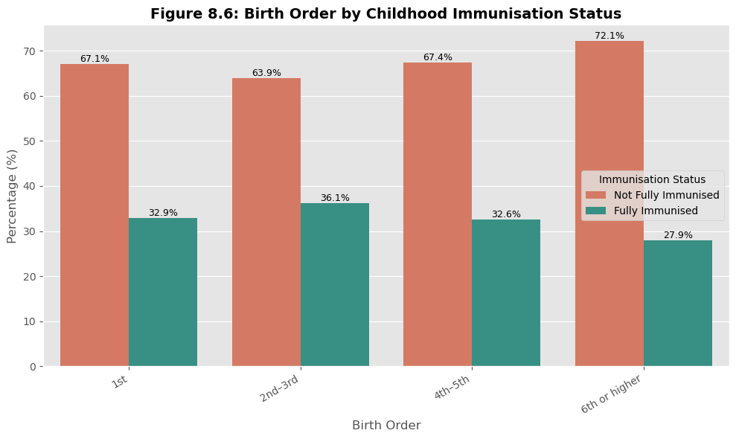
Figure 4.24: Birth Order Group by Childhood Immunization Status
Immunization completeness declined modestly with increasing birth order, with first-born children showing a somewhat higher proportion of complete immunization than children of birth order six or higher, though the overall association (Cramér's V = 0.063) remained relatively weak.
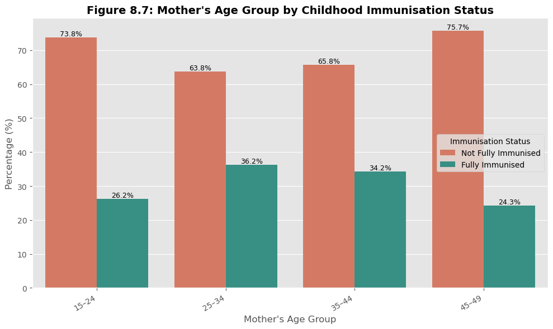
Figure 4.25: Mother's Age Group by Childhood Immunization Status
Immunization completeness varied only modestly across maternal age groups (Cramér's V = 0.094), without a clear monotonic pattern, suggesting that maternal age alone is a comparatively weak determinant relative to the socioeconomic and healthcare-utilization variables discussed below.
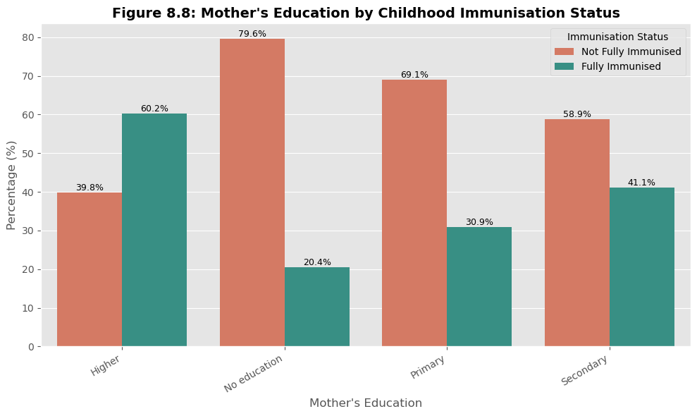
Figure 4.26: Mother's Education Level by Childhood Immunization Status
A clear positive gradient was observed between maternal education and complete immunization: children of mothers with no formal education showed the lowest proportion of complete immunization, rising progressively through primary, secondary, and higher education. This pattern, together with the comparatively strong Cramér's V of 0.278 reported in Section 4.2.3, is consistent with the wider literature identifying maternal education as one of the most robust predictors of childhood immunization in Nigeria and other high-burden settings.
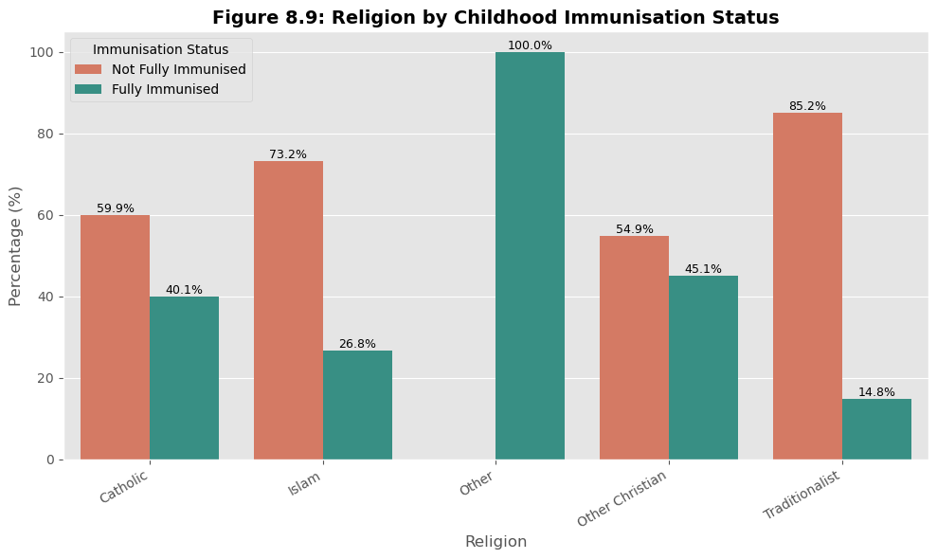
Figure 4.27: Religion by Childhood Immunization Status
Immunization completeness varied by religious affiliation (Cramér's V = 0.181), a pattern that is plausibly confounded with the geographic and socioeconomic distribution of religious groups across Nigeria's geopolitical zones rather than reflecting religion as an independent causal determinant.
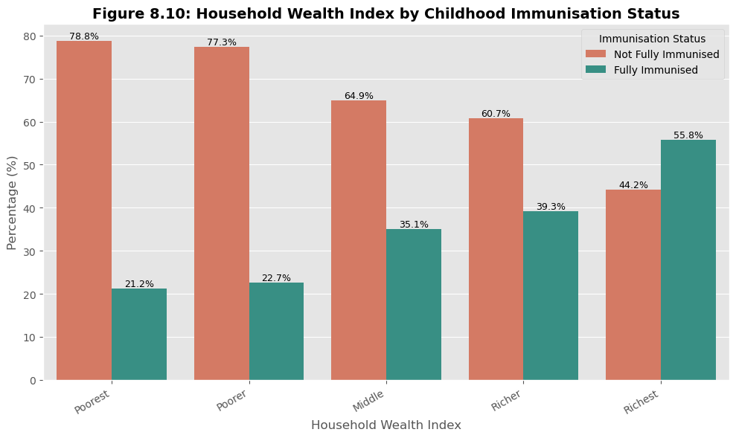
Figure 4.28: Household Wealth Index by Childhood Immunization Status
A clear positive gradient was again observed: children in the poorest households showed the lowest proportion of complete immunization, rising steadily through poorer, middle, richer, and richest quintiles. This mirrors the maternal-education gradient and reflects the well-established relationship between household socioeconomic status and healthcare-seeking capacity.
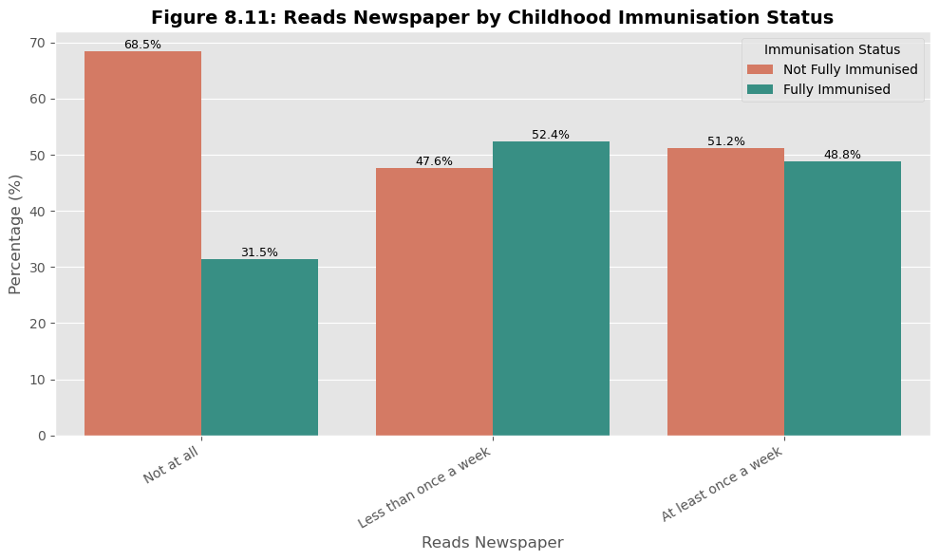
Figure 4.29: Newspaper Readership by Childhood Immunization Status
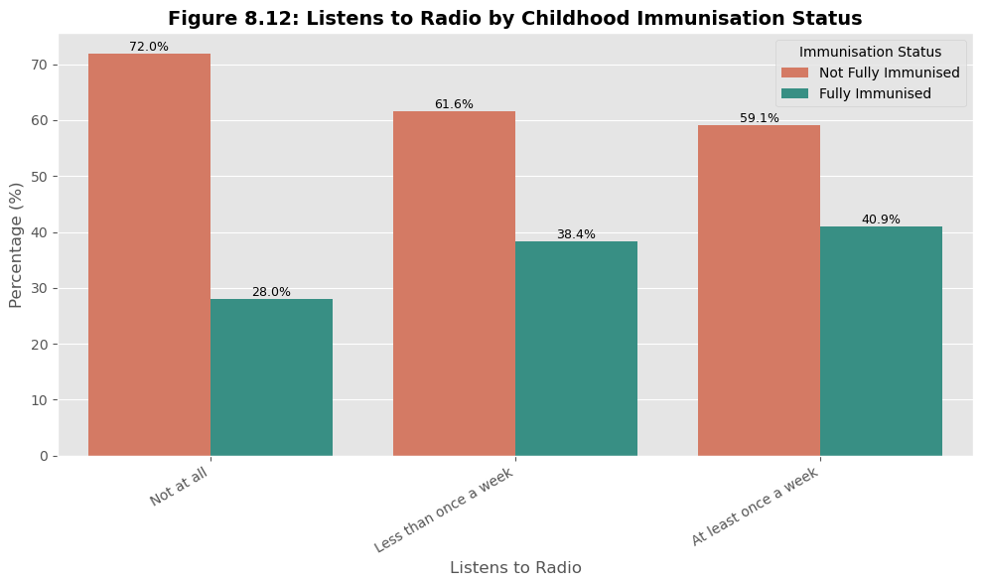
Figure 4.30: Radio Listening by Childhood Immunization Status
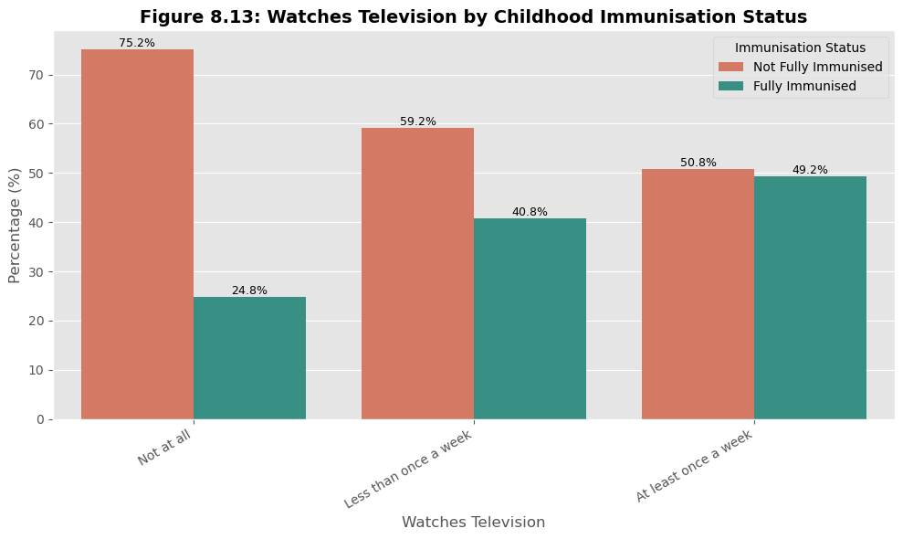
Figure 4.31: Television Watching by Childhood Immunization Status
All three media-exposure indicators showed a positive association with complete immunization, with television watching showing the strongest bivariate association (Cramér's V = 0.229) of the three, followed by radio listening (0.125) and newspaper readership (0.109). This pattern is consistent with mass-media exposure serving as a channel for maternal and child health information, including immunization reminders and health messaging.
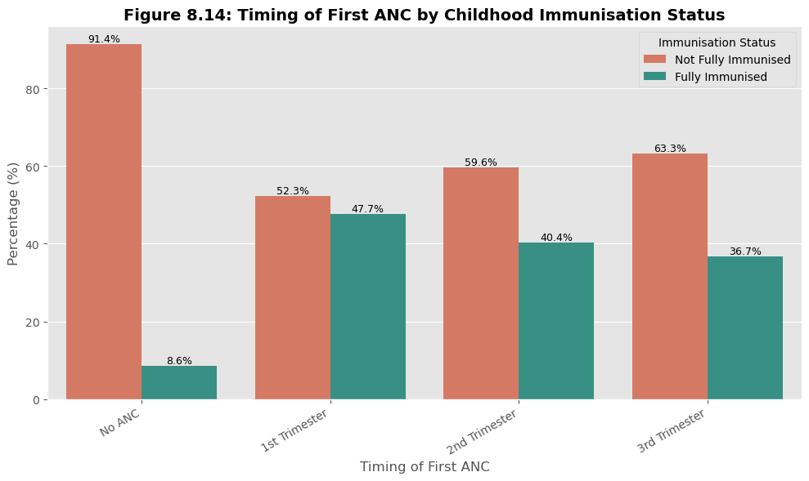
Figure 4.32: Timing of First Antenatal Care Visit by Childhood Immunization Status
Children whose mothers initiated antenatal care earlier in pregnancy showed a substantially higher proportion of complete immunization than children whose mothers received no antenatal care at all, with a clear step-down in immunization completeness as ANC timing shifted from "No ANC" toward the first trimester and beyond. This variable recorded the second-highest Cramér's V of any predictor examined (0.322).
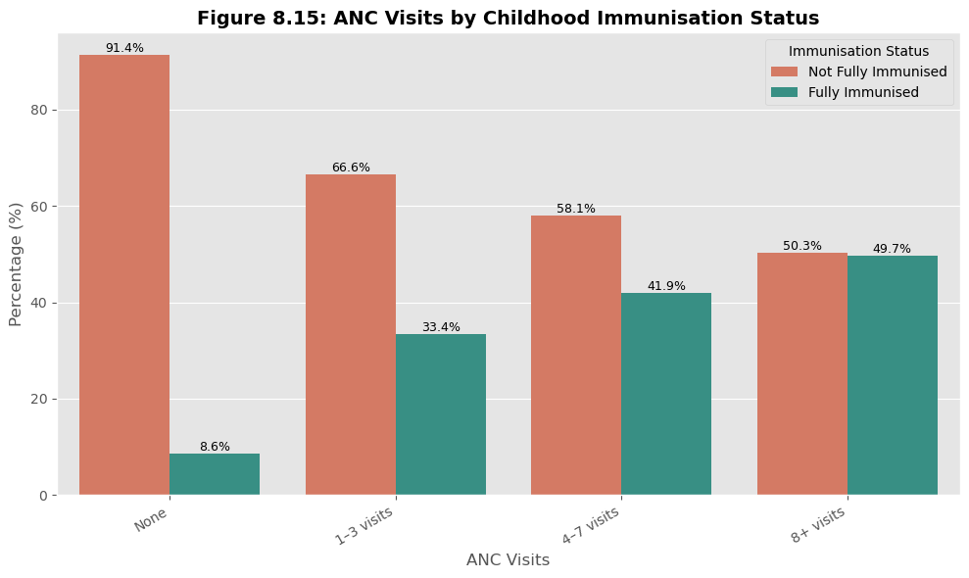
Figure 4.33: Number of Antenatal Care Visits by Childhood Immunization Status
The relationship between ANC visit frequency and complete immunization was the strongest bivariate association observed in the entire exploratory analysis (Cramér's V = 0.332): children whose mothers attended eight or more ANC visits showed a markedly higher proportion of complete immunization than children whose mothers attended no ANC visits at all, with a clear, near-monotonic gradient across the intermediate categories.
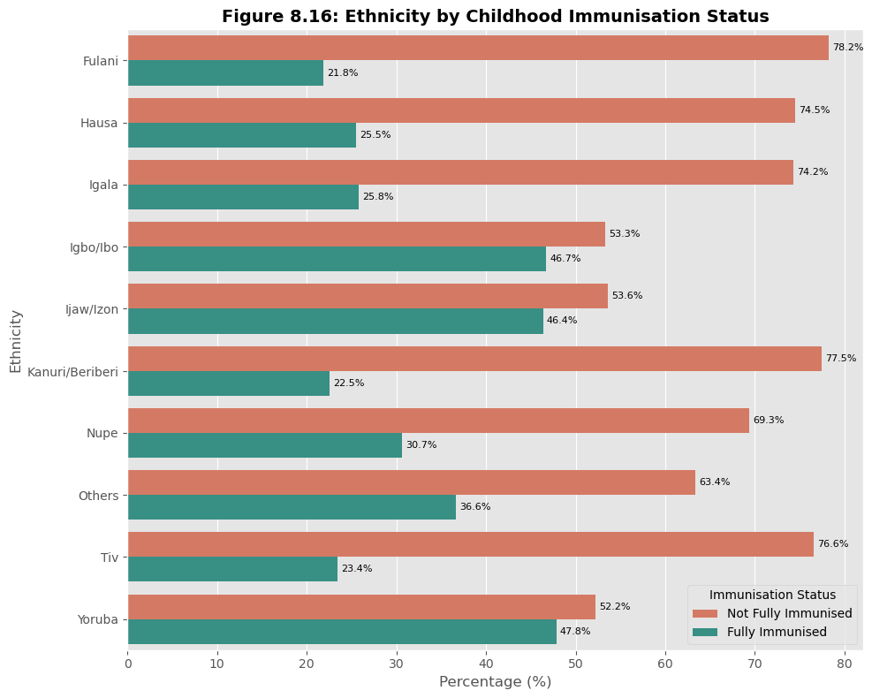
Figure 4.34: Ethnicity by Childhood Immunization Status
Immunization completeness varied across ethnic groups (Cramér's V = 0.195), a pattern that, as with religion, likely reflects the geographic concentration of ethnic groups across zones with differing healthcare infrastructure and coverage levels rather than an independent ethnic effect.
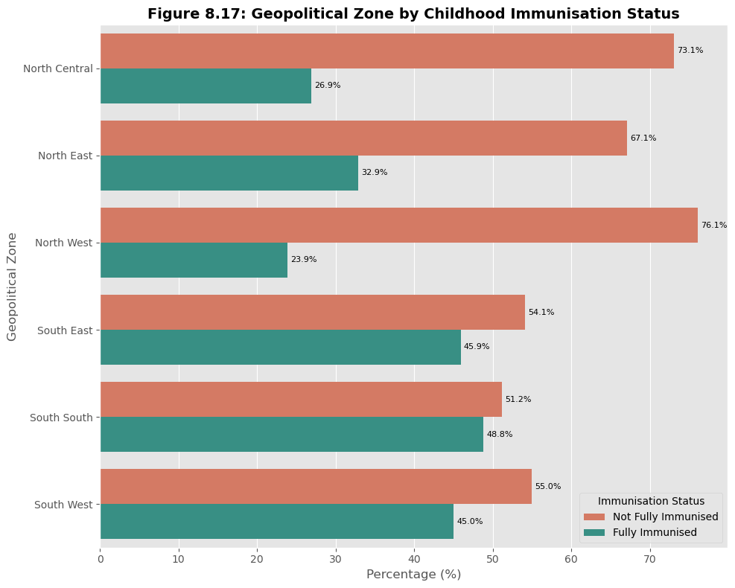
Figure 4.35: Geopolitical Zone by Childhood Immunization Status
Clear differences in immunization completeness were observed across Nigeria's six geopolitical zones (Cramér's V = 0.198), consistent with the well-documented north-south disparity in immunization coverage reported in the wider NDHS literature (Alabi et al., 2024), with northern zones generally showing lower proportions of complete immunization than southern zones.

4.2.3 Association (Cramér's V) Analysis
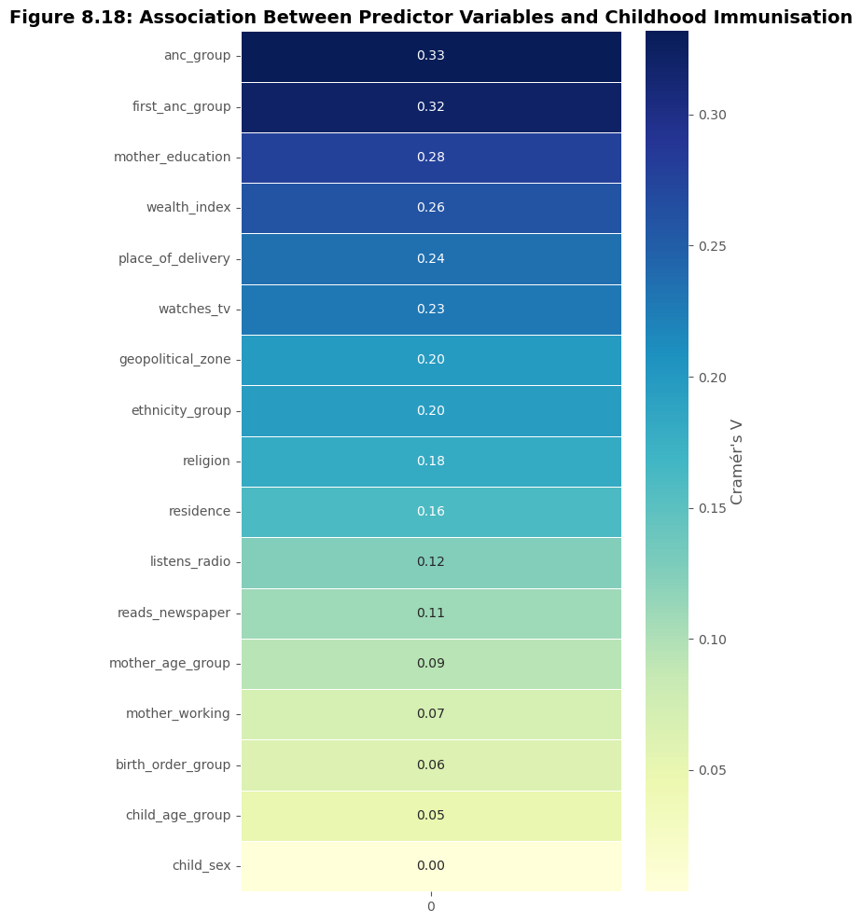
Figure 4.36: Association Between Predictor Variables and Childhood Immunization Status (Cramér's V Heatmap)
To formally rank the strength of association between each categorical predictor and childhood immunization status prior to machine learning modelling, Cramér's V was computed for each variable using a chi-square test of independence. Table 4.3 presents the ranked results.
Table 4.3: Cramér's V Association Between Predictor Variables and Childhood Immunization Status (Ranked)
Predictor Variable | Cramér's V
Number of ANC visits | 0.332
Timing of first ANC visit | 0.322
Mother's education | 0.278
Wealth index | 0.260
Place of delivery | 0.236
Watches television | 0.229
Geopolitical zone | 0.198
Ethnicity group | 0.195
Religion | 0.181
Residence (urban/rural) | 0.161
Listens to radio | 0.125
Reads newspaper | 0.109
Mother's age group | 0.094
Mother's employment status | 0.070
Birth order group | 0.063
Child age group | 0.049
Child sex | 0.004

The association analysis confirms a clear hierarchy among predictor domains. Maternal healthcare-utilization variables - the number and timing of antenatal care visits - showed the strongest associations with complete immunization, followed by socioeconomic variables (maternal education and wealth index) and place of delivery. Media exposure and geographic/ethnic variables showed moderate associations, while purely demographic characteristics (child sex, child age group, birth order, maternal age group) showed the weakest associations. This ranking directly foreshadows the feature importance results obtained from the final Random Forest model in Section 4.5, and provided the empirical basis for retaining all seventeen predictors, including the weaker demographic variables, in the machine learning feature set, since even weakly associated variables can contribute to predictive performance in combination with stronger predictors.

4.3 Model Comparison
Eleven machine learning models - baseline and hyperparameter-tuned variants of five algorithms - were trained on the processed 39-feature training set (n = 3,621) and evaluated on the held-out test set (n = 906). Table 4.4 presents the full comparison, ranked by F1-score, the metric used as the tuning criterion.
Table 4.4: Performance Comparison of All Eleven Models on the Test Set (Ranked by F1-Score)
Rank | Model | Accuracy | Precision | Recall | F1-Score | ROC-AUC
1 | Tuned SVM | 58.06% | 42.86% | 82.55% | 0.5642 | 0.6943
2 | Tuned Random Forest | 59.16% | 43.38% | 79.19% | 0.5606 | 0.6985
3 | Tuned XGBoost | 54.53% | 40.92% | 86.24% | 0.5551 | 0.6914
4 | Tuned Decision Tree | 51.77% | 39.61% | 88.93% | 0.5481 | 0.6634
5 | Balanced Logistic Regression | 60.93% | 44.17% | 71.14% | 0.5450 | 0.6796
6 | Tuned Logistic Regression | 55.30% | 40.53% | 76.85% | 0.5307 | 0.6638
7 | Baseline XGBoost | 64.02% | 45.07% | 42.95% | 0.4399 | 0.6608
8 | Baseline Decision Tree | 61.37% | 41.82% | 44.63% | 0.4318 | 0.5710
9 | Baseline Random Forest | 67.00% | 49.77% | 35.57% | 0.4149 | 0.6898
10 | Baseline SVM | 67.99% | 52.41% | 29.19% | 0.3750 | 0.6872
11 | Baseline Logistic Regression | 65.45% | 45.99% | 28.86% | 0.3546 | 0.6802

Two consistent patterns are evident across Table 4.4. First, every baseline model achieved comparatively high Accuracy (61.4%-68.0%) but low Recall (28.9%-44.6%), reflecting a tendency to favour the majority "not fully immunized" class; the baseline SVM, for example, achieved the second-highest Accuracy of any model (67.99%) but the second-lowest Recall (29.19%), correctly identifying fewer than one in three fully immunized children. Second, hyperparameter tuning combined with class-balancing (class_weight="balanced" or, for XGBoost, scale_pos_weight) systematically shifted this trade-off in every algorithm: Recall rose substantially (by 20 to 60 percentage points depending on the algorithm) while Accuracy fell, since the tuned models became more willing to predict the minority "fully immunized" class, at the cost of additional false positives. This trade-off is an expected and, for this study's purposes, a desirable consequence of optimising for F1-score rather than Accuracy: in a public-health screening context, correctly identifying children at risk of incomplete immunization (which corresponds to Recall on the minority "fully immunized" class being interpreted alongside its complement) is generally of greater programmatic value than maximising overall correct-classification rate.
Among the tuned models, the Tuned SVM achieved the single highest F1-score (0.5642), narrowly ahead of the Tuned Random Forest (0.5606), a difference of only 0.0036 that is unlikely to be practically meaningful given the test-set size. However, the Tuned Random Forest achieved the highest ROC-AUC of any of the eleven models (0.6985), the highest Accuracy among the top-five F1-ranked models (59.16%), and a marginally higher Precision than the Tuned SVM (43.38% versus 42.86%), indicating a slightly better overall balance between correctly identifying fully immunized children and avoiding false positives. On this combined basis - and following the project supervisor's guidance that Random Forest be adopted as the final model - the Tuned Random Forest was selected as the final predictive model for this study, and is examined in detail in Section 4.4.

4.4 Random Forest Results
The Random Forest algorithm was selected as the final model for this study. Both the baseline and tuned configurations are presented below to illustrate the effect of hyperparameter optimisation on this specific algorithm, before the tuned model's confusion matrix, ROC curve, and feature importance are examined in detail.
Table 4.5: Baseline versus Tuned Random Forest Performance
Configuration | Accuracy | Precision | Recall | F1-Score | ROC-AUC
Baseline Random Forest | 67.00% | 49.77% | 35.57% | 0.4149 | 0.6898
Tuned Random Forest | 59.16% | 43.38% | 79.19% | 0.5606 | 0.6985

The baseline Random Forest, trained with default hyperparameters, achieved strong Accuracy (67.00%) - second only to the baseline SVM among all eleven models - but a low Recall of 35.57%, meaning that fewer than four in ten fully immunized children were correctly identified. Following hyperparameter tuning via five-fold GridSearchCV (best parameters: n_estimators = 300, max_depth = 5, min_samples_leaf = 2, min_samples_split = 2, max_features = "sqrt", with class_weight = "balanced"), Recall more than doubled to 79.19%, and F1-score improved from 0.4149 to 0.5606. ROC-AUC also improved, from 0.6898 to 0.6985, the highest value achieved by any of the eleven models evaluated in this study, indicating that the tuned Random Forest possesses the strongest overall class-discrimination ability, independent of the choice of classification threshold.
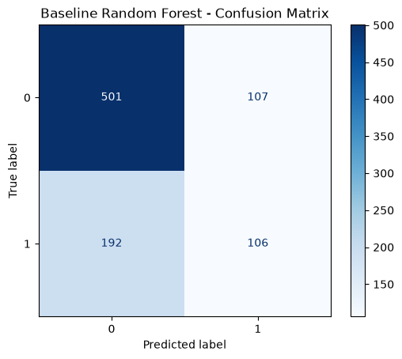
Figure 4.37: Confusion Matrix - Baseline Random Forest
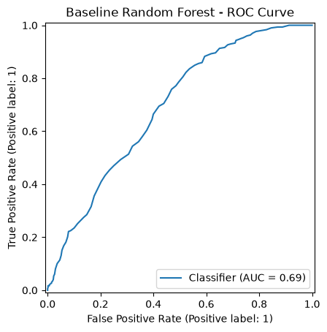
Figure 4.38: ROC Curve - Baseline Random Forest
Figure 4.37 shows that the baseline Random Forest correctly classified the majority of "not fully immunized" children but missed a substantial share of "fully immunized" children (a high false-negative count relative to true positives), consistent with its low Recall of 35.57%. Figure 4.38 shows a ROC curve well above the diagonal chance line, corresponding to its ROC-AUC of 0.6898, indicating moderate discriminative ability even before tuning.

4.4.1 Confusion Matrix (Tuned Random Forest)
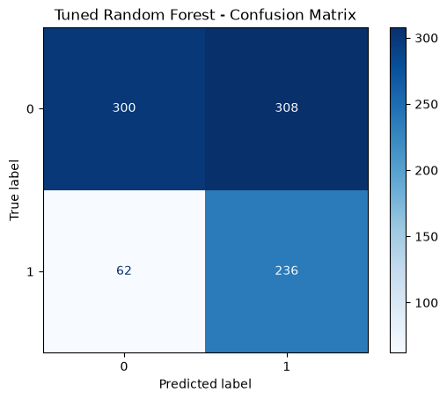
Figure 4.39: Confusion Matrix - Tuned Random Forest (Final Model)
The confusion matrix for the tuned Random Forest, computed on the 906-observation test set (608 not-fully-immunized and 298 fully-immunized children), reflects the shift toward higher Recall described above: the model correctly identified the large majority of truly fully immunized children (Recall = 79.19%, corresponding to approximately 236 of the 298 fully immunized children in the test set being correctly flagged, with the remainder misclassified as not fully immunized), at the cost of a higher false-positive rate among truly not-fully-immunized children (consistent with the drop in Precision to 43.38% and Accuracy to 59.16% relative to the untuned baseline). This pattern is precisely the trade-off intended by optimising the tuning process for F1-score under class imbalance: the tuned model is deliberately more willing to flag a child as potentially fully immunized, reducing missed true positives at the cost of additional false alarms.

4.4.2 ROC Curve (Tuned Random Forest)
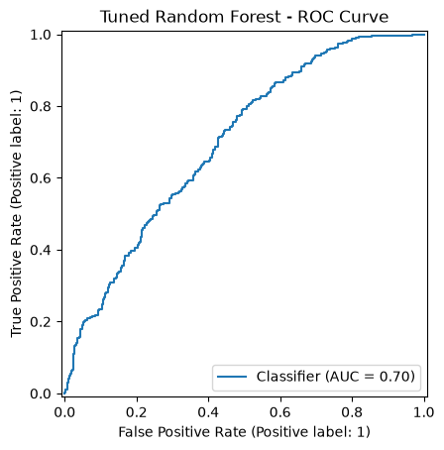
Figure 4.40: ROC Curve - Tuned Random Forest (Final Model)
The ROC curve for the tuned Random Forest lies further above the diagonal no-discrimination line than any of the other ten models evaluated, corresponding to its leading ROC-AUC of 0.6985. Because ROC-AUC evaluates discrimination across all possible probability thresholds rather than at a single fixed cut-off, this result indicates that the tuned Random Forest's underlying predicted probabilities carry more genuine information about a child's true immunization status than those of any other model tested, even though its Accuracy at the default 0.5 threshold is lower than several baseline models. This threshold-independence is a key reason the tuned Random Forest was preferred as the final model over the marginally higher-F1 Tuned SVM.

4.4.3 Feature Importance
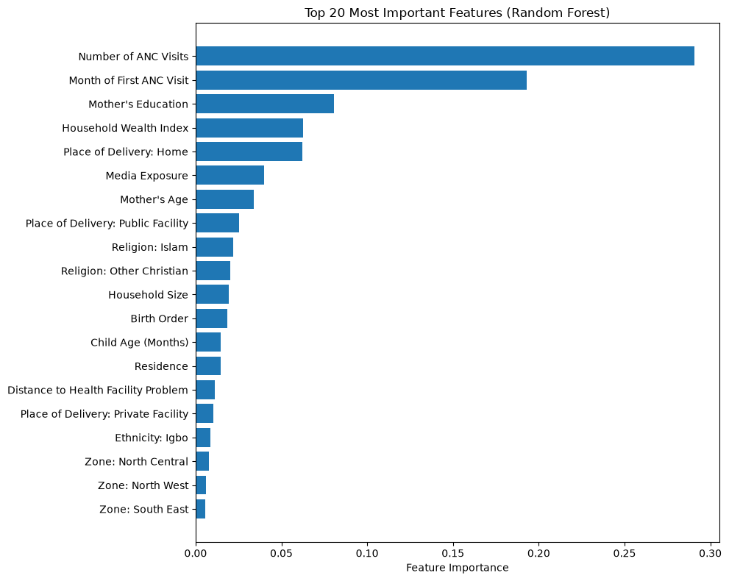
Figure 4.41: Top 20 Most Important Features (Tuned Random Forest, Gini-Based Importance)
Table 4.6: Top 20 Features by Random Forest (Gini) Importance
Rank | Feature | Importance
1 | Number of ANC Visits | 0.2909
2 | Month of First ANC Visit | 0.1931
3 | Mother's Education | 0.0808
4 | Household Wealth Index | 0.0627
5 | Place of Delivery: Home | 0.0623
6 | Media Exposure | 0.0400
7 | Mother's Age | 0.0340
8 | Place of Delivery: Public Facility | 0.0253
9 | Religion: Islam | 0.0219
10 | Religion: Other Christian | 0.0201
11 | Household Size | 0.0195
12 | Birth Order | 0.0185
13 | Child Age (Months) | 0.0145
14 | Residence | 0.0145
15 | Distance to Health Facility Problem | 0.0114
16 | Place of Delivery: Private Facility | 0.0105
17 | Ethnicity: Igbo | 0.0087
18 | Zone: North Central | 0.0078
19 | Zone: North West | 0.0058
20 | Zone: South East | 0.0058

Feature importance analysis, conducted using the Gini-based importance measure of the final tuned Random Forest, identifies the number of antenatal care visits as the single most influential predictor, contributing approximately 29.1% of the model's total predictive importance, followed closely by the month of the first antenatal care visit (19.3%). Together, these two maternal healthcare-utilization variables account for nearly half (48.4%) of the model's total feature importance, decisively confirming the pattern already suggested by the Cramér's V association analysis in Section 4.2.3. Maternal socioeconomic characteristics - mother's education (8.1%) and household wealth index (6.3%) - rank third and fourth, reinforcing the well-established socioeconomic gradient in immunization completeness. Place of delivery also features prominently, with home delivery (6.2%) and public-facility delivery (2.5%) both appearing among the top eight features, consistent with the earlier bivariate finding that facility-based delivery is associated with higher immunization completeness. Media exposure, mother's age, religion, household size, birth order, child's age, residence, distance to a health facility, and selected ethnicity and geopolitical-zone indicators complete the top twenty features, each contributing a comparatively small but non-trivial share of predictive importance.

4.4.4 SHAP Model Interpretation
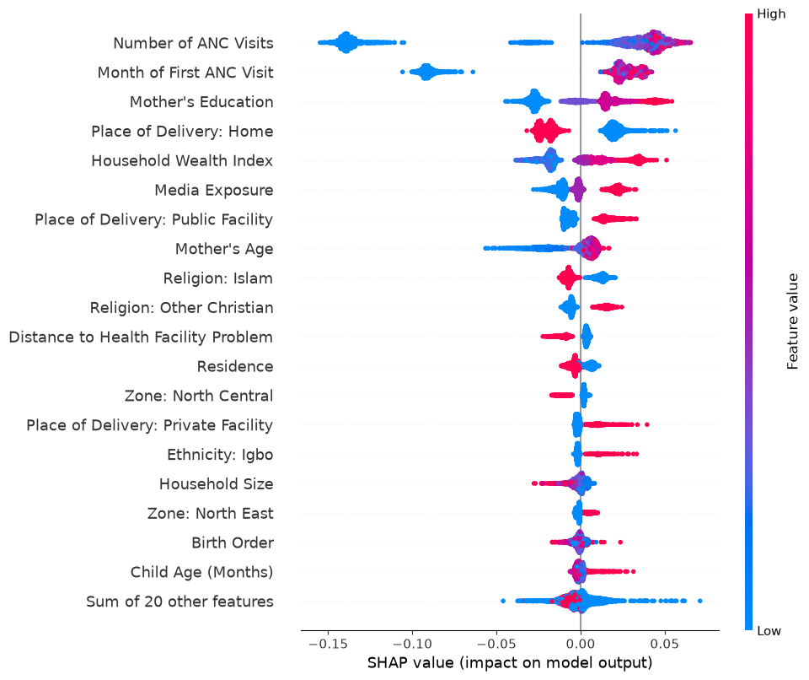
Figure 4.42: SHAP Summary (Beeswarm) Plot for the Tuned Random Forest Model
SHapley Additive exPlanations (SHAP) were computed for the tuned Random Forest to provide a complementary, model-agnostic view of feature influence at the level of individual predictions, rather than the aggregate Gini-based importance reported above. The SHAP summary plot in Figure 4.42 confirms that the number of ANC visits, the timing of the first ANC visit, mother's education, household wealth index, and place of delivery exert the strongest influence on individual predictions, consistent with the Gini-based feature importance ranking. In the SHAP plot, each point represents one child in the training set, with its horizontal position indicating the magnitude and direction of that feature's contribution to the predicted probability of complete immunization for that specific child, and its colour indicating whether the child's value for that feature was relatively high (red) or low (blue). The wide horizontal spread of points for ANC visits and ANC timing indicates that these features exert a large and highly variable influence across children, with higher (redder) values of ANC visits and earlier ANC initiation generally pushing predictions toward a higher probability of complete immunization. The convergence of the SHAP analysis with the Gini-based feature importance results provides additional confidence that the final model's predictions are grounded in substantively meaningful public-health determinants rather than idiosyncratic patterns in the training data, strengthening the case for the model's practical interpretability and applicability.

Summary of Findings
- Of 4,527 Nigerian children aged 12-23 months in the 2023-24 NDHS analytic sample, only 32.91% had received all nine basic vaccine doses that constitute complete immunization, while 67.09% had not.
- Bivariate and Cramér's V association analysis identified maternal healthcare-utilization variables - the number of ANC visits (V = 0.332) and the timing of the first ANC visit (V = 0.322) - as the strongest correlates of complete immunization, ahead of socioeconomic variables such as mother's education (V = 0.278) and wealth index (V = 0.260); purely demographic variables such as child sex (V = 0.004) and child age group (V = 0.049) showed negligible to weak association.
- Across eleven machine learning models (baseline and tuned Logistic Regression, Decision Tree, Random Forest, XGBoost, and Support Vector Machine), hyperparameter tuning combined with class-balancing consistently improved Recall and F1-score at the cost of Accuracy, reflecting the expected trade-off when addressing class imbalance.
- The Tuned Support Vector Machine achieved the highest F1-score (0.5642) by a narrow margin, but the Tuned Random Forest achieved the highest ROC-AUC (0.6985) of any model, alongside a competitive F1-score (0.5606), Accuracy of 59.16%, Precision of 43.38%, and Recall of 79.19%, and was adopted as the final model for this study.
- Feature importance and SHAP analysis of the final Random Forest model confirmed that antenatal care attendance (visit frequency and timing) contributes almost half of the model's total predictive importance, followed by maternal education, household wealth, and place of delivery, with demographic and purely geographic variables contributing comparatively little.
- Feature engineering - specifically, grouping the high-cardinality ethnicity and place-of-delivery variables and constructing a composite media-exposure variable - reduced the processed feature space from a potential 213 columns to 39, improving model tractability without discarding substantive predictive information.

CHAPTER FIVE: DISCUSSION, CONCLUSION AND RECOMMENDATIONS

5.1 Discussion of Findings

5.1.1 Comparison with Literature
The finding that only 32.91% of children aged 12-23 months in this NDHS 2023-24-derived sample were fully immunized is broadly consistent with, though somewhat lower than, the 39% national figure for basic-vaccination completeness reported in the 2023-24 NDHS Key Indicators Report itself (FMOH et al., 2024, as cited in FMOH, 2025), a difference plausibly attributable to methodological choices in this study - notably, the strict nine-dose definition adopted, the exclusion of children with any unknown dose status rather than treating them as "not fully immunized", and the removal of children with unresolved missing antenatal care data. The result is closer to, though still somewhat higher than, the alarmingly low coverage rates (11-18%) reported by Alabi et al. (2024) among young mothers specifically in northern Nigeria, and considerably lower than the national full-immunization estimates of 63.6%-82% reported by Adeyinka et al. (2024) using earlier NDHS rounds and a somewhat different immunization-coverage estimation approach. These discrepancies illustrate a recurring challenge in the Nigerian immunization literature: full-immunization estimates are highly sensitive to the specific vaccine list used, the treatment of "don't know" and missing responses, and whether a child's age is capped strictly at the survey-recommended 12-23 month window or extended to allow for catch-up vaccination in older children - a methodological sensitivity that future researchers should report transparently, as this study has attempted to do in Chapter Three.
The identification of antenatal care attendance and timing as the dominant predictors of complete immunization is strongly consistent with the wider empirical literature. Tesfaye et al. (2023), analysing Ethiopian DHS data with machine learning methods, similarly found adequate ANC visits and institutional delivery among the top predictors of childhood vaccination completeness, and Tadese et al. (2024) reported comparable healthcare-utilization variables as leading predictors of incomplete immunization across pooled East African DHS data. This convergence across countries and survey rounds lends confidence to the substantive interpretation - grounded in the Andersen Behavioral Model discussed in Section 2.2 - that antenatal care functions as a critical point of contact between the health system and the family, through which health workers can inform, remind, and refer mothers toward subsequent childhood immunization services. The comparatively weaker importance of purely demographic variables such as child sex and child age group in the present study similarly mirrors weak or null demographic effects typically reported in comparable Nigerian and East African studies, while the socioeconomic gradient (maternal education and wealth index) observed here reaffirms a near-universal finding in the childhood immunization literature across low- and middle-income countries.
Where this study's findings diverge from the reviewed literature is primarily methodological rather than substantive: whereas some published DHS-based ML studies (e.g., Tesfaye et al., 2023) reported decision-rule classifiers (PART, J48) outperforming Random Forest, the present study found the Tuned Random Forest achieving the strongest ROC-AUC among five algorithm families, with the Tuned SVM achieving a marginally higher F1-score. This suggests that the relative ranking of algorithms in DHS-based immunization prediction is not fixed across countries, survey rounds, and feature sets, reinforcing the value of the systematic, multi-algorithm comparative approach undertaken in this study rather than defaulting to a single presumed "best" algorithm.

5.1.2 Implications for Public Health
The concentration of predictive importance in antenatal care attendance and timing carries a clear, actionable implication for Nigerian immunization programming: interventions that increase the frequency and reduce the delay of antenatal care attendance are likely to have downstream benefits for childhood immunization completeness, beyond their direct maternal health benefits. Practically, this suggests prioritising the integration of immunization counselling, scheduling, and reminder systems into routine antenatal care contacts, so that the substantial minority of Nigerian mothers who do attend ANC - even if not the full recommended eight-contact schedule - are systematically informed about, and where possible pre-scheduled for, their child's subsequent immunization appointments. The secondary importance of maternal education and household wealth further suggests that demand-side barriers (awareness, perceived value of immunization) and supply-side or affordability barriers (indirect costs of clinic visits, opportunity cost of mothers' time) both remain relevant, and that programmes combining community health education with efforts to reduce the practical cost of clinic attendance (such as community-based and outreach immunization services) are likely to be more effective than either approach alone. Finally, the prominence of home delivery as a predictor of incomplete immunization, alongside the observed north-south geopolitical-zone disparities, reinforces the case for continued investment in facility-based delivery promotion and geographically targeted immunization outreach, particularly in northern Nigeria, where this study's findings, together with those of Alabi et al. (2024), point to persistently and substantially lower coverage.

Strengths of the Study
- The study is based on the most recent (2023-24) round of the Nigeria Demographic and Health Survey, offering an up-to-date picture of childhood immunization determinants in Nigeria.
- A rigorous, transparent data-cleaning process was applied to the outcome variable, including logical (rather than blanket-imputed) resolution of missing antenatal care data, distinguishing genuinely unknown vaccination status from negative responses.
- Eleven models spanning five algorithm families were compared under a consistent preprocessing and evaluation pipeline, with hyperparameter tuning conducted via cross-validated grid search rather than manual adjustment, reducing the risk of algorithm-selection bias.
- Model interpretability was addressed through two complementary techniques - Gini-based feature importance and SHAP analysis - which produced convergent findings, strengthening confidence in the substantive conclusions drawn from the final model.
- Feature engineering decisions (cardinality reduction for ethnicity and place of delivery; testing of additional candidate predictors via Cramér's V) were empirically justified and documented rather than applied by default.

Limitations of the Study
- As with all DHS-based analyses, the immunization status of children without a health card was determined by maternal recall, which is subject to recall bias and may underestimate or overestimate true vaccination status for individual children.
- The cross-sectional design of the NDHS means that all predictors and the outcome are measured at a single point in time, precluding causal inference; the associations and feature importance values reported in this study should be interpreted as predictive rather than causal.
- The final Tuned Random Forest model's Accuracy (59.16%) and Precision (43.38%) remain moderate, reflecting the inherent difficulty of predicting individual-level health behaviour from the survey-based predictors available in the NDHS; unmeasured factors such as vaccine stock-outs, caregiver attitudes and beliefs, and specific health-worker interactions are not captured in the DHS and could plausibly improve predictive performance if available.
- The removal of 373 children with unresolved missing antenatal care data (Section 3.5.1), while methodologically justified, marginally reduces the representativeness of the final analytic sample relative to the full 12-23 month NDHS population.
- The study's outcome definition is restricted to the nine-dose "basic" immunization schedule and does not incorporate more recently introduced vaccines (e.g., the second measles dose, Rotavirus, Pneumococcal Conjugate Vaccine), meaning that its findings characterise "basic" rather than "complete recommended" immunization in the fullest current sense.

5.4 Conclusion
This study set out to develop and evaluate machine learning models for predicting complete childhood immunization status among Nigerian children aged 12-23 months, using the 2023-24 Nigeria Demographic and Health Survey. Following rigorous data cleaning and feature engineering, eleven models spanning five algorithm families were trained and compared, with the Tuned Random Forest - achieving the highest ROC-AUC (0.6985) of any model alongside a competitive F1-score (0.5606) - adopted as the final predictive model. Feature importance and SHAP analysis of this model demonstrated that maternal healthcare-utilization variables, particularly the frequency and timing of antenatal care visits, are the dominant predictors of complete childhood immunization in this dataset, together accounting for nearly half of the model's total predictive importance, ahead of maternal education, household wealth, and place of delivery. These findings, which are consistent with the theoretical expectation that antenatal care functions as a critical point of health-system contact, and with comparable machine learning studies conducted in Ethiopia and East Africa, reinforce the case for integrating immunization promotion and scheduling into routine antenatal care services as a means of improving Nigeria's persistently low childhood immunization coverage.

Recommendations
- The National Primary Health Care Development Agency (NPHCDA) and state primary healthcare boards should strengthen the integration of immunization counselling, scheduling, and reminder systems into routine antenatal care contacts, given the dominant predictive importance of ANC attendance and timing identified in this study.
- Community health outreach programmes should specifically target mothers who attend no antenatal care or initiate it late in pregnancy, since this study identifies these mothers' children as bearing the highest predicted risk of incomplete immunization.
- Given the persistent north-south geopolitical-zone disparity confirmed in this study and the wider literature, immunization resource allocation and outreach intensity should continue to be weighted toward northern geopolitical zones, alongside continued investment in maternal education and household economic empowerment programmes as longer-term structural interventions.
- Health facilities should be encouraged and resourced to promote facility-based delivery, given the observed association between home delivery and incomplete immunization, since facility delivery represents an additional missed opportunity for immunization promotion when it does not occur.
- Future implementations of predictive tools of this kind should be piloted and validated prospectively within routine health information systems, with attention to fairness and equity across geopolitical zones and socioeconomic groups, before being used to inform individual-level targeting decisions.

Suggestions for Future Research

Future studies should explore whether incorporating additional data sources not captured in the NDHS - such as facility-level vaccine stock-out records, distance/travel-time to the nearest immunising facility calculated via geospatial methods, or caregiver attitudinal and knowledge measures - can improve predictive performance beyond the moderate Accuracy and Precision achieved in this study.

Longitudinal or panel-survey designs, where feasible, would allow future researchers to move beyond the predictive associations reported here toward stronger causal inference regarding the effect of antenatal care attendance on subsequent immunization completeness.

Given the narrow margin between the Tuned Random Forest and Tuned SVM in this study's F1-score comparison, future work could explore ensemble or stacking approaches that combine multiple algorithms, as well as deep learning approaches, to assess whether further performance gains are achievable on DHS-scale datasets.

Comparative replication of this study's pipeline using subsequent NDHS rounds, as they become available, would allow tracking of whether the relative importance of antenatal care, maternal education, and household wealth as predictors of immunization completeness changes over time as Nigeria's immunization programme evolves.

Future researchers should investigate model fairness across geopolitical zones and socioeconomic strata before any operational deployment of similar predictive tools, to ensure that predictive targeting does not inadvertently reinforce existing coverage disparities.

REFERENCES
Systematic review of social determinants of childhood immunization in low- and middle-income countries and equity impact analysis of childhood vaccination coverage in Nigeria. (2024). BMC Public Health / PMC. https://www.ncbi.nlm.nih.gov/pmc/articles/PMC10917251/
Adeyinka, D. A., et al. (2024). Trends and predictors of full immunization coverage in Nigeria. Discover Public Health, 21. https://doi.org/10.1186/s12982-024-00283-x
Alabi, M. A., Fasasi, M. I., Uche, O. R., Nwankwo, G. I., & Ukwu, H. U. (2024). Factors associated with full childhood vaccination coverage among young mothers in Northern Nigeria. Pan African Medical Journal, 47(4). https://doi.org/10.11604/pamj.2024.47.4.37517
Federal Ministry of Health [Nigeria], National Population Commission (NPC) [Nigeria], & ICF. (2024). Nigeria Demographic and Health Survey 2023-24 Key Indicators Report. NPC and ICF.
Federal Ministry of Health [Nigeria]. (2013). National Routine Immunization Strategic Plan (NRISP) 2013-2015. Federal Ministry of Health.
Federal Ministry of Health [Nigeria]. (2025). The Nigeria Child Survival Action Plan 2025-2029. Federal Ministry of Health. https://health.gov.ng/wp-content/uploads/2025/06/FINAL-Nigeria-Child-Survival-Action-Plan.pdf
Tadese, Z. B., et al. (2024). Prediction of incomplete immunization among under-five children in East Africa from recent demographic and health surveys: A machine learning approach. Scientific Reports, 14, 11529. https://doi.org/10.1038/s41598-024-62641-8
Tesfaye, S. H., et al. (2023). Machine learning algorithms' application to predict childhood vaccination among children aged 12-23 months in Ethiopia: Evidence 2016 Ethiopian Demographic and Health Survey dataset. PLOS ONE. https://doi.org/10.1371/journal.pone.0288867
World Health Organization. (2020). Immunization Agenda 2030: A global strategy to leave no one behind. WHO.
World Health Organization. (2026, July 15). Global childhood immunization coverage inches forward despite conflict and hesitancy - UNICEF, WHO [Press release]. https://www.who.int/news/item/15-07-2026-global-childhood-immunization-coverage-inches-forward-despite-conflict-and-hesitancy---unicef--who
Hastie, T., Tibshirani, R., & Friedman, J. (2009). The elements of statistical learning: Data mining, inference, and prediction (2nd ed.). Springer.

