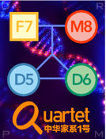


Quartet Report for Transcriptomics

Summary

This report summarizes the quality of the data generated from Quartet RNA reference materials based on several key quality control (QC) metrics. Each metric is accompanied by its current value, historical average, ranking among all datasets evaluated, and the corresponding performance grade.

QC_metrics | Value | Historical_value | Rank | Performance
Signal-to-Noise Ratio (SNR) | 13.739 | 19.505 ± 7.039 | 16/22 | Fair
Relative Correlation with Reference Datasets (RC) | 0.590 | 0.924 ± 0.048 | 22/22 | Bad
Total Score | 1.157 | 5.603 ± 2.884 | 20/22 | Bad

QC Metrics

Signal-to-Noise Ratio (SNR):
SNR is established to characterize the ability of a platform or lab or batch, which is able to distinguish intrinsic differences among distinct biological sample groups ('signal') from variations in technical replicates of the same sample group ('noise').

Relative Correlation with Reference Datasets (RC):
RC is the Pearson correlation coefficient between the ratios of a test dataset for a given pair of samples and the corresponding ratio-based reference datasets, representing the trend of numerical consistency of the ratio-based expression profiles. To improve reliability, the mean of the three replicates of each sample group was calculated before performing ratio-based expression analysis. Fold changes were transformed using log2 scaling.

Total Score:
The performance of the submitted data will be graded as Bad, Fair, Good, or Great based on the ranking by comparing the total score with the historical datasets. The total score is the harmonic mean of the scaled values of the number of features, missing percentage, absolute correlation, coefficient of variation, Signal-to-Noise Ratio (SNR), and relative correlation with reference datasets (RC).

Performance Category:
Based on the scaled total score, the submitted data will be ranked together with all Quartet historical datasets. The higher the score, the higher the ranking. After this, the performance levels will be assigned based on their ranking ranges.
· Bad: Lowest quintile (0-20th percentile).
· Fair: Lower middle quartile (21st-50th percentile).
· Good: Upper middle quartile (51st-80th percentile).
· Great: Highest quintile (81st-100th percentile).

Performance Grade
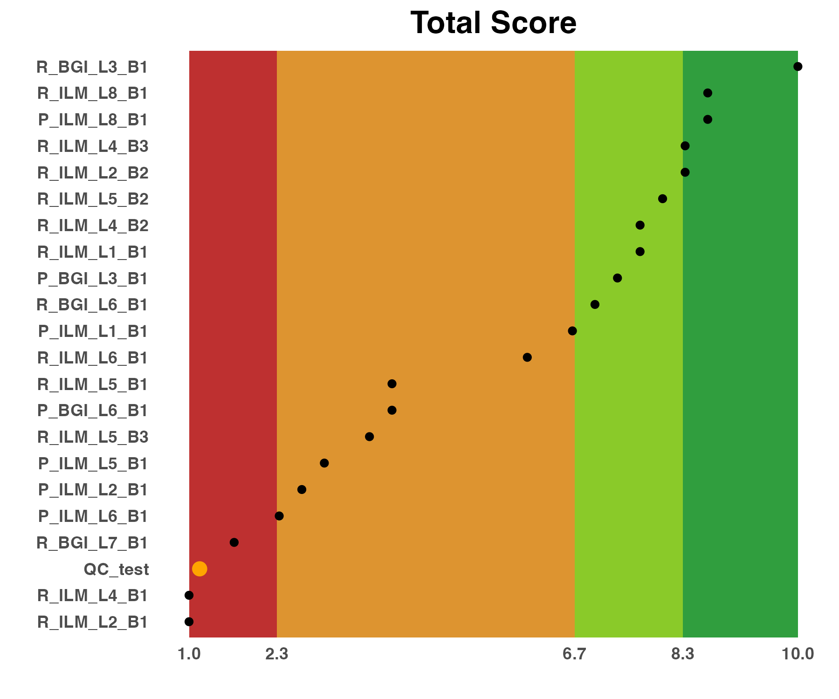
Scores of evaluation metrics for the current batch and all historical batches assessed. For better comparison and presentation, the total score was scaled to the interval [1, 10], with the worst dataset being 1 and the best dataset scoring 10. Please note that the results shown here are scaled values for all batches in each metric. The name of your data is QC_test.

SNR and RC Performance
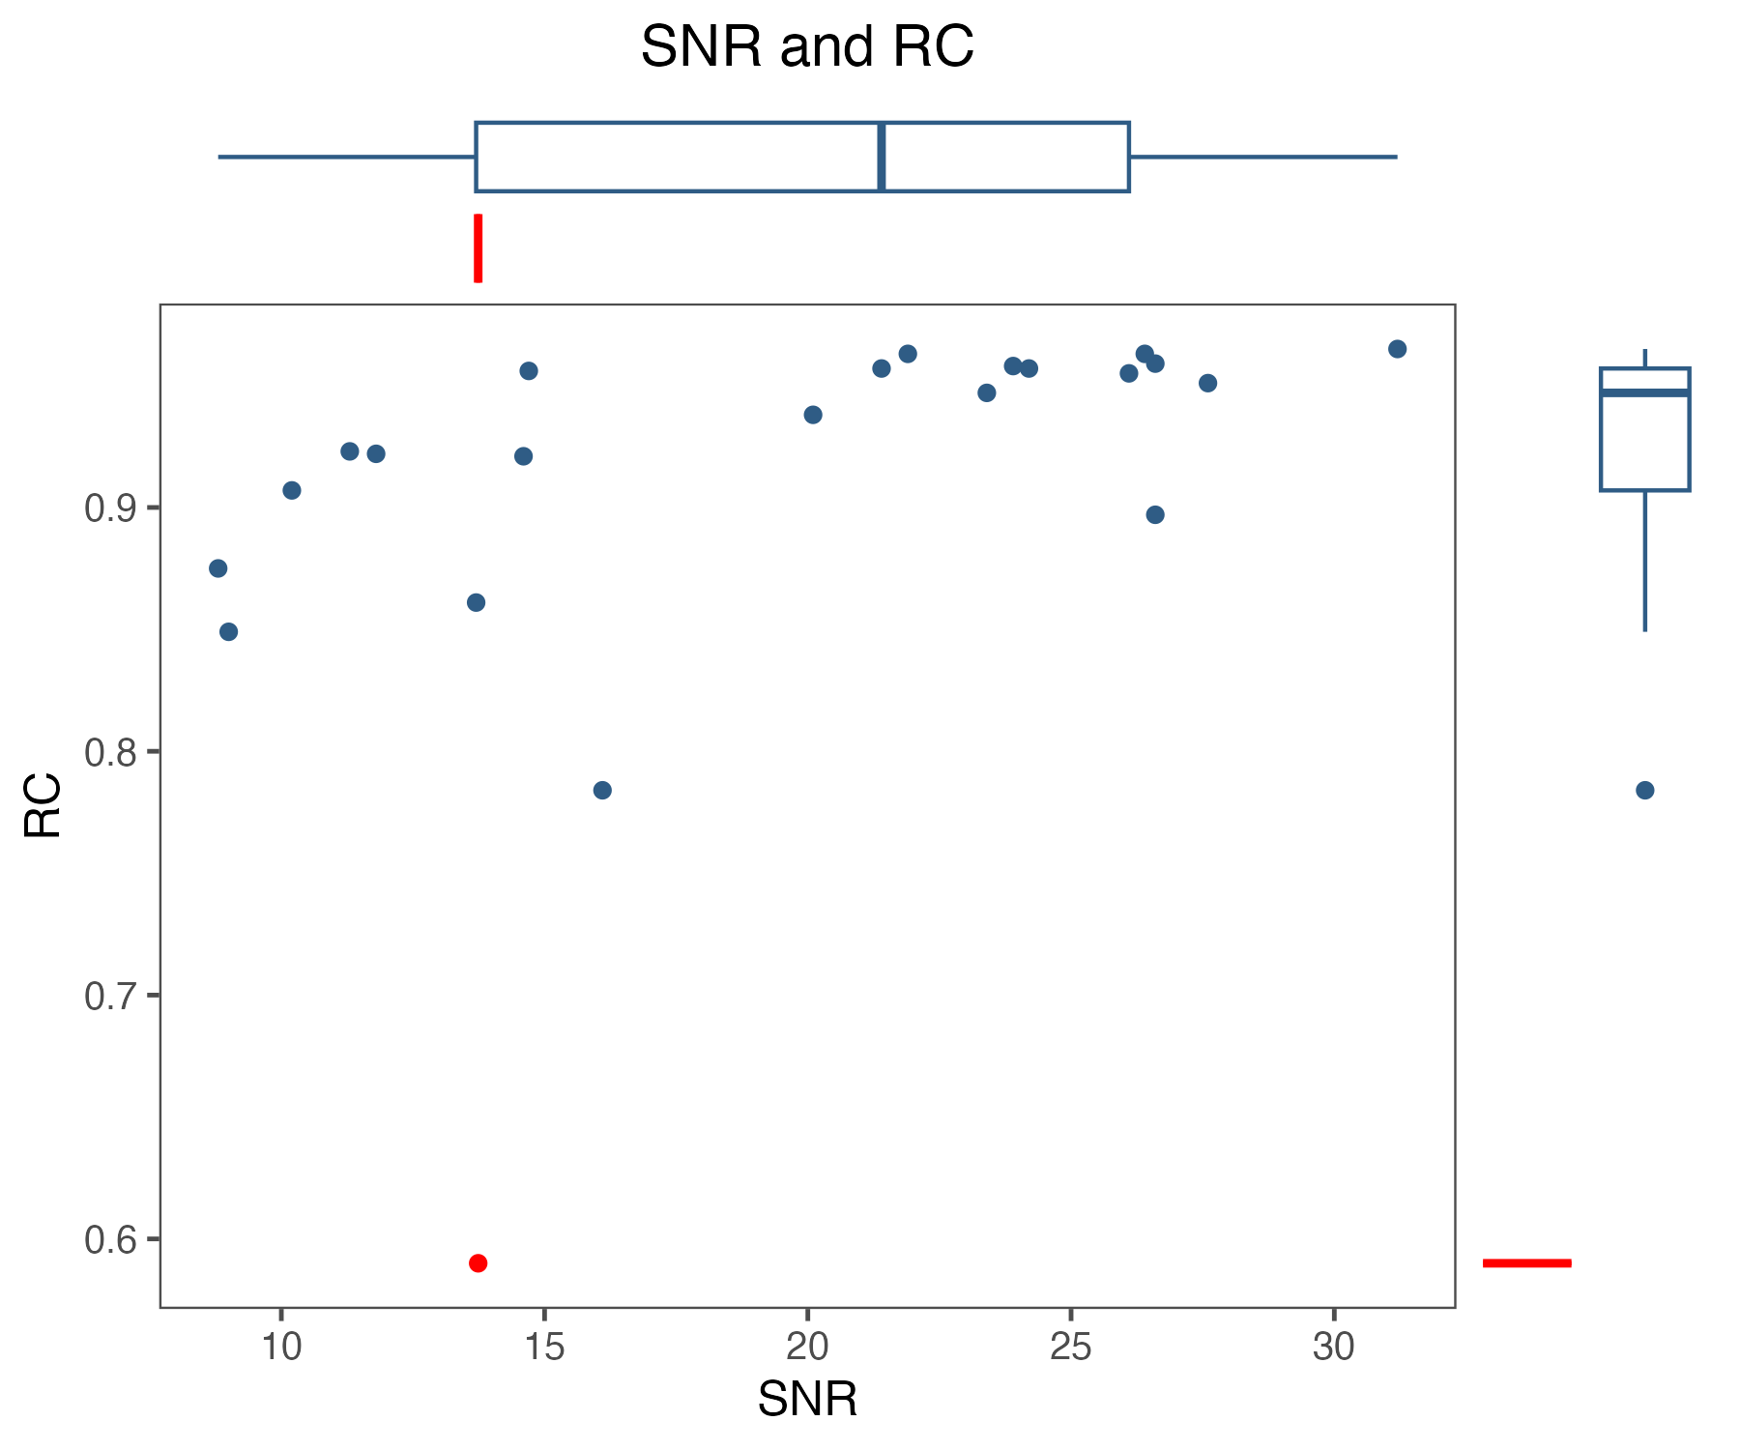
Performance metrics and thresholds using Quartet RNA reference materials.

Signal-to-Noise Ratio
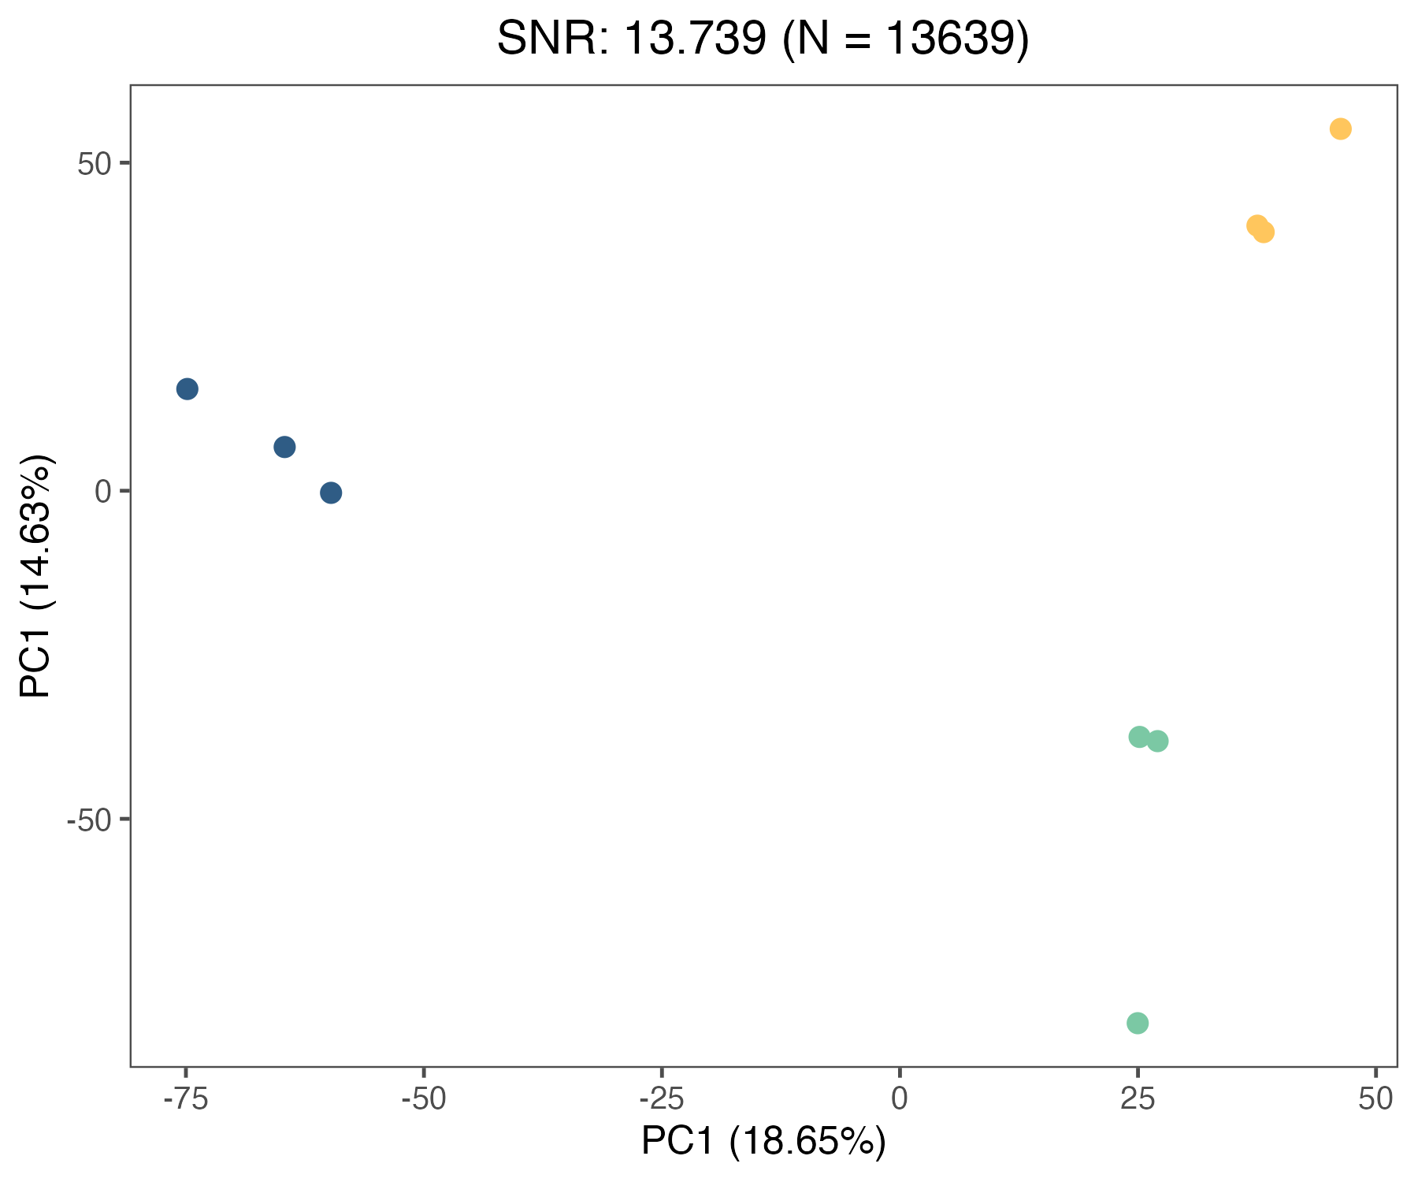
Signal-to-noise ratio (SNR) is defined as the ratio of the power of a signal to the power of noise.

Correlation with Reference Datasets
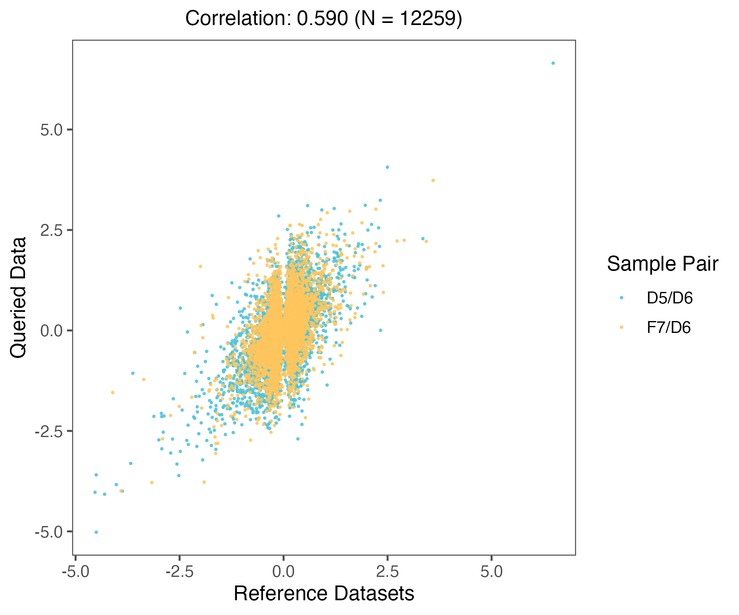
RC was calculate based on the Pearson correlation coefficient between the relative expression levels of a dataset for a given pair of groups and the corresponding reference fold-change values.

Supplementary Information

Reference
1. Zheng, Y. et al. Multi-omics data integration using ratio-based quantitative profiling with Quartet reference materials. Nature Biotechnology 1–17 (2023).
2. Yu, Y. et al. Quartet RNA reference materials improve the quality of transcriptomic data through ratio-based profiling. Nature biotechnology 1–15 (2023).

Disclaimer
This Data Quality Report is provided as an analysis of the specific dataset evaluated and is intended for informational purposes only. While every effort has been made to ensure the accuracy and reliability of the analysis, the information is presented "AS IS" without warranty of any kind, either express or implied. The authors and distributors of this report shall not be held liable for any actions taken in reliance thereon. Users are advised that the findings within this report are not to be used as definitive statements on the quality of any product or process beyond the scope of the dataset assessed. This report is not intended for use in critical applications, commercial decision-making, or for regulatory compliance without professional verification and independent validation. No guarantee, either expressed or implied, is made regarding the use or results of the analysis, including without limitation, the correctness, accuracy, reliability, or applicability of the findings.

