**Quartet Data Portal User Guide for**

**WGS Quality Assessment Report**

# Preparation

|  |  |
| --- | --- |
| QDP Address | <https://chinese-quartet.org/> |
| OSSUtil | https://docs.chinese-quartet.org/tools/ossutil/ |
| Input files | The file name suffix should be:  _LCL5_R1.fastq.gz, _LCL5_R2.fastq.gz  _LCL6_R1.fastq.gz, _LCL6_R2.fastq.gz  _LCL7_R1.fastq.gz, _LCL7_R2.fastq.gz  _LCL8_R1.fastq.gz, _LCL8_R2.fastq.gz |

# Log on to QDP

## 2.1 QDP account

1) If you have a request for the reference materials, please go to [http://chinese-quartet.org/#/materials](http://chinese-quartet.org/" \l "/materials) to request the reference materials. The Quartet team will contact you for further confirming your information and send you a registration email.

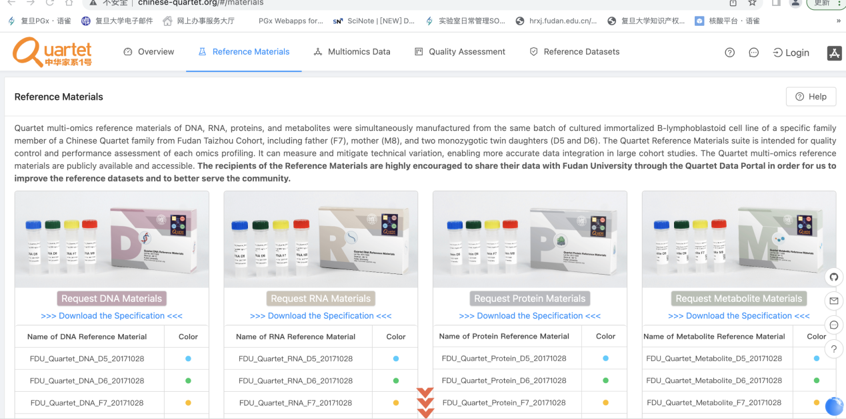

1. If you do not have a request for the reference materials, please send an email to **quartet@fudan.edu.cn** for a QDP account.

## 2.2 Log on to QDP

Address: http://chinese-quartet.org/

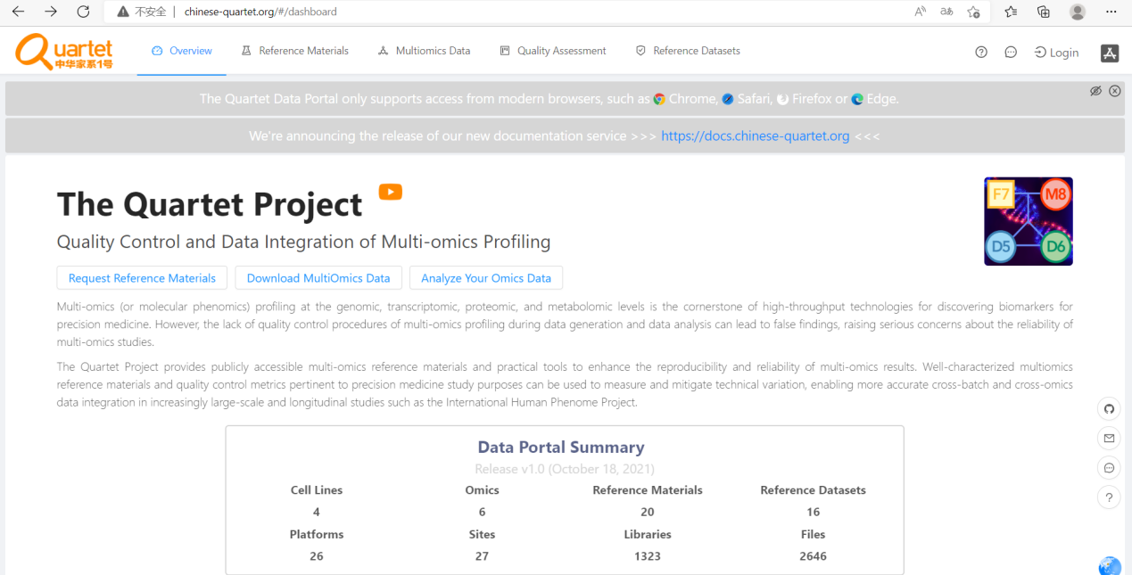

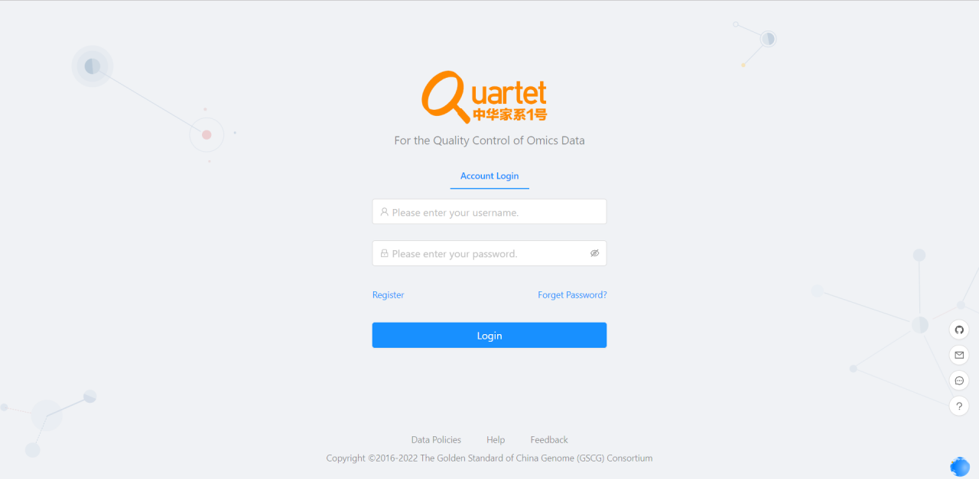

## 2.3 Select Quality Assessment> QC Apps

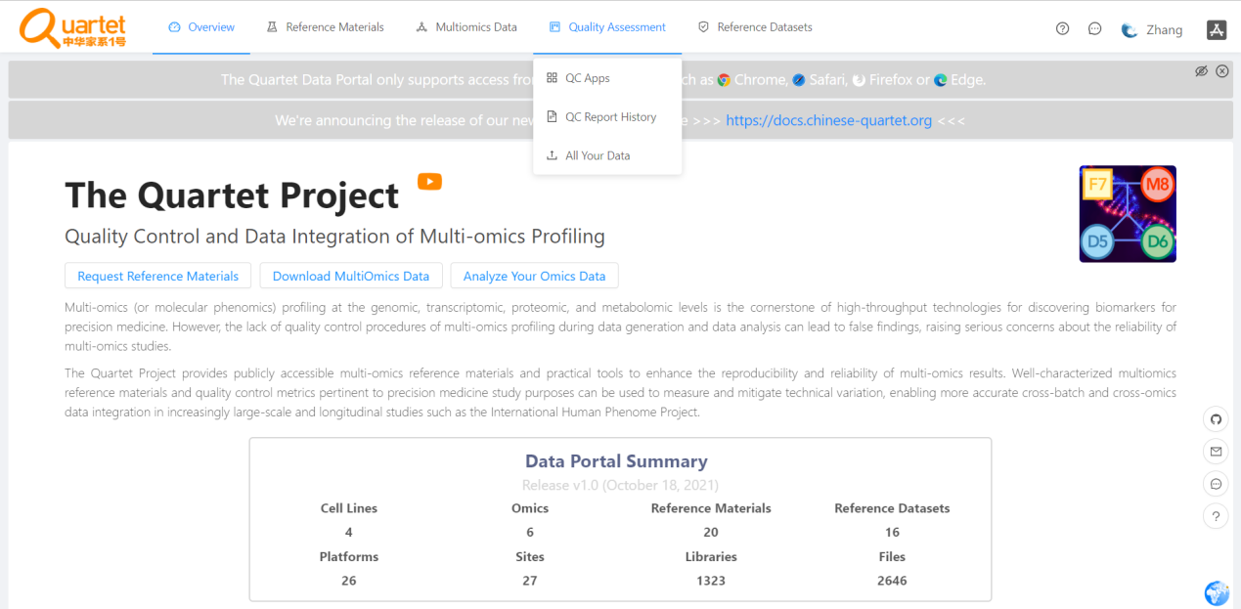

# Upload DNA sequencing data

## 3.1 Select Genomic> Upload Your Data> Run

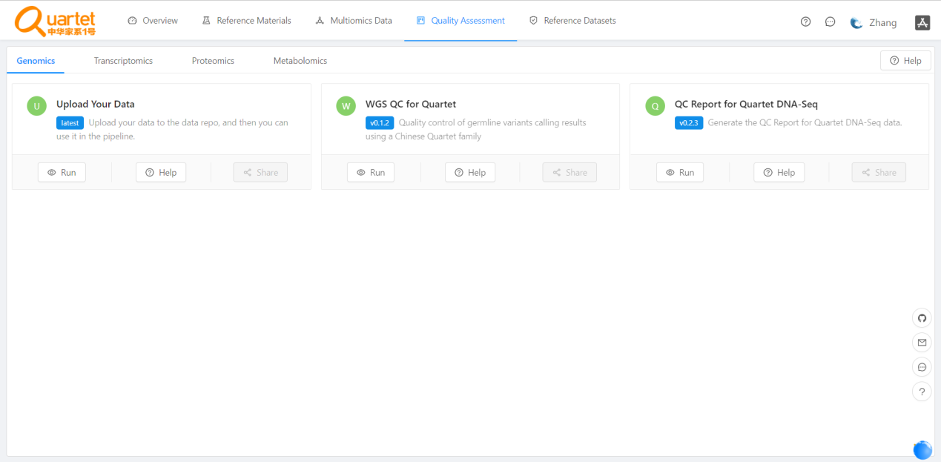

## 3.2 Click the symbol called “Register & Upload Your Data”

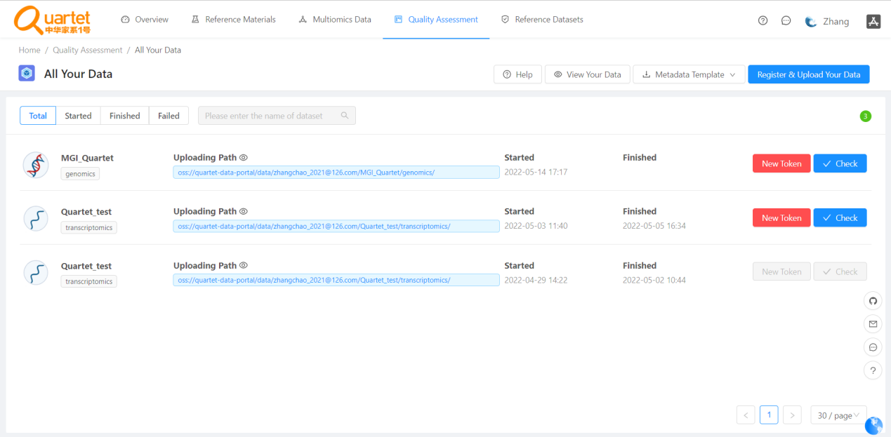

## 3.3 Fill in Dataset Name, DataType select Genomics, and click Submit

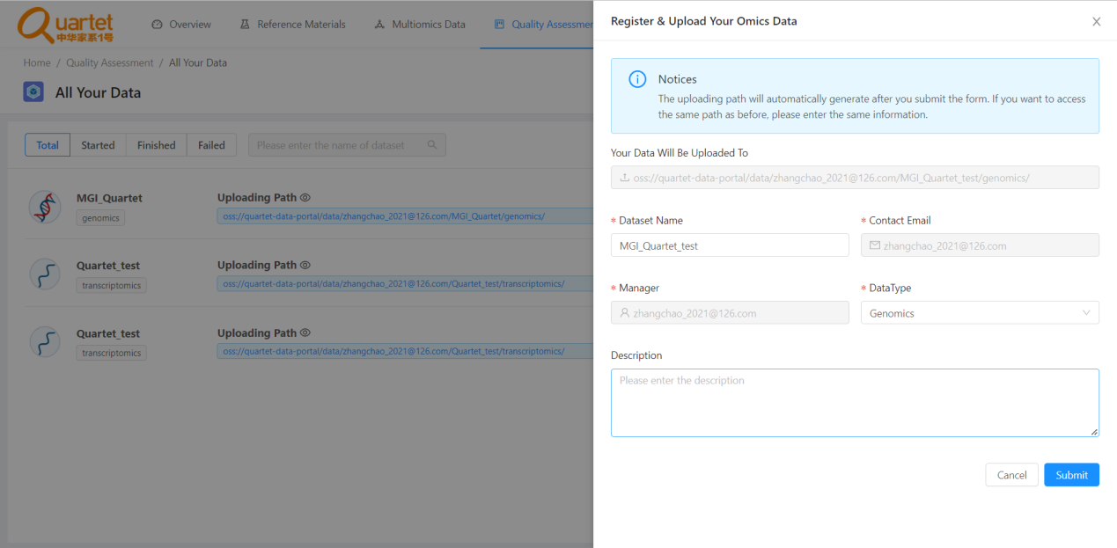

## Click the symbol called “New Token”. Copy the autorizedCode, which is for subsequent ossbrowser login

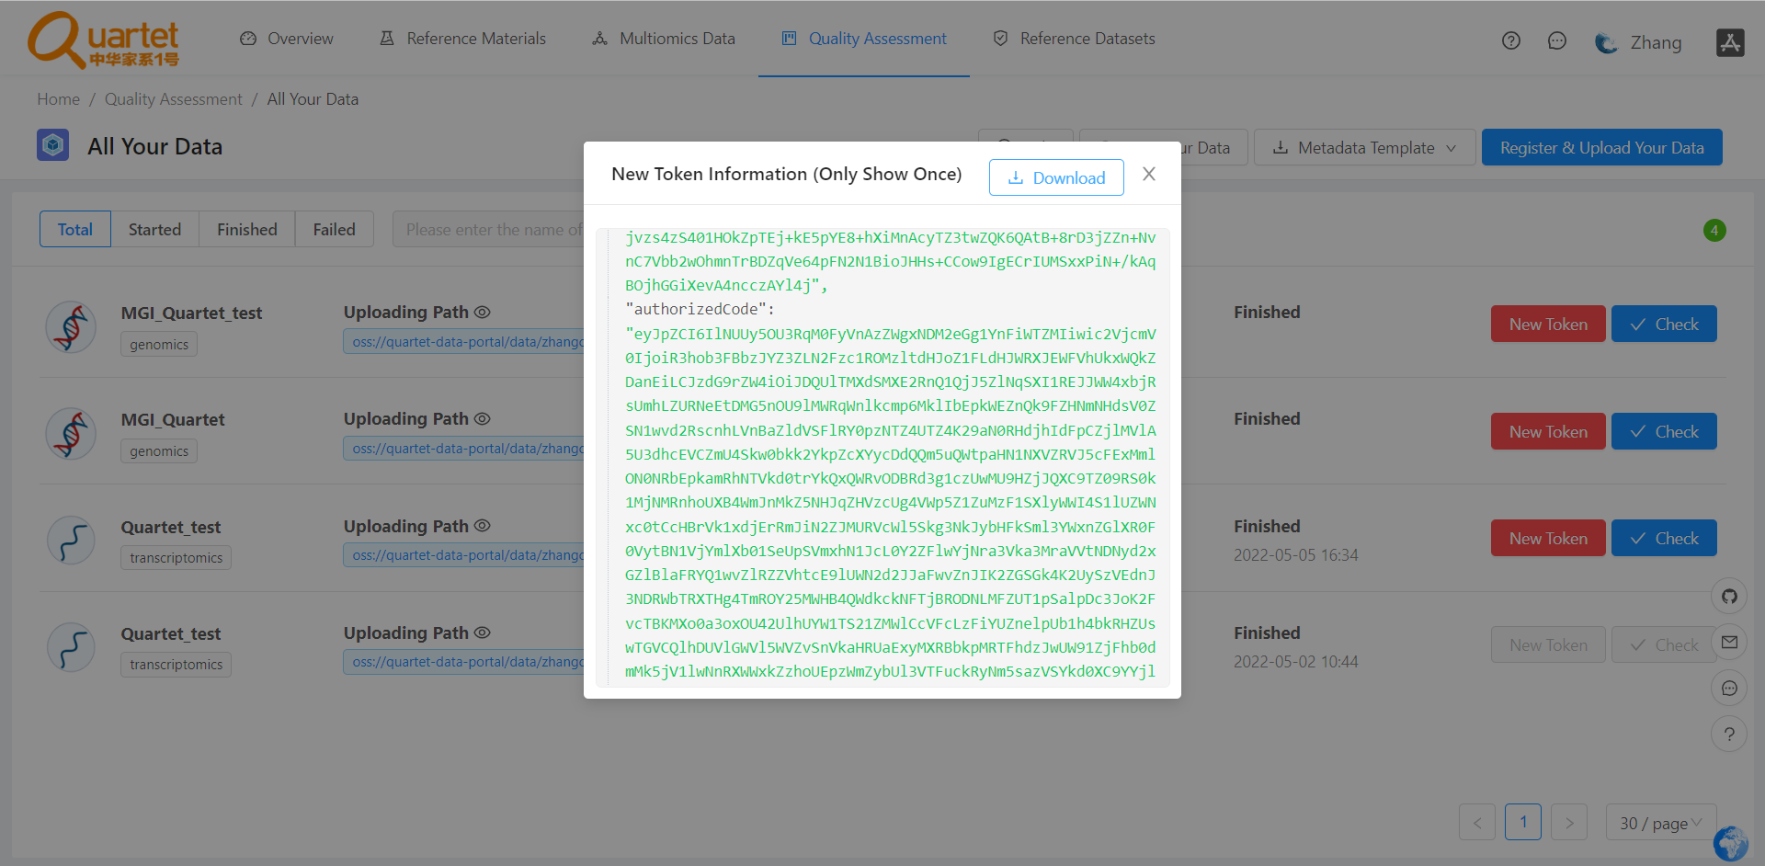

## Please follow the ossutil document to upload your data.

ossutil is a user friendly command line tool to upload data to the Quartet Data Portal. It supports the following operating systems: Windows, Linux, and macOS. You can download and install the ossutil version that best suits your requirements.

<https://docs.chinese-quartet.org/tools/ossutil/>

# Run WGS app

## 4.1 Select Genomic> WGS QC for Quartet> Run

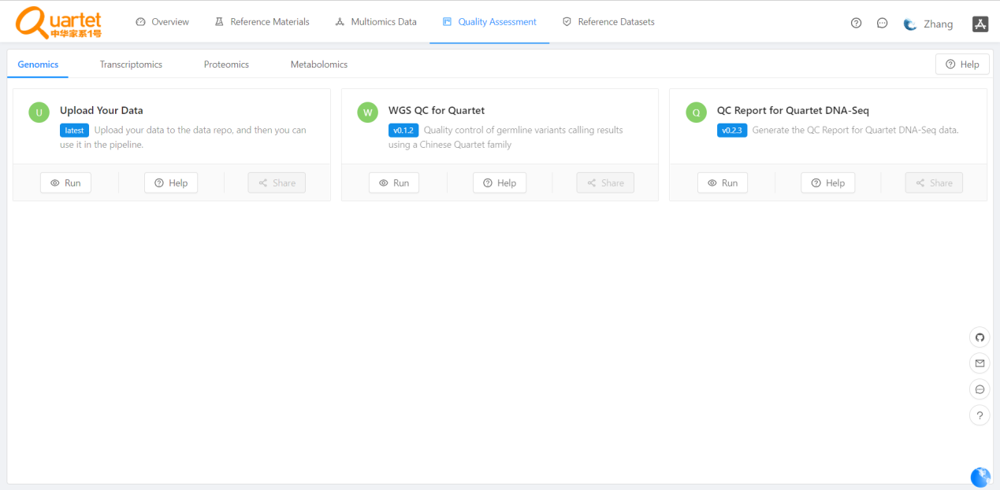

## 4.2 Click the symbol called “Start Assessment”

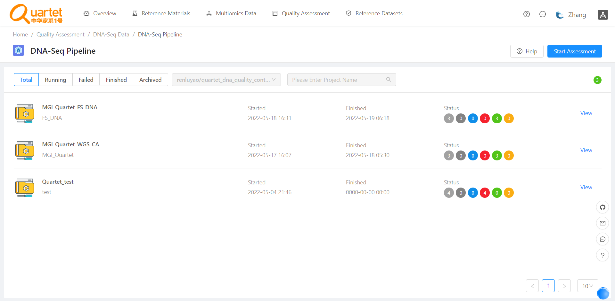

## 4.3 Fill in Assessment Name and Description. Then click Next.

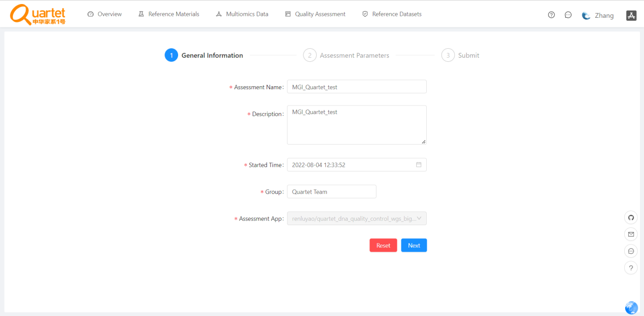

## 4.4 Fill in Sample information

Sample ID should be numbers. It is set D5+D6+F7+M8 Four samples as a group, Sample ID for one group of samples filled in 1, Sample ID for two groups of samples filled in 2, Sample ID for three groups of samples filled in 3.Assessment Parameters can be downloaded and checked.

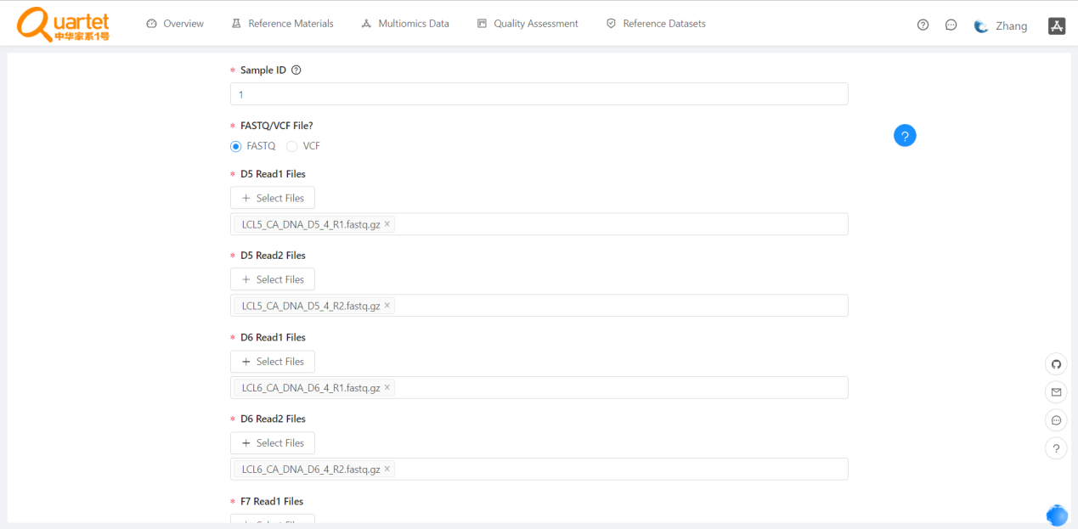

## 4.5 Click the symbol called “Run Assessment”

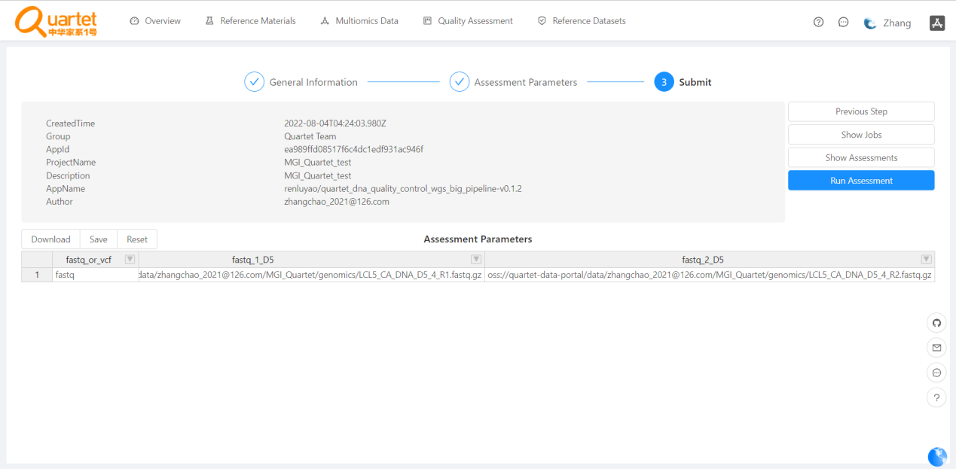

## 4.6 Check the status of Run Assessment



# Results and Report

## 5.1 Select Genomic> QC Report for Quartet DNA Seq-Run

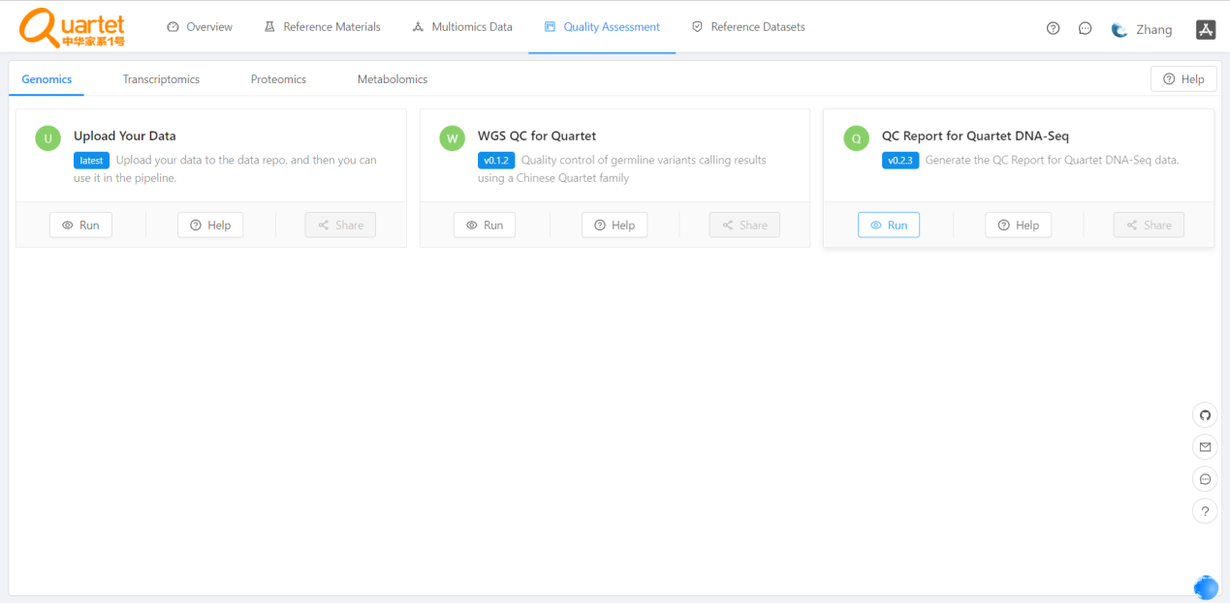

## 5.2 Click the symbol called “New QC Report”

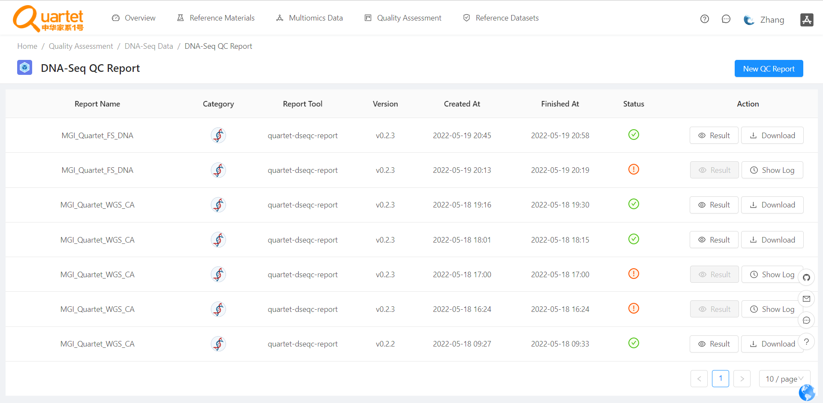

## 5.3 Follow the Steps as prompted

