# Quartet Data Portal User Guide for Metabolomic Quality Assessment Report

# Preparation

|  |  |
| --- | --- |
| QDP Address | <https://chinese-quartet.org/> |
| Input files | The file format (suffix) should be .csv.  The **data file** is the metabolite concentration result of metabolomics profiling. The required file format has samples in columns and two columns named "metabolites" and "HMDBID" including the names and HMDB IDs of metabolite compounds.  The **metadata file** has the information of each sample in the data file. With columns named "col_names" (names of samples, identical to their names in the columns of data file), "strategy" (Targeted or Untargeted), "lab" (the name of lab), "sample" (D5, D6, F7 and M8 for Quartet samples), "rep" (the replicates for each sample) and "batch" (the name of batch). |

# Log on to QDP

## 2.1 Request for Quartet Metabolite RMs and QDP account

1) If you have a request for the reference materials, please go to [http://chinese-quartet.org/#/materials](http://chinese-quartet.org/" \l "/materials) to request the reference materials. The Quartet team will contact you for further confirming your information and send you a registration email.

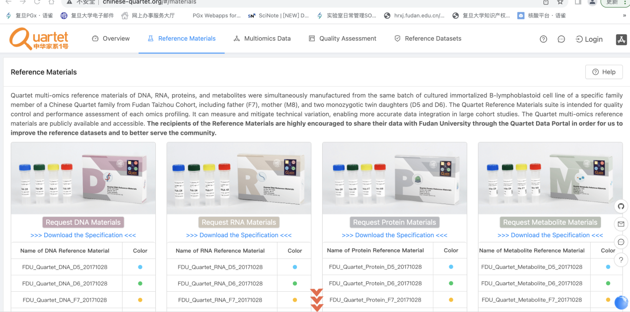

1. If you do not have a request for the reference materials, please send an email to **quartet@fudan.edu.cn** for a QDP account.

## 2.2 Log on to QDP

Address: http://chinese-quartet.org/

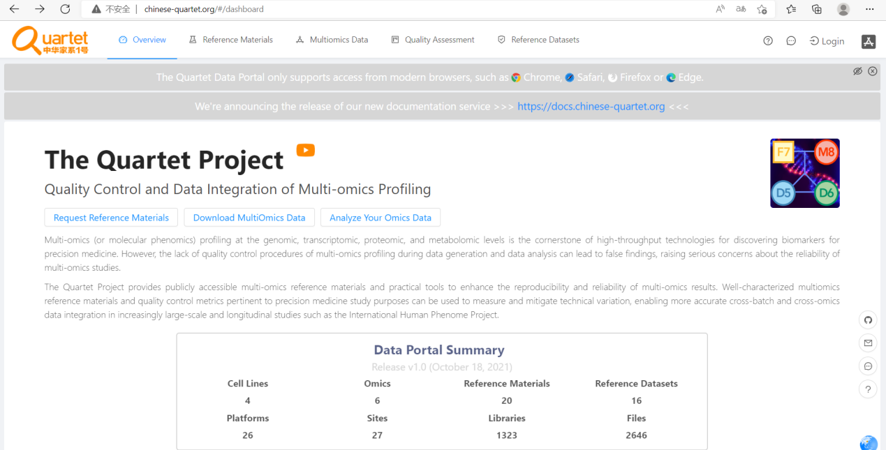

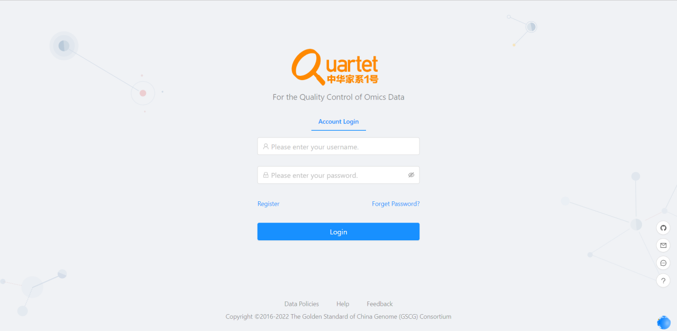

## 2.3 Select Quality Assessment> QC Apps

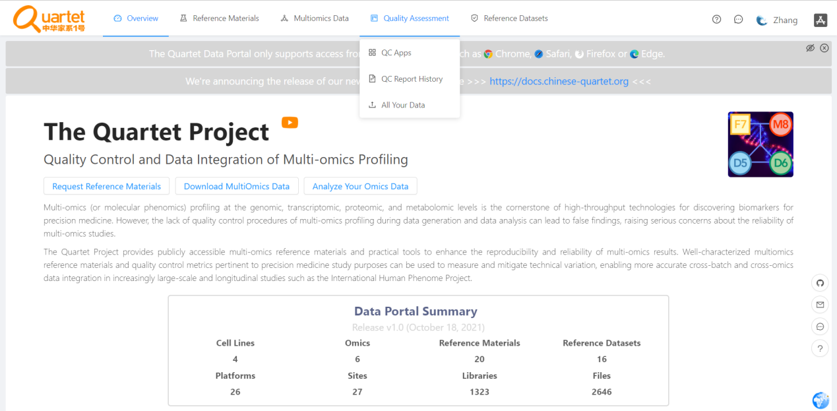

# Run QC Report

## 3.1 Select “Metabolomics­” > QC Report for Quartet Metabolomics>“Run”.

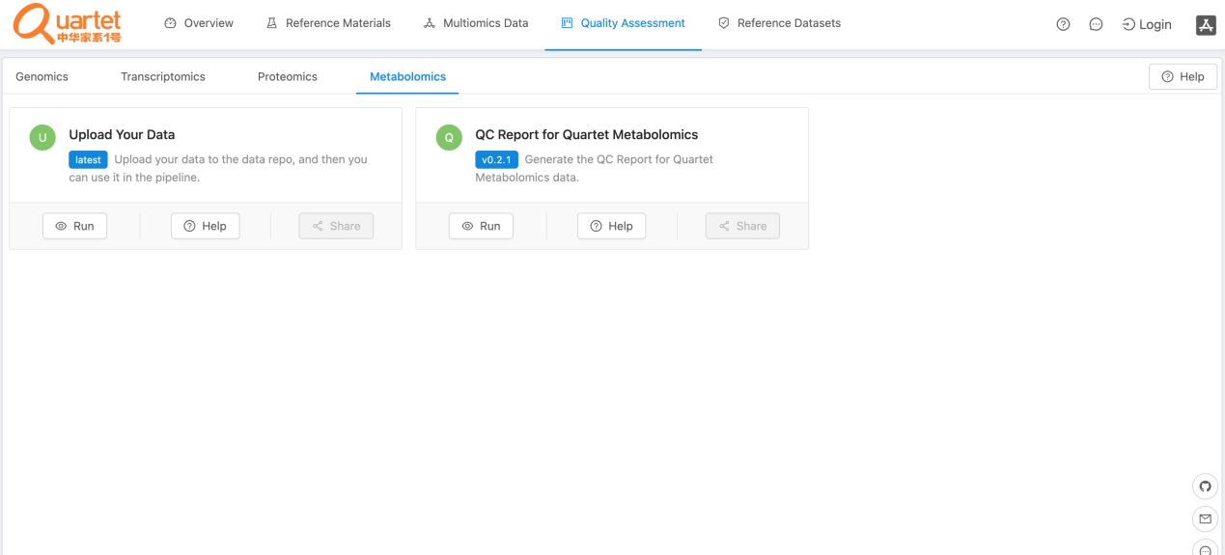

## 3.2 Click the symbol called “New QC Report”.

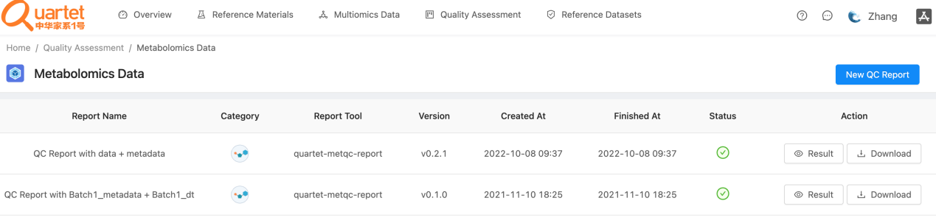

## 3.3 Select “Step1: Choose Report” > “QC Report for Quartet Metabolomics”.

## 

## 3.4 Select “Step2: Upload File(s)” > “QC Report for Quartet Metabolomics”. Please note that the files need to be in csv format. For details of the fixed format of the uploaded files, please refer to

## <https://docs.chinese-quartet.org/data_pipelines/metabolomics/qc_report/>

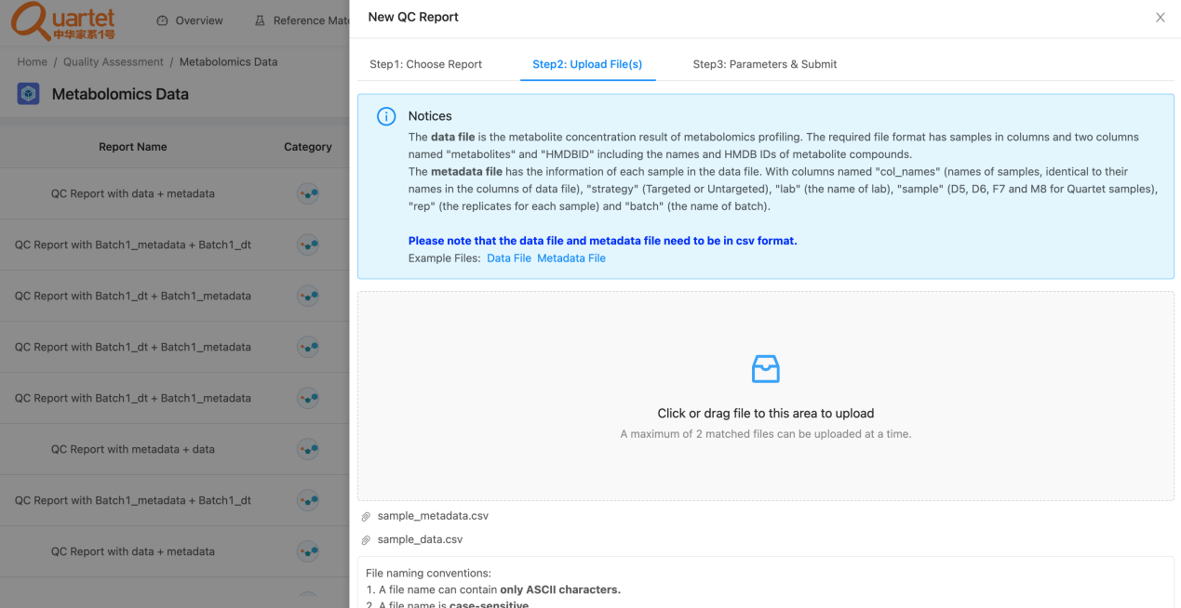

## 3.5 After uploading the tested files, select “Step3: Parameters & Submit”. Fill in the required information and click “Submit”.

## 

## 3.6 Then you can preview or download your QC report by clicking “Result” or “Download” respectively.

