**Quartet Data Portal User Guide for**

Proteomic Quality Assessment Report

# Preparation

|  |  |
| --- | --- |
| QDP Address | <https://chinese-quartet.org/> |
| Input files | The file format (suffix) should be .csv. |

# Log on to QDP

## 2.1 QDP account

1) If you have a request for the reference materials, please go to [http://chinese-quartet.org/#/materials](http://chinese-quartet.org/" \l "/materials) to request the reference materials. The Quartet team will contact you for further confirming your information and send you a registration email.

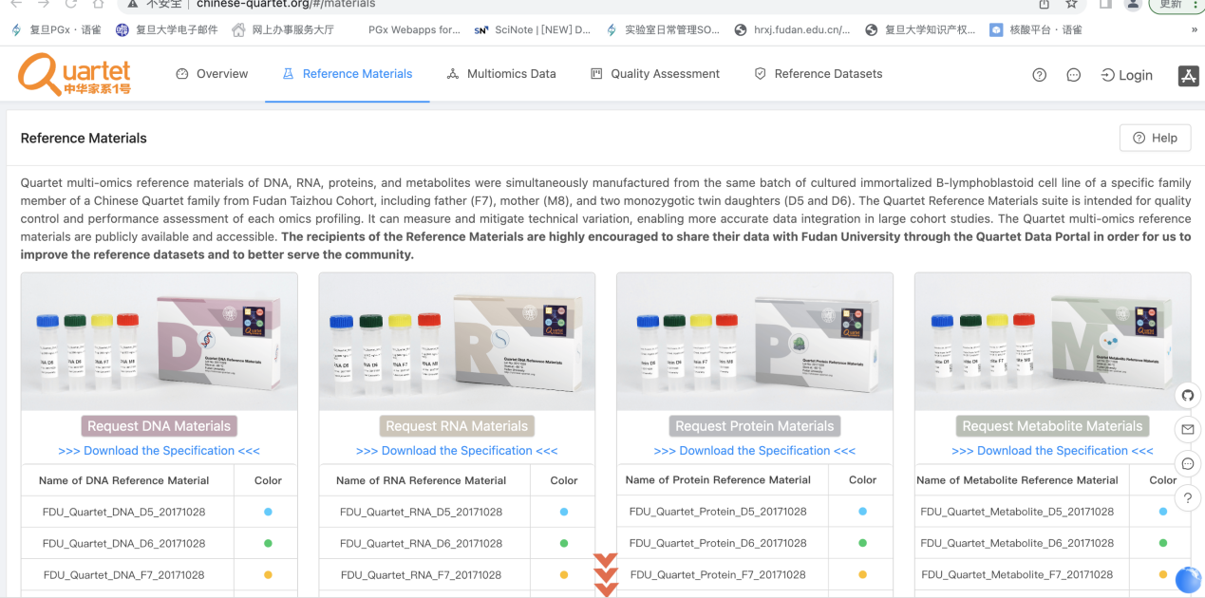

1. If you do not have a request for the reference materials, please send an email to **quartet@fudan.edu.cn** for a QDP account.

## 2.2 Log on to QDP

Address: http://chinese-quartet.org/

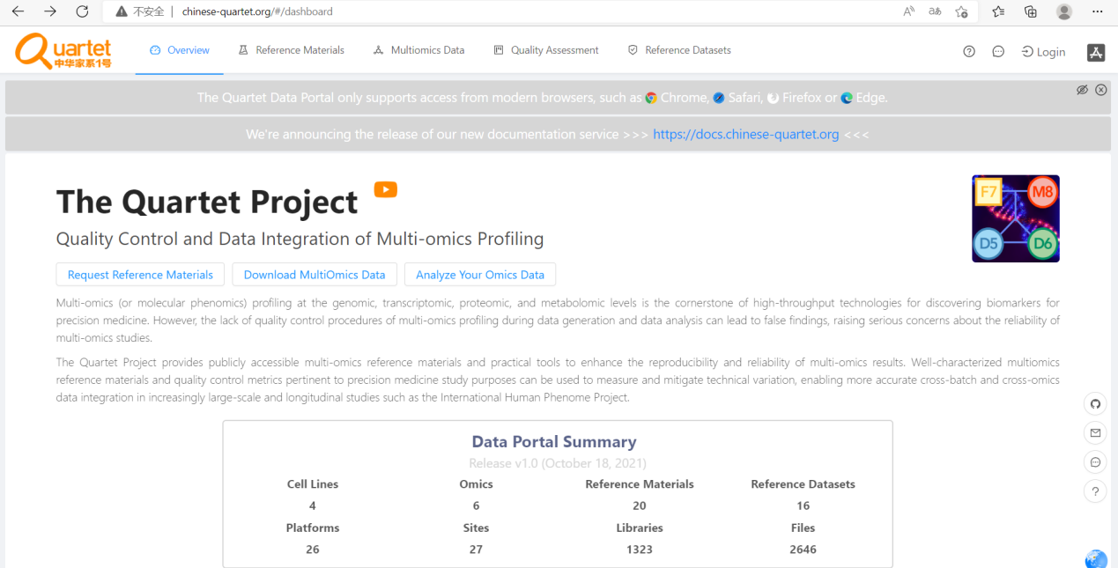

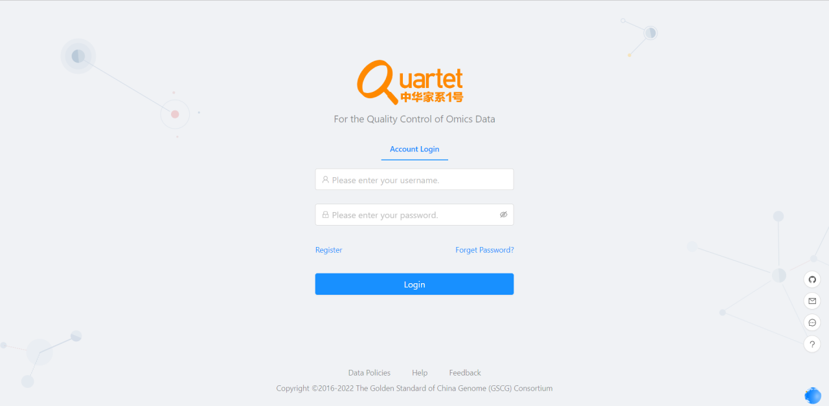

## 2.3 Select Quality Assessment> QC Apps

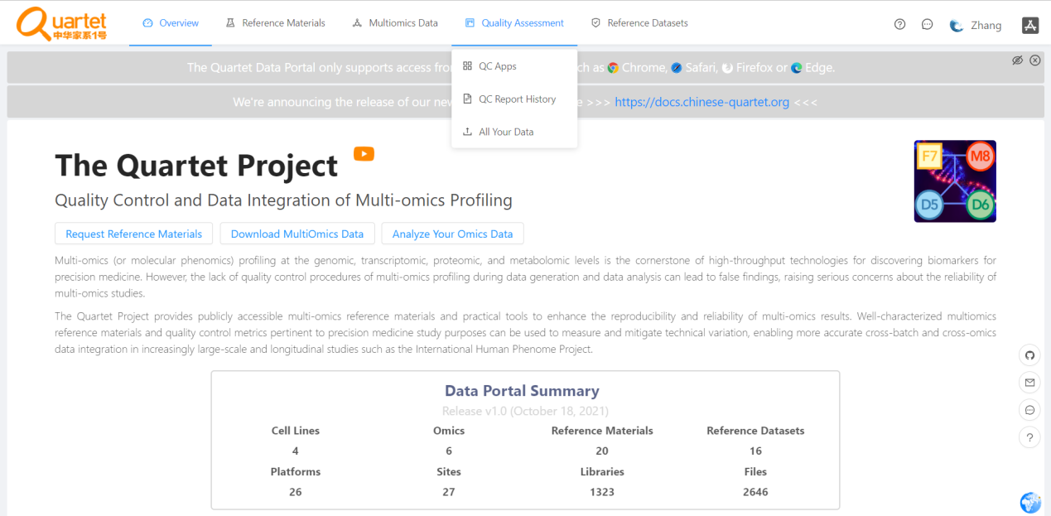

# Run QC Report

## 3.1 Select “Proteomics” > “Run”.

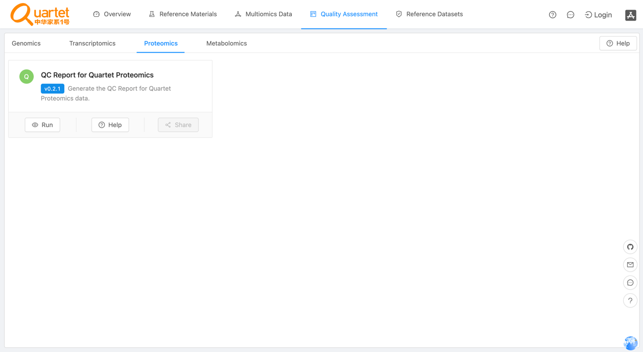

## 3.2 Click the symbol called “New QC Report”.

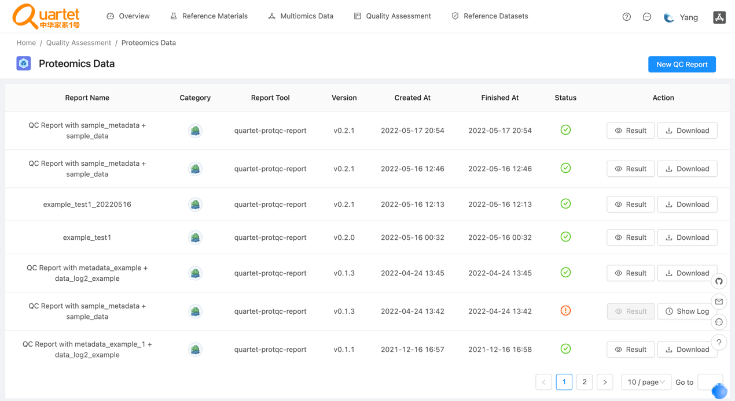

## 3.3 Select “Step1: Choose Report” > “QC Report for Quartet Proteomics”.

## 

## 3.4 Select “Step2: Upload File(s)” > “QC Report for Quartet Proteomics”. Please note that the files need to be in csv format. For details of the fixed format of the uploaded files, please refer to

## <https://docs.chinese-quartet.org/data_pipelines/proteomics/qc_report/>.

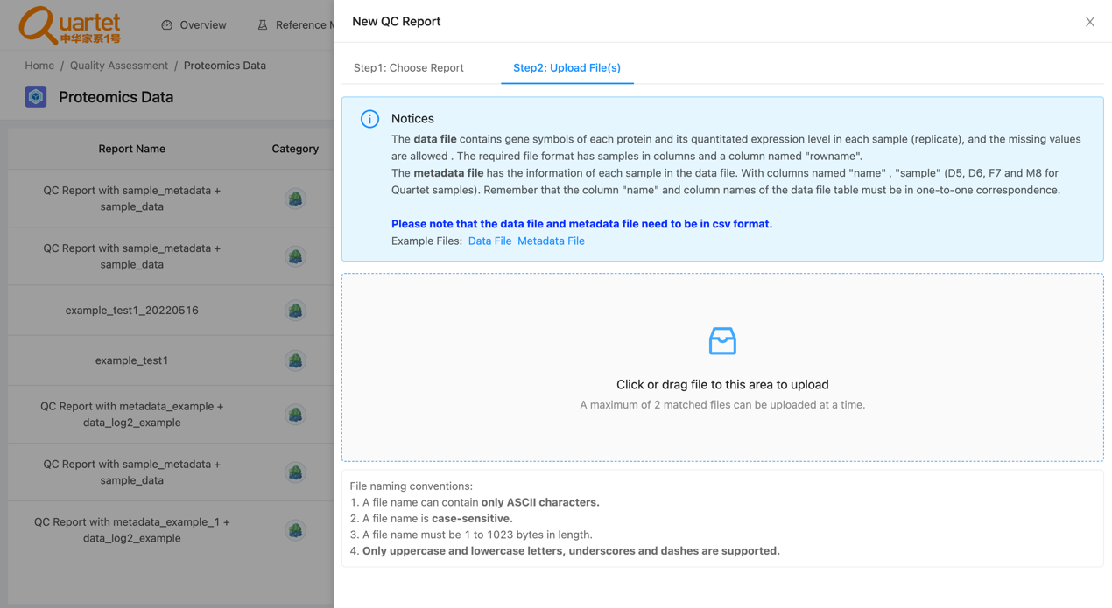

## 3.5 After uploading the tested files, select “Step3: Parameters & Submit”. Fill in the required information and click “Submit”.

## 

## 3.6 Then you can preview or download your QC report by clicking “Result” or “Download” respectively.

