**Quartet Data Portal User Guide for**

Proteomic Quality Assessment Report

# Preparation

|  |  |
| --- | --- |
| QDP Address | <https://chinese-quartet.org/> |
| OSSUtil | <https://docs.chinese-quartet.org/tools/ossutil/> |
| Input files | The file format (suffix) should be .csv. |

# Log on to QDP

## 2.1 QDP account

1) If you have a request for the reference materials, please go to <http://chinese-quartet.org/#/materials> to request the reference materials. The Quartet team will contact you for further confirming your information and send you a registration email.

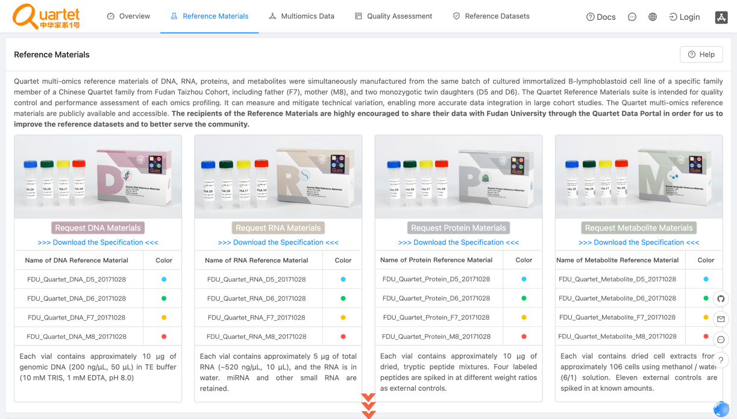

2) You can download the specification file by clicking *Download the Specification.*

3) For preview the specification, please drop down and click *Protein Materials.*

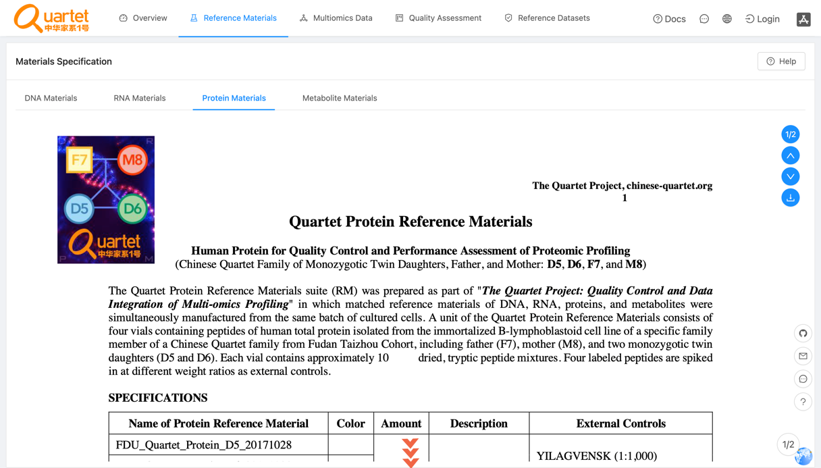

3) If you do not have a request for the reference materials, please send an email to **quartet@fudan.edu.cn** for a QDP account.

## 2.2 Login

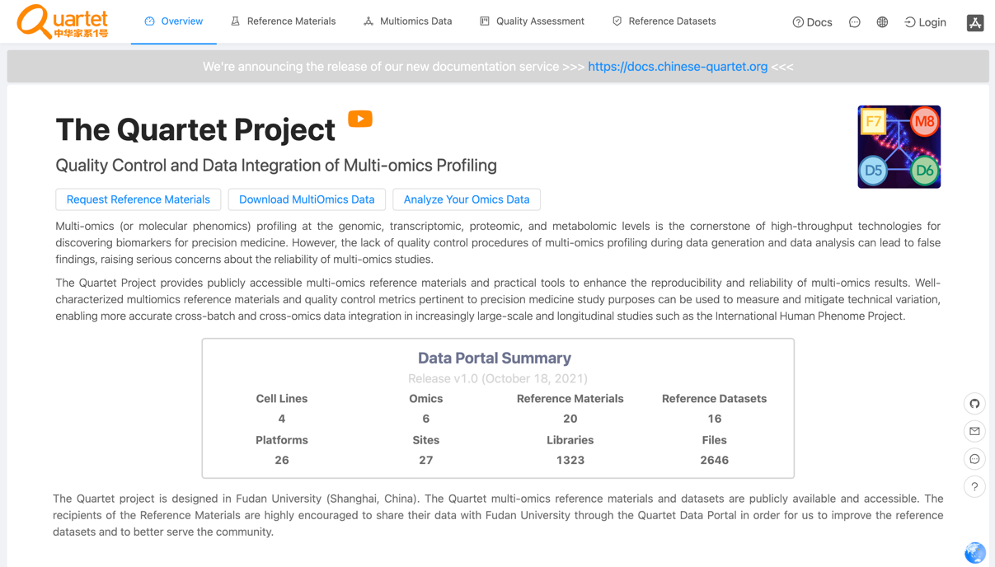

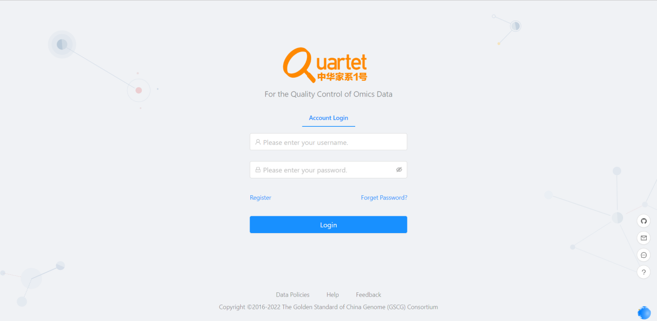

## 2.3 Select *Quality Assessment > QC Apps.*

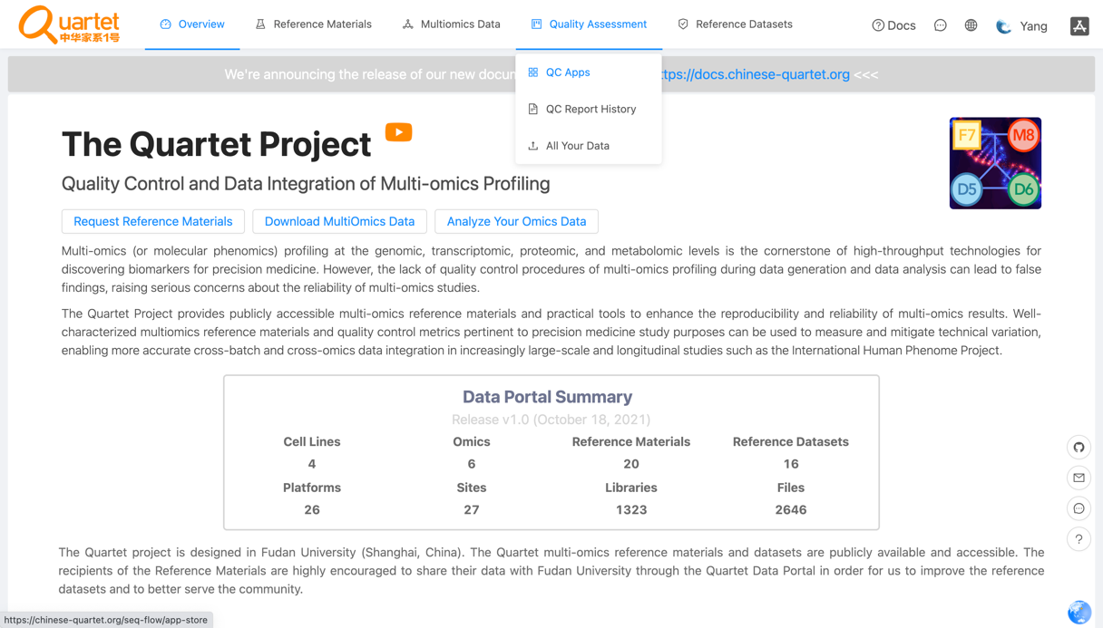

# Run QC Report

## 3.1 Select *Proteomics > Run.*

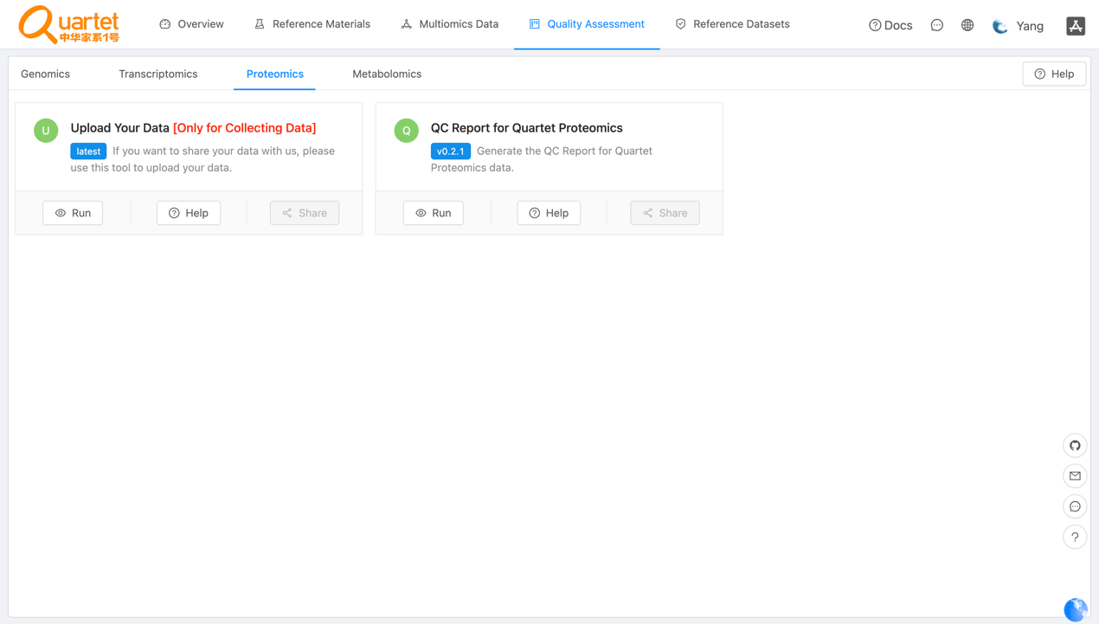

## 3.2 Click *New QC Report*.

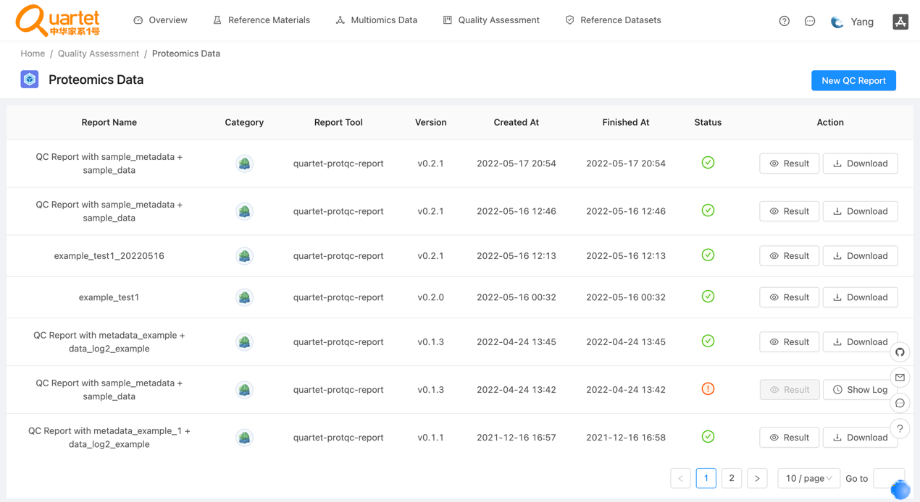

## 3.3 Select *Step1: Choose Report > QC Report for Quartet Proteomics.*

## 

## 3.4 Select *Step2: Upload File(s) > QC Report for Quartet Proteomics.*

1) For details of the fixed format of the data file and the metadata file, please refer to <https://docs.chinese-quartet.org/data_pipelines/proteomics/qc_report/>.

2) To ensure the data file and the metadata file are matched, please drag or click files simultaneously into the uploading area.

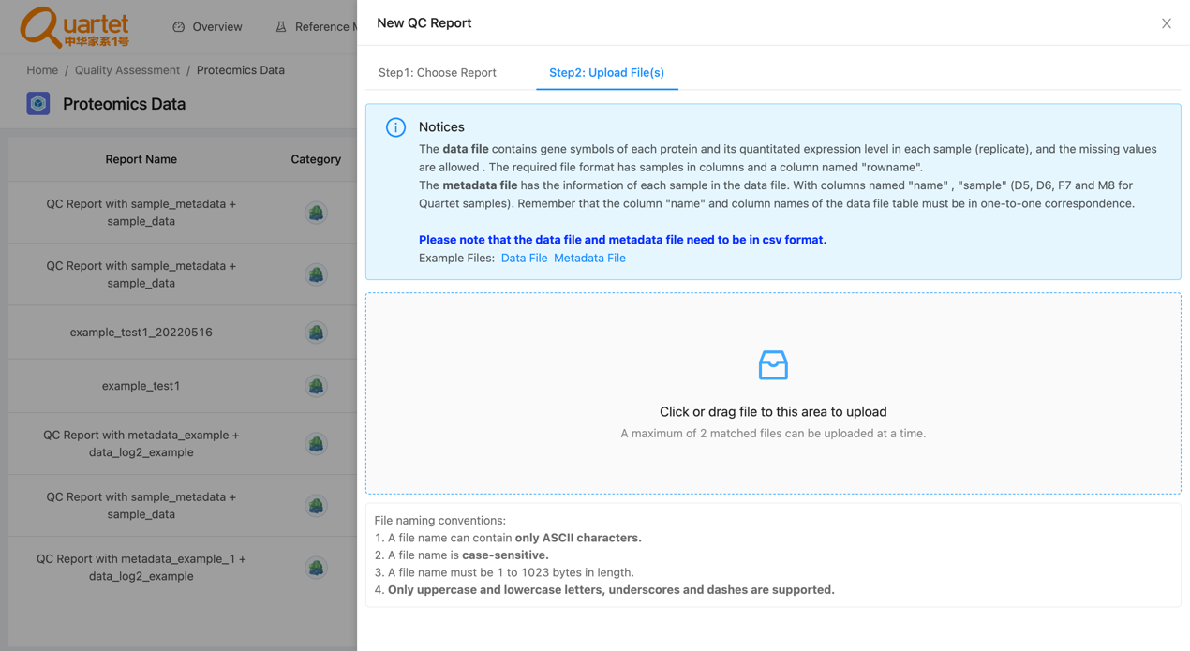

## 3.5 After uploading the tested files, select *Step3: Parameters & Submit*. Fill in the required information and click *Submit*.

## 

## 3.6 Then you can preview or download your QC report by clicking *Result* or *Download* respectively.

