Quartet Data Portal User Guide for
Proteomic Quality Assessment Report

Preparation
QDP Address | https://chinese-quartet.org/
Input files | The file format (suffix) should be .csv.

Log on to QDP

2.1 QDP account
1) If you have a request for the reference materials, please go to http://chinese-quartet.org/#/materials to request the reference materials. The Quartet team will contact you for further confirming your information and send you a registration email.
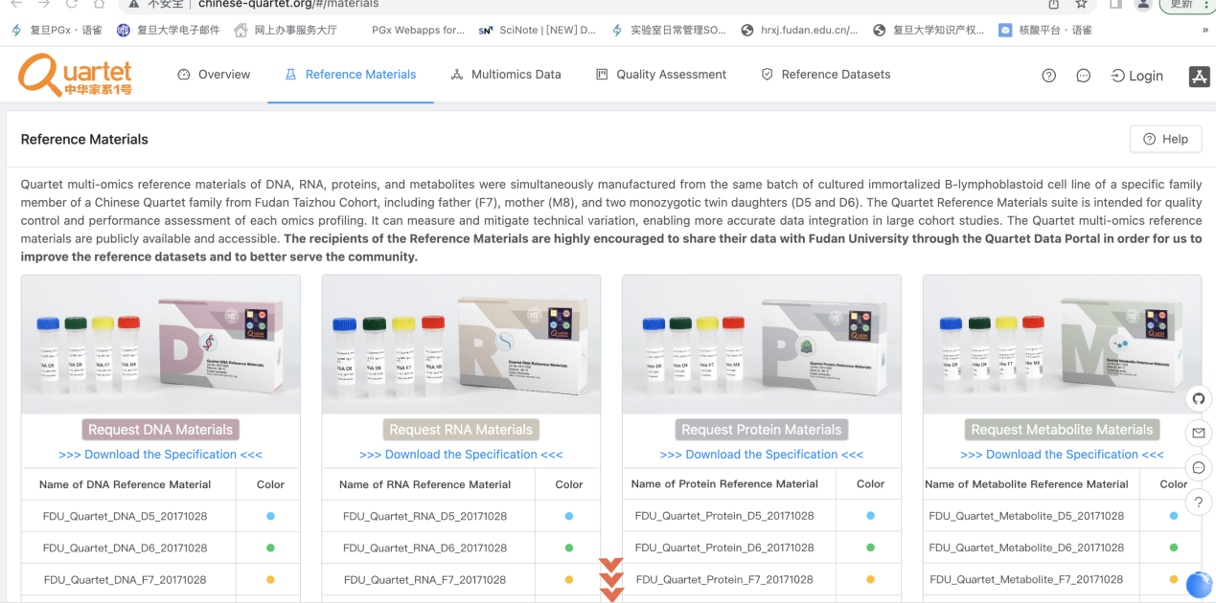

- If you do not have a request for the reference materials, please send an email to quartet@fudan.edu.cn for a QDP account.

2.2 Log on to QDP
Address: http://chinese-quartet.org/
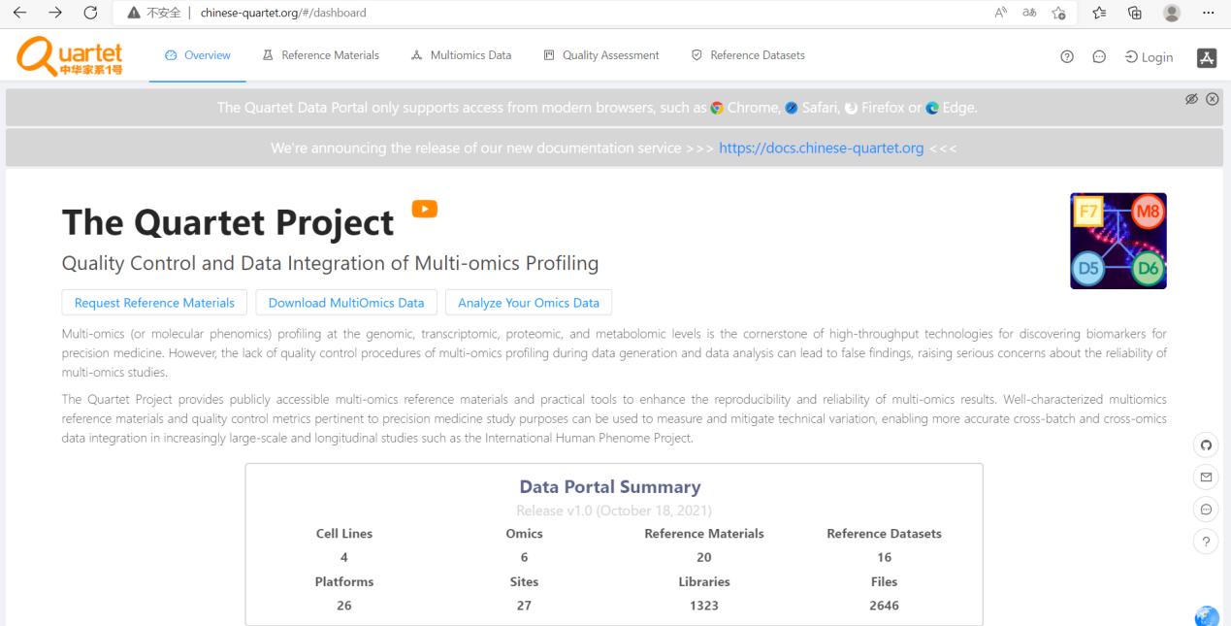
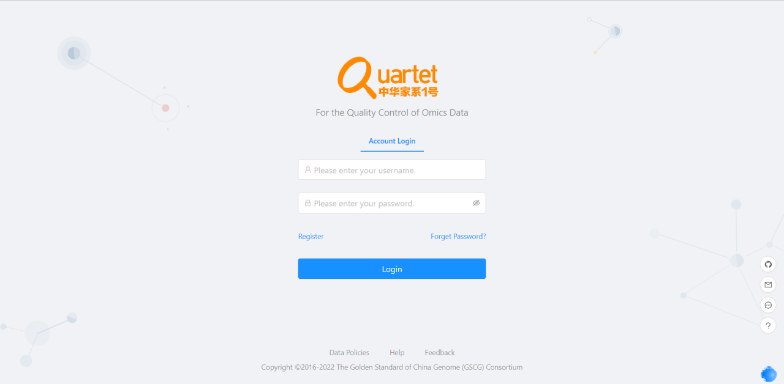

2.3 Select Quality Assessment> QC Apps
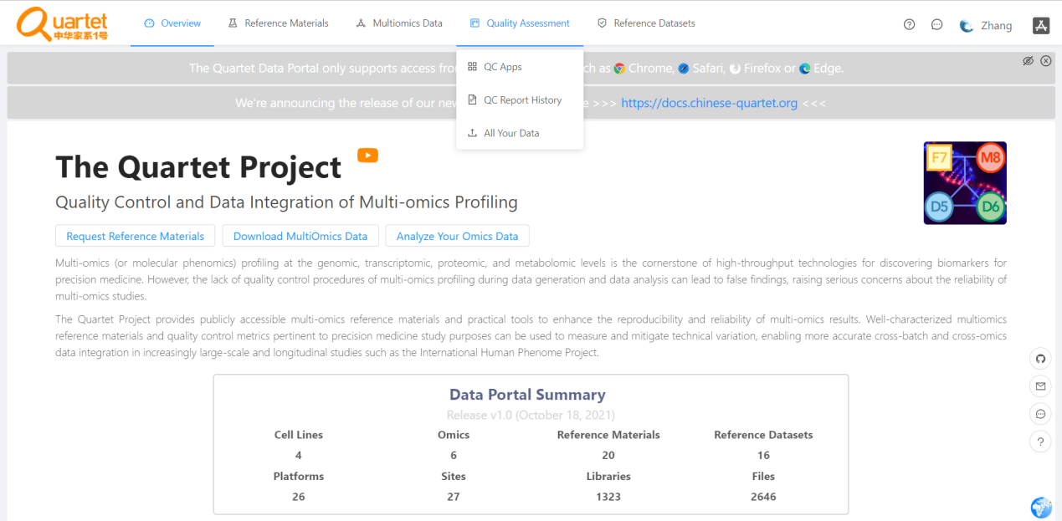

Run QC Report

3.1 Select “Proteomics” > “Run”.
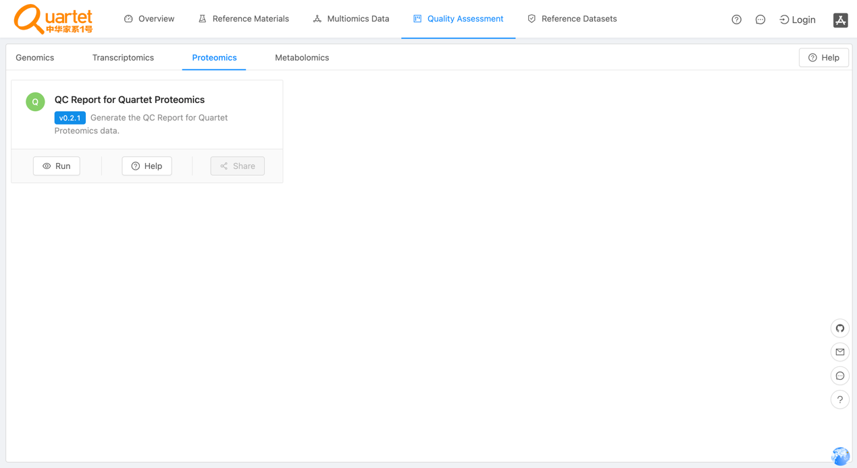

3.2 Click the symbol called “New QC Report”.
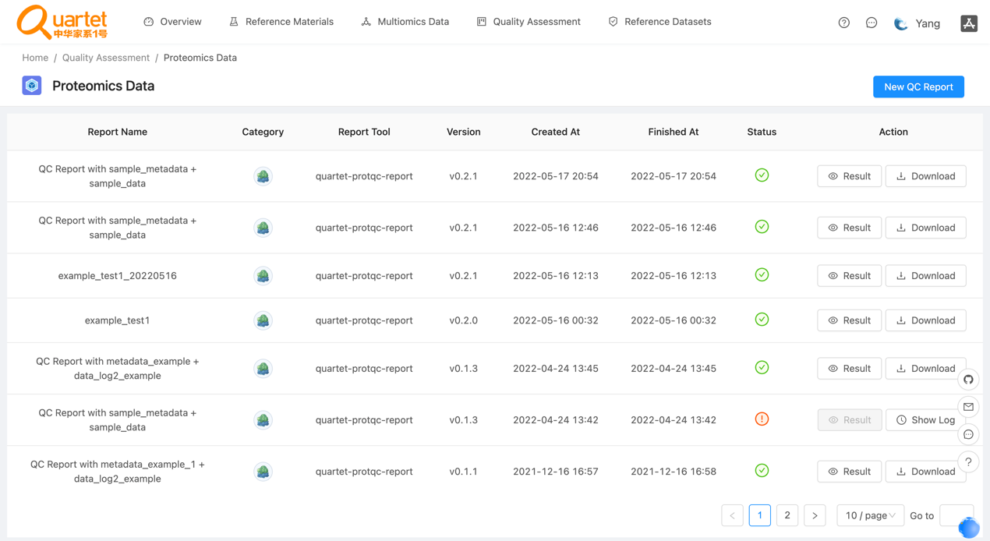

3.3 Select “Step1: Choose Report” > “QC Report for Quartet Proteomics”.

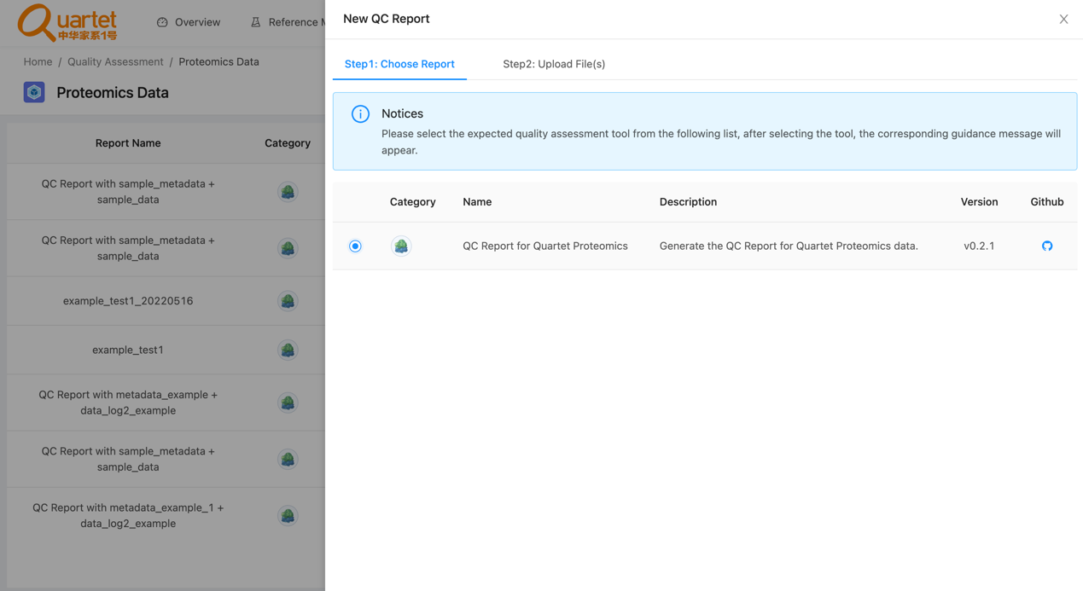

3.4 Select “Step2: Upload File(s)” > “QC Report for Quartet Proteomics”. Please note that the files need to be in csv format. For details of the fixed format of the uploaded files, please refer to

https://docs.chinese-quartet.org/data_pipelines/proteomics/qc_report/.
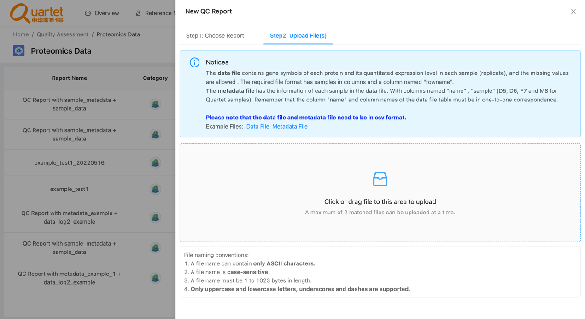

3.5 After uploading the tested files, select “Step3: Parameters & Submit”. Fill in the required information and click “Submit”.

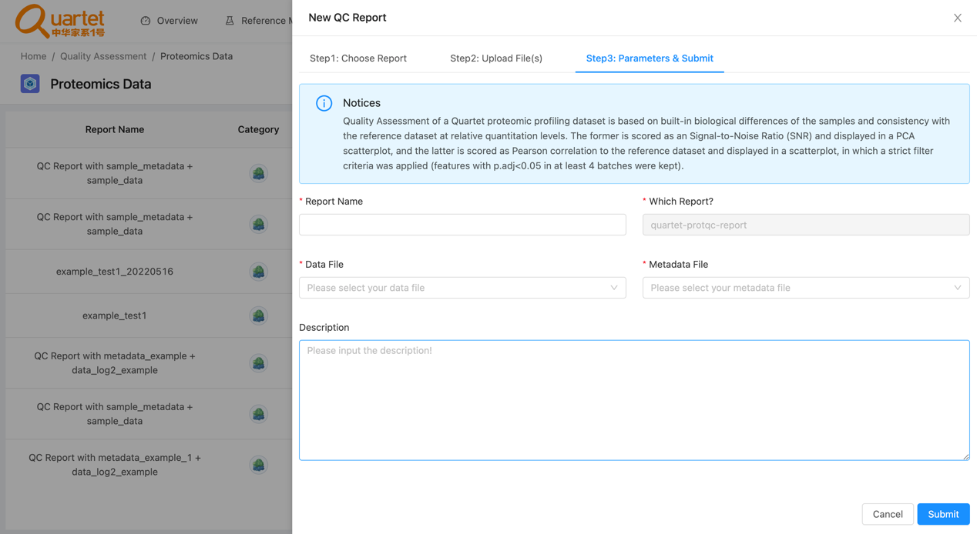

3.6 Then you can preview or download your QC report by clicking “Result” or “Download” respectively.
