Quartet Data Portal User Guide for
RNA-Seq Quality Assessment Report

Preparation
QDP Address | http://chinese-quartet.org/
OSSUtil | https://docs.chinese-quartet.org/tools/ossutil/
Input files | The file name suffix should be:  The data format that can be analysed online are pair-end FASTQ files, with suffixes of _R1.fastq.gz and _R2.fastq.gz or _R1.fq.gz and _R2.fq.gz.  Your dataset must contain four groups D5, D6, F7 and M8, with at least 2 technical replicates in each group.

Log on to QDP

2.1 QDP account
1)If you have a request to receive reference materials, please go to http://chinese-quartet.org/#/materials to request the reference materials, and the Quartet team will contact you to send the reference materials and send you a link to register your account.

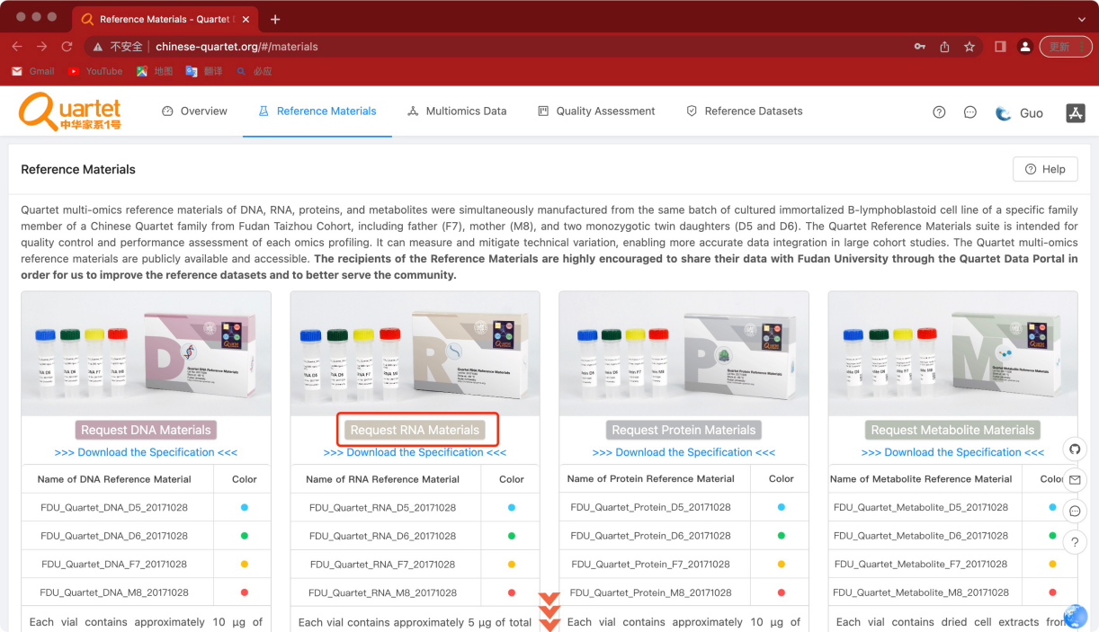

- If you do not have a request for reference materials, please send an email to quartet@fudan.edu.cn to request an account.

2.2 Log on to QDP
Address：http://chinese-quartet.org/
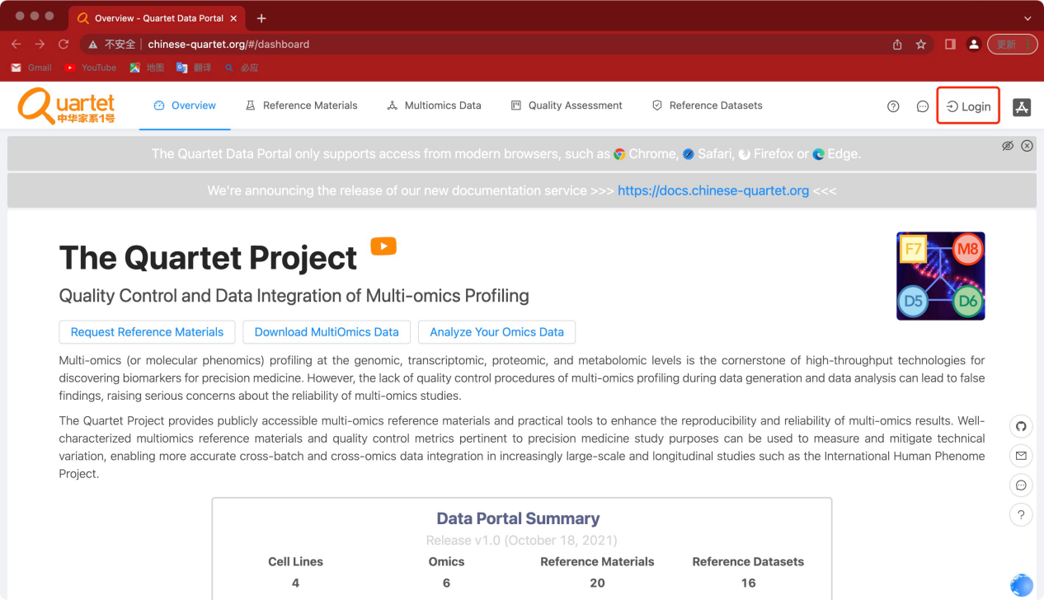

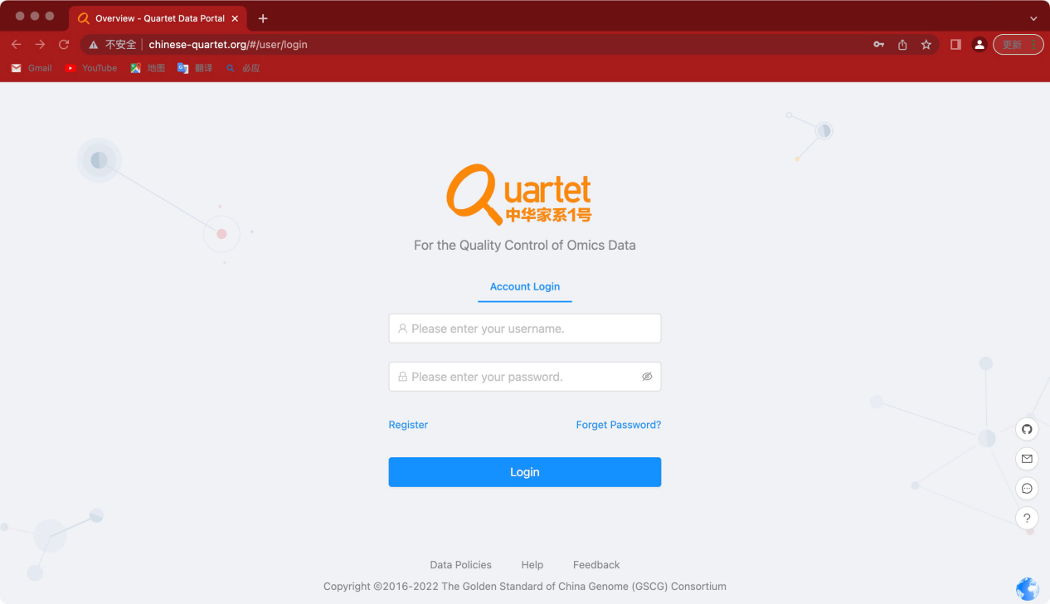

2.3 Select Quality Assessment-QC Apps
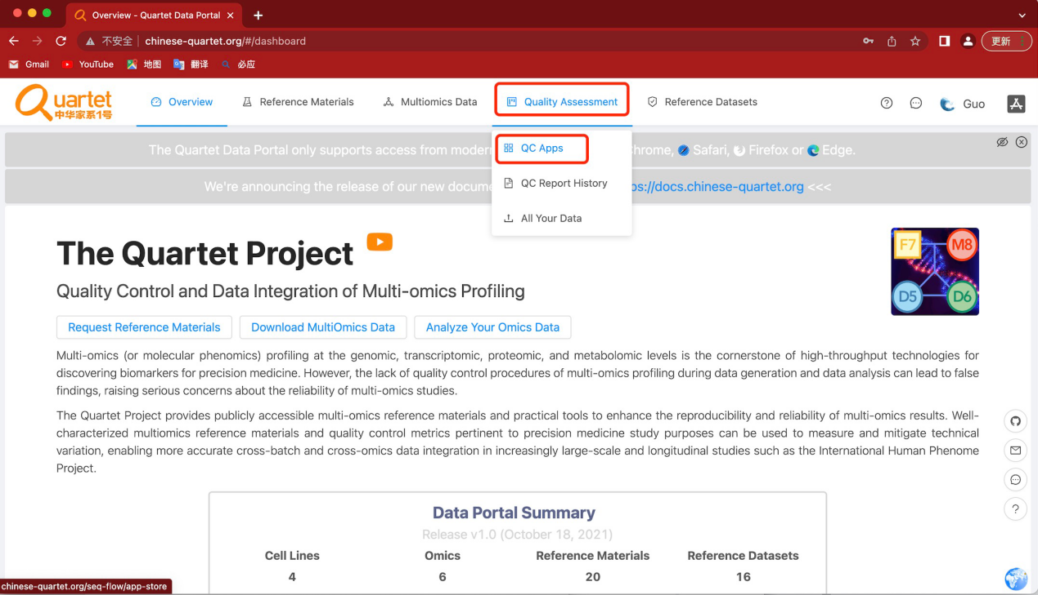

Upload RNA sequencing data

3.1 Select Transcriptomics> Upload Your Data> Run
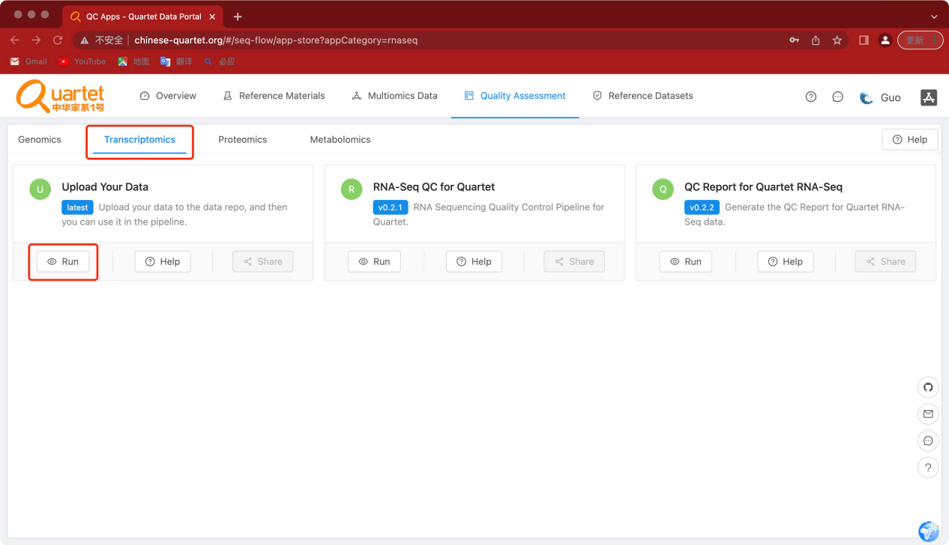

3.2 Click the symbol called “Register & Upload Your Data”
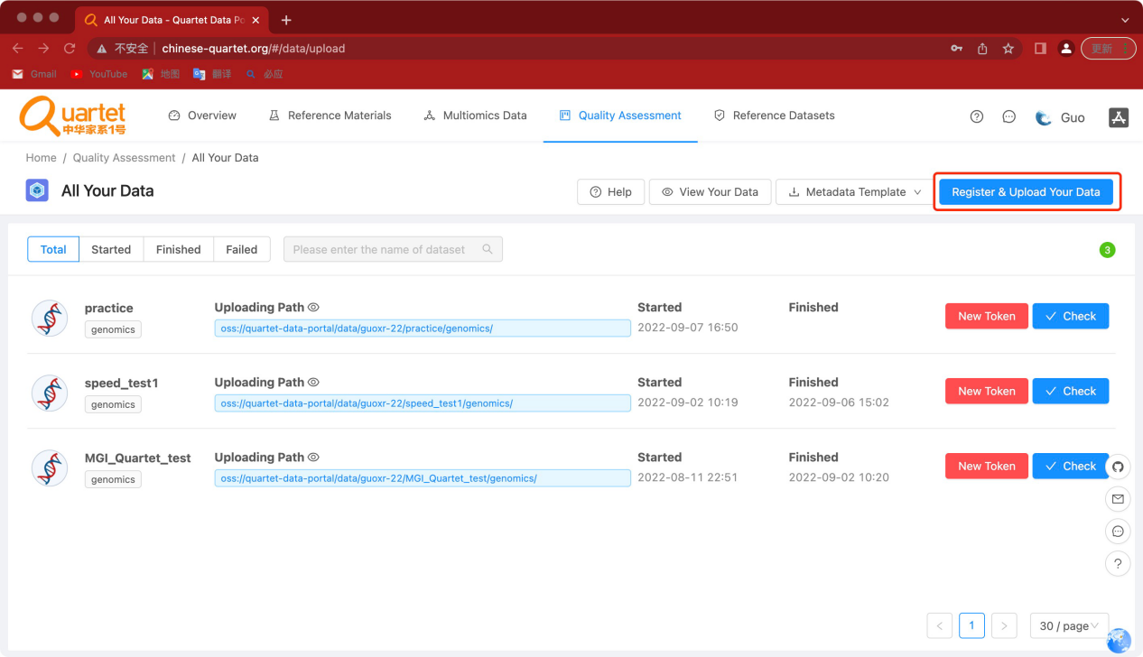

3.3 Fill in Dataset Name, DataType select Transcriptomics, and click Submit
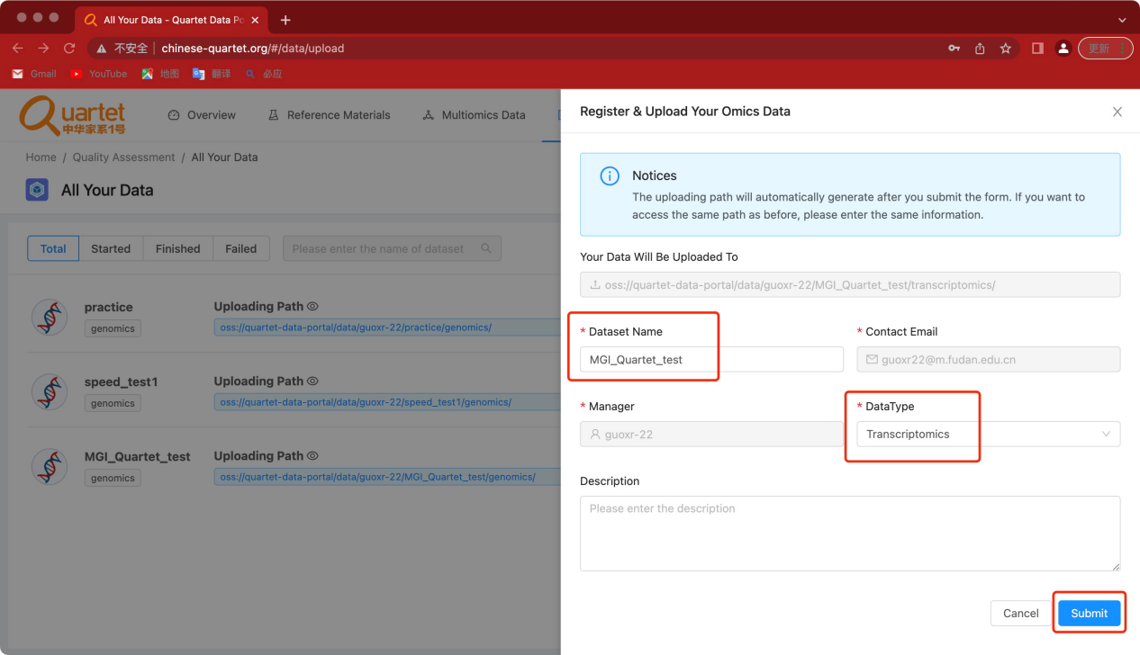

Click the symbol called “New Token”. Copy the autorizedCode, which is for

subsequent ossbrowser login
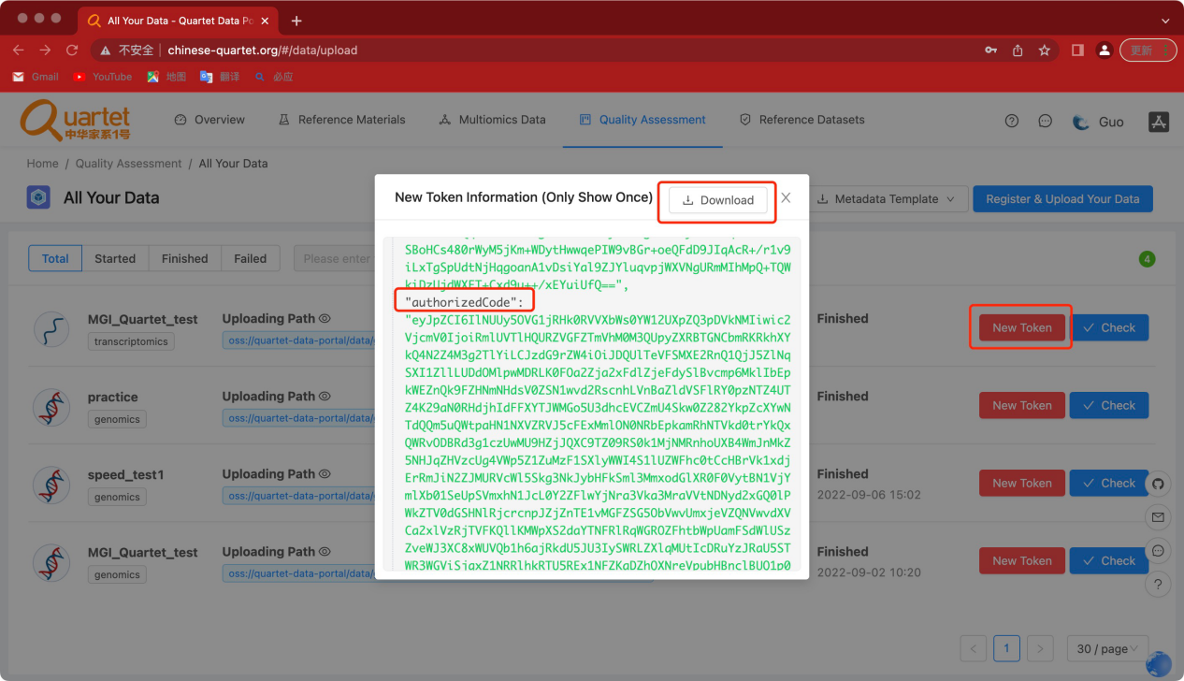

Please follow the ossutil document to upload your data
ossutil is a user friendly command line tool to upload data to the Quartet Data Portal. It supportsthe following operating systems: Windows, Linux, and macOS. You can download and install the ossutil version that best suits your requirements.

https://docs.chinese-quartet.org/tools/ossutil/

Run RNA-Seq app

4.1 Select Transcriptomics> RNA-Seq QC for Quartet> Run
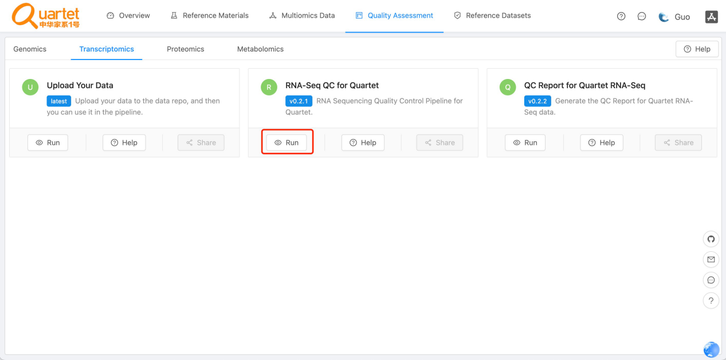

4.2 Click the symbol called “Start Assessment”
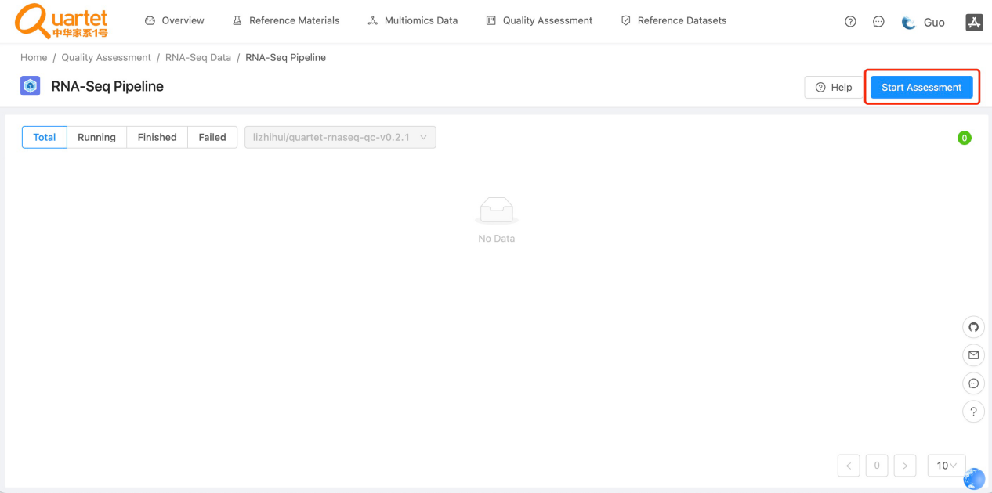

4.3 Fill in Assessment Name and Description. Then click Next.
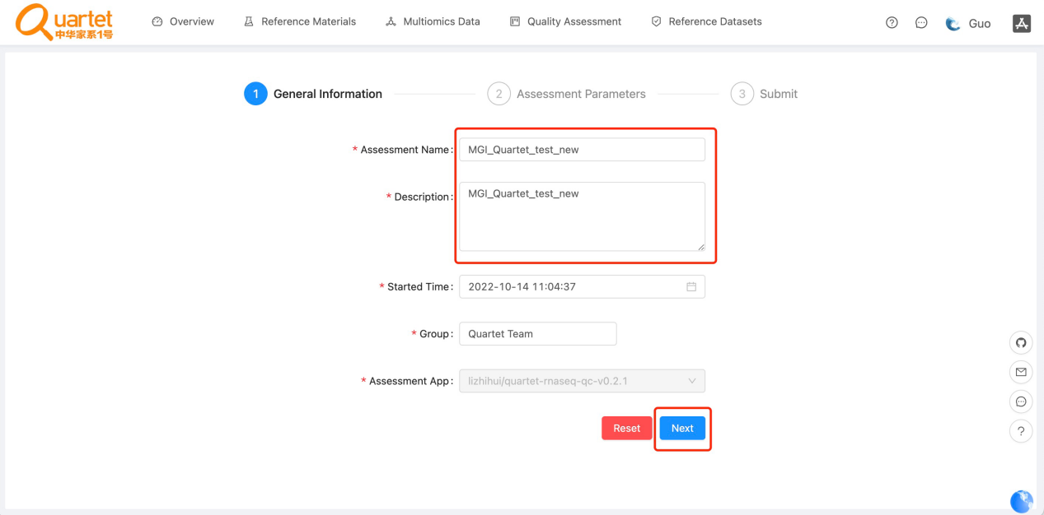

4.4 Fill in Sample information
Sample ID Fill in the numbers; Select the read files and click upload. The parameters other than read file can be selected as default files or you can upload your own files.Assessment Parameters can be downloaded and checked.
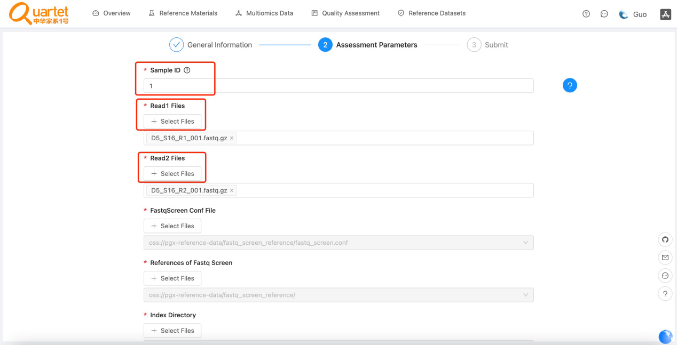

4.5 Click the symbol called “Run Assessment”
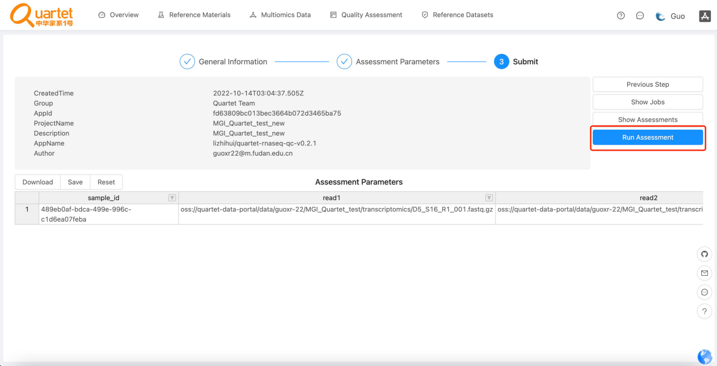

4.6 Check the status of Run Assessment
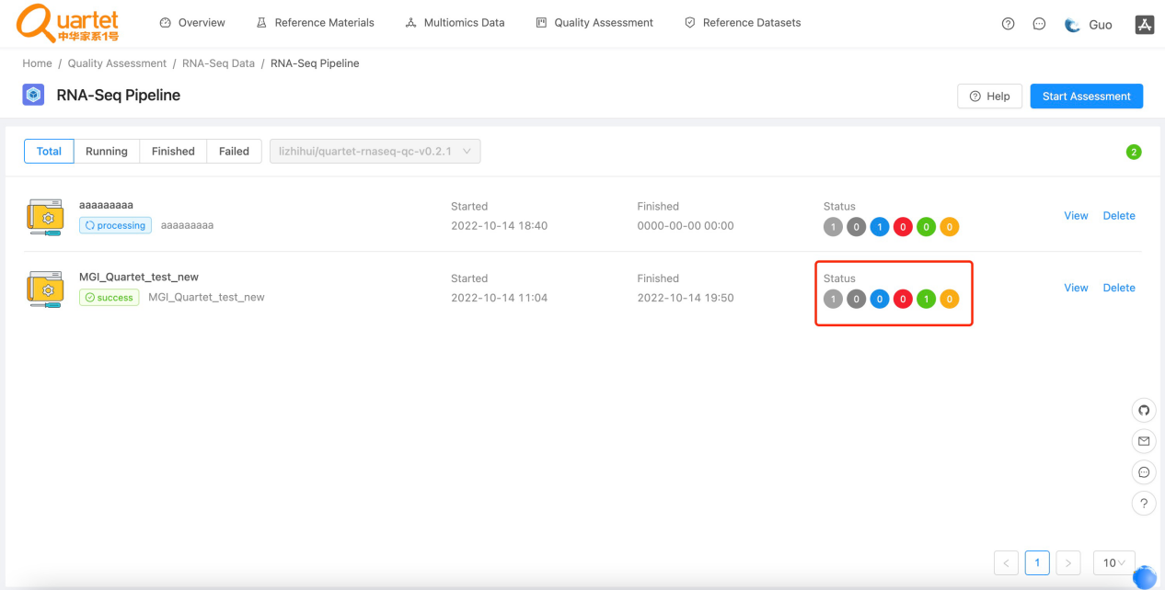

Results and Report

5.1 Select Transcriptomics> QC Report for Quartet RNA Seq-Run
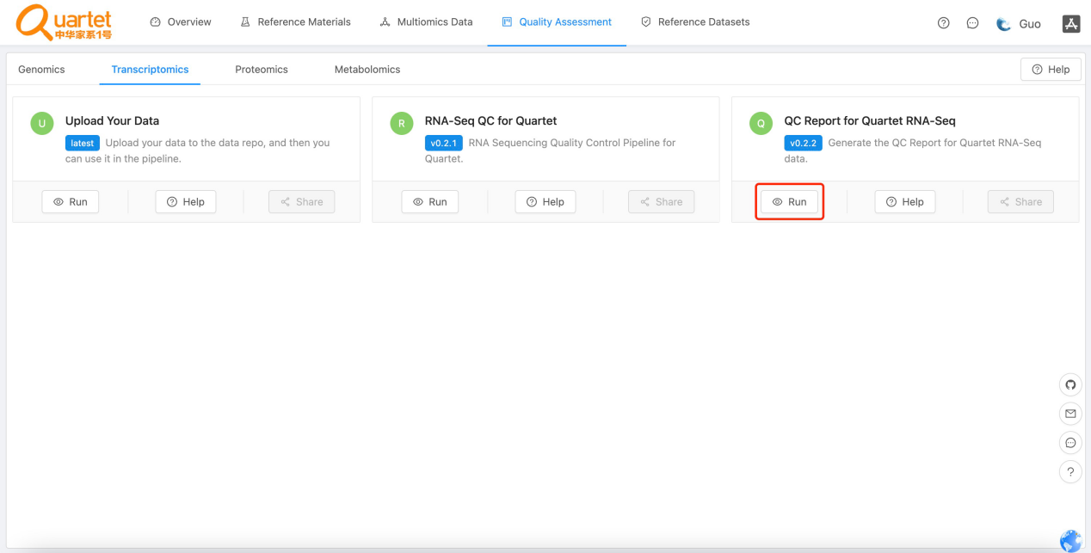

5.2 Click the symbol called “New QC Report”
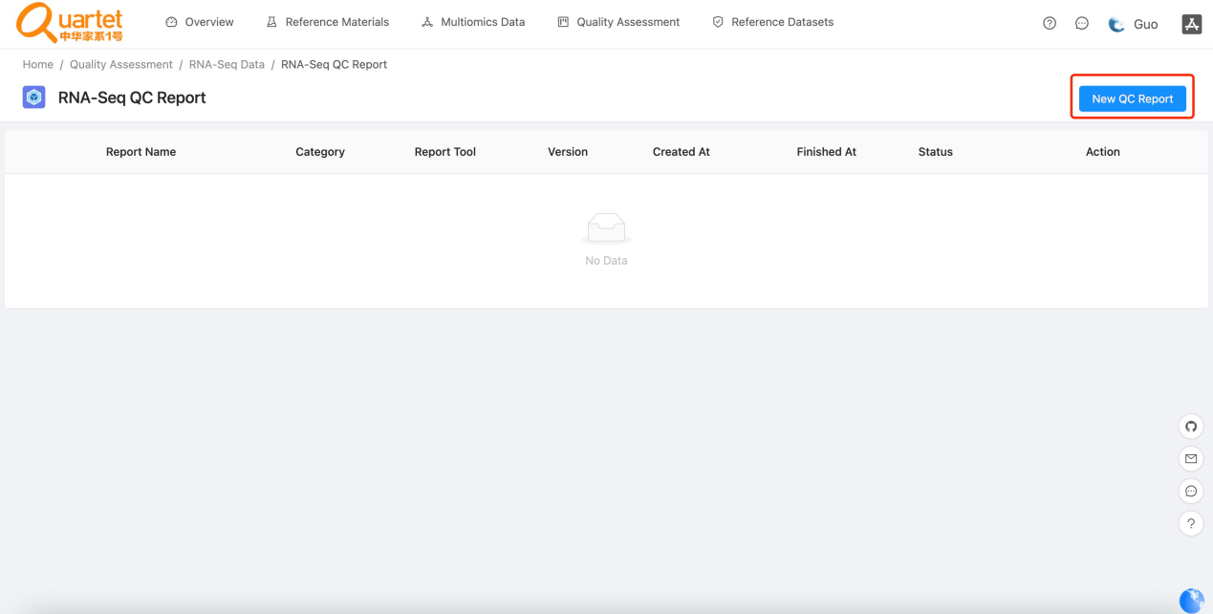

5.3 Follow the Steps as prompted
