Quartet Data Portal User Guide for
Proteomic Quality Assessment Report

Preparation
QDP Address | https://chinese-quartet.org/
OSSUtil | https://docs.chinese-quartet.org/tools/ossutil/
Input files | The file format (suffix) should be .csv.

Log on to QDP

2.1 QDP account
1) If you have a request for the reference materials, please go to http://chinese-quartet.org/#/materials to request the reference materials. The Quartet team will contact you for further confirming your information and send you a registration email.
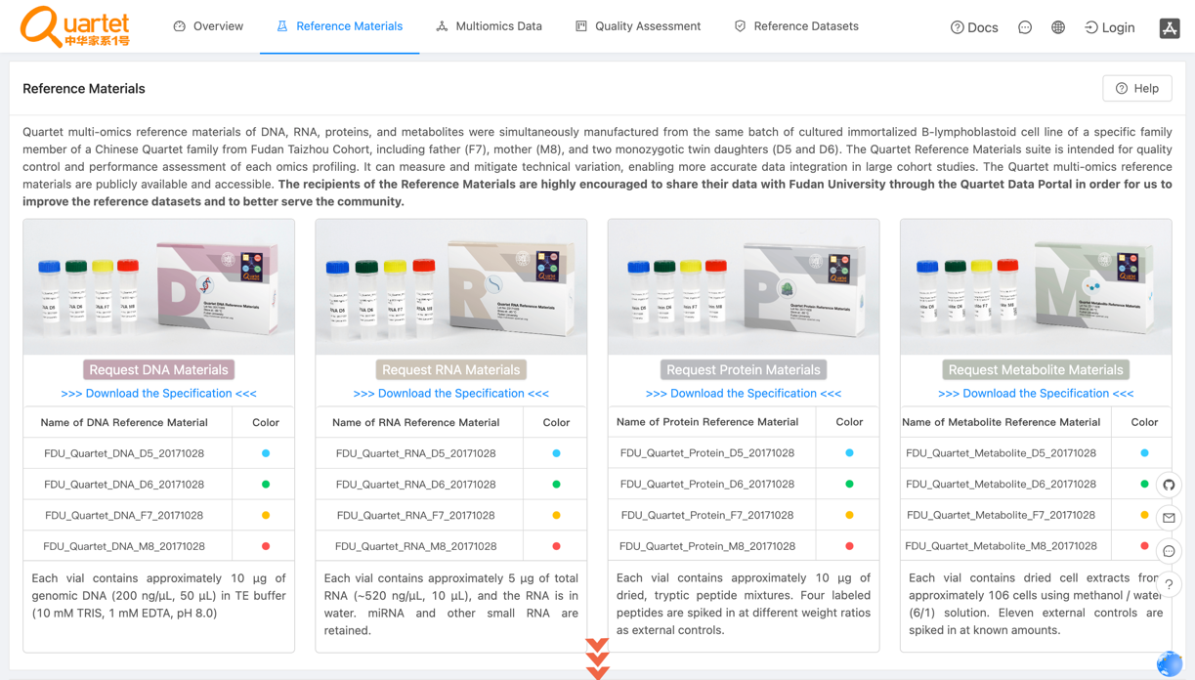
2) You can download the specification file by clicking Download the Specification.
3) For preview the specification, please drop down and click Protein Materials.
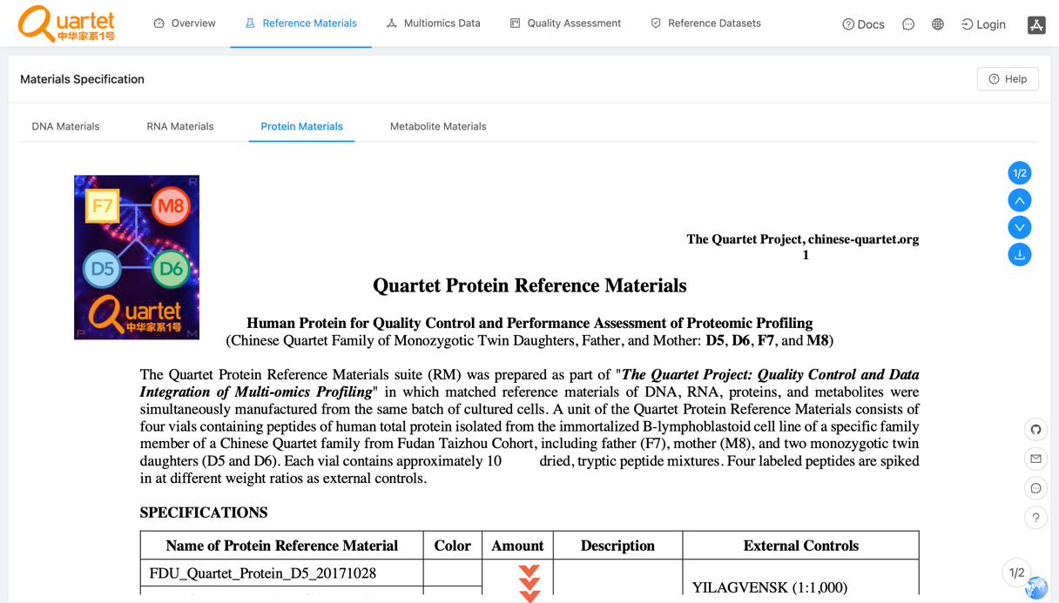
3) If you do not have a request for the reference materials, please send an email to quartet@fudan.edu.cn for a QDP account.

2.2 Login
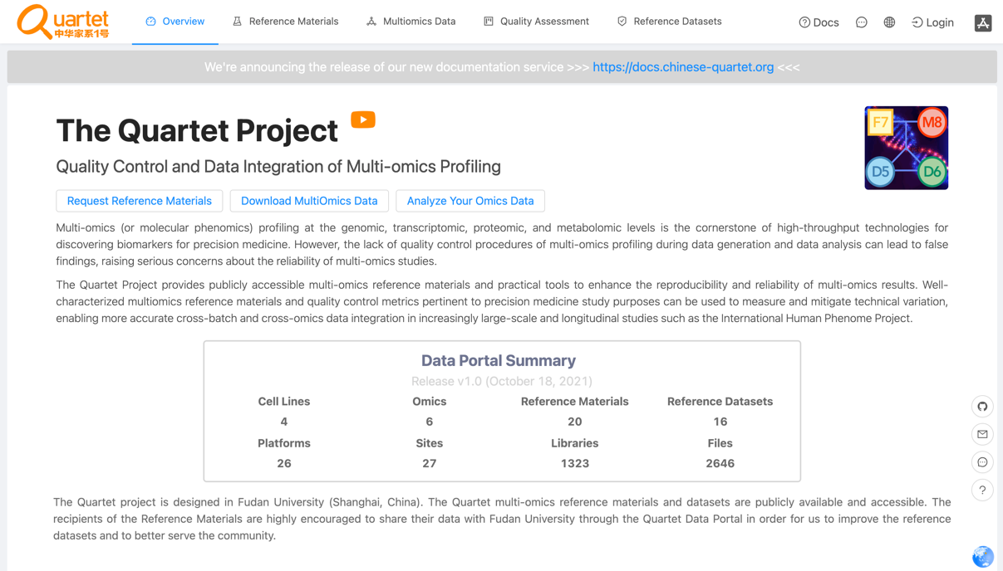
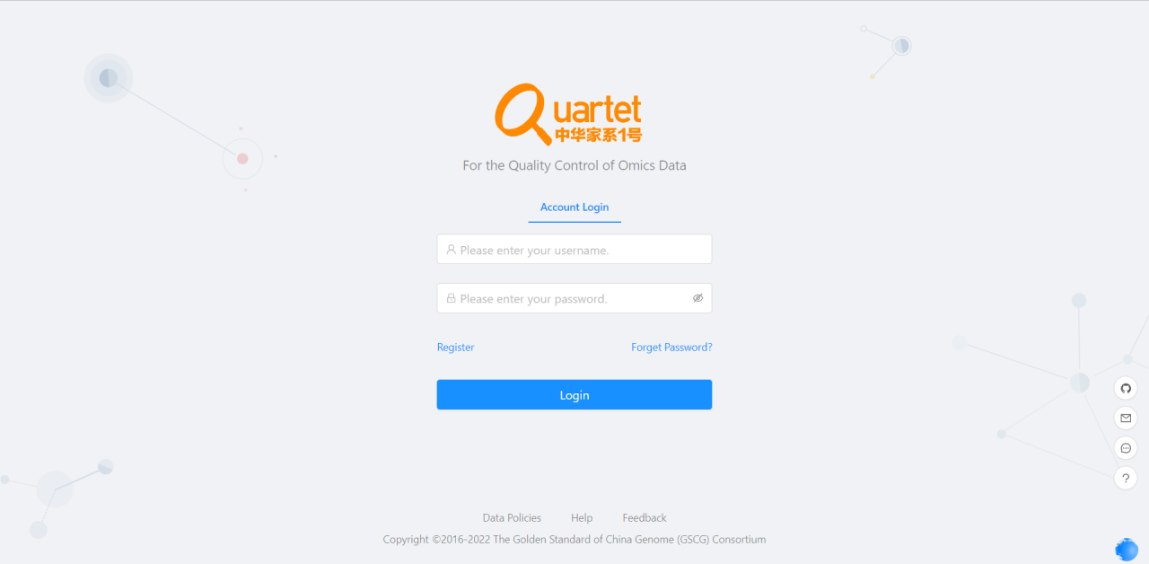

2.3 Select Quality Assessment > QC Apps.
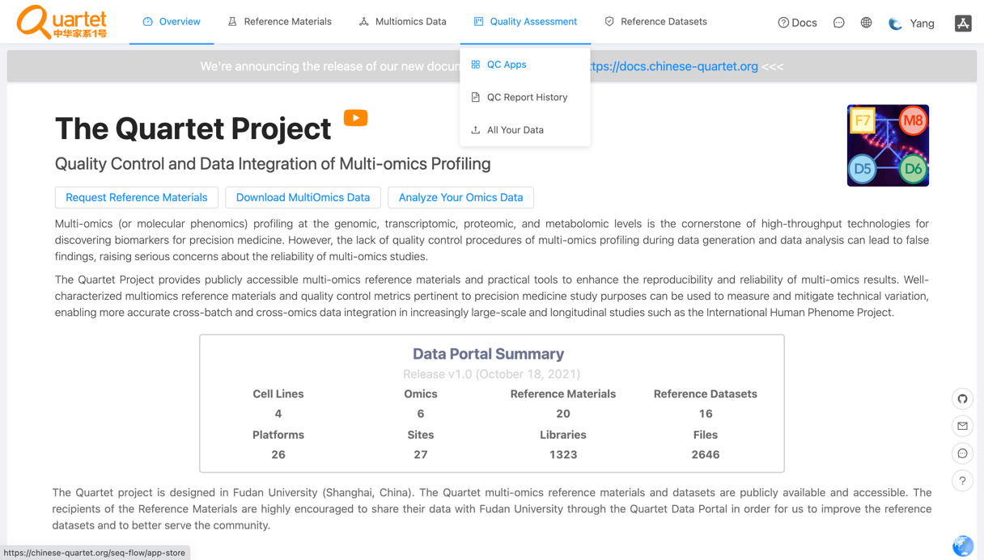

Run QC Report

3.1 Select Proteomics > Run.
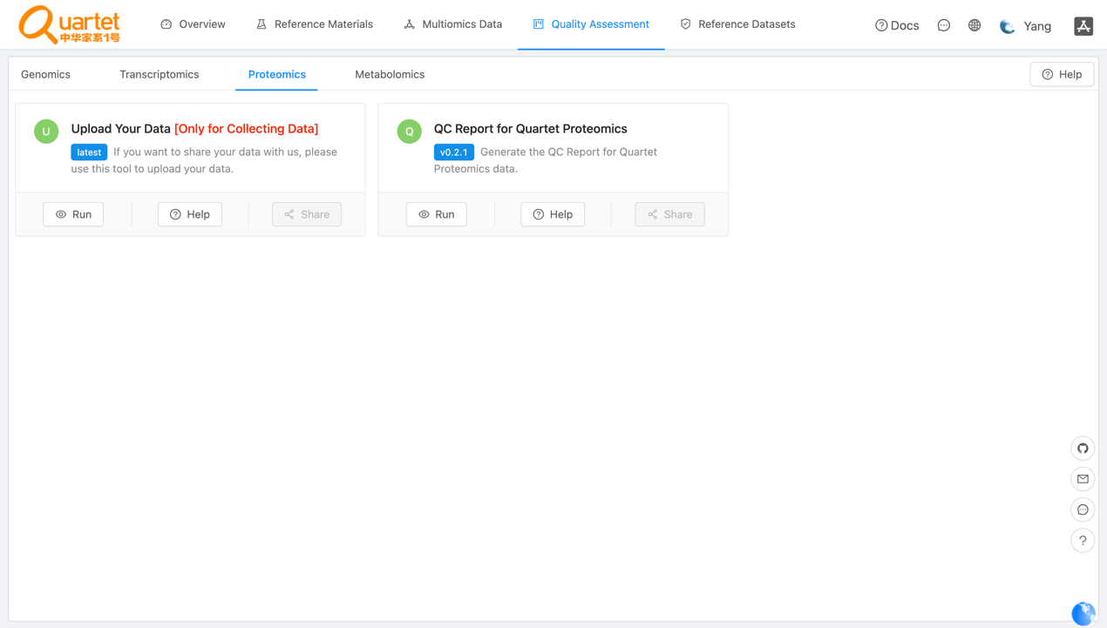

3.2 Click New QC Report.
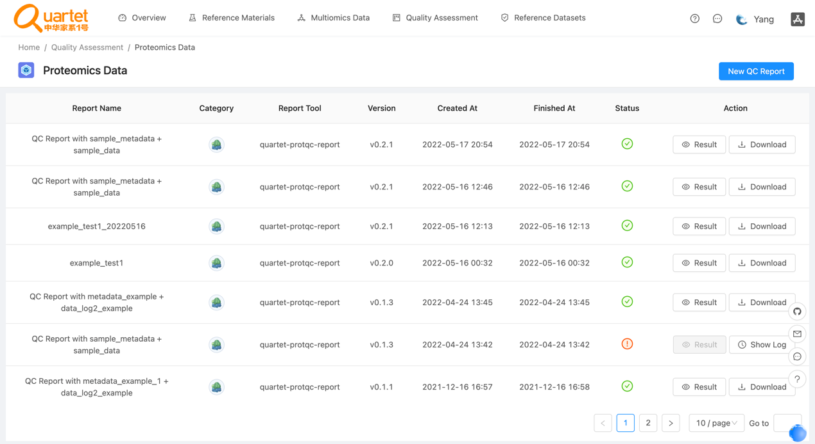

3.3 Select Step1: Choose Report > QC Report for Quartet Proteomics.

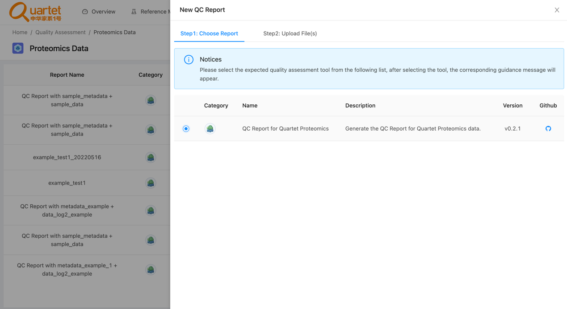

3.4 Select Step2: Upload File(s) > QC Report for Quartet Proteomics.
1) For details of the fixed format of the data file and the metadata file, please refer to https://docs.chinese-quartet.org/data_pipelines/proteomics/qc_report/.
2) To ensure the data file and the metadata file are matched, please drag or click files simultaneously into the uploading area.
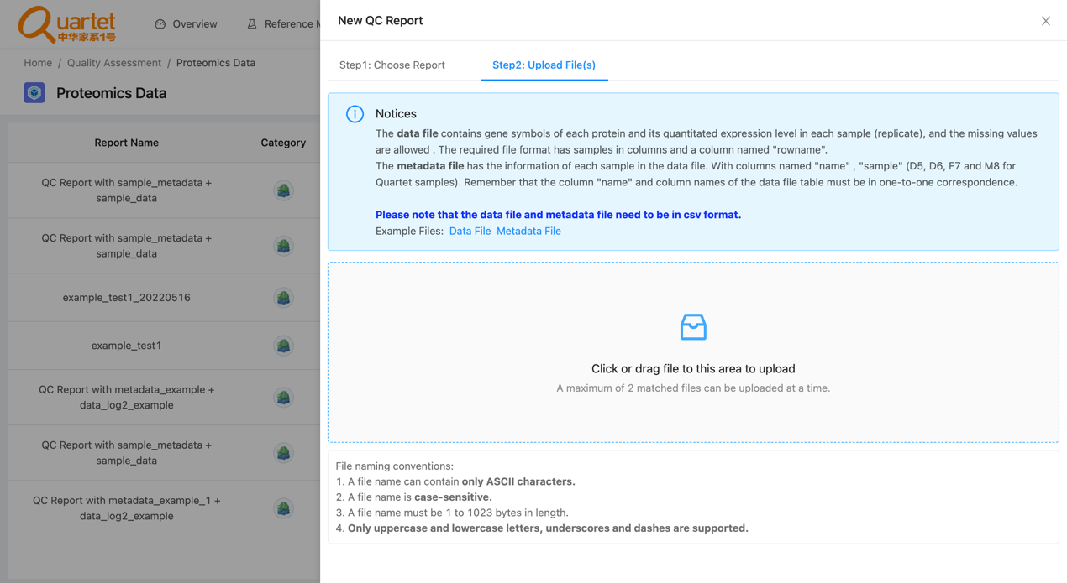

3.5 After uploading the tested files, select Step3: Parameters & Submit. Fill in the required information and click Submit.

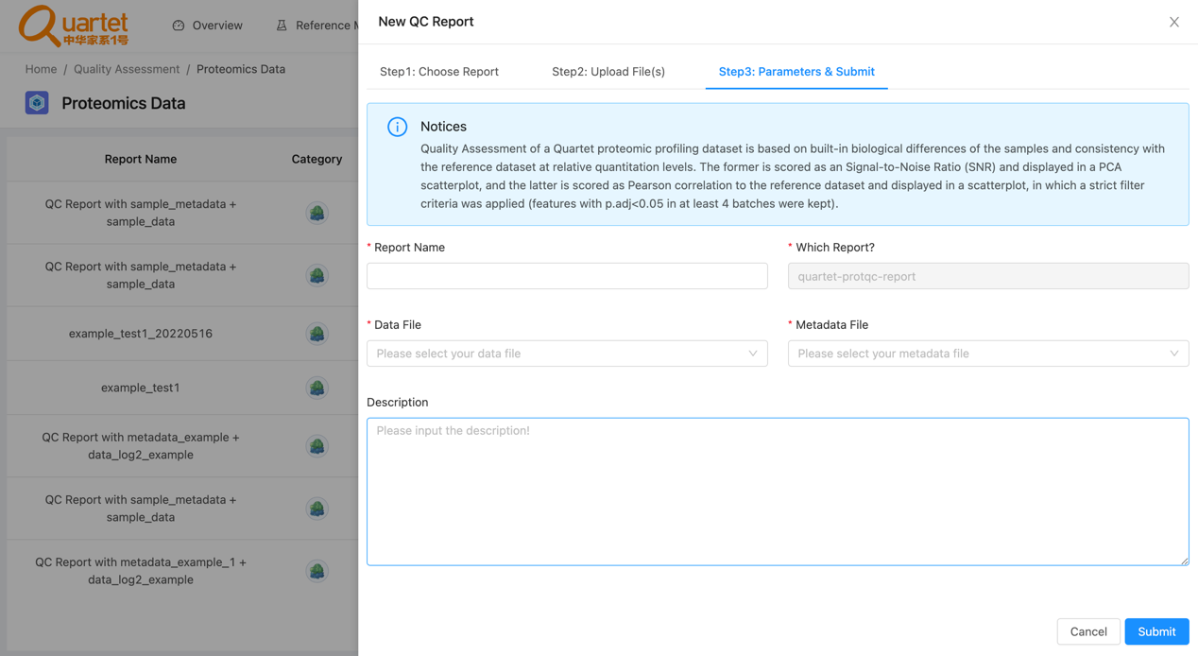

3.6 Then you can preview or download your QC report by clicking Result or Download respectively.
