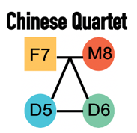

Quartet Report for Metabolomics

Assessment Summary
Quality metrics | Value | Historical value (mean ± SD) | Rank | Performance
Signal-to-Noise Ratio (SNR) | 2.381 | 16.63 ± 5.15 | 22 / 23 | Bad
Relative Correlation with Reference Datasets (RC) | 0.886 | 0.9 ± 0.08 | 19 / 23 | Bad
Recall of DAMs in Reference Datasets (Recall) | 0.029 | 0.77 ± 0.18 | 22 / 23 | Bad
Total Score | 1.932 | 6.89 ± 1.99 | 22 / 23 | Bad

Quality Control Metric

Signal-to-Noise Ratio (SNR):
We apply SNR in the reliability assessment of metabolome data based on the built-in biological differences between Quartet samples. SNR is the fraction of distances between different Quartet samples ('signal') and distances between technical replicates ('noise') on 2D-PCA scatter plot, where a high SNR indicates the tight clustering of technical and wide dispersion of different Quartet samples replicates, as well as good reproducibility and discriminability overall the batch level.

Relative Correlation with Reference Datasets (RC):
RC is used for assessment of quantitative consistency with the reference datasets (RDs) at relative levels. To evaluate the performance of both targeted and untargeted metabolomics, the RDs were established with historical datasets of high quality by benchmarking the relative abundance values for each sample pair (D5/D6, F7/D6, M8/D6) at metabolite abundance level. We calculate relative abundance values (ratios to D6) of the queried data for metabolites overlapped with the RDs. Then we calculate the Pearson correlation as RC of measured relative abundance values and those in the RDs.

Recall of DAMs in Reference Datasets (Recall):
Recall is used for qualitative assessment of the accuracy of biological difference detecting, as the fraction of the differential abundancial metabolites (DAMs) in RDs that are successfully retrieved. Here recall is the number of measured DAMs (p < 0.05, t test) divided by the number of DAMs should be identified as RDs.

Total Score:
The performance of the submitted data will be graded as Bad, Fair, Good, or Great based on the ranking by comparing the total score with the historical datasets.The total score is the geometric mean of the scaled values of the number of Signal-to-Noise Ratio (SNR), relative correlation with reference datasets (RC), and recall of DAMs in Reference Datasets (Recall).

Performance Category:
Based on the scaled total score, the submitted data will be ranked together with all Quartet historical datasets. The higher the score, the higher the ranking. After this, the performance levels will be assigned based on their ranking ranges.
· Bad - the bottom 20%.
· Fair - between bottom 20% and median 50%.
· Good - between median 50% and top 20%.
· Great - the top 20%.

Performance Score
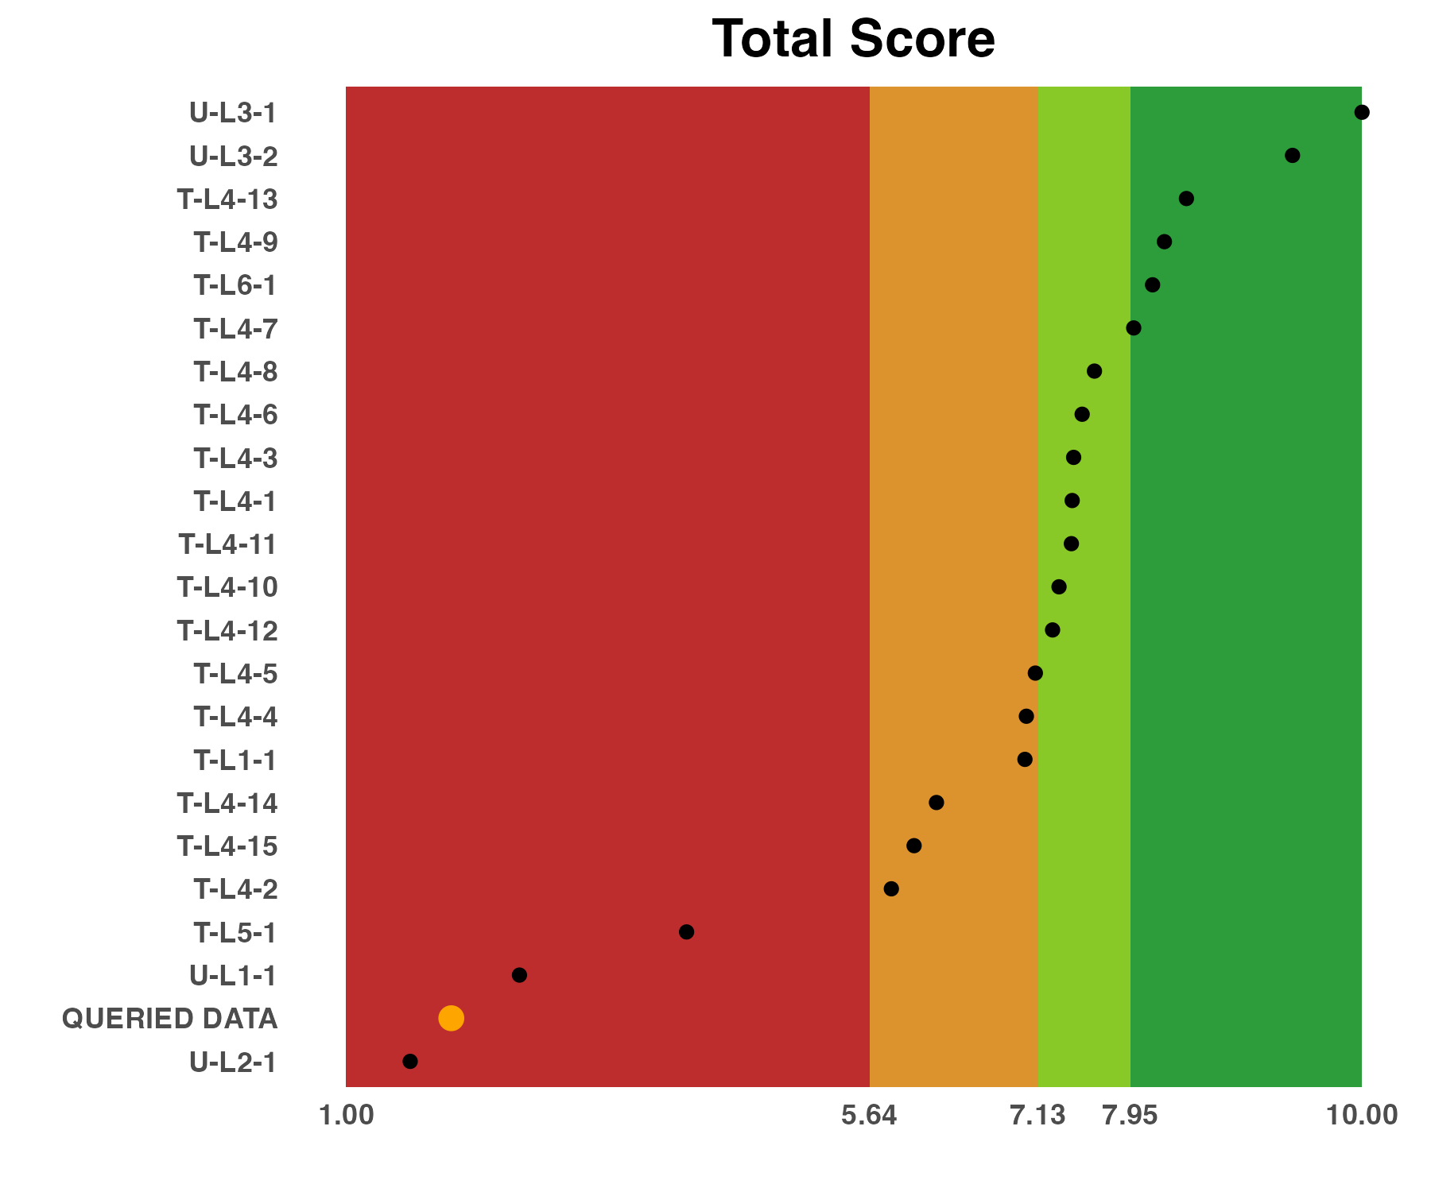
Scores of evaluation metrics for the current batch and all historical batches assessed.Please note that the results shown here are scaled values for all batches in each metric. The name of your data is Queried_Data.

Signal-to-Noise Ratio
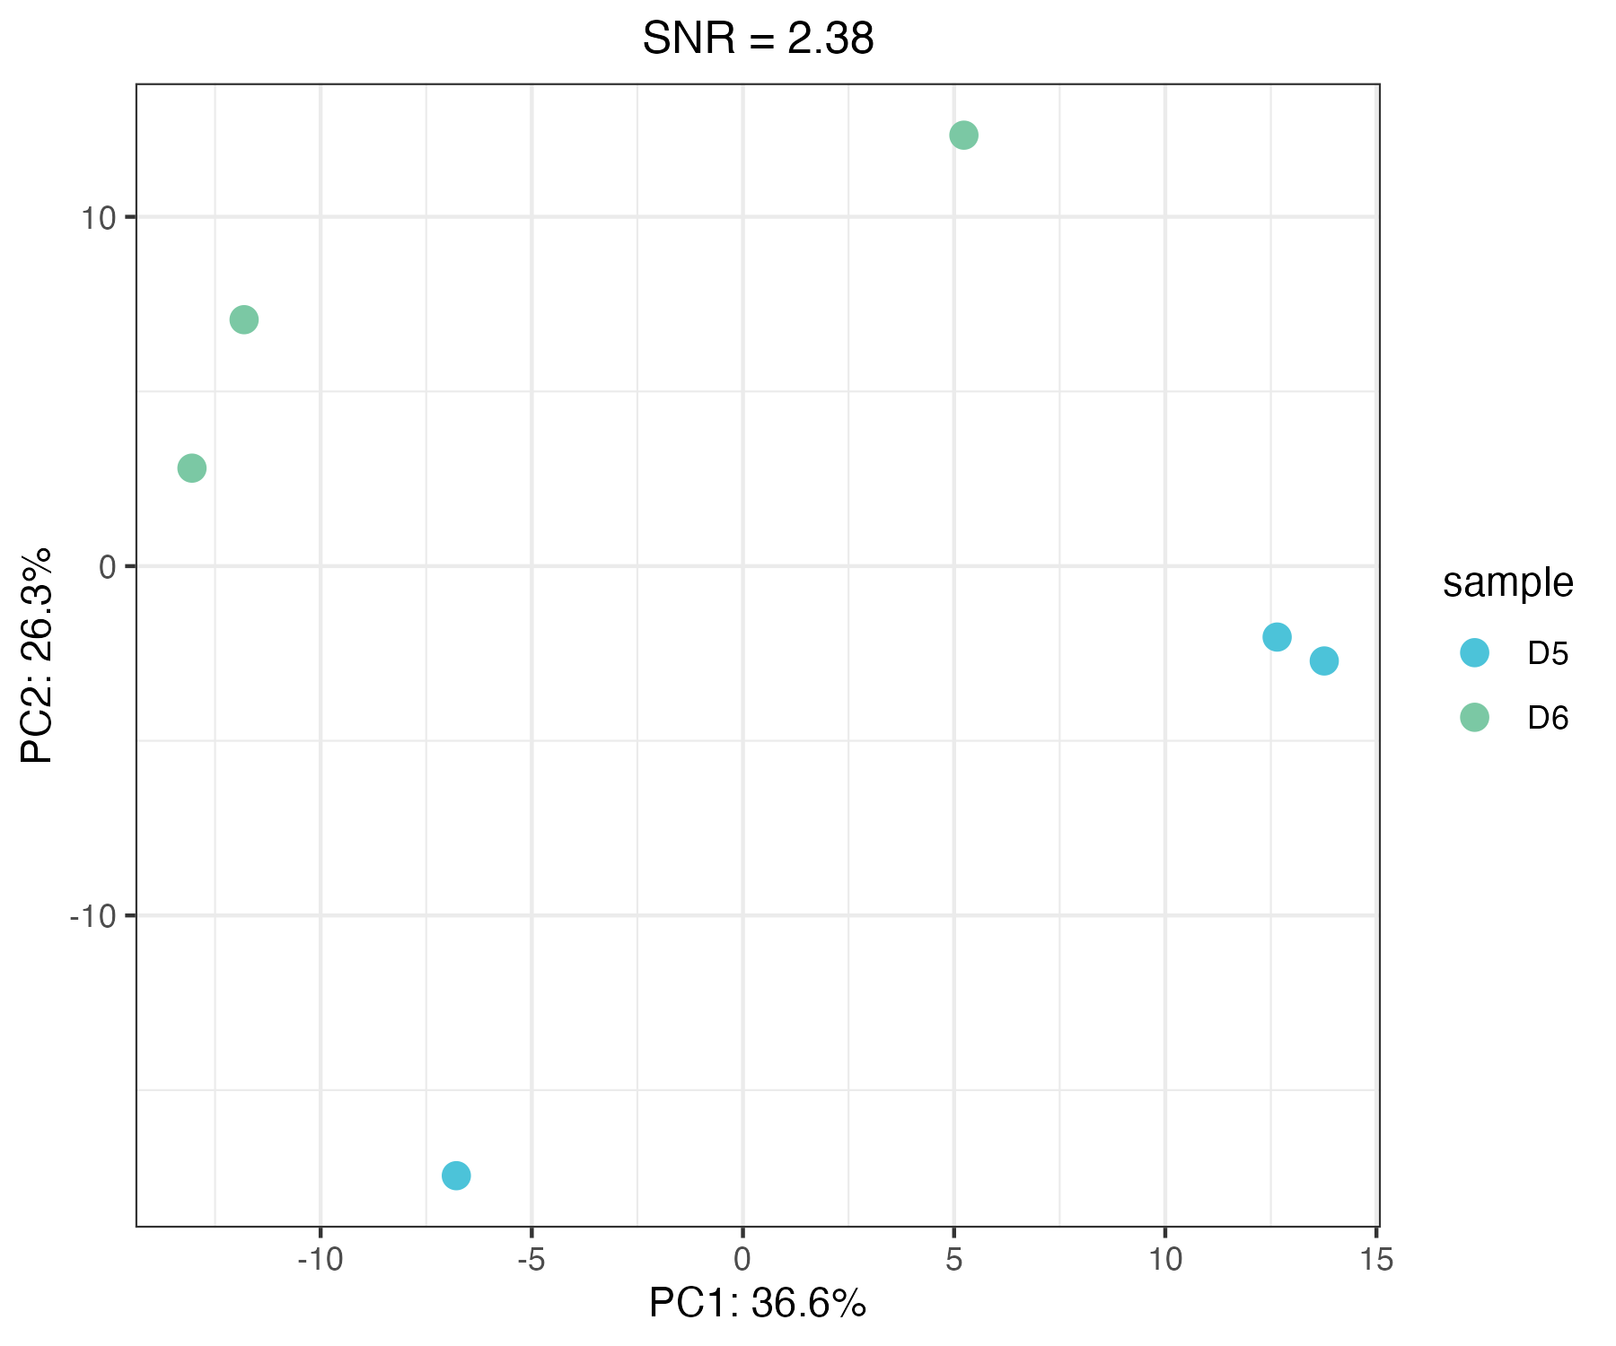
SNR is established to characterize the power in discriminating multiple groups. The PCA plot is used to visualise the metric.

Correlation with Reference Datasets
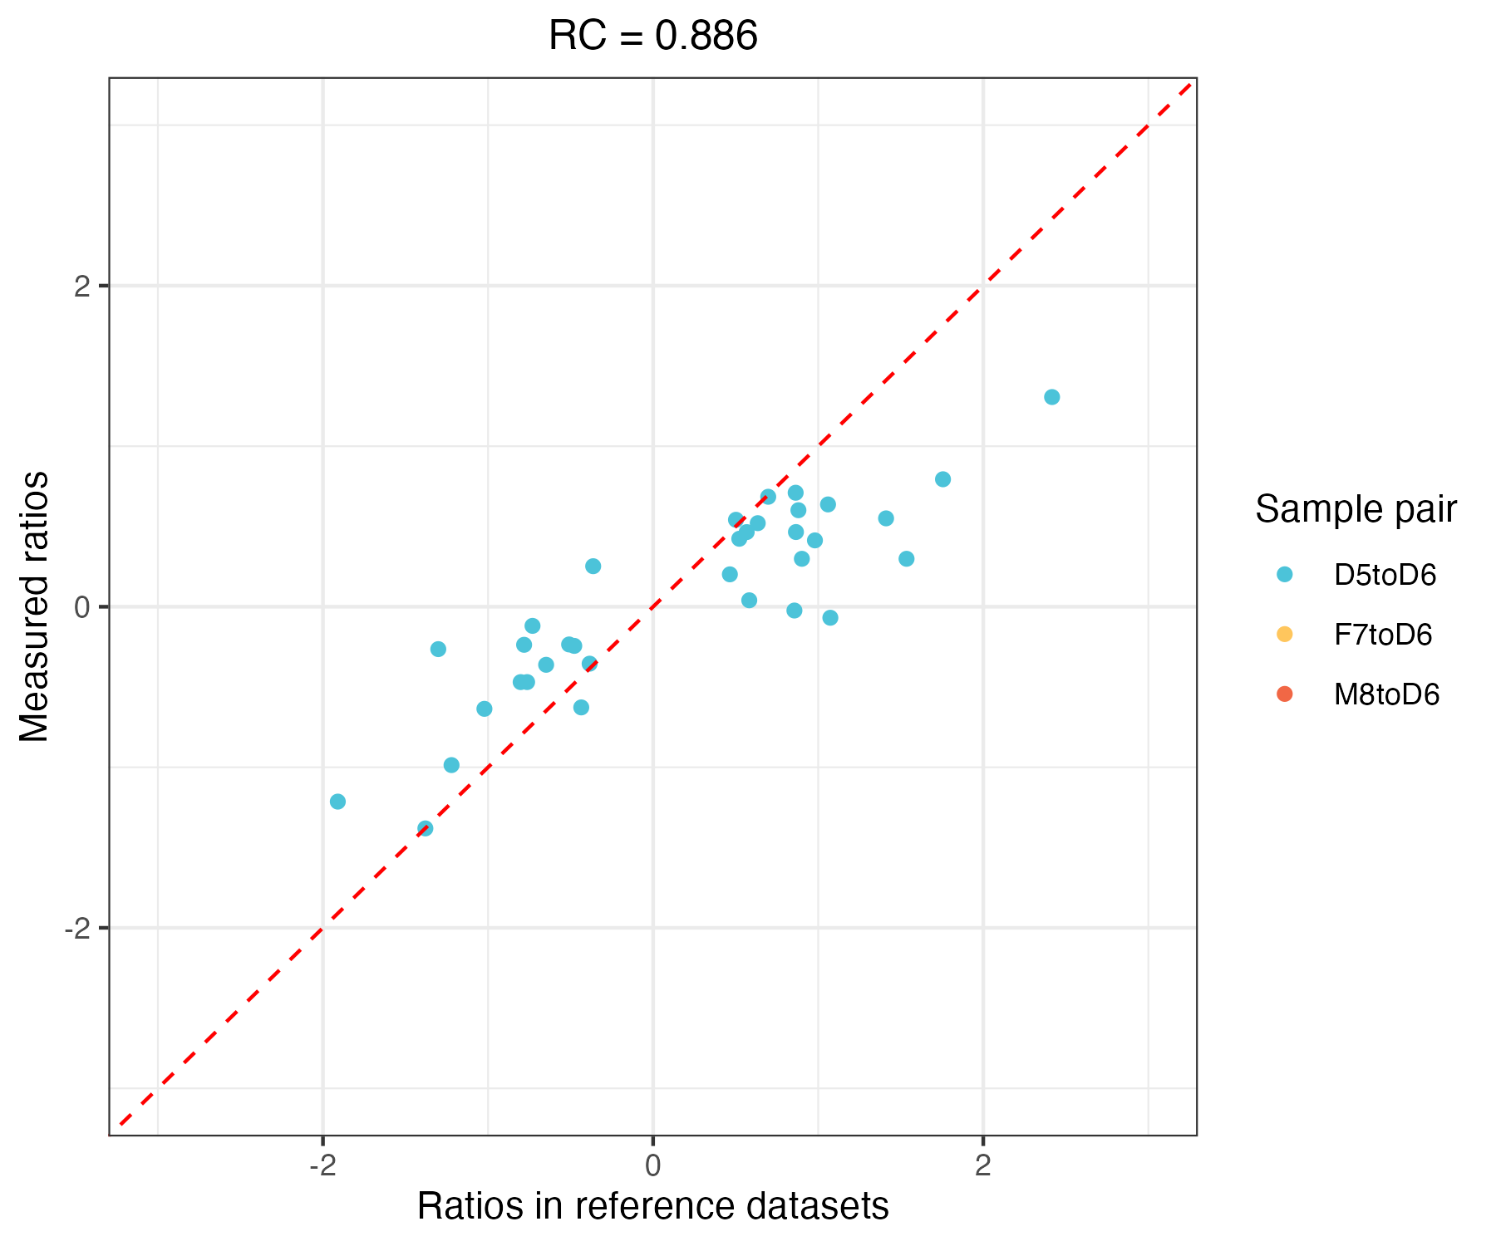
Relative correlation with reference datasets metric which was representing the numerical consistency of the relative expression profiles.

Supplementary Information

Reference
1. Zheng, Y. et al. Multi-omics data integration using ratio-based quantitative profiling with Quartet reference materials. Nature Biotechnology 1–17 (2023).
2. Zhang, N. et al. Quartet metabolite reference materials for assessing inter-laboratory reliability and data integration of metabolomic profiling. bioRxiv 2022.11. 01.514762 (2022).

Contact us
Fudan University Pharmacogenomics Research Center
Project manager: Quartet Team
Email: quartet@fudan.edu.cn

Disclaimer
This quality control report is only for this specific test data set and doesn’t represent an evaluation of the business level of the sequencing company. This report is only used for scientific research, not for clinical or commercial use. We don’t bear any economic and legal liabilities for any benefits or losses (direct or indirect) from using the results of this report.

