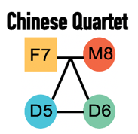

Quartet Report for Proteomics

Assessment Summary
Quality Metrics | Value | Historical Value (mean ± SD) | Rank | Performance
Number of features | 5,948.000 | 4533.938 ± 838.623 | 1/33 | Great
Missing percentage (%) | 4.894 | 24.382 ± 9.879 | 4/33 | Great
Absolute Correlation | 0.986 | 0.92 ± 0.033 | 3/33 | Great
Coefficient of variantion (CV, %) | 6.953 | 22.52 ± 8.324 | 2/33 | Great
Signal-to-Noise Ratio (SNR) | 22.911 | 15.766 ± 8.094 | 7/33 | Great
Relative Correlation with Reference Datasets (RC) | 0.811 | 0.897 ± 0.082 | 6/7 | Bad
Total Score | 8.471 | 4.919 ± 2.185 | 5/33 | Great

Quality Control Metric
The QC pipeline starts from the expression profiles at peptide/protein levels, and enables to calculate 6 metrics. A Total score is the geometric mean of the linearly normalized values of these metrics.

Number of features:
We expect as many proteins (mapped to gene symbols) as possible for downstreaming analyses.

Missing percentage (%):
Too many missing values interfere with comparability. This metric is calculated globally.

Coefficient of variantion (CV %):
A CV value is calculated to indicate the dispersion within replicates feature by feature.

Absolute Correlation:
Pearson correlation reflects overall reproducibility within replicates. We calculate correlation coefficients between each two replicates within each biological sample (D5, D6, F7, M8), and take the median as the final value for absolute correlation.

Signal-to-Noise Ratio (SNR):
SNR is established to characterize the ability of a platform or lab or batch, which is able to distinguish intrinsic differences among distinct biological sample groups ('signal') from variations in technical replicates of the same sample group ('noise').

Relative Correlation with Reference Datasets (RC):
RC is used for assessment of quantitative consistency with the reference dataset at relative levels. For shotgun proteomics, quantitation at peptide levels is theoretically more reliable. Therefore, the reference dataset is established by benchmarking the relative expression values (log2FCs), for each peptide sequence of each sample pair (D5/D6, F7/D6, M8/D6), in historical datasets at peptide levels. We calculate relatively qualified (satisfied with thresholds of p < 0.05) log2FCs of the queried data, for overlapped peptides with the reference dataset, as the input for the assessment of quantitative consistency. Then RC value is Pearson correlation coefficient between the test dataset and the reference dataset.

Total Score:
The performance of the submitted data will be graded as Bad, Fair, Good, or Great based on the ranking by comparing the total score with the historical datasets. The total score is the harmonic mean of the scaled values of the number of features, missing percentage, absolute correlation, coefficient of variation, Signal-to-Noise Ratio (SNR), and relative correlation with reference datasets (RC).

Performance Category:
Based on the scaled total score, the submitted data will be ranked together with all Quartet historical datasets. The higher the score, the higher the ranking. After this, the performance levels will be assigned based on their ranking ranges.
· Bad - the bottom 20%.
· Fair - between bottom 20% and median 50%.
· Good - between median 50% and top 20%.
· Great - the top 20%.

Performance Score
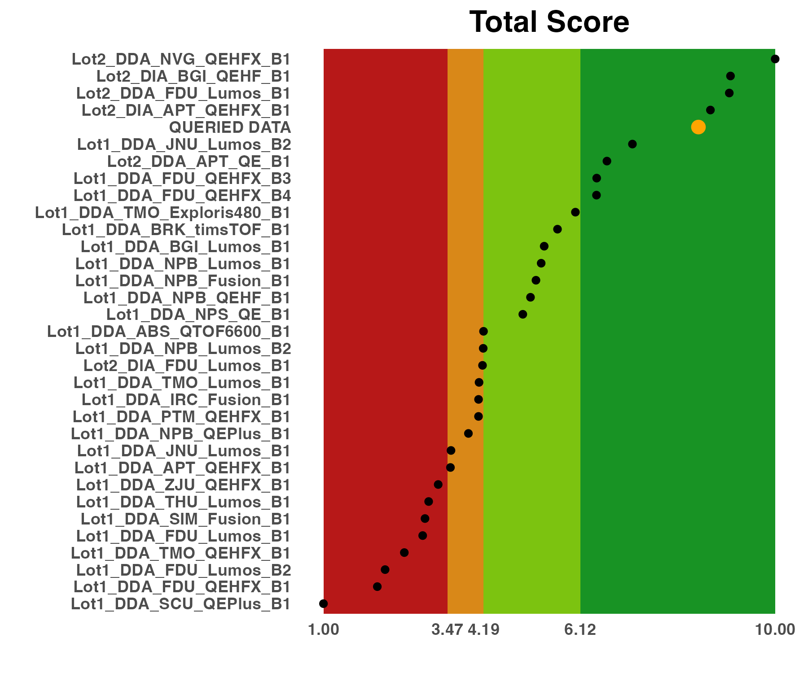
Scores of evaluation metrics for the current batch and all historical batches assessed. Please note that the results shown here are scaled values for all batches in each metric. The name of your data is Queried_Data.

Signal-to-Noise Ratio
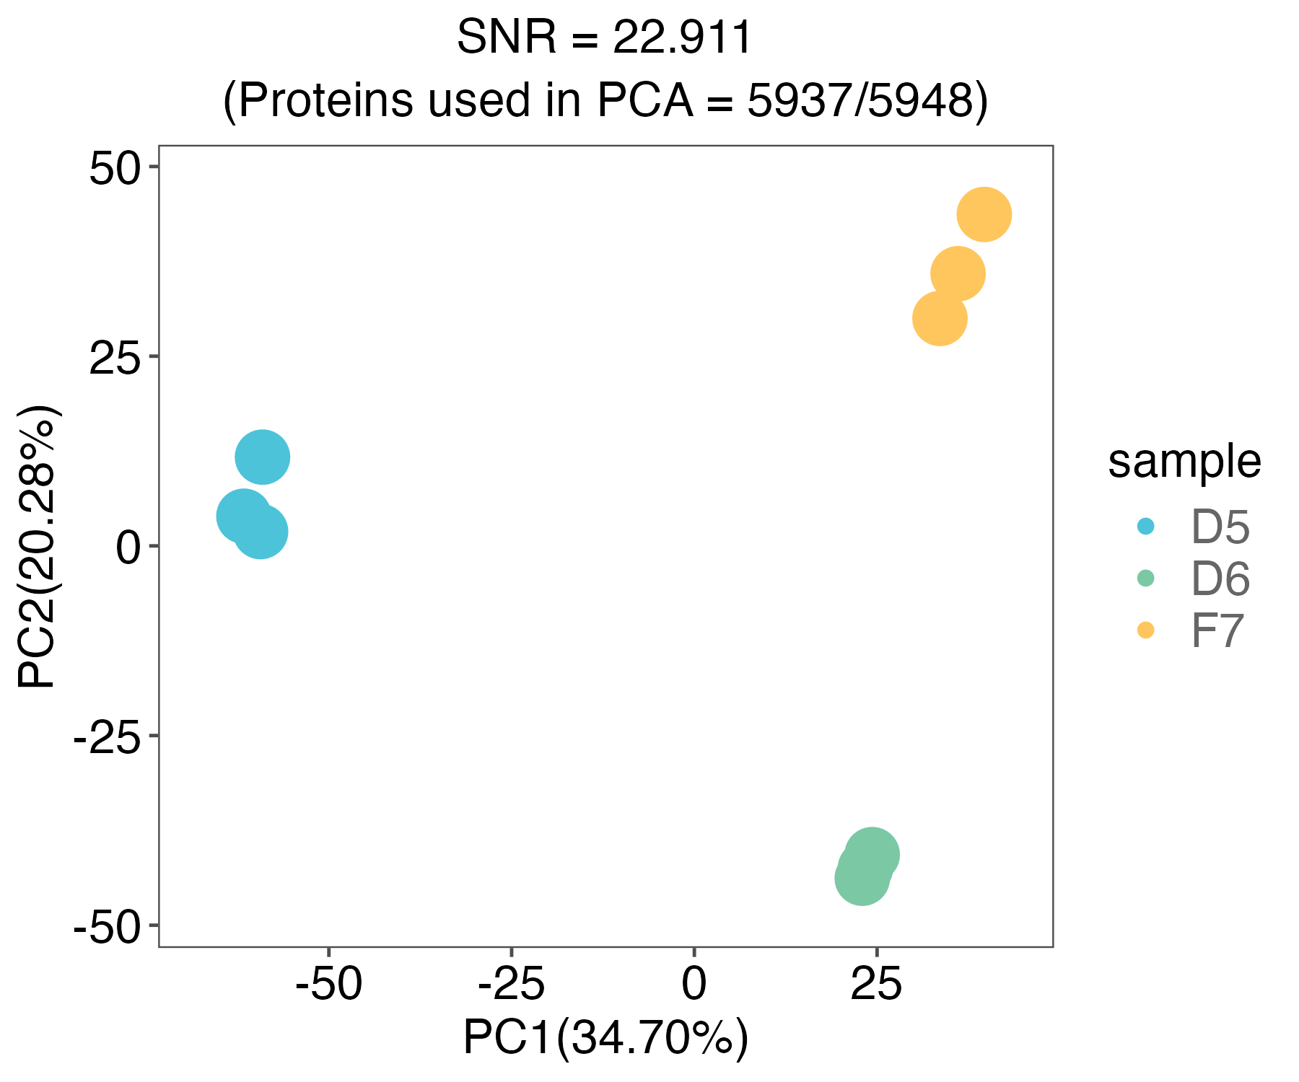
SNR is established to characterize the power in discriminating multiple groups. The PCA plot is used to visualize the metric.

Correlation with Reference Datasets
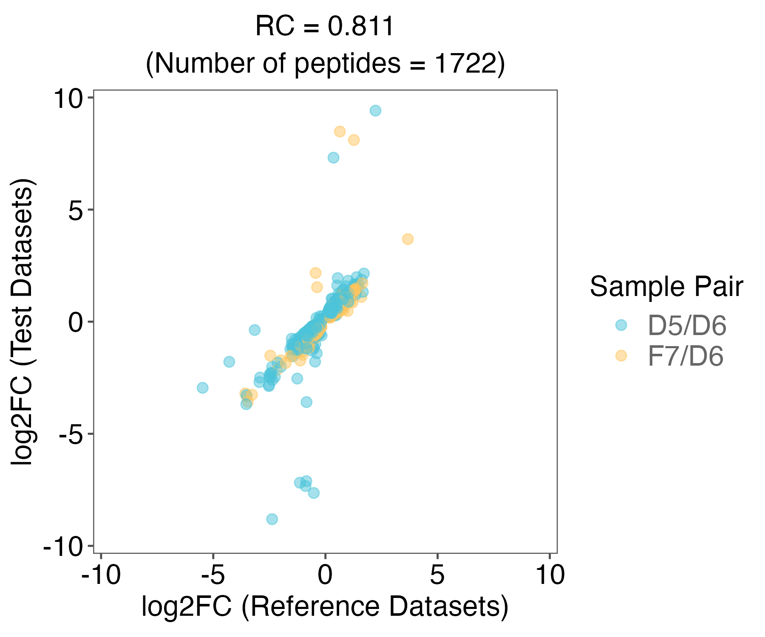
Relative correlation with reference datasets metric which was representing the numerical consistency of the relative expression profiles.

Supplementary Information

Reference
1. Zheng, Y. et al. Multi-omics data integration using ratio-based quantitative profiling with Quartet reference materials. Nature Biotechnology 1–17 (2023).
2. Tian, S. et al. Quartet protein reference materials and datasets for multi-platform assessment of label-free proteomics. Genome Biology 24, 202 (2023).

Contact us
Fudan University Pharmacogenomics Research Center
Project manager: Quartet Team
Email: quartet@fudan.edu.cn

Disclaimer
This quality control report is only for this specific test data set and doesn’t represent an evaluation of the business level of the sequencing company. This report is only used for scientific research, not for clinical or commercial use. We don’t bear any economic and legal liabilities for any benefits or losses (direct or indirect) from using the results of this report.

