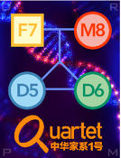


Quartet Report for Genomics

Summary

This report summarizes the quality of the data generated from Quartet DNA reference materials based on several key quality control (QC) metrics. Each metric is accompanied by its current value, historical average, ranking among all datasets evaluated, and the corresponding performance grade.

Metric | Queried Value | Mean ± SD | Rank | Performance
Precision (SNV) | 0.997 | 0.994 ± 0.007 | 4 / 10 | Good
Precision (INDEL) | 0.984 | 0.974 ± 0.015 | 5 / 10 | Good
Recall (SNV) | 0.993 | 0.997 ± 0.004 | 9 / 10 | Bad
Recall (INDEL) | 0.986 | 0.981 ± 0.013 | 4 / 10 | Good
Total Score | 0.993 | 0.992 ± 0.006 | 6 / 10 | Fair

QC Metrics
The QC pipeline starts from the variant calling file, enabling the calculation of the following three metrics. The total score is an F0.5-measure of the SNV score and the INDEL score, which are the mean values of Precision, Recall, and MCR, respectively.

Precision:
Tested call sets were compared with benchmark small variants using hap.py (https://github.com/Illumina/hap.py). Precision is the fraction of called variants in the test dataset that are true.

Recall:
Recall is the fraction of true variants are called in the test dataset.

Mendelian Concordance Rate:
Mendelian concordance rate (MCR) is the number of variants following Mendelian inheritance laws divided by the total number of variants called among the four Quartet samples. Mendelian concordant variants are the variants shared by the twins (D5 and D6) and following Mendelian inheritance laws with parents (Father: F7 and Mother M8). Mendelian analysis was performed using VBT (https://github.com/sbg/VBT-TrioAnalysis). When calculating Mendelian concordance rate of small variants, variants on large deletions were not included, because VBT takes these variants as Mendelian violations.

Total Score:
The submitted data will be graded as Bad, Fair, Good, or Great, depending on how the total score stands against historical data. Total score = (1+0.5^2) x SNV_score x INDEL_score / (0.5^2 x SNV_score + INDEL_score). SNV_score and INDEL_score are obtained by calculating the mean values of Precision, Recall, and MCR, respectively.

Performance Category:
Based on the scaled total score, the submitted data will be ranked together with all Quartet historical datasets. The higher the score, the higher the ranking. After this, the performance levels will be assigned based on their ranking ranges.
· Bad: Lowest quintile (0-20th percentile).
· Fair: Lower middle quartile (21st-50th percentile).
· Good: Upper middle quartile (51st-80th percentile).
· Great: Highest quintile (81st-100th percentile).

Performance Grade
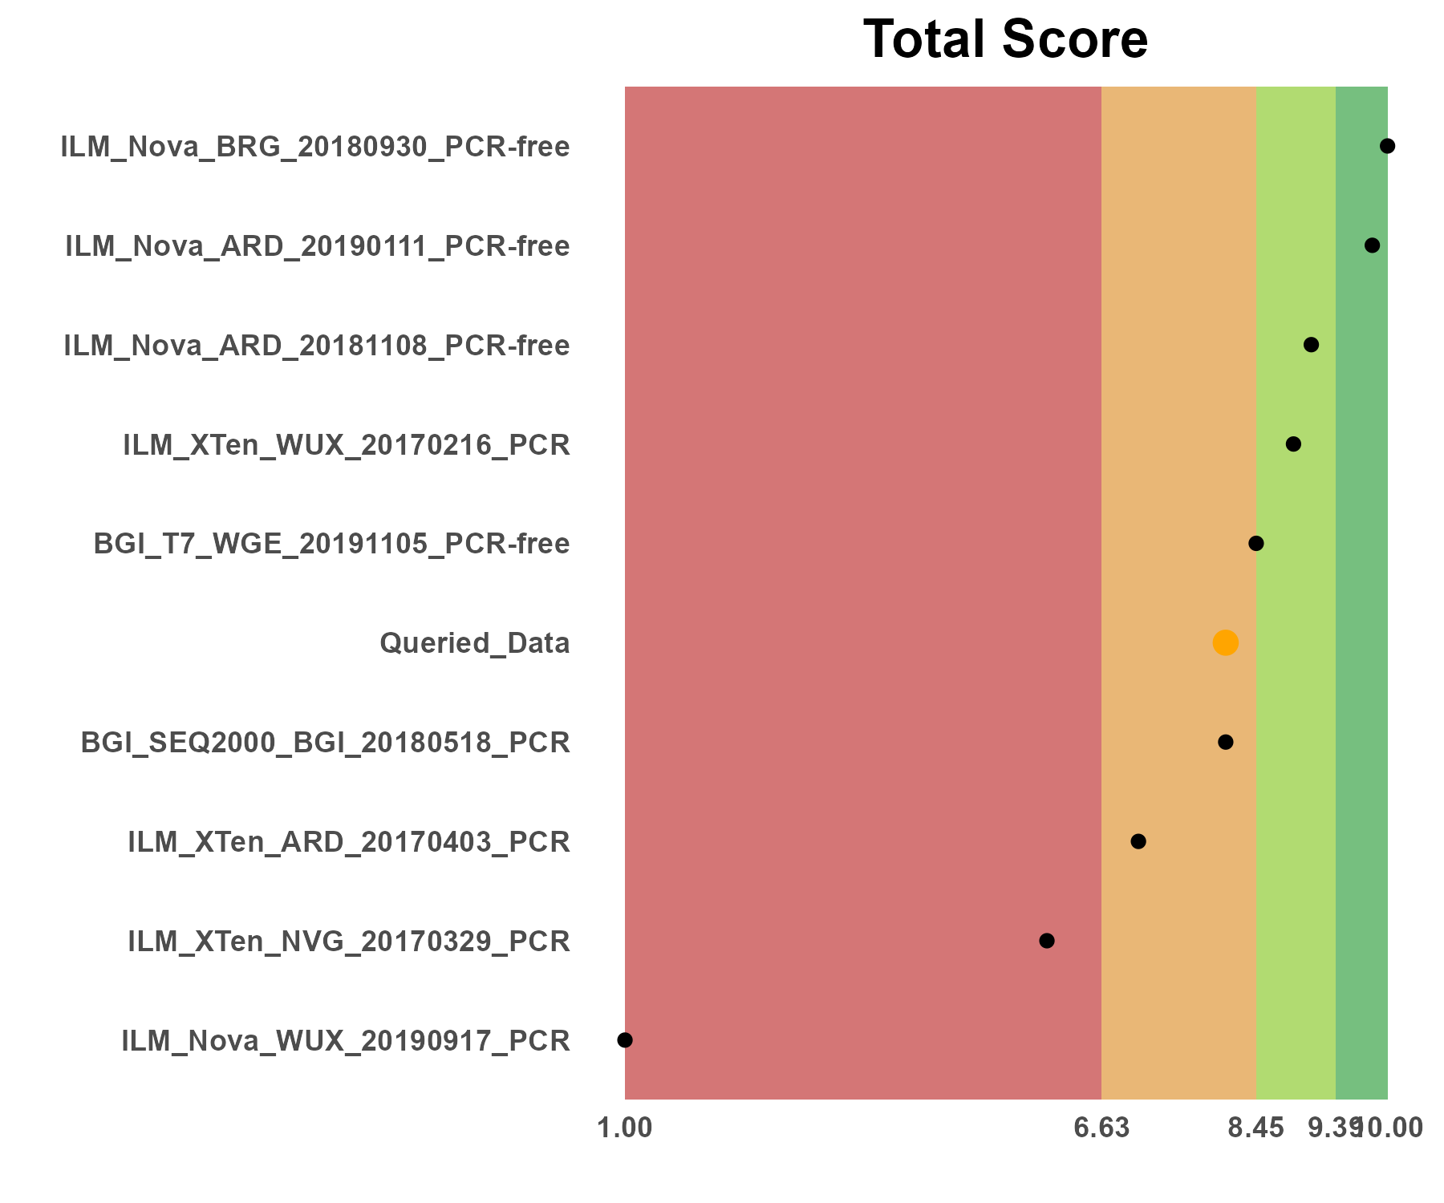
Scores of evaluation metrics for the current batch and all historical batches assessed. For better comparison and presentation, the total score was scaled to the interval [1, 10], with the worst dataset being 1 and the best dataset scoring 10. Please note that the results shown here are scaled values for all batches in each metric. The name of your data is Queried_Data.

Variant Calling Quality Control

Details based on reference datasets
Sample | SNV number | INDEL number | SNV precision | INDEL precision | SNV recall | INDEL recall
LCL5_UU_Illumina_D5_20230629_20171028_EATRISPLUS_UU_LCL5_hc | 3,855,821 | 980,430 | 0.997 | 0.984 | 0.993 | 0.986
Each row represents a set of Quartet samples, i.e. one each of D5, D6, F7 and M8. When multiple sets of technical replicates are measured, the performance of each set will be represented by row.

Supplementary Information

Reference
1. Zheng Y, Liu Y, Yang J, et al. Multi-omics data integration using ratio-based quantitative profiling with Quartet reference materials. Nat Biotechnol. Published online September 7, 2023.
2. Ren L, Duan X, Dong L, et al. Quartet DNA reference materials and datasets for comprehensively evaluating germline variant calling performance. Genome Biol. 2023; 24(1): 270.

Disclaimer
This Data Quality Report is provided as an analysis of the specific dataset evaluated and is intended for informational purposes only. While every effort has been made to ensure the accuracy and reliability of the analysis, the information is presented "AS IS" without warranty of any kind, either express or implied. The authors and distributors of this report shall not be held liable for any actions taken in reliance thereon. Users are advised that the findings within this report are not to be used as definitive statements on the quality of any product or process beyond the scope of the dataset assessed. This report is not intended for use in critical applications, commercial decision-making, or for regulatory compliance without professional verification and independent validation. No guarantee, either expressed or implied, is made regarding the use or results of the analysis, including without limitation, the correctness, accuracy, reliability, or applicability of the findings.

